IEEE P802.11
Wireless LANs
CC36 PLME
Date: 2021-07-12
Author(s):
Name | Affiliation | Address | Phone | email
Youhan Kim | Qualcomm |  |  | youhank@qti.qualcomm.com

Abstract
This submission proposes resolutions for the following comments from CC36 in P802.11be D1.0:

7282, 4914, 7283, 4557, 7284

NOTE – Set the Track Changes Viewing Option in the MS Word to “All Markup” to clearly see the proposed text edits.

Revision History:

R0: Initial version.

CID 7282

CID | Clause | Page.Line | Comment | Proposed Change
7282 | 36.4.2 | 557.45 | "EHT PHY MIB attributes are defined in Annex C with specific values defined in Table 36-68". It doesn't look like Table 36-68 defines any values. What is meant here? | Clarify

Background

D1.0 P557
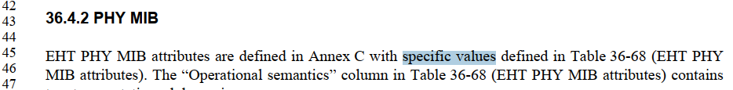

D1.0 P551
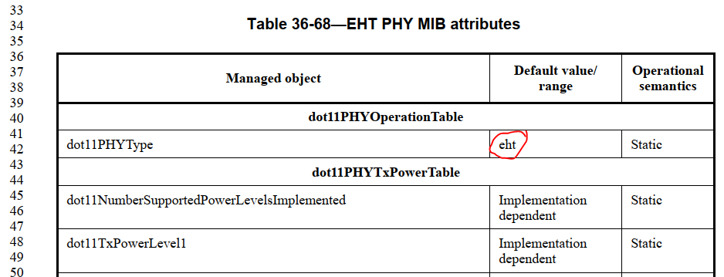

Proposed Resolution: CID 7282
Rejected
dot11PHYType is defined to have the value ‘eht’ in Table 36-68 (D1.0 P551L42).
Table 36-68 also defines that the value for most of the other MIB variables are ‘implementation dependent’.

CID 4914

CID | Clause | Page.Line | Comment | Proposed Change
4914 | 36.4.3 | 558.09 | EHT sounding NDP is not explained in the text. so, to indicate the NDP case clearly, add the following text.  " For an EHT sounding NDP, there is no Data field and NSYM = 0." | As in comment

Background

D1.01 P579-580
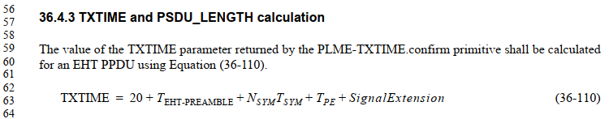
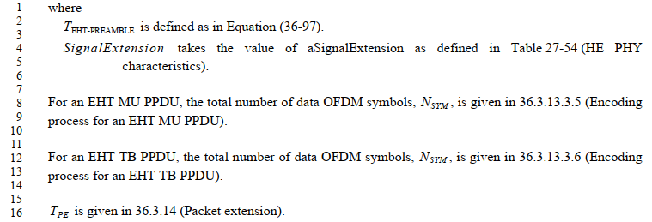

Proposed Resolution: CID 4914
Revised
Note to commenter:
Agree that N_SYM for NDP should be stated. Instruction to editor below implements the proposed change with some editorial updates.

Instruction to editor:
Add the following new paragraph at D1.01 P580L14:
“For an EHT sounding NDP, the total number of data OFDM symbols, \it{N_{SYM}}, is 0.”

CID 7283

CID | Clause | Page.Line | Comment | Proposed Change
7283 | 36.4.3 | 559.60 | "PSDU_LENGTH" in (36-118) should have index u | Add index (PSDU_LENGTH -> PSDU_LENGTH_u)

Background

D1.01 P559

Proposed Resolution: CID 7283
Accepted

CID 4557

CID | Clause | Page.Line | Comment | Proposed Change
4557 | 36.4.3 | 560.49 | Add the following sentence to clarify the EHT NDP case:  The value of the PSDU_LENGTH parameter returned in the PLME-TXTIME.confirm primitive for an EHT sounding NDP is 0. | as in the comment.

Background

D1.0 P558
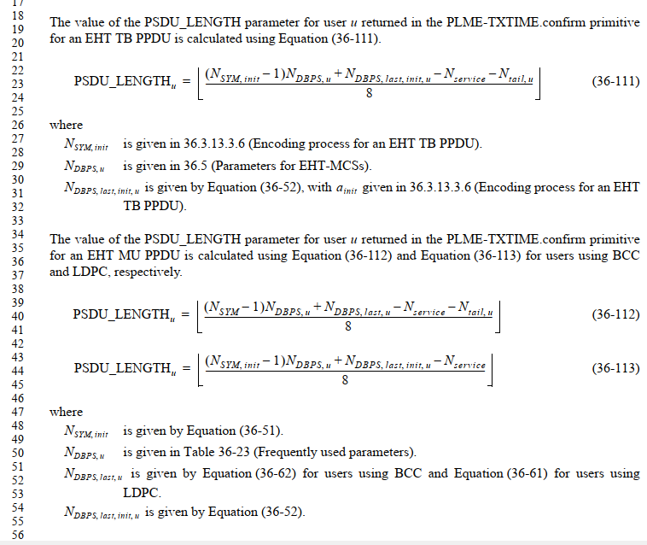

Proposed Resolution: CID 4557
Revised
Note to commenter:
Agree that PSDU_LENGTH parameter in PLME-TXTIME.confirm primitive is not defined for NDP. The proposed location to add that by the commenter, however, is where “RXVECTOR” is defined. Instruction to editor below defines the PSDU_LENGTH parameter in PLME-TXTIME.confirm primitive in a more proper location.

Instruction to editor:
Add the following new paragraph at D1.01 P580L56:
“The value of the PSDU_LENGTH parameter returned in the PLME-TIME.confirm primitive for an EHT sounding NDP is 0.”

CID 7284

CID | Clause | Page.Line | Comment | Proposed Change
7284 | 36.4.4 | 560.53 | Change "The static EHT PHY characteristics is provided through ..." to "The static EHT PHY characteristics are provided through ..." | See comment

Background

D1.0 P560

Proposed Resolution: CID 7284
Accepted

[End of File]

