IEEE P802.11
Wireless LANs
CC36 CR on PPDU Encoding Process
Date: 2021-07-12
Author(s):
Name | Affiliation | Address | Phone | email
Youhan Kim | Qualcomm |  |  | youhank@qti.qualcomm.com

Abstract
This submission proposes resolutions for the following comments from CC36 in P802.11be D1.0:

4546, 7186, 4841, 8094, 7187, 7188, 4842, 6433, 4843, 7476, 5527, 4549, 7189, 4548, 5474

NOTE – Set the Track Changes Viewing Option in the MS Word to “All Markup” to clearly see the proposed text edits.

Revision History:

R0: Initial version.
R1: Added proposed resolutions to CIDs 4549, 7189, 4548, 5474

CID 4546, 7186

CID | Clause | Page.Line | Comment | Proposed Change
4546 | 36.3.7.2 | 383.52 | Remove "and frequency segment".  Make the similar change to all the CSD per chain step in clauses in 36.3.7 (e.g P384L13) | as in the comment.
7186 | 36.3.7.2 | 383.52 | "for each transmit chain and frequency segment".  Since we've eliminated 80+80, 160+160, etc., I believe all signals now have only a single segment by definition.  In 11ax all signals has indices i_TX and i_seg, but the latter has been removed in 11be. Compare e.g. Equations (27-1) in 11ax and (36-7) in 11be. | Remove "and frequency segment". Also fix in other places where appropriate.

Background

D1.01 P405

D1.01 P406

D1.01 P406

D1.01 P407

D1.01 P408

D1.01 P408

D1.01 P408

D1.01 P409

D1.01 P410

Proposed Resolution: CID 4546, 7186
Revised
Note to commenter:
Agree with the commenter that “frequency segment” is not needed because EHT has only one frequency segment. The instruction to editor implements the text changes suggested by the commenter.

Instruction to editor:
In D1.01, change “spatial stream and frequency segment” to “spatial stream” at
P405L52
P406L13
P406L47
P407L18
P408L1
P408L35
P408L52
P409L13
P410L11
(Note to editor: Same resolutions for CIDs 4546 and 7186.)

CID 4841

CID | Clause | Page.Line | Comment | Proposed Change
4841 | 36.3.7.6 | 385.34 | From the U-SIG, we can use the extra tone for data. so, the number of available is 56 tone for data and pilot. so, delete the f) | As in comment

Background

D1.0 P385
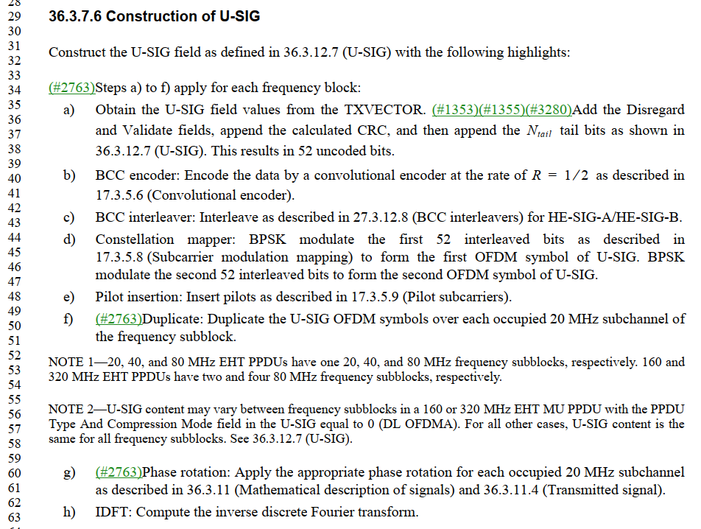

Proposed Resolution: CID 4841
Rejected
Step f) is not related to the fact that U-SIG uses 4 extra tones to carry information compared to L-SIG. The duplication over all occupied 20 MHz is required and correct.

CID 8094

CID | Clause | Page.Line | Comment | Proposed Change
8094 | 36.3.7.6 | 385.34 | frequency block should be frequencty subblock | as in comment

Background

D1.0 P385
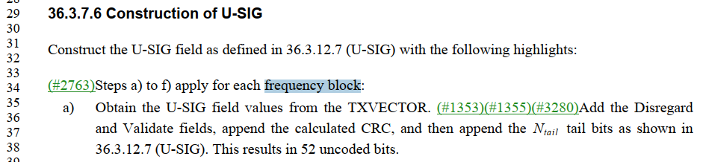

Proposed Resolution: CID 8094
Revised
Note to commenter:
The instruction to editor implements the text changes suggested by the commenter.

Instruction to editor:
At D1.01 P407L34, change “frequency block” to “frequency subblock”.

CID 7187

CID | Clause | Page.Line | Comment | Proposed Change
7187 | 36.3.7.6 | 385.37 | Change "as shown in" to "as described in" | See comment

Background

D1.0 P385
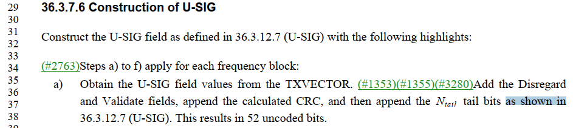

Proposed Resolution: CID 7187
Accepted

CID 7188

CID | Clause | Page.Line | Comment | Proposed Change
7188 | 36.3.7.6 | 385.52 | Change "subblock" to "subblocks" | See comment

Background

D1.0 P385
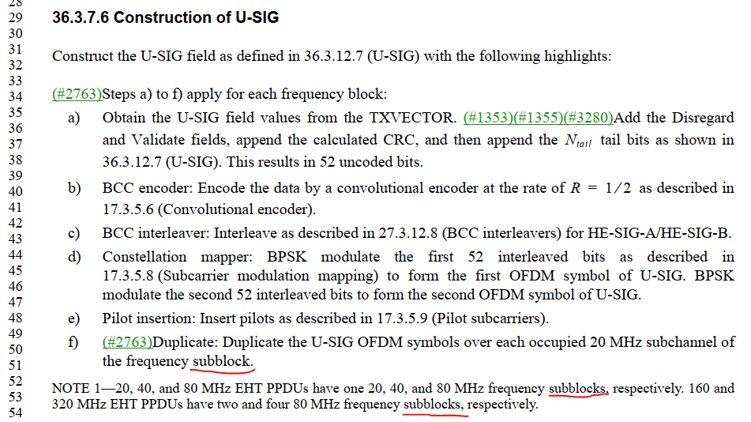

Proposed Resolution: CID 7188
Rejected
There is no “subblock” at P385L52.
There is a “subblock” at P358L51, but L34 says “… apply for each frequency subblock”. Hence, the singular “subblock” is correct at L51.

CID 4842, 6433

CID | Clause | Page.Line | Comment | Proposed Change
4842 | 36.3.7.6 | 385.56 | To make it clear, add the size of the frequency block.. | change " between frequency subblocks " with " between 80MHz frequency subblocks"
6433 | 36.3.7.6 | 385.56 | Add "80 MHz" between "between" and "frequency". | As in comment

Background

D1.0 P385

Proposed Resolution: CID 4842, 6433
Accepted
(Note to editor: Same resolutions for CIDs 4842 and 6433.)

CID 4843

CID | Clause | Page.Line | Comment | Proposed Change
4843 | 36.3.7.6 | 385.57 | To indicate the DL OFDMA, the DL/UL flag in U-SIG should be used. add the DL-UL flag in U-SIG is set to 0 in this sentence. | before (DL OFDMA), add " the DL-UL flag in U-SIG is set to 0"

Background

D1.01 P407

Proposed Resolution: CID 4843
Revised
Note to commenter:
Agree with the commenter that UL/DL flag is also used in determining DL OFDMA. Instruction to editor below implements the proposed change by the commenter, but with some editorial updates.

Instruction to editor:
At D1.01 P407L57, change
“field in the U-SIG equal to 0 (DL OFDMA).”
to
“field equal to 0 and the UL/DL field equal to 0 in the U-SIG (DL OFDMA).”

CID 7476

CID | Clause | Page.Line | Comment | Proposed Change
7476 | 36.3.7.8 | 386.58 | Change "Prepend a GI; 0.8 us..." to "Prepend a GI of 0.8 us..." | As in comment

Background

D1.0 386:

Proposed Resolution: CID 7476
Accepted

CID 5527

CID | Clause | Page.Line | Comment | Proposed Change
5527 | 36.3.7.9 | 387.11 | In  "..except the UL MU-MIMO transmission not using EHT single stream pilot EHT-LTF mode as described in 36.3.12.10 (EHT-LTF)",  the term of EHT single stream pilot EHT-LTF mode is not defined in 36.3.12.10 (EHT-LTF).  It would be better to just say as  "..except the UL MU-MIMO transmission by using 1x-LTF as described in 36.3.12.10 (EHT-LTF)". | As in comment

Background

D1.0 387:
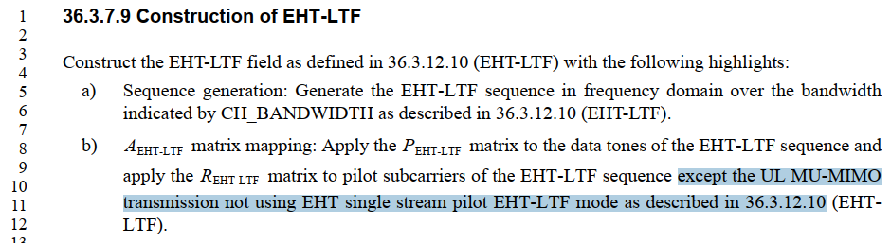

D1.01 P491:
…
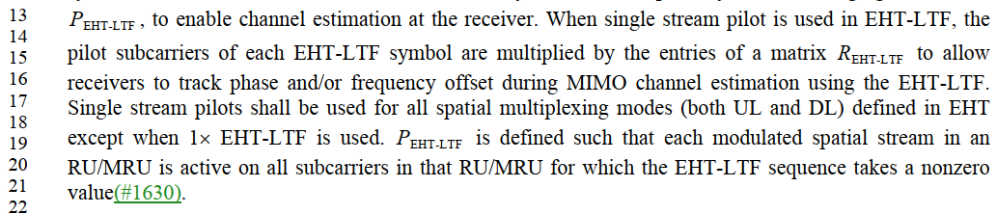

P1.01 P496:
…

Proposed Resolution: CID 5527
Rejected
36.3.12.10 has the description of the use of single stream pilot in EHT-LTF at D1.01 P491L13-21. Also, Equation (36-41) within 36.3.12.10 uses the term sigle stream pilot EHT-LTF mode to describe how the EHT-LTF is generated.

CID 4549

CID | Clause | Page.Line | Comment | Proposed Change
4549 | 36.37.10 | 387.49 | MCS14 is a special case for which segment parser and deparser step is not needed for 2x996-tone RU. Need to add some text to clarify on this | as in the comment.

Background

D1.0 P387:
…
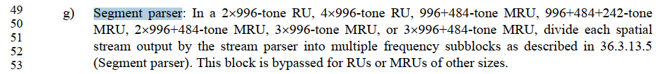

D1.01 P397:
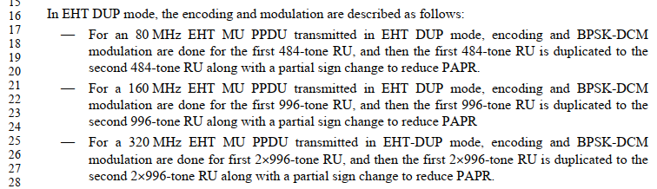

D1.01 P657:
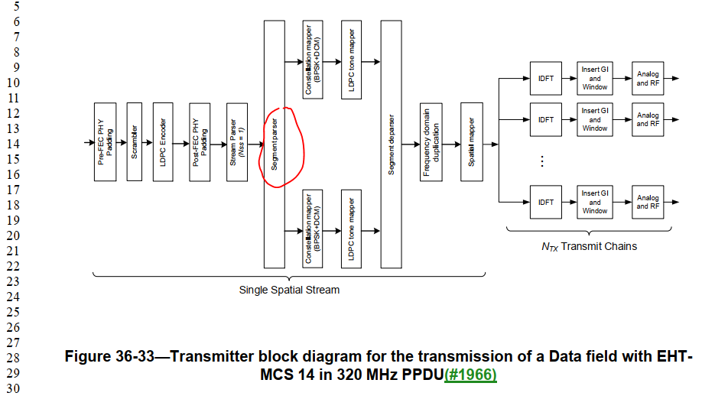

D1.01 P516-7
…
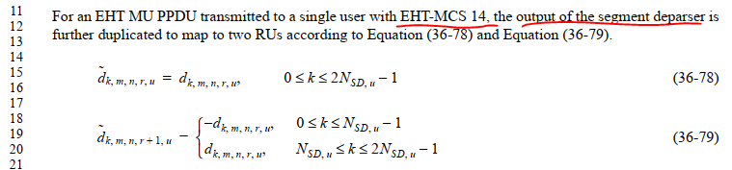

Proposed Resolution: CID 4549
Rejected
MCS 14 in a 320 MHz EHT MU PPDU uses two 2x996-tone RU (see D1.01 P397L25-28). And Figure 36-33 on D1.01 P657 shows that the segment parser/deparser are used for MCS 14 in 320 MHz EHT MU PPDU. Also, 36.3.13.10 (D1.01 P517) states that the frequency duplication for MCS 14 is done at the segement deparser output. Hence, segment parser/deparser are used for for MCS 14 in EHT MU PPDU (which uses 2x996-tone RU).

CID 7189

CID | Clause | Page.Line | Comment | Proposed Change
7189 | 36.3.7.10 | 387.51 | Change "output by" to "output from" | See comment

Background

D1.0 P387:
…
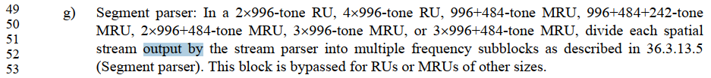

Proposed Resolution: CID 7189
Accepted

CID 4548, 5474

CID | Clause | Page.Line | Comment | Proposed Change
4548 | 36.3.7.10 | 388.15 | Should be "after steps a) to n)" | as in the comment.
5474 | 36.3.7.10 | 388.15 | steps a) to m) should be steps a) to n) | as in comment

Background

D1.0 P388:
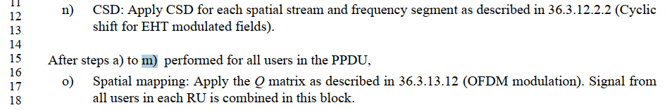

Proposed Resolution: CID 4548, 5474
Revised
Note to commenter:
Commenter is correct that “m)” should be “n)”. Instruction to editor below implements the proposed change.

Instruction to editor:
At D1.01 P410L15, change “a) to m)” to “a) to n)”.
(Note to editor: Same resolutions for CIDs 4548 and 5474.)

[End of File]

