IEEE P802.11
Wireless LANs
CC36 Comment Resolutions for Annex C
Date: 2021-07-11
Author(s):
Name | Affiliation | Address | Phone | Email
Eunsung Park | LG Electronics | 19, Yangjae-daero 11gil, Seocho-gu, Seoul 137-130, Korea |  | esung.park@lge.com
Dongguk Lim |  |  |  | dongguk.lim@lge.com
Jinyoung Chun |  |  |  | jiny.chun@lge.com
Jinsoo Choi |  |  |  | js.choi@lge.com

Abstract
This submission proposes resolutions for the following 2 CIDs:
4500, 4623

Revisions:
- Rev 0: Initial version of the document.

Interpretation of a Motion to Adopt

A motion to approve this submission means that the editing instructions and any changed or added material are actioned in the TGbe D1.01 Draft. This introduction is not part of the adopted material.

Editing instructions formatted like this are intended to be copied into the TGbe D1.01 Draft (i.e. they are instructions to the 802.11 editor on how to merge the text with the baseline documents).

TGbe Editor: Editing instructions preceded by “TGbe Editor” are instructions to the TGbe editor to modify existing material in the TGbe draft. As a result of adopting the changes, the TGbe editor will execute the instructions rather than copy them to the TGbe Draft.

CIDs 4500, 4623
CID | Clause | PP.LL | Comment | Proposed Change | Resolution
4500 | Annex C.3 | 602.22 | The term "EHT NDP" is incorrect. | Please replace "EHT NDP" with "EHT sounding NDP" | Accepted
4623 | Annex C | 591.65 | Though not a MIB expert, I see "dot11PhyEHTTable" as a comment but a) no actual defintion of this in clause 36 and b) no actual row for this in the "dot11phy OBJECT IDENTIFIER" | a) Define dot11PhyEHTTable in 36.4.2. b) Search on "dot11phy OBJECT IDENTIFIER ::= { ieee802dot11 4 } " in 11me and extend. Note that VHT and HE both seem to have the same problem. | Rejected  In the current spec, dot11PHYEHTTable is defined in Table 36-38 (EHT PHY MIB attributes) and is included in the dot11phy OBJECT IDENTIFIER (See P613L61 of D1.01). As for VHT and HE, these issues can be dealt with in REVme.

Discussion
P613L61 of D1.01
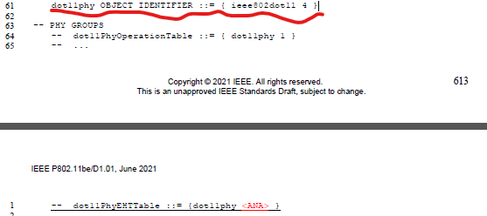

Table 36-38 EHT PHY MIB attributes
