IEEE P802.11
Wireless LANs
Fixes to timing measurement
Date: 2021-07-07
Author(s):
Name | Affiliation | Address | Phone | email
Joseph Seok | Self |  |  | seok.joseph@gmail.com
Alfred Asterjadhi | Qualcomm Inc. |  |  | asterjadhi@gmail.com
Abstract
This contribution proposes editorial fixes to certain timing measurement figures that have used the wrong field name.

All the changes are related to Draft P802.11REVme D0.0.

Discussion:
- Figure 11-33 (Timing measurement procedure) and Figure P-1 (Parameters recorded by Observing STA when monitoring Fine Timing Measurement frames), use Follow On Dialog Token in their respective illustrations. However, as shown in the frame format below, the field name is actually Follow Up Dialog TokenThis contribution proposes to fix these inconsistencies by replacing the Follow On Dialog Token with the correct field name, i.e., Follow Up Dialog Token.

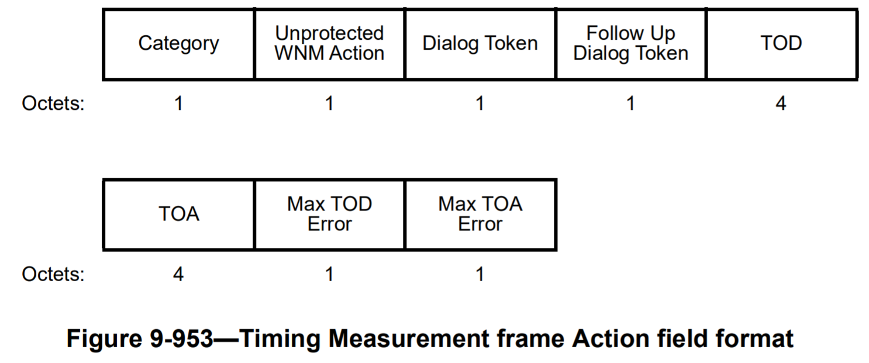

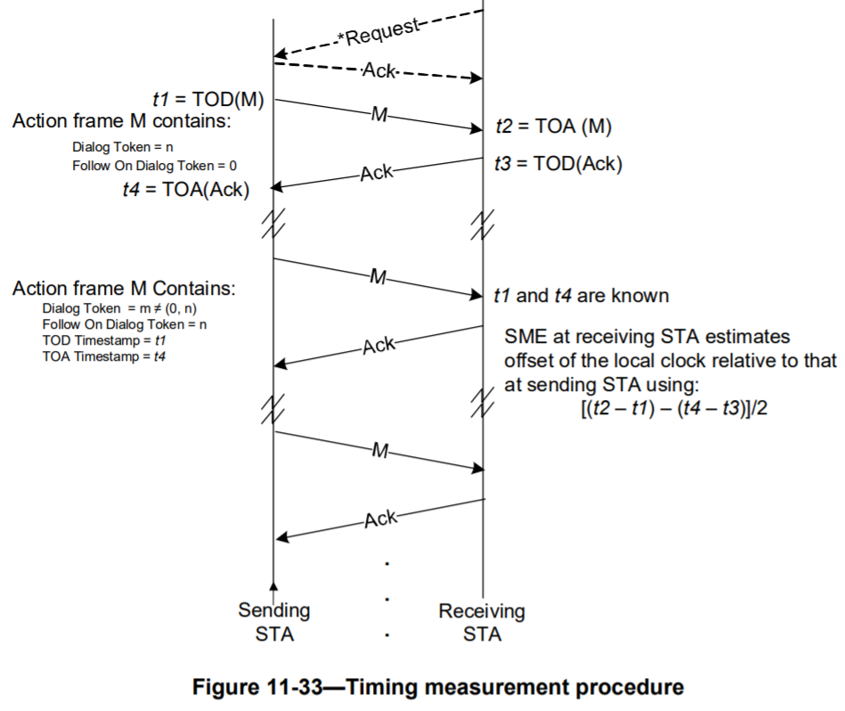

Proposed changes (note to editor: the changes are equivalent to replacing Follow On Dialog Token with Follow Up Dialog Token in the existing figures):

Replace Figure 11-33 (Timing measurement procedure) in Draft P802.11REVme D0.0 with the following.

Replace Figure P-1 (Parameters recorded by Observing STA when monitoring Fine Timing Measurement frames) in Draft P802.11REVme D0.0 with the following.

