IEEE P802.11
Wireless LANs
Fixes to timing measurement
Date: 2021-06-25
Author(s):
Name | Affiliation | Address | Phone | email
Joseph Seok | Self |  |  | seok.joseph@gmail.com
Abstract
This contribution fixes the timing measurement figures that have used the wrong field name.

All the changes are related to Draft P802.11REVme D0.0.

Discussion:
- In Figure 11-33 (Timing measurement procedure) and Figure P-1 (Parameters recorded by Observing STA when monitoring Fine Timing Measurement frames), the Follow On Dialog Token is a wrong name. This contribution proposes to change it to the Follow Up Dialog Token.

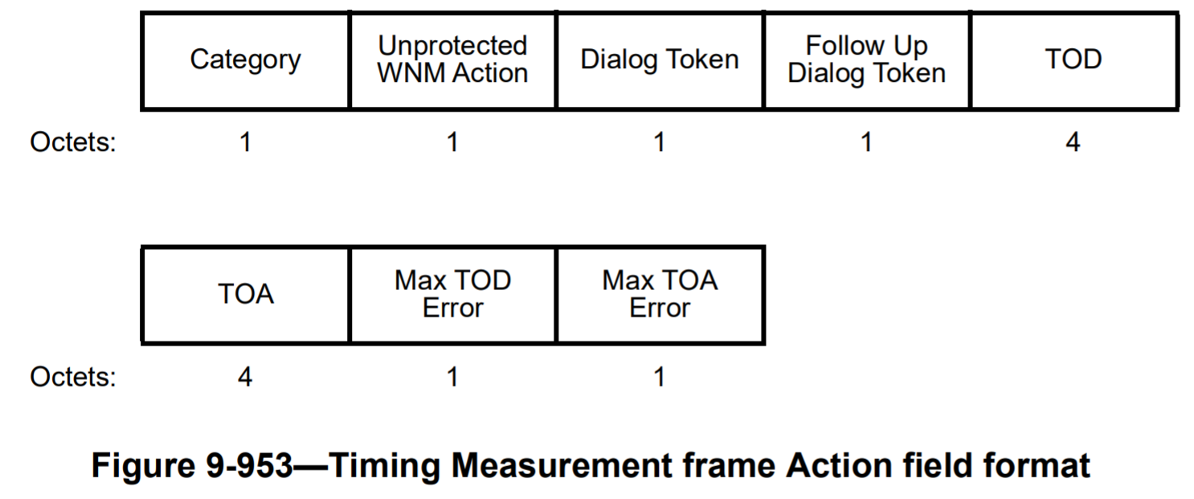

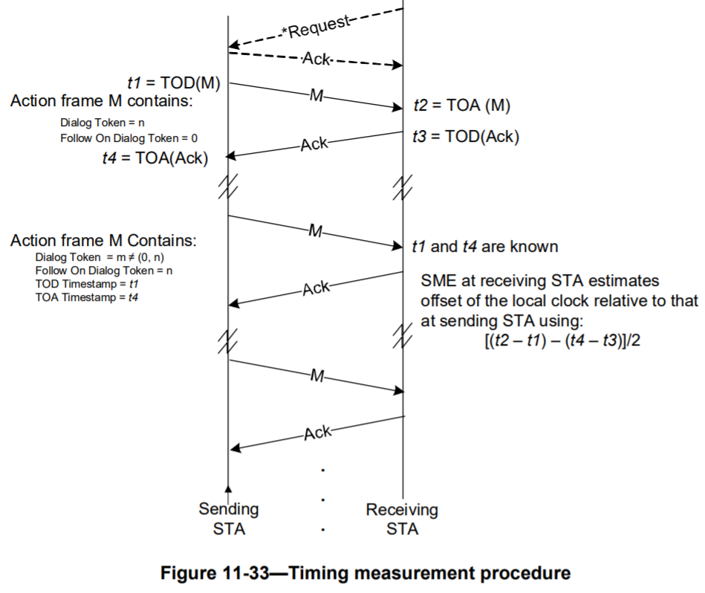

Proposed changes:

Replace Figure 11-33 (Timing measurement procedure) in Draft P802.11REVme D0.0 with the following.

Replace Figure P-1 (Parameters recorded by Observing STA when monitoring Fine Timing Measurement frames) in Draft P802.11REVme D0.0 with the following.

