IEEE P802.11
Wireless LANs
PDT for 9.4.2.295c.4 Supported EHT-MCS And NSS Set field
Date: 2021-06-22
Author(s):
Name | Affiliation | Address | Phone | email
Eunsung Park | LG Electronics | 19, Yangjae-daero 11gil, Seocho-gu, Seoul 137-130, Korea |  | esung.park@lge.com
Dongguk Lim |  |  |  | dongguk.lim@lge.com
Jinyoung Chun |  |  |  | Jiny.chun@lge.com
Jinsoo Choi |  |  |  | js.choi@lge.com
Youhan Kim | Qualcomm |  |  | youhank@qti.qualcomm.com

Abstract
This submission proposes the draft text for 9.4.2.295c.4 Supported EHT-MCS And NSS Set field.

Revisions:
- Rev 0: Initial version of the document.

References:
[1] P802.11be D1.0

Discussion
The following figure shows the Supported EHT-MCS And NSS Set field format.
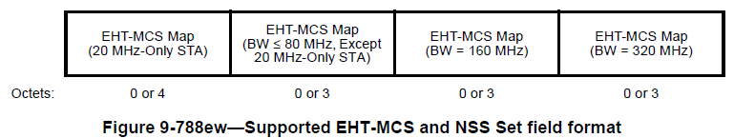

In the current design of Supported EHT-MCS And NSS Set field, there are two issues to be addresed.
- Issue 1: Non-AP STA’s participation in a wider bandwidth PPDU transmission or reception
- Issue 2: 2.4 GHz band

Issue 1
Basically, 20/80/160 MHz operating non-AP STA shall be able to participate in a wider BW PPDU transmission or reception. However, the current Supported EHT-MCS And NSS Set field cannot indicate the max NSS for each MCS when a non-AP STA participates in a wider BW PPDU transmission or reception since EHT-MCS Map subfield for X MHz is not present when the STA’s operating channel width is narrower than X MHz as shown below table.
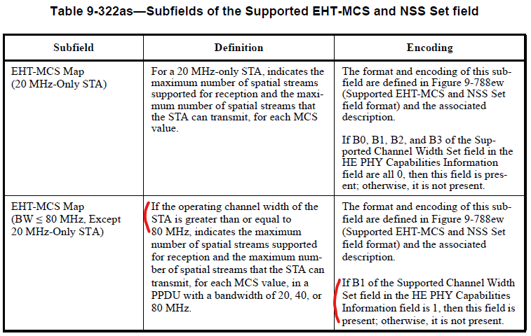
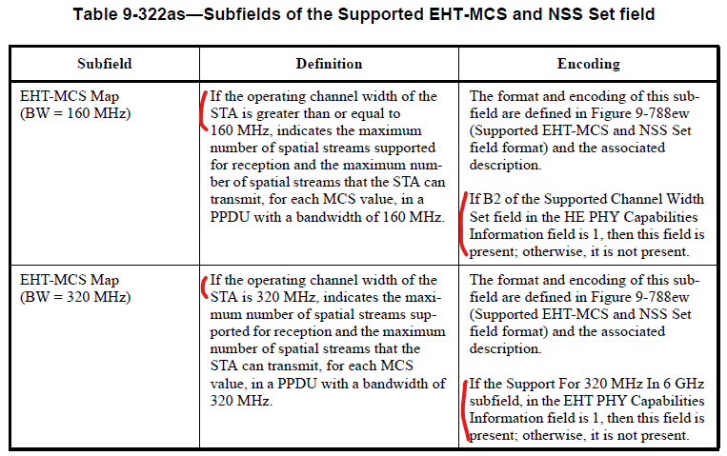

To resolve this issue, we provide two options.
- Option 1: Simple clarification of the existing subfields by adding a description related to non-AP STAs
- Optoin 2: Redesign of the Supported EHT-MCS And NSS Set field.

- Option 1
The current design is modified by simply adding PPDU BW applicable for non-AP STAs. The following table shows an example.

Subfield | Definition | Encoding
EHT-MCS Map  (20 MHz-Only STA) | For a 20 MHz-only STA, indicates the maximum number of spatial streams supported for reception and the maximum number of spatial streams that the STA can transmit, for each MCS value in a PPDU with a bandwidth of 20 MHz, 40 MHz, 80 MHz, or 160 MHz. | The format and encoding of this subfield are defined in Figure 9-788ew (Supported EHT-MCS and NSS Set field format) and the associated description.  If B1, B2, and B3 of the Supported Channel Width Set field in the HE PHY Capabilities Information field are all 0, then this field is present; otherwise, it is not present.
EHT-MCS Map  (BW<=80 MHz, Except 20 MHz-Only STA) | Except for a 20 MHz-only STA, indicates the maximum number of spatial streams supported for reception and the maximum number of spatial streams that the STA can transmit, for each MCS value, in a PPDU with a bandwidth of 20, 40, or 80 MHz.  For a 20 MHz or 80 MHz operating non-AP STA, additionally indicates the maximum number of spatial streams supported for reception and the maximum number of spatial streams that the non-AP STA can transmit, for each MCS value in a PPDU with a bandwidth of 160 MHz or 320 MHz. | The format and encoding of this subfield are defined in Figure 9-788ew (Supported EHT-MCS and NSS Set field format) and the associated description.  If B1 of the Supported Channel Width Set field in the HE PHY Capabilities Information field is 1, then this field is present; otherwise, it is not present.
EHT-MCS Map  (BW=160 MHz) | If the operating channel width of the STA is greater than or equal to 160 MHz, indicates the maximum number of spatial streams supported for reception and the maximum number of spatial streams that the STA can transmit, for each MCS value, in a PPDU with a bandwidth of 160 MHz.  For a 160 MHz operating non-AP STA, additionally indicates the maximum number of spatial streams supported for reception and the maximum number of spatial streams that the non-AP STA can transmit, for each MCS value in a PPDU with a bandwidth of 320 MHz. | The format and encoding of this subfield are defined in Figure 9-788ew (Supported EHT-MCS and NSS Set field format) and the associated description.  If B2 of the Supported Channel Width Set field in the HE PHY Capabilities Information field is 1, then this field is present; otherwise, it is not present.
EHT-MCS Map  (BW=320 MHz) | If the operating channel width of the STA is 320 MHz, indicates the maximum number of spatial streams supported for reception and the maximum number of spatial streams that the STA can transmit, for each MCS value, in a PPDU with a bandwidth of 320 MHz. | The format and encoding of this subfield are defined in Figure 9-788ew (Supported EHT-MCS and NSS Set field format) and the associated description.  If the Support For 320 MHz In 6 GHz subfield, in the EHT PHY Capabilities Information field is 1, then this field is present; otherwise, it is not present.

It is just a simple modification and does not cause an overhead increase. Also, we can use Figure 9-788ew as it is. Even though this design cannot indicate a different max Nss value when a STA participate in a wider bandwidth transmission or reception, using the same max value is reasonable since the non-AP STA’s operating channel width is still the same even in a wider bandwidth transmission or reception.

- Option 2
A totally new design is considered with newly defined subfields regardless of the STA’s operating channel width. The following table shows an example.
Subfield | Definition | Encoding
EHT-MCS Map  (BW≤80 MHz) | Indicates the maximum number of spatial streams supported for reception and the maximum number of spatial streams that the STA can transmit, for each MCS value, in a PPDU with a bandwidth of 20, 40, or 80 MHz. | The format and encoding of this subfield are defined in Figure 9-788ew (Supported EHT-MCS and NSS Set field format) and the associated description.
EHT-MCS Map  (BW=160 MHz) | Indicates the maximum number of spatial streams supported for reception and the maximum number of spatial streams that the STA can transmit, for each MCS value, in a PPDU with a bandwidth of 160 MHz. | The format and encoding of this subfield are defined in Figure 9-788ew (Supported EHT-MCS and NSS Set field format) and the associated description.
EHT-MCS Map  (BW=320 MHz) | Indicates the maximum number of spatial streams supported for reception and the maximum number of spatial streams that the STA can transmit, for each MCS value, in a PPDU with a bandwidth of 320 MHz. | The format and encoding of this subfield are defined in Figure 9-788ew (Supported EHT-MCS and NSS Set field format) and the associated description.
Figure 9-788ew needs to be also modified. The following figure shows an example.
In each STA regardless of its operating channel width, this design can separately indicate the max Nss value for each bandwidth. However, it can increase overhead since all of the subfields should be always present. Furthermore, considering 20 MHz-only STA, 4 octets are required in each subfield. Note that each of the current subfield consists of 0 or 3 octets except for the EHT-MCS Map (20 MHz-Only STA) subfield having 0 or 4 octets.

Since D1.0 is already published, we prefer to minimize the change in the spec. Also, in terms of the overhead, option 1 is better. Hence, our preference is option 1.

Issue 2
11be also supports a 20 / 40 MHz operating STA in 2.4 GHz but there is no subfield to indicate the max NSS for each MCS for a PPDU in 2.4 GHz. To reslove this issue, we can define additional subfields in the Supported EHT-MCS And NSS Set field for the 2.4 GHz band but as mentioned above to minimize the spec change the existing subfields can be reused with a simple modification. The following table shows an example.

Subfield | Definition | Encoding
EHT-MCS Map  (20 MHz-Only STA) | For a 20 MHz-only STA, indicates the maximum number of spatial streams supported for reception and the maximum number of spatial streams that the STA can transmit, for each MCS value in a PPDU with a bandwidth of 20 MHz, 40 MHz, 80 MHz, or 160 MHz. | The format and encoding of this subfield are defined in Figure 9-788ew (Supported EHT-MCS and NSS Set field format) and the associated description.  In 5 GHz, if B1, B2, and B3 of the Supported Channel Width Set field in the HE PHY Capabilities Information field are all 0, then this field is present; otherwise, it is not present.  In 2.4 GHz, if B0 of the Supported Channel Width Set field in the HE PHY Capabilities Information field is 0, then this field is present; otherwise, it is not present.
EHT-MCS Map  (BW<=80 MHz, Except 20 MHz-Only STA) | Except for a 20 MHz-only STA, indicates the maximum number of spatial streams supported for reception and the maximum number of spatial streams that the STA can transmit, for each MCS value, in a PPDU with a bandwidth of 20, 40, or 80 MHz.  For a 20 MHz or 80 MHz operating non-AP STA, additionally indicates the maximum number of spatial streams supported for reception and the maximum number of spatial streams that the non-AP STA can transmit, for each MCS value in a PPDU with a bandwidth of 160 MHz or 320 MHz. | The format and encoding of this subfield are defined in Figure 9-788ew (Supported EHT-MCS and NSS Set field format) and the associated description.  In 5 GHz or 6 GHz, if B1 of the Supported Channel Width Set field in the HE PHY Capabilities Information field is 1, then this field is present; otherwise, it is not present.  In 2.4 GHz, if B0 of the Supported Channel Width Set field in the HE PHY Capabilities Information field is 1, then this field is present; otherwise, it is not present.
EHT-MCS Map  (BW=160 MHz) | If the operating channel width of the STA is greater than or equal to 160 MHz, indicates the maximum number of spatial streams supported for reception and the maximum number of spatial streams that the STA can transmit, for each MCS value, in a PPDU with a bandwidth of 160 MHz.  For a 160 MHz operating non-AP STA, additionally indicates the maximum number of spatial streams supported for reception and the maximum number of spatial streams that the non-AP STA can transmit, for each MCS value in a PPDU with a bandwidth of 320 MHz. | The format and encoding of this subfield are defined in Figure 9-788ew (Supported EHT-MCS and NSS Set field format) and the associated description.  If B2 of the Supported Channel Width Set field in the HE PHY Capabilities Information field is 1, then this field is present; otherwise, it is not present.
EHT-MCS Map  (BW=320 MHz) | If the operating channel width of the STA is 320 MHz, indicates the maximum number of spatial streams supported for reception and the maximum number of spatial streams that the STA can transmit, for each MCS value, in a PPDU with a bandwidth of 320 MHz. | The format and encoding of this subfield are defined in Figure 9-788ew (Supported EHT-MCS and NSS Set field format) and the associated description.  If the Support For 320 MHz In 6 GHz subfield, in the EHT PHY Capabilities Information field is 1, then this field is present; otherwise, it is not present.

TGbe Editor: Please modify Table 9-322as-Subfields of the Supported EHT MCS and NSS Set field of D1.0 as follows:

Subfield | Definition | Encoding
EHT-MCS Map  (20 MHz-Only STA) | For a 20 MHz-only STA, indicates the maximum number of spatial streams supported for reception and the maximum number of spatial streams that the STA can transmit, for each MCS value in a PPDU with a bandwidth of 20 MHz, 40 MHz, 80 MHz, or 160 MHz. | The format and encoding of this subfield are defined in Figure 9-788ew (Supported EHT-MCS and NSS Set field format) and the associated description.  In 5 GHz, if B1, B2, and B3 of the Supported Channel Width Set field in the HE PHY Capabilities Information field are all 0, then this field is present; otherwise, it is not present.  In 2.4 GHz, if B0 of the Supported Channel Width Set field in the HE PHY Capabilities Information field is 0, then this field is present; otherwise, it is not present.
EHT-MCS Map  (BW<=80 MHz, Except 20 MHz-Only STA) | Except for a 20 MHz-only STA, indicates the maximum number of spatial streams supported for reception and the maximum number of spatial streams that the STA can transmit, for each MCS value, in a PPDU with a bandwidth of 20, 40, or 80 MHz.  For a 20 MHz or 80 MHz operating non-AP STA, additionally indicates the maximum number of spatial streams supported for reception and the maximum number of spatial streams that the non-AP STA can transmit, for each MCS value in a PPDU with a bandwidth of 160 MHz or 320 MHz. | The format and encoding of this subfield are defined in Figure 9-788ew (Supported EHT-MCS and NSS Set field format) and the associated description.  In 5 GHz or 6 GHz, if B1 of the Supported Channel Width Set field in the HE PHY Capabilities Information field is 1, then this field is present; otherwise, it is not present.  In 2.4 GHz, if B0 of the Supported Channel Width Set field in the HE PHY Capabilities Information field is 1, then this field is present; otherwise, it is not present.
EHT-MCS Map  (BW=160 MHz) | If the operating channel width of the STA is greater than or equal to 160 MHz, indicates the maximum number of spatial streams supported for reception and the maximum number of spatial streams that the STA can transmit, for each MCS value, in a PPDU with a bandwidth of 160 MHz.  For a 160 MHz operating non-AP STA, additionally indicates the maximum number of spatial streams supported for reception and the maximum number of spatial streams that the non-AP STA can transmit, for each MCS value in a PPDU with a bandwidth of 320 MHz. | The format and encoding of this subfield are defined in Figure 9-788ew (Supported EHT-MCS and NSS Set field format) and the associated description.  If B2 of the Supported Channel Width Set field in the HE PHY Capabilities Information field is 1, then this field is present; otherwise, it is not present.
EHT-MCS Map  (BW=320 MHz) | If the operating channel width of the STA is 320 MHz, indicates the maximum number of spatial streams supported for reception and the maximum number of spatial streams that the STA can transmit, for each MCS value, in a PPDU with a bandwidth of 320 MHz. | The format and encoding of this subfield are defined in Figure 9-788ew (Supported EHT-MCS and NSS Set field format) and the associated description.  If the Support For 320 MHz In 6 GHz subfield, in the EHT PHY Capabilities Information field is 1, then this field is present; otherwise, it is not present.

