IEEE P802.11  
Wireless LANs

|  |  |  |  |  |
| --- | --- | --- | --- | --- |
| PDT-summary-EHT-sounding-combinations | | | | |
| Date: 2021-06-22 | | | | |
| Author(s): | | | | |
| Name | Company | Address | Phone | email |
| Ross Jian Yu | Huawei | Huawei Industrial Base, Shenzhen, Guangdong, China |  | ross.yujian@huawei.com |
| Ming Gan |  |  |  |
| Stephen McCann |  |  |  |
| Edward Au |  |  |  |
|  |  |  |  |
|  |  |  |  |  |

Abstract

This document contains proposed draft text for EHT sounding combinations.

R0: initial version

***Background (not part of the PDTs):***

There are many combintations for sounding. The proposal is to have two tables for a better summary and understanding of EHT sounding, similar to the EHT-LTF type and GI duration combinations.

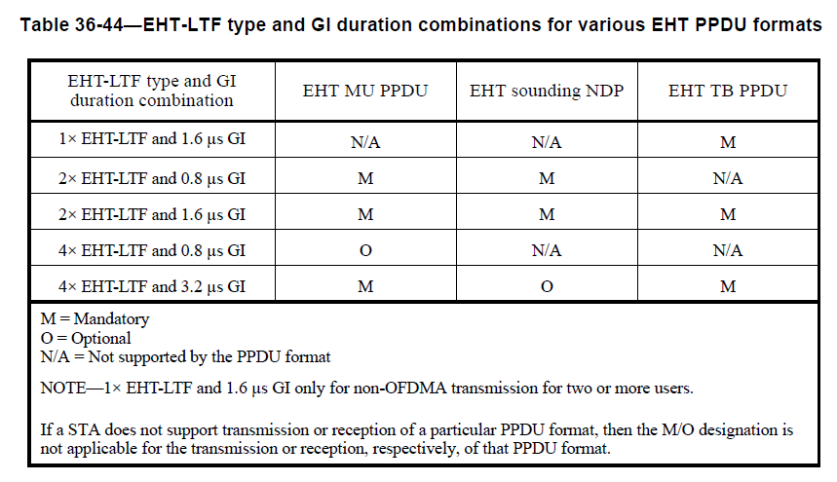

Reference:

**Table 9-322ar—Subfield of the EHT PHY Capabilities Information field**

|  |  |  |
| --- | --- | --- |
| SU Beamformer | Indicates support for operation as an SU beam- former. | Set to 0 if not supported. Set to 1 if supported.  NOTE—Set to 1 if any of the following subfields, MU Beamformer (BW  ≤ 80 MHz), MU Beam- former (BW = 160 MHz), and MU Beamformer (BW = 320 MHz), is 1. |
| SU Beamformee | Indicates support for operation as an SU beam- formee. | For an AP:  Set to 0 if not sup- ported.  Set to 1 if supported.  Set to 1 for a non-AP STA. |
| Triggered SU Beam- forming Feedback | For an AP, indicates support for the reception of partial and full bandwidth SU feedback in an EHT TB sounding sequence.  For a non-AP STA, indicates support for the transmission of partial and full bandwidth SU feedback in an EHT TB sounding sequence. | Set to 0 if not supported. Set to 1 if supported. |
| Triggered MU Beam- forming Partial BW Feedback | For an AP, indicates support for the reception of partial bandwidth MU feedback in an EHT TB sounding sequence.  For a non-AP STA, indicates support for the transmission of partial bandwidth MU feedback in an EHT TB sounding sequence. | Set to 0 if not supported. Set to 1 if supported.  For a non-AP STA, this field is set to 1 if the Partial Bandwidth DL MU-MIMO subfield is set to 1. |
| Triggered CQI Feed- back | For an AP, indicates support for the reception of partial and full bandwidth CQI feedback in an EHT TB sounding sequence.  For a non-AP STA, indicates support for the transmission of partial and full bandwidth CQI feedback in an EHT TB sounding sequence. | Set to 0 if not supported. Set to 1 if supported. |
| Non-Triggered CQI Feedback | For an AP, indicates support for the reception of full bandwidth non-triggered CQI feedback. For a non-AP STA, indicates support for the transmission of full bandwidth non-triggered CQI feedback. | Set to 0 if not supported. Set to 1 if supported. |
| MU Beamformer (BW ≤ 80 MHz) | For an AP, indicates the support for non- OFDMA DL MU-MIMO transmission and the required MU sounding, for PPDU bandwidths of 20, 40, and 80 MHz. | For an AP STA:  Set to 0 if not sup- ported.  Set to 1 if supported.  If the maximum number of spatial streams indicated for transmission, for any MCS, in the EHT-MCS Map (BW ≤ 80 MHz, Excluding 20 MHz-Only STA) subfield within the Supported MCS and Nss Set field, is greater or equal to four, then set to 1.  Reserved for a non-AP STA. |
| MU Beamformer (BW = 160 MHz) | For an AP, indicates the support for non- OFDMA DL MU-MIMO transmission and the required MU sounding, for PPDU bandwidths of 160 MHz. | For an AP STA:  Set to 0 if not supported.  Set to 1 if supported.  If the maximum number of spatial streams indicated for transmission, for any MCS, in the EHT-MCS Map (BW = 160 MHz) subfield within the Supported MCS and Nss Set field, is greater or equal to four, then set to 1.  Reserved for a non-AP STA. |
| MU Beamformer (BW = 320 MHz) | For an AP, indicates the support for non- OFDMA DL MU-MIMO transmission and the required MU sounding, for PPDU bandwidths of 320 MHz. | For an AP STA:  Set to 0 if not supported.  Set to 1 if supported.  If the maximum number of spatial streams indicated for transmission, for any MCS, in the EHT-MCS Map (BW = 320 MHz) subfield within the Supported MCS and Nss Set field, is greater or equal to four, then set to 1.  Reserved for a non-AP STA. |

***Background Ended***

***PDT part begins:***

***Instructions to the editor: please add the following to the end of 35.5.2 EHT sounding protocol***

A summary of EHT sounding combinations are shown in Table xx1 and xx2.

**Table xx1 Beamformer and Beamformee Combinations for AP and non-AP STA**

|  |  |  |
| --- | --- | --- |
|  | AP | Non-AP STA |
| SU Beamformee | O | M |
| SU Beamformer | CM  NOTE—Set to 1 if any of the following subfields, MU Beamformer (BW ≤ 80 MHz), MU Beamformer (BW = 160 MHz), and MU Beamformer (BW = 320 MHz), is 1. | O |
| MU Beamformee | N/A for an AP | M |
| MU Beamformer (BW ≤ 80 MHz) | CM  If the maximum number of spatial streams indicated for transmission, for any MCS, in the EHT-MCS Map (BW ≤ 80 MHz, Excluding 20 MHz-Only STA) subfield within the Supported MCS and Nss Set field, is greater or equal to four, then set to 1. | N/A |
| MU Beamformer (BW = 160 MHz) | CM  If the maximum number of spatial streams indicated for transmission, for any MCS, in the EHT-MCS Map (BW = 160 MHz) subfield within the Supported MCS and Nss Set field, is greater or equal to four, then set to 1. | N/A |
| MU Beamformer (BW = 320 MHz) | CM  If the maximum number of spatial streams indicated for transmission, for any MCS, in the EHT-MCS Map (BW = 320 MHz) subfield within the Supported MCS and Nss Set field, is greater or equal to four, then set to 1. | N/A |

**Table xx2 SU/MU/CQI Feedback Combinations for AP and Non-AP STA**

|  |  |  |  |  |
| --- | --- | --- | --- | --- |
|  | Trigger based | | Non-trigger based | |
|  | AP | Non-AP STA | AP | Non-AP STA |
| SU feedback | O for partial and full bandwidth | O for partial and full bandwidth | M for full bandwidth reception  CM for full bandwidth transmission  Set to 1 if AP is a SU beamformee  N/A for partial bandwidth | M for full bandwidth transmission  CM for full bandwidth reception  Set to 1 if STA is a SU beamformer  N/A for partial bandwidth |
| MU feedback | O for patial bandwidth reception  M for full bandwidth reception | M for full bandwidth transmission  CM for partial bandwidth transmission  This field is set to 1 if the Partial Bandwidth DL MU-MIMO subfield is set to 1. | N/A for full and partial bandwidth | N/A for full and partial bandwidth |
| CQI feedback | O for partial and full bandwidth reception | O for partial and full bandwidth transmission | O for full bandwidth reception  N/A for partial bandwidth | O for full bandwidth transmission  N/A for partial bandwidth |