IEEE P802.11
Wireless LANs
ARC SC teleconferences minutes 17 June 2021
Date: 2021-06-17
Author(s):
Name | Affiliation | Address | Phone | email
Joseph LEVY | InterDigital Communication, Inc. | 111 W 33rd Street  New York, NY 10120 | +1.631.622.4139 | jslevy@ieee.org
Abstract
This document contains the minutes of the IEEE 802.11 ARC SC teleconference held on 7 June 2021 at 19:00-21:00 h ET.

Note: Highlighted text are action items. A- precedes comments from the document’s author, C- precedes comments, R- precedes responses to comments.

Contents:
Thursday 17 June 2021, 19:00-21:00 h ET 3
Administration: 3
Contributions: 3
Next Steps: 7
Adjourned: 21:02 h ET 7
Attendance: 8

Thursday 17 June 2021, 19:00-21:00 h ET

Administration:
Chair: Mark Hamilton, Ruckus/CommScope
Vice Chair: Joseph Levy, InterDigital
Secretary: Joseph Levy, InterDigital

Meeting called to order by the Chair 19:03 ET
Agenda slide deck: 11-21/0982r0

Call for Patents:
The Chair reviewed the Patent policy and called for potentially essential patents – there was no response to the call.
IEEE SA Copyright Policy:
The Chair reviewed the Copyright policy.
Core Principles:
The Chair reviewed the IEEE Core Principles.
Participation:
The Chair reviewed the participation policy.
Approval of the Agenda:
- Attendance, noises/recording, meeting protocol reminders
- Policies, duty to inform, participation rules
- Contribution/discussion topics:
  - 802.11 TGbe’s evolving multi-link architecture contributions
    - 11-21/0577r2 – Presented to TGbe (June 7), continued discussion in ARC?
    - 11-21/0396r3
- Next Steps
The Chair reviewed the agenda and called for comments or amendments to the agenda. Duncan did update the document and there have been comments from TGbe that still need to be worked. But nothing major to discuss.
No amendments were provided.
The proposed agenda was accepted without objection.

Contributions:
11-21/0577r2 – Presented to TGbe (June 7) – Duncan Ho (Qualcomm) presenting
Duncan provided a review of updates and comments:
- MLD Upper MAC and MLD Lower MAC were applied globally
- Corrected order of figure
- Added AP only
- Text modified to say merging process (done during the meeting).
- Two paragraphs were added to talk about BA score boarding – as the description was missing. (Upper and lower MLD MAC) – added but not yet posted to mentor (will be in r3?).
- A note was added just above clause 35.
- The purpose of this text is to clarify the architecture and not add normative behavior.
C - What is the purpose of sending the Scoreboarding from the upper MAC may be sent to the lower MAC? If a fast reply is required, it should not have to wait.
R - If you force the model, of the Upper MAC controlling, there may be delay and currently if you don’t receive the block ACK you just re-transmit.
C - Scoreboarding is on the receive path. Not the Tx path.
You may information that is a full STA – BA Scoreboarding is like BA reporting.
Isn’t the BA Scoreboarding in 10.25.6.3 – Check
C – The phase: “an MLD can also support multiple MAC sublayers” – should be: “an MLD supports multiple MAC sublayers”. –
R – Will consider changing it.
C – In the third paragraph – change to: An MLD supports multiple MAC layers, coordinated by an SME.
The next paragraph: states that SME keeps the authentication and association states. But the SME shouldn’t be exposed all this data/details. For SME 802.11 usually says the stacks shared the information.
R – GTKs shouldn’t be shared.
R – Most of the listed information is in upper MAC and therefore is not really shared.
R – Proposing removing the sentence “the SME of the MLD has access the state information that is common for all links ….” And deleting the “In addition” in the next sentence.
Other edits discussed:
Changing: The Authenticator and MAC-SAP of the AP MLD are identified by the same AP MLD MAC address. The Supplicant and the MAC-SAP of the non-AP MLD are identified by the same non-AP MLD MAC address.
Changing band/channel to bands or channels.
Block Ack scoreboarding is only for individually address frames.
Group addressed data frame deliver – is OK. Also fixed the unicast to individually addressed
How is the third bullet different than the second bullet? Deleted the second bullet and modified the third one to include … and SN/PM assignment using GTK/IGTK …
It noted that figure 4-yyy – up and down are not correct for the layers – this has triggered comments in previous drafts. It may be simpler to fix it now.
R – Will keep the document simple, so I would prefer not to change it. Also, it was noted this is clause 4.

Some discussion on ESS and BSS -
C – Each AP has its own BSS –
C – This is in clause 4.3.
C – If we are not changing it, we should just keep the base line.
C – This will be discussed when we discuss - 11-21/0396r3
C – The reference model for two links. Figure 4.xxx Reference model for an MLD for two links.
The data path needs to go through the whole layer, so you may not need the MLD layer.
C – The legacy portion (non-MLD) is not shown in this picture. There is nothing here about the legacy. As we agreed to for now.
C – But how the legacy interacts with an MLD must be described. In this case it looks like a legacy AP, both cases need to be covered. The MLD works as a module that turns different APs that are co-located into an MLD.
C – Maybe the solution is to note that the figure is for MLO only. When we say MLD are we only talking about MLO operation.
C – When we are talking about MLO – we are talking about MLDs talking to each other, it doesn’t address legacy, and group addressed frames.
C – if it is a device – then it is device.
R – but the MLD is a logical device.
C – So since the MLD is a logical entity – it only deals with MLO frame exchanges.
C – But there will be an AP for link 1 and one for link 2 – they are different. I would like to see these entities.
C – This will be discussed when we discuss 11-21/0396.
C – Don’t want to introduce legacy in to MLO – the legacy part should be unchanged.
Chair – Let’s not open that can of worms now.
C – In the figure – do we need divide the MLD into MLD and legacy.
Chair – We are not discussing the legacy issue in this document. Let’s move on to 11-21/0396 so we can discuss the legacy issue.
11-21/0396r3
Mark Hamilton presenting – the point of this document now is so how do we add legacy to the architecture.
On slide 3 – made it based on Figure 5-1
The MLD Upper MAC – sublayer and there are MLD Lower MAC will also provide serve a legacy upper MAC (see slide 4) and added the BSS in the figure, and there are separate stacks at the top.
C – Is there a function at the top of the lower MAC to route frames to the different upper MACs.
R – Address 1 filtering can handle that – as it can deal with the peer filtering. So, the Address 1 filtering needs to know the association type for each transmitting peer and this added information is used to route the frame to the legacy or MLD upper MAC.
Beacons, prob request and probe responses are handled by the legacy upper MAC. But there is additional information provided for MLO – but the legacy upper MAC builds the beacons.
Association frames and actions frames – coming from the MLD to an MLD peer – go to/from MLD Upper MAC.
So, some management is only on the legacy peer, and some are in the MLD peer.
Adding the management frame discussion.
Beacon information is coming from the MLD’s MLME to the legacy upper MAC so it can include it in the beacon.
Discussion:
C – The legacy upper MAC can deal with getting and including the MLD information in the beacon transmissions or a device that supports MLO.
C – The DS should be added, the device that support MLO will have multiple DSAFs – So the diagram is not complete, as it is.
R – Moving on to slide 6 – which shows the multiple DSAFs.
C – The MLO architecture first should be decoupled – so there would be a separate picture - with additional legacy interconnections.
Some discussion on logical devices and physical devices and their definition.
C – This is why MLO uses the term affiliated.
C – What is the affiliated AP? The following drawing was made during the discussion. The red circled entities are the affiliated APs, and the yellow circled entity is the MLD.
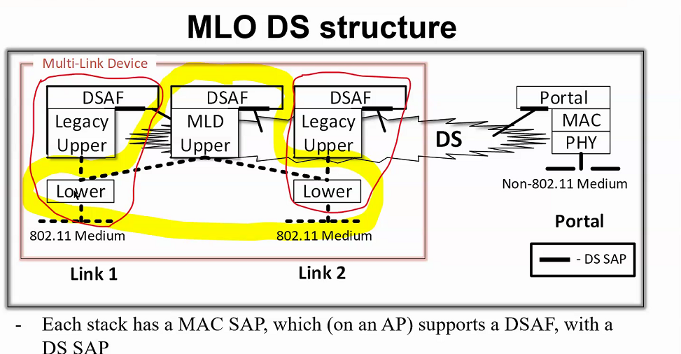

C – This figure is much clearer – we may not need to rename the lower layer as it is just shared.
C – Why does this matter. It will be the same beacon message. The legacy devices will decode everything they can, the MLDs will decode what they can’t understand. All the specification needs to describe is the connectivity, how the MLD supports multilink operation. There are multiple APs that form a MLD to support MLO operation to achieve MLO advantages. These are the same function with different portions. Architecturally – a single AP is a legacy AP.
C – This picture is sharing lower portions and there are interactions that happen, due to the lower portions being shared. So, it is important that these interactions be explained, and the behavior described.
C – So this is describing how the MLD behaves – e.g., the beacons are sent via legacy – it is the same beacon.
C – The link 1 BSS must have beacons.
C – It should be made very clear how the beacons are formed and processed. The functionality should be clear. It isn’t necessary to describe which modules are shared.
C – The AP affiliated with the MLD, is only a portion of the “legacy” AP.
C – The yellow line is ok for the data portion of the logical MLD. But the management service needs more than the yellow line.
C – To achieve interoperability – how much of this we need to describe?

Next Steps:
- Upcoming Teleconferences:
  - Annex G
    - June 21: 13:00 ET, 2 hours
  - TGbe multi-link architecture topic
    - During July plenary
- Contributions requested/expected:

Adjourned: 21:02 h ET

Attendance:
Name | Affiliation
Hamilton, Mark | Ruckus/CommScope
Ho, Duncan* | Qualcomm
Huang, Po-Kai | Intel Corporation
Levy, Joseph | InterDigital, Inc.
Petrick, Albert | Jones-Petrick and Associates, LLC.
Rolfe, Benjamin* | Blind Creek Associates
Rosdahl, Jon | Qualcomm Technologies, Inc.
Wang, Lei | Futurewei Technologies
Yang, Jay | Nokia
yi, yongjiang | Spreadtrum Communication USA Inc.
* Added based on Webex participants list.

