IEEE P802.11
Wireless LANs
ANQP elements Augmentation Proposal
Date: 2021-10-11
Author(s):
Name | Affiliation | Address | Phone | email
Jerome Henry | Cisco Systems |  |  | jerhenry@cisco.com
Stephen McCann | Huawei |  |  | Stephen.mccann@ieee.org
Mark Hamilton | Ruckus/CommScope | 350 W. Java Dr  Sunnyvale, CA | +1 303 818 8472 | mark.hamilton2152@gmail.com
Mark Rison | Samsung Cambridge Solution Centre | SJH, CB4 0DS, U.K. | +44 1223 434600 | at Samsung (a global commercial entity) I’m the letter emme then dot rison
Bart Brinkman | Cisco Systems |  |  | bbrinckm@cisco.com
Abstract
This submission proposes several new ANQP elements that would be of use for the Wi-Fi Alliance and federations use cases.

All the changes are related to Draft P802.11REVme D0.3.

CID | Comment | Proposed Change | Resolution
93 | Modern networks allow more than one types of credentials, but may not allow all types | Specify credential types that can be advertised as allowed, along with the allowed validation method and required lifetime for these credentials | Revise, define a new ANQP element that clarifies which credentials are accepted, along with the acceptation method.
94 | Privacy is a primary determinator for network attachment choice. Without knowing if the local network requires a real identity or accepts anonymous IDs, users are forced to reveal more than they want or need | Define a privacy indicator element that clarifies if the network allows for anonymous connections | Revise, define a Privacy indicator element for ANQP

Discussion:
- In large federations (where multiple venues may allow for multiple sources of identities), the multi-to-multi relationship makes it difficult for the STA profile to understand the required identity and credential expectations of the venue, and how these map to the identity profile that the STA is configured to use.
- This ambiguity can cause unnecessary overhead or may cause the STA to send discovery messages that may not be required by the infrastructure (and that can in turn, affect the user privacy or result in a lower user experience).
- This submission proposes additional ANQP elements that can assist a STA in clarifying the required identity and credential expectations of the infrastructure.
- In a multi-to-multi environment (e.g., multiple venue members of a federation), each venue may advertise a RCOI (Roaming Consortium) that allow STAs to provide multiple identities, each with different credential type requirements (e.g., simple email, proof of residence, identity validation or other). Each venue may also accept multiple types of credentials. However, the venue may also be constrained in the type of credentials it can accept (e.g., ‘only accept credentials where the user identity can be verified’) – this is a limitation in WBA and WFA scenarios
- It is useful to define the credential types that the venue can accept, as this may be a subset of the credentials accepted by all of the RCOI members within a federation (e.g., type of credentials accepted, with type of verification accepted, credential lifetime)
- The venue may also mandate that the user connects with a verifiable outer identity. In other cases, the venue requirements are satisfied with an anonymous outer identity, provided that an authentication source validates the user credentials. It may be useful to specify if the venue requires a ‘real’ outer identity or not, potentially removing the need for clients to expose their user identity where it is not needed.

Proposed resolution:

Revised.

Modify the tables in the following clause as shown:
9.4.1.34 Venue Info field
Table 9-93 Venue group codes and descriptions

Venue group code | Venue group description
… | …
11 | Outdoor
12 | Credential
123-255 | Reserved

Table 9-94 Venue type assignments

Venue group code | Venue type code | Venue description
… | … | …
11 | 7-255 | Reserved
12 | 0 | Unspecified Miscellaneous Entities
12 | 1 | Service Provider
12 | 2 | Cloud or Social Media Provider
12 | 3 | Cable Industry
12 | 4 | Government
12 | 5-255 | Reserved

Modify the table in the following clause as shown:
    - Access Network Query Protocol (ANQP) elements
Table 9-404 ANQP-element definitions

ANQP-element name | InfoID | ANQP-element  (subclause)
… | … | …
Local MAC Address Policy | 283 | 9.4.5.29
Credential Types | <283+ANA> | 9.4.5.30
Service Level Agreement | <283+ANA+1> | 9.4.5.31
Excluded NAI Realm | <283+ANA+2> | 9.4.5.32
Reserved | <283+ANA+3> 284 - 56 796 | -
Vendor Specific | 56 797 | 9.4.5.8
Reserved | 56 798 – 65 535 | -

Insert the following new subclause, after 9.4.5.29

9.4.5.30. Credential Types ANQP-element

The Credential Types ANQP-element provides a STA with information about the types of credentials accepted via that AP. The format of the Credential Types ANQP-element is shown in Figure 9-1035a.

 | Info ID | Length | Credential Types Count | Credential Types Tuples
Octets: | 2 | 1 | 1 | Mx3
Figure 9-1035a — Credential Types ANQP-element format

To editor: in figure 9-1035a above, in “Mx3”, “x” is a multiplication glyph.
The Info ID and Length fields are defined in 9.4.5.1 (General).

The Credential Types Count field specifies the number M of Credential Types Tuple subfields.

The Credential Types Tuples subfield contains zero or more Credential Types Tuple subfields.

The format of a Credential Types Tuple subfield is shown in Figure 9-1035b.

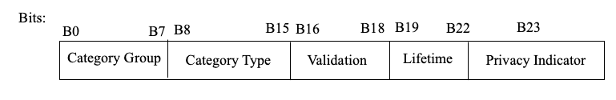

Figure 9-1035b - Credential Types Tuple subfield format

The Category Group and Category Type subfields specify the credential issuer(s) accepted via the AP, mapped to the Venue group code and the Venue type code in Table 9-66, respectively.

The Validation subfield indicates the minimum type of credential validation that must occur for the credentials to be deemed valid. The values of the subfield are defined in Table 9-413a.

Table 9-413a Validation subfield values

Value | Validation method | Notes
0 | No verification | Credentials do not need to be verified
1 | Any method allowed
2 | Email verification
3 | SMS verification
4 | Government ID | e.g., account obtained by showing a government ID
5 | Government issued credentials | e.g., a certificate issued by a government
6-7 | Reserved

The Lifetime subfield indicates the minimum age required for the credentials to be acceptable, in units of year quarters.

The Privacy Indicator subfield is set to 1 if this AP requires the user to expose a contactable identity to the AP (usually for legal purposes). It is set to 0 if this AP accepts anonymous roaming.

 | Comment | Proposed Change | Resolution
95 | Users offered the choice between 2 networks may prefer to attach to the one that provides the best SLA, or for which they have an offload agreement with. However, such indication is not provided, limiting the quality of the experience for the user | Define a settlement indicator, and an SLA indicator, that clarifies if the network will accept all roaming, offer paid services or free services only, and if the network supports a form of SLA. | Revise, define a new ANQP element that clarifies the settlement and SLA values for the network

Insert the following new subclause, after 9.4.5.30

9.4.5.31 Service Level Agreement ANQP-Element

The Service Level Agreement ANQP-element provides a STA with information about the type of roaming supported by the AP, and the service level agreement (SLA) offered by the AP for a given roaming type. The format of the SLA ANQP-element is shown in Figure 9-1035c.

 | Info ID | Length | Venue SLA Policy Count | Venue SLA Policy Tuples
Octets: | 2 | 1 | 1 | variable
Figure 9-1035c — Service Level Agreement ANQP-element format

The Info ID and Length fields are defined in 9.4.5.1 (General).

The Venue SLA Policy Count field specifies the number of Venue SLA Policy Tuple subfields.

The Venue SLA Policy Tuples subfield contains zero or more Venue SLA Policy Tuple subfields.

The format of a Venue SLA Policy Tuple subfield is shown in Figure 9-1035d.

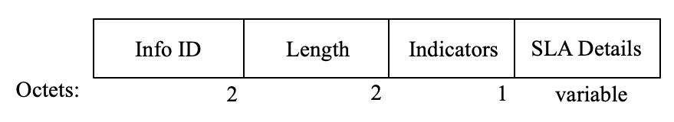
Figure 9-1035d – Venue SLA Policy Tuple subfield format

The Indicators subfield indicates the roaming services accepted by the venue and their associated SLAs. The format of the Indicators subfield is shown in Figure 9-1035e.

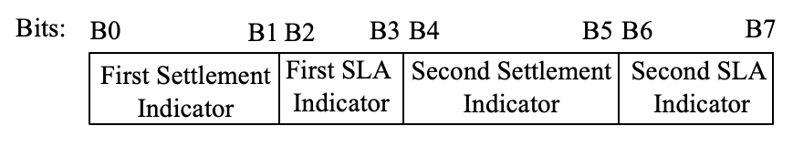
Figure 9-1035e – Venue SLA Policy Tuple subfield format

The First Settlement Indicator and Second Settlement Indicator subfields each indicate a type of roaming service accepted by the venue. The values of the First Settlement Indicator and Second Settlement Indicator subfields are specified in Table 9-413b

Table 9-413b Settlement Indicator

Settlement Indicator Value | Settlement Type
0 | All
1 | Free services
2 | Paid services
3 | Reserved

The First SLA Indicator and Second SLA Indicator subfields each indicate the SLA that the AP offers for the respective settlement type. The values of the First SLA Indicator and Second SLA Indicator subfields are specified in Table 9-413c and follow the Olympic model defined in IETF RFC 2597 (Appendix).

To editor, insert the following reference to annex A:
IETF RFC 2597, Assured Forwarding PHB Group, J. Heinanen, F. Baker, W. Weiss, J. Wroclawski, June 1999

Table 9-413c SLA Indicator

Settlement Indicator Value | SLA
0 | No Olympic Model SLA
1 | Bronze
2 | Silver
3 | Gold

If the First SLA Indicator subfield is set to 0, the Second Settlement Indicator and Second SLA Indicator subfields are reserved. Otherwise, the First SLA Indicator and Second SLA Indicator subfields differ, and a nonzero value in the First SLA Indicator subfield takes precedence over a value of 0 in the Second SLA Indicator subfield, for the settlement type indicated by the First SLA Indicator subfield.
The SLA Details subfield is an optional vendor specific UTF-8 string that can be used to indicate the details of the SLA (e.g., minimum bandwidth, max jitter or delay, etc.). The content of this subfield is beyond the scope of this specification.

9.4.5.32 Excluded NAI Realm ANQP-Element

The Excluded NAI Realm ANQP-element provides a list of network access identifier (NAI) realms corresponding to SSPs or other entities whose networks or services are not accessible via this AP, even if they are members of a roaming consortium advertised by this AP. The format of the Excluded NAI Realm ANQP-element is shown in Figure 9-1035f.

 | Info ID | Length | Excluded NAI Realm Count | Excluded NAI Realm Tuples
Octets: | 2 | 1 | 1 | variable
Figure 9-1035f — Excluded NAI Realm ANQP-element format

The Info ID and Length fields are defined in 9.4.5.1 (General).

The Excluded NAI Realm Count field specifies the number of Excluded NAI Realm Tuple subfields.

The Excluded NAI Realm Tuples field contains zero or more Excluded NAI Realm Tuple subfields.

The format of an Excluded NAI Realm Tuple subfield is shown in Figure 9-1035g.

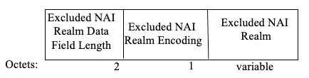
Figure 9-1035g – Excluded NAI Realm Tuple subfield format

The Excluded NAI Realm Data Field Length subfield is equal to 1 plus the length of the Excluded NAI Realm subfield.

The Excluded NAI Realm Encoding subfield is shown in Figure 9-1035-h.
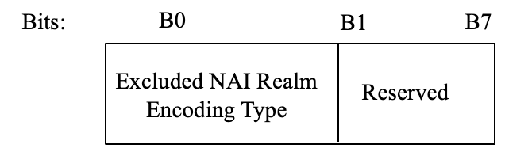
Figure 9-1035h – Excluded NAI Realm Encoding subfield format

The Excluded NAI Realm Encoding Type subfield is set to 0 to indicate that the NAI realm(s) in the Excluded NAI Realm subfield is/are formatted in accordance with IETF RFC 4282. It is set to 1 to indicate that it/they might not be formatted in accordance with IETF RFC 4282.

The Excluded NAI Realm subfield contains one or more NAI realms formatted as defined in the Excluded NAI Realm Encoding Type subfield. If there is more than one excluded NAI realm in this subfield, the excluded NAI realms are delimited by a semicolon character (i.e., “;”, which is encoded in UTF-8 as 0x3B).

Modify the table in the following clause as shown:
11.22.3.3.1 General
Table 11-16 — ANQP usage

ANQP-element name | ANQP-element  (subclause) | ANQP-element type | BSS/AP | BSS non-AP | IBSS  STA
… | … | … | … | … | …
Local MAC Address Policy | 9.4.5.29 | S | T | R | -
Credential Types | 9.4.5.30 | S | T | R | -
Service Level Agreement | 9.4.5.31 | S | T | R | -
Excluded NAI Realm | 9.4.5.32 | S | T | R | -

Insert the following new subclause, after 11.22.3.3.16:

11.22.3.3.17 Credentials and Privacy procedure

Some networks advertise support for multiple SSPs, for example through a roaming consortium However, the venue might only accept credentials from a subset of the roaming consortium members. In other scenarios, the venue may have specific constraints on the type of credentials that are acceptable, for example based on the identity verification conducted at the credential creation, or the age of the credentials. The Credential Types ANQP-element is used by a non-AP STA to discover the venue requirements for accepted credentials, which includes the SSP categories that are accepted, and the type of validation and age required for the credentials.

Authentication will then occur between the non-AP STA and the SSP through a protected tunnel. In some cases, the local venue requires the non-AP STA to also share locally a contactable identity. The Privacy Indicator field in the Credential Types ANQP-element provides an indication on the venue requirements for contactable identity allowing the STA to preserve the user’s privacy when identity exposure is not needed.
A Credential Types Tuple subfield shall be ignored if the value in the Validation, Category Group and/or Category Type subfield is reserved.
A First or Second Settlement Indicator subfield and the corresponding First or Second SLA Indicator subfield, respectively, shall be ignored if the value in the First or Second Settlement Indicator subfield, respectively, is reserved.

In some venues, a subset of SSP credentials might not be accepted, for example because they are local competitors. The Excluded NAI Realm ANQP-element provides a list of realms from which credentials are not accepted by the AP.

When multiple credentials are accepted, the local venue may have specific agreements with each SSP based on the roaming profile. The SLA ANQP-element provides the STA with information about the SLA locally available based on the roaming type.

Insert the following new bullets, between bullets 4) and 5) in R.2.2:

R.2.2 Airport

5) Credential Types ANQP-element present containing two Credential Types subfields, the first indicating Category Group = 12, Category Type = 1 (Service Provider), Validation = 2 (email, SMS, Government ID or Government issued credentials), Lifetime = 0 (account has been in existence for any duration) and Privacy Indicator = 1 (contactable identity required), the second indicating Category Group = 12, Category Type = 2 (Cloud or Social Media Provider), Validation = 4 (Government ID or Government issued credentials), Lifetime = 4 (account has been in existence for one year or more) and Privacy Indicator = 1 (contactable identity required).

6) SLA ANQP-element present containing First Settlement Indicator = 1 (free services), First SLA Indicator = 1 (Bronze), Second Settlement Indicator = 2 (paid services), Second SLA Indicator = 2 (Silver).

Discussion:
- In large federations (where multiple venues may allow for multiple sources of identities) using RCOI, the multi-to-multi relationship makes it difficult for the STA profile to understand which member of the RCOI is actually accepted in the venue. In some cases, the RCOI includes a large group of entities, some of which provide identity services and own access networks, and some of which also competing with each other. In that case, some venues may not accept credentials from competing entities. Therefore, in complement to the RCOI, it is useful to define a list of excluded Realms, i.e. realms which credentials are not accepted by the local venue.

Modify the following clause:

R.2.3 Shopping
A shopper visits a shopping mall and wants to use a smartphone to discover items on sale. In this mall, the mall’s IT department is providing WLAN facilities for all of the stores in the mall; therefore, there is only one SSID for shoppers (i.e., there is not a different SSID for each store in the mall). The user arrives at the mall and taps an icon on the screen to put the smartphone in “shopping mode.” The smartphone’s shopping application causes the non-AP STA to carry out the following steps:
a) The smartphone’s non-AP STA performs an active scan by transmitting a Probe Request frame containing the wildcard SSID and an Interworking element with Access Network Type subfield set to “Free Public Network.” In response, it receives Probe Response frames from several of the mall’s APs, but only one SSID is provided, which is “Silicon Valley Mall.” The mall’s APs did not transmit Probe Response frames for the SSIDs “Engineering,” “Deliveries,” and “Janitorial” since their access network type is “Private network.”
b) The Probe Response frame received by the smartphone indicated the following capabilities:
1) Extended Capabilities element indicates: AP provides interworking service.
2) Interworking element indicates: venue group = 6 (mercantile) and venue type = 4 (shopping mall), Internet = 0 (unspecified).
3) RSNE indicates: IEEE 802.1X authentication.
c) Since the AP indicated Interworking service is available, the smartphone’s non-AP STA uses the MLME-GAS.request primitive to invoke GAS to request the Capability List ANQP-element (see 9.4.5.3). In the Capability List ANQP-element, the AP has indicated support for Venue Name, and Domain Name and Excluded NAI Realm. Subsequent to receipt of the Capability List ANQP-element, the non-AP STA invokes the MLME-GAS.request primitive to retrieve the other two lists.
d) Next, the non-AP STA’s supplicant searches the received Domain Name list to determine whether it has any stored credentials for these domains and also searches the list of excluded NAI realms to determine which realm credentials are not accepted. If so the non-AP STAs finds accepted credentials,
1) The smartphone autonomously associates to the “Silicon Valley Mall Shopping” SSID and displays the following information:
i) Venue name: Silicon Valley Mall, 1234 Main Street, Rownhams, CA 98765-1234
ii) SSID: Silicon Valley Mall
iii) Venue type: Shopping Mall
2) The supplicant autonomously provides the security credentials for the selected domain.
e) Higher layer protocols then download discount coupons being offered for items on sale.

