IEEE P802.11
Wireless LANs
CC35 PHY CIDs 19 18 14 15 527
Date: 2021-06-14
Author(s):
Name | Affiliation | Address | Phone | email
Brian Hart | Cisco Systems |  |  | brianh@cisco.com

Abstract
This submission proposes resolutions for the following comments from comment collection on P802.11-REVme D0.0:

19
18
14, 15, 527

NOTE – Set the Track Changes Viewing Option in the MS Word to “All Markup” to clearly see the proposed text edits.

Revision History:

R0: Initial version.
R1: Corrected filename
R2: Updates after call and email discussions

CID 19

CID | Clause | Page.Line | Comment | Proposed Change
19 | 21.3.3 | 3127.45 | VHT uses "Segment" in assocation with two different concepts: for non-contiguous spectrum (e.g. Equation (21-11)) and for per-80MHz processing (e.g. the Segment parser used to construct two 80 MHz streams for BCC interleaving etc as part of creating a 160 MHz PPDU), although it is clear that the former usage is the intended usage (clause 3: "frequency segment: A contiguous block of spectrum used by a transmission."; and Nseg=1 for 160MHz in Table 21-5). However, many members see "Segment parser" in the block diagrams and are more familiar with 160 MHz, so then associate "segment" with 80 MHz processing (or less for narrower PPDUs). This caused on-going confusion in 11ax: e.g. as late as D7.0 of 11ax there was a fundamental error on this topic: the number of data tones per frequency segment, Nsd, had two incompatible definitions (Nsd in table 27-13 that differed for 80+80 vs 160 versus Nsd in section 27.5.7 that had no differentiation between 80+80 vs 160). 11ax's ultimate fix was almost complete: it kept "frequency segment" for non-contiguous PPDUs, and used "frequency subblock" for 80 MHz processing (or less for narrower PPDUs); but the confusing/ misleading term "Segment de/parser" remains. By its name, "segment parser" implies it takes one input stream and parses it into one or more segments. But for 160 MHz, the so-called Segment parser takes one stream and parses into two frequency subblocks in *one* segment. | "Segment parsed/parser/parsing" are terms used locally within the VHT, TVHT and S1G PHYs PHYs today (and HE PHY) so making a name correction is relatively straightforward. However, "Segment de/parser" are embedded terms in the industry, and - despite the need to reduce confusion in 11ax and now 11be - it may be too confusing to entirely replace the name. Meanwhile it is fair to point out that, for 80+80, if not for 160M, the "Segment parser" outputs both segments and frequency subblocks. Then change "Segment [de]parser/parsing/parsed" to "Frequency-subblock/Segment [de]parser/parsed/parsing" throughput the draft. This change has the virtue that a) searching for "Segment pars" is still successful, b) the more correct name appears first, c) the new name is not incorrect in that sometimes the Frequency-subblock/Segment parser does output segments.

Discussion

Agree that the commenter raises an important concern, and the “Segment Parser” name led to confusion in 11be also. However, concern was expressed by 11be members that changing the names of existing operations would cause traceability confusion. Accordingly we explore two options:

Add clarifying NOTEs in the VHT clause (the expectation is the same notes would be added to the HE clause too, once it is rolled in).

Proposed Resolutions: CID 19
Revised.
Note to Commenter:
To avoid causing confusion to implementers, a clarifying NOTE is inserted as described in 21/0965R<motionedRevision> under CID 19.

Instruction to Editor:
Implement the proposed text updates listed under CID 19 in 21/0965R<motionedRevision>

Proposed Text Updates: CID 19

Instruction to Editor: Update D0.0
21.3.10.7 Segment parser

NOTE – The output of the operation described in this subclause is named a frequency subblock rather than a segment because it applies to both 80+80 and 160 MHz PPDUs, where the 160 MHz PPDU has two parser outputs yet one frequency segment (see Table 21-5 (Timing-related constants)). A more precise name for this operation would be frequency subblock parser.

21.3.10.9.3 Segment deparser
NOTE – The input of the operation described in this subclause is named a frequency subblock rather than a segment because it applies to 160 MHz PPDUs which has two deparser inputs yet one frequency segment (see Table 21-5 (Timing-related constants)). A more precise name for this operation would be frequency subblock deparser.

Sidebar: no notes need to be included for TVHT (clause 22) given that “The segment parser as described in 21.3.10.7 (Segment parser) is not used in Clause 22” and “The segment deparser is not used in Clause 22”. Also, no notes need to be included for S1G (clause 23) since the segment parser/deparser is defined by reference to clause 21: “The segment parser for S1G 16 MHz PPDUs is the same as those specified for 160 MHz PPDUs in 21.3.10.7 (Segment parser)” and “The segment deparser for S1G 16 MHz PPDUs is the same as those specified for 160 MHz PPDUs in 21.3.10.9.3 (Segment deparser).”

CID 18

CID | Clause | Page.Line | Comment | Proposed Change
18 | 17.3.4.1 | 2904.50 | 11be is adding the concept that some reserved PHY bits or values are Validate and some are Disregard. This concept works well for certain fields in PHY clauses. | Define the LSIG Reserved bit and the 8 undefined values of the RATE field as "Validate", conditioned on dot1SomethingSomething (to allow for legacy implementations that might not check these fields). Incorporate these Validate checks and dot11SomethingSomething into the RX procedure (17.3.12).

Discussion
The commenter raises good points. After discussion, there has been some non-standard usage of the Reserved bit so it is better to leave this as a true Reserved bit. However, the standard does not properly accomodate invalid RATE fields, so that portion can be updated. A receiver, upon receiving an unknown RATE field, has no idea how to proceed, and so this should be treated in the same way as a parity erorr (i.e., FormatViolation).

Note: the unknown RATE fields are all characterized by the R4 bit of the RATE field being equal to 0:
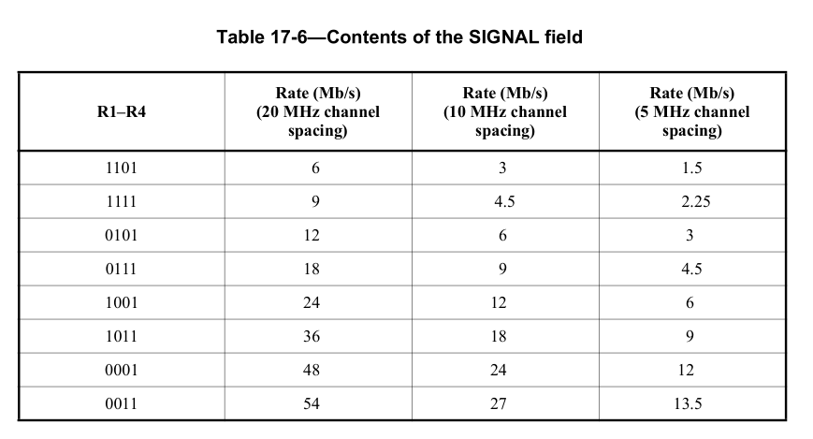
… where:
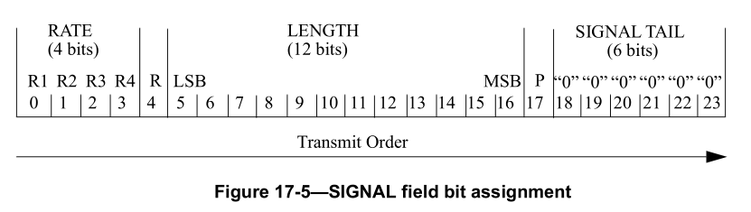

Proposed Resolutions: CID 18
Revised.
Note to Commenter:
Due to certain legacy behavior, it is better to leave the Reserved bit as a true Reserved bit. However, the standard does not properly accomodate invalid RATE fields, so changes are made so PHY-RXEND.indication(FormatViolation) is issued in this scenario. See 21/0965R<motionedRevision> under CID 18.

Instruction to Editor:
Implement the proposed text updates listed under CID 18 in 21/0965R<motionedRevision>

Proposed Text Updates: CID 18

Editor, modify as shown via Word track changes

17.3.12 Receive PHY
…
If the indicated rate in the SIGNAL field is not receivable, a PHY-RXSTART.indication primitive shall not be issued. The PHY shall indicate the error condition by issuing a PHY-RXEND.indication(UnsupportedRate) primitive and hold CCA busy for the calculated duration of the PPDU. If the PHY header is receivable, but the parity check of the PHY header is not valid or the RATE field equals an undefined value (i.e., R4 equals 0), then a PHY-RXSTART.indication primitive shall not be issued. The PHY shall indicate the error condition using a PHY-RXEND.indication(FormatViolation) primitive.
…

Editor, at P2934L1 in Figure 17-20 (copied below for reference) change:
- “RX SIGNAL Parity” to “RX SIGNAL Parity and RATE checks”
- “Parity Fail” to “Parity or RATE check fails”
- “Parity Correct” to “Parity and RATE checks pass”

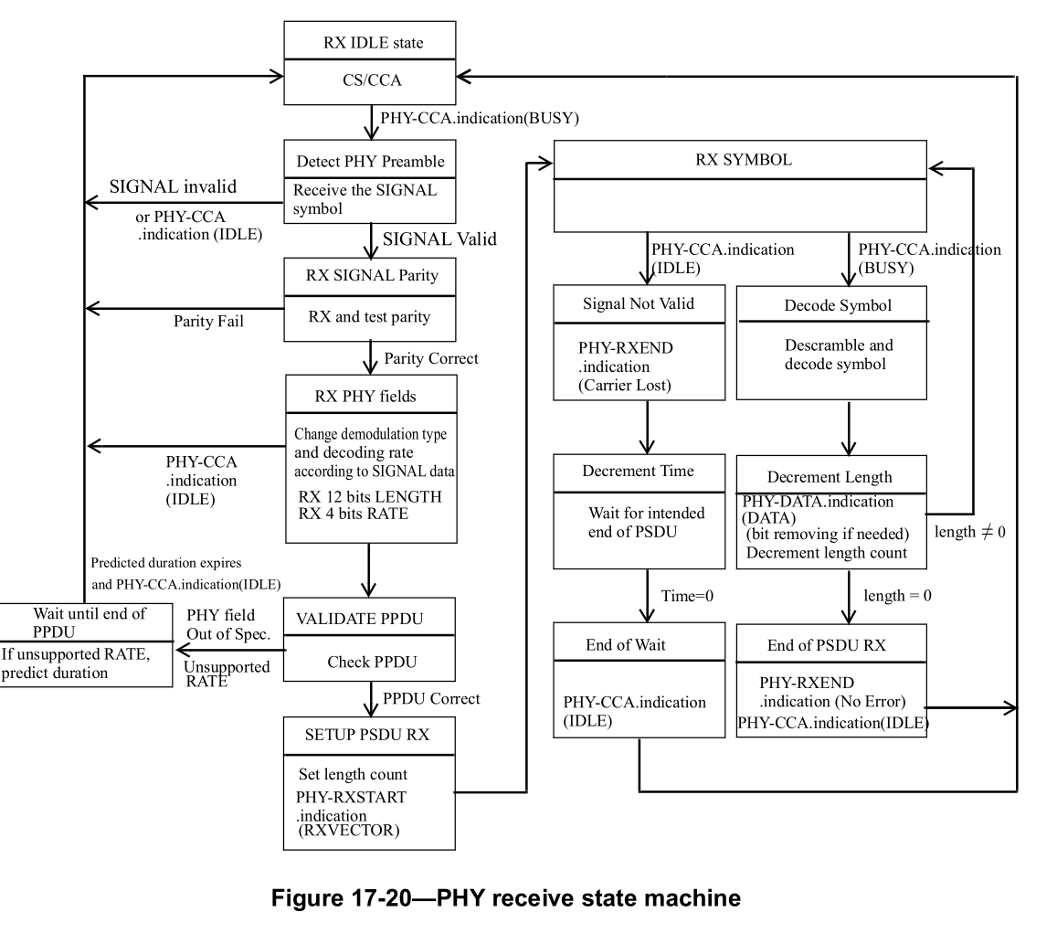

Editor, at P3040L1 in Figure 19-27 (copied below for reference) change:
- “RX and test parity” to “RX and check Parity and RATE”

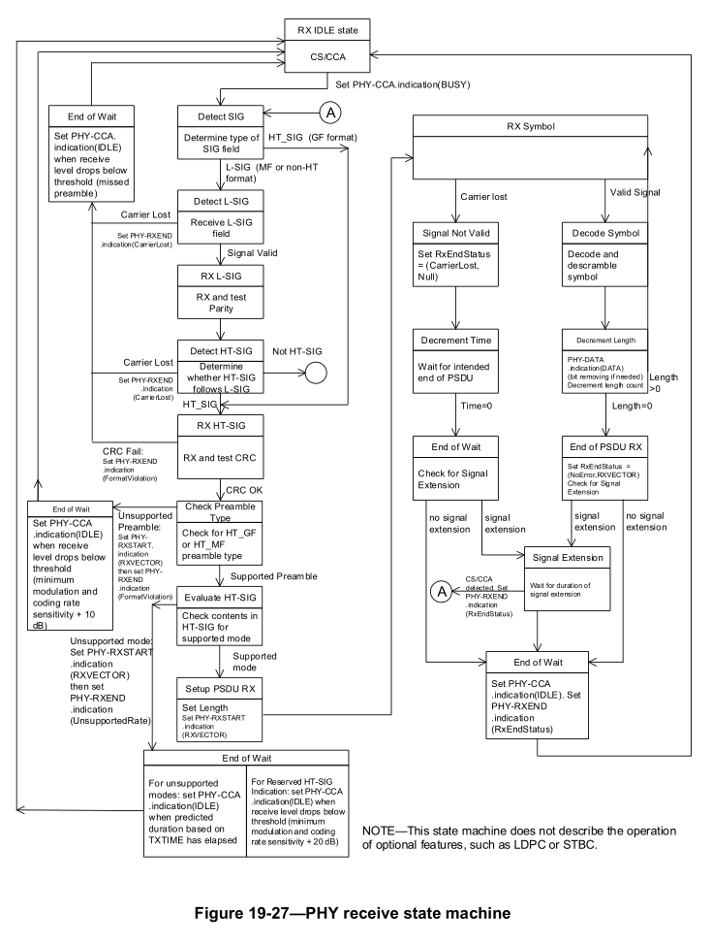

Editor, note location at P3211L52
After the PHY-CCA.indication(BUSY, channel-list) primitive is issued, the PHY entity shall begin receiving the training symbols and searching for L-SIG in order to set the maximum duration of the data stream. If the check of the L-SIG parity bit and RATE field fails, a PHY-RXSTART.indication primitive is not issued, and instead the PHY shall issue the error condition PHY-RXEND.indication(FormatViolation) primitive.

Editor, at P3214L1, in Figure 19-27 (copied below for reference):
- Change “RX and test parity” to “RX and check Parity and RATE field”
- Change “Parity Fail” to “Parity or RATE checks fail”
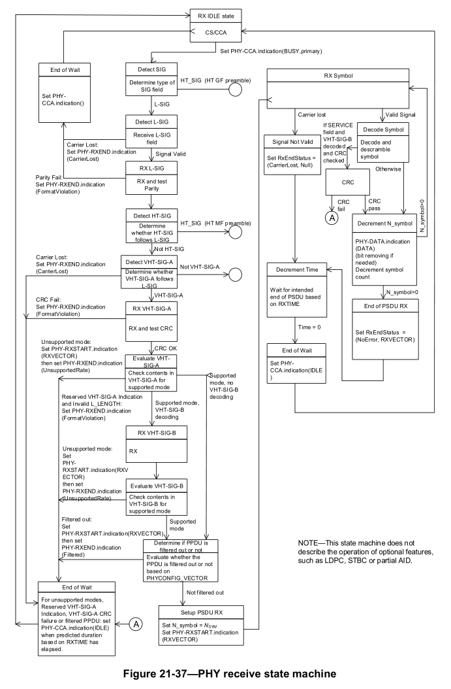

CID 14, 15, 527

CID | Clause | Page.Line | Comment | Proposed Change
14 | 6.3.55.1 | 520.48 | The PHY clauses contain the word "frame" when oftentimes "PPDU" or "PPDU containing the frame" is meant instead. The language referenced here confuses frames with PPDUs; and also is unclear if the PHY or MAC is responsible for applying the offset. | Try "t2 and t4 correspond to the point in time at which the start of the preamble for the incoming PPDU containing the frame arrives at the receive antenna connector. Because time is needed to detect the frame and synchronize with the logical structure of the PPDU, an implementation determines when the start of the preamble of the incoming PPDU containing the frame arrived at the receive antenna connector by capturing a timestamp some time after it occurred and [who - MAC or PHY?] compensating for the delay by subtracting an offset from the captured value." Sadly this whole feature should be scrubbed for clarity in this regards.
15 | 15 | 2835.1 | The PHY clauses use the word "frame" which is a synonym for the L2 MDPU. Oftentimes the PHY clauses should just use "PPDU" instead, or perhaps "PPDU containing the frame". Further background: the PHY is aware of PSDUs (and perhaps frames by extension), but the PHY shold not need to be aware of the timing of frames: e.g. PSDU might be an MPDU or AMPDU (with various fields around the frame), and the PHY should not need to know how many bytes precede the first frame in a PSDU. | Review all uses of "frame" within the PHY clauses and rewrite in terms of PSDU and PPDU (or PPDU containing a frame). See especially language associated with TIME_OF_DEPARTURE_*, *_START_OF_FRAME_OFFSET, RCPI, CH_BANDWIDTH_IN_NON_HT, DYN_BANDWIDTH_IN_NOT_HT, P2898L46, mathematical terms (e.g. 17.3.2.5: better to use field/subfield instead of frame/subframe), Modulation accuracy test (e.g. 17.3.9.8), (note P2939L2 is a good use of "frame"), P2944L6, change "frame format" to "PHY format" (e.g. P2944L33), introduction (e.g. 19.1.1) etc etc in clauses 15-25
527 |  |  | We should not refer to PPDUs as frames, since this is needlessly confusing. "frame" should be a synonym for "MPDU" only | Change all references to "frame"s that are in fact PPDUs to "PPDU"

Discussion

Generally in agreement with the commenter: “frame” should be reserved for the L2 MPDU, and then, in the PHY clauses, the mix of ill-defined and/or mis-used terms should be replaced by a smaller set of precisely defined, correctly layered terms.

As part of that clean-up, we note that “packet” is used in several ambiguous ways:
- As PPDU (e.g., )
- As PSDU (e.g., “The packet error ratio (PER) shall be 10% or less when the PSDU length is 1000 octets …”)
- As the number of OFDM symbols in the Data field (e.g., 17.3.9.8 Transmit modulation accuracy test : “Lp is the length of the packet”)
The use of “packet” arises because it is often used in cellular-related wireless texts (arguably as a synonym for PPDU) but in IEEE/IETF “packet” is more closely related to a L3 payload (e.g., “IP packet”). Accordingly, we change “packet” to “PPDU”, “PSDU”, “Data field” as appropriate. The term “transmission” (used for a transmitted PPDU), is left alone.

Related, the PHY deals with PSDUs and it should not talk about MPDUs except where specifically required (e.g., A-MPDU signalling within HT SIG fields). So change MPDU to PSDU (e.g. clauses 15 and 16).

All this requires a line-by-line analysis. For instance S1G NDP CMAC PPDUs are frame-like, and these are not touched (instead, consider CIDs 2398, 4404, 4710).

The procedure was to search for “frame”/”packet”/“MPDU” within the PHY clauses 6.5, 15-25 and certain other clauses, and determine the most suitable change accordingly.

To preserve the traceability of names and avoid implementation confusion, no change is made to the name of any PPDU format/frame/field.

After being informed by email discussions, notable changes are:

1) The definition of aSIFSTime has not been refreshed for the signal extension, the AGC or TRN fields (used in the millimeter wave PHYs) and is not future proofed for the PE of 11ax. In all these cases, “end of the last symbol on the WM” is unsafe. Some suitable 11ax language has been repurposed, i.e., “later of the end of a PPDU or the end of the signal extension if present, on the WM”.

Also, we have a sentence where SIFS is measured “on the medium” and then must pertain ot PPDUs not frames, so clean that up.

2) The definition of aRxPHYDelay has not been refreshed for the signal extension, the AGC or TRN fields (used in the in millimeter wave PHYs) and is not future proofed for the PE of 11ax. In all these cases, “last symbol of a frame on the WM” is unsafe.

Specifically: a) the PE need not be constructed from symbols at all, or might be constructed from 25/50/75% of an OFDM symbol, b) the AGC and TRN fields optionally at the end of mmWave PPDUs are not described as being composed of symbols (they are composed of “sequences” using “rotated pi/2 BPSK modulation”) and c) really this leads us to the overarching issue that the terms aSIFSTime and aRxPHYDelay are used between the MAC sublayer and PHY layer so should be as abstract as possible. “symbol” is a granular PHY term, and means different things for different waveforms – i.e., there is one kind of “symbol” in DSSS, another kind of “symbol” in CCK, then “OFDM symbol”, and various “symbols” in the mmWave PHYs (but not in connection with the AGC and/or TRN fields), etc. The MAC reader should not have to go into the bowels of the mmWave clause and apply judgement as to whether a “rotated pi/2 BPSK modulation” of the +-1 in a Golay sequence in the AGC and/or TRN field counts as a symbol or not.

Better and future proofed language looks like “later of the end of a PPDU or the end of the signal extension if present, on the WM”, such as is already used in 11ax.

Sidebar: for OFDM traditionally aSIFSTime = 16us = aRxPHYDelay (12us) + aMACProcessingDelay (2us) + aRxTxTurnaroundTime (2us). However, at 2.4 GHz, aSIFSTime = 10us so we have aSIFSTime = 10us = aRxPHYDelay (6us) + aMACProcessingDelay (2us) + aRxTxTurnaroundTime (2us). Thus, aRxPHYDelay does not include the signal extension.

3) What is packet error rate when we don’t really have packets? “Packet error rate” is really “PSDU error rate”: i.e., number of errored PSDUs divided by number of transmitted PSDUs. Ditto, clause 15/16 is also a PSDU error rate, rather than a frame error rate, for improved layering. However, there is some desire to not change terms and live with packet so let’s keep “packet error rate” yet with an inline definition: “packet error rate (i.e., number of errored PSDUs divided by number of transmitted PSDUs)”

4) The EVM test is very vague in its use of packets / frames /etc: is the EVM calculated over the Data field or the SIG fields + Data field or the entire PPDU? From various email discussions, it is clear that the industry interprets it as over the Data field only, so make that explicit.

Sidebar: EVM ambiguity

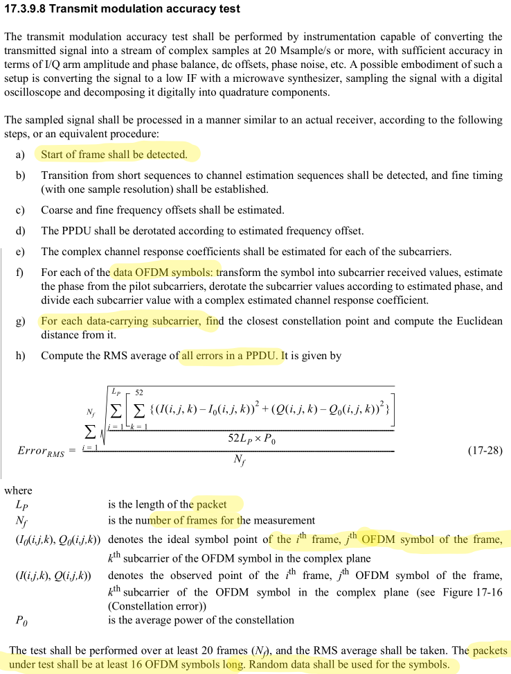

Arguments that EVM is calculated over the Data field only
- Primary
  - Step g) refers to “data-carrying subcarriers”. Taken together with “data OFDM symbols” in step “f)” this implies only the Data field is considered
  - The last line says “random data shall be used for the symbols”, where “the symbols” refers back to “packets … shall be at least 16 OFDM symbols long”. Since it only makes sense for the Data field to hold random data, then it seems that “packets” is being used as a synonym for “Data field”
    - If so, when Lp is defined as “the length of the packet” then this is the length of the Data field
  - It is not explained how to find the closest constellation point for LSTF or LLTF, and indeed the LSTF is a mix of +-sqrt(13/6) * (1+j) and 0, and this is nowhere described as a constellation point or symbol point
    - i.e. “the dog that didn’t bark”
  - Related, it is arguable if the the LSIG contains “data carrying” subcarriers or not.
  - LSTF is arguably made up of 10 short symbols, which would be an anomalously high proportion of the “16 OFDM symbols”
- Secondary
  - LSTFs don’t have to be transmitted very cleanly
  - The EVM is compared against an MCS-dependent threshold, and that MCS only appears in the Data field
Arguments that EVM is calculated over the entire PPDU
- Primary
  - Apart from some ambiguous cases, “packet” is used unambiguously elsewhere to mean the entire PPDU – e.g.,
    - Equation (17-2):
    - Annex I where “I.1.8 The entire packet for the BCC example / The packet in its entirety is shown in the tables in this subclause. … short training field sequence … long training sequence … SIGNAL field …Data field ”
    - “The CCA of the OFDM PHY shall indicate a busy medium for the intended duration of the transmitted packet.”
… so then Lp plausibly refers to the entire PPDU
  - The first highlighted use of “frame”, at “a)” signifies PPDU, but if so then the second and third highlighted use of “frame” implies that EVM is calculated over the whole PPDU.
  - Step “h)” refers to all errors in a PPDU.
Arguments that EVM is calculated over the LSIG and Data field
- According to the definition at P2900L42, Ck modulating tones are either data, pilots or training symbols, so the 48 Ck during LSIG are certainly data symbols. Arguably data symbols modulate data-carrying subcarriers, and if this is accepted then the LSIG falls within the scope of g)

I believe that it makes most sense to define EVM over the Data field only, and wider discussion points us in the same direction.

5) Issues meriting some level of attention are (usually) identified by Word comments and include:
- 802.11a subframes to fields and (new) subfields
- Instead of “data portion of packet contains an A-MPDU”, simplify to “PSDU contains an A-MPDU”
- From P771L47, RCPI is “RCPI is a measure of the received RF power averaged over all of the receive chains in the data portion of a received frame”, so use “Data field” (or similar, for different PHY clauses that don’t have a Data field) in place of frame.
- Added a note to clarify that the TX/RX_START_OF_FRAME_OFFSET are actually between the start of the PPDU and the primitive (not start of PSDU and the primitive)

Proposed Resolutions: CIDs 14
Revised.
Note to Commenter:
Changes substantially as requested by the commenter, including a clean-up of “packet” have been implemented in 21/0965R<motionedRevision> under CID 14.

Instruction to Editor:
Implement the proposed text updates listed under CID 14 in 21/0965R<motionedRevision>

Proposed Resolutions: CIDs 15, 527
Revised.
Note to Commenter:
Changes substantially as requested by the commenter have been implemented in 21/0965R<motionedRevision> under CID 14.

Instruction to Editor:
No changes beyond those defined under CID 14.

Proposed Text Updates: CIDs 14, 17, and 527

Instruction to Editor: Update D0.0

P162L11
medium access control (MAC) frame: The unit of data exchanged between MAC entities. Syn: medium access control (MAC) protocol data unit (MPDU).

P165L38

P167L8
received channel power indicator (RCPI): An indication of the total channel power (signal, noise, and interference) of a received PPDU measured on the channel and at the antenna connector used to receive the PPDU

P207L28

P212L15
PER packet error ratio

For P329-486, editor, change according to the following templates:
“The RCPI of the received PPDU containing the frame.”
“The RSNI of the received PPDU containing the frame”
“This value represents the RCPI that the AP or PCP measured of the received PPDU containing the corresponding … frame.”
“The RCPI value represents the measured RCPI of the received PPDU containing the corresponding … frame.”
“The RSNI value represents the measured RSNI of the received PPDU containing the corresponding … frame.”

P229L61
The Frame request/report pair returns a picture of all of the channel traffic and a count of all of the frames
received at the measuring STA. For each unique Transmitter Address, the STA reports the Transmitter
Address, number of frames received from this transmitter, average power level (RCPI) for PPDUs containing these frames, and BSSID indicated by the transmitter.

P520L43
NOTE 1—In Figure 6-16 (Timing measurement primitives and timestamps capture), t1 and t3 correspond to the point in time at which the start of the preamble for the PPDU containing the Timing Measurement or Ack frame appears at the transmit antenna connector. An implementation may capture a timestamp during the transmit processing earlier or later than the point at which it actually occurs and offset the value to compensate for the time difference.
NOTE 2—In Figure 6-16 (Timing measurement primitives and timestamps capture), t2 and t4 correspond to the point in time at which the start of the preamble for the PPDU containing the Timing Measurement or Ack frame arrives at the receive antenna connector. Because time is needed to detect the PPDU and synchronize with its logical structure, an implementation determines when the start of the preamble for the PPDU arrived at the receive antenna connector by capturing a timestamp some time after it occurred and compensating for the delay by subtracting an offset from the captured value.

P522L49, P523L58, P425L10
t1 Integer 0–(2 32 –1) The value of t1 (see Figure 6-16 (Timing measurement primitives and timestamps capture)) for the PPDU containing the Timing Measurement frame identified by the Follow Up Dialog Token, in units of 10 ns, or null if the Follow Up Dialog Token is 0.

P522L58, P524L4, P525L21
t4 Integer 0–(2 32 –1) The value of t4 (see Figure 6-16 (Timing measurement primitives and timestamps capture)) for the PPDU containing the Timing Measurement frame identified by the Follow Up Dialog Token, in units of 10 ns, or null if the Follow Up Dialog Token is 0

P525L29
t2 Integer 0 – (2 32 –1) The value of t2 (see Figure 6-16 (Timing measurement primitives and timestamps capture)) for the PPDU containing the Timing Measurement frame identified by the Dialog Token, in units of 10 ns, or null if the Dialog Token is 0.

P525L37
t3 Integer 0 – (2 32 –1) The value of t3 (see Figure 6-16 (Timing measurement primitives and timestamps capture)) for the PPDU containing the Timing Measurement frame identified by the Dialog Token, in units of 10 ns, or null if the Dialog Token is 0.

P526L22
NOTE 1—In Figure 6-17 (Fine timing measurement primitives and timestamps capture), t1 and t3 correspond to the point in time at which the start of the preamble for the PPDU containing the Fine Timing Measurement or Ack frame appears at the transmit antenna connector. An implementation may capture a timestamp during the transmit processing earlier or later than the point at which it actually occurs and offset the value to compensate for the time difference.
NOTE 2—In Figure 6-17 (Fine timing measurement primitives and timestamps capture), t2 and t4 correspond to the point in time at which the start of the preamble for the PPDU containing the Fine Timing Measurement or Ack frame arrives at the receive antenna connector. Because time is needed to detect the PPDU and synchronize with its logical structure, an implementation determines when the start of the preamble for the PPDU arrived at the receive antenna connector by capturing a timestamp some time after it occurred and compensating for the delay by subtracting an offset from the captured value.

P529L47, P531L12, P532L26
t1 Integer 0–(2 48 –1) The value of t1 (see Figure 6-17 (Fine timing measurement primitives and timestamps capture)) for the PPDU containing the Fine Timing Measurement frame identified by the Follow Up Dialog Token, in units of picoseconds, or null if the Follow Up Dialog Token is 0

P529L58, P531L21, P532L39
t4 Integer 0–(2 48 –1) The value of t4 (see Figure 6-17 (Fine timing measurement primitives and timestamps
capture)) for the PPDU containing the Fine Timing Measurement frame identified by the Follow Up Dialog Token, in units of picoseconds, or null if the Follow Up Dialog Token is 0.

P532L51
t2 Integer 0–(2 48 –1) The value of t2 (see Figure 6-17 (Fine timing measurement primitives and timestamps capture)) for the PPDU containing the Fine Timing Measurement frame identified by the Dialog Token, in units of picoseconds, or null if the Dialog Token is 0.

P532L51
t3 Integer 0–(2 48 –1) The value of t3 (see Figure 6-17 (Fine timing measurement primitives and timestamps capture)) for the PPDU containing the Fine Timing Measurement frame identified by the Dialog Token, in units of picoseconds, or null if the Dialog Token is 0.

P748L33
aSIFSTime Integer The nominal time (in microseconds) that the MAC and PHY require from reception of the later of the end of a PPDU or the end of the signal extension if present, on the WM, until the MAC and PHY have processed the PPDU and any frame(s) therein, and responded with the start on the WM of the PPDU containing the earliest possible response frame. See 10.3.7 (DCF timing relations).

P749L10
aRxPHYDelay Integer The nominal time (in microseconds) that the PHY uses to deliver the last bit of a received PSDU to the MAC from the later of the end of the PPDU or the end of the signal extension if present, on the WM.

P749L27
aRIFSTime Integer Value of the reduced interframe space (in microseconds), which is the time
by which multiple transmissions from a single transmitter may be separated,
when no SIFS-separated response transmission is expected. See 10.3.2.3.2
(RIFS)

P749L48
aMaxCSIMatricesReportDelay Integer The maximum time (in milliseconds) between the reception of a PSDU containing a frame containing a CSI Feedback Request or an HT NDP announcement and the transmission of the first PSDU containing a CSI frame containing channel state information measured from the received Sounding Complete frame. See 10.34.2.4.4 (CSI reporting for calibration).

P749L53
aMaxTODError Integer An estimate of the maximum error (in 10 ns units) in the TX_START_OF_FRAME_OFFSET value in the PHY-TXSTART.confirm primitive. The estimated maximum error includes any error due to implementation component and environmental (including temperature) variability.

P749L58
aMaxTOAError Integer An estimate of the maximum error (in 10 ns units) in the RX_START_OF_FRAME_OFFSET value in the PHY-RXSTART.indication primitive. The estimated maximum error includes any error due to implementation component and environmental (including temperature) variability

P750L3
aTxPHYTxStartRFDelay Integer The delay (in units of 0.5 ns) between a PHY-TXSTART.request primitive being issued and the first PPDU energy sent by the transmitting port, for the current channel.

P756L9

8.1 Scope of PHY services
The PHY services provided to the MAC are described in this clause. Different PHYs are defined as part of this standard. Each PHY can consist of the following protocol functions:
a) A function that defines a method of mapping the PSDUs into a PPDU format suitable for sending and receiving data, management and control information between two or more STAs.

P756L39

The function of the PHY is to provide a mechanism for transferring PSDUs between two or more STAs.

P762L63
If dot11TimingMsmtActivated is true, then the PHY shall include TX_START_OF_FRAME_OFFSET in
the TXSTATUS, if the PHY includes this parameter in the TXSTATUS.

NOTE – A more precise name for TX_START_OF_FRAME_OFFSET would be TX_START_OF_PPDU_TO_PHY_TXSTART_PRIMITIVE_OFFSET. Similarly, a more precise name for RX_START_OF_FRAME_OFFSET would be RX_START_OF_PPDU_TO_PHY_RXSTART_PRIMITIVE_OFFSET.

P763L5
8.3.5.6 PHY-TXSTART.confirm
8.3.5.6.4 Effect of receipt
The receipt of this primitive by the MAC entity causes the MAC to start the transfer of data octets. Parameters in the TXSTATUS are returned to the MAC which can then include them in transmitted MPDUs. See Annex P for use of TXSTATUS parameters for timing.

P771L45
RCPI is a parameter included in the PHY-RXEND.indication primitive that the PHY provides the local MAC entity. If present, RCPI is a measure of the received RF power averaged over all of the receive chains in the data portion of a received PPDU.

P2835-2951 (i.e. DSSS to 11g)
Editor: change all instances of “MPDU” into “PSDU” excepting:
- P2860L49 “so each MPDU corresponds to a PSDU that is carried in a PPDU.”
- P2929L15 “MPDU” in figure
- P2932L19 “MPDU” in figure

P1704L38
An IEEE 802.11 implementation of a non-DMG STA shall not allow the space between PPDUs that are defined to be separated by a SIFS, as measured on the medium, to vary from the nominal SIFS by more than ± 10% × (aSlotTime – aAirPropagationTime) for the PHY in use. An implementation of a DMG STA shall not allow the space between PPDUs that are defined to be separated by a SIFS, as measured on the medium, to vary from the nominal SIFS by more than –0% or +10% × (aSlotTime – aAirPropagationTime).

P2836L40, P2877L40, P2892L6, P2941L35
TIME_OF_DEPARTURE_REQUESTED false, true. When true, the MAC entity requests that the PHY entity measures and reports time of departure parameters corresponding to the time when the first PPDU energy is sent by the transmitting port; when false, the MAC entity requests that the PHY entity neither measures nor reports time of departure parameters.

P2837L11, P2892L60
The allowed values are false or true. A parameter value of true indicates that the MAC sublayer is requesting
that the PHY entity provides measurement of when the first PPDU energy is sent by the transmitting port and reporting within the PHY-TXSTART.confirm primitive. A parameter value of false indicates that the MAC sublayer is requesting that the PHY entity not provide time of departure measurement nor reporting in the PHY-TXSTART.confirm primitive.

P2837L48, P2878P12, P2894L12, P2942L51, P3061L41, P3119L29, P3248L13, P3301L21, P3463L51
RX_START_OF_FRAME_OFFSET 0 to 2 32 – 1. An estimate of the offset (in 10 ns units) from the point in time at which the start of the preamble of the PPDU arrived at the receive antenna connector to the point in time at which this primitive is issued to the MAC.

P2838L46, P2895L40, P2941L51, P2966L6
TIME_OF_DEPARTURE 0 to 2 32 – 1. The locally measured time when the first PPDU energy is sent by the transmitting port, in units equal to 1/ TIME_OF_DEPARTURE_ClockRate. This parameter is present only if TIME_OF_DEPARTURE_REQUESTED is true in the corresponding request.

P2838L56, P2878L6, P2895L54, P2942L11, P2966L17, P3062L52, P3434L47
TX_START_OF_FRAME_OFFSET 0 to 2 32 – 1. An estimate of the offset (in 10 ns units) from the point in time at which the start of the preamble of the PPDU was transmitted at the transmit antenna connector to the point in time at which this primitive is issued to the MAC

P2839L4, P2896L5
The allowed values for the TIME_OF_DEPARTURE parameter are integers in the range 0 to 2 32 – 1.
This parameter is used to indicate when the first PPDU energy is sent by the transmitting port in units equal to 1/TIME_OF_DEPARTURE_ClockRate. TIME_OF_DEPARTURE may be included in the transmitted
frame in order for recipients on multiple channels to determine the time differences of air propagation times between transmitter and recipients and hence to compute the location of the transmitter.

P2846L37, P2872L56, P2933L17, P3041L56, P3099L57, P3213L44, P3413L17, P3533L46, P3099L56
NOTE—The RX_START_OF_FRAME_OFFSET value is used as described in 6.3.55 (Timing measurement) in order to estimate when the start of the preamble for the incoming PPDU was detected on the medium at the receive antenna connector.

P2847L6, P2933L23
Also, in both cases, the CCA of the DSSS PHY shall indicate a busy medium for the intended duration of the transmitted PPDU as indicated by the LENGTH field. The intended duration is indicated by the LENGTH field (length 1 µs).

P2857L50, P2887L29, P2925L13, P3031L35, P3204L37, P3395L46
fL is the nominal center frequency in Hz of the lowest channel in the channel set, the channel set is the set of channels upon which PPDUs providing measurements are transmitted, the channel set comprises channels uniformly spaced across f H – f L  50 MHz

P2858L12
15.4.6.2 Receiver minimum input level sensitivity
The PER (i.e., number of errored PSDUs divided by the number of transmitted PSDUs) shall be less than 810 –2 at an MPDU length of 1024 octets for an input level of –80 dBm measured at the antenna connector. This PER shall be specified for 2 Mb/s DQPSK modulation. The test for the minimum input level sensitivity shall be conducted with the ED threshold set  –80 dBm.

15.4.6.3 Receiver maximum input level
If the STA is non-ERP, the receiver shall provide a maximum PER of 810 –2 at an MPDU length of 1024 octets for a maximum input level of –4 dBm measured at the antenna connector. This PER shall be specified for 2 Mb/s DQPSK modulation.

15.4.6.4 Receiver adjacent channel rejection
Adjacent channel rejection is defined between any two channels with  30 MHz separation in each channel group defined in 15.4.4.3 (Channel Numbering of operating channels).
The adjacent channel rejection shall be  35 dB with an PER of 810 –2 using 2 Mb/s DQPSK modulation described in 15.4.4.5 (Modulation and channel data rates) and an MPDU length of 1024 octets.
The adjacent channel rejection shall be measured using the following method:
Input a 2 Mb/s DQPSK modulated signal at a level 6 dB greater than specified in 15.4.6.2 (Receiver minimum input level sensitivity). In an adjacent channel ( 30 MHz separation as defined by the channel numbering), input a signal modulated in a similar fashion that adheres to the transmit mask specified in 15.4.5.5 (Transmit spectrum mask) to a level 41 dB above the level specified in 15.4.6.2 (Receiver minimum input level sensitivity). The adjacent channel signal shall be derived from a separate signal source. It shall not be a frequency shifted version of the reference channel. Under these conditions, the PER shall be less than or equal to 810 –2

P2859L32, P2889L35
The RCPI is a measure of the received RF power in the selected channel for a received PPDU. This parameter shall be a measure by the PHY of the received RF power in the channel measured over the entire PSDU portion of the received PPDU or by other equivalent means that meet the specified accuracy.

P2860L46
The HR/DSSS PHY consists of the following two protocol functions:
a) A PHY function that defines a method for mapping the PSDUs into a PPDU format suitable for sending and receiving data, management and control information between two or more STAs. The PHY exchanges PPDUs that contain PSDUs. The MAC uses the PHY service, so each MPDU corresponds to a PSDU that is carried in a PPDU.

P2887L56
The PER (i.e., number of errored PSDUs divided by the number of transmitted PSDUs) shall be less than 810 –2 at a PSDU length of 1024 octets for an input level of –76 dBm measured at the antenna connector. This PER shall be specified for 11 Mb/s CCK modulation. The test for the minimum input level sensitivity shall be conducted with the ED threshold set less than or equal to –76 dBm.

16.3.8.3 Receiver maximum input level
If the STA is non-ERP, the receiver shall provide a maximum PER of 810 –2 at a PSDU length of 1024 octets for a maximum input level of –10 dBm measured at the antenna connector. This PER shall be specified for 11 Mb/s CCK modulation.

16.3.8.4 Receiver adjacent channel rejection
Adjacent channel rejection is defined between any two channels with  25 MHz separation in each channel
group, as defined in 16.3.6.3 (Channel Numbering of operating channels).
The adjacent channel rejection shall be greater than or equal to than 35 dB, with an PER of 810 –2 using 11 Mb/s CCK modulation described in 16.3.6.4 (Modulation and channel data rates) and a PSDU length of 1024 octets.
The adjacent channel rejection shall be measured using the following method.
Input an 11 Mb/s CCK modulated signal at a level 6 dB greater than specified in 16.3.8.2 (Receiver minimum input level sensitivity). In an adjacent channel (  25 MHz separation as defined by the channel numbering), input a signal modulated in a similar fashion, which adheres to the transmit mask specified in 16.3.7.4 (Transmit spectrum mask), to a level 41 dB above the level specified in 16.3.8.2 (Receiver minimum input level sensitivity). The adjacent channel signal shall be derived from a separate signal source. It shall not be a frequency shifted version of the reference channel. Under these conditions, the PER shall beless than or equal to 810 –2

P2890L39
a) A function that defines a method of mapping the IEEE 802.11 PSDUs into a PPDU format suitable for sending and receiving data, management and control information between two or more STAs.

P2893L9
NOTE—The CH_BANDWIDTH_IN_NON_HT parameter is not present when the PPDU is transmitted by a non-VHT STA. The CH_BANDWIDTH_IN_NON_HT parameter is not present when the PPDU is transmitted by a VHT STA to a non-VHT STA. See 10.6.12 (Channel Width in non-HT and non-HT duplicate PPDUs).

P2893L21
NOTE—The DYN_BANDWIDTH_IN_NON_HT parameter is not present when the PPDU is transmitted by a non-VHT STA. The DYN_BANDWIDTH_IN_NON_HT parameter is not present when the PPDU is transmitted by a VHT STA to a non-VHT STA. See 10.6.12 (Channel Width in non-HT and non-HT duplicate PPDUs).

P2894L59
The allowed values for the RCPI are in the range 0 to 255, as defined in 17.3.10.7 (Received channel power indicator (RCPI) measurement). This parameter is a measure by the PHY of the received channel power. RCPI indications of 8 bits are supported. RCPI shall be measured over the entire received PPDU or by other equivalent means that meet the specified accuracy.

P2895L1

17.2.3.7 RXVECTOR CH_BANDWIDTH_IN_NON_HT
If present, the allowed values for CH_BANDWIDTH_IN_NON_HT are CBW20, CBW40, CBW80, CBW160, and CBW80+80. If present and valid, this parameter indicates the bandwidth of the non-HT duplicate PPDU. This parameter is used by the MAC only when valid (see 10.3.2.9 (CTS and DMG CTS procedure) and 10.6.6.6 (Channel Width selection for Control frames)).

NOTE—The CH_BANDWIDTH_IN_NON_HT parameter is not present when the PPDU is received by a non VHT STA (see 10.6.12 (Channel Width in non-HT and non-HT duplicate PPDUs)).

17.2.3.8 RXVECTOR DYN_BANDWIDTH_IN_NON_HT
If present, the allowed values for DYN_BANDWIDTH_IN_NON_HT are Static and Dynamic. If present and valid, this parameter indicates whether the transmitter is capable of Static or Dynamic bandwidth
operation. This parameter is used by the MAC only when valid (see 10.3.2.9 (CTS and DMG CTS procedure) and 10.6.6.6 (Channel Width selection for Control frames)). If DYN_BANDWIDTH_IN_NON_HT is present, then CH_BANDWIDTH_IN_NON_HT is also present.

NOTE—The DYN_BANDWIDTH_IN_NON_HT parameter is not present when the PPDU is received by a non-VHT STA (see 10.6.12 (Channel Width in non-HT and non-HT duplicate PPDUs))

P2898L46
An illustration of the transmitted PPDU and its parts appears in Figure 17-4 (OFDM training structure) (in 17.3.3 (PHY preamble (SYNC))).

P2900L28
The transmitted baseband signal is composed of contributions from several OFDM symbols.
r_{PPDU}(t) = r_{PREAMBLE}(t) + r_{SIGNAL}(t-tSIGNAL) + r_{DATA}(t-tDATA) (17-2)

The fields of which Equation (17-2) are composed are described in 17.3.3 (PHY preamble (SYNC)), 17.3.4 (SIGNAL field), and 17.3.5.10 (OFDM modulation). The time offsets t_{FIELD} determine the starting time of the corresponding field; t SIGNAL is equal to 16 s for 20 MHz channel spacing, 32 s for 10 MHz channel spacing, and 64 s for 5 MHz channel spacing, and t DATA is equal to 20 s for 20 MHz channel spacing, 40 s for 10 MHz channel spacing, and 80 s for 5 MHz channel spacing.

All of the fields of the signal are constructed as the summation of one or more subfields, where each subfield is defined to be a windowed inverse Fourier transform of a set of coefficients, C k , with C k defined later as data, pilots, or training symbols in 17.3.3 (PHY preamble (SYNC)) to 17.3.5 (DATA field).

r_{SUBFIELD}(t) = w_{TSUBFIELD}(t) <unchanged summation etc>(17-3)

The parameters  F and N ST are described in Table 17-5 (Timing-related parameters). The resulting waveform is periodic with a period of T FFT = 1/ F . Shifting the time by T GUARD creates the “circular prefix” used in OFDM to avoid ISI from the previous subfield. Three kinds of T GUARD are defined: for the short training sequence (= 0 s), for the long training sequence (= T GI2 ), and for data OFDM symbols (= T GI ). (Refer to Table 17-5 (Timing-related parameters).) The boundaries of the subfield are set by a multiplication by a time-windowing function, w_{TSUBFIELD}(t), which is defined as a rectangular pulse, w_{T}(t), of duration T, accepting the value T_{SUBFIELD}. The time-windowing function, w T (t), depending on the value of the duration parameter, T, may extend over more than one period, T FFT . In particular, window functions that extend over multiple periods of the FFT are utilized in the definition of the preamble. Figure 17-2 (Illustration of OFDM frame with cyclic extension and windowing for (a) single reception or (b) two receptions of the FFT period) illustrates the possibility of extending the windowing function over more than one period, T FFT , and additionally shows smoothed transitions by application of a windowing function, as

P2901L51
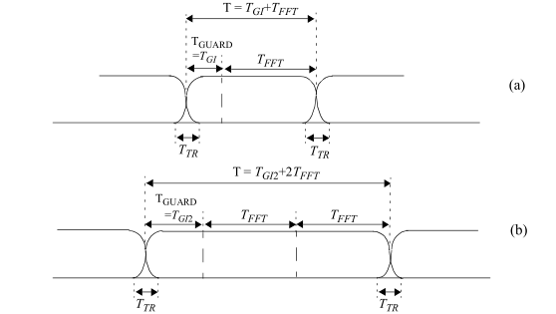
Figure 17-2—Illustration of OFDM subfield with cyclic extension and windowing for (a) single reception or (b) two receptions of the FFT period

P2923L58, P3518L58

a) Start of PPDU shall be detected.

P2924L23
h) Compute the RMS average of all errors in the DATA field of a PPDU. It is given by
Lp is the length of the DATA field
Nf is the number of PPDUs for the measurement
(I 0 (i,j,k), Q 0 (i,j,k)) denotes the ideal symbol point of the i th PPDU, j th OFDM symbol of the DATA field, k th subcarrier of the OFDM symbol in the complex plane
(I(i,j,k), Q(i,j,k)) denotes the observed point of the i th PPDU, j th OFDM symbol of the DATA field, k th subcarrier of the OFDM symbol in the complex plane (see Figure 17-16 (Constellation error))

P2924L62
The test shall be performed over at least 20 PPDUs (N f ), and the RMS average shall be taken. The DATA fields under test shall be at least 16 OFDM symbols long. Random data shall be used for the symbols.

P2925L40
The PER (i.e., number of errored PSDUs divided by the number of transmitted PSDUs) shall …

P2928L11
The RCPI is a measure of the received RF power in the selected channel for a received PPDU. This parameter shall be a measure by the PHY of the received RF power in the channel measured over the entire received Data field or by other equivalent means that meet the specified accuracy.

P2930L22
The PPDU transmission shall be completed and the PHY entity shall enter the receive state. Each
PHY-TXEND.request primitive is acknowledged with a PHY-TXEND.confirm primitive from the PHY.

P2933L34
In the event that a change in the RSSI causes the status of the CCA to return to the IDLE state before the complete reception of the PSDU, as indicated by the PHY LENGTH field, the error condition shall be reported to the MAC using a PHY-RXEND.indication(CarrierLost) primitive and the PHY receiver shall return to the RX IDLE state. The CCA of the OFDM PHY shall indicate a busy medium for the intended duration of the transmitted PPDU.

P2940L24
a) A function that defines a method for mapping the PSDUs into a PPDU format suitable for sending and receiving data, management and control information between two or more STAs using the associated PHY system. The PHY exchanges PPDUs that contain PSDUs. The MAC uses the PHY service, so each MPDU corresponds to a PSDU that is carried in a PPDU.

P2943L51
For ERP-OFDM modes, an ERP PPDU is terminated by a period of no transmission with a duration of aSignalExtension called the signal extension. The purpose of this extension is to make the TXTIME calculation in 18.5.3 (TXTIME) result in a transmission duration interval that includes an additional duration of aSignalExtension. The SIFS for Clause 17 (Orthogonal frequency division multiplexing (OFDM) PHY specification) PPDUs is 16 µs, and the SIFS for Clause 16 (High rate direct sequence spread spectrum (HR/DSSS) PHY specification) PPDUs is 10 µs. The longer SIFS in Clause 17 (Orthogonal frequency division multiplexing (OFDM) PHY specification) is to allow extra time for the convolutional decode process to finish. As Clause 18 (Extended Rate PHY (ERP) specification) PPDUs use a SIFS of 10 µs, this extra aSignalExtension length extension causes the transmitter to compute the Duration field in the MAC header incorporating the aSignalDuration of “idle time” following each ERP-OFDM transmission, which causes the NAV value of Clause 16 (High rate direct sequence spread spectrum (HR/DSSS) PHY specification) STAs to be set correctly.

P2939L1, P2953L29
NOTE—A Class 2 ERP STA will not be able to operate in a BSS whose AP includes in the basic rate set, and uses for transmission of group-addressed frames, only rates that the STA does not support.

P2944L4
The “CS mechanism” described in 10.3.2.1 (CS mechanism) combines the NAV state and the STA’s transmitter status with physical CS to determine the busy/idle state of the medium. A STA shall determine that the medium is idle through the use of the CCA mechanism for the interval specified. The starting reference of slot boundaries is the end of the previous PPDU on the medium. For ERP-OFDM PPDUs, this includes the signal extension. For ERP- OFDM PPDUs, a STA shall generate the PHY-RXEND.indication aSignalDuration after the end of the previous PPDU on the medium. This adjustment shall be performed by the STA based on local configuration information set using the PLME SAP.

P2944L33
PHY modulation and rate change for the ERP-OFDM PPDU format follows 17.3.7 (PHY data modulation and modulation rate change)

P2951L5
The long slot time indicated in Table 18-5 (ERP characteristics) shall be used unless the BSS consists only of STAs that support short slot time. STAs indicate support for short slot time by setting the Short Slot Time subfield to 1 when transmitting Association Request and Reassociation Request frames. If the BSS consists of only ERP STAs that support short slot time, an optional short slot time may be used. APs indicate usage of the short slot time indicated in Table 18-5 (ERP characteristics) by setting the Short Slot Time subfield to 1 in all Beacon, Probe Response, Association Response, and Reassociation Response frame transmissions as described in 9.4.1.4 (Capability Information field)

P2953L36, P3059L21, P3110L11, P3292L36, P3431L30, P3460L9
a) A function that defines a method of mapping the PSDUs into a PPDU format suitable for sending and receiving PSDUs between two or more STAs.

P2954L23
The FORMAT parameter determines the overall structure of the PPDU as follows:
— Non-HT format (NON_HT): PPDUs of this format are structured according to the Clause 17 (Orthogonal frequency division multiplexing (OFDM) PHY specification) (OFDM) or Clause 18 (Extended Rate PHY (ERP) specification) (ERP) specification. Support for non-HT format is mandatory.
— HT-mixed format (HT_MF): PPDUs of this format contain a preamble compatible with Clause 17 (Orthogonal frequency division multiplexing (OFDM) PHY specification) and Clause 18 (Extended Rate PHY (ERP) specification) receivers. The non-HT-STF (L-STF), the non-HT-LTF (L-LTF), and the non-HT SIGNAL field (L-SIG) are defined so they can be decoded by non-HT Clause 17 (Orthogonal frequency division multiplexing (OFDM) PHY specification) and Clause 18 (Extended Rate PHY (ERP) specification) STAs. The rest of the PPDU cannot be decoded by Clause 17 (Orthogonal frequency division multiplexing (OFDM) PHY specification) or Clause 18 (Extended Rate PHY (ERP) specification) STAs. Support for HT-mixed format is mandatory.
— HT-greenfield format (HT_GF): HT PPDUs of this format do not contain a non-HT compatible part. Support for HT-greenfield format is optional. An HT STA that does not support the reception of an HT-greenfield format packet shall be able to detect that an HT-greenfield format PPDU is an HT transmission (as opposed to a non-HT transmission). In this case, the receiver shall decode the HT-SIG and determine whether the HT-SIG cyclic redundancy check (CRC) passes.

P2954L51, P3059L59, P3111L31, P3294L13, P3461L3, P3059L61
… supplies the PHY with per-PPDU transmit parameters. Status of the transmission is reported from PHY to MAC by parameters within TXSTATUS. Using the RXVECTOR, the PHY informs the MAC of the receivedPPDU’s parameters. Using the PHYCONFIG_VECTOR, the MAC configures the PHY for operation, independent of PPDU transmission or reception.

P2957L13
MCS FORMAT is HT_MF or HT_GF Selects the modulation and coding scheme used in the transmission of the PPDU. The value used in each MCS is the index defined in 19.5 (Parameters for HT-MCSs). Integer: range 0 to 76. Values of 77 to 127 are reserved. The interpretation of the MCS index is defined in 19.5 (Parameters for HT-MCSs). Y Y
…
CH_BANDWIDTH FORMAT is HT_MF or HT_GF Indicates whether the PPDU is transmitted using 40 MHz or 20 MHz channel width. Enumerated type: HT_CBW20 for 20 MHz and 40 MHz upper and 40 MHz lower modes HT_CBW40 for 40 MHz Y Y

P2958L14
SOUNDING FORMAT is HT_MF or HT_GF Indicates whether this PPDU is a sounding PPDU. Enumerated type: SOUNDING indicates this is a sounding PPDU. NOT_SOUNDING indicates this is not a sounding PPDU. Y Y
…
GI_TYPE FORMAT is HT_MF or HT_GF Indicates whether a short guard interval is used in the transmission of the PPDU. Enumerated type: LONG_GI indicates short GI is not used in the PPDU. SHORT_GI indicates short GI is used in the PPDU. Y Y

P2961L26, P3433L22
TIME_OF_DEPARTURE_REQUESTED Enumerated type: true indicates that the MAC entity requests that the PHY entity measures and reports time of departure parameters corresponding to the time when the PPDU energy is sent by the transmitting port. false indicates that the MAC entity requests that the PHY entity neither measures nor reports time of departure parameters.

P2961L42, P3433L28
RX_START_OF_FRAME_OFFSET 0 to 2 32 – 1. An estimate of the offset (in 10 ns units) from the point in time at which the start of the preamble of the PPDU arrived at the receive antenna connector to the point in time at which this primitive is issued to the MAC.

P2966L1
… (specified in 19.3.11.12 (Non-HT duplicate transmission)) that duplicates the 20 MHz non-HT PPDU in two 20 MHz halves of a 40 MHz channel.

P2967L58
The HT-SIG, HT-STF, HT-GF-STF, HT-LTF1, and HT-LTFs exist only in HT PPDUs. In non-HT PPDUs only the L-STF, L-LTF, L-SIG, and Data fields exist

In both HT-mixed format and HT-greenfield format PPDUs, there are two types of HT-LTFs: Data HT-LTFs (HT-DLTFs) and Extension HT-LTFs (HT-ELTFs). HT-DLTFs are always included in HT PPDUs to provide the necessary reference for the receiver to form a channel estimate that allows it to demodulate the Data field. The number of HT-DLTFs, , may be 1, 2, or 4 and is determined by the number of space-time streams being transmitted in the PPDU (see Table 19-13 (Number of HT-DLTFs required for data space-time streams)). HT-ELTFs provide additional reference in sounding PPDUs so that the receiver can form an estimate of additional dimensions of the channel beyond those that are used by the Data field. The number of HT-ELTFs, , may be 0, 1, 2, or 4 (see Table 19-14 (Number of HT-ELTFs required for extension spatial streams)). PHY preambles in which HT-DLTFs are followed by HT-ELTFs are referred to as staggered preambles. The HT-mixed format and HT-greenfield format PPDUs shown in Figure 19-1 (PPDU format) both contain staggered preambles for illustrative purposes.
Transmissions of PPDUs with the TXVECTOR parameter NO_SIG_EXTN equal to false are terminated by a period of no transmission for a duration of aSignalExtension. See 10.3.8 (Signal extension).

P2970L62
… relative placement of the PHY preamble training fields vary depending on the PPDU format being used, as indicated by these parameters. Apply cyclic shifts. Determine spatial mapping to be used for HT-STF and HT-LTFs in an HT-mixed format PPDU and HT-GF-STF and HT-LTFs in an HT-greenfield format PPDU from the EXPANSION_MAT parameter of the TXVECTOR. Refer to 19.3.9 (HT preamble) for details.
b) Construct the PHY preamble SIGNAL fields from the appropriate fields of the TXVECTOR by adding tail bits, applying convolutional coding, formatting into one or more OFDM symbols, applying cyclic shifts, applying spatial processing, calculating an inverse Fourier transform for each OFDM symbol and transmit chain, and prepending a cyclic prefix or GI to each OFDM symbol in each transmit chain. The number and placement of the PHY preamble SIGNAL fields depend on the PPDU format being used. Refer to 19.3.9.3.5 (L-SIG definition), 19.3.9.4.3 (HT-SIG definition), and 19.3.9.5.4 (HT-greenfield format HT-SIG).

P2971L39
… The number of resulting symbols is given by Equation (19-41), and the number of repeated coded bits used for padding is given by Equation (19- 42). The resulting bit string constitutes the Data field of the PPDU.

P2980L1
- One or several HT-LTFs, provided as a way for the receiver to estimate the channel between each spatial mapper input and receive chain. The first HT-LTFs (HT-DLTFs) are necessary for demodulation of the Data field and are followed, for sounding PPDUs only, by optional HT-LTFs (HT-ELTFs) to sound extra spatial dimensions of the MIMO channel,
- HT-SIG, which provides all the information required to interpret the HT PPDU format. In the case of multiple transmit chains, the HT preambles use cyclic shift techniques to prevent unintentional beamforming.

19.3.9.2 HT-mixed format preamble

In HT-mixed format PPDUs, the preamble has fields that support compatibility with Clause 17 (Orthogonal frequency division multiplexing (OFDM) PHY specification) and Clause 18 (Extended Rate PHY (ERP) specification) STAs and fields that support HT operation. The non-HT portion of the HT-mixed format preamble enables detection of the PPDU and acquisition of carrier frequency and timing by both HT STAs and STAs that are compliant with Clause 17 (Orthogonal frequency division multiplexing (OFDM) PHY specification) or Clause 18 (Extended Rate PHY (ERP) specification). The non-HT portion of the HT-mixed format preamble contains the SIGNAL field (L-SIG) defined in Clause 17 (Orthogonal frequency division multiplexing (OFDM) PHY specification) and is thus decodable by STAs compliant with Clause 17 (Orthogonal frequency division multiplexing (OFDM) PHY specification) and Clause 18 (Extended Rate PHY (ERP) specification) as well as HT STAs.

The HT portion of the HT-mixed format preamble enables estimation of the MIMO channel to support demodulation of the Data field by HT STAs. The HT portion of the HT-mixed format preamble also contains the HT-SIG field that supports HT operation.

19.3.9.3 Non-HT portion of the HT-mixed format preamble
19.3.9.3.1 Introduction
The transmission of the L-STF, L-LTF and the L-SIG as part of an HT-mixed format PPDU is described in 19.3.9.3.2 (Cyclic shift definition) to 19.3.9.3.5 (L-SIG definition).

P2981L1
The cyclic shift is applied to each OFDM symbol in the PPDU separately. Table 19-9 (Cyclic shift for non-HT portion of PPDU) specifies the values for the cyclic shifts that are applied in the L-STF (in an HT-mixed format PPDU), the L-LTF, and L-SIG. It also applies to the HT-SIG in an HT-mixed format PPDU.

P2984L43
Throughout the HT portion of an HT-mixed format preamble, cyclic shift is applied to prevent beamforming when similar signals are transmitted in different space-time streams. The same cyclic shift is applied to these streams during the transmission of the Data field. The values of the cyclic shifts to be used during the HT portion of the HT-mixed format preamble (with the exception of the HT_SIG) and the Data field are specified in Table 19-10 (Cyclic shift values of HT portion of PPDU).

19.3.9.4.3 HT-SIG definition

The HT-SIG is used to carry information required to interpret the HT PPDU formats. The fields of the HT-SIG are described in Table 19-11 (HT-SIG fields).

P2985L43, P3444L62
Aggregation 1 Set to 1 to indicate that the PSDU contains an A-MPDU; otherwise, set to 0.

P2986L59
The time domain waveform for the HT-SIG in an HT-mixed format PPDU in a 20 MHz transmission shall be as shown in Equation (19-16).

P2986L9, P3481L51
NOTE—A value of 0 in the HT Length field indicates a PPDU that does not include a Data field, i.e., NDP. NDP transmissions are used for sounding purposes only … The NDP ends after the last …

P2989L55
The HT-LTF portion has one or two parts. The first part consists of one, two, or four HT-LTFs that are necessary for demodulation of the Data field. These HT-LTFs are referred to as HT DLTFs. The optional second part consists of zero, one, two, or four HT-LTFs that may be used to sound extra spatial dimensions of the MIMO channel that are not utilized by the Data field. These HT-LTFs are referred to as HT-ELTFs. If a receiver has not advertised its ability to receive HT-ELTFs, it shall either issue a PHY-RXEND.indication(UnsupportedRate) primitive upon reception of a PPDU that includes HT-ELTFs or decode that PPDU. (When an HT PPDU includes one or more HT-ELTFs, it is optional for a receiver that has not advertised its capability to receive HT-ELTFs to decode the Data field.)

P2991L24
In 40 MHz transmissions, including MCS 32 format PPDUs, the sequence to be transmitted is shown in
Equation (19-24).

P2993L57
For HT-greenfield operation, compatibility with Clause 17 (Orthogonal frequency division multiplexing (OFDM) PHY specification) and Clause 18 (Extended Rate PHY (ERP) specification) STAs is not required. Therefore, the portions of the preamble that are compatible with Clause 17 (Orthogonal frequency division multiplexing (OFDM) PHY specification) and Clause 18 (Extended Rate PHY (ERP) specification) STAs are not included. The result is a shorter and more efficient PPDU format that includes a STF, LTF(s), and an HT-SIG

19.3.9.5.2 Cyclic shift definition for HT-greenfield format preamble

Throughout the HT-greenfield format preamble, cyclic shift is applied to prevent beamforming when similar signals are transmitted on different spatial streams. The same cyclic shift is applied to these streams during the transmission of the Data field. The values of the cyclic shift to be used during the HT- greenfield format preamble, as well as the Data field of the HT-greenfield format PPDU, are specified in Table 19-10 (Cyclic shift values of HT portion of PPDU).

19.3.9.5.3 HT-GF-STF definition

The HT-GF-STF is placed at the beginning of an HT-greenfield format PPDU.

P2994L47
The content and format of the HT-SIG of an HT-greenfield format PPDU is identical to the HT-SIG in an HT-mixed format PPDU, as described in 19.3.9.4.3 (HT-SIG definition). The placement of the HT-SIG in an HT-greenfield format PPDU is shown in Figure 19-1 (PPDU format). In HT-greenfield format PPDUs, the HT-SIG is transmitted with the same cyclic shifts and the same spatial mapping as the preceding portions of the preamble. This use of the same cyclic shifts and spatial mapping is done to accommodate the estimation of channel parameters needed to robustly demodulate and decode the information contained in the HT-SIG.

P2996L4
The format of the LTF portion of the preamble in an HT-greenfield format frame is similar to that of the HT-LTF in an HT-mixed format PPDU, as described in 19.3.9.4.6 (HT-LTF definition), with the difference that the first HT-LTF (HT-LTF1) is twice as long (8 s) as the other HT-LTFs. The time domain waveform for the long training symbol on transmit chain i TX for the first HT-LTF in an HT-greenfield format PPDU shall be as shown in Equation (19-31).

P2996L29
The first HT-LTF (HT-LTF1) consists of two periods of the long training symbol, preceded by a double- length (1.6 s) cyclic prefix. The placement of the first and subsequent HT-LTFs in an HT-greenfield format PPDU is shown in Figure 19-1 (PPDU format).

For P2996-3544, editor, change “data field” to “Data field” and “data field” to “Data fields”

…
Figure 25-16—Transmitter block diagram for Data field of a CMMG SC mode PPDU

P2997L46
Support for the reception of PPDUs with BCC-encoded Data fields is mandatory.

P3000L36
Compute the number of available bits, , in the minimum number of OFDM symbols in which the Data field of the PPDU may fit.

P3007L43
The basic patterns are also different according to the total number of space-time streams for the Data field of the PPDU.

P3008L60
- When the PPDU is transmitted using one of the (optional) beamforming techniques

P3010L35
With transmit beamforming with explicit feedback, the steering matrix is determined using either for CSI feedback or for noncompressed and compressed matrices feedback from the STA to which the beamformed PPDU is addressed

When there are fewer space-time streams than transmit chains, the first columns of the matrices above that are square might be used.
The same matrix shall be applied to subcarrier k during all parts of the PPDU in HT-greenfield format and all parts of the PPDU following and including the HT-STF field in an HT-mixed format PPDU. This operation is transparent to the receiver.

P3011L24, P3012L1
Z is 3 in an HT-mixed format PPDU and 2 in an HT-greenfield format PPDU

P3013L8
Short GI is used in the Data field of the PPDU when the Short GI field in the HT-SIG is equal to 1.

P3017L11
In explicit beamforming, in order for STA A to transmit a beamformed PPDU to STA B, STA B measures the channel matrices and sends STA A either the effective channel

P3028L38

19.3.18.5 PPDU alignment
If no signal extension is required (see 19.3.2 (PPDU format)), the receiver shall emit a PHY-CCA.indication(IDLE) primitive (see 8.3.5.12 (PHY-CCA.indication)) at the 4 µs boundary following the reception of the last symbol of the PPDU. If a signal extension is required, the receiver shall emit a PHY- CCA.indication(IDLE) primitive a duration of aSignalExtension after the 4 µs boundary following the reception of the last symbol of the PPDU. This situation is illustrated for an HT-greenfield format PPDU using short GI in Figure 19-21 (PHY-TXEND.confirm alignment (HT-greenfield format with short GI)).

P3029
The relative constellation PPDU-averaged RMS error, calculated first by averaging over subcarriers, spatial streams, and OFDM symbols, shall not exceed a data-rate-dependent value according to Table 19-22 (Allowed relative constellation error versus constellation size and coding rate). The number of spatial streams under test shall be equal to the number of utilized transmitting STA antenna (output) ports and also equal to the number of utilized testing instrumentation input ports. In the test, with EQM MCSs shall be used and no beamforming steering matrix shall be used. Each output port of the transmitting STA shall be connected through a cable to one input port of the testing instrumentation. The same requirement applies both to 20 MHz channels and 40 MHz channels.

P3030L32
a) Detect the start of PPDU.
b) Detect the transition from short sequences to channel estimation sequences, and establish fine timing
(with one sample resolution).
c) Estimate the coarse and fine frequency offsets.
d) Derotate the PPDU according to estimated frequency offset.
e) Estimate the complex channel response coefficients for each of the subcarriers and each of the transmit chains.
f) For each of the data OFDM symbols, transform the symbol into subcarrier received values, estimate the phase from the pilot subcarriers in all spatial streams, derotate the subcarrier values according to estimated phase, group the results from all of the receiver chains in each subcarrier to a vector, multiply the vector by a zero-forcing equalization matrix generated from the channel estimated during the channel estimation phase.
g) For each data-carrying subcarrier in each spatial stream, find the closest constellation point and compute the Euclidean distance from it.
h) Compute the average of the RMS of all errors in the Data field. It is given by Equation (19-89).
…
Nf is the number of PPDUs for the measurement
I 0 i f i s i ss i sc      Q 0 i f i s i ss i sc      denotes the ideal symbol point in the complex plane in subcarrier i sc , spatial stream i ss , and OFDM symbol i s of the Data field in PPDU i f

I i f i s i ss i sc      Q i f i s i ss i sc      denotes the observed symbol point in the complex plane in subcarrier i sc , spatial stream i ss , and OFDM symbol i s of the Data field in PPDU i f is the average power of the constellation
The vector error on a phase plane is shown in Figure 17-16 (Constellation error).
The test shall be performed over at least 20 PPDUs (N f ), and the average of the RMS shall be taken. The Data fields under test shall be at least 16 OFDM symbols long. Random data shall be used for the symbols

P3031L61
The PER (i.e., number of errored PSDUs divided by the number of transmitted PSDUs) shall be less than 10% for a PSDU length of 4096 octets with the rate-
dependent input levels listed in Table 19-23 (Receiver minimum input level sensitivity) or less.

P3035L4
The RCPI is a measure of the received RF power in the selected channel for a received PPDU. This parameter shall be a measure by the PHY of the received RF power in the channel measured over the Data field of the received PPDU. The received power shall be the average of the power in all active receive chains

P3037L10, P3530L8, P3531L15
The PPDU transmission shall be completed, and the PHY entity shall enter the receive state

P3038L38, P3212L44
SETUP PSDU TX

P3041L13

If the PHY preamble reception is successful and a valid HT-SIG CRC is indicated:
— Upon reception of an HT-mixed format preamble, the HT PHY shall not generate a PHY-CCA.indication(IDLE) primitive for the predicted duration of the PPDU, as defined by TXTIME in 19.4.3 (TXTIME calculation), for all supported and unsupported modes except Reserved HT-SIG Indication. Reserved HT-SIG Indication is defined in the fourth item below.
— Upon reception of a GF preamble by an HT STA that does not support GF, the HT PHY shall not generate a PHY-CCA.indication(IDLE) primitive until either the predicted duration of the PPDU from the contents of the HT-SIG field, as defined by TXTIME in 19.4.3 (TXTIME calculation), except Reserved HT-SIG Indication, elapses or until the received level drops below the receiver minimum sensitivity level of BPSK, R=1/2 in Table 19-23 (Receiver minimum input level sensitivity) + 10 dB (–72 dBm for 20 MHz, –69 dBm for 40 MHz). Reserved HT-SIG Indication is defined in the fourth item below.
— Upon reception of a GF preamble by an HT STA that supports GF, the HT PHY shall not generate a PHY-CCA.indication(IDLE) primitive for the predicted duration of the PPDU, as defined by TXTIME in 19.4.3 (TXTIME calculation), for all supported and unsupported modes except Reserved HT-SIG Indication. Reserved HT-SIG Indication is defined in the fourth item below.

P3047L59
For non-HT modes of operation, refer to Clause 17 (Orthogonal frequency division multiplexing (OFDM) PHY specification) and Clause 18 (Extended Rate PHY (ERP) specification) for TXTIME calculations, except that PPDUs transmitted with a value of NON_HT_DUP_OFDM for the TXVECTOR parameter NON_HT_MODULATION shall use Equation (18-1) for TXTIME calculation.

P3060L23
MCS The MCS parameter is an enumerated type that indicates the modulation and coding scheme used in the transmission of the PPDU. Values are integers in the range 0 to 31 and the values 9.1, 12.1, 12.2, 12.3, 12.4, 12.5 and 12.6.
— An MCS value of 0 indicates the use of DMG control mode.
— MCS values of 1 to 12 and 9.1, 12.1, 12.2, 12.3, 12.4, 12.5, 12.6 indicate use of single carrier modulations. The value is an index to Table 20-15 (DMG SC mode modulation and coding schemes).
— MCS values of 25 to 31 indicate use of DMG low-power SC mode. The value is an index to Table 20-21 (DMG low-power SC mode modulation and coding schemes). Y Y

P3061L19
SNR This parameter indicates the SNR measured during the reception of a DMG control mode PPDU. Values are –13 dB to 50.75 dB in 0.25 dB steps. N

P3061L23, P3462L37
RCPI Is a measure of the received RF power measured over the preamble of a received PPDU. Refer to 20.3.10 (Received channel power indicator (RCPI) measurement) for the definition of RCPI. N Y

P3061L26
ANT_CONFIG Indicates which antenna configuration(s) is to be used throughout the transmission of the PPDU, and when to switch between configurations. Values are implementation dependent. Y N

P3061L33, P3463:44
TIME_OF_DEPARTURE_REQUESTED
Enumerated type:
— true indicates that the MAC entity requests that the PHY PHY entity measures and reports time of departure parameters corresponding to the time when the first PPDU energy is sent by the transmitting port.
— false indicates that the MAC entity requests that the PHY PHY entity neither measures nor reports time of departure parameters. O N

P3061L50, P3433L38, P3464L15
LAST_RSSI In the TXVECTOR, LAST_RSSI indicates the received power level of the last PPDU with a valid PHY header that was received a SIFS before transmission of the current PPDU; otherwise, it is 0 (10.3.2.3.3 (SIFS)). In the RXVECTOR, LAST_RSSI indicates the value of the LAST_RSSI field from the header of the received PPDU. Valid values are integers in the range 0 to 15:
— Values of 2 to 14 represent power levels ....
— A value of 15 represents power greater than or equal to …
— A value of 1 represents power less than or equal to …
— A value of 0 indicates that the previous PPDU was not received a SIFS before the current transmission.
Y

P3062L41, P3434L39
TIME_OF_DEPARTURE When the first PPDU energy is sent by the transmitting port, in units equal to 1/TIME_OF_DEPARTURE_ClockRate. This parameter is present only if TIME_OF_DEPARTURE_REQUESTED is true in the corresponding request.

P3064L5, P3435L57, P3465L11
The transmitter center frequency shall converge to within 1 ppm of its final value within 0.9 µs from the start of the PPDU.

P3064L23, P3465L26
The transmit power-on ramp is defined as the time it takes for a transmitter to rise from less than 10% to greater than 90% of the average power to be transmitted in the PPDU.
The transmit power-on ramp shall be less than 10 ns.
The transmit power-down ramp is defined as the time it takes the transmitter to fall from greater than 90% to less than 10% of the maximum power to be transmitted in the PPDU.

P3064L38, P3436L18
Antenna setting shall remain constant for the transmission of the entire PPDU except for the case of transmission of BRP-TX PPDUs (see …). During the transmission of BRP-TX PPDUs, it shall remain constant for the transmission of the STF, CE field, and Data field.

P3067L63
The preamble is the part of the PPDU that is used for PPDU detection, AGC, frequency offset estimation, synchronization, and channel estimation. The format of the preamble consists of a Short Training field followed by a Channel Estimation field. Figure 20-3 (SC preamble) illustrates the SC preamble.

P3068L39, P3439L17
The Channel Estimation field is used for channel estimation, as well as indication of which modulation is going to be used for the PPDU.

P3068L60, P3439L36
When the data field of the PPDU is modulated using single carrier, the Gu 512 and Gv 512 fields are concatenated in the order shown in …

P3072L8, P3484L54
The RCPI is a measure of the received RF power in the selected channel for a received PPDU. This parameter shall be a measure by the PHY of the received RF power in the channel measured over the … of the received PPDU.

P3073L9, P341L9, P3441L9
The preamble is the part of the … control mode PPDU that is used for PPDU detection, AGC, frequency offset estimation, synchronization, indication of PPDU type and channel estimation.

P3077L26, P3443L31
A SC PPDU is composed of the Short Training field (STF), the channel estimation field (CE), the Header, SC blocks and optional training fields, as shown in Figure 20-8 (SC PPDU format).

Figure 20-8—SC PPDU format

P3078L48
Aggregation B37 Set to 1 to indicate that the PSDU contains an A-MPDU; otherwise, set to 0.

P3079L7, P3445L14
Last RSSI … Contains a copy of the parameter LAST_RSSI from the TXVECTOR. The value is an unsigned integer: Values 2 to 14 represent power levels … dBm. A value of 15 represents a power greater than or equal to … dBm. A value of 1 represents a power less than or equal to… dBm. A value of 0 indicates that the previous PPDU was not received a SIFS before the current transmission.

P3080L33
NOTE 2—Base_Length1 is the maximum Length value such that the PPDU with the base MCS specified in SC header has the given N BLKS .
NOTE 3—Base_Length2 is the maximum number of data octets in PSDU such that the PPDU with the extended MCS has the given N BLKS

P3084L44
if BRP PPDU and N CW N CWmin  N CW N CWmin

P3090L48, P3449L13, P3498L55
The instrumentation shall perform carrier lock, symbol timing recovery and amplitude adjustment and equalization while making the measurements. The equalizer shall be trained using information in the SC preamble (STF and/or CEF). For the … SC mode EVM, measuring Ns samples at the sample rate, the measured symbols should not contain the first and the last hundred symbols of a given PPDU (ramp up/ down). The EVM is calculated according to the formula below:

P3097L2, P3452L19, P3530L58
The preamble format (control or SC mode) depend on the MCS in the PHY-TXSTART.request primitive. The PHY shall calculate the length of the PPDU according the MCS and the length specified in the PHY-TXSTART.request primitive, adding padding bits if necessary.

P3097L16, P3452L34
Transmission of the PSDU is completed with the transmission of the last bits of the (encoded) PSDU. If no TRN-T/R fields are specified in the PHY-TXSTART.request primitive, the PHY shall issue a PHY- TXEND.confirm primitive after the transmission of the last bits. If TRN units are requested in the PHY- TXSTART.request primitive, the transmission continues with the transmission of AGC subfields and TRN units. The PHY issues the PHY-TXEND.confirm primitive to the MAC after the transmission of the last TRN unit. The transmission shall be completed, and the PHY entity shall enter the receive state. Each PHY-TXEND.request primitive is acknowledged with a PHY-TXEND.confirm primitive from the PHY.

P3099L45, P3533L38
After the PHY-CCA.indication(BUSY) primitive is issued, the PHY entity shall … IThe PHY shall decode the header and determine the MCS, length and other parameters needed for the demodulation of the remainder of the PPDU.

P3099L61, P3533L50
At the end of the Data field … after the Data field and measure the channel. After the end of the training fields, the PHY shall generate a PHY-CCA.indication(IDLE) primitive …

P3100L10, P3533L52
In the case of signal loss … until the expected end of the PPDU, including AGC and TRN fields.

P3100L30, P3454L18
20.9.2 Beamforming PPDU format

P3102L28
The PPDU Type and Training Length fields present within the SC mode header, control mode header and LP SC mode header are used to indicate that a PPDU is BRP PPDU and the length of the training fields, respectively.

P3102L48, P3455L35
The minimum duration of the data field of a BRP PPDU when sent in an SC mode is aBRPminSCblocks SC blocks (see …) and, if needed, the Data field of the PPDU shall be extended by extra zero padding to generate the required number of SC blocks.

P3103L46, P3456L8
The AGC field in the BRP PPDU is composed of 4N AGC subfields. Each AGC subfield consists of the sequence [Ga 64 Ga 64 Ga 64 Ga 64 Ga 64 ] when the PPDU is transmitted using the SC mode and [Gb 64 Gb 64 Gb 64 Gb 64 Gb 64 ] when the PPDU is transmitted using the control mode. The sequences Ga 64 and Gb 64 are defined in 20.10 (Golay sequences). The sequences are transmitted using rotated π/2-BPSK modulation.
In a BRP-TX PPDU, the transmitter may change the TX AWV configuration at the beginning of each AGC subfield. Any transmit signal transients that occur due to this TX AWV configuration change shall completely settle by the end of the first Ga64 or Gb64 subsequence. The set of AWVs used for the AGC subfields should be the same as that used for the TRN-T subfields. In a BRP-RX PPDU, the transmitter shall use the same TX AWV as in the preamble and data fields of the PPDU.

P3104L27
In a BRP-RX PPDU, all of the TRN and CE subfields are transmitted using the same AWV as the preamble and data field of the PPDU. In a BRP-TX PPDU, the CE subfield shall be transmitted using the same AWV as the preamble and data field of the PPDU. In a BRP-TX PPDU, the transmitter may change AWV at the beginning of each TRN subfield. Any transmit signal transients that occur due to TX AWV configuration changes at the beginning of TRN subfields shall settle by the end of the first 64 samples of the subfield

P3116L35, P3248L34
NOTE—On reception, where valid, the CH_BANDWIDTH_IN_NON_HT parameter is likely to be a more reliable indication of subformat and channel width than the NON_HT_MODULATION and CH_BANDWIDTH parameters, since for non-HT or non-HT duplicate PPDUs, CH_BANDWIDTH is a receiver estimate of the bandwidth, whereas CH_BANDWIDTH_IN_NON_HT is the signaled bandwidth.

P3194L4
A value in the Group ID field in VHT-SIG-A (see 21.3.8.3.3 (VHT-SIG-A definition)) in the range 1 to 62 indicates a VHT MU PPDU. Prior to transmitting a VHT MU PPDU, group assignments have been established by the AP for DL-MU-MIMO capable STAs using the Group ID Management frame as defined in 9.6.22.3 (Group ID Management frame format).

P3203L64
i) Compute the average across PPDUs of the RMS of all Data field errors per PPDU as given by Equation (19-89).

P3204L63
The PER (i.e., number of errored PSDUs divided by the number of transmitted PSDUs) shall be less than 10% for a PSDU length of 4096 octets with the rate-dependent input levels listed in Table 21-25 (Receiver minimum input level sensitivity).

P3210L30
If all of the following conditions are met:
— If dot11TODImplemented and dot11TODActivated are true or if dot11TimingMsmtActivated is true,
— The TXVECTOR parameter TIME_OF_DEPARTURE_REQUESTED is true, then the PHY shall issue a PHY-TXSTART.confirm primitive to the MAC, forwarding the TIME_OF_DEPARTURE corresponding to the time when the first PPDU energy is sent by the transmitting port and TIME_OF_DEPARTURE_ClockRate parameter within the TXSTATUS. If dot11TimingMsmtActivated is true, then the PHY shall forward the value of TX_START_OF_FRAME_OFFSET in the TXSTATUS.

P3279L11
The PER (i.e., number of errored PSDUs divided by the number of transmitted PSDUs) shall be less than 10% for a PSDU length of 4096 octets with the rate-dependent input levels listed in Table 22-22 (Receiver minimum input level sensitivity).

P3295L11
NDP_INDICATION Determine the type of S1G PPDU. Set to 1 if this PPDU is one of NDP CMAC PPDUs as defined in 23.3.12 (NDP CMAC PPDUs). Set to 0 otherwise.

P3295L56, P3462L11
AGGREGATION Indicates whether the PSDU contains an A-MPDU. Enumerated type: AGGREGATED indicates this PSDU contains an A-MPDU. NOT_AGGREGATED indicates this PSDU does not contain an A-MPDU. Y Y

P3298L44
LENGTH
AGGREGATION is AGGREGATED Indicates the PPDU duration in number of symbols in the PSDU Y Y
AGGREGATION is NOT_AGGREGATED Indicates the PPDU duration in number of octets in the PSDU Y Y

P3299L10
APEP_LENGTH
FORMAT is S1G and AGGREGATION is AGGREGATED If equal to 0, indicates an S1G NDP for both RXVECTOR and TXVECTOR. If greater than 0 in the TXVECTOR, indicates the number of octets in the A-MPDU pre-EOF padding (see 10.12.2) carried in the PSDU. This parameter is used to determine the number of OFDM symbols in the Data field that do not appear after an A-MPDU subframe with 1 in the EOF subfield. MU O
(FORMAT is S1G_DUP_2M or SIG_DUP_1M) and AGGREGATION is AGGREGATED If equal to 0, indicates an S1G NDP for both RXVECTOR and TXVECTOR. If greater than 0 in the TXVECTOR, indicates the number of octets in the A-MPDU pre-EOF padding (see 10.12.2) carried in the PSDU. This parameter is used to determine the number of OFDM symbols in the Data field that do not appear after an A-MPDU subframe with 1 in the EOF subfield. Y O

P3300L57
TRAVELING_PILOTS Set to 1 if traveling pilots are used in the PPDU. Set to 0 otherwise. Y

P3304L28
The general structure for S1G_LONG is defined as in Figure 23-2 (S1G_LONG format). This PPDU format can be used for MU and SU beamformed transmissions using 2 MHz, 4 MHz, 8 MHz, and 16 MHz PPDUs.
…
The general structure for S1G_1M is defined as in Figure 23-3 (S1G_1M format). This PPDU format is used for S1G_1M PPDU SU transmission.

P3324L27
The transmitted RF signal is derived by upconverting the complex baseband signal, which consists of several fields. The timing boundaries for the various fields of the different PPDU formats are shown in Figure 23-5 (Timing boundaries for S1G PPDU fields), where N LTF is the number of LTF or D-LTF field symbols and is defined in Table 23-10 (Number of LTFs required for different numbers of space-time streams) (in 23.3.8.2.2.4 (LTF definition)), for up to .

P3325L4
For the S1G_1M PPDU PPDU format and the S1G_SHORT PPDU PPDU format, the signal transmitted on transmitted on transmit chain i TX shall be as shown in Equation (23-2).

P3328L45
If CH_BANDWIDTH is CBW1,
If CH_BANDWIDTH is CBW2,
If FORMAT is S1G or S1G_DUP_2M and CH_BANDWIDTH is CBW4,
…
If FORMAT isS1G or S1G_DUP_2M and CH_BANDWIDTH is CBW8 ,
…
If FORMAT is S1G or S1G_DUP_2M and CH_BANDWIDTH is CBW16,
…
If FORMAT is S1G_DUP_1M and CH_BANDWIDTH is CBW2,
…
If FORMAT is S1G_DUP_1M and CH_BANDWIDTH is CBW4,
…
If FORMAT is S1G_DUP_1M and CH_BANDWIDTH is CBW8,
…
If FORMAT is S1G_DUP_1M and CH_BANDWIDTH is CBW16,

P3335L18, P3342L18, P3344L17, P3356L25
Set to the value obtained from the TXVECTOR parameter RESPONSE_INDICATION. The Response Indication field indicates the presence and type of the PPDU that is expected to follow SIFS after the current transmission (see 10.3.2.5).

P3335L23, P3342L24, P3344L22, P3356L33
… Traveling Pilots Set to 1 to indicate traveling pilots usage in PPDU. Otherwise 0 to indicate regular pilot tone locations.

P3371L22
A 2 MHz NDP sounding shall not be duplicated. Instead, a 4 MHz, 8 MHz, or 16 MHz NDP shall be transmitted whenever needed. NDP CMAC PPDUs transmitted over a 4 MHz, 8 MHz, or 16 MHz channel shall be carried in an S1G 2 MHz duplicate PPDU

P3372L37
Compressed beamforming feedback using 19.3.12.3.6 (Compressed beamforming feedback matrix) is the only beamforming feedback format defined for S1G operation. In certain cases when the ψ angle is not included in the feedback frame (e.g., for SU feedback with N c = 1), the ψ angles not included in the feedback report are given the values below, which will correspond to a single column V matrix having elements with equal magnitude:

P3373L36
Bandwidth field is set to the same value as the TXVECTOR parameter CH_BANDWIDTH in the preceding VHT NDP Announcement frame carried in an S1G PPDU.

P3375L6
An RXVECTOR parameter NDP_INDICATION equal to 1 indicates reception of an NDP CMAC PPDU, and the NDP CMAC PPDU body field of the frame is obtained from the RXVECTOR parameter NDP_CMAC_PPDU_BODY

P3375L19
NDP CMAC frames are not MPDUs but NDPs, but they obey the rules for equivalent MPDUs, as shown in Table 23-29 (NDP CMAC PPDU Type field values).

P3376L30, P3377L11
The Early Sector Indicator field is set to 1 to indicate that the NDP CTS frame is followed by the sectorized
beam frame exchange. It is set to 0 to indicate that the NDP CTS frame is not followed by the
sectorized beam frame exchange.

P3379L50
The Uplink Data Indicator (UDI) subfield indicates if the STA has uplink data to transmit and is used by an SST STA to indicate its selected SST channel:
— Set to 0 to indicate that there is no uplink data present
— Set to 1 to indicate that there is uplink data present but the estimated time for the transmission of the uplink Data frames that are present at the STA is not determined.
— Set to a value between 2 and 9 to indicate the relative position of the selected SST channel with respect to the lowest numbered channel in the SST Enabled Channel Bitmap field of a received SST Operation element. For example, setting the UDI to 2 indicates that the selected SST channel is the first channel in the SST Enabled Channel Bitmap field, while setting the UDI to 3 indicates that the selected SST channel is the second channel in the SST Enabled Channel Bitmap field, etc.
— Set to a value greater than 9 to indicate the estimated time, in units of 40 s, required for the transmission of the uplink Data frames that are present at the STA, excluding the duration of their response and applicable IFS durations.

P3380L41
If the Idle Indication field is 0, the Duration field is set as described in 9.2.5.7 (Setting for control response frames) where the value is expressed in units of 40 s. If the Idle Indication field is 1, the Duration field is set to the duration of time, in milliseconds, during which an idle period (during which there is no frame transmission) is expected from the STA that elicited the response, starting from the end of the NDP Ack frame response

P3396L6
The PER (i.e., number of errored PSDUs divided by the number of transmitted PSDUs) shall be less than 10% for a PSDU length of 256 octets with the rate-dependent input levels listed in Table 23-34 (Receiver minimum input level sensitivity).

P3399L45
The device shall not issue a PHY-CCA.indication(BUSY, {primary2}), PHY-CCA.indication(BUSY, {secondary2}), PHY-CCA.indication(BUSY, {secondary4}), or PHY-CCA.indication(BUSY, {secondary8}) until the end of the duration indicated by the PPDU or until all conditions above are no longer satisfied. Additionally, for both type 1 and type 2 channels, the device shall issue a PHY-CCA.indication(BUSY, {primary1}) if any received signal in the primary 1 MHz channel exceeds the CCA-ED threshold of –75 dBm within a period aCCATime.

P3454L59
If the Enhanced Beam Tracking Request field in the PHY header is 0, each BRP PPDU is composed of an STF, a CE field, and a Data field followed by a training field containing an AGC field and a receiver training field, as shown in Figure 20-20 (BRP PPDU structure).

P3485
The CMMG control mode PPDU is composed of CMMG control mode STF, CMMG control mode CEF, CMMG control mode SIG, CMMG control mode Data field, and possibly AGC and TRN-R/T subfields. This is shown in Figure 25-13 (CMMG control mode PPDU format).

P3485L26
The CMMG control mode PPDU is composed of CMMG control mode STF, CMMG control mode CEF, CMMG control mode SIG, CMMG control mode Data field, and possibly AGC and TRN-R/T subfields. This is shown in Figure 25-13 (CMMG control mode PPDU format).

P3401L18, P3401L48, P3402L36
The device shall not issue a PHY-CCA.indication(BUSY, …. until the end of the duration indicated by the PPDU or until all conditions above are no longer satisfied.

P3432L19, P3461L24
MCS The MCS parameter is an enumerated type that indicates the modulation and coding scheme used in the transmission of the PPDU. Values are integers in the range ….

P3433L11
SNR This parameter indicates the SNR measured during the reception of a CDMG control mode PPDU. Values are –10 dB to 53.75 dB in 0.25 dB steps. N Y
ANT_CONFIG Indicates which antenna configuration(s) is to be used throughout the transmission of the PPDU and when to switch between configurations. Values are implementation dependent. Y N

P3434L11
ROBUST_MODE This parameter incorporating with the MCS parameter is an enumerated type that indicates CDMG control mode or CDMG robust PHY mode used in the transmission of the PPDU. It is present if MCS index is 0. Values are integers in the range 0–2.
— A CDMG ROBUST_MODE value of 0 indicates the use of CDMG control mode.
— A CDMG ROBUST_MODE value of 1 indicates the use of CDMG robust PHY mode 0.
— A CDMG ROBUST_MODE value of 2 indicates the use of CDMG robust PHY mode 1. This parameter is not present if MCS index is not 0. Y Y

P3435L16
The transmitted spectrum shall be measured on data PPDUs longer than 10 µs without the training fields.

P3436L57
The description for CDMG PPDU structure and related equations is the same as that contained in 20.3.5.1 (General).

P3438L28
The preamble is the part of the PPDU that is used for PPDU detection, AGC, frequency offset estimation, synchronization, I/Q imbalance estimation, indication of modulation (SC), and channel estimation. The SFS field in the preamble enables the receiver to perform estimation and compensation for the PPDU in a time domain and frequency domain according to the STF. The format of the preamble consists of a Short Training field followed by a Channel Estimation field. Figure 24-2 (CDMG SC mode preamble) illustrates the SC mode preamble.
…
Figure 24-2—CDMG SC mode preamble

P3439L50
Figure 24-3—Channel Estimation field for SC PPDUs

P3444L36
PPDU Type 1 32 Corresponds to the TXVECTOR parameter PPDU_TYPE.
— PPDU Type = 0 (BRP-RX PPDU, see 20.9.2.2.3 (BRP PPDU header fields)), indicates either a PPDU whose Data field is followed by one or more TRN subfields (when the Beam Tracking Request field is 0 or in CDMG control mode), or a PPDU that contains TRN subfields to be appended to a future response PPDU (when the Beam Tracking Request field is 1).
— PPDU Type = 1 (BRP-RX PPDU, see 20.9.2.2.3 (BRP PPDU header fields)), indicates a PPDU whose Data field is followed by one or more TRN subfields. The transmitter may change AWV at the beginning of each TRN subfield. The field is reserved when the Training Length field is 0

P3461L36
LENGTH Indicates the number of octets in the PSDU in the range from 0 to 262 143. A value of zero indicates a PPDU in which no Data field follows the SIG. Y

P3465L48
The PER (i.e., number of errored PSDUs divided by the number of transmitted PSDUs) shall be less than 10% for a PSDU length of 4096 octets with the rate-
dependent input levels listed in Table 25-2 (Receiver sensitivity).

P3469L11
Figure 25-1—PPDU structure for the SC mode PPDU with CBW540 MHz
Figure 25-2—PPDU structure for the SC mode PPDU with CBW1080 MHz
Figure 25-3—PPDU structure for the OFDM mode PPDU

P3471L10
The windowing function w T Field (nT S ) is used to smooth the transition between adjacent fields in the PPDU where OFDM mode modulation is employed.

P3471L41
The CMMG PHY preamble is the part of the PHY PPDU that is used for PPDU detection, AGC, frequency offset estimation, synchronization, indication of transmission mode (Control mode, SC mode, or OFDM mode), indication of transmission bandwidth (540 MHz or 1080 MHz), and channel estimation. The format of the preamble is common to both SC PPDUs and OFDM PPDUs and consists of a Short Training field followed by a Channel Estimation field. The content of the Short Training field is the same between SC and OFDM PPDUs (see 25.3.5.2 (CMMG Short Training field)), but the content of the Channel Estimation field is not the same between such PPDUs (see 25.3.5.3 (CMMG Channel Estimation field)).

P3479L35
B36–B39 Last RSSI 4 For SC/OFDM mode: Contains a copy of the parameter LAST_RSSI from the TXVECTOR. When set to 0, this field is reserved and ignored by the receiver. The value is an unsigned integer:
— Values of 2 to 14 represent power levels (–71+value×2) dBm.
— A value of 15 represents a power greater than or equal to –42 dBm.
— A value of 1 represents a power less than or equal to –68 dBm. Value of 0 indicates that the previous PPDU was not received an SIFS period before the current transmission. For control mode: Reserved.

P3480L7
B40–B41 Spreading Factor/Aggregation/Additional PPDU 2
For control mode:
— Set to 0: spreading by 13
— Set to 1: spreading by 7
— Set to 2: spreading by 4
— Set to 3: no spreading
For SC/OFDM mode:
Aggregation:
— Set to 1 indicate that the PSDU contains an A-MPDU; otherwise, set to 0.
Additional PPDU:
— Contains a copy of the parameter ADD_PPDU from the TXVECTOR. A value of 1 indicates that this PPDU is immediately followed by another PPDU with no IFS or preamble on the subsequent PPDU.
— A value of 0 indicates that no additional PPDU follows this PPDU

P3481L7
B55–B56 PPDU Type 2 When the Training Length field is nonzero, corresponds to the TXVECTOR parameter PPDU_TYPE.
— PPDU Type = 11 indicates either a PPDU whose Data field is followed by one or more TRN-R subfields, or a PPDU that is requesting TRN-R subfields to be appended to a future response PPDU.
— PPDU Type = 10 indicates a PPDU whose Data field is followed by one or more TRN-T subfields. When the Training Length field is zero and PPDU Type = 01, indicates that PPDU is a sounding PPDU. This field is reserved when the Training Length field is zero and PPDU Type = 00.

P3483L41
25.3.12 Encoding of Data field
…
e) Data field encoding: The j th bit set that is composed of all the j th bits of N CW LDPC codeword is encoded with 1-bit parity check to create a parity bit T j , j = 0, 1, …, n–1. All the parity bits T j (j = 0, 1, …, n–1) are combined into a parity data word with length of n bits.

P3484L36
Example of data field encoding:
…
e) Data field encoding: Encoded with 1-bit parity check to create d 13 , length of 672 bits

P3490L28
A CMMG SC mode PPDU is composed of the CMMG SC mode STF, the CMMG SC mode CEF, the CMMG SC mode SIG field, the optional CMMG SC mode SCTF, the SC data block, and the optional training fields, which is defined in Figure 25-17 (Format of CMMG SC mode PPDU) where the SCTF fields is transmitted for 1080 MHz channel bandwidth

P3500L33
A CMMG OFDM mode OFDM PPDU is composed of the CMMG OFDM mode STFs, the CMMG OFDM mode CEF, the CMMG OFDM mode SIG field, the CMMG OFDM mode Short Training Field (OSTF), the CMMG OFDM mode Channel Estimation Field (OCEF), CMMG OFDM mode symbols, and the optional training fields, as shown in Figure 25-22 (Format of the CMMG OFDM mode PPDU).

P3504L27
If the channel bandwidth is 540 MHz, the preamble sequence and the CMMG OFDM mode SIG fields defined in the above subclauses are specified at the SC chip rate (T C ). For transmission in the OFDM (nominal) sample rate, the signal is resampled with a 3/2 rate change. The resampling is done by upsampling by a factor of 3, filtering by the filter h Filt defined in 25.3.11 (hFilt definition), and downsampling by a factor of 2 (see equation below). To define the transmission of the preamble when the PPDU is an OFDM mode PPDU, the preamble waveform is defined below

P3505L38
The OCEF provides a means for the receiver to estimate the MIMO channel between the set of constellation mapper outputs (or, if STBC is applied, the STBC encoder outputs) and the receive chains. The transmitter provides training for N STS space-time streams (spatial mapper inputs) used for the transmission of the PSDU(s). For each tone, the MIMO channel that can be estimated is a N RX × N STS matrix. A PPDU transmission has a preamble that contains OCEF symbols, where the data tones of each OCEF symbol are multiplied by entries belonging to a matrix

P3518L63
d) The PPDU shall be de-rotated according to estimated frequency offset.
e) The complex channel response coefficients shall be estimated for each of the subcarriers using information contained in the preamble (STF/CEF and/or OCEF).
f) For each of the OFDM symbols: transform the symbol into subcarrier received values, estimate the phase from the pilot subcarriers, derotate the subcarrier values according to estimated phase, and divide each subcarrier value with a complex estimated channel response coefficient.
g) For each data-carrying subcarrier, compute the Euclidean distance to the ideal location for the symbol, or pilot.
h) Compute the RMS average of all errors in the Data field of a PPDU. It is given by
…
Nf is the number of PPDUs
i is the PPDU index
…
P 0 is the average power of the constellation (I * ,Q * ) computed over the i th PPDU

The measurements shall occur on the OFDM symbols and shall not occur on the other kinds of symbols. The measurement shall be performed on at least 10 PPDUs with 16 symbols at least in each of them. Random data shall be used.

P3520L57
25.7 Analog beamforming PPDU format
25.7.1 TX sector sweep
The PPDUs sent during TX sector sweep are control mode PPDUs as defined in 25.4 (CMMG control mode).

P3521L14
— BRP-RX PPDUs are PPDUs that have TRN-R training sequences following the Data field. These PPDUs enable receiver antenna weight vector training.

P3521L53
The beam refinement AGC fields are composed of 4N repetitions of the sequence when the PPDU is transmitted using the control mode in bandwidth 540 MHz, when the PPDU is transmitted using the SC mode in bandwidth 540 MHz, when the PPDU is transmitted using the OFDM mode in bandwidth 540 MHz, when the PPDU is transmitted using the control mode in bandwidth 1080 MHz, when the PPDU is transmitted using the SC mode in bandwidth 1080 MHz, and when the PPDU is transmitted using the OFDM mode in bandwidth 1080 MHz. The sequences , , , , , and are defined in 25.8 (ZCZ sequence). The sequences are transmitted using rotated π/2-QPSK modulation.
In a BRP-TX PPDU, the transmitter may change the TX AWV configuration at the beginning of each AGC subfield. Any transmit signal transients that occur due to this TX AWV configuration change shall completely settle by the end of the first , , or subsequence in bandwidth 540 MHz and , , or subsequence in bandwidth 1080 MHz. The set of AWVs used for the AGC subfields should be the same as that used for the TRN-T subfields. In a BRP-RX PPDU, the transmitter shall use the same TX AWV as in the preamble and data fields of the PPDU.

P3522L43
Each subfield CEF matches the Channel Estimation field defined in 25.3.5 (CMMG PHY preamble). The 4N subfields T 1 to T 4N each consist of the sequence in bandwidth 540 MHz and in bandwidth 1080 MHz. The sequences , , , and are defined in Table 25-33 (The sequence set Zi256, i=1,2,3,4), and , , , and are defined in Table 25-34 (The sequence set Zi512, i=1,2,3,4) in 25.8 (ZCZ sequence). The sequences are transmitted using rotated π/2-QPSK modulation. When transmitting the CEF subfield, the transmitter shall use the same AWV as in the preamble and data fields of the PPDU. Any transmit signal transients that occur due to TX AWV configuration changes between subfields shall settle by the end of the first 64 samples of the subfield.

P3523L5
25.7.2.8 BRP resampling in an OFDM mode PPDU
The BRP AGC field, the CEF, and Tn/Rn field are specified at the SC chip rate (T c ). When appended to an OFDM mode PPDU, the signal is resampled as defined in 25.3.10 (CMMG duplication transmission on a 1080 MHz channel).

P3529L46
The PHY shall then issue a PHY-TXSTART.request primitive, and transmission of the PHY preamble shall start, based on the parameters passed in the PHY-TXSTART.request primitive. The PHY shall calculate the length of the PPDU according the MCS and the length specified in the PHY-TXSTART.request primitive, adding padding bits if necessary

P3534L16
End of PPDU Wait
Wait till End of PPDU Time

P3601L59, P3632L23
… Hold CCA busy for PPDU duration of a correctly received PPDU but carrier lost during reception of MPDU 15.3.7 (Receive PHY) M Yes □ No □
… Hold CCA busy for PPDU duration of a correctly received but out of specification PPDU 15.3.7 (Receive PHY) M Yes □ No □

P3611L49
OF2.18 PPDU duration calculation M Yes □ No □

P3612L6
OF2.19.3.2 Hold CCA busy for PPDU duration of a correctly received PPDU, but carrier lost during reception of MPDU 17.3.10.6 (CCA requirements) OF2.19.3: M Yes □ No □ N/A □

P3620L41
OF5.1 Minimum input level sensitivity at packet error ratio (PER) = 10% with 1000 octet PSDU

P3621L61
OF5.6 Maximum input level sensitivity at packet error ratio (PER) = 10% with 1000 octet PSDUs (10 MHz channel spacing)

P3623L11
OF5.11 Maximum input level sensitivity at packet error ratio (PER) = 10% with 1000 octet PSDUs (5 MHz channel spacing)

P4397L1
I.1.8 The entire PPDU for the BCC example
The PPDU in its entirety is shown in the tables in this subclause. These tables illustrate the short training sequence section (Table I-22 (Time domain representation of the short training sequence)), the long training sequence section (Table I-23 (Time domain representation of the long training sequence)), the SIGNAL field (Table I-24 (Time domain representation of the SIGNAL field (1 symbol))), and the six DATA symbols (Table I-25 (Time domain representation of the DATA field: symbol 1of 6) to Table I-30 (Time domain representation of the DATA field: symbol 6 of 6)).

