IEEE P802.11
Wireless LANs
PDT Additional Corrections to the Trigger Frame RU Allocation Table
Date: 2021-06-07
Author(s):
Name | Affiliation | Address | Phone | Email
Steve Shellhammer | Qualcomm |  |  | shellhammer@ieee.org
Youhan Kim |  |  |  | youhank@qti.qualcomm.com
Bin Tian |  |  |  | btian@qti.qualcomm.com
Yanjun Sun |  |  |  | yanjuns@qti.qualcomm.com

Discussion #1
In the Trigger Frame RU Allocation table entries for MRU2x996+484, the mapping from the PS160, B0 and B7-B1 of the RU Allocation field to the MRU number is unclear. The table needs to be modified to fix this issue. For reference, see the figure below from document 802.11-20/1703r6.

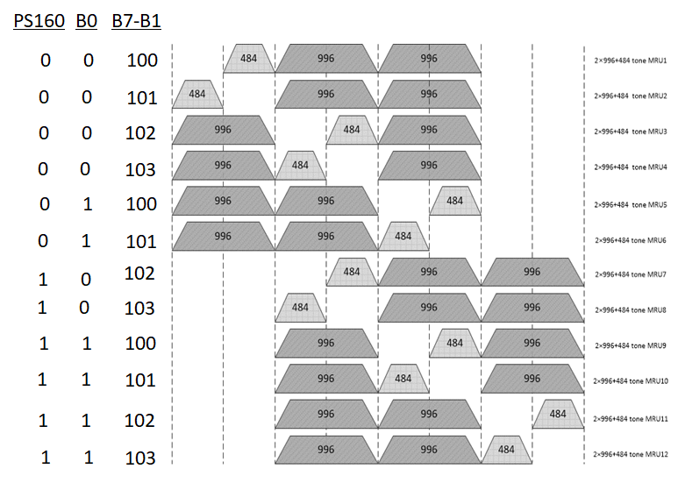

TGbe editor: Please make the following changes in Table 9-29j1—Encoding of PS160 and RU Allocation subfields in an EHT variant User Info field:

Change This:

PS160 subfield | B0 of the RU Allocation subfield | B7–B1 of the RU Allocation subfield | Bandwidth (MHz) | RU/MRU size | RU/MRU index | PHY RU/MRU index
$$⋮$$ | $$⋮$$ | $$⋮$$ | $$⋮$$ | $$⋮$$ | $$⋮$$ | $$⋮$$
0 | 0 | 100–103 | 320 | 2×996 +484 | MRU1 to MRU4, respectively | MRU index
0 | 1 |  |  |  | MRU5 and MRU6, respectively
1 | 0 |  |  |  | MRU7 and MRU8, respectively
1 | 1 |  |  |  | MRU9 to MRU12, respectively

To This:

PS160 subfield | B0 of the RU Allocation subfield | B7–B1 of the RU Allocation subfield | Bandwidth (MHz) | RU/MRU size | RU/MRU index | PHY RU/MRU index
$$⋮$$ | $$⋮$$ | $$⋮$$ | $$⋮$$ | $$⋮$$ | $$⋮$$ | $$⋮$$
0 | 0 | 100-103 | 320 | 2$×$996  +484 | MRU1 to MRU4, respectively | MRU Index
0 | 1 | 100-101 |  |  | MRU5 and MRU6, respectively
0 | 1 | 102-103 | Any | Reserved | Reserved
1 | 0 | 100-101 | Any | Reserved | Reserved
1 | 0 | 102-103 | 320 | 2$×$996  +484 | MRU7 and MRU8, respectively
1 | 1 | 100-103 |  |  | MRU9 to MRU12, respectively

Discussion #2
- The 52+26-tone MRU1 is only present in the in the 20 and 40 MHz PPDUs.
- The 52+26-tone MRU6 is only present in the 40 MHz PPDU.
- The 52+26-tone MRU7 and MRU12 are reserved.
- See Figure below from document 802.11-20/1703r6.

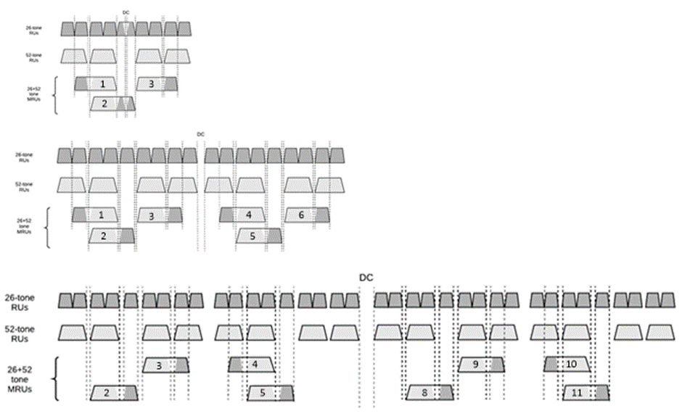

Discussion #2 (cont.)
- The 106+26-tone MRU2 is only present in the in the 20 and 40 MHz PPDUs.
- The 106+26-tone MRU3 is only present in the in the 40 MHz PPDU.
- The 106+26-tone MRU6 and MRU7 are reserved.
- See Figure below from document 802.11-20/1703r6.

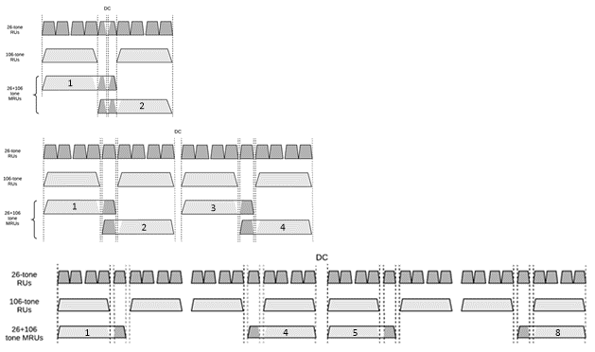

TGbe editor: Please make the following changes in Table 9-29j1—Encoding of PS160 and RU Allocation subfields in an EHT variant User Info field:

PS160 subfield | B0 of the RU Allocation subfield | B7–B1 of the RU Allocation subfield | Bandwidth (MHz) | RU/MRU size | RU/MRU index | PHY RU/MRU index
0–3:  80 MHz subblock where the  MRU is located |  | 70 | 20, 40 | 52+26 | MRU1 | 12×Ν +  MRU index
 |  | 70 | 80, 160, or 320 | Reserved | Reserved
 |  | 71-72 | 20, 40, 80, 160, or 320 | 52+26 | MRU2 to MRU3, respectively
 |  | 73–74 | 40, 80, 160, or 320 | 52+26 | MRU4 to MRU5, respectively
 |  | 75 | 40 | 52+26 | MRU6
 |  | 75 | 80, 160, or 320 | Reserved | Reserved
 |  | 76 | Any | Reserved | Reserved
 |  | 77-80 | 80, 160, or  320 | 52+26 | MRU8 to MRU11, respectively
 |  | 81 | Any | Reserved | Reserved
 |  | 82 | 20, 40, 80,  160, or 320 | 106+26 | MRU1 | 8×Ν +  MRU index
 |  | 83 | 20, 40 | 106+26 | MRU2
 |  | 83 | 80, 160, or 320 | Reserved | Reserved
 |  | 84 | 40 | 106+26 | MRU3
 |  | 84 | 80, 160, or 320 | Reserved | Reserved
 |  | 85 | 40, 80, 160, or 320 | 106+26 | MRU4
 |  | 86 | 80, 160, or  320 | 106+26 | MRU5
 |  | 87-88 | Any | Reserved | Reserved
 |  | 89 | 80, 160, or 320 | 106+26 | MRU8
 |  | 90–93 | 80, 160, or  320 | 484+242 | MRU1 to MRU4, respectively | MRU index 4×Ν

