IEEE P802.11
Wireless LANs
802.1AS Time Synchronization Support for TM/FTM
Date: 2021-11-01
Author(s):
Name | Affiliation | Address | Phone | email
Jerome Henry | Cisco Systems |  |  | jerhenry@cisco.com
Malcolm Smith | Cisco Systems |  |  | mmsmith@cisco.com
Ganesh Venkatesan | Intel Corporation | 2111 NE 25th Ave, Hillsboro, OR 97124 | 503 334 6720 | ganesh.venkatesan@intel.com
Abstract
This submission proposes to fix the mechanism supporting 802.1AS time exchange with 802.11.

All the changes are related to Draft P802.11REVme D0.3.

CID | Comment | Proposed Change | Resolution
90 | 802.1AS defines a FollowUp element to carry host time information in an FTM frame. This element is necessary to the implementation of TSN to 802.11. However, this element is not defined in 802.11, forcing implementers to use a VAS element | Define in 9.4.2 the 1AS Follow up element as specified by 802.1AS, and add support for this element in 9.6.7.33 | Revise, define options to clarify 802.1AS usage

Discussion:
802.1AS is a Standard prepared by the Time-Sensitive Networking Task Group of IEEE 802.1, and which goal is Timing and Synchronization for Time- Sensitive Applications.
The Standard defines procedures by which two or more devices connected over an IEEE 802 network can exchange time information to synchronize their time.
This synchronization is crucial to time, delay and jitter-sensitive applications (e.g., industrial settings, AR/VR, gaming and more).
Clause 12 applies to time exchange over 802.11 links, and leverages exiting procedures in 802.11-2020, namely 11.21.5 (Timing Measurement) and 11.21.6 (Fine Timing Measurement).
The intent is that, beyond sharing timestamps (t₁,t₄), the peer STA / RSTA also sends a “FollowUp Information” field that includes host time and synchronization information (called preciseOriginTimestamp, rateRatio, correctionField, etc.).

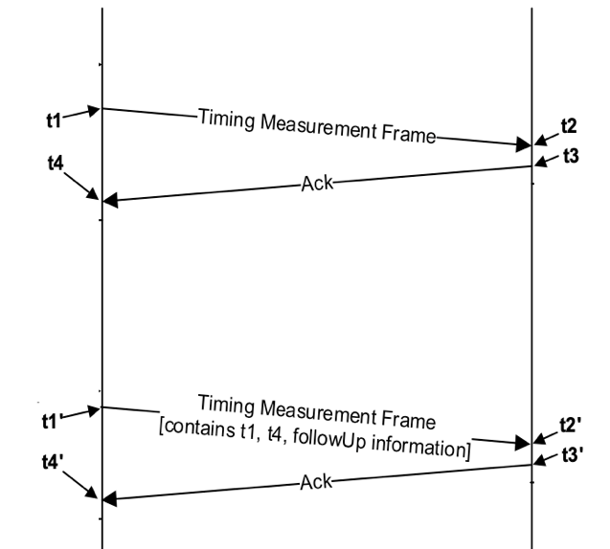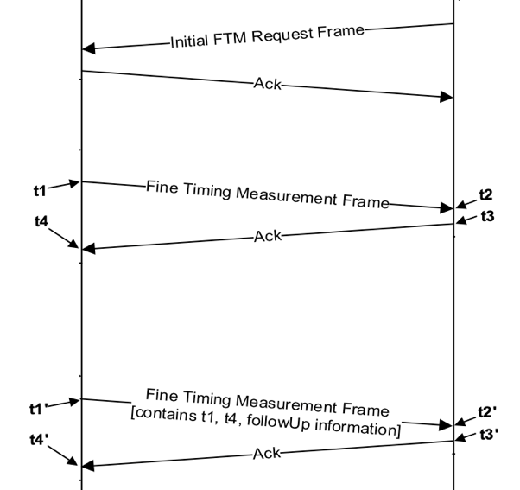

The current implementation of 802.1AS in 802.11 suffers from 3 core limitations:
- Problem 1: the STA does not know if the AP is TM/FTM capable for the purposes of time synchronization. The AP only announces support for TM/FTM in general, but not support for FollowUp Information, making TM/FTM mostly unusable for clock synchronization outside of specialized settings (a ‘normal’ STA must guess whether the AP will share time sync information)
- Problem 2: the STA starts by sending a Timing Measurement Request or Initial Fine Timing Measurement Request. But the AP does not know if the goal is ranging or time synchronization -> the AP cannot know if the STA expects FollowUp Information for this exchange
- Problem 3: the FollowUp Information is currently sent as VSIE. Although VSIE is an easy vehicle to carry anything, it may make sense to define a proper IE for this usage, to facilitate TSN extension and integration into 802.11

Proposed resolution:

Revised. Define a capability element expression for time synchronization requests over TM/FTM. Define an 802.11 IE for FollowUp Information that can be used to carry 1AS time sync information

Insert the following new subclause (where we add a new 1AS FollowUp Information element), after 9.4.2.290:

9.4.2.291 1AS FollowUp Information element

The 1AS FollowUp Information element is used to carry timing synchronization information in contexts where a STA needs to align its time precisely with that of a reference server. The format of the 1AS FollowUp Information element is shown in figure 9-1200a (1AS FollowUp Information element).

 | Element ID | Length | 1AS FollowUp Information
Octets: | 1 | 1 | variable
Figure 9-1200a — 1AS FollowUp Information element format

The Element ID and Length are defined in 9.4.2.1 (General). The 1AS FollowUp Information field is defined in [2X1].

Insert the following references to Clause 2:

References:

[2X1] IEEE Std 802.1ASTM-2020, Timing and Synchronization for Time- Sensitive Applications

Edit table 9-190 (Extended Capabilities field) as follows

Bit | Information | Notes
90 | 1AS Timing Synchronization | The AP sets the 1AS Timing Synchronization field to 1 when dot11TimingSyncrhonizationActivated is true and set to 0 otherwise
88, 9091-n | Reserved

Edit C.3 dot11WirelessMgmtOptionsEntry, by:
Adding at the bottom of the Dot11WirelessMgmtOptionsEntry ::= SEQUENCE {, insert) list:
dot11TimingSynchronizationActivated TruthValue

Adding at the end of the of the Dot11WirelessMgmtOptionsEntry control variable list, after ::= { dot11WirelessMgmtOptionsEntry 53 }

dot11TimingSynchronizationActivated OBJECT-TYPE
SYNTAX TruthValue
MAX-ACCESS read-write
STATUS current
DESCRIPTION
"This is a control variable.
It is written by an external management entity or the SME.
Changes take effect at the next occurrence of an MLME-START.request or MLME-JOIN.request primitive.
This attribute, when true, indicates that the station capability for 1AS timing information exchange is enabled. False indicates the station has no 1AS timing information exchange capability or that the capability is present but is disabled."
DEFVAL { false}
::= { dot11WirelessMgmtOptionsEntry 54 }

Edit Clause 9.6.13.28 (Timing Measurement Request frame format, where we add support for 1AS FollowUp), as follows:

The format of the Timing Measurement Request frame Action field is shown in Figure 9-1152 (Timing Measurement Request frame Action field format).
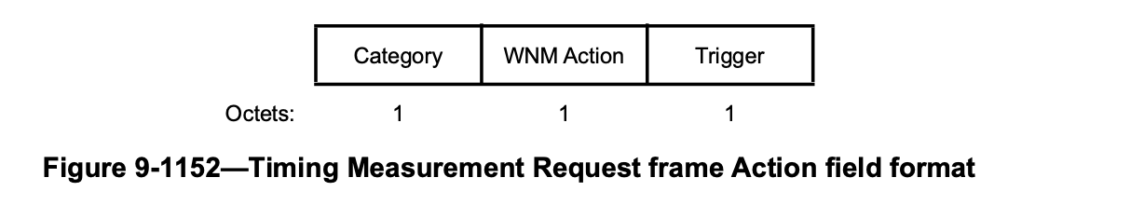

The Category field is defined in 9.4.1.11 (Action field).
The WNM Action field is defined in 9.6.13.1 (WNM Action fields).
The Trigger field set to the value 1 indicates that the sending STA requests a timing measurement procedure at the receiving STA as defined in 11.21.5 (Timing measurement procedure). The Trigger field set to the value 0 indicates that the sending STA requests that the receiving STA stop sending Timing Measurement frames. The Trigger field set to the value 2 indicates that the sending STA requests that the receiving STA includes the 1AS FollowUp Information element in the TM frame(s). Trigger field values 23–255 are reserved.

Edit Clause 9.6.14.3 (Timing Measurement frame format), as follows:

 | Category | Unprotected WNM Action | Dialog Token | Follow Up Dialog Token | TOD
Octets: | 1 | 1 | 1 | 1 |  | 4

 | TOA | Max TOD Error | Max TOA Error | 1AS FollowUp Information (optional)
Octets: | 4 | 1 | 1 | variable
Figure 9-1156 — Timing Measurement frame Action field format

(at the end of clause 9.6.14.3:)
The 1AS FollowUp field is optionally present. If present, it contains the 1AS FollowUp Information element as defined in 9.4.2.291 (1AS FollowUp Information element).

Edit the table in Clause 6.3.55.2.2 as follows:

Name | Type | Valid Range | Description
Trigger | Integer | 0-12 | The trigger to identify the action

Edit the table in Clause 6.3.55.3.2 as follows:

Name | Type | Valid Range | Description
Trigger | Integer | 0-12 | The trigger to identify the action

Edit Clause 6.3.55.4.2 as follows:

MLME-TIMINGMSMT.request(
Peer MAC Address,
Dialog Token,
Follow Up Dialog Token,
t1,
Max t1 Error,
t4,
Max t4 Error,
1AS FollowUp Information
VendorSpecific )

(insert at the end of the table in Clause 6.3.55.4.2):

Name | Type | Valid Range | Description
1AS FollowUp Information | As defined in 9.4.2.291 (1AS FollowUp Information element) | As defined in 9.4.2.291 (1AS FollowUp Information element) | Optional element containing the 1AS FollowUp Information time synchronization information

Edit Clause 6.3.55.5.2 as follows:

MLME-TIMINGMSMT.indication(
Peer MAC Address,
Dialog Token,
Follow Up Dialog Token,
t1,
Max t1 Error,
t4,
Max t4 Error,
1AS FollowUp Information
VendorSpecific )

(insert at the end of the table in Clause 6.3.55.5.2):

Name | Type | Valid Range | Description
1AS FollowUp Information | As defined in 9.4.2.291 (1AS FollowUp Information element) | As defined in 9.4.2.291 (1AS FollowUp Information element) | Optional element containing the 1AS FollowUp Information time synchronization information

Edit Clause 9.6.7.32 (Fine Timing Measurement Request frame format, where we add support for 11AS FollowUp) as follows:

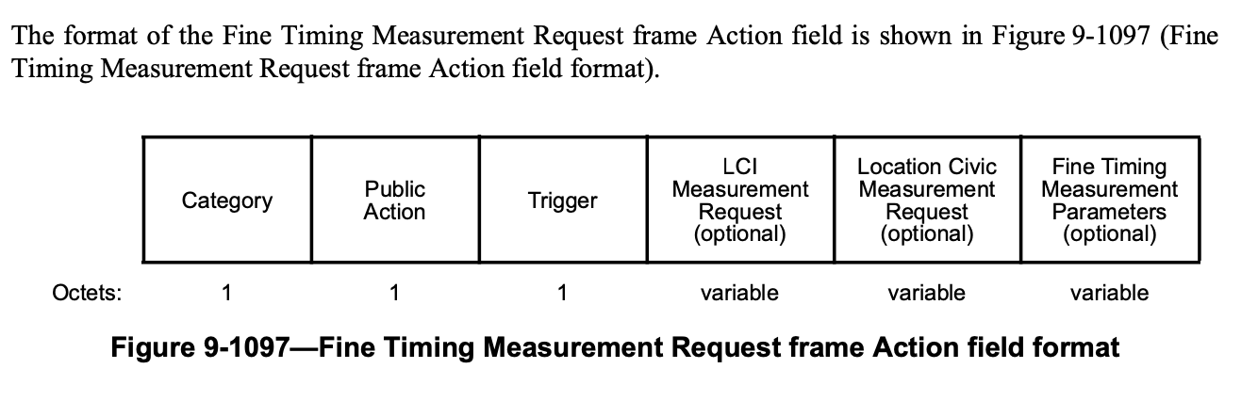

The Category field is defined in 9.4.1.11 (Action field).
The Public Action field is defined in 9.6.7.1 (Public Action frames).
The Trigger field set to 1 indicates that the initiating STA requests that the responding STA start or continue sending Fine Timing Measurement frames (see 11.21.6 (Fine Timing Measurement (FTM) procedure)). The trigger field set to 0 indicates that the initiating STA requests that the responding STA stop sending Fine Timing Measurement frames. The Trigger field set to 5 indicates that the initiating STA requests that the responding STA start or continue sending Fine Timing Measurement and also send the 1AS FollowUp Information element in the FTM frame(s). Trigger field values 26-255 are reserved.

Edit clause 9.6.7.33 (Fine Timing Measurement frame format) as follows:

The Fine Timing Measurement frame is used to support the FTM procedure described in 11.21.6 (Fine timing measurement (FTM) procedure). The format of the Fine Timing Measurement frame Action field is shown in Figure 9-1098 (Fine Timing Measurement frame Action field format).

 | Category | Public Action | Dialog Token | Follow Up Dialog Token | TOD |  | TOA
Octets: | 1 | 1 | 1 | 1 |  | 6 |  | 6

 | TOD error | TOA Error | LCI Report (optional) | Location Civic Report (optional) | Fine Timing Measurements Parameters (optional) | 1AS FollowUp Information (optional)
Octets: | 2 | 2 | variable | variable | variable | variable
Figure 9-1098 — Fine Timing Measurement frame Action field format

(…/… at the end of the Clause):
The 1AS FollowUp field is optionally present. If present, it contains the 1AS FollowUp Information element as defined in 9.4.2.291 (1AS FollowUp Information element).

Edit the table in Clause 6.3.56.2.2 as follows:

Name | Type | Valid Range | Description
Trigger | Integer | 0-16 | The trigger to identify the action

Edit the table in Clause 6.3.56.3.2 as follows:

Name | Type | Valid Range | Description
Trigger | Integer | 0-16 | The trigger to identify the action

Edit Clause 6.3.56.4.2 as follows:

MLME-FINETIMINGMSMT.request(
Peer MAC Address,
Dialog Token,
Follow Up Dialog Token,
t1,
Max t1 Error Exponent,
t4,
Max t4 Error Exponent,
LCI Report,
Location Civic Report,
Fine Timing Measurement Parameters,
1AS FollowUp Information
VendorSpecific )

(insert at the end of the table in Clause 6.3.56.4.2):

Name | Type | Valid Range | Description
1AS FollowUp Information | As defined in 9.4.2.291 (1AS FollowUp Information element) | As defined in 9.4.2.291 (1AS FollowUp Information element) | Optional element containing the 1AS FollowUp Information time synchronization information

Edit Clause 6.3.56.6.2 as follows:

MLME-FINETIMINGMSMT.indication(
Peer MAC Address,
Dialog Token,
Follow Up Dialog Token,
t1,
Max t1 Error Exponent,
t4,
Max t4 Error Exponent,
LCI Report,
Location Civic Report,
Fine Timing Measurement Parameters,
1AS FollowUp Information
VendorSpecific )

(insert at the end of the table in Clause 6.3.56.6.2):

Name | Type | Valid Range | Description
1AS FollowUp Information | As defined in 9.4.2.291 (1AS FollowUp Information element) | As defined in 9.4.2.291 (1AS FollowUp Information element) | Optional element containing the 1AS FollowUp Information time synchronization information

