IEEE P802.11
Wireless LANs
Frame exchange sequences and Annex G – divorce procedings
Date: 2021-05-12
Author(s):
Name | Affiliation | Address | Phone | email
Robert Stacey | Intel |  | 503-724-0893 | robert.stacey@intel.com
Abstract
An investigation into separating the term frame exchange sequence from its definition in based on Annex G

Problem statement

In a previous ARC meeting we discussed changing the definition of frame exchange sequence so that it is not dependent on Annex G.

The term frame exchange sequence could then be used, primarily in the contexts of power save and maintaining medium control, without Annex G providing a complete list of all valid frame exchange sequences.

This document looks at all use of the term “frame exchange sequence(s)” and all references to “Annex G” with suggested changes.

References to “Annex G” and “frame exchange sequence”

This is a comprehensive list from: 802.11-2020, 11ax/D8.0, 11ay/D7.0, 11ba/D8.0.

There are significantly more references to “frame exchange” (without “sequence”). Some of these are synonyms for frame exchange sequence (this is clear from the context). Most of them are unrelated.

3. Definitions, acronyms, and abbreviations
3.1 Definitions

frame exchange sequence: A sequence of frames specified by Annex G.

Discussion: Definition needs to change so that the term is useful even if Annex G is not complete. The new definition needs to capture the intended meaning in the contexts where it is used.

Proposed change 1: Include the single frame transmission case in the definition.

Change the definition to “frame exchange sequence: A frame that is not an immediate response and that does not solicit an immediate response or a sequence of frames exchanged between two STAs where each frame in the sequence is addressed to the other STA and either solitics an immediate response from the other STA or is the response to a frame from the other STA that solicits an immediate reponse. If the frame exchange sequence consists of frames transmitted by more than one STA, then the frame exchange sequence is carried in SIFS separated PPDUs that might include a PPDU that does not carry any frames (e.g., an NDP PPDU).”

Proposed change 2: Don’t include the single frame transmission case.

Change definition to “frame exchange sequence: A sequence of frames exchanged between two STAs where each frame in the sequence is addressed to the other STA and either solitics an immediate response from the other STA or is the response to a frame from the other STA that solicits an immediate reponse. A frame exchange sequence is carried in SIFS separated PPDUs that might include a PPDU that does not carry any frames (e.g., an NDP PPDU).”

Notes: Not sure this covers HCCA sequences adequately, e.g., QoS +CF Ack.

quality-of-service (QoS) facility: The set of enhanced functions, channel access rules, frame formats, frame
exchange sequences and managed objects used to provide parameterized and prioritized QoS.

Discussion: No change needed; consistent with new definition.

transmission opportunity (TXOP): An interval of time during which a particular quality-of-service (QoS)
station (STA) has the right to initiate frame exchange sequences onto the wireless medium (WM).
NOTE—A TXOP is defined by a starting time and a maximum duration.

Discussion: No change needed; consistent with new definition.

3.2 Definitions specific to IEEE Std 802.11

groupcast with retries (GCR) transmission opportunity (TXOP): An interval of time during which an
access point (AP) or a mesh station (STA) has the right to initiate frame exchange sequences onto the
wireless medium (WM) for the purpose of transmitting multiple frames that are subject to the GCR service.

hybrid coordinator (HC): A type of coordinator, defined as part of the quality-of-service (QoS) facility,
that implements the frame exchange sequences and medium access control (MAC) service data unit
(MSDU) handling rules defined by the hybrid coordination function (HCF).

transmission opportunity (TXOP) responder: A station (STA) that transmits a frame in response to a
frame received from a TXOP holder during a frame exchange sequence, but that does not acquire a TXOP in
the process.

Discussion: No change needed; consistent with new definition.

4. General description
4.3 Components of the IEEE 802.11 architecture
4.3.16 Television very high throughput (TVHT) STA

The 20 MHz, 40 MHz, 80 MHz, 160 MHz, or 80+80 MHz channel widths and more than 4 spatial streams
are not used in STAs operating as TVHT STAs. The features and behaviors of VHT STAs specified in
Clause 6, Clause 8, Clause 9, Clause 10, Clause 11, Clause 14, and Annex G apply to TVHT STAs as well,
unless stated otherwise.
…
For Annex G, the following replacements are applied for TVHT STAs:
— “TVHT” replaces “VHT”.
— “tvht” replaces “vht”.

Discussion: How to interprate Annex G if implemented a TVHT STA.

Proposed change: Move statement to Annex G.

6. Layer management
6.3 MLME SAP interface
6.3.3 Scan
6.3.3.2 MLME-SCAN.request
6.3.3.2.4 Effect of receipt
This request initiates the scan process when the current frame exchange sequence is completed.

Discussion: The meaning in this context is not clear. At face value it means that the scanning can begin once a current SIFS separated frame exchange ends. However, there is no expectation that the scanning process begin the instant the primitive is received. And there is no guarantee that the scanning process could begin immediately after the current frame exchange sequence anyway (the channel may go busy).

Proposed change: Change to “This request initiates the scan process.” (no reference to frame exchange sequence)

6.3.4 Synchronization
6.3.4.2 MLME-JOIN.request
6.3.4.2.4 Effect of receipt
This primitive initiates a synchronization procedure once the current frame exchange sequence is complete.
The MLME synchronizes its timing with the specified BSS based on the information provided in the
SelectedBSS parameter. The MLME subsequently issues an MLME-JOIN.confirm primitive that reflects
the results.

Discussion: Similar to scan statement.

Proposed change: Change to “This primitive initiates the synchronization procedure.” (no reference to frame exchange sequence. Use definite article – there is only one synchronization procedure.)

6.3.11 Start
6.3.11.2 MLME-START.request
6.3.11.2.4 Effect of receipt
This primitive initiates the BSS initialization procedure once the current frame exchange sequence is
complete. The MLME subsequently issues an MLME-START.confirm primitive that reflects the results of
the creation procedure.

Discussion: Similar to scan statement.

Proposed change: Change to “This primitive initiates the BSS initialization procedure.” (no reference to frame exchange sequence)

9.2.4.5.11 Mesh Power Save Level subfield
The Mesh Power Save Level subfield indicates whether the mesh STA’s peer-specific mesh power
management mode will be deep sleep mode or light sleep mode after the successful completion of the frame
exchange sequence.

Discussion: “the frame exchange sequence” (definite article) is a reference to the frame exchange sequence where this subfield occurs (QoS Data frames in a mesh BSS). Similar to Power Management subfield.

9. Frame formats
9.2 MAC frame formats
9.2.4 Frame fields
9.2.4.1 Frame Control field
9.2.4.1.7 Power Management subfield

The Power Management subfield is used to indicate the power management mode of a STA. The subfield is
either reserved (as defined below) or remains constant in each frame from a particular STA within a frame
exchange sequence (see Annex G). The value indicates the mode of the STA after the successful completion
of the frame exchange sequence.

Discussion: Explicit reference to a frame exchange sequence as defined in Annex G. However, while this requirement appears to be complete it is quite ambiguous. Annex G does not define sequences from the perspective of a specific STA, so the statement requires that the PM stay constant for sequences initiated by this STA and for sequences in which this STA is a responder. If the STA is not the initiator, how does the STA know when the sequence has ended? For example, the he-mu-cascading sequence. I suspect this requirement made sense when sequences were simple (it covered the fragmentation burst case, for example), but the situation is much more complex now.

Proposed change: Delete reference to Annex G.

9.2.4.5 QoS Control field
9.2.4.5.1 QoS Control field structure
9.2.4.5.11 Mesh Power Save Level subfield
The Mesh Power Save Level subfield indicates whether the mesh STA’s peer-specific mesh power
management mode will be deep sleep mode or light sleep mode after the successful completion of the frame
exchange sequence.

9.2.5 Duration/ID field (QoS STA)
9.2.5.2 Setting for single and multiple protection under enhanced distributed channel
access (EDCA)
TSINGLE-MSDU | is the estimated time required for the transmission of the allowed frame  exchange sequence defined in 10.23.2.9 (for a TXOP limit of 0), including  applicable IFSs

Discussion: Annex G is not relevant here. The statement refers explicitly to sequences defined in 10.23.2.9.

9.2.5.4 Setting for frames sent by a TXOP holder under HCCA
Within a frame sent by a TXOP holder under hybrid coordination function (HCF) controlled channel access
(HCCA), to provide NAV protection for the entire controlled access phase (CAP), the Duration/ID field is
set to one of the following values:
c) Otherwise
2) If the frame is the sole or final frame in the TXOP, the actual remaining time needed for this
frame exchange sequence

9.3 Format of individual frame types

9.3.1 Control frames
9.3.1.8 BlockAck frame format
9.3.1.8.1 Overview
An EDMG STA sets the No Memory Kept subfield to 1 to indicate that the free memory space indicated in
the last RBUFCAP subfield might not be kept at the start of the next frame exchange sequence; otherwise if
set to 0, free memory space indicated by the RBUFCAP subfield is kept by the receiver for the next frame
exchange sequence for the corresponding TID(s). The No Memory Kept subfield is reserved if transmitted
by a STA that is not an EDMG STA.

9.3.2 Data frames
9.3.2.1 Format of Data frames
9.3.2.1.5 Duration field
The Duration field calculation for the Management frame is based on the rules in 10.6 that determine the
data rate at which the Control frames in the frame exchange sequence are transmitted. If the calculated
duration includes a fractional microsecond, that value is rounded up to the next higher integer. All STAs
process Duration field values less than or equal to 32 767 from valid Management frames to update their
NAV settings as appropriate under the coordination function rules.

9.3.3 (PV0) Management frames
9.3.3.1 Format of (PV0) Management frames
The Duration field calculation for the Management frame is based on the rules in 10.6 that determine the
data rate at which the Control frames in the frame exchange sequence are transmitted. If the calculated
duration includes a fractional microsecond, that value is rounded up to the next higher integer. All STAs
process Duration field values less than or equal to 32 767 from valid Management frames to update their
NAV settings as appropriate under the coordination function rules.

10. MAC sublayer functional description
10.2 MAC architecture
10.2.2 DCF
For a STA to transmit, it shall sense the medium to determine if another STA is transmitting. If the medium is
not determined to be busy (see 10.3.2.1), the transmission may proceed. The CSMA/CA distributed algorithm
mandates that a gap of a minimum specified duration exists between frame exchange sequences. A transmitting
STA shall verify that the medium is idle for this required duration before attempting to transmit. If the medium
is determined to be busy, a non-DMG STA shall defer until the end of the current transmission, and a DMG
STA may defer until the end of the current transmission. After deferral, or prior to attempting to transmit again
immediately after a successful transmission, the STA shall initialize a backoff counter to a random backoff
count [see Equation (10-1)] and shall decrement the backoff counter once per interval of aSlotTime (a backoff
slot) while the medium is idle. A refinement of the method may be used under various circumstances to further
minimize collisions—here the transmitting and receiving STA exchange short Control frames (RTS and CTS
frames for non-DMG STAs, and RTS and DMG CTS frames for DMG STAs) after determining that the
medium is idle and after any deferrals or backoffs, prior to data transmission. The details of CSMA/CA,
deferrals, and backoffs are described in 10.3. RTS/CTS and RTS/DMG CTS exchanges are also presented
in 10.3.

10.2.3 Hybrid coordination function (HCF)
10.2.3.1 General
The QoS facility includes an additional coordination function called HCF that is usable only in QoS network
configurations. The HCF shall be implemented in all QoS STAs except mesh STAs. Instead, mesh STAs
implement the MCF. The HCF combines functions from the DCF with some enhanced, QoS-specific
mechanisms and frame subtypes to allow a uniform set of frame exchange sequences to be used for QoS data
transfers. The HCF uses both a contention based channel access method, called the enhanced distributed
channel access (EDCA) mechanism for contention based transfer and a controlled channel access, referred to
as the HCF controlled channel access (HCCA) mechanism, for contention free transfer.

The following rules apply for HCF contention based channel access:
d) During an EDCA TXOP won by an EDCAF a STA may initiate multiple frame exchange sequences
to transmit MMPDUs and/or MSDUs within the same AC. The duration of this EDCA TXOP is
bounded, for an AC, by the value dot11QAPEDCATableTXOPLimit for an AP and by
dot11EDCATableTXOPLimit for a non-AP STA. A value of 0 for this duration means that the
EDCA TXOP is limited as defined by the rule for TXOP limit of 0 found in 10.23.2.9.

When the first frame in a frame exchange sequence intended to carry a QoS Data, QoS Null or Management
frame is an RTS or CTS frame, the RTS or CTS frame shall be transmitted using the access category of the
corresponding QoS Data or QoS Null frame or the access category used for medium access of the Management
frame.

10.2.3.3 HCF controlled channel access (HCCA)
The HCCA mechanism uses a QoS-aware centralized coordinator, called a hybrid coordinator (HC). The HC
is collocated with the AP of the BSS and uses the HC’s higher priority of access to the WM to initiate frame
exchange sequences and to allocate TXOPs to itself and other STAs in order to provide limited-duration CAPs
for contention free transfer of QoS data.

A STA may initiate multiple frame exchange sequences during a polled TXOP of sufficient duration to
perform more than one such sequence.

10.2.5 Combined use of DCF, HCF and TUA
The DCF and the hybrid coordination function are defined so they may operate within the same BSS. The HCF
access methods (controlled and contention based) operate sequentially. Sequential operation allows the polled
and contention based access methods to alternate, within intervals as short as the time to transmit a frame
exchange sequence, under rules defined in 10.23.

10.3 DCF
10.3.2 Procedures common to the DCF and EDCAF
10.3.2.3 IFS
10.3.2.3.3 SIFS
SIFS is the shortest of the IFSs between transmissions from different STAs. SIFS shall be used when STAs
have seized the medium and need to keep it for the duration of the frame exchange sequence to be performed.
Using the smallest gap between transmissions within the frame exchange sequence prevents other STAs, which
are required to wait for the medium to be idle for a longer gap, from attempting to use the medium, thus giving
priority to completion of the frame exchange sequence in progress.

Discussion: frame exchange sequence in this context is not dependent on Annex G, i.e., the specific sequences of frames is not important. A general statement is being made here that as long as the IFS is the SIFS, control of the medium is retained.

10.3.2.6 RTS/CTS with fragmentation
Each frame contains information that defines the duration of the next transmission. The duration information
from RTS frames shall be used to update the NAV to indicate busy until the end of Ack frame 0. The duration
information from the CTS frame shall also be used to update the NAV to indicate busy until the end of Ack
frame 0. Both Fragment 0 and Ack frame 0 shall contain duration information to update the NAV to indicate
busy until the end of Ack frame 1. This shall be done by using the Duration/ID field in the Data and Ack
frames. This shall continue until the last fragment, which shall have a duration of one Ack time plus one SIFS,
and its Ack frame, which shall have its Duration/ID field set to 0. Each fragment and Ack frame acts as a
virtual RTS frame and CTS frame; therefore no further RTS/CTS frames need to be generated after the
RTS/CTS that began the frame exchange sequence.

Discussion: In this context, frame exchange sequence refers specifically to the sequence being described and is not dependent on Annex G.

10.3.2.9 CTS and DMG CTS procedure
After transmitting an RTS frame, the STA shall wait for a CTSTimeout interval with a value of aSIFSTime +
aSlotTime + aRxPHYStartDelay. This interval begins when the MAC receives a PHY-TXEND.confirm
primitive. If a PHY-RXSTART.indication primitive does not occur during the CTSTimeout interval, the STA
shall conclude that the transmission of the RTS frame has failed, and this STA shall invoke its backoff
procedure upon expiration of the CTSTimeout interval. If a PHY-RXSTART.indication primitive does occur
during the CTSTimeout interval, the STA shall wait for the corresponding PHY-RXEND.indication primitive
to determine whether the RTS frame transmission was successful. The recognition of a valid CTS frame sent
by the recipient of the RTS frame, corresponding to this PHY-RXEND.indication primitive, shall be
interpreted as successful response, permitting the frame exchange sequence to continue (see Annex G). The
recognition of anything else, including any other valid frame, shall be interpreted as failure of the RTS frame
transmission. In this instance, the STA shall invoke its backoff procedure at the PHY-RXEND.indication
primitive and may process the received frame.

10.3.2.11 Acknowledgment procedure

After transmitting an MPDU that requires an Ack or BlockAck frame as a response (see Annex G), the STA
shall wait for an AckTimeout interval, with a value of aSIFSTime + aSlotTime + aRxPHYStartDelay, starting at
the PHY-TXEND.confirm primitive. If a PHY-RXSTART.indication primitive does not occur during the
AckTimeout interval, the STA concludes that the transmission of the MPDU has failed, and this STA shall
invoke its backoff procedure upon expiration of the AckTimeout interval.

10.3.2.13 MU acknowledgment procedure
Responses to A-MPDUs within a VHT MU PPDU that are not immediate responses to the VHT MU PPDU
are transmitted in response to explicit BlockAckReq frames by the AP. Examples of VHT MU PPDU frame
exchange sequences are shown in Figure 10-13 and Figure 10-14.
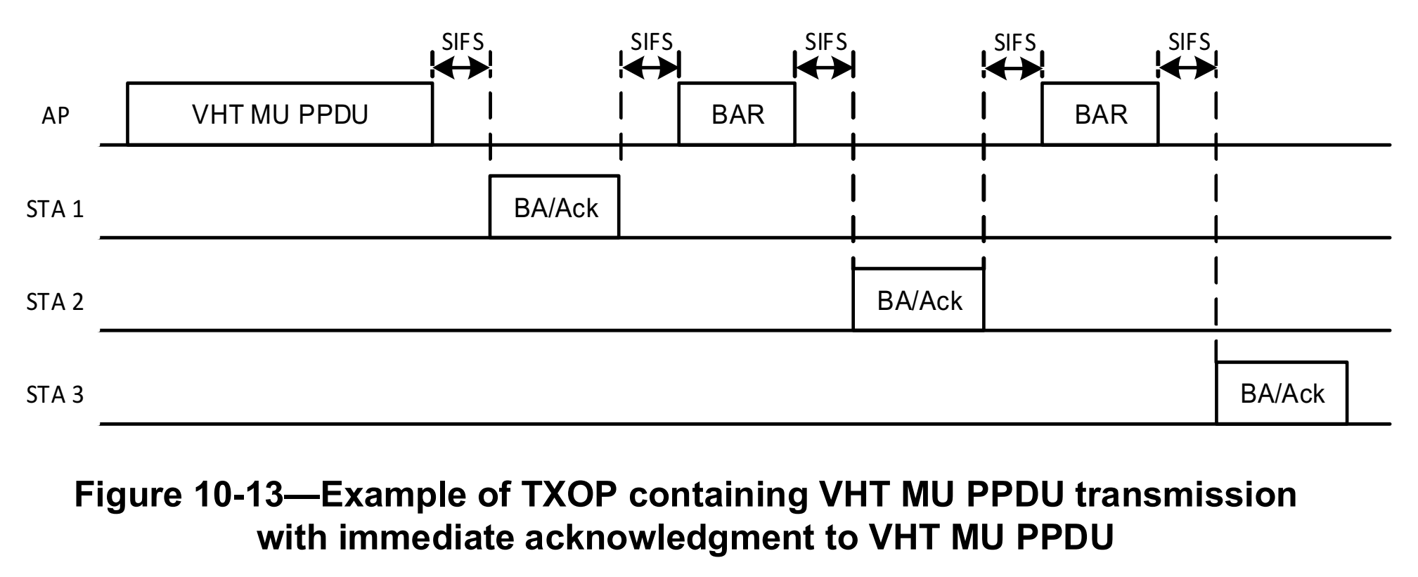
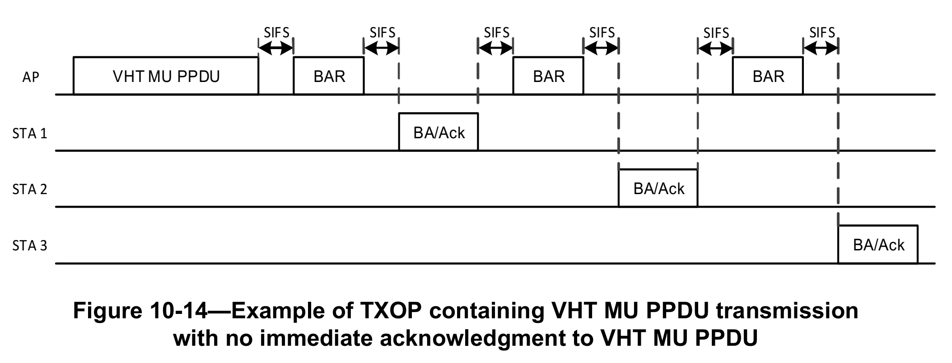

10.3.3 Random backoff procedure

The contention window (CW) parameter shall take an initial value of aCWmin. Every STA shall maintain a
STA short retry count (SSRC) as well as a STA long retry count (SLRC), both of which shall take an initial
value of 0. The SSRC shall be incremented when any short retry count (SRC) associated with any MPDU with the Type subfield equal to Data or Management is incremented. The SLRC shall be incremented when any
long retry count (LRC) associated with any MPDU with the Type subfield equal to Data or Management is
incremented. The CW shall take the next value in the series every time an unsuccessful attempt to transmit an
MPDU causes either STA retry count to increment, until the CW reaches the value of aCWmax. A retry is
defined as the entire sequence of frames sent, separated by SIFSs, in an attempt to deliver an MPDU, as
described in Annex G. Once it reaches aCWmax, the CW shall remain at the value of aCWmax until the CW is
reset. This improves the stability of the access protocol under high-load conditions. See Figure 10-15.

Discussion: The reference to Annex G here is indended to fully define the sequences that “attempt to deliver an MPDU.” The term MPDU is used in error because a frame is an MPDU (you can’t have a sequence of MPDUs delivering an MPDU). The intent was to deal with fragmentation and the attempted delivery of a complete MDSU or MMPDU.

10.3.4 DCF access procedure
10.3.4.4 Recovery procedures and retransmit limits

Under DCF, error recovery is always the responsibility of the STA that initiates a frame exchange sequence
(described in Annex G). Many circumstances might cause an error to occur that requires recovery. For
example, the CTS frame might not be returned after an RTS frame is transmitted. This may happen due to a
collision with another transmission, due to interference in the channel during the RTS or CTS frame, or
because the STA receiving the RTS frame has an active virtual CS condition (indicating a busy medium time
period).

Error recovery shall be attempted by retrying transmissions for frame exchange sequences that the initiating
STA infers have failed. Retries shall continue, for each failing frame exchange sequence, until the transmission
is successful, or until the relevant retry limit or lifetime is reached, whichever occurs first. A STA shall
maintain an SRC and an LRC for each MSDU or MMPDU awaiting transmission. These counts are
incremented and reset independently of each other.

A STA in PS mode, in an infrastructure BSS, initiates a frame exchange sequence by transmitting a PS-Poll
frame to request data from an AP. If no Ack, Data, or Management frame is received from the AP in response
to a PS-Poll frame, then the STA shall retry the sequence, by transmitting another PS-Poll frame. If the AP
sends a Data or Management frame in response to a PS-Poll frame, but fails to receive the Ack frame
acknowledging this Data or Management frame, the next PS-Poll frame from the same STA might cause a
retransmission of the last MSDU 28. If the AP responds to a PS-Poll frame by transmitting an Ack frame, then
responsibility for the Data or Management frame delivery error recovery shifts to the AP because the data are
transferred in a subsequent frame exchange sequence, which is initiated by the AP. The AP shall attempt to
deliver one buffered BU to the STA that transmitted the PS-Poll frame, using any frame exchange sequence
valid for an individually addressed BU. If the PS STA that transmitted the PS-Poll frame returns to doze state
after transmitting the Ack frame in response to receipt of this BU, but the AP fails to receive this Ack frame,
then the AP retries transmission of this BU until the relevant retry limit is reached. See 11.2.3.7 for details on
filtering of extra PS-Poll frames.

10.6 Multirate support
10.6.6 Rate selection for Control frames
10.6.6.6 Channel Width selection for Control frames

An S1G STA that has set the 1 MHz Control Response Preamble Support field to 1 in the S1G Capabilities
element transmitted to its peer STA shall use S1G_1M preamble transmission as the response of
S1G_SHORT_PREAMBLE or S1G_LONG_PREAMBLE as follows:
— In a TXOP, a STA shall not set the TXVECTOR parameter CH_BANDWIDTH to a value greater
than the RXVECTOR parameter CH_BANDWIDTH for the next frame exchange sequence.

Discussion: There is an error here: the RXVECTOR accompanies reception of an individual PPDU. The phrase “RXVECTOR for the next frame exchange sequence” is nonsense. The intent is to say the the bandwidth of a PPDU in a TXOP cannot be wider than the previous PPDU (received or transmitted) in the TXOP because once control is lost over a subchannel (through inoccupancy) contention is needed to regain control of that subchannel. The statement can be made without reference to frame exchange sequences.

10.6.7.6 Channel Width selection for Control frames transmitted by EDMG STAs
An EDMG STA that sends a Control frame in response to a frame carried in a non-EDMG duplicate PPDU
shall set the TXVECTOR parameters CH_BANDWIDTH and CHANNEL_AGGREGATION as follows:
⎯ If the frame that elicited the response includes the channel bandwidth information in the RXVECTOR parameter CH_BANDWIDTH_SIGNALING or BW_IN_CT, CH_BANDWIDTH and CHANNEL_AGGREGATION shall be set to a value that represents the equivalent channels indicated by the CH_BANDWIDTH_SIGNALING or BW_IN_CT parameter, respectively;
⎯ Otherwise if the STA received at least one EDMG PPDU as part of the current frame exchange sequence, CH_BANDWIDTH and CHANNEL_AGGREGATION shall be set to respectively, the value of the RXVECTOR parameters CH_BANDWIDTH and CHANNEL_AGGREGATION of the last received EDMG PPDU in the current frame exchange sequence.
⎯ Otherwise if the STA transmitted at least one EDMG PPDU or non-EDMG duplicate PPDU as part of the current frame exchange sequence, CH_BANDWIDTH and CHANNEL_AGGREGATION shall be set to, respectively, the value of the TXVECTOR parameters CH_BANDWIDTH and CHANNEL_AGGREGATION of the last EDMG PPDU or non-EDMG duplicate PPDU, whichever came later, transmitted by the STA in the current frame exchange sequence.
⎯ Otherwise, CH_BANDWIDTH and CHANNEL_AGGREGATION shall be set to, respectively, the estimated value of the RXVECTOR parameters CH_BANDWIDTH and CHANNEL_AGGREGATION of the frame that elicited the response.

Discussion: The statements here are very dependent on the definition of frame exchange sequence. The requirement seems to be to set the TXVECTOR a certain way when there is a mix of PPDUs used in the frame exchange sequence, which makes the requirement dependent on when the sequence starts and ends.

10.23 HCF
10.23.2 HCF contention based channel access (EDCA)
10.23.2.2 EDCA backoff procedure

For the purposes of this subclause, transmission failure of an MPDU is defined as follows:
— After transmitting an MPDU (even if it is carried in an A-MPDU or as part of a VHT or S1G MU PPDU or as part of an HE MU PPDU that is sent using TXVECTOR parameter NUM_USERS > 1) that requires an immediate response:
— The STA shall wait for a timeout interval of duration aSIFSTime + aSlotTime + aRxPHYStartDelay, starting when the MAC receives a PHY-TXEND.confirm primitive. If a PHY-RXSTART.indication primitive does not occur during the timeout interval, the transmission of the MPDU has failed.
— If a PHY-RXSTART.indication primitive does occur during the timeout interval, the STA shall wait for the corresponding PHY-RXEND.indication primitive to recognize a valid response MPDU (see Annex G) that either does not have a TA field or is sent by the recipient of the MPDU requiring a response. If anything else, including any other valid frame, is recognized, the transmission of the MPDU has failed.
— The nonfinal (re)transmission of an MPDU that is delivered using the GCR unsolicited retry retransmission policy (10.23.2.12.2) is defined to be a failure.
— In all other cases, the transmission of the MPDU has not failed.

Discussion: The reference to Annex G is unnecessary and, in fact, might be misleading. The intent here is to validate that the received PPDU (from PHY-RXSTART.indication to PHY-RXEND.indication) carries at least one MPDU that meets the condition in the later part of the sentence (that either does not have a TA field or is sent by the recipient of the MPDU requiring a response). Can be rewritten without reference to Annex G.

10.23.2.3 EDCA TXOPs
There are three modes of EDCA TXOP defined: initiation of an EDCA TXOP, sharing an EDCA TXOP, and
multiple frame transmission within an EDCA TXOP. Initiation of the TXOP occurs when the EDCA rules
permit access to the medium. Sharing of the EDCA TXOP occurs when an EDCAF within an AP or PCP that supports DL-MU-MIMO has obtained access to the medium, making the corresponding AC the primary AC, and
includes traffic from queues associated with other ACs in VHT, EDMG or S1G MU PPDUs transmitted during the
TXOP. Multiple frame transmission within the TXOP occurs when an EDCAF retains the right to access the
medium following the completion of a frame exchange sequence, such as on receipt of an Ack frame.

Discussion: The three modes of an EDCA TXOP is confusing. Nevertheless, the statement that references frame exchange sequence is introducing a term “multiple frame transmission within a TXOP” that is further defined in 10.23.2.8.

10.23.2.4 Obtaining an EDCA TXOP

In an infrastructure BSS, AIFSN[AC] is advertised by an EDCA AP in the EDCA Parameter Set element in
Beacon and Probe Response frames transmitted by the AP. The value of AIFSN[AC] shall be greater than or
equal to 2 for non-AP STAs. The value of AIFSN[AC] shall be greater than or equal to 1 for APs. An EDCA
TXOP is granted to an EDCAF when the EDCAF determines that it shall initiate the transmission of a frame
exchange sequence. Transmission initiation shall be determined according to the following rules:

On these specific slot boundaries, each EDCAF shall make a determination to perform one and only one of the
following functions:
— Decrement the backoff counter.
— Initiate the transmission of a frame exchange sequence.
— Invoke the backoff procedure due to an internal collision.
— Do nothing.

A STA shall save the TXOP holder address for the BSS in which it is associated. The TXOP holder
address is the MAC address from the Address 2 field of the frame that initiated a frame exchange sequence except if this is a CTS frame, in which case the TXOP holder address is the Address 1 field. If the TXOP holder address is obtained from a Control frame, a VHT STA or HE STA shall save the nonbandwidth signaling TA value obtained from the Address 2 field. If a non-VHT non-HE STA receives an RTS frame with the RA matching the MAC address of the STA and the MAC address in the TA field in the RTS frame matches the saved TXOP holder address, then the STA shall send the CTS frame after SIFS, without regard for, and without resetting, its NAV. If a VHT
STA or HE STA receives an RTS frame with the RA matching the MAC address of the STA and the nonbandwidth
signaling TA value obtained from the Address 2 field in the RTS frame matches the saved TXOP holder
address, then the STA shall send the CTS frame after SIFS, without regard for, and without resetting, its
NAV. If a CMMG STA receives an RTS frame with the RA matching the MAC address of the STA and the
TA value obtained from the Address 2 field in the RTS frame matches the saved TXOP holder address, then
the STA shall send the CTS frame after SIFS, without regarding for, and without resetting its NAV. When a
STA receives a frame addressed to it that requires an immediate response, except for RTS and Trigger frames (see 26.5.2.5 (UL MU CS mechanism)), it shall transmit the response independent of its NAV. The saved TXOP holder address shall be cleared when the NAV is reset or when the NAV counts down to 0.

Discussion: Related to the definition of a TXOP and maintaining control of the medium. Specifically, about the frame exchange that initiates a TXOP.

10.23.2.8 Multiple frame transmission in an EDCA TXOP

Multiple frames of the primary AC may be transmitted in an EDCA TXOP that was acquired following the
rules in 10.23.2.4. Frames that are pending in other ACs shall not be transmitted in this EDCA TXOP except
when permitted by the rules in 10.23.2.7. If a TXOP holder has in its transmit queue an additional frame of the
primary AC (or, where permitted, a secondary AC) and the duration of transmission of that frame plus any
expected acknowledgment for that frame is less than the remaining TXNAV timer value and, if
dot11MCCAActivated is true, the remaining RAV timer value, then the TXOP holder may commence
transmission of that frame a SIFS (or RIFS, if the conditions defined in 10.3.2.3.2 are met, or PIFS, if the
frame contains a bandwidth signaling TA) after the completion of the immediately preceding frame exchange
sequence, subject to the TXOP limit restriction as described in 10.23.2.9. A STA shall not commence the
transmission of an RTS with a bandwidth signaling TA until at least a PIFS after the immediately preceding
frame exchange sequence. A CMMG STA shall not commence the transmission of an RTS frame until at least
PIFS time after the immediately preceding frame exchange sequence. An HT STA that is a TXOP holder may
transmit multiple MPDUs of the same AC within an A-MPDU as long as the duration of transmission of the
A-MPDU plus any expected BlockAck frame response is less than the remaining TXNAV timer value and, if
dot11MCCAActivated is true, the remaining RAV timer value. An S1G STA that is a TXOP holder may
transmit multiple MPDUs of the same AC within an A-MPDU as long as the duration of transmission of the
A-MPDU plus any expected (NDP) BlockAck frame response is less than the remaining TXNAV timer
value.

After a valid response (see Annex G) to the initial frame of a TXOP, if the Duration/ID field is set for multiple
frame transmission and there is a subsequent transmission failure, the corresponding channel access function
may transmit after the CS mechanism (see 10.3.2.1) indicates that the medium is idle at the TxPIFS slot
boundary (see Figure 10-25) provided that the duration of that transmission plus the duration of any expected
acknowledgment and applicable IFS is less than the remaining TXNAV timer value and, if
dot11MCCAActivated is true, the RAV timer. At the expiration of the TXNAV timer and if
dot11MCCAActivated is true, the RAV timer, if the channel access function has not regained access to the
medium, then the EDCAF shall invoke the backoff procedure that is described in 10.23.2.4. Transmission
failure is defined in 10.23.2.12.

Discussion: The reference seems to point the reader to Annex G for a definition of “valid response.” Annex G does not provide such a definition. The intent is probably to identify allowed responses to the initial frame of a TXOP and treat those as a “valid response”. However, Annex G is not explicit on

10.23.2.10 Truncation of TXOP

A TXOP holder that transmits a CF-End frame shall not initiate any further frame exchange sequences within
the current TXOP.

An S1G STA that transmits an NDP CF-End frame shall set the frame’s Duration field to 0 and shall initiate
no other frame exchange sequences in the current TXOP.

Discussion: These two statements are not dependent on the allowed sequences in Annex G. Further, the statements are somewhat circular since TXOP is a bunch of frame exchange sequences; a TXOP is comprised of what you send. What we really want to say here is that if you send a CF-End (or NDP CF-End) then the next thing you do is compete for a new TXOP.

Figure 10-28 shows an example of TXOP truncation. In this example, the STA accesses the medium using
EDCA channel access and then transmits a nav-set sequence (e.g., RTS/CTS for non-DMG STAs or
RTS/DMG CTS for DMG STAs) (using the terminology of Annex G). After a SIFS, it then transmits an
initiator-sequence, which may involve the exchange of multiple PPDUs between the TXOP holder and TXOP
responders. At the end of the second sequence, the TXOP holder has no more data that it can send that fits
within the TXOP limit; therefore, it truncates the TXOP by transmitting a CF-End frame.
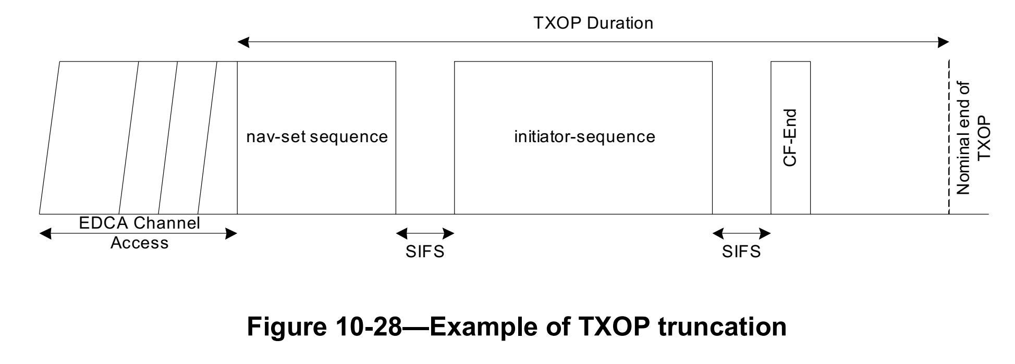

Discussion: refers to Annex G for terms “nav-set” and “initiator-sequence.” This is an example and could include specific sequence. The significance of nav-set and initiator-sequence is not clear.

10.23.3 HCF controlled channel access (HCCA)

Discussion: In the HCCA subclause, Annex G is complete wrt frame exchange sequences. More modern sequences – the ones that have Annex G issues – are not used under HCCA.

10.23.3.1 General

An HC may perform a backoff following an interruption of a frame exchange sequence due to lack of an
expected response under the rules described in 10.23.3.2.3, using the parameters dot11HCCWmin,
dot11HCCWmax, and dot11HCCAIFSN and the backoff rules in 10.2 and 10.23.2.2. The decision to perform
a backoff by the HC is dependent on conditions such as interference from an overlapping BSS. The mechanism
to detect the interference from an overlapping BSS and the decision to perform a backoff, DFS (such as
in 11.6), or other techniques (such as inter-BSS scheduling) is beyond the scope of this standard.

10.23.3.2 HCCA procedure
10.23.3.2.1 General
To start an HCCA TXOP, the HC gains control of the WM by waiting a shorter time before initiating the first
transmission of the TXOP than STAs using the EDCA procedures. The duration values used in QoS frame
exchange sequences reserve the medium to permit completion of the current sequence.

10.23.3.2.2 CAP generation
When the HC needs access to the WM to start a CAP, the HC shall sense the WM. When the WM is
determined to be idle at the TxPIFS slot boundary as defined in 10.3.7, the HC shall transmit either a QoS
(+)CF-Poll with the duration value set to cover the polled TXOP, or the first frame of any permitted frame
exchange sequence with the duration value set to cover the HCCA TXOP. A CAP shall not extend across a
TBTT. The occurrence of a TBTT implies the end of the CAP, after which the regular channel access
procedure (EDCA or HCCA) is resumed. It is possible that no Data frame was transmitted during an HCCA
TXOP. The shortened termination of the HCCA TXOP does not imply an error condition. CAPs are illustrated
in Figure 10-29.

After the last frame of all other nonfinal frame exchange sequences (e.g., sequences that convey individually
addressed QoS Data or Management frames) during an HCCA TXOP, the holder of the current HCCA TXOP
shall wait for one SIFS before transmitting the first frame of the next frame exchange sequence. The HC may
sense the channel and reclaim the channel if the WM is determined to be idle at the TxPIFS slot boundary after
the HCCA TXOP (see Figure 10-25). A CAP ends when the HC does not reclaim the channel at the TxPIFS
slot boundary after the end of an HCCA TXOP.

10.23.3.3 HCCA TXOP structure and timing

Any QoS Data frame of a subtype that includes CF-Poll contains a TXOP limit in its QoS Control field. The
ensuing polled TXOP is protected by the NAV set by the Duration field of the frame that contained the QoS
(+)CF-Poll function, as shown in Figure 10-30. Within a polled TXOP, a STA may initiate the transmission of
one or more frame exchange sequences, with all such sequences nominally separated by a SIFS. The STA shall
not initiate transmission of a frame unless the transmission and any acknowledgment or other immediate
response expected from the peer MAC entity are able to complete prior to the end of the remaining TXOP
duration. All transmissions, including response frames, within the polled TXOP are considered to be the part of
the TXOP, and the HC shall account for these when setting the TXOP limit. If the TXOP Limit subfield in the
QoS Control field of the QoS Data frame that includes CF-Poll is equal to 0, then the STA to which the frame
is directed to shall respond with either one MPDU or one QoS Null frame.

10.23.3.4 NAV operation of a TXOP under HCCA

When a STA receives a frame addressed to it and requires an acknowledgment, it shall respond with an Ack or
QoS +CF-Ack frame independent of its NAV. A non-AP STA shall accept a polled TXOP by initiating a frame
exchange sequence independent of its NAV.

10.23.3.5 HCCA transfer rules
10.23.3.5.1 General
A TXOP obtained by receiving a QoS (+)CF-Poll frame uses the specified TXOP limit consisting of one or
more frame exchange sequences with the sole time-related restriction being that the final sequence shall end
not later than the TXOP limit. In QoS CF-Poll and QoS CF-Ack +CF-Poll frames, the TID subfield in the QoS
Control field indicates the TS for which the poll is intended. The requirement to respond to that TID is
nonbinding, and a STA may respond with any frame. Upon receiving a QoS (+)CF-Poll frame, a STA may
send any frames, i.e., QoS Data frames belonging to any TID as well as Management frames in the obtained
TXOP. MSDUs may be fragmented in order to fit within TXOPs.

10.23.3.5.3 Use of RTS/CTS
In order to provide improved NAV protection, a STA may send an RTS frame as the first frame of any frame
exchange sequence without regard for dot11RTSThreshold or dot11TXOPDurationRTSThreshold.

10.23.4 Admission control at the HC
10.23.4.2 Contention based admission control procedures
10.23.4.2.3 Procedure at non-AP STAs
The MAC variable used_time is the amount of time used, in units of 32 μs, by the STA in
dot11EDCAAveragingPeriod. The MAC variable admitted_time is the medium time allowed by the AP, in
units of 32 μs, in dot11EDCAAveragingPeriod. The STA shall update the value of used_time:
b) After each successful or unsuccessful frame exchange sequence,
used_time = used_time + MPDUExchangeTime

The MPDUExchangeTime is the duration of the frame exchange sequence. For the case of an MPDU
transmitted with Normal Ack ack policy and without RTS/CTS protection, this equals the time required to
transmit the MPDU plus the time required to transmit the expected response frame plus one SIFS. Frame
exchange sequences that do not include any Data frames are excluded from the used_time update. Any RD
transmission granted by the AP is excluded from the used_time update. If the used_time value reaches or
exceeds the admitted_time value, the corresponding EDCAF shall no longer transmit QoS Data frames or QoS
Null frames using the EDCA parameters for that AC as specified in the QoS Parameter Set element. However,
a STA may choose to temporarily replace the EDCA parameters for that EDCAF with those specified for an
AC of lower priority, if no admission control is required for those ACs.

10.23.5 Restricted access window (RAW) operation
10.23.5.2 RAW structure and timing
If the Cross Slot Boundary subfield in the RAW Slot Definition subfield within the RAW Assignment
subfield of the RPS element is set to 1, a STA is allowed to cross its assigned RAW slot boundary to
complete the ongoing frame exchange sequence.

If the Cross Slot Boundary subfield in the RAW Slot Definition subfield within the RAW Assignment
subfield of the RPS element is set to 0, a STA shall not transmit or cause to be transmitted a frame exchange
sequence that would exceed boundary of its allocated RAW slot.

10.23.5.4 Slotted channel access procedure in RAW

An AP may designate a RAW for trigger frames by setting the RAW type to Triggering Frame RAW. When
the RAW type is Triggering Frame RAW, each STA in the RAW Group is only allowed to send up to one
trigger frame during its assigned RAW slot as described in 10.23.5.3. In the Triggering Frame RAW, a
trigger frame is limited to a QoS Null contained in a non-A-MPDU frame or a (NDP) PS-Poll frame. In the
Triggering Frame RAW, the STA transmits a trigger frame to the AP not earlier than the start of its assigned
RAW slot. The duration of the trigger frame exchange sequence shall not exceed a RAW slot duration
calculated by the RAW Slot Definition subfield in the RAW Assignment subfield of the RPS element. And,
in the Triggering Frame RAW, crossing RAW slot boundary is not allowed.

10.24 Mesh coordination function (MCF)
10.24.3 MCF controlled channel access (MCCA)
10.24.3.7 MCCAOP advertisement
10.24.3.7.6 Complete update of the tracked MCCAOP reservations of a neighbor mesh STA

If the mesh STA does not receive all MCCAOP Advertisement elements of the sender of the MCCAOP
advertisement before a frame exchange sequence on the wireless medium causes the mesh STA to set its
NAV, the mesh STA shall perform the MCCAOP advertisement request procedure as described
in 10.24.3.7.8.

10.24.3.7.7 Partial update of the tracked MCCAOP reservations of a neighbor mesh STA

If the bit in position n of the Advertisement Elements Bitmap in the received MCCAOP Advertisement is
equal to 1 and if the bit in position n of the Advertisement Elements Bitmap tracked for the sender of the
received MCCAOP advertisement is equal to 0, the mesh STA shall add the reservations of the received
MCCAOP Advertisement element with the MCCAOP Advertisement Element Index set to n to its tracked
reservations. If the mesh STA does not receive this MCCAOP Advertisement element of the sender of the
MCCAOP Advertisement before a frame exchange sequence on the wireless medium causes the mesh STA
to set its NAV, the mesh STA shall perform the MCCAOP Advertisement request procedure as described
in 10.24.3.7.8.

10.27 Protection mechanisms
10.27.2 Protection mechanism for non-ERP receivers
In the case of a BSS composed of only ERP STAs, but with knowledge of a neighboring co-channel BSS
having non-ERP traffic, the AP might need protection mechanisms to protect the BSS’s traffic from
interference. This provides propagation of NAV to all attached STAs and all STAs in a neighboring co-channel
BSS within range by messages sent using rates contained in the BSSBasicRateSet parameter. The frames that
propagate the NAV throughout the BSS include RTS/CTS/Ack frames, all Data frames with the More
Fragments field equal to 1, all Data or Management frames sent in response to PS-Poll frame that are not proceeded in the frame exchange sequence by a Data frame with the More Fragments field equal to 1, and CFEnd frames.

10.32 Link adaptation
10.32.3 Link adaptation using the VHT variant HT Control field
This subclause applies to frame exchange sequences that include PPDUs containing an HT variant HT Control
field. The VHT variant HT Control field may be used by VHT STAs and S1G STAs.

10.34 Transmit beamforming
10.34.2 HT transmit beamforming with implicit feedback
10.34.2.2 Unidirectional implicit transmit beamforming
The PPDU exchange can be summarized as follows:
a) STA A initiates the frame exchange sequence by sending an unsteered PPDU to STA B. The PPDU
includes a training request (TRQ= 1) in a +HTC MPDU.

Discussion: Annex G includes the implicit-txbf sequence. It is relevant, but not referenced here.

10.34.2.3 Bidirectional implicit transmit beamforming
The PPDU exchange can be summarized as follows:
a) STA A initiates the frame exchange sequence by sending an unsteered PPDU to STA B. The PPDU
includes a training request (TRQ= 1) in a +HTC MPDU.

Discussion: Annex G includes the implicit-txbf sequence. It is relevant, but not explicitly referenced here. There is also an admission that the sequence as defined Annex G is incomplete: (* The trq/sounding protocol also operates within aggregates. In this case the TRQ is carried in all +HTC frames (of which there has to be at least one) within the TRQ initiator’s transmission. The response PPDU either is a sounding PPDU, or carries at least one +HTC frame with an ndp-announce, in which case the following PPDU is an NDP sounding PPDU. The following syntax is an simplified representation of this sequence. *)

10.34.2.4 Calibration
10.34.2.4.2 Calibration capabilities
A STA may initiate a calibration training frame exchange sequence with another STA if that STA supports
calibration. A STA shall not initiate a calibration training frame exchange with another STA if that STA does
not support calibration.

Discussion: The calibration exchange is not defined in Annex G. At least not explicitly. Might be part implicit_txbf, but who knows.
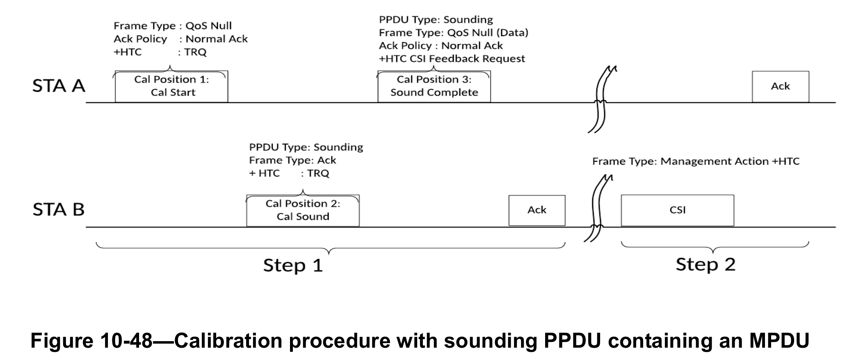

10.34.3 Explicit feedback beamforming
An HT beamformee that sets the Explicit Transmit Beamforming CSI Feedback field of its HT Capabilities
element to either 2 or 3 shall transmit Explicit CSI feedback after SIFS or later in the HT beamformer’s TXOP
as a response to a non-NDP request for feedback in a frame that is appropriate for the current frame exchange
sequence following Table 10-26. An HT beamformee that sets the Explicit Noncompressed Beamforming
Feedback Capable field of its HT Capabilities element to either 2 or 3 shall transmit Explicit Noncompressed
Beamforming feedback after SIFS or later in the HT beamformer’s TXOP as a response to a non-NDP request
for feedback in a frame that is appropriate for the current frame exchange sequence following Table 10-26.

An HT beamformee that sets the Explicit Compressed Beamforming Feedback Capable field of its HT
Capabilities element to either 2 or 3 shall transmit Explicit Compressed Beamforming feedback after SIFS or
later in the HT beamformer’s TXOP as a response to a non-NDP request for feedback in a frame that is
appropriate for the current frame exchange sequence following Table 10-26.

An HT beamformee that sets the Explicit Transmit Beamforming CSI Feedback field of its HT Capabilities
element to either 2 or 3 shall transmit the Explicit CSI feedback after SIFS or later in the HT beamformer’s
TXOP as a response to an NDP request for feedback in a frame that is appropriate for the current frame
exchange sequence following Table 10-27.

An HT beamformee that sets the Explicit Noncompressed Beamforming Feedback Capable field of its HT
Capabilities element to either 2 or 3 shall transmit the Explicit Noncompressed Beamforming feedback after
SIFS or later in the HT beamformer’s TXOP as a response to an NDP request for feedback in a frame that is
appropriate for the current frame exchange sequence following Table 10-27.

An HT beamformee that sets the Explicit Compressed Beamforming Feedback Capable field of its HT
Capabilities element to either 2 or 3 shall transmit the Explicit Compressed Beamforming feedback after SIFS
or later in the HT beamformer’s TXOP as a response to an NDP request for feedback in a frame that is
appropriate for the current frame exchange sequence following Table 10-27.

Discussion: In all cases, use of the term frame exchange sequence refers to specific frame exchange sequence used for explicit feedback beamforming.

10.34.5 Explicit feedback beamforming for CMMG STAs
A CMMG beamformee that sets the Explicit Compressed Feedback Capable field of its CMMG Capabilities
element to either 2 or 3 shall transmit explicit compressed beamforming feedback after SIFS or later in the
beamformer’s TXOP as a response to a non-NDP request for feedback in a frame that is appropriate for the
current frame exchange sequence following Table 10-28.

A CMMG beamformee that sets the Explicit Compressed Beamforming Feedback Capable field of its CMMG
Capabilities element to either 2 or 3 shall transmit the explicit compressed beamforming feedback after SIFS or
later in the CMMG beamformer’s TXOP as a response to an NDP request for feedback in a frame that is
appropriate for the current frame exchange sequence following Table 10-29.

Discussion: In all cases, use of the term frame exchange sequence refers to specific frame exchange sequence used for explicit feedback beamforming for CMMG STAs.

10.35 Antenna selection (ASEL)
10.35.2 ASEL frame exchange procedure
A STA shall not initiate an ASEL training frame exchange sequence with another STA unless that STA
supports ASEL, as determined by the ASEL Capability field (see 9.4.2.55.7).

The frame exchange sequence for transmit ASEL is shown in Figure 10-51, where the term ASEL transmitter
identifies the STA that is conducting transmit ASEL, and the term transmit ASEL responder identifies the STA
that provides ASEL feedback. The frame exchange comprises the following steps:

The frame exchange sequence for receive ASEL is shown in Figure 10-52, where the term ASEL receiver
identifies the STA that is conducting receive ASEL, and the term ASEL sounding-capable transmitter
identifies the STA sending the consecutive sounding PPDUs used for receive ASEL calculations. The frame
exchange comprises the following steps:

Discussion: Use of the term frame exchange sequence refers to specific frame exchange sequence used for antenna selection training.

10.36 Null data PPDU (NDP) sounding
10.36.5.3 Rules for fragmented feedback in VHT sounding protocol sequences
A VHT beamformer shall not transmit a Beamforming Report Poll frame to a VHT SU-only beamformee
unless the VHT beamformer has received at least one feedback segment of the VHT compressed beamforming
feedback from the VHT beamformee in the current frame exchange sequence.

Discussion: Use of the term current frame exchange sequence refers to sounding sequence.

10.39 DMG and CMMG channel access
10.39.5 Contention based access period (CBAP) transmission rules
A STA shall not extend a transmission frame exchange sequence that started during a CBAP beyond the end
of that CBAP. A STA that initiates a sequence shall check that the frame exchange sequence, including any
control frame responses, completes before the end of the CBAP.

10.39.6 Channel access in scheduled DTI
10.39.6.2 Service period (SP) allocation
An SP that is not a TDD SP is assigned to the source CMMG STA identified in the Source AID subfield in an Allocation field that is not an obsolete allocation within the Extended Schedule element. The source CMMG STA shall initiate the frame exchange sequence that takes place during the SP at the start of the SP, except when the source CMMG STA intends to establish a CMMG protected period in which case the rules described in 10.39.6.6 shall be followed before the source CMMG STA initiates the frame exchange in the SP. The SP allocation identifies the TC or TS for which the allocation is made; however, the type of traffic transmitted is not restricted to the
specified TC or TS (11.4.1).

Except for an SP using TDD channel access and under the conditions specified in 10.39.6.2.2, in no case shall the source or destination DMG STA extend a transmission frame exchange sequence that
started during an SP beyond the end of that SP. A STA that initiates a sequence shall check that the frame
exchange sequence, including any control frame responses, completes before the end of the SP.

10.42 DMG beamforming

Discussion: The DMG beamforming subclause consists of about 40 pages in 802.11-2020 plus another 100 pages in 11ay. Most of this is describes PPDU exchanges. There is nothing in 802.11-2020 Annex G on beamforming and 11ay adds the following:
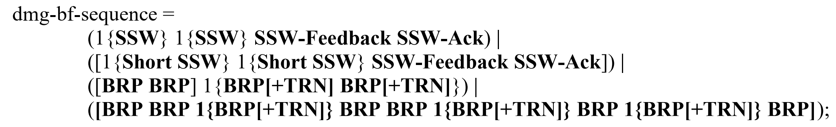
That is it. If I was implementing DMG (EDMG) beamforming, I would ignore this.

10.42.7 Beam tracking
Figure 10-89 illustrates a beam tracking frame exchange sequence when the beam tracking initiator requests
TRN-R subfields, while Figure 10-90 illustrates a beam tracking frame exchange sequence when the beam
tracking initiator requests TRN-T subfields.

10.42.9 CDMG enhanced beam tracking
BRP frames transmitted during enhanced beam tracking may be aggregated within A-MPDUs.
Figure 10-93 illustrates a beam tracking frame exchange sequence when the beam tracking initiator requests
TRN-R subfields, while Figure 10-94 illustrates a beam tracking frame exchange sequence when the beam
tracking initiator requests TRN-T subfields.

10.42.10 EDMG beamforming
10.42.10.2 MIMO beamforming
10.42.10.2.4 Hybrid beamforming for SU-MIMO and MU-MIMO
10.42.10.2.4.3 Sounding phase
10.42.10.2.4.3.2 Hybrid beamforming sounding with BRP frame(s)
10.42.10.2.4.3.2.1 SU-MIMO sounding (for both initiator and responder)
Figure 10-94f illustrates an example of a frame exchange sequence using the SU-MIMO hybrid beamforming
12 protocol.

10.45 DMG relay operation
10.45.2 Link switching
10.45.2.4 Relay frame exchange rules
10.45.2.4.4 Operation of FD-AF RDS
For each frame received at the RDS during the SP, the RDS shall follow the same rules for frame exchange
sequences as described in Annex G and 10.39. This includes switching the state of each RF available to the
RDS from receive to transmit, and vice versa, depending upon the frame type and its ack policy.

Discussion: “the RDS shall follow the same rules for frame exchange sequences as described in Annex G” is superfluous. Of course it shall; Annex G is normative.

10.50 Bidirectional TXOP
10.50.1 Overview
Bidirectional TXOP (BDT) allows an S1G AP and an S1G non-AP STA to exchange a sequence of uplink
and downlink PPDUs separated by SIFS. This operation combines both uplink and downlink channel access
into a continuous frame exchange sequence between a pair of S1G STAs. S1G STAs that participate in BDT
use information that is present in the Frame Control field, SIGNAL field and NDP CMAC PPDUs to signal
an undergoing BDT as described in 10.50.2. The objective of this operation is to minimize the number of
contention-based channel accesses, improve channel efficiency by reducing the number of frame exchanges,
and reduce S1G STA power consumption by shortening Awake state times.

Discussion: Confusing statement. How do you combine uplink and downlink channel access into a continuous frame exchange sequence? I think it means combine separate “uplink” and “downlink” frame exchange sequences into one frame exchange sequence.

10.53 Sectorized beam operation
10.53.4 TXOP-based sectorization operation
Four types of frame exchange sequences, which can lead to the SO conditions by OBSS non-AP STAs or
OBSS APs are described.
a) SO frame exchange sequence 1: As illustrated in Figure 10-106, the AP starts a frame exchange with
the omnidirectional beam to establish a link with a STA and set up the protection for the duration of
the sectorized beam transmission.

11. MLME
11.2 Power management
11.2.3 Power management in a non-DMG infrastructure network
11.2.3.1 General

A STA that is associated with an AP and that changes power management mode shall inform the AP of this fact
using the Power Management subfield within the Frame Control field of transmitted frames. The STA shall
remain in its current power management mode until it informs the AP of a power management mode change
via a frame exchange that includes an acknowledgment from the AP. Power management mode shall not
change during any single frame exchange sequence , as described in Annex G.

11.2.3.2 Non-AP STA power management modes

To change power management modes a STA shall inform the AP by completing a successful frame exchange
(as described in Annex G) that is initiated by the STA. This frame exchange shall include a Management
frame, Extension frame or Data frame from the STA, and an Ack or a BlockAck frame from the AP. The
Power Management subfield(s) in the Frame Control field of the frame(s) sent by the STA in this exchange
indicates the power management mode that the STA shall adopt upon successful completion of the entire frame
exchange, except where the Power Management subfield is reserved (see 9.2.4.1.7). A non-AP STA shall not
change power management mode using a frame exchange that does not receive an Ack or BlockAck frame
from the AP, or using a BlockAckReq frame.

11.2.6 SM power save
In dynamic SM power save mode, the HT STA enables its multiple receive chains when it receives the start of a
frame exchange sequence addressed to it, while the EDMG STA enables its multiple receive chains only
when the frame it receives indicates that the following transmission requires the activation of multiple receive
chains. Such a frame exchange sequence shall start with a single-spatial stream individually addressed frame that is not a Trigger frame and that requires an immediate response and that is addressed to the STA in dynamic SM power save mode. For an HT STA, an RTS/CTS sequence may be used for this purpose. For an EDMG STA in dynamic SM power save mode, a Grant/Grant Ack sequence shall be used for this purpose (see 10.39.12.4.2). The STA shall, subject to its spatial stream capabilities (see 9.4.2.55.4, 9.4.2.265 and 9.4.2.157.3) and operating mode (see 11.40), be capable of receiving a PPDU that is sent using more than one spatial stream a SIFS after the end of its response frame transmission. The HT STA may switch back to the single receive chain mode immediately after the frame exchange sequence. The EDMG STA switches to the multiple receive chain mode when it receives a frame addressed to it and the frame indicates the following transmission requires multiple receive chains (see 10.39.12.4); the EDMG STA switches back immediately when the frame exchange sequence ends.

The STA can determine the end of the frame exchange sequence through any of the following:
— It receives an individually addressed frame addressed to another STA.
— It receives a frame with a TA that differs from the TA of the frame that started the TXOP.
— It receives a PPDU and classifies the PPDU as inter-BSS PPDU (see 26.2.2 (Intra-BSS and interBSS PPDU classification)).
— It receives an HE MU PPDU where the RXVECTOR parameter BSS_COLOR is the BSS color of
the BSS in which the STA is associated, the RXVECTOR parameter does not have any STA_ID of
an RU that identifies the STA as the recipient or one of the recipients of the RU (see 26.11.1
(STA_ID)), and the BSS Color Disabled subfield in the most recently received HE Operation element from the AP with which the STA is associated is 0.
— The CS mechanism (see 10.3.2.1) indicates that the medium is idle at the TxPIFS slot boundary
(defined in 10.3.7).

11.2.7 Power management in a PBSS and DMG infrastructure BSS
11.2.7.1 General
If the MM-SME Power Mode field within the MMS element sent by an MM-SME coordinated STA is 1, all
STAs advertised in the MMS element shall switch to the doze state when the wakeup schedule of any one STA
or a successful frame exchange as described in Annex G brings the STA to the doze state.

If the MM-SME Power Mode field within the MMS element sent by an MM-SME coordinated STA is 0, all
STAs advertised in the MMS element shall switch to the awake state when the wakeup schedule of any one
STA or a successful frame exchange as described in Annex G brings the STA to the awake state.

11.2.7.2 Non-AP and non-PCP STA power management mode
11.2.7.2.2 Non-AP and non-PCP STA operation without a wakeup schedule

To change its power state without a wakeup schedule, a non-AP and non-PCP STA shall inform the AP or PCP
by completing a successful frame exchange (as described in Annex G) that is initiated by the STA and that
includes a Management frame, Extension frame or Data frame, and also an Ack or a BlockAck frame from the
AP or PCP. The Power Management subfield(s) in the Frame Control field of the frame(s) sent by the STA in
this exchange that contain a BU or are QoS Null frame indicate the power state that the STA shall adopt upon
successful completion of the entire frame exchange. A non-AP and non-PCP STA shall not change its power
state using a frame exchange that does not receive an Ack or BlockAck frame from the AP or PCP, or using a
BlockAckReq frame.

11.2.7.3.2 PCP operation without a wakeup schedule

Alternatively, to change its power state without a wakeup schedule, the PCP shall inform all associated STAs
by completing a successful frame exchange (as described in Annex G) that is initiated by the PCP and that
includes a Management frame, Extension frame or Data frame, and also an Ack or a BlockAck frame from the
associated STA. The Power Management subfield(s) in the Frame Control field of the frame(s) sent by the PCP
in this exchange that contain a BU or are QoS Null frame indicate the power state that the PCP shall adopt upon
successful completion of the entire frame exchange. The PCP shall not change its power state using a frame
exchange that does not receive an Ack or BlockAck frame from the associated STA, or using a BlockAckReq
frame.

11.21 Wireless network management procedures
11.21.13 BSS max idle period management
The Max Idle Period field of the BSS Max Idle Period element indicates the time period during which a STA
can refrain from transmitting frames to its associated AP without being disassociated. A non-AP STA is
considered inactive if the AP has not received a Data frame, PS-Poll frame, or Management frame (protected or
unprotected as specified in this paragraph) of a frame exchange sequence initiated by the STA for a time period
greater than or equal to the time specified by the Max Idle Period field. If the Idle Options field requires

11.22.3.2 GAS Protocol
11.22.3.2.1 General
Figure 11-38 describes the GAS frame exchange sequence when dot11GASPauseForServerResponse is true
and the result of the GAS Query Request fits within one MMPDU.

Figure 11-39 describes the GAS frame exchange sequence when dot11GASPauseForServerResponse is true
and the result of the GAS Query Request is too large to fit in one MMPDU and GAS fragmentation is used for
delivery. The number of GAS Comeback Request and GAS Comeback Response frames depends on the
number of GAS fragments required for delivery of the result of the GAS Query Request.

Figure 11-40 describes the GAS frame exchange sequence when dot11GASPauseForServerResponse is false.
The number of GAS Comeback Request and GAS Comeback Response frames depends on the number of
GAS fragments required for delivery of the GAS Query Response.
Figure 11-41 describes the GAS frame exchange sequence when a STA sends a Group Addressed GAS
Request frame to a group of STAs. The receiving STA may or may not respond to the GAS Query Request. If
the receiving STA responds, it may respond with either a GAS Initial Response frame or a Group Addressed
GAS Response frame.

Discussion: Annex G is not relevant here; specifically references “GAS frame exchange sequence”. These are not frame exchange sequences in the Annex G sense (SIFS separated). These are magagement level exchanges, i.e., Management/Ack frame exchange potentially long delay, Management/Ack frame exchange.
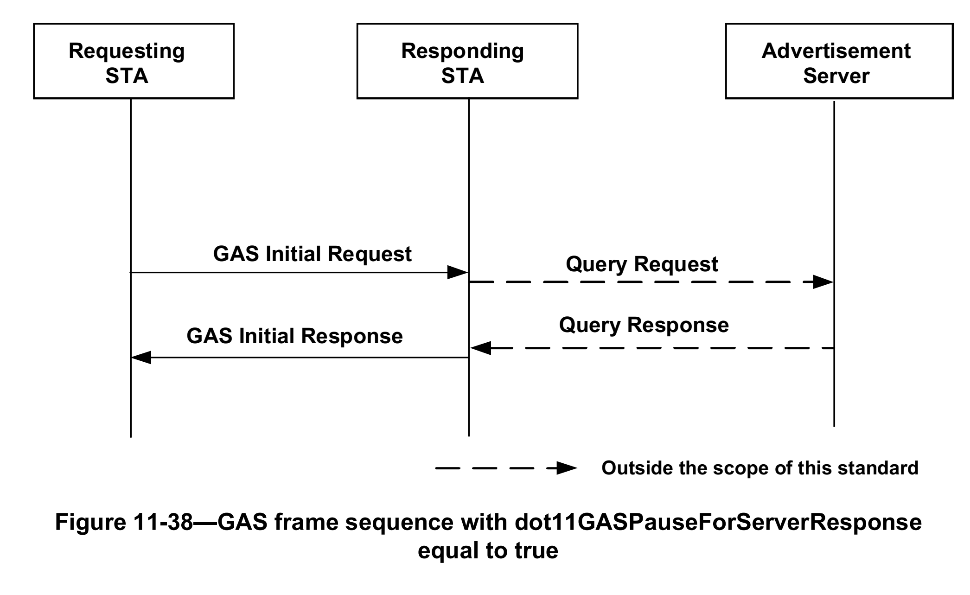
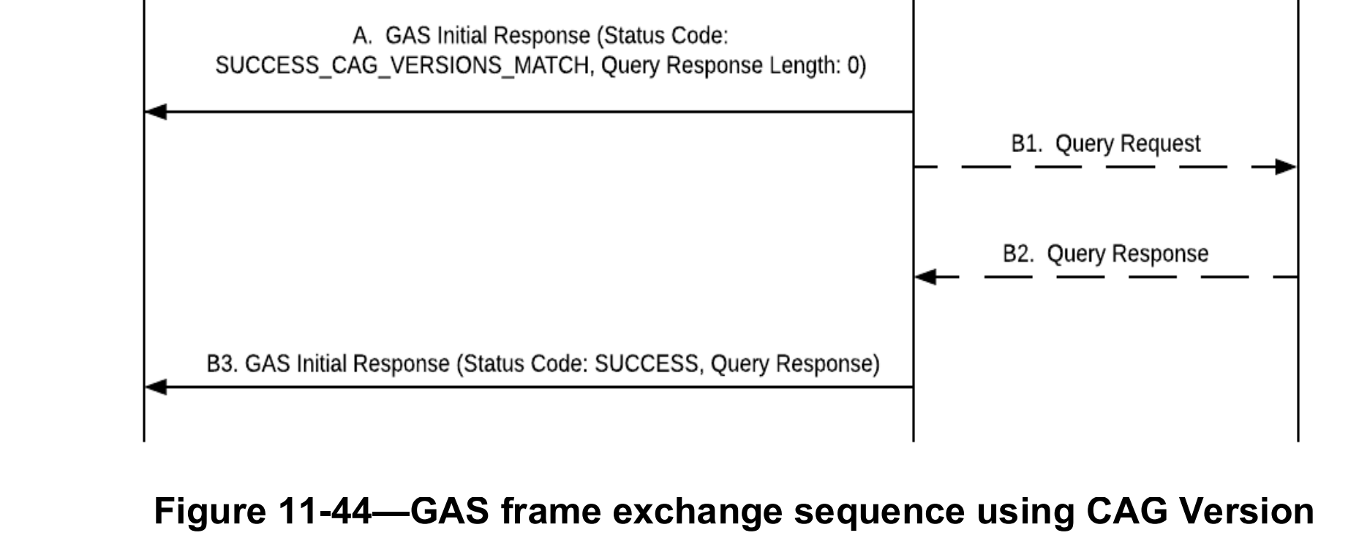

11.22.3.2.6 GAS procedures interaction with multiple BSSID set
Non-AP STAs in the unassociated state may use GAS procedures to query Advertisement Servers for
information. As described in 11.22.3.2, APs indicate their support for a particular GAS advertisement protocol
by including an Advertisement protocol element with that Advertisement protocol ID in Beacon and Probe
Response frames as described in 9.3.3.2 and 9.3.3.10 respectively. Non-AP STAs receiving Beacon or Probe
Response frames from different APs may choose to engage in GAS frame exchange sequences with one or
more of these APs. In some deployment scenarios, these APs may be operating as a multiple BSSID set (as
defined in 11.10.14) and may relay the GAS queries to the same Advertisement Server. Depending on the
configuration of the IEEE 802.11 access network, the external network and the Advertisement Server, a query
response from the Advertisement Server might or might not be dependent on the BSSID used in the GAS
frame exchange sequence and thus the STA from which the query was relayed. If the GAS Query Response is
dependent on the BSSID, a requesting STA may choose to post queries using GAS procedures to more than
one STA and expect possibly different Query Responses. If the Query Response is not dependent on the
BSSID, then a requesting STA may choose to post queries using GAS procedures to only one STA in the
multiple BSSID set (i.e., posting the same query to another member of the multiple BSSID set would yield the
same response).

11.42 Operation under the control of a GDB
11.42.1 General

Subclause 11.42 describes procedures for STAs when they are operating under the control of a GDB to satisfy
regulatory requirements. For operation under such restrictions, GDD dependent STAs operate according to the
control procedures of a GDD enabling STA that enables their operation. The frame exchange sequence
between GDD enabling STA and GDD dependent STAs for enabling their operation occurs in State 4
(see 11.3.1).

26. High Efficiency (HE) MAC specification
26.2 HE channel access
26.2.6 MU-RTS Trigger/CTS frame exchange procedure
26.2.6.2 MU-RTS Trigger frame transmission
After transmitting an MU-RTS Trigger frame, the AP shall wait for a CTSTimeout interval of
aSIFSTime + aSlotTime + aRxPHYStartDelay that begins when the MAC receives the PHY-TXEND.confirm primitive for the transmitted MU-RTS Trigger frame. If the MAC does not receive a PHYRXSTART.indication primitive during the CTSTimeout interval, the AP shall conclude that the transmission of the MU-RTS Trigger frame has failed, and, if the MU-RTS Trigger frame initiated a TXOP, the AP
shall invoke its backoff procedure. If the MAC receives a PHY-RXSTART.indication primitive during the
CTSTimeout interval, then the MAC shall wait for the corresponding PHY-RXEND.indication primitive to
determine whether the MU-RTS Trigger frame transmission was successful. The receipt of a CTS frame
from any non-AP STA addressed by the MU-RTS Trigger frame before the PHY-RXEND.indication primitive shall be interpreted as the successful transmission of the MU-RTS Trigger frame, permitting the frame
exchange sequence to continue. The receipt of any other type of frame shall be interpreted as a failure of the
MU-RTS Trigger frame transmission. In this instance, the AP may process the received frame and, if the
MU-RTS Trigger frame initiated a TXOP, shall invoke its backoff procedure at the PHY-RXEND.indication
primitive.

Discussion: The text here seems to copy the text in

26.5 MU operation
26.5.3 MU cascading sequence
An MU cascading sequence is a frame exchange sequence between an AP and one or more non-AP STAs in
which the AP, within a single PPDU, acknowledges one or more frames from a STA, and triggers the STA
for a further UL transmission. An example of an MU cascading sequence is shown in Figure 26-5 (An example of an MU cascading sequence).

Discussion: There is no explicit reference to Annex G, but Annex G does defined the following:
he-cascading-sequence = he-dl-mu-sequence + he-ul-mu-sequence.
Hewever, this is NOT consistent with the definition in this subclause.

26.14 Power management
26.14.4 HE dynamic SM power save
A non-AP HE STA in dynamic SM power save mode (see 11.2.6 (SM power save)) that sets the HE
Dynamic SM Power Save subfield in the HE MAC Capabilities Information field in the HE Capabilities element it transmits to 1 shall follow the dynamic SM power save procedures defined in 11.2.6 (SM power
save) and shall also enable its multiple receive chains if it responds to a Trigger frame that starts a frame
exchange sequence that satisfies the following conditions:
— The Trigger frame is transmitted with a single spatial stream.
— The Trigger frame is from the associated AP or from the AP corresponding to the transmitted BSSID
if the non-AP HE STA is associated with an AP corresponding to a nontransmitted BSSID and has
indicated support for receiving Control frames with TA set to the transmitted BSSID by setting the
Rx Control Frame To MultiBSS subfield to 1 in the HE Capabilities element that the non-AP HE
STA transmits.
— The Trigger frame is an MU-RTS Trigger frame, BSRP Trigger frame or BQRP Trigger frame that
includes a User Info field with the AID12 subfield equal to the 12 LSBs of the AID of the non-AP
HE STA (see 26.5.2.2.1 (General)).

The non-AP HE STA shall, subject to its spatial stream capabilities (see 9.4.2.55.4 (Supported MCS Set
field), 9.4.2.157.3 (Supported VHT-MCS and NSS Set field) and 9.4.2.248 (HE Capabilities element)) and
operating mode (see 11.41 (Notification of operating mode changes) and 26.9 (Operating mode indication)), be capable of receiving a PPDU that is sent using more than one spatial stream a SIFS after the end of the
PPDU that it sends in response. The STA may switch back to single receive chain mode immediately after
the end of the frame exchange sequence.

NOTE 3—The STA determines the end of the frame exchange sequence as described in 11.2.6 (SM power save).

Annex B
(normative)
Protocol Implementation Conformance Statement (PICS)
proforma

B.2.2 General abbreviations for Item and Support columns
FS | frame exchange sequence

The acronym is not used

Annex C
(normative)
ASN.1 encoding of the MAC and PHY MIB

C.3 MIB Detail
dot11RTSThreshold OBJECT-TYPE
SYNTAX Unsigned32 (0..6500631)
MAX-ACCESS read-write
STATUS current
DESCRIPTION
"This is a control variable.
It is written by an external management entity.
Changes take effect as soon as practical in the implementation.
This attribute indicates the number of octets in a PSDU, below which an
RTS/CTS handshake is not performed if dot11TXOPDurationRTSThreshold is
1023 or it is not present, except as RTS/CTS is used as a cross modulation
protection mechanism as defined in 10.27 (Protection mechanisms). An RTS/
CTS handshake is performed at the beginning of any frame exchange sequence
where the PSDU contains an MPDU with the Type subfield equal to Data or
Management and an individual address in the Address 1 field, and the
length of the PSDU is greater than this threshold. Setting this attribute
to be larger than the maximum PSDU size has the effect of turning off the
RTS/CTS handshake for frames of Data or Management type transmitted by
this STA. Setting this attribute to 0 has the effect of turning on the
RTS/CTS handshake for all frames of Data or Management type transmitted by
this STA."
DEFVAL { 6500631 }
::= { dot11OperationEntry 2 }
References:

[1] 11-17/1261r2 Resolution for “Obsolete Annex G?”, Graham Smith
[2] 11-21/0578r1 Obsolete Annex G, Graham Smith

