IEEE P802.11  
Wireless LANs

|  |  |  |  |  |  |  |  |  |  |  |  |  |  |  |  |  |  |  |  |  |  |  |  |  |  |  |  |  |  |  |  |  |  |  |  |  |  |  |  |  |  |  |  |  |  |  |  |  |  |  |
| --- | --- | --- | --- | --- | --- | --- | --- | --- | --- | --- | --- | --- | --- | --- | --- | --- | --- | --- | --- | --- | --- | --- | --- | --- | --- | --- | --- | --- | --- | --- | --- | --- | --- | --- | --- | --- | --- | --- | --- | --- | --- | --- | --- | --- | --- | --- | --- | --- | --- | --- |
| |  |  |  |  |  | | --- | --- | --- | --- | --- | | CC35 PHY Comments | | | | | | Date: 2021-05-12 | | | | | | Author(s): | | | | | | Name | Affiliation | Address | Phone | email | | Youhan Kim | Qualcomm |  |  | [youhank@qti.qualcomm.com](mailto:youhank@qti.qualcomm.com) | |  |  |  |  |  | |  |  |  |  |  | |  |  |  |  |  | |  |  |  |  |  | |  |  |  |  |  | |

Abstract

This submission proposes resolutions for the following comments from comment collection on P802.11-REVme D0.0:

17, 83, 84, 85, 86, 87, 88, 89, 349, 567, 568, 569, 597, 143

NOTE – Set the Track Changes Viewing Option in the MS Word to “All Markup” to clearly see the proposed text edits.

**Revision History:**

R0: Initial version.

R1: Added CIDs 567, 568, 569, 597, 143

# CID 17

|  |  |  |  |  |
| --- | --- | --- | --- | --- |
| **CID** | **Clause** | **Page.Line** | **Comment** | **Proposed Change** |
| 17 | 15.3.3.7 | 2841.40 | This figure has got broken since the top line has 4 outputs but no input. Also the superscripts are hard to read. Finally it is unclear where the output comes from. | Copy across figure 16-3 since there the top line has an input and it says "X15 first" in two places (yet check for any other differences that aren't corrections, but AFAIK there shouldn't be any). |

**Discussion**

Figure 15-2 has all the issues pointed out by the commenter.

|  |
| --- |
|  |

Figure 16-3 does not have the issues seen in Figure 15-2 as the commenter has also pointed out.

|  |
| --- |
|  |

Unfortunately, there is no Visio source file for either Figure 15-2 or Figure 16-3. Hence, copying Figure 16-3 to Figure 15-2 would require a ‘bitmap’ figure copy, which is not desired. Thus, a new Figure 15-2 has been drawn using Visio.

Furthermore, 15.3.3.7 (PHY CRC field) for DSSS PHY and 16.2.3.7 (PHY CRC (CRC-16) field) for HR/DSSS PHY are almost word-to-word identical. There is no need to repeat the same information.

**Proposed Resolution: CID 17**

**Revised**.

**Note to Commenter:**

A new Visio drawing for Figure 15-2 is provided. Also, 16.2.3.7 is updated to simply refer to 15.3.3.7, rather than repeat the same information.

**Instruction to Editor:**

Implement the proposed text updates for CID 17 in [https://mentor.ieee.org/802.11/dcn/21/11-21-0823-01-000m-cc35-phy-comments.docx](https://mentor.ieee.org/802.11/dcn/21/11-21-0823-00-000m-cc35-phy-comments.docx)

**Proposed Text Updates: CID 17**

*Instruction to Editor: Update D0.0 P2841 as shown below.*

15.3.3.7 PHY CRC field

The SIGNAL, SERVICE, and LENGTH fields shall be protected with a CRC-16 FCS. The CRC-16 FCS shall be the 1s complement of the remainder generated by the modulo 2 division of the protected PHY fields by the polynomial:

*x*16 + *x*12 + *x*5 + 1

The protected bits shall be processed in transmit order. All FCS calculations shall be made prior to data scrambling. A schematic of the processing is shown in Figure 15-2.

As an example, the SIGNAL, SERVICE, and LENGTH fields for a DBPSK signal with an MPDU length of 192 µs (24 octets) would be given by the following:

0101 0000 0000 0000 0000 0011 0000 0000 (leftmost bit transmitted first in time)

The 1s complement FCS for these protected PHY preamble bits would be the following:

0101 1011 0101 0111 (leftmost bit transmitted first in time)

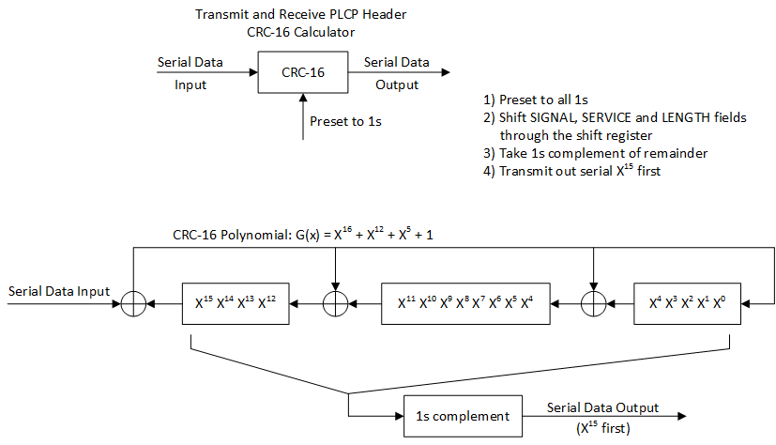

**Figure 15-2 – CRC-16 implementation**



An illustrative example of the CRC-16 FCS using the information from Figure 15-2 (CRC-16 implementation) is shown in Figure 15-3 (Example CRC calculation).

Data CRC registers

MSB LSB

1111111111111111 ; initialize preset to 1s

0 1110111111011111

1 1101111110111110

0 1010111101011101

1 0101111010111010

0 1011110101110100

0 0110101011001001

0 1101010110010010

0 1011101100000101

0 0110011000101011

0 1100110001010110

0 1000100010001101

0 0000000100111011

0 0000001001110110

0 0000010011101100

0 0000100111011000

0 0001001110110000

0 0010011101100000

0 0100111011000000

0 1001110110000000

0 0010101100100001

0 0101011001000010

0 1010110010000100

1 0101100100001000

1 1010001000110001

0 0101010001000011

0 1010100010000110

0 0100000100101101

0 1000001001011010

0 0001010010010101

0 0010100100101010

0 0101001001010100

0 1010010010101000

0101101101010111 ; 1s complement, result = CRC FCS parity

Figure 15-3 – Example CRC calculation

*Instruction to Editor: Update D0.0 P2865 as shown below.*

16.2.3.7 PHY CRC (CRC-16) field

The SIGNAL, SERVICE, and LENGTH fields shall be protected with a CRC-16 FCS. The CRC-16 FCS is defined in 15.3.3.

# CID 83

|  |  |  |  |  |
| --- | --- | --- | --- | --- |
| **CID** | **Clause** | **Page.Line** | **Comment** | **Proposed Change** |
| 83 | 19.3.9.4.6 | 2990.46 | N_HTDLTF should be N_HT-DLTF, where "_" indicates subscript. | Replace "N_HTDLTF" with "N_HT-DLTF", where "_" indicates subscript. |

**Discussion**

D0.0 P2990:

|  |
| --- |
|  |

D0.0 P2967-2968

|  |
| --- |
|  |

Commenter is correct that *NHTDLTF* should be *NHT-DLTF* per P2968L1.

There is one more place where *NHTDLTF* is used instead of *NHT-DLTF* , in Equation (19-26).

|  |
| --- |
|  |

**Proposed Resolution: CID 83**

**Revised**.

**Note to Commenter:**

The instruction to Editor below fixes N_HTDLTF to N_HT-DLTF at the place cited by the commenter, as well as in Equation 19-26.

**Instruction to Editor:**

Change “N_{HTDLTF}” to “N_{HT-DLTF}” at D0.0 P2990L46 (within Table 19-13) and P2993L24 (within Equation (19-26)).

# CID 84, 85, 86, 87

|  |  |  |  |  |
| --- | --- | --- | --- | --- |
| **CID** | **Clause** | **Page.Line** | **Comment** | **Proposed Change** |
| 84 | 19.4.3 | 3047.24 | L_SIG and HT_SIG should be L-SIG and HT-SIG respectively. | Replace "L_SIG" with "L-SIG". Replace "HT_SIG" with "HT-SIG". |
| 85 | 19.4.3 | 3047.30 | L_SIG and HT_SIG should be L-SIG and HT-SIG respectively. | Replace "L_SIG" with "L-SIG". Replace "HT_SIG" with "HT-SIG". |
| 86 | 19.4.3 | 3047.34 | HT_SIG should be HT-SIG. | Replace "HT_SIG" with "HT-SIG". |
| 87 | 19.4.3 | 3047.37 | HT_SIG should be HT-SIG. | Replace "HT_SIG" with "HT-SIG". |

**Discussion**

D0.0 P3047:

|  |
| --- |
|  |

Note that Table 19-6 defines the terms to be *TL-SIG* and *THT-SIG* as the commenter has pointed out.

D0.0 P2975:

|  |
| --- |
| … |

**Proposed Resolution: CID 84, 85, 86, 87**

**Accepted**

# CID 88

|  |  |  |  |  |
| --- | --- | --- | --- | --- |
| **CID** | **Clause** | **Page.Line** | **Comment** | **Proposed Change** |
| 88 | 19.4.3 | 3047.48 | T_L-SIG is also defined in Table 19-6, where "_" indicates suscript. | Add "T_L-SIG" to the list, where "_" indicates subscript. |

**Discussion**

D0.0 P3047:

|  |
| --- |
|  |

D0.0 P2975:

|  |
| --- |
| … |

Commenter is correct that *TL-SIG* is defined in Table 19-6, and should be listed at P3047L48.

**Proposed Resolution: CID 88**

**Revised**.

**Note to Commenter:**

The instruction to Editor below provides the exact place at which T_L-SIG should be added.

**Instruction to Editor:**

At D0.0 P3047L48, change “T_{SYM}, T_{SYMS}, T_{HT-SIG}” to “T_{SYM}, T_{SYMS}, T_{L-SIG}, T_{HT-SIG}”.

# CID 89

|  |  |  |  |  |
| --- | --- | --- | --- | --- |
| **CID** | **Clause** | **Page.Line** | **Comment** | **Proposed Change** |
| 89 | 21.4.3 | 3220.18 | T_L-SIG is also defined in Table 21-5, where "_" indicates suscript. | Add "T_L-SIG" to the list, where "_" indicates subscript. |

**Discussion**

D0.0 P3220:

|  |
| --- |
|  |

D0.0 P3143:

|  |
| --- |
| … |

Commenter is correct that *TL-SIG* is defined in Table 21-5, and should be listed at P3220L18.

**Proposed Resolution: CID 89**

**Revised**.

**Note to Commenter:**

The instruction to Editor below provides the exact place at which T_L-SIG should be added.

**Instruction to Editor:**

At D0.0 P3220L18, change “T_{SYM}, T_{SYMS}, T_{VHT-SIG-A}” to “T_{SYM}, T_{SYMS}, T_{L-SIG}, T_{VHT-SIG-A}”.

# CID 349

|  |  |  |  |  |
| --- | --- | --- | --- | --- |
| **CID** | **Clause** | **Page.Line** | **Comment** | **Proposed Change** |
| 349 | 17.2.3.6 | 2894.62 | "RCPI indications of 8 bits are supported." duplicates first sentence | Delete the cited sentence |

**Discussion**

D0.0 P2894:

|  |
| --- |
|  |

Agree with the commenter that the first sentence (“… in the range of 0 to 255”) conveys the same information as “RCPI indications of 8 bits are supported”.

**Proposed Resolution: CID 349**

**Accepted.**

# CID 567

|  |  |  |  |  |
| --- | --- | --- | --- | --- |
| **CID** | **Clause** | **Page.Line** | **Comment** | **Proposed Change** |
| 567 | 21.3.10.12 | 3192.6 | non-HT dup data portion needs to be power normalized across N_tx, the same as legacy preamble portion. Otherwise, there is a power bump of sqrt(Ntx) from preamble to data portion. The same issue needs to be addressed in future clause for HE. | add N_tx in the denominator of the normalization factor. |

**Discussion**

The equation under question is in the equation describing the transmission of Non-HT duplicate PPDUs by a VHT STA.

D0.0 P3192:

|  |
| --- |
|  |

Note that the ‘general’ equation for VHT is Equation (21-13), where the normalization factor *NNorm* is specified to be *NTX* for pre-VHT modulated fields, where the pre-VHT modulated fields is very similar to Non-HT duplicate PPDUs – i.e. L-STF/L-LTF/L-SIG fields duplicated over multiple 20 MHz subchannels.

D0.0 P3150-3151:

|  |
| --- |
| … |

Another evidence that Equation (21-100) should have additional normalization by 1/*NTX* is that Equation (21-25) for L-SIG has such normalization term. Hence, without the same normalization in Equation (21-100), the Data portion of Non-HT duplicate PPDU would have higher TX power than L-SIG.

D0.0 P3156:

|  |
| --- |
|  |

Lastly, this issue was found while reviewing the Non-HT duplicate PPDU section in 11be, where it was agreed that normalization by 1/*NTX* is needed. See <https://mentor.ieee.org/802.11/dcn/21/11-21-0477-01-00be-comment-resolution-for-non-ht-duplicate-transmission.docx> which has passed motion (Motion 169 in <https://mentor.ieee.org/802.11/dcn/20/11-20-1982-18-00be-tgbe-motions-list-for-teleconferences-part-2.pptx>).

**Proposed Resolution: CID 567**

**Revised**.

**Note to Commenter:**

The instruction to Editor below provides the exact place at which N_TX should be added.

**Instruction to Editor:**

In Equation (21-100) at D0.0 P3192L7, add N_{TX} to the normalization factor by changing “sqrt( N^{Tone}_{NON_HT_DUP_OFDM-Data} )” to “sqrt( N_{TX} N^{Tone}_{NON_HT_DUP_OFDM-Data} )”.

# CID 568

|  |  |  |  |  |
| --- | --- | --- | --- | --- |
| **CID** | **Clause** | **Page.Line** | **Comment** | **Proposed Change** |
| 568 | 19.3.11.12 | 3013.32 | non-HT dup data portion needs to be power normalized across N_tx, the same as legacy preamble portion. Otherwise, there is a power bump of sqrt(Ntx) from preamble to data portion. | add N_TX in the denominator of the normalization factor. |

**Discussion**

D0.0 P3192:

|  |
| --- |
|  |

Discussion for this CID 568 is similar to that for CID 567, so will not be repeated.

**Proposed Resolution: CID 568**

**Revised**.

**Note to Commenter:**

The instruction to Editor below provides the exact place at which N_TX should be added.

**Instruction to Editor:**

In Equation (19-61) at D0.0 P3013L33, add N_{TX} to the normalization factor by changing “sqrt( N^{Tone}_{NON-HT Duplicate} )” to “sqrt( N_{TX} N^{Tone}_{NON-HT Duplicate} )”.

# CID 569

|  |  |  |  |  |
| --- | --- | --- | --- | --- |
| **CID** | **Clause** | **Page.Line** | **Comment** | **Proposed Change** |
| 569 | 19.3.7 | 2978.37 | The normalization factor of N_TX in the denominator is not correct for HT portion. Need to update according to VHT and HE equations. | Separate normalization factor differently for preamble portion and data portion as in Equation (21-13) and definition of N_Norm in P3151L24.. |

**Discussion**

D0.0 P2978:

|  |
| --- |
|  |

Commenter is correct that the normalization is not always N_TX, but could also be N_STS.

**Proposed Resolution: CID 569**

**Revised**.

**Note to Commenter:**

The instruction to Editor below introduces a new variable N_Norm which can be either N_TX or N_STS.

**Instruction to Editor:**

Implement the proposed text updates for CID 569 in [https://mentor.ieee.org/802.11/dcn/21/11-21-0823-01-000m-cc35-phy-comments.docx](https://mentor.ieee.org/802.11/dcn/21/11-21-0823-00-000m-cc35-phy-comments.docx)

**Proposed Text Updates: CID 569**

*Instruction to Editor: Update D0.0 P2978L37 as shown below.*

Each baseband waveform, , is defined via the discrete Fourier transform (DFT) per OFDM symbol as shown in Equation (19-4).

 (19-4)

This general representation holds for all fields. A suggested definition of the windowing function, , is given in 17.3.2.5 (Mathematical conventions in the signal descriptions). The frequency domain symbols  represent the output of any spatial processing in subcarrier  for transmit chain  required for the field.

The function  is used to represent a rotation of the upper tones in a 40 MHz channel as shown in Equation (19-5) and Equation (19-6).

 (19-5)

 (19-6)

The scale factor in Equation (19-4) causes the total power of the time domain signal as summed over all transmit chains to be either 1 or lower than 1 when required. Table 19-8 (Value of tone scaling factor) summarizes the various values of . For L-STF, L-LTF, L-SIG and HT-SIG fields in an HT PPDU using the HT-mixed format, *NNorm* = *NTX*. For all other fields in an HT PPDU using the HT-mixed format, *NNorm* = *NSTS*. In an HT PPDU using the HT-greenfield format, *NNorm* = *NSTS* for all fields.

# CID 597

|  |  |  |  |  |
| --- | --- | --- | --- | --- |
| **CID** | **Clause** | **Page.Line** | **Comment** | **Proposed Change** |
| 569 | 21.3.7.4 | 3151.31 | In Equation (21-13), the descriptions of Tsubfield for windowing function wTSubfield (t) is not correct for VHT-LTF and VHT-Data. It did not take into account of the number of VHT-LTF symbols, and VHT-Data symbols in the transmission. | Tsubfield is ..., NVHT-LTFxTVHT-LTF for VHT-LTF and ...for VHT-SIG-B. Tsubfield is NSYMxTSYM for VHT-Data, that is ... |

**Discussion**

Comment is on D0.0 P3151:

|  |
| --- |
|  |

where the windowing function is used in Equation on P3150:

|  |
| --- |
|  |

The commenter seems to think that the “Subfield” corresponds to the entire VHT-LTF “section” (i.e. all VHT-LTF symbols) and the entire Data “section” (i.e. all Data symbols). However, Subfield refers to a single OFDM symbol because:

* Equation (21-13) does not have any index for OFDM symbol, and does not have any summation over multiple OFDM symbols. Hence, Equation (21-13) is representing only one OFDM symbol.
* REVme D0.0 P3150 says the following, which means the a “Field” is the entire VHT-LTF or Data ‘section’ is a “Field”, and individual OFDM symbols are the “Subfield”

|  |
| --- |
| … |

* Note for example as well that Equation (21-95) describing the VHT Data field applies the windowing function for each OFDM symbol (P3190)

|  |
| --- |
|  |

**Proposed Resolution: CID 597**

**Rejected**.

REVme D0.0 P3150L31 says

“Each field … is defined as the summation of one or more subfields, where each subfield is defined to be an inverse discrete Fourier transform …”.

Hence, Equation (21-13) is describing a single OFDM symbol, and thus the windowing function is applied per OFDM symbol. Therefore, the current text at REVme D0.0 P3151L28-36 is correct.

# CID 143

|  |  |  |  |  |
| --- | --- | --- | --- | --- |
| **CID** | **Clause** | **Page.Line** | **Comment** | **Proposed Change** |
| 143 | 16.2.6 | 2873.19 | In Figure 16-9, which is the receive state machine, should the third step on the left ("SET RXPHY FIELDS") be "DETECT RXPHY FIELDS" or some such? | Change "SET RXPHY FIELDS" to "DETECT RXPHY FIELDS" or "VALIDATE RXPHY FIELDS". |

**Discussion**

D0.0 P2873 (HR/DSSS PHY RX procedure):

|  |
| --- |
|  |

Note that the corresponding DSSS PHY RX procedure is

D0.0 P2848 (Figure 15-9):

|  |
| --- |
|  |

Note that the fields in the SIGNAL field is not ‘detected’, but rather received and processed by the PHY. Thus, what DSSS PHY has in Figure 15-9 (“RX PHY Fields”) makes sense.

As the Editors did not have a Visio source file for Figure 16-9, a new Visio drawing (based on the source file for Figure 15-9) is provided.

**Proposed Resolution: CID 143**

**Revised**.

**Note to Commenter:**

Following the convention in Figure 15-9, “SET RXPHY FIELDS” is changed to “RX PHY FIELDS”.

**Instruction to Editor:**

Implement the proposed text updates for CID 143 in [https://mentor.ieee.org/802.11/dcn/21/11-21-0823-01-000m-cc35-phy-comments.docx](https://mentor.ieee.org/802.11/dcn/21/11-21-0823-00-000m-cc35-phy-comments.docx)

*Instruction to Editor: Replace Figure 16-9 at D0.0 P2873 with the following one.*

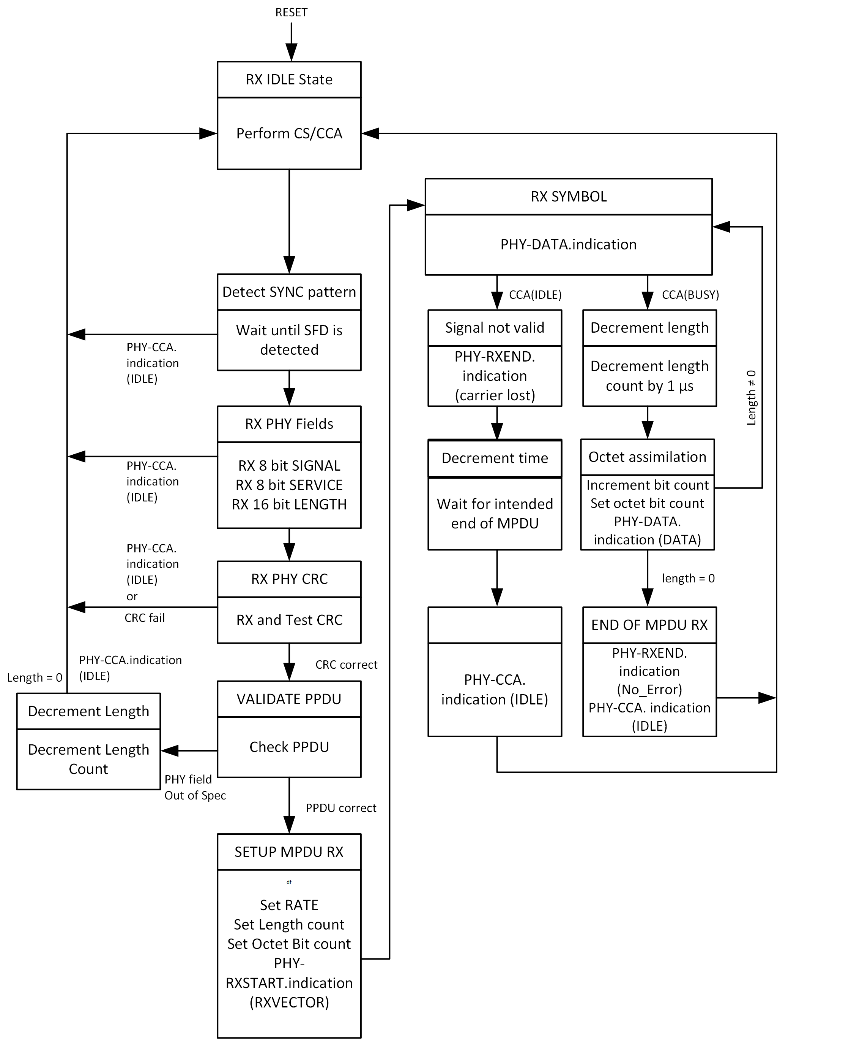



[End of File]