IEEE P802.11  
Wireless LANs

|  |  |  |  |  |  |  |  |  |  |  |  |  |  |  |  |  |  |  |  |  |  |  |  |  |  |  |  |  |  |  |  |  |  |  |  |  |  |  |  |  |  |  |  |  |  |  |  |  |  |  |
| --- | --- | --- | --- | --- | --- | --- | --- | --- | --- | --- | --- | --- | --- | --- | --- | --- | --- | --- | --- | --- | --- | --- | --- | --- | --- | --- | --- | --- | --- | --- | --- | --- | --- | --- | --- | --- | --- | --- | --- | --- | --- | --- | --- | --- | --- | --- | --- | --- | --- | --- |
| |  |  |  |  |  | | --- | --- | --- | --- | --- | | CC35 PHY Comments | | | | | | Date: 2021-05-11 | | | | | | Author(s): | | | | | | Name | Affiliation | Address | Phone | email | | Youhan Kim | Qualcomm |  |  | [youhank@qti.qualcomm.com](mailto:youhank@qti.qualcomm.com) | |  |  |  |  |  | |  |  |  |  |  | |  |  |  |  |  | |  |  |  |  |  | |  |  |  |  |  | |

Abstract

This submission proposes resolutions for the following comments from comment collection on P802.11-REVme D0.0:

17, 83, 84, 85, 86, 87, 88, 89, 349

NOTE – Set the Track Changes Viewing Option in the MS Word to “All Markup” to clearly see the proposed text edits.

**Revision History:**

R0: Initial version.

# CID 17

|  |  |  |  |  |
| --- | --- | --- | --- | --- |
| **CID** | **Clause** | **Page.Line** | **Comment** | **Proposed Change** |
| 17 | 15.3.3.7 | 2841.40 | This figure has got broken since the top line has 4 outputs but no input. Also the superscripts are hard to read. Finally it is unclear where the output comes from. | Copy across figure 16-3 since there the top line has an input and it says "X15 first" in two places (yet check for any other differences that aren't corrections, but AFAIK there shouldn't be any). |

**Discussion**

Figure 15-2 has all the issues pointed out by the commenter.

|  |
| --- |
|  |

Figure 16-3 does not have the issues seen in Figure 15-2 as the commenter has also pointed out.

|  |
| --- |
|  |

Unfortunately, there is no Visio source file for either Figure 15-2 or Figure 16-3. Hence, copying Figure 16-3 to Figure 15-2 would require a ‘bitmap’ figure copy, which is not desired. Thus, a new Figure 15-2 has been drawn using Visio.

Furthermore, 15.3.3.7 (PHY CRC field) for DSSS PHY and 16.2.3.7 (PHY CRC (CRC-16) field) for HR/DSSS PHY are almost word-to-word identical. There is no need to repeat the same information.

**Proposed Resolution: CID 17**

**Revised**.

**Note to Commenter:**

A new Visio drawing for Figure 15-2 is provided. Also, 16.2.3.7 is updated to simply refer to 15.3.3.7, rather than repeat the same information.

**Instruction to Editor:**

Implement the proposed text updates for CID 17 in <https://mentor.ieee.org/802.11/dcn/21/11-21-0823-00-000m-cc35-phy-comments.docx>

**Proposed Text Updates: CID 17**

*Instruction to Editor: Update D0.0 P2841 as shown below.*

15.3.3.7 PHY CRC field

The SIGNAL, SERVICE, and LENGTH fields shall be protected with a CRC-16 FCS. The CRC-16 FCS shall be the 1s complement of the remainder generated by the modulo 2 division of the protected PHY fields by the polynomial:

*x*16 + *x*12 + *x*5 + 1

The protected bits shall be processed in transmit order. All FCS calculations shall be made prior to data scrambling. A schematic of the processing is shown in Figure 15-2.

As an example, the SIGNAL, SERVICE, and LENGTH fields for a DBPSK signal with an MPDU length of 192 µs (24 octets) would be given by the following:

0101 0000 0000 0000 0000 0011 0000 0000 (leftmost bit transmitted first in time)

The 1s complement FCS for these protected PHY preamble bits would be the following:

0101 1011 0101 0111 (leftmost bit transmitted first in time)

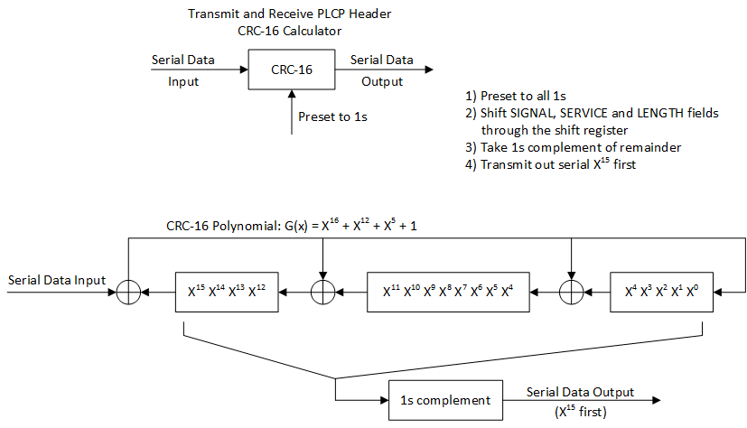

**Figure 15-2 – CRC-16 implementation**



An illustrative example of the CRC-16 FCS using the information from Figure 15-2 (CRC-16 implementation) is shown in Figure 15-3 (Example CRC calculation).

Data CRC registers

MSB LSB

1111111111111111 ; initialize preset to 1s

0 1110111111011111

1 1101111110111110

0 1010111101011101

1 0101111010111010

0 1011110101110100

0 0110101011001001

0 1101010110010010

0 1011101100000101

0 0110011000101011

0 1100110001010110

0 1000100010001101

0 0000000100111011

0 0000001001110110

0 0000010011101100

0 0000100111011000

0 0001001110110000

0 0010011101100000

0 0100111011000000

0 1001110110000000

0 0010101100100001

0 0101011001000010

0 1010110010000100

1 0101100100001000

1 1010001000110001

0 0101010001000011

0 1010100010000110

0 0100000100101101

0 1000001001011010

0 0001010010010101

0 0010100100101010

0 0101001001010100

0 1010010010101000

0101101101010111 ; 1s complement, result = CRC FCS parity

Figure 15-3 – Example CRC calculation

*Instruction to Editor: Update D0.0 P2865 as shown below.*

16.2.3.7 PHY CRC (CRC-16) field

The SIGNAL, SERVICE, and LENGTH fields shall be protected with a CRC-16 FCS. The CRC-16 FCS is defined in 15.3.3.

# CID 83

|  |  |  |  |  |
| --- | --- | --- | --- | --- |
| **CID** | **Clause** | **Page.Line** | **Comment** | **Proposed Change** |
| 83 | 19.3.9.4.6 | 2990.46 | N_HTDLTF should be N_HT-DLTF, where "_" indicates subscript. | Replace "N_HTDLTF" with "N_HT-DLTF", where "_" indicates subscript. |

**Discussion**

D0.0 P2990:

|  |
| --- |
|  |

D0.0 P2967-2968

|  |
| --- |
|  |

Commenter is correct that *NHTDLTF* should be *NHT-DLTF* per P2968L1.

There is one more place where *NHTDLTF* is used instead of *NHT-DLTF* , in Equation (19-26).

|  |
| --- |
|  |

**Proposed Resolution: CID 83**

**Revised**.

**Note to Commenter:**

The instruction to Editor below fixes N_HTDLTF to N_HT-DLTF at the place cited by the commenter, as well as in Equation 19-26.

**Instruction to Editor:**

Change “N_{HTDLTF}” to “N_{HT-DLTF}” at D0.0 P2990L46 (within Table 19-13) and P2993L24 (within Equation (19-26)).

# CID 84, 85, 86, 87

|  |  |  |  |  |
| --- | --- | --- | --- | --- |
| **CID** | **Clause** | **Page.Line** | **Comment** | **Proposed Change** |
| 84 | 19.4.3 | 3047.24 | L_SIG and HT_SIG should be L-SIG and HT-SIG respectively. | Replace "L_SIG" with "L-SIG". Replace "HT_SIG" with "HT-SIG". |
| 85 | 19.4.3 | 3047.30 | L_SIG and HT_SIG should be L-SIG and HT-SIG respectively. | Replace "L_SIG" with "L-SIG". Replace "HT_SIG" with "HT-SIG". |
| 86 | 19.4.3 | 3047.34 | HT_SIG should be HT-SIG. | Replace "HT_SIG" with "HT-SIG". |
| 87 | 19.4.3 | 3047.37 | HT_SIG should be HT-SIG. | Replace "HT_SIG" with "HT-SIG". |

**Discussion**

D0.0 P3047:

|  |
| --- |
|  |

Note that Table 19-6 defines the terms to be *TL-SIG* and *THT-SIG* as the commenter has pointed out.

D0.0 P2975:

|  |
| --- |
| … |

**Proposed Resolution: CID 84, 85, 86, 87**

**Accepted**

# CID 88

|  |  |  |  |  |
| --- | --- | --- | --- | --- |
| **CID** | **Clause** | **Page.Line** | **Comment** | **Proposed Change** |
| 88 | 19.4.3 | 3047.48 | T_L-SIG is also defined in Table 19-6, where "_" indicates suscript. | Add "T_L-SIG" to the list, where "_" indicates subscript. |

**Discussion**

D0.0 P3047:

|  |
| --- |
|  |

D0.0 P2975:

|  |
| --- |
| … |

Commenter is correct that *TL-SIG* is defined in Table 19-6, and should be listed at P3047L48.

**Proposed Resolution: CID 88**

**Revised**.

**Note to Commenter:**

The instruction to Editor below provides the exact place at which T_L-SIG should be added.

**Instruction to Editor:**

At D0.0 P3047L48, change “T_{SYM}, T_{SYMS}, T_{HT-SIG}” to “T_{SYM}, T_{SYMS}, T_{L-SIG}, T_{HT-SIG}”.

# CID 89

|  |  |  |  |  |
| --- | --- | --- | --- | --- |
| **CID** | **Clause** | **Page.Line** | **Comment** | **Proposed Change** |
| 89 | 21.4.3 | 3220.18 | T_L-SIG is also defined in Table 21-5, where "_" indicates suscript. | Add "T_L-SIG" to the list, where "_" indicates subscript. |

**Discussion**

D0.0 P3220:

|  |
| --- |
|  |

D0.0 P3143:

|  |
| --- |
| … |

Commenter is correct that *TL-SIG* is defined in Table 21-5, and should be listed at P3220L18.

**Proposed Resolution: CID 89**

**Revised**.

**Note to Commenter:**

The instruction to Editor below provides the exact place at which T_L-SIG should be added.

**Instruction to Editor:**

At D0.0 P3220L18, change “T_{SYM}, T_{SYMS}, T_{VHT-SIG-A}” to “T_{SYM}, T_{SYMS}, T_{L-SIG}, T_{VHT-SIG-A}”.

# CID 349

|  |  |  |  |  |
| --- | --- | --- | --- | --- |
| **CID** | **Clause** | **Page.Line** | **Comment** | **Proposed Change** |
| 349 | 17.2.3.6 | 2894.62 | "RCPI indications of 8 bits are supported." duplicates first sentence | Delete the cited sentence |

**Discussion**

D0.0 P2894:

|  |
| --- |
|  |

Agree with the commenter that the first sentence (“… in the range of 0 to 255”) conveys the same information as “RCPI indications of 8 bits are supported”.

**Proposed Resolution: CID 349**

**Accepted.**

[End of File]