IEEE P802.11
Wireless LANs
AANI SC Meeting Minutes May 2021 - Interim
Date: 2021-05-13
Author(s):
Name | Affiliation | Address | Phone | email
Ganesh VENKATESAN | Intel | 2111NE 25th Ave, Hillsboro, OR 97124 | 5033346720 | ganesh.venkatesan@intel.com
Al PETRICK | InterDigital, Inc |  |  | al@jpasoc.com
Graham SMITH | SR Technologies | Sunrise, Florida |  | gsmith@srtrl.com
Joseph LEVY | InterDigital, Inc. | 111 W 33rd Street  New York, NY 10120 | +1.631.622.4139 | joseph.levy@interdigital.com
Abstract
This document contains the minutes of the IEEE 802.11 AANI SC teleconference held on 11 May 2021, 11:15-13:15 h ET, 12 May 2021 19:00-21:00 h ET, 13 May 2021 11:15-13:15 h ET, 17 May 2021 19:00-21:00 h ET.

Note: Highlighted text are action items.
Q- proceeds a question asked at the meeting
A- proceeds an answer given by the presenter
C- proceeds a comment

r0: Draft minutes from Tuesday 11 May 2021.
r1: Draft minutes from Wednesday 12 May 2021, Thursday 13 May 2021, and Monday 17 May added.
Contents:
Tuesday 11 May 2021, 11:15 h ET: 3
Wednesday 12 May 2021, 19:00 h ET: 6
Thursday 13 May 2021, 11:15 h ET: 11
Monday, 17 May 2021, 19:00 - 21:00 h ET 14

Tuesday 11 May 2021, 11:15 h ET:

Chair: Joseph LEVY, InterDigital
Acting Secretary: Ganesh VENKATESAN, Intel

- The teleconference was called to order by Chair 11:15 hrs. EDT,
Ganesh VENKATESAN (Intel) volunteered to be acting secretary.

Agenda slide deck 11-21/0640r0

2. The Chair reminded everyone to sign attendance and reminded attendees of the AANI Operating rules.

3. Approval of the Agenda(s):
Tuesday 11 May 2021 11:15-13:15 h ET
  - Call for Secretary
  - Administrative: Reminders, Rules, Guidelines, Resources, Participation, Approval of Minutes [10 min]
  - Status [10 min.]
  - Contributions/Discussion:
    - 11-21/0751r0 “Comments on draft technical report”, Robert Stacey (Intel)
    - Discussion on way forward on the technical report
    - Contributions related to the WBA LS
Wednesday 12 May 2021 19:00-21:00 h ET
  - Call for Secretary
  - Administrative: Reminders, Rules, Guidelines, Resources, Participation [10 min]
  - Status [5 min.]
  - Contributions/Discussion:
    - 11-20/0013r12 “Draft technical report on interworking between 3GPP 5G network & WLAN”, Hyun Seo Oh (ETRI)
Thursday 13 May 2021 11:15-13:15 h ET
  - Call for Secretary
  - Administrative: Reminders, Rules, Guidelines, Resources, Participation [10 min]
  - Status [5 min.]
  - Contributions/Discussion:
    - Contributions related to the WBA LS
    - Contributions related to the technical report
Monday 17 May 2021 19:00-21:00 h ET
  - Call for Secretary
  - Administrative: Reminders, Rules, Guidelines, Resources, Participation [10 min]
  - Status [5 min.]
  - Contributions/Discussion
  - Future Sessions Planning [10 min.]

The Chair reviewed the agenda. The proposed agenda was approved without objection.

4. Guidelines, Resources, Policies and Participation were presented by the chair.
Slides 6 – 10 of 11-21/0640r0
Reviewing: Guidelines for IEEE-SA Meetings, the IEEE SA Copyright Policy, and Participation Guidelines.

- Approval of Minutes
Minutes from the March 2021 Plenary Telecons:
11-21/0521r0 “AANI SC Teleconference Minutes March 2021 - plenary”
Chair called for any Comments or objections? none
Minutes approved without objection.

11-21/0604r0 “AANI SC Teleconference 06 Apr 2021 Meeting Minutes”
11-21/0764r0 “AANI SC teleconference Minutes 28 April 2021”
Chair called for any Comments or objections? none
Minutes approved without objection.

- Status on Proposal on Interworking
Chair went through Slides 12 and 13 of 11-21/0640r0 reviewing the status of
The "Draft technical report on interworking between 3GPP 5G network and WLAN" 11-20/0013r12 and the work related to the WBA Report an LS 11-21-0170r0.

- Interworking Technical Report Contribution:
11-21/0751r0 “Comments on draft technical report”, Robert Stacey (Intel)
--comments on the introductory section
objective is vague does not clearly callout what the intent is. The report is an overview describing how 802.11 interworks with 3GPP.
-- terminology concerns
Terminal is what is referred to in 802.11 domain as STA plus additional higher layer functions. UE and TE are synonymous (does not requires WLAN and 3GPP radio, presence of either is good enough) in the context of the report.

C: UE in 3GPP implies that the device is aware of signaling needed to access the 3GPP core network.
A: That distinction should be called out in the report (not that a UE includes 3GPP and 802.11 Radio versus TE only includes an 802.11 Radio)
C: Agree that the report should clarify that distinction.

3GPP Access network in Figure-3 is not relevant (and should be removed)
Same comment to Figure-4

Section-4 discusses access to the core network via wireless LAN (and not interworking) -- should be reworked to describe the 2-phase access to the core network over wireless LAN.

-- concerns related to the conclusion
Need to callout where/how the new functional entities and signaling procedures are identified.
The only way to access a WLAN network is by scanning and subsequent association -- why is this a recommendation?
R8 and R9 are interfaces defined in 802.1CF and are not WLAN interfaces.

C: What is the way forward?
the chair called for volunteers to take the comments and address them in a future version of the report.
C: Agree that the comments are valid and need to be addressed.
C: overview of the technical report.
A: Merge 2.1 and the text in Introduction and title it as Overview.
C: Section 3 Interworking model UE is from the 3GPP and TE is from 802.1
A: Based on earlier discussion CE/TE distinction is really about the presence or absence of higher layer protocol support for 3GPP core network.
C: Scope of this report should be limited to interworking and not about mechanisms for access to core network.
C: Is Figure-2 OK?
A: Access Network portion of the figure is irrelevant. But more importantly UE/TE definitions are not precise (is misleading).
C: We need to explain/describe what purpose the 3GPP Access Network in the figure serves. Eliminating the 3GPP Access Network from the figure may have issues as well.
C: Need to describe the two means of getting to the core network -- one via 3GPP Access and one via WLAN; the model is OK. The terminology is probably what we need to fix.
A: How the Core Network is accessed does not matter in the context of this report.
A: As long as we clearly define UE and TE, the figure can stay as is.
C: Figure-3 is from 802.1CF reference model.
R: R3(Y2) is not relevant.
A: Section-4 is describing gaining access to the Access Network. The 2-phase procedure should be described here.

C: Continue discussion on the reflector? Draft changes for discussion this week?
C: Need time to work on the comments; make use of the reflector to ask for comment clarification.

- WBA Report/Liaison Statement
The Chair asked if there are any contributions related to the WBA Liaison at this time?
No response.
The Chair asked Osama Aboul-Magd if he would review his contribution again, since there were many attendees of this meeting that did not attend the Teleconference when he originally presented the document.

- WBA Report/Liaison Statement Contribution:
11-21/0616r0 “802.11ax Features and Applicability to 5G and Wi-Fi Convergence” Osama Aboul-Magd (Huawei Technologies) - previously presented 13 April 2021.
C: TWT as a power save mechanism; RTWT targets low latency use cases.
C: OBSS PD based reuse is based on a 3GPP technique. Need to determine what terminology is used in the 3GPP domain.
C: TWT is a scheduling scheme (originally from .11ah), allows for minimizing contention and may serve as a QoS-enhancement.
A: .11ax does not spell out TWT as a QoS-enhancement.
C: If TWT has a potential to enhance QoS, we should call it out (may be the history was for Power Save).
C: Trigger/Resource Allocation can allow for prioritization and hence enhance QoS.
C: .11ax facilitates scheduling -- resulting in better QoS.
A: That is the intent of the second bullet in the conclusion slide (but QoS improvements depend on implementation choices).

- Meeting recessed at 13.16 h ET

Wednesday 12 May 2021, 19:00 h ET:

Chair: Joseph Levy, InterDigital
Acting Secretary: Al Petrick, InterDigital

- The teleconference was called to order by Chair 19:02 hrs. EDT
Al Petrick (InterDigital) volunteered to be acting secretary.

Agenda slide deck 11-21/0640r1

- Approval of the Agenda:
The Chair called for any additions and contributions to Agenda.
No new contributions additions to the Agenda.
No objection with current Agenda.

- Attendance reminder and review of the AANI Operating rules.
The Chair presented IEEE -SA Guidelines, Copywrite Policies and Participation requirements (slides 6-10 – doc:640r0).

- AANI Status
The Chair reviewed the current status / activity in AANI (slide 17 – Doc: 640r1).
The Chair reviewed the 802.11ax features in doc: Doc: 616r0 by Osama (11ax Chair) on how they relate to WBA. Osama Doc: 616 during AANI meeting on Tuesday May 10, 2021.

- Discussion
The Chair pointed out there are no Contributions for today and suggested the following ways to move forward:
- Continue discussions on the 11ax features in Doc:616
- Discuss what should be in a reply LS to the WBA LS.
No feedback from the group.
The Chair briefly reviewed Doc:616 for those who were not at the last AANI meeting.
The Chair reviewed Slides 6 and 7 – Doc:616.
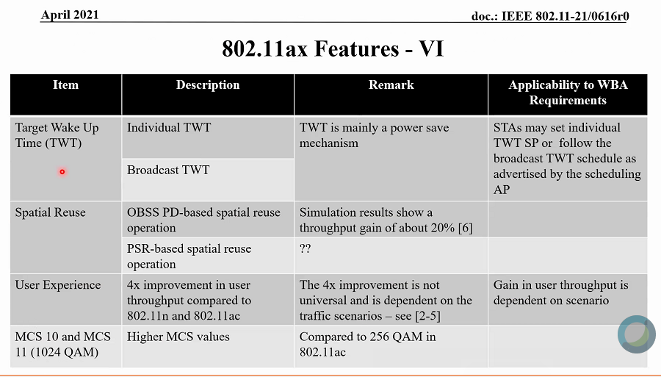
Chair: TWT - may be used for scheduling.
Chair: Spatial Reuse - not sure if these apply to WBA.
Chair: MCS 10 or MCS 11 - How will they address QoS capabilities.
Chair: BQRP - Report allows for the assignment of and allocation DL MU and UL MU resources for QoS capability.
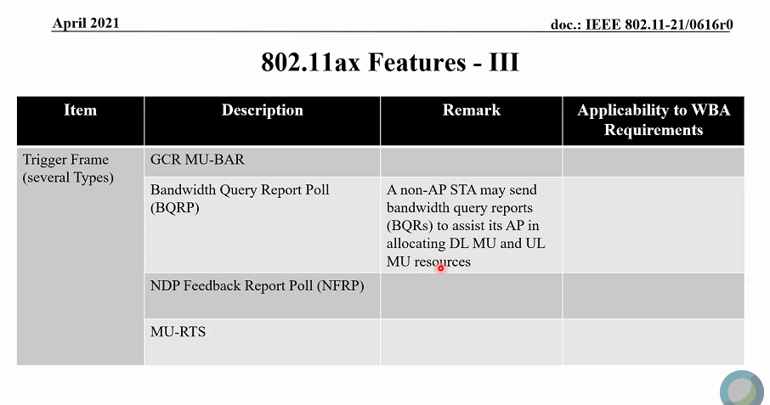

Chair: Is MU-RTS useful for QoS capability?
C: MU-RTS - Is used to efficiently reserve the medium, reduce contention and achieve optimal QoS.
Q: Was the basic trigger frame discussed.
Chair: Basic trigger frame (BTF) was discussed in the last meeting. BTF enable QoS behavior when use by higher layers to manage the system.
C: Add this for the basic trigger frame. AP allocates the RU for each STA which reduces contentions between STAs, by the AP allocating RUs each STA and achieve UL MU transmissions. Reduction of collisions yields higher throughput and improves QoS.
C: What is WBA looking for? 11ax was about HE, SR. Does WBA want details how 11ax works?
A: Chair: From the LS report. WBA is looking for QoS solutions to specific use cases. 802.11ax has features if used, can provide QoS capability to their use cases.
A: Chair: The group should draft a LS to WBA stating 802.11 have these features built-in that can meet QoS requirements through implementations.
A: Chair: Should highlight features that are pausing QoS as well. Should highlight such features in 11be and include .11 future plans and how to direct future plans to meet the needs that WBA is seeking.
Chair: Slide 22 below: Should provide WBA with a list of features that prioritize traffic? e.g., TWT, basic trigger frame,
C: Yes; Differentiate the level of TWT.

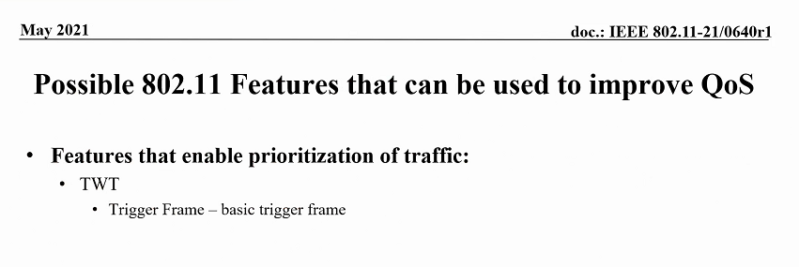

Chair: We have .11ax and non-11ax features.
Chair: Should we include User Access?
C: Slide 22 add Allocation of resources below “efficient allocation of resources for traffic prioritization of traffic” and User Access
Chair suggests to flush-out the features list.
Slide 5 Osama’s presentation Doc: 616 below.
Chair: Do RUs contribute to the allocation?
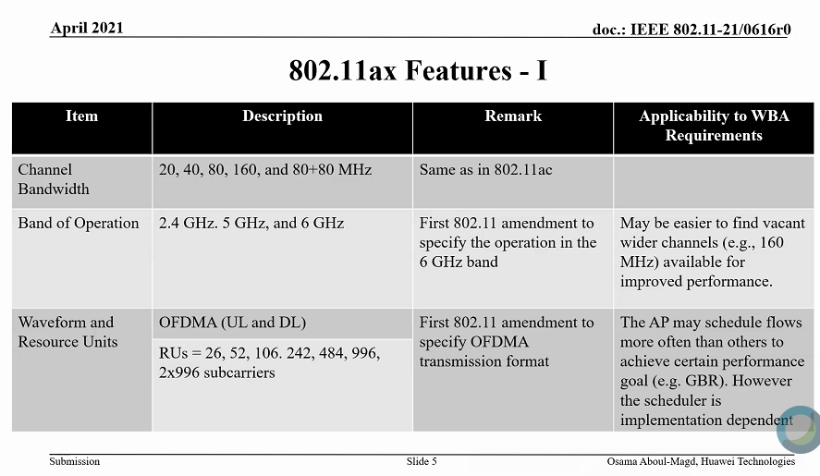

C: Band of Operation – can be used with Fast Session Transfer or Fast BSS transition which provides better BW and QoS.
Chair: Leave off MU BAR? – hearing no support from the group.
Chair: BSRP – This is a measurement frame, will not address this.
C: BSRP - Gathers all the STAs requirements request on the type of traffic. It’s a supporting feature.
C: Chair; Added note – BSRP supporting features can assist scheduler.
C: No need of for note, currently states “Can be used as an input to the scheduler”.
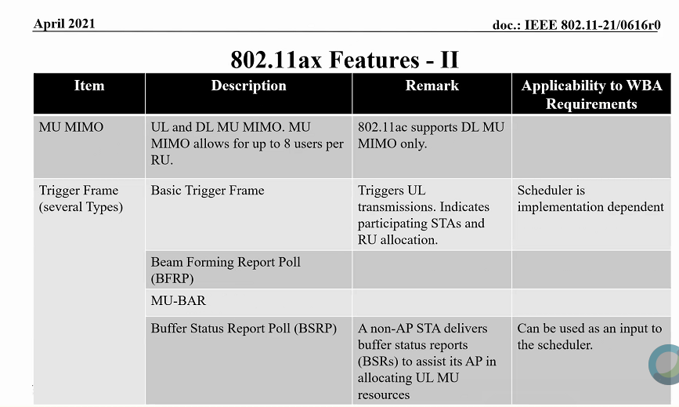

Chair: Slide 7: GCR MU-BAR - group doesn’t see this contributing.
Chair: Does BFRP contribute?
C: Yes, Same as BSRP “can be used as an input to the scheduler”.
Chair: Does MU-RTS contribute?
C: It’s a function for the protection - not directly related to the schedule QoS.
Chair: Leave out MU-RTS.
Chair: Features we currently have….
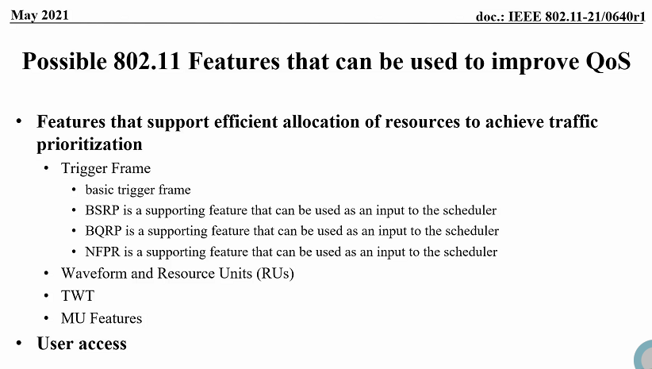

Chair: Does TWT make sense to add?
C: Yes, support both types: individual and broadcast.
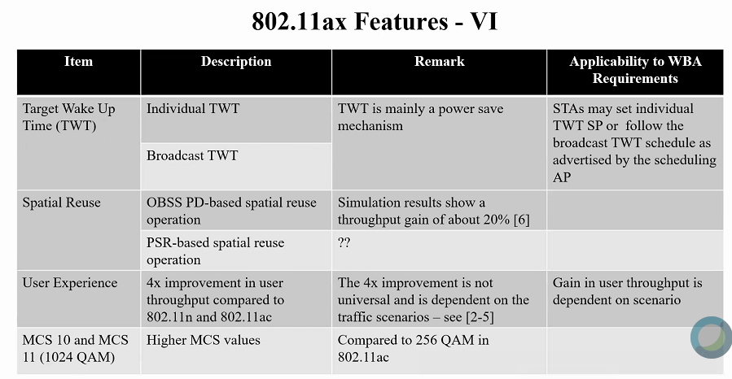

Chair: See Spatial Reuse as a supporting resource feature. No comment from the group.
Chair: added a new feature type on slide 22 below: Features that support increasing effective available resources.
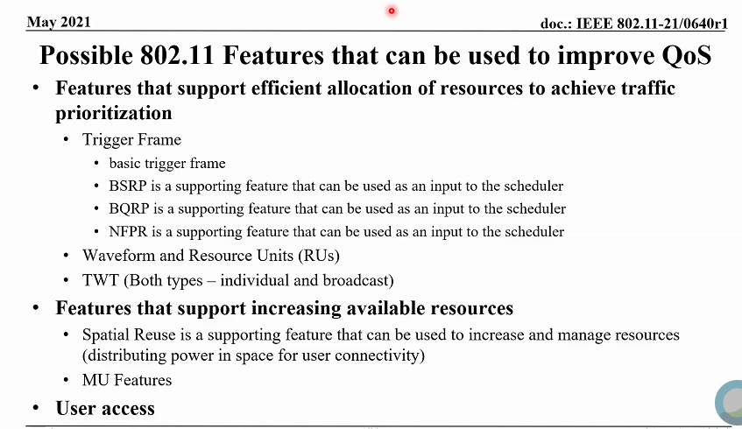
Some discussion from the group on Spatial Reuse related to distributing power in space for user connectivity and QoS.
Chair: added “Features that support increasing available resources”

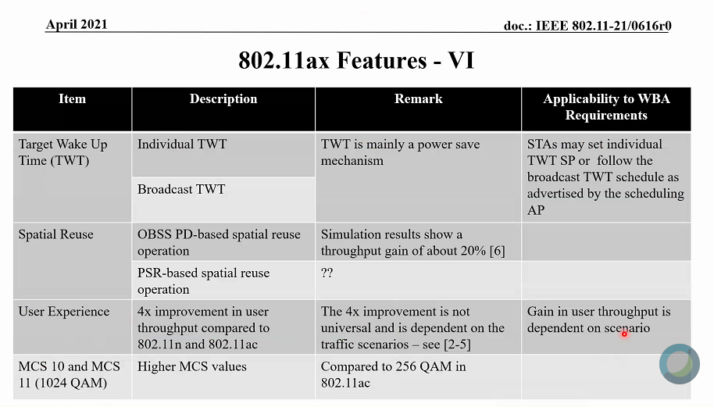
Chair: Group has no interest in User Experience for WBA.
Chair: Include MCS 10 and MCS 11.
Chair: One commenter suggests not to include Band of Operation.
C: Fast session transfer, Fast BSS Transition these are not related to 11ax. These features can achieve increased throughput and optimal QoS.
Chair: 802.11-2020 features should include: Fast session transfer, Fast BSS Transition and TCLAS (see list below)
Chair: Add OFDMA (UL and DL) to the features that support efficient allocation of resources to achieve traffic prioritization.
Chair: No response, keep RUs part of the (UL and DL).
Chair: MU-MIMO- See this as a feature that supports available resources - remains in this category - no change.
Chair: Finished all Osama’s slides.
Chair: review’s final slide below to group.
C: Add TSPEC – it’s used more often than TCLAS.
C: Add Multi-band Operation it’s related to Fast Session Transfer and can be used alone.
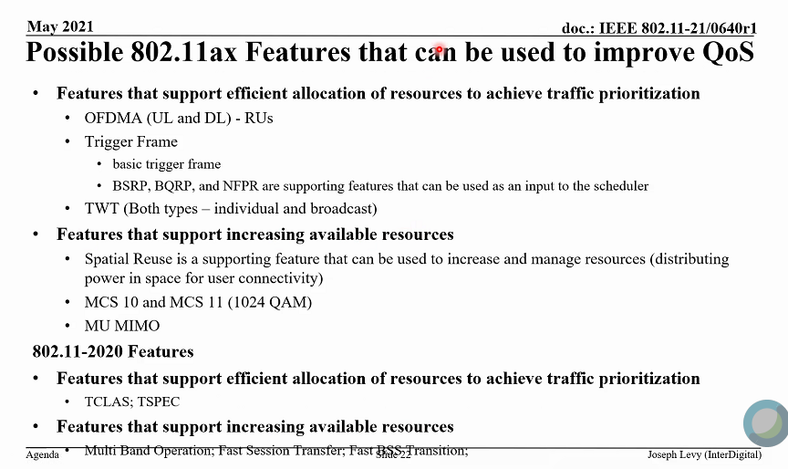

- Next steps
Chair: to use above to generate draft liaison statement.
Chair: Open to volunteers to take on features to provide input text to the liaison statement.
Next CC; AM 2 tomorrow, Thursday 11:15 – 13:15 h ET

- Meeting recessed at 21:00 h ET
Recess until tomorrow morning.

Thursday 13 May 2021, 11:15 h ET:

Chair: Joseph Levy, InterDigital
Acting Secretary: Graham Smith

- The teleconference was called to order by Chair 11:15 h ET,
Graham Smith (SRT) volunteered to be acting secretary.

Agenda slide deck 11-21/0640r2

- The Chair reminded everyone to sign attendance and reminded attendees of the AANI Operating rules.
See attendance list at the bottom of this document.

- Approval of the Agenda:
Thursday 13 May 2021 11:15-13:15 h ET
  - Call for Secretary
  - Administrative: Reminders, Rules, Guidelines, Resources, Participation [10 min]
  - Status [5 min.]
  - Contributions/Discussion:
    - Contributions related to the WBA LS
    - Contributions related to the technical report

The Chair reviewed the agenda. The proposed agenda was adopted without objection.
- Guidelines, Resources, Policies and Participation were presented by the chair.
Slides 5 – 9 of 21/0765
Copyright policy slides were presented, slides 7 and 8

- AANI SC Status/Activity
Slide 17
  - Contributions related to the "Draft technical report on interworking between 3GPP 5G network and WLAN" (11-20/0013r12).
    - At the Tuesday 11 May AANI SC contribution 11-21/0751r0 “Comments on draft technical report”, Robert Stacey (Intel) was presented and discussed.
    - The authors are considering the comments and formulating a way forward – TBS: either during a session of this meeting or on the AANI SC reflector and a subsequent teleconference.
  - The WBA LS (11-21-0170r0) - specifically, addressing 802.11ax or other 802.11-2020 capabilities that can be used to meet the use cases identified in the LS.
  - Contributions:
    - 11-21/0616r0 “802.11ax Features and Applicability to 5G and Wi-Fi Convergence” Osama Aboul-Magd (Huawei Technologies) - presented 13 April 2021. (additional input requested)
Additional discussion was had on Tuesday 11 May 2021
  - Pending contributions:
    - how TCLAS improvements in 802.11-2020 relate to QoS for 5G flows - TBS

- 802.11ax Features:
  - Features that support efficient allocation of resources to achieve traffic prioritization
    - OFDMA (UL and DL) - RUs
    - Trigger Frame
      - basic trigger frame
      - BSRP, BQRP, and NFPR are supporting features that can be used as an input to the scheduler
    - TWT (Both types – individual and broadcast)
  - Features that support increasing available resources
    - Spatial Reuse (distributing power in space for user connectivity)
    - MCS 10 and MCS 11 (1024 QAM)
    - MU MIMO (distributing power in space for user connectivity)
  - 802.11-2020 Features:
  - Features that support efficient allocation of resources to achieve traffic prioritization
    - TCLAS; TSPEC
  - Features that support increasing available resources
    - Multi Band Operation; Fast Session Transfer; Fast BSS Transition

The Chair asked if there any other contributions? No response.
The Chair asked if we should continue discussion on WBA and QoS?
Discussion
C – HCCA and TPECS, Historically HCCA was invented to provide QoS. It does work but never taken up in the mainstream. 11aa used TSPECs for OBSS. It is very efficient.
C – Concerned that no certification.
C – Do not agree HCCA should be included. Not supported. What is a “real” QoS feature? Do have criteria for what are real QoS features.

Chair – Added new slide “QoS Scope” and edited during following discussion
Added TCLAS, TSPEC, HCCA to 802.11 2020 features.

A – Should be based on WBA questions.
C – Guaranteed bit rates have been mainly based on voice, but there are other applications where bit rate not the issue, more latency or more user experience.
C - 802.11 is a MAC/PHY not the specification of a scheduler. Not providing a turnkey solution for QoS is the same as not supplying a scheduler.
C - I am not sure if TSPEC is in use as well, or combined in any features in 11ax, voice and video streaming is different to interactive steaming. Buffer can be used in streaming.
C – Voice is real time, video can be buffered, but real time video is close to gaming requirement. Any network can implement HCCA. We should include HCCA for discussion.
C – Scheduled not specified in 3GPP? How can they therefore claim support of so many calls etc.? Some vendors make claims, some do not. In what ways is 802.11 different to 3GPP?
A – 3GPP controls its spectrum. Tight admission controls and a top down scheduler. Schedule not specified as implementation dependent.
C – Can we expand EDCA with trigger frames? TSID? 11be work?
Chair – We cannot include features being implemented in TGbe. Advanced features from TGbe must be provided by TGbe.
C – Virtually all QoS today uses EDCA, License v unlicensed – In licensed, amount of resource is fixed, in unlicensed it varies and only indirect control. MU-EDCA could be included in 11ax list (Note: was added on Slide 20). How is QoS measured? Assumptions are based on a scheduler and how it works, we could do the same thing. In Cellular, voice gets special handling but not much more than that.
C – UEs do provide uplink priority of their resources rather than packet view of the world, as does 802.11.
C – Are we trying to prove that 802.11 can meet the QoS requirements of 5G? What are we trying to do here?
A – We provide voice, streaming all the time over Wi-Fi, but for some reason 802.11 looked at as a non-reliable interface for these real time applications. Our liaison response should show we have all the features necessary and comes down to how these are configured.
C – Despite QoS specific points, Press Release had simulations against ITT 2020 requirements. This is a good reference point. Large majority of cases Wi-Fi latency is in fact very low. But legacy devices have not scaled well.

Chair – back to scope of WBA report and concerns, QoS – Scope points on new Slide 21, do these capture the points? We should probably align these with WBA report.
“Real Time”
- Voice – minimum bit rate, latency
- Real time/Interactive Streaming (e.g., Gaming) =- Latency, higher minimum bit rate (than voce)
“Data Rate Dependent”
- Video Streaming – minimum but rate, latency (can use buffering)
(align with WBA use cases)

The Chair asked for a volunteer to draft liaison statement? No response.

Any other business? None

Agenda completed.

- The meeting recessed at 12:32 h ET.

Monday, 17 May 2021, 19:00 - 21:00 h ET

Chair: Joseph Levy, InterDigital
Acting Secretary: Al Petrick, InterDigital

- The teleconference was called to order by Chair 19:03 hrs. EDT
Al Petrick (InterDigital) volunteered to be acting secretary.

Agenda slide deck 11-21/0640r4

- Approval of the Agenda (11-21/0640r4 slide 23):
The Chair called for any additions and contributions to Agenda.
Both presenters available to present their contributions.
No objection with current Agenda.

- Attendance reminder and review of the AANI Operating rules.
The Chair presented IEEE -SA Guidelines, Copywrite Policies and Participation requirements (slides 6-10 – doc:640r0).

- AANI Status
The Chair reviewed the current status / activity in AANI (slide 12 – Doc: 640r4).
Chair: Any questions? No questions from the group.

- Discussion/Contributions

Doc: 859r0 proposed changes draft technical report presented by Hyun Seo OH (ETRI)
Hyun: There are 21 comments --- focused on Robert Stacey’s comments: (see below).

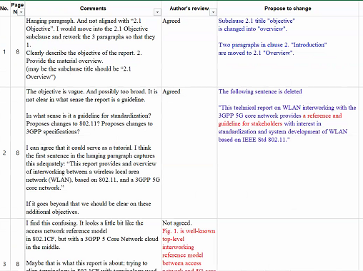
Presenter reviewed proposed comments (figures and text).
C: Agree with comment #4.

C: Comment #8 802.11 mechanism

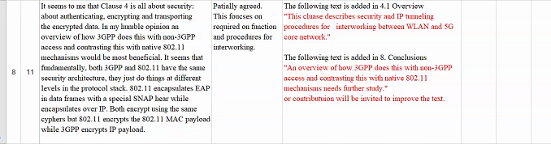
C: To gain access to the core network, authentication twice, encryption 2 layers as require by 3GPP
C: Security depends upon the specific server in use and the implementations which are independent of each other. Achieving consensus on security could be challenging.
C: There is potential for reducing overhead in the trusted case. Would like to see trusted case in the report.
C: Both device and network security should be addressed in the report.
C: 802.11 doesn’t go beyond the device security. Application security is never considered in 802.11, only device access.
C: One way is opening up a “port” to get on to the network. (802.1 x concept of a port) We need to describe steps to open “ports”.
C: Agreed to review security text for comment #8.

Presenter reviewed comment #10 (below)
Q: Why is subclause 4.1 important. No impact. It’s not necessary to mention this in the report.
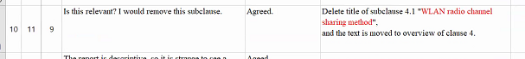
C: Agrees, deleting the cause is a better option. Do we need Layer 2 discussions? Only the LLC sublayer is important.
C: If we are discussing MAC functionality, we are discussing 802.11. 802.11 does specify the interface to the LLC level.
A: There is a proposal to delete subclause 4.1., it will be considered.

Hyun: reviewed comment #11 (below)
Robert: Agrees with comment #11

C: Authentication and registration are used for behaviors at different layers. These occur at layer 2 in 802.11. In 3GPP they occur between the end device and backend. Processes are different. Need to clarify the difference in the terms in the text and how they are used.
A: Will clarify sentence in comment #12.
C: How do we proceed with comment #12? The DS provides registration and authentication and allows the device to register with the APs in an ESS, enabling a IPSEC tunnel for 3GPP. Need to break into a 2-step process.
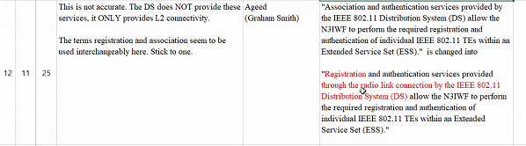
Chair: IPSEC is not in scope, it’s not part of 802.11.
C: It’s in the report.
C: We are discussing the TE registration to 802.11.
C: There are more steps involved for setting up the TCP link not described.
C: It’s a 2-step process to Trust the network. 1) process of getting network access 2) process to access the 5G core.
C: What is the objective the report? Now it’s a tutorial. The scope is now like a tutorial. Need to describe the process to access the 5G core. Which includes authenticating and associating with the network and access to the 5G core.
C: Does the Chair agree this is a tutorial?
Chair: An example doesn’t make the report a tutorial. Segments of the report are germane to the WBA LS and to 3GPP, if the 802.11 WG wants to use it that way.
C: For security, we should describe part of security from 802.11 specification. 802.11 supports IPSEC but does not specify it.
C: 3GPP doesn’t care if the access network is open or secured.
C: For the Trusted case, 3GPP relies on IPSEC tunnel.
C: 3GPP may roll out the untrusted case first.
C: 3GPP operators have implementations for trusted WLAN access. There are plans for more trusted vs untrusted case.

Chair: Members believe Item #12 needs additional work. Commenters may have views on this comment. Suggests continuing discussion on the email reflector, with all the views (including the commenter) and generate text before the next CC for discussion.
Chair: Is this an acceptable way forward?

The presenter and commentors agreed to this way forward.

There will be additional discussion on comment #12, using the email reflector.

Presenter reviewed comment #14
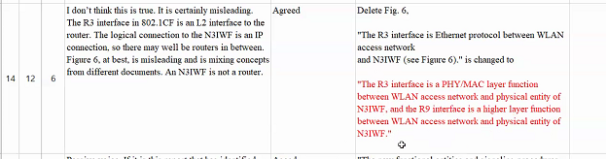
C: Why do we need to describe physical connections. The R3 is an ethernet connection between the access point and the N3IWF, it’s not relevant. What’s important is IP connection to N3IWF.
C: Some confusion between the relationship of R3 and R9. In Figure 4, R9 is a different interface than R3 and is not the next layer interface. What is the IP layer interface running over R3?
A: R3 is an L2 interface.
C: There may not be an L2 interface, there may be AP routers in-between.
C: Is there a higher layer protocol operating on R3.
A: While copying Figure 4 and Figure 6 text was omitted by accident.
C: We should stop describing R3. This could be simplified by stating it’s a multi-step process to get access to the N3IWF.
C: R9 is an 802.1CF.
C: 802.1CF Item – return to the protocol interface discussion. Not sure 3GPP defines interfaces as a protocol. 3GPP defines which protocols operation over specific interfaces --- all well-defined.
C: 3GPP may be using logical links.
C: 3GPP has logical links and interfaces.
C: Believe 3GPP interface is an API, like a protocol.
C: Box A communicates to Box B over the interface. The protocols are defined by the messages transmitted.
C: In IEEE 802 interfaces are between layers. Are the interfaces being used this way?
C: Believe the interfaces are used between Box A and Box B.
A: Believe the 3GPP is using the…….response as the interface. The reference point is the same interface.
C: Still some confusion with the interfaces with the group.
Chair: item #14 continue offline discussion on the email reflector to discuss with 802.1CF experts
C: Why did 802.1CF believe it useful to define R1 and R3. If they find it useful, why don’t we find it useful to discuss them.
Chair: Believe they were useful they were included in 802.1CFl. Needs additional discussion on the email reflector. Is this a good way forward? We can get the 802.1CF expert involved in the discussion.
Chair: 802.1CF is a standard stand-a-lone networking interface not specific to 3GPP – using general networking terms.
C: The “R” terminology are reference points in 3GPP documents (complex diagrams). The reference points are “interfaces” to boxes. “R” is an interface to a router and not the interface over-the-air.
C: R1 and R3 text are data flows and R8 and R9 are management flows. If correct additional sorting is needed. If R8 and R9 are on top of R1 and R3 – that’s a different approach. Still confused. Needs more off-line discussion.

For further discussion on the email reflector: The text discusses R1 and R3 as data flows and R8 and R9 as management or control. Does this match the 802.1CF concepts or are they 802.1CF layers? Needs to include 802.1CF experts.

Presenter: reviews comment #18 (below)
C: Agree with the added text for my comment, but it’s not addressing the comment. Cannot get access the 3GPP core without completing the scanning and association process.
C: Did no gap analysis that led to the recommendation for scanning and association.
Chair: Do we have a way forward?
C: Yes,
Chair: Hyun do you understand both commenter’s objections?
A: Yes,
C: Is there any action?
Chair: The issues are understood by the presenter and he will come back with another proposal. To promote progress, this discussion should continue on the reflector.

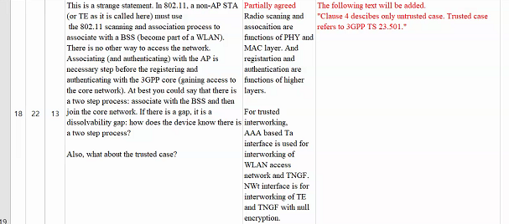

Presenter: reviewed comment #19

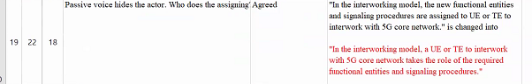
Presenter: reviewed comment #21
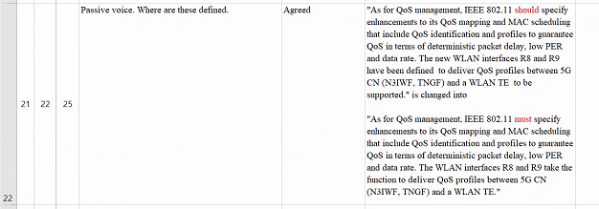

C: My comment was the 1st paragraph “The new WLAN Interfaces R8 and R9….” Why are they new interfaces? States have been defined. Where did R8 and R9 come from? Definition is not clear.
C: Comment #19 is related to Comment #21. Comment #19 fixes the passive voice issue. Need to fix the text content.
A: Understood, passive voice is relevant.
C: There are specific procedures and functionality that must be implemented in the UE and TE.
Chair: For the remaining 3 comments (19,20, &21) What statement we trying to make? How should we make the statement? There are differences of opinions. We need to discuss them and reach consensus on what is made here and how to sort them on the critical points. However, if there are no critical points these comments should be removed. Is this approach agreed?
A: Yes.

Chair: Hyun are there any critical things you need?
Hyun to clarify Robert’s comments and provide text changes. If text changes are agreed too, then the text changes will be made to the technical report. Discussion should continue on the AANI email reflector.

Chair: No motions for the closing plenary. Comment discussions are still open and the report not complete.

Chair:
Meeting Adjourned

from [V] Mark Hamilton Ruckus/CommScope to everyone: 7:47 PM
The terms "registration" and "authentication" have multiple meanings, depending on what layer is doing this. We need to clarify the differences.

- Administrative Aspects
Chair: Posted Doc 865r0 Reply LS draft statement on the 802.11 document server. It’s a rough draft. Please feel free to review the document. Please post comments on the email reflector or directly to the Discussion of this draft Reply LS should be had on the email reflector for group discussion.

- Future Session Planning
Chair: Four (4) sessions planned during the July plenary. Hopefully, most the issues will be discussed by email before the July meeting. Teleconferences planned and setup for May 25th. Plan to discuss the draft LS on the CC. If there is progress and topics to be discussed at the scheduled teleconferences they will be held as scheduled, if not they will be cancelled.
The teleconference starting time to 9AM ET, as the best compromise for Europe and Asia participation.

Agreed by the participants.

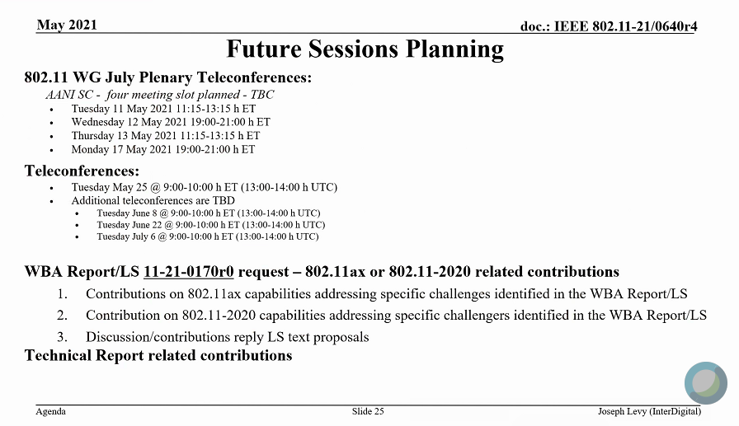

Chair: Any other business or issues?
No other business or issues

- The meeting adjourned at 20:58 h ET.

References:

