IEEE P802.11
Wireless LANs
TGbe Comment Resolutions for CID 3165
Date: 2021-05-10
Author(s):
Name | Affiliation | Address | Phone | Email
Eunsung Park | LG Electronics | 19, Yangjae-daero 11gil, Seocho-gu, Seoul 137-130, Korea |  | esung.park@lge.com
Dongguk Lim |  |  |  | dongguk.lim@lge.com
Jinyoung Chun |  |  |  | jiny.chun@lge.com
Jinsoo Choi |  |  |  | js.choi@lge.com
Youhan Kim | Qualcomm |  |  | youhank@qti.qualcomm.com
Brian Hart | Cisco |  |  | brianh@cisco.com

Abstract
This submission proposes resolutions for the comment of CID 3165:

Revisions:
- Rev 0: Initial version of the document.
- Rev 1: Revision based on the SP result and discussion

Interpretation of a Motion to Adopt

A motion to approve this submission means that the editing instructions and any changed or added material are actioned in the TGbe D0.3 Draft. This introduction is not part of the adopted material.

Editing instructions formatted like this are intended to be copied into the TGbe D0.4 Draft (i.e. they are instructions to the 802.11 editor on how to merge the text with the baseline documents).

TGbe Editor: Editing instructions preceded by “TGbe Editor” are instructions to the TGbe editor to modify existing material in the TGbe draft. As a result of adopting the changes, the TGbe editor will execute the instructions rather than copy them to the TGbe Draft.

CID 3165
CID | Clause | PP.LL | Comment | Proposed Change
3165 | 36.3.2.2 | 183.53 | "An EHT AP shall be able to allocate an RU or MRU on a 20 MHz channel within the BSS bandwidth in a 40 MHz, 80 MHz, 160 MHz, or 320 MHz EHT MU or EHT TB PPDU to a 20 MHz operating non-AP EHT STA."  This is up to the AP's scheduler. | Change "An EHT AP shall be able to allocate" to "An EHT AP may allocate".  Similar change at P184L10 and P184L32.

Discussion
From the non-AP EHT STA perspective, the following motion was passed.
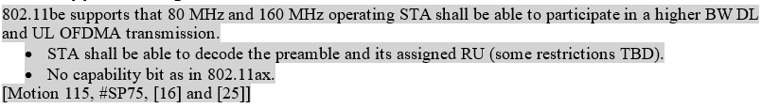

Based on the motion above, D0.4 states the following.
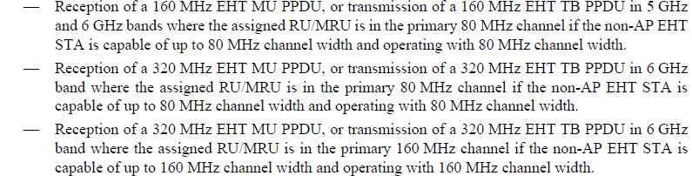

Also, for 20 MHz operating non-AP EHT STA, D0.4 states the following.
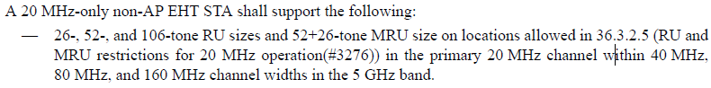

However, whether the EHT AP’s support for 20 / 80 / 160 MHz operating non-AP EHT STA in a wider bandwidth is mandatory or optional has not determined yet. To resolve CID 3165, we need to decide it, and thus, provide two options as follows.

Option 1: Similar to the non-AP EHT STA, EHT AP’s support for 20 / 80 / 160 MHz operating non-AP EHT STA in a wider bandwidth DL and UL OFDMA transmission is conditional mandatory, i.e., keep the original sentence.
An EHT AP shall be able to allocate an RU (see 36.3.2.1 (Subcarriers and resource allocation for wideband)) or MRU (see 36.3.2.3 (Subcarriers and resource allocation for multiple RUs)) on a 20 MHz channel within the BSS bandwidth in a 40 MHz, 80 MHz, 160 MHz, or 320 MHz EHT MU or EHT TB PPDU to a 20 MHz operating non-AP EHT STA.

Option 2: EHT AP’s support for 20 / 80 / 160 MHz non-AP EHT STA in a wider bandwidth is optional and it is depending on the AP’s scheduler, i.e., modify the corresponding sentence as the commenter suggests.
An EHT AP may allocate an RU (see 36.3.2.1 (Subcarriers and resource allocation for wideband)) or MRU (see 36.3.2.3 (Subcarriers and resource allocation for multiple RUs)) on a 20 MHz channel within the BSS bandwidth in a 40 MHz, 80 MHz, 160 MHz, or 320 MHz EHT MU or EHT TB PPDU to a 20 MHz operating non-AP EHT STA.

For reference,
IEEE SA Standards Style Manual (https://mentor.ieee.org/myproject/Public/mytools/draft/styleman.pdf) states
9. Standard language i.e., shall, should, may, and can
Mandatory requirements set within an IEEE standard are clearly distinguished by using specific standard
verbs—specifically, shall, should, may, and can.
Shall, should, may, and can are defined in 6.4.7 of the IEEE SA Standards Board Operations Manual.
The word shall indicates mandatory requirements strictly to be followed in order to conform to the standard
and from which no deviation is permitted (shall equals is required to).
Note that the word must is deprecated and shall not be used when stating mandatory requirements; must is used only to
describe unavoidable situations. The word will is deprecated and shall not be used when stating mandatory
requirements; will is only used in statements of fact.
The word should indicates that among several possibilities, one is recommended as particularly suitable
without mentioning or excluding others; or that a certain course of action is preferred but not necessarily
required (should equals is recommended that).
The word may is used to indicate a course of action permissible within the limits of the standard (may
equals is permitted to).
The word can is used for statements of possibility and capability, whether material, physical, or causal (can
equals is able to)

SP: Which option do you prefer?
Option 1 / Option 2 / Abstain: 26 / 18 / 17

Based on the SP result, I propose the resolution for CID 3165 as follows.

Resolution
Revised

We agreed that EHT AP’s support for 20 / 80 / 160 MHz operating non-AP EHT STA in a wider bandwidth DL and UL OFDMA transmission is mandatory in 21/0786r0. Also, we need a sentence to clarify that this support is depending on AP’s capability.

TGbe editor to make the changes shown in 11-21/0786r1.
TGbe Editor: Please make the following changes in the third paragraph of 36.3.2.2 Support of wide bandwidth OFDM operationg of D0.4:
A 20 MHz operating non-AP EHT STA supports 26-tone RU, 52-tone RU, 106-tone RU, 242-tone RU 52+26-tone MRU, and 106+26-tone MRU in locations allowed in 36.3.2.5 (RU and MRU restrictions for 20 MHz operation(#3276)) when participating in EHT DL and UL OFDMA transmissions with PPDU bandwidth larger than 20 MHz. An EHT AP shall be able to allocate an RU (see 36.3.2.1 (Subcarriers and resource allocation for wideband)) or MRU (see 36.3.2.3 (Subcarriers and resource allocation for multiple RUs)) on a 20 MHz channel within the BSS bandwidth in a 40 MHz, 80 MHz, 160 MHz, or 320 MHz EHT MU or EHT TB PPDU to a 20 MHz operating non-AP EHT STA depending on an AP’s operating channel width.

TGbe Editor: Please make the following changes in the seventh paragraph of 36.3.2.2 Support of wide bandwidth OFDM operationg of D0.4:
An 80 MHz operating non-AP EHT STA shall be able to participate in 160 MHz and 320 MHz, EHT DL and UL OFDMA transmissions. An EHT AP shall be able to allocate an RU (see 36.3.2.1 (Subcarriers and resource allocation for wideband) or MRU (see 36.3.2.3 (Subcarriers and resource allocation for multiple RUs)) on one 80 MHz channel within the BSS bandwidth in a 160 MHz or 320 MHz EHT MU or EHT TB PPDU to an 80 MHz operating non-AP EHT STA depending on an AP’s operating channel width.

TGbe Editor: Please make the following changes in the eleventh paragraph of 36.3.2.2 Support of wide bandwidth OFDM operationg of D0.4:
A 160 MHz operating non-AP EHT STA shall be able to participate in 320 MHz EHT DL and UL OFDMA transmissions. An EHT AP shall be able to allocate an RU or MRU on the primary 160 MHz channel within the BSS bandwidth in a 320 MHz EHT MU or EHT TB PPDU to a 160 MHz operating non-AP EHT STA depending on an AP’s operating channel width.

