IEEE P802.11
Wireless LANs
Reference Correction in 36.3.12.2.2
Date: 2021-04-28
Author(s):
Name | Affiliation | Address | Phone | email
Genadiy Tsodik | Huawei
Wook Bong Lee | Samsung

Abstract
This submission proposes text updates on P802.11be D0.4 to resolve a wrong reference in subclause 36.3.12.2.2.

NOTE – Set the Track Changes Viewing Option in the MS Word to “All Markup” to clearly see the proposed text edits.

Revision History:

R0: Initial version.

Discussion

In D0.4 P322, the subclause 36.3.12.2.2 comprises:

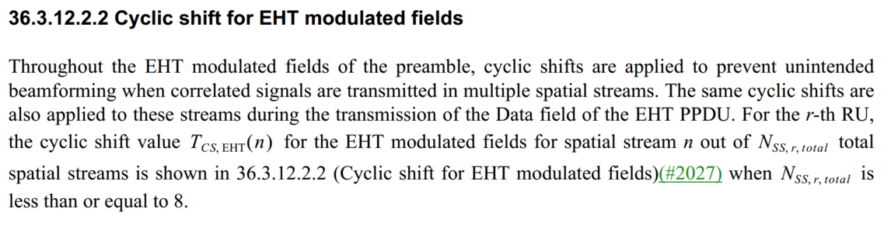
The reference mentioned in the subclause refers to the subclause itself.

Proposed Text Update

As this reference intends to specify the Cyclic Shift values for Nss,r,total less than or equal to 8, we can refer to the relevant table of D8.0 P802.11ax.

Instruction to Editor: Update subclause 36.3.12.2.2 in D0.4 as shown below.

36.3.12.2.2 Cyclic shift for EHT modulated fields

Throughout the EHT modulated fields of the preamble, cyclic shifts are applied to prevent unintended
beamforming when correlated signals are transmitted in multiple spatial streams. The same cyclic shifts are
also applied to these streams during the transmission of the Datafield of the EHT PPDU. For the r-th RU,
the cyclic shift value T_{CS,EHT}(n) for the EHT modulated fields for spatial stream n out of N_{ss,r,total} total
spatial streams is shown in
Table 21-11 (Cyclic shift values for the VHT modulated fields of a
PPDU) when N_{ss,r,total} is less than or equal to 8.

