IEEE P802.11  
Wireless LANs

|  |  |  |  |  |
| --- | --- | --- | --- | --- |
| Proposed Resolution for REVme CC35 Editor1 ad-hoc Comments | | | | |
| Date: 2021-07-12 | | | | |
| Author: | | | | |
| Name | Affiliation | Address | Phone | Email |
| Emily Qi | Intel Corporation | 2111 NE 25th Ave.  Hillsboro OR 97124 |  | Emily.h.qi@intel.com |

##### This submission present proposed resolutions for comments in the Editor1 ad-hoc group.

##### The proposed changes are based on REVme/D0.0.

##### Revision history:

##### R0 – initial version

R1 –

R2 – Incorporated feedback from TGme teleconferences on 5/13 and 5/24

R3 - Incorporated feedback from TGme teleconferences on 6/21.

R4 – Updated the resolution for CID 571.

|  |  |  |  |  |  |
| --- | --- | --- | --- | --- | --- |
| CID | Clause | Page | Line | Comment | Proposed Change |
| 258 | 3.2 |  |  | There is no need for definitions of "individually addressed bufferable unit" and "group addressed bufferable unit"; these follow from the definitions of "bufferable unit" and "individually addressed"/"group addressed" | Delete the definitions referred to |

***Discussion:***

We have the definition for bufferable unit (BU), but not for "individually addressed" or "group addressed".

Therefore, we still need these definitions.

At 176.34:

bufferable unit (BU): A medium access control (MAC) service data unit (MSDU), aggregate MAC service  
data unit (MSDU) [quality-of-service (QoS) stations (STAs) only], or bufferable MAC management  
protocol data unit (MMPDU)

At 182.24:

group addressed bufferable unit (BU): A group addressed medium access control (MAC) service data unit  
(MSDU) or group addressed bufferable MAC management protocol data unit (MMPDU).

At 184.39:

individually addressed bufferable unit (BU): An individually addressed medium access control (MAC)  
service data unit (MSDU), individually addressed aggregate MAC service data unit (A-MSDU) [quality-ofservice (QoS) stations (STAs) only], or individually addressed bufferable MAC management protocol data  
unit (MMPDU).

Discussion on 5/13:

group addressed and individually addressed are defined in 3.1

**group addressed:** When applied to a medium access control (MAC) service data unit (MSDU), it is an  
MSDU with a group address as the destination address (DA). When applied to a MAC protocol data unit  
(MPDU), it is an MPDU with a group address in the Address 1 field. *Syn*: **multicast**

**individually addressed:** When applied to a medium access control (MAC) service data unit (MSDU), it is  
an MSDU with an individual address as the destination address (DA). When applied to a MAC protocol data  
unit (MPDU), it is an MPDU with an individual address in the Address 1 field. *Syn:* **directed, unicast**

***Proposed resolution:***

Accepted.

==================

|  |  |  |  |  |  |
| --- | --- | --- | --- | --- | --- |
| CID | Clause | Page | Line | Comment | Proposed Change |
| 312 | 9.3.3.11 | 874.00 |  | "FFE field" should be "FFE" when it refers to the (crypto) element, not the field containing it | Fix in Table 9-40--Authentication frame body |

***Discussion:***

N/A

***Proposed resolution:***

Accepted.

Note to the editor, the location is at 874.6

=========

|  |  |  |  |  |  |
| --- | --- | --- | --- | --- | --- |
| CID | Clause | Page | Line | Comment | Proposed Change |
| 313 | 9.3.3.11 | 878.00 |  | "Finite Cyclic Group" needs a "field" afterwards | Fix in Table 9-41--Presence of fields and elements in Authentication frames (2x in "The Finite Cyclic Group is present if") |

***Discussion:***

N/A.

***Proposed resolution:***

Accepted.

Note to Editor: Locations are 878.9 and 878.40

====

|  |  |  |  |  |  |
| --- | --- | --- | --- | --- | --- |
| CID | Clause | Page | Line | Comment | Proposed Change |
| 571 | 9.4.1.9 | 900 |  | The term "advertisement server" should be capitalised | Change "advertisement server" to "Advertisement Server". Also at P901L13, P2381L11, P2388L11, P2396L5, P2396L6, P2396L32 |

***Discussion:***

According to the Editorial Style Guide, proper names of entities outside 802.11 may use capotal letters. Generally, follow whatever appears to be the prevailing custom.

The “advertisement server” is an entity name outside 802.11. It is used as “Advertisement Server”, also shown in other 44 instances in D0.0.

Here are additional locations: 175.30; 181.50, 181.52, 4558.27.

Discussion on 5/13:

“advertisement server” was introduced in 11u. it was introduced by 802.11. It is not an entity outside 802.11.

Therefore, “advertisement server” should be used.

More discussion. Emily to talk to Stephen.

7/12: Feedback from Stephen: agree to change all occurrences of "Advertisement Server" to "advertisement server".

***Proposed resolution:***

Revised.

Change all instances in D0.1 (except the instances on page 2567 &2568) of "Advertisement Server" to "advertisement server". Total instances are 41.

On Page 2567 & 2568 of D0.1, change "Advertisement Server" to “"Advertisement server". 3 instances in figure 11-40, figure 11-41 and figure 11-42.

~~Change "advertisement server" to "Advertisement Server" at 900.62, P901L13, P2381L11, P2388L11, P2396L5, P2396L6, P2396L32, 175.30; 181.50, 181.52, 4558.27.~~

======

|  |  |  |  |  |  |
| --- | --- | --- | --- | --- | --- |
| CID | Clause | Page | Line | Comment | Proposed Change |
| 294 | 9.4.2.21.7 | 1044.00 |  | The "might"s here are actually "may"s. Since "may" are not allowed in Clause 9, reword as "In this case, some of the elements included in the Reported FrameBody subelement might be truncated, and the subelement itself might be truncated or fragmented overmultiple Beacon Reports when its size exceeds the maximum element size, as described below:-- Truncation of Reported TIM elements such that only the first 4 octets of theelement are reported and the element Length field is modified to indicate the truncated length of 4." etc. | As it says in the comment |

***Discussion:***

The location is 1044.14, as shown:

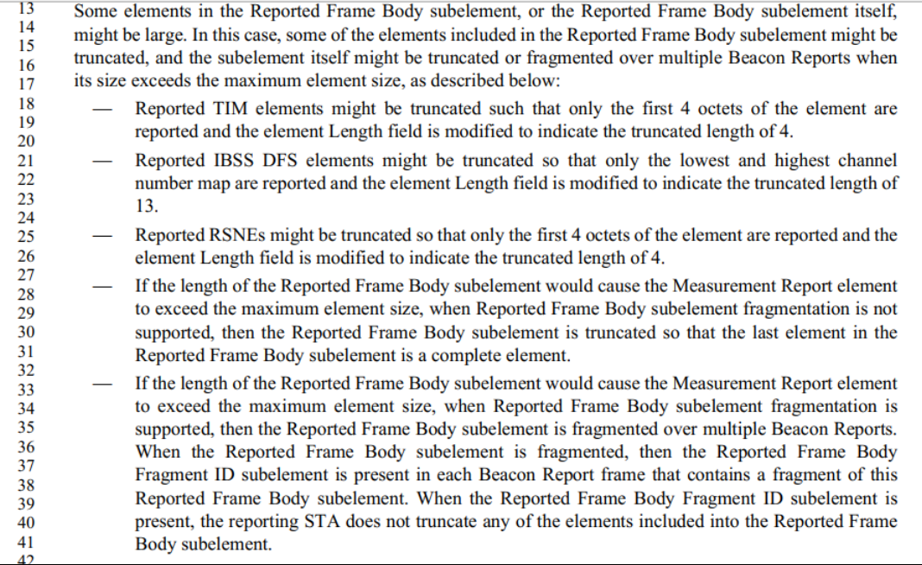

The proposed resolution is to change “Reported TIM elements might be truncated” to “Truncation of Reported TIM elements”.

I believe the commenter suggested a similar change to line 21 and line 25.

Discussion on 5/13:

Need more discussion.

Assign the comment to Mark R.

***Proposed resolution:*** Revised.

At 1044.18, change “Reported TIM elements might be truncated” to “Truncation of Reported TIM elements”.

At 1044.21, change “Reported IBSS DFS elements might be truncated” to “Truncation of IBSS DFS elements”

At 1044.25, change “Reported RSNEs might be truncated” to “Truncation of RSNEs”.

========

|  |  |  |  |  |  |
| --- | --- | --- | --- | --- | --- |
| CID | Clause | Page | Line | Comment | Proposed Change |
| 36 | 3.4 | 204.00 |  | The PTID acronym was introduced by 802.11ah but does not have an entry in Section 3.4. There is a reference in 9.8.3.1 Frame Control field to the PTID/Subtype field which says: The 3 LSBs of the TID as defined in 9.2.4.5.2 (TID subfield) for PV1 QoS Data frames (Type fieldequal to 0 and 3) transmitted by a QoS STA. | Add the following entry to Section 3.4 Acronyms and abbreviations: PTID partial TID (the 3 LSBs of a TID) |

***Discussion:***

There are 14 instances of PTID in D0.0.

I think we should add PTID acronym in 3.4:

PTID partial TID (the 3 LSBs of a TID)

This comment is similar to CID 229 as discussed on 5/24.

***Proposed resolution:***

Accepted.

Note to Editor: At 213.2, add “PTID partial TID (the 3 LSBs of a TID)”.

====

|  |  |  |  |  |  |
| --- | --- | --- | --- | --- | --- |
| CID | Clause | Page | Line | Comment | Proposed Change |
| 346 | 9.7 | 1673.00 |  | It's a bit weird to have a dedicated subclause 9.7.2 MPDU delimiter CRC field. If anything, it should be a subclause of 9.7.1 A-MPDU format, and there should be one for the MPDU delimiter MPDU Length field too. | As it says in the comment |

***Discussion:***

No issue was identified in the comment. Subclause 9.7 has been structured in this way since Std 802.11-2012.

At 1673.11, 1672.51, delete: (see 9.7.2 (11MPDU delimiter CRC field)

At 1673.55 delete the subclause title: **9.7.2 MPDU delimiter CRC field**

***Proposed resolution:***

Revised.

At 1673.55 delete the subclause title: 9.7.2 MPDU delimiter CRC field

At 1673.11, 1672.51, delete: (see 9.7.2 (11MPDU delimiter CRC field)

===

|  |  |  |  |  |  |
| --- | --- | --- | --- | --- | --- |
| CID | Clause | Page | Line | Comment | Proposed Change |
| 427 | 9.8.3.1 | 1679.00 |  | "-- The 3 LSBs of the TID as defined in 9.2.4.5.2 (TID subfield) for PV1 QoS Data frames (Type field equal to 0 and 3) transmitted by a QoS STA.-- The Subtype for PV1 Control frames (Type subfield equal to 2) as described in 9.8.4 (PV1 Control frames).-- The Subtype for PV1 Management frames (Type subfield equal to 1) as described in 9.8.5 (PV1 Management frames)."-- is it a type or a subtype? Or a field or a subfield? | As it says in the comment |

***Discussion:***

Cited text is at 1679.5:

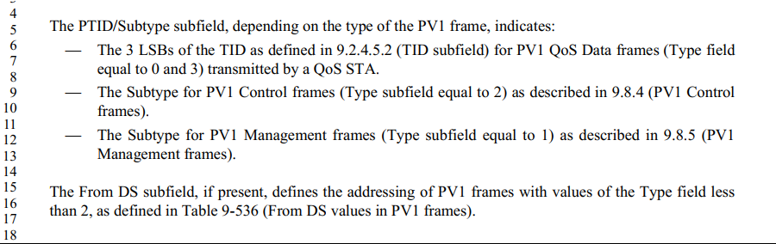

Here are the field and subfields:

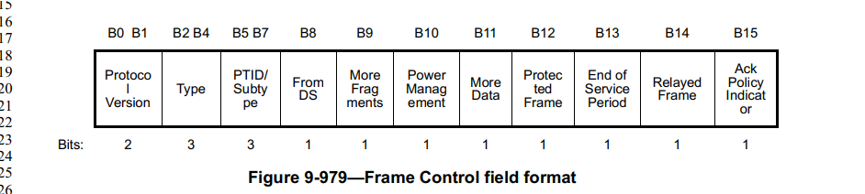

There are Type (B2-B4) and Subtype (B5-B7).

The Frame Control field is a “field”. The rest should be a subfield.

The cited text looks clear to me.

Change “Subtype” to “subtype” at 1679.9 and 1679.12.

***Proposed resolution:***

Revised.

Change “Subtype” to “subtype” at 1679.9 and 1679.12.

At 1679.6, change “Type field  
 to “Type subfield”.

***=======***

|  |  |  |  |  |  |
| --- | --- | --- | --- | --- | --- |
| CID | Clause | Page | Line | Comment | Proposed Change |
| 557 | 9.4.2.22 | 1084.00 |  | Quiet element is also present in the DMG Beacon frame. | The Quiet element is optionally present in Beacon frames, as described in 9.3.3.2 (Beacon frame format), DMG Beacon frames, as described in 9.3.4.2 (DMG Beacon frame format), and Probe Response frames, as described in 9.3.3.10 (Probe Response frame format). |

***Discussion:***

According to section 2.4.3, the Editorial Style Guide:

When defining a new element, as a general rule, do not list the frames that carry the element as part of element definition, and only list the element in the body of each of those frames that can include the element. Listing the frames that can carry the element is duplicate information (it can be inferred from frame definitions), and subject to inconsistencies over iterations of the specifications. Notable exception is when element definition depends on the frame it is carried in.

However, some of elements created in REVmb still include a para at the end of the element definition subclauses, like: (at 1084.18)

“The Quiet element is optionally present in Beacon frames, as described in 9.3.3.2 (Beacon frame format),

and Probe Response frames, as described in 9.3.3.10 (Probe Response frame format). The use of Quiet

elements is described in 11.8.3 (Quieting channels for testing).”.

Suggest this para (at 1084.18) is changed to:

“The use of Quiet elements is described in 11.8.3 (Quieting channels for testing).”.

I did quickly check with other element definitions, and found the similar issues in

**9.4.2.13 Power Constraint element**

**9.4.2.14 Power Capability element**

**9.4.2.15 TPC Request element**

**9.4.2.16 TPC Report element**

**9.4.2.17 Supported Channels element**

**9.4.2.18 Channel Switch Announcement element**

**9.4.2.23 IBSS DFS element**

Should we do the same modification for above subclauses?

***Proposed resolution:***

Revised.

TBD

======

|  |  |  |  |  |  |
| --- | --- | --- | --- | --- | --- |
| CID | Clause | Page | Line | Comment | Proposed Change |
| 125 | 9.6.15.2.2 | 1609.00 |  | Subclause 9.6.15.2.2 explains Mesh Peering Open frame format. However, many of the information elements contained in the frame are not explained as done in other subclauses. Also, Table 9-436 does not show MIC element, OCI element, and Authenticated Mesh Peering Exchange element, where as there are some mentioning on these elements in the subclause. It is very confusing how the Mesh Peering Open frame shall be formatted. | In subclause 9.6.15.2.2 (Mesh Peering Open frame details), add paragraphs explaining what the elements in table 9-436 are. Clarify how the MIC element and OCI element present in the frame. Add pointer to subclause 9.3.3.13 (Action frame format) to clarify the use of Authenticatd Mesh Peering Exchange element. |
| 126 | 9.6.15.3.2 | 1611.00 |  | Subclause 9.6.15.3.2 explains Mesh Peering Confirm frame format. However, many of the information elements contained in the frame are not explained as done in other subclauses. Also, Table 9-437 does not show MIC element, OCI element, and Authenticated Mesh Peering Exchange element, where as there are some mentioning on these elements in the subclause. It is very confusing how the Mesh Peering Confirm frame shall be formatted. | In subclause 9.6.15.3.2 (Mesh Peering Confirm frame details), add paragraphs explaining what the elements in table 9-437 are. Clarify how the MIC element and OCI element present in the frame. Add pointer to subclause 9.3.3.13 (Action frame format) to clarify the use of Authenticatd Mesh Peering Exchange element. |
| 127 | 9.6.15.4.2 | 1612.00 |  | Subclause 9.6.15.4.2 explains Mesh Peering Close frame format. However, many of the information elements contained in the frame are not explained as done in other subclauses. Also, Table 9-438 does not show MIC element, OCI element, and Authenticated Mesh Peering Exchange element, where as there are some mentioning on these elements in the subclause. It is very confusing how the Mesh Peering Confirm frame shall be formatted. | In subclause 9.6.15.4.2 (Mesh Peering Close frame details), complete paragrphs explaining what the elements in table 9-438 are, i.e. what are the Mesh ID and the Mesh Peering Management. Clarify how the MIC element present in the frame. Add pointer to subclause 9.3.3.13 (Action frame format) to clarify the use of Authenticatd Mesh Peering Exchange element. |

***Discussion:***

These comments should be a MAC comment, a submission is required.

Need a direction from the group.

In subclause 9.6.15.2.2 (Mesh Peering Open frame details), add paragraphs explaining what the elements in table 9-436 are.

* There is no need to add explanation. Similar to the other management frame body, see the Beacon frame body, or,
* Add reference in the Note column?

Clarify how the MIC element and OCI element present in the frame.

* in table 9-436, add three rows at the bottom of the table:
  + Last -2/OCI/...
  + Last -1/MIC/reference
  + Last/ Authenticatd Mesh Peering Exchange element/reference

Add pointer to subclause 9.3.3.13 (Action frame format) to clarify the use of Authenticatd Mesh Peering Exchange element.

🡺not needed if we add them to the table.

Remove the paragraphes at 1612.27 and 1612.33.

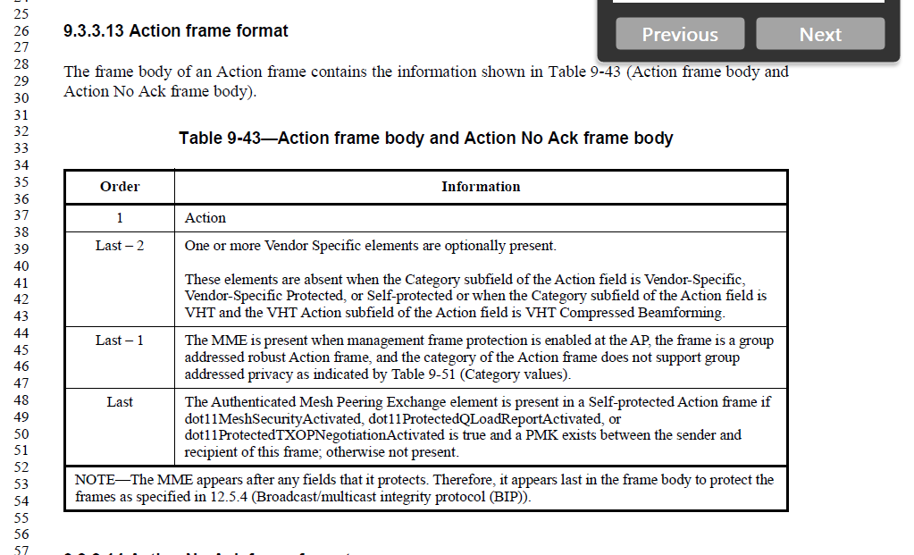

***Proposed resolution:***

***TBD***

====

=====

|  |  |  |  |  |  |
| --- | --- | --- | --- | --- | --- |
| CID | Clause | Page | Line | Comment | Proposed Change |
| 475 |  | 3.4 |  | "Common Advertisement Group" should be lowercase. Ditto last word of "CTR with CBC-MAC Protocol", and probably others in Subclause 3.4 | As it says in the comment |

***Discussion:***

According to the Editorial Style Guide, proper names of entities outside 802.11 may use capotal letters. Generally, follow whatever appears to be the prevailing custom.

Is “Common Advertisement Group” a proper name of entity outside 802.11?

If yes, no need to change it.

I also found some other instances:

at 206.28, change "CTR with CBC-MAC Protocol" to "CTR with CBC-MAC protocol".

At 206.36, change "Company ID" to "company ID".

at 208.57, change "Galois/Counter Mode Protocol" to "Galois/counter mode protocol".

***Proposed resolution:***

REVISED.

at 206.14, change "Common Advertisement Group" to "common advertisement group" ??

at 206.28, change "CTR with CBC-MAC Protocol" to "CTR with CBC-MAC protocol".

At 206.36, change "Company ID" to "company ID".

at 208.57, change "Galois/Counter Mode Protocol" to "Galois/counter mode protocol".

|  |  |  |  |  |  |
| --- | --- | --- | --- | --- | --- |
| CID | Clause | Page | Line | Comment | Proposed Change |
| 339 | 9.4.2.24.1 |  |  | The RSNE examples have random commas. | Add a comma before "//" in all but the last line of each example. Remove the comma before "//" in the last line of each example, if present |

***Discussion:***

N/A

***Proposed resolution:***

Accpeted.

Note to Editor:

Add a comma at 1085.54, 1085.65, 1086.16, 1086.21, 1086.22, 1086.23, 1086.35, 1086.36, 1086.37.

Remove the comma at 1086.38.

=====

=====

|  |  |  |  |  |  |
| --- | --- | --- | --- | --- | --- |
| CID | Clause | Page | Line | Comment | Proposed Change |
|  |  |  |  |  |  |
|  |  |  |  |  |  |

***Discussion:***

***Proposed resolution:***