IEEE P802.11
Wireless LANs
TGbe D0.3 Comment Resolutions
for Restricted TWT SP
Date: 2021-04-15
Author(s):
Name | Affiliation | Address | Phone | email
SunHee Baek | LG Electronics | 19, Yangjae-daero 11gil, Seocho-gu, Seoul 137-130, Korea |  | sunhee.baek@lge.com
Insun Jang |  |  |  | Insun.jang@lge.com
Namyeong Kim |  |  |  | namyeong.kim@lge.com
Jinsoo Choi |  |  |  | js.choi@lge.com
Chunyu Hu | Facebook | 1 Hacker Way, Menlo Park, CA 95034 |  | chunyuhu07@gmail.com
Muhammad Kumail Haider |  |  |  | haiderkumail@fb.com
Boyce Bo Yang | Huawei | Nanjing, China |  | Yangbo59@huawei.com

Abstract
This submission proposes resolutions for one comment regarding restricted TWT with the following CID (1 CID):
- 2922

Revisions:
- Rev 0: Initial version of the document.
- Rev 1: Add additional discussion point and update based on 11be Draft D1.0
- Rev 2: Modify some texts of the further discussion/propose and update based on 11be Draft D1.01.

Interpretation of a Motion to Adopt

A motion to approve this submission means that the editing instructions and any changed or added material are actioned in the TGbe Draft. This introduction is not part of the adopted material.

Editing instructions formatted like this are intended to be copied into the TGbe Draft (i.e. they are instructions to the 802.11 editor on how to merge the text with the baseline documents).

TGbe Editor: Editing instructions preceded by “TGbe Editor” are instructions to the TGbe editor to modify existing material in the TGbe draft. As a result of adopting the changes, the TGbe editor will execute the instructions rather than copy them to the TGbe Draft.

TGbe editor: Please note that baseline is D1.01

CID | Commenter | Assignee | Comment | Proposed Change | Resolution
2922 | SunHee Baek | Chunyu Hu, SunHee Baek | (The part of PDT about quality of service for latency sensitive traffic was approved, and a motion of SP#1 about restricted TWT in 20/1046r11 was passed.) If the starting time of the restricted TWT is postponed, the scheduled total duration of restricted SP is shortened. In this case, the later part of latency sensitive traffic cannot be finished within the remaining time of the SP. | If the STA doesn't stop its TXOP, the starting time of restricted TWT SP shall be postponed and ending time may be postponed (extended). (A related proposal will be presented_21/0091) | Revised  The start time of the restricted TWT SP can be affected by the LL traffic pattern, the preceding TXOP of the STA that does not support the restricted TWT, or OBSS. So the end time of the restricted TWT SP may be extended.  By extending the end time of the restricted TWT SP, the low latency STA can have enough of the medium access time for transmitting the latency sensitive data/traffic.  If the end time is extended, the modified duration of the TWT SP cannot exceed over the original duration of the TWT SP.  TGbe editor, please make changes as shown in doc 11-21/0672r2 tagged as CID 2922
Discussion:
The comment of CID 2922 is about end time of the restricted TWT SP. The start time of the restricted TWT SP can be affected because the WM is busy or transmission of low latency data/traffic is sometimes unpredictable or has randomness. The start time means to start exchange of latency sensitive data/traffic between AP and STA, which means the SP doesn’t move backward itself. For example, the STA that does not support the restricted TWT and does not obtain the announcement of the restricted TWT SP from the associated AP may keep its TXOP. Also, we can consider the TXOP is operating in the OBSS during the restricted TWT SP. The total duration of the restricted TWT SP is reduced, which may not be able to provide enough time for the latency sensitive data/traffic delivery. To meet latency sensitive traffic requirement, a mechanism is needed to have enough of the medium access time. The comment of CID 2922 suggests that the end time of the restricted TWT SP can be extended when the start time is affected because of the busy WM.
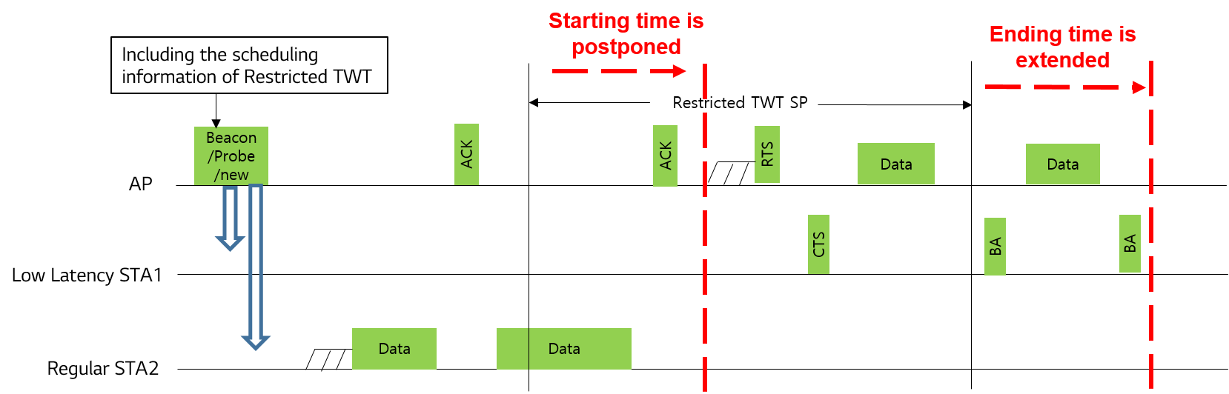
The other discussion point is how to extend the end time of the restricted TWT SP. There can be two options to signaling of the extension from AP to the member STAs; 1) TWT Setup Command in Unsolicited TWT Setup Action frame, and 2) TWT information field. After AP announces the extension, the each STA recalculates the AdjustedMinimumTWTWakeDuration based on the extended TWT SP, which is needed to redefine it to apply in this case. And then, the STA follows the power save rule of the AdjustedMinimumTWTWakeDuration (26.8.5 in 11ax).
- Option 1) Apply TWT Setup Command in Unsolicited TWT Setup Action frame
  - If the member STAs received the unsolicited TWT setup action frame with a particular command number during the restricted TWT SP, the STAs can get information like extension of the TWT SP, the modified end time of the TWT SP, and so on.
- Option 2) Apply TWT information field
  - AP includes information related to the extension of the restricted TWT SP through new fields in the TWT information field. Or if receiving the TWT information field including parficular values in All TWT subfield and Next TWT subfield during the restricted TWT SP, STA recognizes the extension of the restricted TWT and gets information like the modified end time of the TWT SP, etc.

Further Discussion:
The extension are applied only to member STAs that support restricted TWT(rTWT) and let them understand. If there is scheduled any TWT SP and some possibility to overlap with the scheduled TWT SP, the rTWT SP extension shall not be allowed, which is a restriction of the rTWT SP extension.

Issue 1: Necessity of recognizing the extension of rTWT SP by non-member STA
I suppose that the non-member STAs, which do not support rTWT or any TWT mechanism, don’t need to know the rTWT’s extension; although we define a new signaling method for the extension, they also can’t understand what means the signaling.
- If the STAs support TWT mechanism(not rTWT), they will go to doze state except during allocated SP to the STAs.
- If the STAs don’t support TWT mechanism, they will access the channel by using EDCA during the rTWT SP by following baseline.
Moreover, we’ve defined quite interval by aligning the start time of the rTWT SP, which is another method. That is, I expect the non-member STAs have to follow the baseline.

Issue 2: Unfairness on channel access during extended SP
The unfairness is about that the rTWT SP extension gives low latency STA higher priority to delivery latency sensitive traffic(LLD). My intension to extend rTWT SP is to take enough time to transmit/receive LLD between AP and STA, especially to be exchanged in the corresponding SP in terms of LL service (not to give high priority to the STA). The rTWT SP extension is expected that LLD can be shared in enough time when the start time of rTWT is delayed and the duration of rTWT SP is shorten.
I considered two perspectives in this CR as followings;
- 1) Expect that the most of other rTWT STAs to which the SP is not allocated go to doze state and remain in the state during the rTWT SP
- 2) A restriction of rTWT SP extension, that is, if there is scheduled individual/broadcast/restricted TWT SP and some possibility to overlap with the scheduled TWT SP, the rTWT SP extension shall not be allowed.

Issue 3: Overhead of rTWT extension signaling
I am considering the signalling method based on unsolicited TWT setup action frame, TWT information field, and Trigger frame, etc. Although an overhead issue can be followed due to the announcement of rTWT extension, I suppose that overhead can be reduced if the method uses the existing field or frame and satisfies the basic requirement of the low latency STA’s transmission. For example, the announcement of rTWT SP extension can be included in broadcast RU when DL MU PPDU is transmitted. And we can use the usage of a special User Info field in the Trigger frame. (The method of Trigger frame is needed to review more since some limitations.)

Propose:
35.7.4 Channel access rules for restricted TWT service periods
35.7.4.1 General
A non-AP EHT STA with dot11RestrictedTWTOptionImplemented set to true as a TXOP holder shall ensure the TXOP ends before the start of any restricted TWT service periods if the TXOP is obtained outside of a restricted TWT service period.
TGbe editor: Please add the new paragraph
The end time of a restricted TWT service period may be extended when latency sensitive traffic is not able to be completely transmitted within the rTWT service period. The maximum extended duration shouldn’t exceed the overlapped duration between the end time of the overlapping TXOP and the start time of the restricted TWT service period. The r-TWT scheduling AP should not allow the restricted TWT service period to be extended to overlap with any already scheduled individual/broadcast or other restricted TWT service periods. (#2922)
Note: The TXOP of the STA with dot11RestrictedTWTOptionImplemented set to false or operating in the OBSS during the restricted TWT service period may make the WM scheduled for the restricted TWT service period busy.
Note: During the (extended) restricted TWT service period, the STA with dot11RestrictedTWTOptionImplemented set to true follows the procedure described in 26.8.5 (Power save operation during TWT SPs) to determine if the restricted TWT service period termination event has occurred and may enter doze state.

