IEEE P802.11
Wireless LANs
Resolution for CIDs related to MLO Discovery (CC 34)
Date: April 10, 2021
Author(s):
Name | Affiliation | Address | Phone | email
Abhishek Patil | Qualcomm Inc. |  |  | appatil@qti.qualcomm.com
Gaurang Naik
George Cherian
Alfred Asterjadhi
Duncan Ho
Yanjun Sun
Rojan Chitrakar | Panasonic
Rajat Pushkarna
Laurent Cariou | Intel
Tomo Adachi | Toshiba
Insun | LGE
Namyeong
Srinivas Kandala | Samsung
Pascal Viger | Canon
Arik Klein | Huawei
Stephen McCann

Abstract
This submission proposes resolutions for following 2 CIDs received for TGbe CC34: 1037, 2962

Revisions:
- Rev 0: Initial version of the document.
- Rev 1: Revised based on feedback from various members (added as co-authors)
- Rev 2: Additional updates based on offline feedback from various members
- Rev 3: Addition updates based on offline feedback from Arik
  - Includes description text for examples shown in Figure 35-xx5
- Rev 4: Addition updates based on offline feedback from Arik
- Rev 5:
  - Baseline updated to D1.0 and approved doc 11-21/0255r6.
  - Added clarification in 35.3.18.2 that inheritance is applied only when the profile carries complete information
  - Minor updates based on offline feedback
- Rev 6: Minor updates based on additional feedback from Laurent
  - Fixed typo in clause reference (26.17.2.3.3)
  - Clarified that STA Profile field is not carried when ML probing request complete info (consistent with D1.0)

Interpretation of a Motion to Adopt

A motion to approve this submission means that the editing instructions and any changed or added material are actioned in the TGbe Draft. This introduction is not part of the adopted material.

Editing instructions formatted like this are intended to be copied into the TGbe Draft (i.e. they are instructions to the 802.11 editor on how to merge the text with the baseline documents).

TGbe Editor: Editing instructions preceded by “TGbe Editor” are instructions to the TGbe editor to modify existing material in the TGbe draft. As a result of adopting the changes, the TGbe editor will execute the instructions rather than copy them to the TGbe Draft.

CID | Commenter | Section | Pg/Ln | Comment | Proposed Change | Resolution
1037 | Abhishek Patil | 35.3.2.3 | 128.32 | The spec text needs to provide details of the operation for various scenarios:  1. Contents of Beacon frame from TxBSSID  2. non-ML probe response frame sent in response to a broadcast/wildcard non-MLO probe request frame  3. non-ML probe response frame sent in response to a non-ML probe request frame directed to a particular BSSID: case 1) directed to TxBSSID, case 2) directed to a nonTxBSSID  4. ML probe response frame sent in response to a ml probe request frame directed to a particular BSSID. case 1) directed to TxBSSID, case 2) directed to a nonTxBSSID  It will help to show call-flows for each case. | The commenter will provide a contribution | Revised  Agree with the comment. A new subclause is added to clause 35.3.4 to describe sequence of frame exchanged and the different alternatives that a non-AP MLD can follow to discover complete information of an AP MLD and its affiliated APs. The clause also provides high-level summary of the elements that provide information related to MLO discovery carried in each frame. A corresponding clause was added to 35.3.18 to cover the case of MLO discovery when the transmitting AP is a member of a multiple BSSID set.  TGbe editor, please implement changes as shown in doc 11.21/0650r6 tagged 1037
2962 | Tomoko Adachi | 9.4.2.295b.2 | 0.00 | At an AP MLD, information of all the links needs to be provided during discovery. | As in comment. | Revised  Agree with the comment. A new subclause is added to clause 35.3.4 to describe sequence of frame exchanged and the different alternatives that a non-AP MLD can follow to discover complete information of an AP MLD and its affiliated APs. The clause also provides high-level summary of the elements that provide information related to MLO discovery carried in each frame. A corresponding clause was added to 35.3.18 to cover the case of MLO discovery when the transmitting AP is a member of a multiple BSSID set.  TGbe editor, please implement changes as shown in doc 11.21/0650r6 tagged 2962

TGbe editor: Please note baseline is 11be D1.0 and approved doc 11-21/0255r6.

TGbe editor: Please insert the following (new) subclause under clause 35.3.4 as shown below:
35.3.4.xx Frame sequence during MLO discovery
This subclause provides a brief description of the sequence of frames exchanged between a STA affiliated with a non-AP MLD and an AP affiliated with an AP MLD when the AP operating on the link is not a member of a multiple BSSID set. The sequence of frame exchanges and their content for the case where the AP on the link is a member of a multiple BSSID set is described in 35.3.18.xx (Frame sequence during MLD discovery for an AP in a multiple BSSID set).
Each AP affiliated with an AP MLD includes a Reduced Neighbor Report element and a Basic variant Multi-Link element in the Beacon frame and the Probe Response frame that it transmits. The Reduced Neighbor Report element identifies and provides basic information of each AP affiliated with the AP MLD that is operating on other links as defined in 35.3.4.1 (AP behavior). The Basic variant Multi-Link element, when carried in a Beacon frame or Probe Response frame that is not an ML probe response provides only the MLD-level information that is common to all the APs affiliated with the AP MLD as described in 35.3.2.2 (Advertisement of complete or partial per-link information), and 35.3.4.4 (Multi-link element usage rules in the context of discovery). An AP affiliated with an AP MLD includes a partial profile in the Basic variant Multi-Link element, corresponding to another AP affiliated with the same AP MLD that is operating on another link, in a Beacon or Probe Response frame that is not an ML probe response, only if the conditions specified in 35.3.9.2 (Channel switching, enhanced channel switching, and channel quieting) are satisfied.
NOTE – When the transmitting AP corresponds to a transmitted BSSID in a multiple BSSID set, it includes Multiple BSSID element(s) in the Beacon and Probe Response frames that it transmits (see 11.1.3.8 (Multiple BSSID procedure) and 11.1.4.3.4 (Criteria for sending a response)). If the AP corresponding to a nontransmitted BSSID is affiliated with an AP MLD, then its Nontransmitted BSSID Profile subelement carried in the Multiple BSSID element includes a Basic variant Multi-Link element (see 35.3.18 (Multi-link operation in a multiple BSSID set or co-hosted BSSID)).
A non-AP MLD is expected to gather information about an AP MLD and its affiliated APs before initiating a multi-link setup with the AP MLD a link where the AP MLD is operating on. A non-AP MLD has the following options to gather this information:
- For each link where an AP affiliated with the AP MLD is operating on, perform passive or active scanning by following the procedure defined in 11.1.4.2 (Passive scanning) or 11.1.4.3 (Active scanning and probing procedures) respectively.
- Transmit an ML probe request on any link that the AP MLD is operating on, directed to the corresponding AP operating on that link and affiliated with the AP MLD, to obtain complete information about the AP MLD and its affiliated AP(s). An AP affiliated with the AP MLD, operating on another link, that the non-AP MLD is soliciting information for is identified by the value contained in the Link ID subfield of the STA Control field of the Per-STA Profile subelement in an ML probe request. The Complete Profile subfield is set to 1 and the STA Profile field is not present in the Per-STA Profile subfield corresponding to the requested AP.
A non-AP MLD selects one or a combination of the above based on criteria such as power-save, single radio operation, reachability, etc. The non-AP MLD follows the probing rules for the channel where the Probe Request frame is sent in the context of active scanning, such as those specified for a 6 GHz channel (see 26.17.2.3.3 (Non-AP STA scanning behavior)).
NOTE – The ML probe response sent in response to an ML probe request, soliciting complete information, carries a complete profile of the requested AP(s) as defined in 35.3.4.2 (Use of ML probe request and response).
Figure 35-xx1 (Frame sequence during MLO discovery) shows a sequence of frame exchanges that are performed, during discovery, between an AP affiliated with an AP MLD and a STA affiliated with a non-AP MLD.
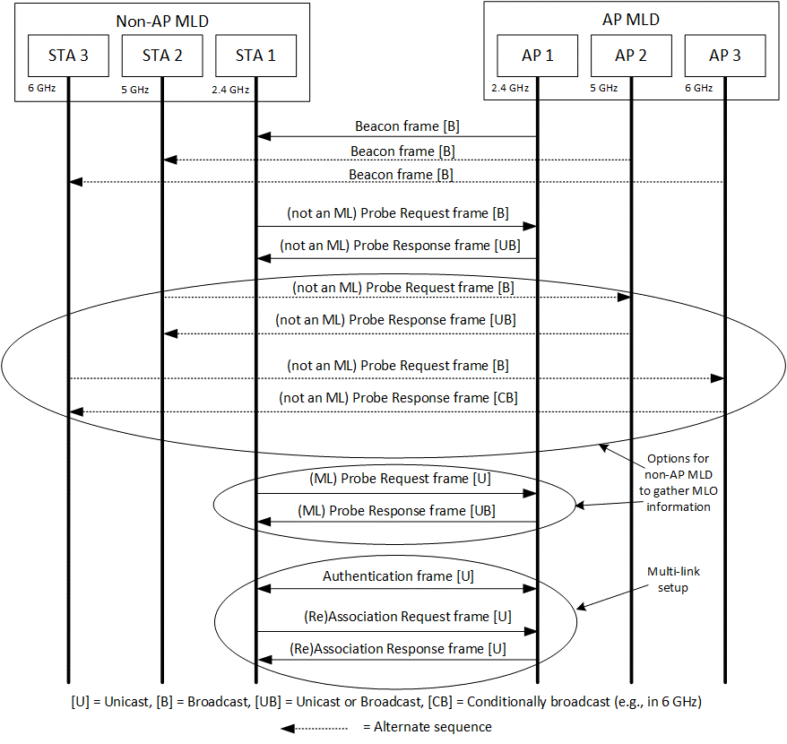
Figure 35-xx1: Frame sequence during MLO discovery
Figure 35-xx2 (Structure of specific elements carried in Management frames transmitted by a STA affiliated with a non-AP MLD) illustrates the contents of a Probe Request frame (both forms), Authentication frame, and (Re)Association Request frame transmitted by a STA affiliated with a non-AP MLD.
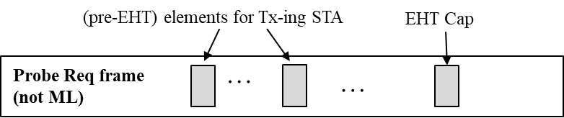
- Contents of Probe Request frame that is not an ML probe request
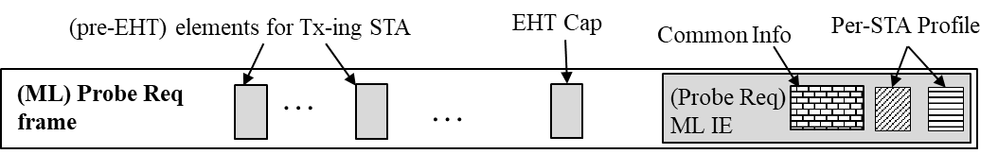
- Contents of Probe Request frame that is an ML probe request
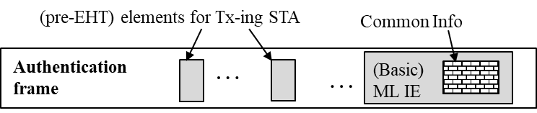
- Content of Authentication frame
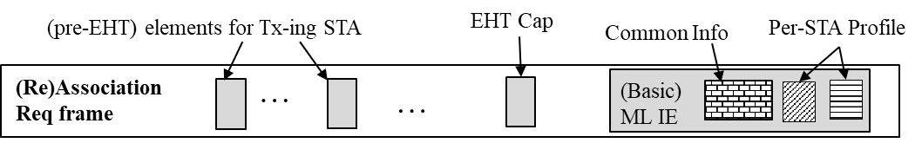
- Content of (Re)Association Request frame
Figure 35-xx2: Structure of specific elements carried in Management frames transmitted by a STA affiliated with a non-AP MLD
When a Management frame transmitted by an AP affiliated with an AP MLD:
- includes a Reduced Neighbor Report element
- and includes a Basic variant Multi-Link element,
- and both elements carry information about the same reported AP that is affiliated with the same AP MLD,
then the transmitting AP sets the value of the Link ID subfield contained in the per-STA profile carried in the Basic variant Multi-Link element corresponding to the reported AP to the same value as the value carried in the Link ID subfield contained in the MLD Parameters field of the Reduced Neighbor Report element, corresponding to that reported AP. The MLD ID subfield carried in the Reduced Neighbor Report element is set to 0 for a reported AP that is affiliated with the same AP MLD as the reporting AP (see 35.3.4.1 (AP behavior)).
Figure 35-xx3 (Structure of specific elements carried in Management frames transmitted by an AP affiliated with an AP MLD and is not a member of a multiple BSSID case) illustrates the contents of a Beacon frame, Probe Response frame, Authentication frame, and (Re)Association Response frame transmitted by an AP affiliated with an AP MLD, that is not a member of a multiple BSSID set.
NOTE – See 35.3.18.xx (Frame sequence during MLD discovery for an AP in a multiple BSSID set) for the contents carried in the Beacon and Probe Response frames transmitted by the AP corresponding to transmitted BSSID in a multiple BSSID set.
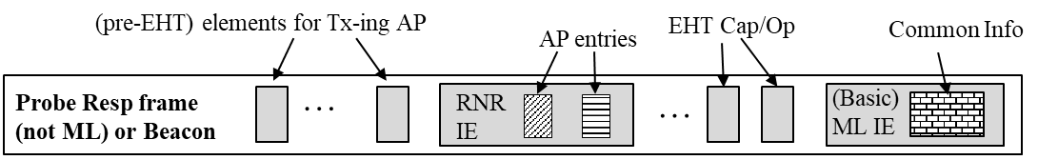
- Contents of Beacon frame or Probe Response frame that is not an ML probe response
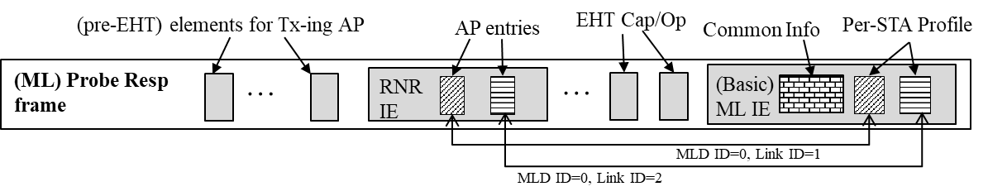
- Contents of a Probe Response frame that is an ML probe response
- Content of Authentication frame
- Contents of (Re)Association Response frame
Figure 35-xx3: Structure of specific elements carried in Management frames transmitted by an AP affiliated with an AP MLD and is not a member of a multiple BSSID case

35.3.18 Multi-link operation in a multiple BSSID set or co-hosted BSSID
TGbe editor: Please insert the following (new) subclause at the end of 35.3.18:
35.3.18.xx Frame sequence during MLD discovery for an AP in a multiple BSSID set
The sequence of frame exchanges for the discovery of an AP MLD where the affiliated AP on the link corresponds to a transmitted BSSID in the multiple BSSID set is the same as that described in clause 35.3.4.xx (Frame sequence during MLD discovery) with the exception that the Beacon and Probe Response frames carry a Multiple BSSID element. The rest of this subclause provides a high-level summary of the procedure when the AP affiliated with an AP MLD corresponds to a nontransmitted BSSID in a multiple BSSID set on the link where the non-AP MLD is performing scanning.
Figure 35-xx4 (Frame sequence during MLO discovery for an AP corresponding to a nontransmitted BSSID) shows a sequence of frame exchanges that are performed, during discovery, between a STA affiliated with a non-AP MLD and an AP affiliated with an AP MLD, that corresponds to a nontransmitted BSSID in a multiple BSSID set.
NOTE 1 – In a multiple BSSID set, only the AP corresponding to the transmitted BSSID in the set transmits a Beacon frame or responds with a Probe Response frame when the Probe Request frame is directed to broadcast destination or to any BSSIDs in the set (see 11.1.3.8 (Multiple BSSID procedure) and 11.1.4.3.4 (Criteria for sending a response)).
NOTE 2 – The Address 3 field and/or SSID field carried in the Probe Request frame, transmitted by a STA affiliated with a non-AP MLD identifies the AP (corresponding to the transmitted BSSID or a particular nontransmitted BSSID) whose information is solicited by the Probe Request frame (see 11.1.3.8.3 (Discovery of a nontransmitted BSSID profile), 11.1.4.3.2 (Active scanning procedure for a non-DMG STA) and 11.1.4.3.8 (Non-scanning probe request transmission)).

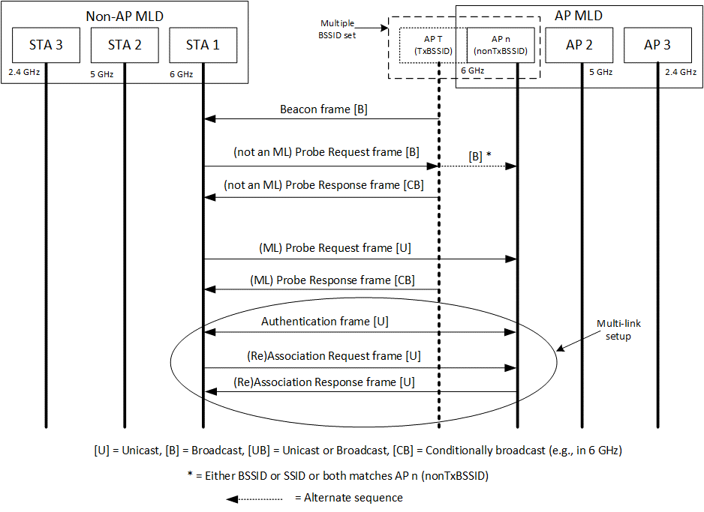
Figure 35-xx4: Frame sequence during MLO discovery for an AP corresponding to a nontransmitted BSSID
The general structure of the Management frame, transmitted by a STA affiliated with a non-AP MLD as shown in Figure 35-xx2 (Structure of specific elements carried in Management frames transmitted by a STA affiliated with a non-AP MLD) is the same regardless of which AP in the multiple BSSID set (i.e., corresponding to the transmitted or nontransmitted BSSID) the frame is directed to.
The information carried in a Probe Response frame transmitted by an AP corresponding to a transmitted BSSID in a multiple BSSID set is different based on whether the Probe Request frame is directed to the transmitted BSSID or to a nontransmitted BSSID in the set. Figure 35.xx5 (Structure of specific elements carried in Management frames transmitted by an AP affiliated with an AP MLD that is a transmitted BSSID) depicts the contents of the Management frames transmitted by the transmitted BSSID for different scenarios.
NOTE – An AP affiliated with an AP MLD includes a partial profile in the Basic variant Multi-Link element, corresponding to another AP affiliated with the same AP MLD that is operating on another link, in the Beacon and Probe Response frame that is not an ML probe response, only if the conditions specified in 35.3.9.2 (Channel switching, enhanced channel switching, and channel quieting) are satisfied.
When a Management frame transmitted by an AP corresponding to the transmitted BSSID in a multiple BSSID set:
- includes a Reduced Neighbor Report element in the frame,
- and includes a Basic variant Multi-Link element in a Nontransmitted BSSID Profile subelement for a particular nontransmitted BSSID carried in the Multiple BSSID element in the frame,
- and the Reduced Neighbor Report element and Basic variant Multi-Link element carries information of the same reported AP that is affiliated with the AP MLD to which the AP corresponding to nontransmitted BSSID is affiliated with,
then the transmitting AP sets the Link ID subfield of the per-STA profile in the Basic variant Multi-Link element corresponding to the reported AP to the same value as the Link ID subfield contained in the MLD Parameters field of the Reduced Neighbor Report element, corresponding to that reported AP. In addition, the MLD ID subfield in the Reduced Neighbor Report element corresponding to the reported AP is set to the same value as the BSSID Index field of the Multiple BSSID-Index element corresponding to the nontransmitted BSSID as defined in 35.3.4.1 (AP behavior).
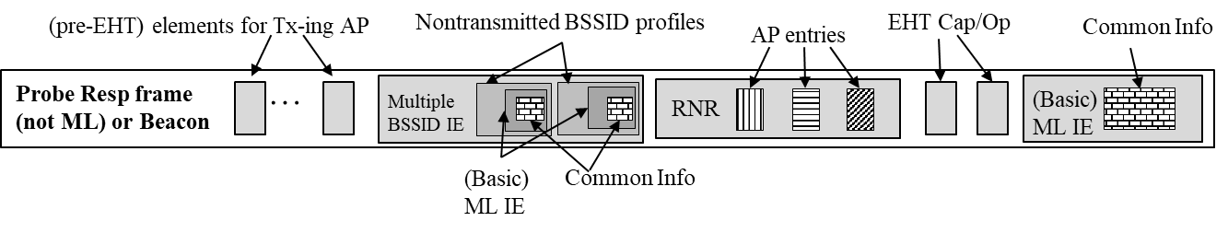
- Content of Beacon frame or Probe Response frame that is not an ML probe response transmitted by AP corresponding to transmitted BSSID
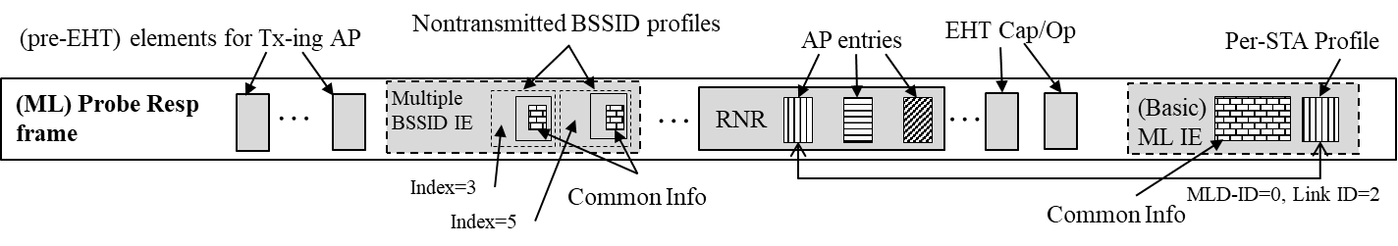
- Contents of Probe Response frame that is an ML probe response when soliciting frame was directed to transmitted BSSID
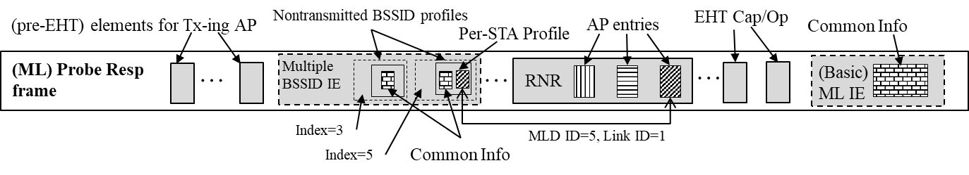
- Contents of Probe Response frame that is an ML probe response when soliciting frame was directed to nontransmitted BSSID corresponding to index 5
- Content of Authentication frame
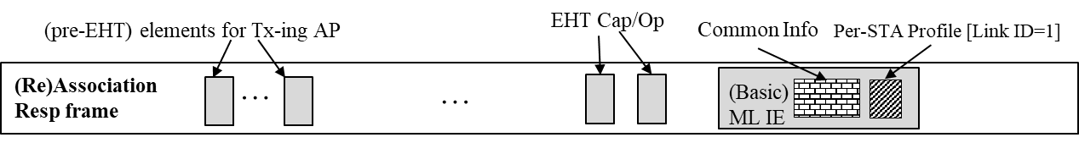
- (Re)Association Response frame transmitted by nontransmitted BSSID corresponding to index 5
Figure 35-xx5: Structure of specific elements carried in Management frames transmitted by an AP affiliated with an AP MLD that is a member of multiple BSSID set
In the example shown in Figure 35.xx5 (Structure of specific elements carried in Management frames transmitted by an AP affiliated with an AP MLD that is a transmitted BSSID), the reporting AP corresponds to the transmitted BSSID in a multiple BSSID set. There are three BSSIDs active in the multiple BSSID set: transmitted BSSID (index 0) and two nontransmitted BSSIDs corresponding to index 2 and index 5 respectively. AP corresponding to each BSSID within the multiple BSSID set is affiliated with a different AP MLD. Each AP MLD has two affiliated APs: One of the affiliated APs is a member of the multiple BSSID set and the other affiliated AP is operating on a different link. In this example, the Beacon frame and Probe Response frame transmitted by the AP corresponding to the transmitted BSSID includes Reduced Neighbor Report (RNR) element carrying three TBTT Information fields each corresponding to an AP that is operating on another link and affiliated with a different AP MLD. The Beacon and Probe Response frame, that is not an ML probe response, transmitted by the AP corresponding to the transmitted BSSID includes Basic variant Multi-Link element. The Beacon and Probe Response frame, that is not an ML probe response frame, transmitted by the AP corresponding to the transmitted BSSID includes Multiple BSSID element. The Nontransmitted BSSID Profile subelement for each AP corresponding to the nontransmitted BSSID includes Basic variant Multi-Link element. This is shown in Figure (a). The Per-STA Profile subelement of the Basic variant Multi-Link element is not included unless conditions specified in 35.3.9.2 (Channel switching, enhanced channel switching, and channel quieting) are satisfied for the reported AP.
When the ML probe request is directed to the AP corresponding to the transmitted BSSID, the ML probe response is transmitted by the AP corresponding to the transmitted BSSID and includes the Basic variant Multi-Link element containing the Per-STA Profile subelement carrying information of the AP that is operating on another link and is affiliated with AP MLD to which the AP corresponding to the transmitted BSSID is affiliated with. This is shown in Figure (b).
When the ML probe request is directed to the AP corresponding to a nontransmitted BSSID, the ML probe response is transmitted by the AP corresponding to the transmitted BSSID and includes, in the Nontransmitted BSSID Profile subelement corresponding to the nontransmitted BSSID, the Basic variant Multi-Link element containing the Per-STA Profile subelement carrying information of the AP that is operating on another link and is affiliated with AP MLD to which the AP corresponding to the nontransmitted BSSID is affiliated with. This is shown in Figure (c).
The Authentication frame and (Re)Association Request/Response frame exchange occur between the STA affiliated with the non-AP MLD and the AP in the multiple BSSID set (either corresponding to the transmitted BSSID or corresponding to the nontransmitted BSSID) that is affiliated with the AP MLD with which the non-AP MLD intends to perform multi-link setup. This is shown in Figures (d) and (e).

35.3.4.1 AP behavior
TGbe editor: Please update the following NOTE in 35.3.4.1 as shown below:
NOTE—The MLD ID subfield in the Reduced Neighbor Report element is used to determine to which AP MLD a reported AP is affiliated to, especially when multiple AP MLDs are reported in the same frame (see example in Figure 35-xx5 (Structure of specific elements carried in Management frames transmitted by an AP affiliated with an AP MLD that is a member of multiple BSSID set)).

35.3.4.3 Non-AP behavior
TGbe editor: Please update the following paragraph in this subclause as shown below:
A non-AP MLD shall be able to discover an AP as an AP affiliated with an AP MLD when it receives the Reduced Neighbor Report element carried in a Beacon or Probe Response frame transmitted by the AP. A non-AP MLD shall be able to infer the relationship between the reported AP and the reporting AP by decoding the MLD ID subfield of the MLD Parameters subfield in the Reduced Neighbor Report element and following the rules described in 35.3.4.1 (AP behavior). Also see example in Figure 35-xx5 (Structure of specific elements carried in Management frames transmitted by an AP affiliated with an AP MLD that is a member of multiple BSSID set).

35.3.5.4 Usage and rules of Basic variant Multi-Link element in the context of multi-link setup
TGbe editor: Please update the following paragraph in this subclause as shown below:
The Link ID subfield of the STA Control field of the Per-STA Profile subelement for the corresponding non-AP STA that requests a link for multi-link setup with the AP MLD is set to the link ID of an AP MLD that is operating on that link. The link ID is obtained during discovery. Also see 35.3.4.xx (Frame sequence during MLO discovery) and 35.3.18.xx (Frame sequence during MLD discovery for an AP in a multiple BSSID set).

35.3.18 Multi-link operation in a multiple BSSID set or co-hosted BSSID
35.3.18.1 General
TGbe editor: Please add the following as the last paragraph in this subclause as shown below:
The Basic variant Multi-Link element, when present in a Nontransmitted BSSID Profile subelement in a Multiple BSSID element, shall carry complete or partial profile of other AP(s) affiliated with the AP MLD with which the AP corresponding to the nontransmitted BSSID is affiliated by following the rules described in 35.3.2.2 (Advertisement of complete or partial per-link information).
35.3.18.2 Inheritance in the per-STA profile of Basic variant Multi-Link element for an AP in a mulitple BSSID set
TGbe editor: Please update the following paragraph in this subclause as shown below:
When the Basic variant Multi-Link element carries complete profile in the Per-STA Profile subelement corresponding to a reported AP, the value of an element, that is not present in the Per-STA Profile subelement of the Basic variant Multi-Link element for a reported AP, shall be the same as the corresponding element value as that of the nontransmitted BSSID profile that carried the Basic variant Multi-Link element or as the element of the transmitted BSSID, present elsewhere in the frame, which is inherited by the nontransmitted BSSID. The hierarchy of inheritance is from transmitted BSSID to the nontransmitted BSSID that carried the Basic variant Multi-Link element and from the nontransmitted BSSID to the AP reported in the per-STA profile.

