IEEE P802.11
Wireless LANs
Resolution for CIDs related to MLO Discovery (CC 34)
Date: April 10, 2021
Author(s):
Name | Affiliation | Address | Phone | email
Abhishek Patil | Qualcomm Inc. |  |  | appatil@qti.qualcomm.com
Gaurang Naik
George Cherian
Alfred Asterjadhi
Duncan Ho
Yanjun Sun

Abstract
This submission proposes resolutions for following 2 CIDs received for TGbe CC34: 1037, 2962

Revisions:
- Rev 0: Initial version of the document.

Interpretation of a Motion to Adopt

A motion to approve this submission means that the editing instructions and any changed or added material are actioned in the TGbe Draft. This introduction is not part of the adopted material.

Editing instructions formatted like this are intended to be copied into the TGbe Draft (i.e. they are instructions to the 802.11 editor on how to merge the text with the baseline documents).

TGbe Editor: Editing instructions preceded by “TGbe Editor” are instructions to the TGbe editor to modify existing material in the TGbe draft. As a result of adopting the changes, the TGbe editor will execute the instructions rather than copy them to the TGbe Draft.

CID | Commenter | Section | Pg/Ln | Comment | Proposed Change | Resolution
1037 | Abhishek Patil | 35.3.2.3 | 128.32 | The spec text needs to provide details of the operation for various scenarios:  1. Contents of Beacon frame from TxBSSID  2. non-ML probe response frame sent in response to a broadcast/wildcard non-MLO probe request frame  3. non-ML probe response frame sent in response to a non-ML probe request frame directed to a particular BSSID: case 1) directed to TxBSSID, case 2) directed to a nonTxBSSID  4. ML probe response frame sent in response to a ml probe request frame directed to a particular BSSID. case 1) directed to TxBSSID, case 2) directed to a nonTxBSSID  It will help to show call-flows for each case. | The commenter will provide a contribution | Revised  Agree with the comment. A new subclause is added to clause 35.3.4 to describe sequence of frame exchanged and the different alternatives that a non-AP MLD can follow to discover complete information of an AP MLD and its affiliated APs. The clause also provides high-level summary of the elements that provide information related to MLO discovery carried in each frame. A corresponding clause was added to 35.3.17 to cover the case of MLO discovery when the transmitting AP is a member of a multiple BSSID set.  TGbe editor, please implement changes as shown in doc 11.21/0650r0 tagged 1037
2962 | Tomoko Adachi | 9.4.2.295b.2 | 0.00 | At an AP MLD, information of all the links needs to be provided during discovery. | As in comment. | Revised  Agree with the comment. A new subclause is added to clause 35.3.4 to describe sequence of frame exchanged and the different alternatives that a non-AP MLD can follow to discover complete information of an AP MLD and its affiliated APs. The clause also provides high-level summary of the elements that provide information related to MLO discovery carried in each frame. A corresponding clause was added to 35.3.17 to cover the case of MLO discovery when the transmitting AP is a member of a multiple BSSID set.  TGbe editor, please implement changes as shown in doc 11.21/0650r0 tagged 2962

TGbe editor: Please note baseline is 11be D0.4.

TGbe editor: Please insert the following (new) subclause under clause 35.3.4 as shown below:
35.3.4.xx Frame sequence during MLD discovery
This subclause provides a brief description of the sequence of frames exchanged between a STA affiliated with a non-AP MLD and an AP affiliated with an AP MLD when the AP operating on the link does not correspond to a nontransmitted BSSID in a multiple BSSID set. The sequence of frame exchanges for the case where the AP corresponds to a nontransmitted BSSID in a multiple BSSID set is described in 35.3.17.xx (Frame sequence during MLD discovery for an AP in a multiple BSSID set).
Each AP of an AP MLD shall include a Reduced Neighbor Report element and Basic variant Multi-Link element in the Beacon frame that it transmits and the Probe Response frame that is not an ML probe response that it transmits. The Reduced Neighbor Report element identifies and provides basic information of each AP affiliated with the AP MLD that is operating on other links as defined in 35.3.4.1 (AP behavior). The Basic variant Multi-Link element provides MLD-level information that is common to all the APs of the AP MLD as described in 35.3.2.2 (Complete or partial per-STA profile), and 35.3.4.4 (Multi-link element usage rules in the context of discovery). The Per-STA Profile subelement of the Basic variant Multi-Link element for one or more AP, operating on another link of the AP MLD, is present in the Beacon and Probe Response frame that is not an ML probe response and carries partial information if conditions specified in 35.3.9 (General Procedures) are satisfied.
NOTE – When the transmitting AP corresponds to a transmitted BSSID in a multiple BSSID set, it also includes Multiple BSSID element in the Beacon and Probe Response frames that it transmits. If the AP corresponding to a nontransmitted BSSID is affiliated with an AP MLD, then its Nontransmitted BSSID Profile subelement carried in the Multiple BSSID element includes a Basic variant Multi-Link element (see 35.3.17 (Multi-BSSID)).
A non-AP MLD can discover an AP MLD by performing passive scanning, by following the procedure in 11.1.4.2 (Passive scanning) or by active scanning, by following the procedure in 11.1.4.3 (Active scanning and probing procedures). A non-AP MLD may choose to transmit an ML probe request on one of the links of the AP MLD to obtain complete information of one or more APs affiliated with the AP MLD that are operating on other link(s) or perform active or passive scanning on each link supported by the AP MLD to gather information of each affiliated AP of the AP MLD. The non-AP MLD’s decision can be based on criteria (such as power-save, single radio operation, reachability, etc). A non-AP MLD is expected to gather information of an AP MLD and its affiliated APs before proceeding to ML setup.
NOTE – The ML probe response sent in response to an ML probe request, soliciting complete information, carries complete profile of the requested AP(s) as defined in 35.3.4.2 (Use of ML probe request and response).
Figure 35-xxx (Frame sequence during MLD discovery) shows a sequence of frame exchanges that are performed, before multi-link setup, between an AP affiliated with an AP MLD and a STA affiliated with a non-AP MLD.
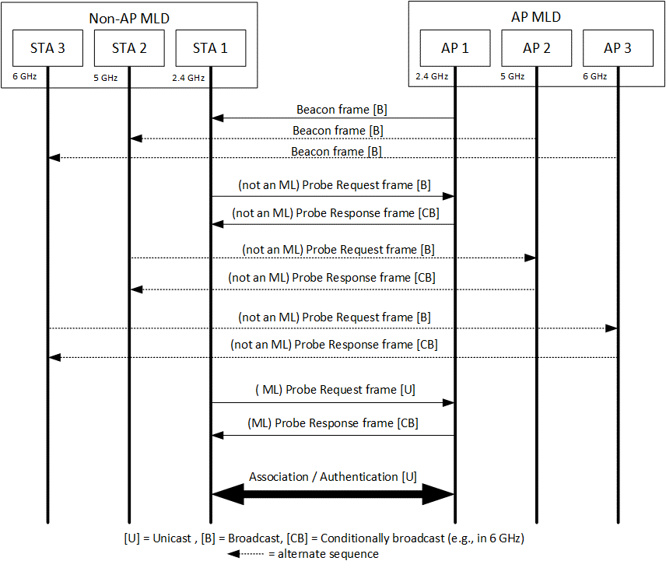
Figure 35-xxx: Frame sequence before multi-link setup
Figure 35-xxx (Contents of Management frame transmitted by STA affiliated with a non-AP MLD) illustrates the contents of a Probe Request frame (both forms) and (Re-)Association Request frame transmitted by a STA affiliated with a non-AP MLD.
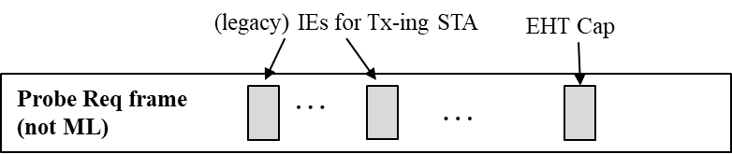
- Contents of Probe Request frame that is not an ML probe request
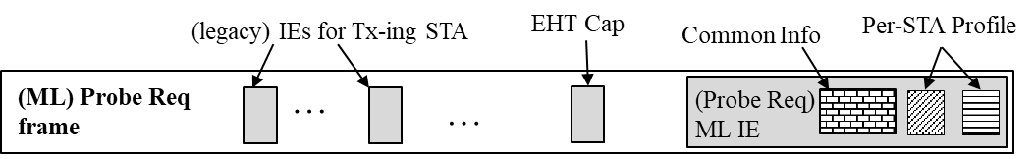
- Contents of Probe Request frame that is an ML probe request
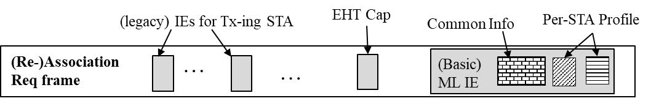
- Content of (Re-)Association Request frame
Figure 35-xxx: Contents of Management frame transmitted by STA affiliated with a non-AP MLD
Figure 35-xxx (Contents of Management frame transmitted by AP affiliated with an AP MLD and not a member of a multiple BSSID case) illustrates the contents of a Beacon frame, Probe Response frame and Association Response frame transmitted by an AP affiliated with an AP MLD, that is not a member of a multiple BSSID set.
NOTE – See 35.3.17.xx (Frame sequence during MLD discovery for an AP in a multiple BSSID set) for contents carried in the Beacon and Probe Response frames transmitted by the AP corresponding to transmitted BSSID in a multiple BSSID set.
When a Beacon frame or a Probe Response frame transmitted by an AP affiliated with an AP MLD includes, a Reduced Neighbor Report element and a Basic variant Multi-Link element, and both elements carry information of the same reported AP that is affiliated with the same AP MLD, the transmitting AP shall set the value of the Link ID subfield of the per-STA profile, of the Basic variant Multi-Link element, corresponding to the reported AP to the same value as the value carried in the Link ID subfield of the TBTT Information field, of the Reduced Neighbor Report element, corresponding to that reported AP.
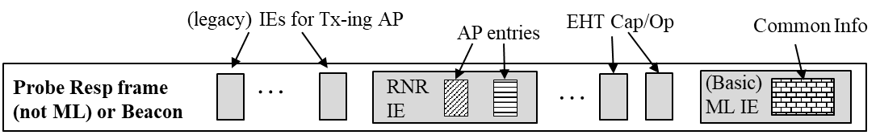
- Contents of Beacon frame or Probe Response frame that is not an ML probe response
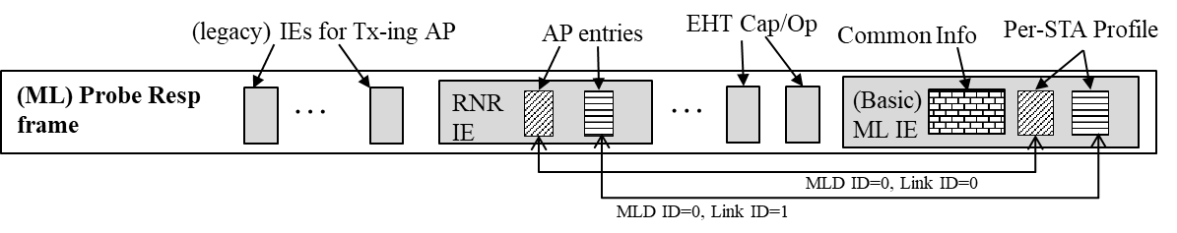
- Contents of a Probe Response frame that is an ML probe response
- Contents of (Re-)Association Response frame
Figure 35-xxx: Contents of Management frame transmitted by AP affiliated with an AP MLD and not a member of a multiple BSSID case

35.3.4.2 Use of ML probe request and response
TGbe editor: Please insert the following paragraph before the paragraph starting “The partial information of a requested AP sent by a reporting AP is defined as part of all elements that is” in this subclause as shown below:
If an AP affiliated with an AP MLD receives a Probe Request frame that is not an ML probe request, it shall respond with a Probe Response frame which is not an ML probe response.

35.3.17 Multi-BSSID
TGbe editor: Please insert the following (new) subclause at the end of 35.3.17:
35.3.17.xx Frame sequence during MLD discovery for an AP in a multiple BSSID set
The sequence of frame exchanges for the discovery of an AP MLD where the affiliated AP on the link corresponds to a transmitted BSSID in the multiple BSSID set is the same as that described in clause 35.3.4.6 (Frame sequence during MLD discovery) with the exception that the Beacon and Probe Response frames carry a Multiple BSSID element.
Figure 35-xxx (Frame sequence before multi-link setup for an AP corresponding to a nontransmitted BSSID) shows a sequence of frame exchanges that are performed, before multi-link setup, between a STA affiliated with a non-AP MLD and an AP affiliated with an AP MLD, that corresponds to a nontransmitted BSSID in a multiple BSSID set.
NOTE – In a multiple BSSID set, only the AP corresponding to the transmitted BSSID in the set transmits a Beacon frame or responds with a Probe Response frame when the Probe Request frame is directed to any BSSIDs in the set (see 11.1.3.8 (Multiple BSSID procedure) and 11.1.4.3.4 (Criteria for sending a response)).
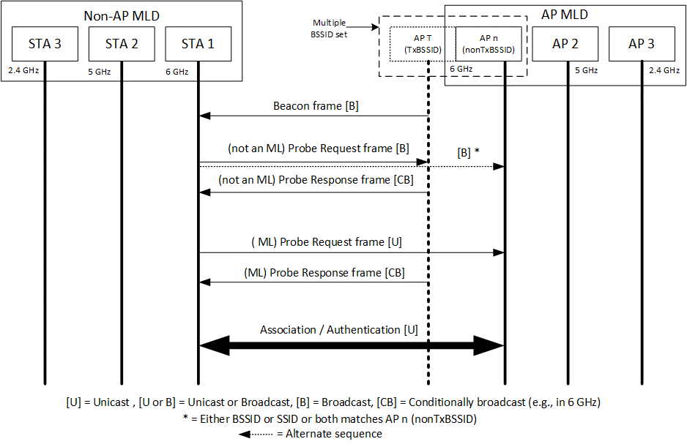
Figure 35-xxx: Frame sequence before multi-link setup for an AP corresponding to a nontransmitted BSSID
The value of the A3 field and/or SSID field carried in the Management frame, transmitted by a STA affiliated with a non-AP MLD determines if the frame is directed to the transmitted BSSID or nontransmitted BSSID. The format of the Management frame, transmitted by a STA affiliated with a non-AP MLD is as shown in Figure 35-xxx (Contents of Management frame transmitted by STA affiliated with a non-AP MLD) and is the same regardless of which AP in the multiple BSSID set (i.e., transmitted or nontransmitted) the frame is direct to.
The information carried a response frame transmitted by the AP corresponding to transmitted BSSID in a multiple BSSID set is different based on whether the request frame is directed to transmitted BSSID or nontransmitted BSSID. Figure 35.xxx (Contents of Management frame transmitted by an AP affiliated with an AP MLD that is a transmitted BSSID) depicts the contents of the Management frame transmitted by the transmitted BSSID for different scenarios.
NOTE - The Per-STA Profile subelement of the Basic variant Multi-Link element for one or more AP, operating on another link of the AP MLD, is present in the Beacon and Probe Response frame that is not an ML probe response and carries partial information if conditions specified in 35.3.9 (General Procedures) are satisfied.
When a Beacon frame or a Probe Response frame transmitted by the transmitted BSSID in a multiple BSSID set includes a Reduced Neighbor Report element and a Basic variant Multi-Link element in a Nontransmitted BSSID Profile subelement for a particular nontransmitted BSSID, and both elements carry information of a reported AP that is affiliated with the an AP MLD to which the nontransmitted BSSID is affiliated with, the transmitting AP shall set the value of the Link ID subfield of the per-STA profile, of the Basic variant Multi-Link element, corresponding to the reported AP to the same value as the value carried in the Link ID subfield of the TBTT Information field, of the Reduced Neighbor Report element, corresponding to that reported AP. In addition, the MLD ID subfield in the Reduced Neighbor Report element corresponding to the reported AP is set to the same value as the BSSID Index field of the Multiple BSSID-Index element corresponding to the nontransmitted BSSID as defined in 35.3.4.1 (AP behavior).
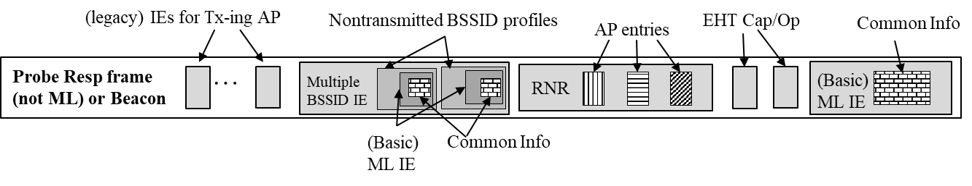
- Beacon frame transmitted by AP corresponding to transmitted BSSID
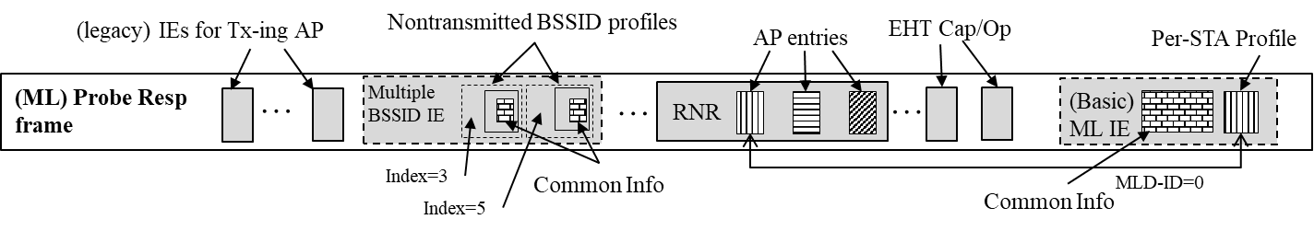
- Contents of Probe Response frame that is an ML probe response when soliciting frame was directed to transmitted BSSID
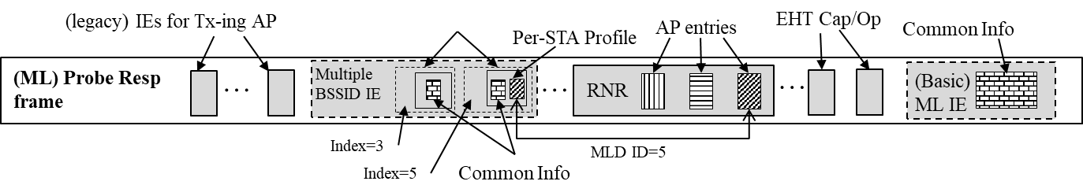
- Contents of Probe Response frame that is an ML probe response when soliciting frame was directed to nontransmitted BSSID (index 5)
- (Re-)Association Response transmitted by nontransmitted BSSID (index 5)
Figure 35-xxx: Contents of Management frame transmitted by an AP affiliated with an AP MLD that is a transmitted BSSID

