IEEE P802.11
Wireless LANs
Behavior at an EBCS AP that provides the relaying service
Date: April 1, 2021
Author(s):
Name | Affiliation | Address | Phone | email
Abhishek Patil | Qualcomm Inc. |  |  | appatil@qti.qualcomm.com
George Cherian
Jouni Malinen
Bahar Sadeghi | Intel
Mark Rison | Samsung
Stephen McCann | Huawei
Michael Montemurro
Hitoshi Morioka | SRC
Antonio | Interdigital

Abstract
This contribution proposes informative text which is to be added to the TGbc draft. The write-up provides high-level summary (along with a couple of examples) of the expected operation at an EBCS AP that provides/supports relaying service. Once approved, the text will be included as part of a CR document that resolves comments submitted during LB 252 for 11bc D1.0.

Revisions:
- Rev 0: Initial version of the document.
- Rev 1: Updated based on feedback received over email
- Rev 2: Several updates based on feedback received when the document was discussed in the 11bc telco on 4/6/21
- Rev 3: Additional updated based on feedback from Mark R.

4.5.xx EBCS relaying service
4.5.xx.1 General
The EBCS relaying service provides a mechanism for an EBCS non-AP STA to send an HLP payload to a specified destination.
4.5.xx.2 EBCS proxy operation
An EBCS proxy is a logical component, which might be collocated with an EBCS AP, that can relay an HLP payload carried in an EBCS UL frame received by an EBCS AP to a destination specified in the frame, typically within an external network.
An EBCS proxy that provides the relaying service evaluates certain criteria before relaying the HLP payload carried in an EBCS UL frame to the destination specified in the frame. Such criteria can include, but are not limited to, verifying the STA certificate, if present, to determine whether the STA transmitting the frame is authorized to send an HLP payload to the specified destination, performing replay checking, and limiting the amount or frequency of HLP payload that is relayed to the specified destination. The evaluation of the criteria can be based on local policies installed at the EBCS proxy and/or based on a relationship established with the specified destination. The establishment of such a relationship is out of scope of this standard.
An EBCS proxy can establish more than one relationship, each with a different destination and potentially different criteria. An EBCS proxy can also append additional information before it relays the HLP payload. The format and content of the information appended are based on the agreement with the specified destination. The relaying service is best effort and the EBCS proxy can choose not to relay the HLP payload if any of the implemented criteria for relaying are not satisfied or for any other reason.
NOTE 1 – The communication between an EBCS AP and an EBCS proxy and the communication between an EBCS proxy and a specified destination are out of scope of this standard.
NOTE 2 – An EBCS proxy evaluating various criteria before it relays an HLP payload helps reduce the likelihood of a DoS attack on the specified destination.
4.5.xx.3 Example configurations for EBCS proxy
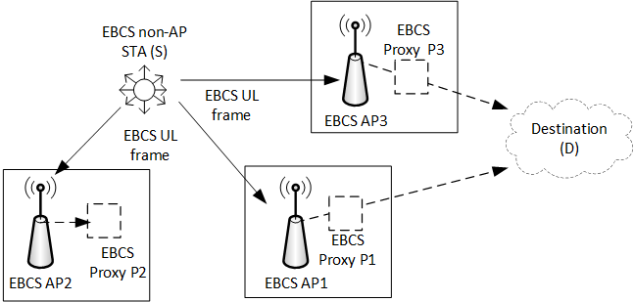
Figure 4-20a (Illustration of relaying operation at an EBCS AP with collocated EBCS proxy) provides an example of the relaying service based on a relationship with a specified destination. In the figure, EBCS proxy P1 and EBCS proxy P3 have established a relationship with a destination (D). An EBCS non-AP STA (S) transmits an EBCS UL frame that is received by EBCS APs in the neighborhood (i.e., AP1, AP2 and AP3). The EBCS UL frame carries the HLP payload, a field carrying the address of D and other fields for security. P1 and P3 verify the certificate of S based on their agreement with D and perform a replay check, to determine whether the criteria for relaying the HLP payload to D are met. If the local policy or the agreement with D requires limiting the amount of HLP payloads being sent to D, either P1 or P3 does not send a HLP payload to D, if the limiting threshold was already reached. If the agreement with D requires the inclusion of additional information, P1 and P3 append appropriate information, before relaying the HLP payload. In the figure, EBCS AP2 discards the contents of the EBCS UL frame. This could be for any number of reasons such as it not providing a relaying service, its collocated proxy not having established a relationship with D, or one or more criteria for relaying not having been satisfied.
Figure 4-20a: Illustration of relaying operation at an EBCS AP with collocated EBCS proxy
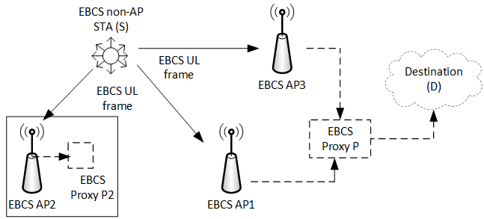
In another example, depicted in Figure 4-20b (Illustration of relaying when EBCS proxy is not collocated within an EBCS AP), the EBCS proxy (P) is not collocated with either EBCS AP1 or EBCS AP3, but resides on an entity in the LAN that A1 and AP3 reside on. EBCS AP1 and EBCS AP3 forward the contents of the EBCS UL frame to P, which evaluates whether the criteria for relaying are met before it relays the HLP payload to the specified destination.
Figure 4-20b: Illustration of relaying when EBCS proxy is not collocated within an EBCS AP
The configuration shown in Figure 4-20b (Illustration of relaying when EBCS proxy is not collocated within an EBCS AP) could be prevalent in commercial deployments, such as airports, train stations, malls, or a warehouse, where multiple EBCS APs are likely to be connected to a single entity on a common LAN (such as a network controller) which provides access to destinations outside the LAN. In such a configuration, the EBCS proxy resides on an entity in the LAN. On the other hand, the configuration shown in Figure 4-20a (Illustration of relaying operation at an EBCS AP with collocated EBCS proxy) could be prevalent in residential deployments where an EBCS AP has direct connectivity to destinations outside the LAN.

