IEEE P802.11
Wireless LANs
Behavior at an EBCS AP that provides relaying service
Date: April 1, 2021
Author(s):
Name | Affiliation | Address | Phone | email
Abhishek Patil | Qualcomm Inc. |  |  | appatil@qti.qualcomm.com
George Cherian
Jouni Malinen
Bahar Sadeghi | Intel
Mark Rison | Samsung
Stephen McCann | Huawei
Michael Montemurro
Hitoshi Morioka | SRC
Antonio | Interdigital

Abstract
This contribution proposes informative text which is to be added to the TGbc draft. The write-up provides high-level summary (along with a couple of examples) of the expected operation at an EBCS AP that provides/supports relaying service. Once approved, the text will be included as part of a CR document that resolves comments submitted during LB 252 for 11bc D1.0.

Revisions:
- Rev 0: Initial version of the document.
- Rev 1: Updated based on feedback received over email

An EBCS AP that provides the relaying service should evaluate certain criteria before relaying the HLP payload carried in an EBCS UL frame transmitted by an EBCS non-AP STA to the destination specified in the frame. Such criteria can include, but are not limited to, verifying the STA certificate, if present, to determine whether the transmitter is authorized to send an HLP payload to the specified destination, performing replay checking, and limiting the amount of HLP payload that is relayed to the specified destination. The evaluation of the criteria can be based on local policies installed at the EBCS AP and/or based on a relationship established with the specified destination. The establishment of such a relationship is out of scope of this standard. An EBCS AP can establish more than one such relationship, each with a different destination and potentially different criteria. An EBCS AP can also append additional information before it relays the HLP payload; the format and content of the information appended are based on the agreement with the specified destination. The relaying service is best effort and the AP can choose not to relay the HLP payload if any of the implemented criteria for relaying are not satisfied or for any other reason.
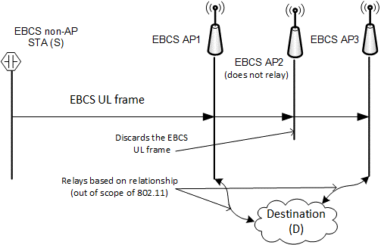
Figure 1: Illustration of relaying operation at EBCS APs
Figure 1 provides an example of the relaying service based on a relationship with a specified destination. In the figure, EBCS AP1 and EBCS AP3 have established a relationship with a destination (D). An EBCS non-AP STA (S) transmits an EBCS UL frame that is received by AP1, AP2 and AP3. The EBCS UL frame carries the HLP payload and a URI to the destination. AP1 and AP3 verify the certificate of S based on their agreement with D and relay the HLP payload to D. AP1 and AP3 also perform a replay check (see 12.100.2.6). If the agreement with D requires inclusion of additional information, the APs appends appropriate information, in the correct format, before relaying the HLP payload. EBCS AP2 discards the EBCS UL frame. This could be for any number of reasons such as it not providing the relaying service, it not having established a relationship with D, or one or more criteria for relaying not being satisfied.

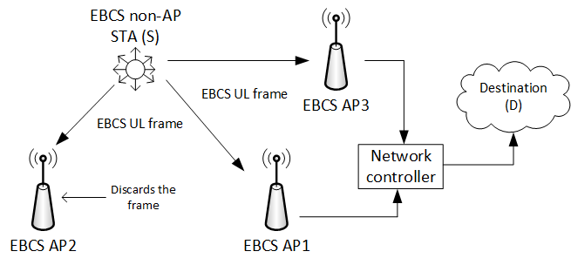
Figure 2: Illustration of relaying from an entity on the LAN managing multiple EBCS APs

In another example, shown in Figure 2, AP1 and AP3 are connected to a network controller on a LAN. In this configuration, the APs direct any traffic that is intended for a destination outside of the LAN to the network controller. The network controller can maintain relationships with one or more destinations and is responsible for applying the criteria to be met in order to relay the information to a specified destination and for appending relevant information (when required) based on the agreement with the specified destination.
Since the EBCS UL frame is transmitted by a STA that is not in associated state with the AP that provides the relaying service, an EBCS AP or an entity on the LAN (such as a network controller) that provides the relaying service generates an IP packet intended for the destination specified in the frame when the criteria for relaying are met.
The configuration shown in Figure 2 is likely to be prevalent in commercial deployments, such as airports, train stations, malls, or a warehouse, where multiple APs are connected to a single entity on the LAN (such as a network controller) which provides access to destinations outside the LAN. On the other hand, the configuration shown in Figure 1 is likely to be prevalent in a residential deployment where the AP has direct connectivity to the destinations outside the LAN.

