IEEE P802.11
Wireless LANs
Behavior at an EBCS AP that provides relaying service
Date: April 1, 2021
Author(s):
Name | Affiliation | Address | Phone | email
Abhishek Patil | Qualcomm Inc. |  |  | appatil@qti.qualcomm.com
George Cherian
Jouni Malinen
Bahar Sadeghi | Intel
Mark Rison | Samsung
Stephen McCann | Huawei
Michael Montemurro
Hitoshi Morioka | SRC
Antonio | Interdigital

Abstract
This contribution proposes explanatory text which is to be added to clause 11. The text provides high-level details (along with a couple of examples) of the expected operation at an EBCS AP that provides/supports relaying service. Once approved, the text will be included as part of a CR document that resolves comments submitted during LB 252 for 11bc D1.0.

Revisions:
- Rev 0: Initial version of the document.

An EBCS AP that provides the relaying service is expected to evaluate certain criteria before deciding to relay the HLP payload carried in an EBCS UL frame transmitted by an EBCS non-AP STA to a destination specified in the frame. Such criteria can include, but are not limited to, verifying the STA certificate to determine whether the transmitter is authorized to send an HLP payload to the specified destination, performing replay checking and limiting the amount of HLP payload that is relayed. The evaluation of the criteria can be based on local policies installed at the EBCS AP and/or based on a relationship established with an entity at the specified destination. The establishment of such a relationship is out of scope of this standard. A EBCS AP could also append additional information before it relays the HLP payload. The format and the information to be appended would be determined based on the agreement with the specified destination. The relaying service is best effort and the AP can choose not to relay the HLP payload if any of the above criteria are not satisfied or for any other reason.
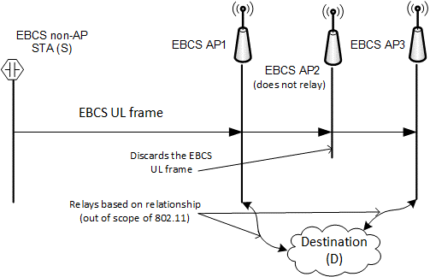
An EBCS AP can establish more than one such relationship, each with a different destination, and applies the criteria based that apply to each such relationship.
Figure 1: Illustration of relaying operation at EBCS APs
Figure 1 provides an example of the relaying service based on a relationship with the specified destination. In the figure, EBCS AP1 and EBCS AP3 have established a relationship with a destination (D). An EBCS non-AP STA (S) transmits an EBCS UL frame that is received by AP1, AP2 and AP3. The EBCS UL frame carries the HLP payload and a URI to the destination. AP1 and AP3 verify the certificate of S based on their agreement with D and relay the HLP payload to D. AP1 and AP3 also perform a replay check (see 12.100.2.6). If the agreement with D requires inclusion of additional information, the APs will append appropriate information, in the correct format, before relaying the HLP payload. EBCS AP2 discards the EBCS UL frame. This could be for any number of reasons such as it is not providing the relaying service, or it has not established a relationship with D or one or more criteria for relaying was not satisfied.

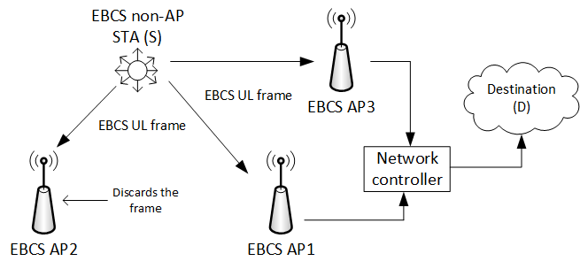
Figure 2: Illustration of relaying from an entity on the LAN managing multiple EBCS APs

In another example, shown in Figure 2, AP1 and AP3 are connected to a network controller on a LAN. In this configuration, the APs direct any traffic that is intended for a destination outside of the LAN to the network controller. The network controller maintains relationships with one or more destinations and is responsible for applying the criteria to be met in order to relay the information to a specified destination, and for appending relevant information (when required) based on the agreement with the specified destination.
Since the EBCS UL frame is transmitted by a STA that is not in associated state with the AP that provides the relaying service, an EBCS AP or an entity on the LAN (such as a network controller) that provides relaying service generates an IP packet intended for the destination specified in the frame when the criteria for relaying are met.
The configuration shown in Figure 2 is likely to be prevalent in commercial deployments, such as airports, train stations, malls, or a warehouse, where an entity in the LAN provides access to destinations outside the LAN, whereas the configuration shown in Figure 1 is likely to be prevalent in a residential deployment.

