IEEE P802.11
Wireless LANs

Spec Text for TXOP Return for Triggered SU
Date: 2021-03-27
Author(s):
Name | Affiliation | Address | Phone | email
Yunbo Li | Huawei |  |  | liyunbo@huawei.com
Ming Gan
Yuchen Guo
Guogang Huang
Yiqing Li
Zhenguo Du
Rob Sun
Dibakar | Intel |  |  | Dibakar.das@intel.com

CID | Commenter | P.L | Clause | Comment | Proposed Change | Resolution
3329 | Yunbo Li | 125.05 | 35 | Needs to a subclause to cover the operation of modified MU-RTS. And in this subclause, also needs to add a mechanism for a STA that allocated SU transmitted time by Modified MU-RTS to return the TXOP to AP if it has some remain duration. So that the it reduce the airtime waste and also avoid the third party STA to jump in. | I prepare a presentation 21/61 to discuss this topic | Revised – agree with the commenter.  The corresponding signalling and behaviour at AP and non-AP STA side are added.  TGbe editor to make the changes shown in 11-21/0552r5

Discussion:

After AP allocate time within an obtained TXOP to a non-AP STA by transmitting an MU-RTS TXS Trigger frame, there are two use cases that needs the non-AP STA to return the TXOP to AP.
- If there is remaining time in allocated SU time period after the target STA finished the transmission of buffered data, a mechanism is needed to return the control to AP. Otherwise,
  - It is a waist for the system, no one can use it;
  - The third party STA may contend the channel within this period
- If the P2P Peer STA is not available, and the non-AP STA doesn’t have any Data to transmit target to its associated AP

Please find more details in 21/270r0, and 21/0061r0.

The A-control subfield is a good candidate to support the signalling. It can be carried in QoS Data frame (for UL SU case), which no extra signalling overhead. And also can be carried in QoS Null frame (for both P2P and UL SU case).

There are several candidate A-control types can be used:
- Command and Status (CAS)
- Single Response Scheduleing (SRS)
- Other existing A-control type
- A new A-control type

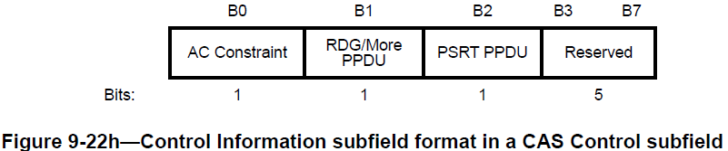

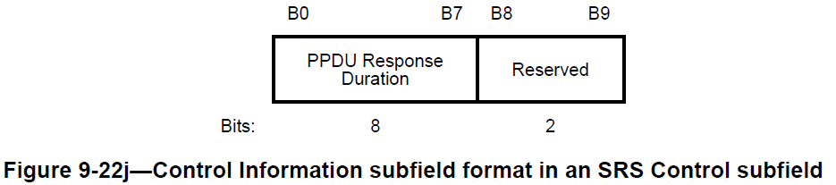

The proposed text is base on SRS Control subfield, if the group converge on other type of A-control, the spec text can be changed accordingly.

During the offline discussion, some people arise the concern that the candidate A-control types are optional supported in the spec, it may affect the implementation of Triggered TXOP Sharing mechanism (Triggered TXOP Sharing itself is also an optional feature, but with an additional optional A-Control, it means double optional). So an “implicit solution” which is QoS Null frame without A-control subfiled is also propose to terminate the TXOP Sharing. This “implicit solution” has two constrains: 1) it can not be carried in QoS Data frame; 2) the scheduled non-AP STA can not send out a QoS Null frame without A-control anymore for whatever reason, except it intends to terminate the TXOP sharing.

Since the explicit indication and implicit indication has their own use cases and benefits, the standard can adopt both of them and the the chip vendor can choose one of them or both in implementation.

Two strong opinions are received in offline discussion. One is prefer to use explicit indication for the TXOP sharing termination which is simpler and more flexible; the other is against to carry the signaling in an optional A-control type. It is hard to find a proper A-control to meet the two requirements at the same time.

More Data subfield in Frame Control is currently reserved in the frames sent from non-AP to AP. Seems the More Data bit could meet the two requirements. So More Date subfiled is used to carry the signalling in doc 552r5.

- Introduction

Interpretation of a Motion to Adopt

A motion to approve this submission means that the editing instructions and any changed or added material are actioned in the TGbe Draft. The introduction and the explanation of the proposed changes are not part of the adopted material.

Editing instructions formatted like this are intended to be copied into the TGbe Draft (i.e. they are instructions to the 802.11 editor on how to merge the text with the baseline documents).

- Proposed spec text

The baseline for this text is TGbe D0.4

TGbe editor: Modify the paragraphs in 9.2.4.1.1 (General) as follows:

9.2.4.1.1 General

For a frame carried in an non-S1G PPDU, when the Type subfield is not 1 or the Subtype subfield is not 6, the remaining subfields within the Frame Control field are To DS, From DS, More Fragments, Retry, Power Management, More Data/TXOP Sharing Termination (#3329), Protected Frame, and +HTC. In this case, the format of the Frame Control field is shown in Figure 9-3 (Frame Control field format in non-S1G PPDUs when Type subfield is not equal to 1 or Subtype subfield is not equal to 6).

 | B0 B1 | B2 B3 | B4 B7 | B8 | B9 | B10 | B11 | B12 | B13 | B14 | B15
 | Protocol Version | Type | Subtype | To DS | From DS | More Fragments | Retry | Power Management | More Data/ TXOP Sharing Termination | Protected Frame | +HTC
Bits: | 2 | 2 | 4 | 1 | 1 | 1 | 1 | 1 | 1 | 1 | 1
Figure 9-3—Frame Control field format in non-S1G PPDUs when Type subfield is not equal to 1 or Subtype subfield is not equal to 6

TGbe editor: add below paragraphs in 9.2.4.1.8 (More Data subfield):

9.2.4.1.8 More Data/TXOP Sharing Termination subfield

If a frame is transmitted by an EHT non-AP STA to its associated AP, then B13 of the Frame Control field is the TXOP Sharing Termination subfield, otherwise B13 of the Frame Control field is the More Data subfield.

The TXOP Sharing Termination subfield indicates whether the PPDU carrying the TXOP Sharing Termination subfield is the last PPDU within the allocated time specified in the received MU RTS TXS Trigger frame. The TXOP Sharing Termination subfield is set to 1 if the PPDU is the last PPDU; otherwise it is set to 0. (#3329)

TGbe editor: Change following paragraph in 35.2.1.3.2 (AP behavior) as follows:

35.2.1.3.2 AP behaviour

(#3329) If the AP receives a CTS frame in response to its transmitted MU RTS TXS Trigger frame to a non-AP STA with the TxOP Sharing Mode subfield equal to 1 then the AP shall not transmit any PPDU within the allocated time specified in the MU RTS TXS Trigger frame unless:
- The AP received a frame from the non-AP STA that the TXOP Sharing Termination subfield in Frame Control field is set to 1.

If the EHT AP receives a CTS frame in response to its transmitted MU RTS TXS Trigger frame with the TXOP Sharing Mode subfield equal to 2 then the AP shall not initiate any PPDU transmission within the allocated time specified in the MU RTS TXS Trigger frame unless
- The AP received a frame from the non-AP STA that the TXOP Sharing Termination subfield in Frame Control field is set to 1.

After the EHT AP responses to the frame from the non-AP STA that the TXOP Sharing Termination subfield in Frame Control field is set to 1, the EHT AP may tranmit a following frame SIFS after the response frame.

TGbe editor: add following paragraphs at the end of 35.2.1.3.3 (Non-AP STA behavior) as follows:

35.2.1.3.3 Non-AP STA behavior

During the allocated time, if there is a transmission failure, the non-AP STA may transmit after the CS mechanism (see 10.3.2.1 (CS mechanism)) indicates that the medium is idle at the TxPIFS slot boundary (see Figure 10-25 (EDCA mechanism timing relationships)) or invoke the backoff procedure described in 10.23.2.2 (EDCA backoff procedure). If the transmission failure happens for the first frame after the non-AP STA response CTS to its associated AP, and the target STA of the failure frame is not its associated AP, the non-AP STA should transmit to a different STA or wait for the allocated time to expire.

(#3329) A non-AP STA addressed in the MU-RTS TX Trigger frame may send a frame with the TXOP Sharing Termination subfield in Frame Control field equals to 1 to its associated AP. After successfully transmitting a frame with the TXOP Sharing Termination subfield in Frame Control field equals to 1, the non-AP STA shall not transmit any more PPDUs within the time allocated in theMU-RTS TXS Trigger frame.

End of change

