IEEE P802.11
Wireless LANs

Spec Text for TXOP Return for Triggered SU
Date: 2021-03-27
Author(s):
Name | Affiliation | Address | Phone | email
Yunbo Li | Huawei |  |  | liyunbo@huawei.com
Ming Gan
Yuchen Guo
Guogang Huang
Yiqing Li
Zhenguo Du
Rob Sun
Dibakar | Intel |  |  | Dibakar.das@intel.com

CID | Commenter | P.L | Clause | Comment | Proposed Change | Resolution
3329 | Yunbo Li | 125.05 | 35 | Needs to a subclause to cover the operation of modified MU-RTS. And in this subclause, also needs to add a mechanism for a STA that allocated SU transmitted time by Modified MU-RTS to return the TXOP to AP if it has some remain duration. So that the it reduce the airtime waste and also avoid the third party STA to jump in. | I prepare a presentation 21/61 to discuss this topic | Revised – agree with the commenter.  The corresponding signalling and behaviour at AP and non-AP STA side are added.  TGbe editor to make the changes shown in 11-21/0552r1

Discussion:

After AP allocate time within an obtained TXOP to a non-AP STA by transmitting an MU-RTS TXS Trigger frame, there are two use cases that needs the non-AP STA to return the TXOP to AP.
- If there is remaining time in allocated SU time period after the target STA finished the transmission of buffered data, a mechanism is needed to return the control to AP. Otherwise,
  - It is a waist for the system, no one can use it;
  - The third party STA may contend the channel within this period
- If the P2P Peer STA is not available, and the non-AP STA doesn’t have any Data to transmit target to its associated AP

Please find more details in 21/270r0, and 21/0061r0.

The A-control subfield is a good candidate to support the signalling. It can be carried in QoS Data frame (for UL SU case), which no extra signalling overhead. And also can be carried in QoS Null frame (for both P2P and UL SU case).

There are several candidate A-control types can be used:
- Command and Status (CAS)
- Single Response Scheduleing (SRS)
- Other existing A-control type
- A new A-control type

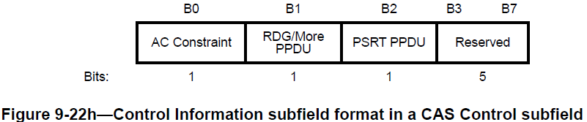

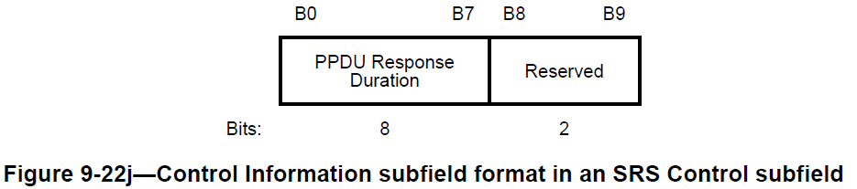

The proposed text is base on SRS Control subfield, if the group converge on other type of A-control, the spec text can be changed accordingly.

During the offline discussion, some people arise the concern that the candidate A-control types are optional supported in the spec, it may affect the implementation of Triggered TXOP Sharing mechanism (Triggered TXOP Sharing itself is also an optional feature, but with an additional optional A-Control, it means double optional). So an “implicit solution” which is QoS Null frame without A-control subfiled is also propose to terminate the TXOP Sharing. This “implicit solution” has two constrains: 1) it can not be carried in QoS Data frame; 2) the scheduled non-AP STA can not send out a QoS Null frame without A-control anymore for whatever reason, except it intends to terminate the TXOP sharing.

Since the explicit indication and implicit indication has their own use cases and benefits, the standard can adopt both of them and the the chip vendor can choose one of them or both in implementation.

- Introduction

Interpretation of a Motion to Adopt

A motion to approve this submission means that the editing instructions and any changed or added material are actioned in the TGbe Draft. The introduction and the explanation of the proposed changes are not part of the adopted material.

Editing instructions formatted like this are intended to be copied into the TGbe Draft (i.e. they are instructions to the 802.11 editor on how to merge the text with the baseline documents).

- Proposed spec text

The baseline for this text is TGbe D0.4

TGbe editor: Modify the paragraphs in 9.2.4.6a.9 (SRS Control) as follows:

9.2.4.6a.9 SRS Control

 | B0-B7 | B8 | B9
 | PPDU Response Duration | TXOP Sharing Termination | Reserved
Bits: | 8 | 1 | 1
Figure 9-22j—Control Information subfield format in an SRS Control subfield

The TXOP Sharing Termination subfield indicates whether the PPDU carrying the frame with the SRS Control subfield is the last PPDU within the allocated time specified in the UL Length field of the received MU RTS TXS Trigger frame. The TXOP Sharing Termination subfield is set to 1 if the PPDU is the last PPDU; otherwise it is set to 0.

TGbe editor: Change following paragraph in 35.2.1.3.2 (AP behavior) as follows:

35.2.1.3.2 AP behaviour

(#3329) If the AP receives a CTS frame in response to a transmitted MU RTS TXS Trigger frame with the TxOP Sharing Mode subfield equal to 1 then the AP shall not transmit any PPDU within the allocated time specified in the UL Length field unless:
- The AP is the intended receiver of a frame sent by the non-AP STA that requires an immediate response.
- The CS mechanism indicates that the medium is idle at the TxPIFS slot boundary after the end of either the transmission of the last immediate response frame sent to that STA or the reception of the last frame from that STA that did not require an immediate response.
- The AP received a frame from the non-AP STA that the TXOP Sharing Termination subfield in SRS Control subfield is set to 1.
- The AP received a QoS Null frame without A-control subfield.

TGbe editor: add following paragraphs at the end of 35.2.1.3.3 (Non-AP STA behavior) as follows:

35.2.1.3.3 Non-AP STA behavior

(#3329) A non-AP STA addressed in the MU-RTS TX Trigger frame may send a QoS Data or QoS Null frame with the TXOP Sharing Termination subfield in SRS Control subfield equals to 1, or a QoS Null frame without A-control subfield to associated AP. After transmitting a QoS Data or QoS Null frame with the TXOP Sharing Termination subfield in SRS Control subfield equals to 1, or a QoS Null frame without A-control subfield, the non-AP STA shall not transmit any more PPDUs within the time allocated in theMU-RTS TXS Trigger frame.

End of change

