IEEE P802.11
Wireless LANs
Comment Resolution for CID 1606
Date: 2021-03-29
Author(s):
Name | Affiliation | Address | Phone | Email
Eunsung Park | LG Electronics | 19, Yangjae-daero 11gil, Seocho-gu, Seoul 137-130, Korea |  | esung.park@lge.com
Dongguk Lim |  |  |  | dongguk.lim@lge.com
Jinyoung Chun |  |  |  | jiny.chun@lge.com
Jinsoo Choi |  |  |  | js.choi@lge.com

Abstract
This submission proposes a resolution for CID 1606.

Revisions:
- Rev 0: Initial version of the document.

Interpretation of a Motion to Adopt

A motion to approve this submission means that the editing instructions and any changed or added material are actioned in the TGbe D0.3 Draft. This introduction is not part of the adopted material.

Editing instructions formatted like this are intended to be copied into the TGbe D0.3 Draft (i.e. they are instructions to the 802.11 editor on how to merge the text with the baseline documents).

TGbe Editor: Editing instructions preceded by “TGbe Editor” are instructions to the TGbe editor to modify existing material in the TGbe draft. As a result of adopting the changes, the TGbe editor will execute the instructions rather than copy them to the TGbe Draft.

CID 1606
CID | Clause | PP.LL | Comment | Proposed Change | Resolution
1606 | 36.3.2.1 | 176.05 | There is no detail on Null Subcarriers, e.g., its subcarrier indices. | Specify the indices for Null Subcarriers. | Revised  In the 11ax spec, there is a section which describes null subcarriers. Similarly, add a new section and texts for null subcarriers.  TGbe editor to make the changes shown in 11-21/0551r0.

Discussion
In the 11ax spec, 27.3.2.3 (Null subcarriers) describes null subcarriers for each bandwidth and is placed right before the section for pilot subcarriers within the Subcarrier and resource allocation section.
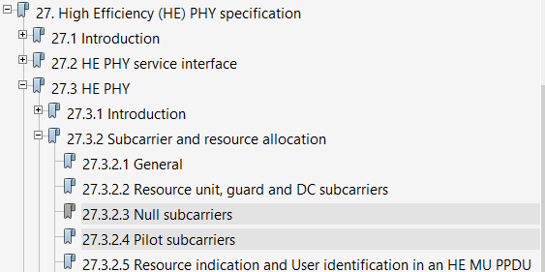
Thus, I suggest to create a new section for null subcarriers right berfore 36.3.2.4 (Pilot subcarriers) and the proposed text is based on the 11ax spec.
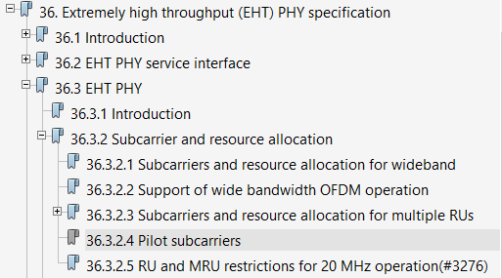

TGbe Editor: Please create the following new section right before 36.3.2.4 (Pilot Subcarriers):
36.3.2.4 Null subcarriers
There are null subcarriers between the 26-, 52- and 106-tone RU locations as illustrated in Figure 27-5 (RU locations in a 20 MHz HE PPDU), Figure 27-6 (RU locations in a 40 MHz HE PPDU) and Figure 36-4 (RU locations in an 80 MHz EHT PPDU). The null subcarriers are located near the DC or edge tones to provide protection from transmit center frequency leakage, receiver DC offset, and interference from neighboring RUs or MRUs. The null subcarriers have zero energy. The indices of the null subcarrier for 20 MHz and 40 MHz are enumerated in Table 27-10 (Null subcarrier indices). The indices of the null subcarrier for 80 MHz, 160 MHz and 320 MHz are enumerated in Table 36-xx (Null subcarrier indices for 80 MHz, 160 MHz and 320 MHz).
Table 36-xx – Null subcarrier indices for 80 MHz, 160 MHz and 320 MHz
Channel Width | RU Size | Null Subcarrier indices
80 MHz | 26, 52, 106 | {null subcarrier indices in 40 MHz – 256, null subcarrier indices in 40 MHz + 256}
 | 242, 484, 996 | None
160 MHz | 26, 52, 106 | {null subcarrier indices in 80 MHz – 512, null subcarrier indices in 80 MHz + 512}
 | 242, 484, 996, 2x996 | None
320 MHz | 26, 52, 106 | {null subcarrier indices in 160 MHz – 1024, null subcarrier indices in 160 MHz + 1024}
 | 242, 484, 996, 2x996, 4x996 | None
The indices of the null subcarrier for MRUs shall follow the indices of the null subcarrier for each component RU.

