IEEE P802.11 Wireless LANs
Proposed text for 26.5 (MU operation)
Date: 2021-03-23
Author(s):
Name | Affiliation | Address | Phone | Email
Chong Han | pureLiFi |  |  | chong.han@purelifi.com
Nikola Serafimovski |  |  |  | nikola.serafimovski@purelifi.com
Stephan Berner |  |  |  | stephan.berner@purelifi.com
Mostafa Afgani |  |  |  | Mostafa.afgani@purelifi.com
Tamas Weszely |  |  |  | Tamas.weszely@purelifi.com
Abstract
This document is to reflect the changes needed for the implementation of UL Random Access proposed for LC MAC to support the LC HE PHY. This document provides text to be incorporated in the TGbb draft for the sub-clause 26.5 (MU operation). The base documents are IEEE P802.11ax/D8.0 and IEEE P802.11bb/D0.4.

Discussion: Highlighted text preceded by “Discussion” are not to be copied into the TGbb Draft. Such text provides rationale for the proposed changes.

History
R1: add the explanatory text

26.5.2 UL MU operation
Discussion: this document is to reflect the changes needed for the implementation of UL Random Access proposed for LC MAC to support the LC HE PHY. The proposal is presented in 11-19/0846r1. The main changes needed for the subclause is: to reserve RU for random access; and not to use 2045 or 2046 on AID subfield to indicate the RU is available for unassociated/unallocated STAs.

26.5.2.2 Rules for soliciting UL MU frames

26.5.2.2.1 General

Change the 8th paragraph as follows:
Discussion: the following paragraph reserves a specific RU (e.g., RU1) for random access by unselected non-AP LC STAs .

NOTE—An AP does not send a Trigger frame containing a User Info field with AID12 subfield carrying the 12 LSBs of the AID of a non-AP STA or a frame addressed to a non-AP STA that carries a TRS Control subfield if the AP has received from the non-AP STA an OM Control subfield with UL MU Disabled subfield set to 1 and UL MU Data Dis- able subfield set to 0 (see 26.9.3 (Transmit operating mode (TOM) indication)). For LC AP, the AID12 subfield for RU1 is reserved for the random access by non-AP LC STAs that are unselected for any other RUs. Multiple RUs may be allocated for random access if needed in the future.

Change the 9th paragraph as follows:

An AP that transmits a PPDU may solicit an HE TB PPDU from one or more non-AP STAs through one of the following mechanisms:
- Including in the PPDU one or more Trigger frames that include one or more User Info fields with one of the following AID12 subfield settings:
• The AID12 subfield is set to the 12 LSBs of the AID of the non-AP STA if the User Info field is addressed to a STA that is associated with the AP.
• The AID12 subfield is set to the 12 LSBs of the AID of the non-AP STA if the User Info field is addressed to a STA that is associated with an AP corresponding to a nontransmitted BSSID in a multiple BSSID set to which the AP belongs, the TA field of the Trigger frame is set to the trans- mitted BSSID and the non-AP STA has set the Rx Control Frame To MultiBSS subfield in the HE Capabilities element it transmits to 1.
Discussion: the following paragraph reserves a specific RU (e.g., RU1) for random access by unselected non-AP LC STAs .
• The AID12 subfield indicates that one or more contiguous RA-RUs are allocated (see 26.5.4 (UL OFDMA-based random access (UORA)). For LC AP, the AID12 subfield for RU1 is set to 0 if the User Info field is addressed to non-AP LC STAs that are unselected for any other RUs. As illustrated in Figure 26-4, the RU1 is fixed and reserved to random access. Non-AP LC STAs may utilise the RU to access the UL channel randomly if their IDs are not selected in any other RUs in the same trigger frame.
- Including in the PPDU one or more individually addressed frames that include a TRS Control sub- field and that:
• Are carried in an S-MPDU that solicits an immediate Ack frame (see 10.12.8 (Transport of S- MPDUs))
• Are carried in an A-MPDU that solicits an immediate BlockAck frame (see 10.25.6.7 (Origina- tor’s behavior))
• Are carried in a multi-TID A-MPDU that solicits an immediate Multi-STA BlockAck frame (see 26.6.3 (Multi-TID A-MPDU and ack-enabled single-TID A-MPDU))
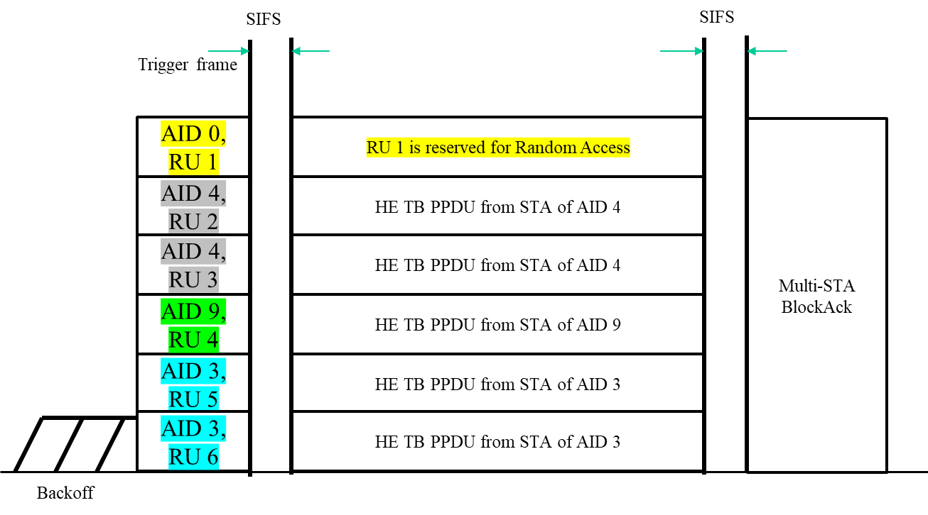
Figure 26-4 An example of UL MU operation cycle in the LC HE MAC

26.5.2.2.3 Padding for a triggering frame

Change the 3rd paragraph as follows:
Discussion: the following paragraph allocates the RUs for unassociated non-AP STAs as in the HE MAC. However, this is to be avoided in LC HE MAC due to the high collision probabilities it may cause.

An AP transmitting a Trigger frame that contains at least one User Info field with AID12 subfield indicating allocation of one or more contiguous RA-RUs for unassociated non-AP STAs should ensure that the number of bits following the last bit of SCH is at least 4 × NDBPS for a non-HT PPDU, HT PPDU or VHT PPDU, or NDBPS for an HE PPDU, where SCH is the last User Info field with AID12 subfield equal to either 2045 or 2046. This paragraph does not apply to the LC.

26.5.2.2.4 Allowed settings of the Trigger frame fields and TRS Control subfield
Change the 15th paragraph as follows:
Discussion: the following paragraph indicate unallocated RU in the Trigger frame as in the HE MAC. However, this is to be avoided in LC HE MAC due to the high collision probabilities it may cause.

An AP may indicate an unallocated RU in a Trigger frame by including a User Info field with the AID12 subfield set to 2046. The AP shall place any User Info fields with the AID12 subfield set to 2046 after User Info fields with the AID12 subfield set to a value less than 2046. This paragraph does not apply to the LC.

26.5.2.3 Non-AP STA behaviour for UL MU operation

26.5.2.3.1 General
Change the 3rd paragraph as follows:

A non-Ap STA shall not transmit an HE TB PPDU if all the conditions in 26.5.2.3.2 (Conditions for not responding with an HE TB PPDU) are satisfied. Otherwise, a non-AP STA shall transmit an HE TB PPDU a SIFS after a received PPDU if all of the following conditions are met:
—The received PPDU contains either a Trigger frame (that is not an MU-RTS variant) with a User Info field addressed to the non-AP STA, or a frame addressed to the non-AP STA that contains an TRS Control subfield. A User Info field in the Trigger frame is addressed to a non-AP STA if one of the following conditions are met:
• The AID12 subfield is equal to the 12 LSBs of the AID of the non-AP STA and the Trigger frame is sent by the AP with which the non-AP STA is associated with or by the AP correspond- ng to the transmitted BSSID if the non-AP STA is associated with an AP corresponding to a nontransmitted BSSID and has indicated support for receiving Control frames with TA field set to the transmitted BSSID by setting the Rx Control Frame To MultiBSS subfield to 1 in the HE Capabilities element that the STA transmits.
• The AID12 subfield indicates allocation of one or more contiguous RA-RUs for associated STAs, the non-AP STA is associated with the AP that sent the Trigger frame, the non-AP STA supports the UORA procedure, and the conditions the conditions in 26.5.4 (UL OFDMA-based random access (UORA)) are satisfied.
Discussion: the following paragraph allocates the RUs for unassociated non-AP STAs as in the HE MAC. However, this is to be avoided in LC HE MAC due to the high collision probabilities it may cause.
• The AID12 subfield indicates allocation of one or more contiguous RA-RUs for unassociated STAs, the non-AP STA is not associated with the AP that sent the Trigger frame, the non-AP STA supports the UORA procedure, the conditions in 26.5.4 (UL OFDMA-based random access (UORA)) are satisfied, and the resource that the non-AP STA gains access to is sufficient for the non-AP STA to include the pending frame. This paragraph does not apply to the LC.
Discussion: the following paragraph reserves a specific RU (e.g., RU1) for random access by unselected non-AP LC STAs .
• The AID12 subfield for RU1 indicates the RU is reserved for non-AP LC STAs that are unselected for any other RUs.
- The CS Required subfield in the Trigger frame is 1 and the UL MU CS condition described in 26.5.2.5 (UL MU CS mechanism) indicates the medium is idle, or the CS Required subfield in a Trigger frame is 0 or the response was solicited by a frame containing a TRS Control subfield.
- The UL MU Disable subfield is 0 and the UL MU Data Disable subfield is 0 in the most recent OM Control subfield (if any) sent by the non-AP STA to the AP or the UL MU Disable subfield is 0 and the UL MU Data Disable subfield is 1 in the most recent OM Control subfield (if any) sent by the non-AP STA to the AP and the frame that is being triggered is an acknowledgment (see 26.9.3 (Transmit operating mode (TOM) indication)).

