IEEE P802.11
Wireless LANs
Segment Parser CR on P802.11be D0.4 – part 3
Date: 2021.03.22
Author(s):
Name | Company | Address | Phone | email
Bo Gong | Huawei Technologies |  |  | gongbo8@hisilicon.com
Jianhan Liu | Mediatek |  |  | Jianhan.Liu@mediatek.com
Ross Jian Yu | Huawei Technologies |  |  | ross.yujian@huawei.com
This submission shows
- Resolution for a comment received from TGbe comment collection (TGbe Draft D0.3)
- The proposed changes are based on 11be D0.4.

The submission provides resolutions to CIDs 2993, 1588.

CID 2993
Page.  Line | Clause Number | Comment | Proposed Change | Resolution
287.1 | 36.3.12 | Some subsections are missing in data field, e.g. Pre-FEC padding process, Dual carrier modulation, Segment deparser. | Please add missing subsections | Revised  (1) The pre-FEC padding process has been described in 36.3.13.3.4 of P802.11be D0.4 (or 36.3.12.3.4 of P802.11be D0.3) EHT PPDU padding process and 36.3.13.3.5 of P802.11be D0.4 (or 36.3.12.3.5 of P802.11be D0.3) Encoding process for an EHT MU PPDU. There is no need to add a separate subsection.  (2) The subsections of dual carrier modulation and segment deparser are provided.  Instructions to the editor: Please make the changes as shown in 11/21-0543r1

CID 1588
Page.  Line | Clause Number | Comment | Proposed Change | Resolution
287.01 | 36.3.12 | Segment deparser block is defined in the transmitter block diagram. A new subsection which adresses this block is also needed in the Data field section. | Add a new subsection for segment deparser into the Data field section and describe its detail. | Revised  Agreed in principle. Reflect the detailed explanation.  Instructions to the editor: Please make the changes as shown in 11/21-0543r1  Note to the editor: The resolution for CID 1588 is part of the resolution for CID 2993.

Discussion:
We have reviewed the specification of 11ax D8.0. It is found that the usage of $N_{SD}$ can be divided into two categories.
- The one is that, $N_{SD}$ is used in the scenario where no special emphasis of DCM is required, such as, OFDM modulation (Line 2, Page 658), the calculation of RMS of the PPDU (Line 26, Page 680), and the calculation of the average data subcarrier power (Line 36, Page 681). In this condition, $N_{SD}$ indicates the number of the data subcarriers (the number of the subcarriers that are not pilots in an RU/MRU).
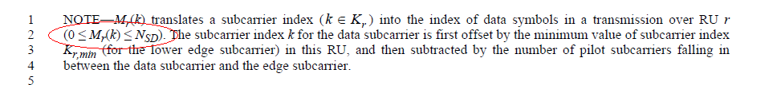
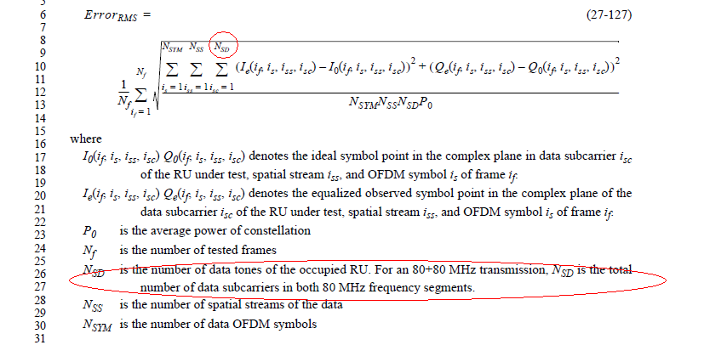
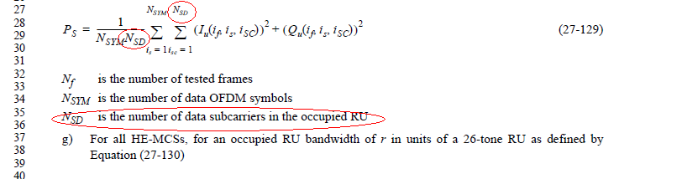

- The other is that, $N_{SD}$ is used in the scenario where DCM affects the operation or the input/output parameters of the module, such as, constellation mapping (Line 28, Page 648) and LDPC tone mapper (Line 7, Page 650). In this condition, the value of $N_{SD}$ with DCM is half of the value of $N_{SD}$ without DCM and special instructions are given to clarify the value of $N_{SD}$.
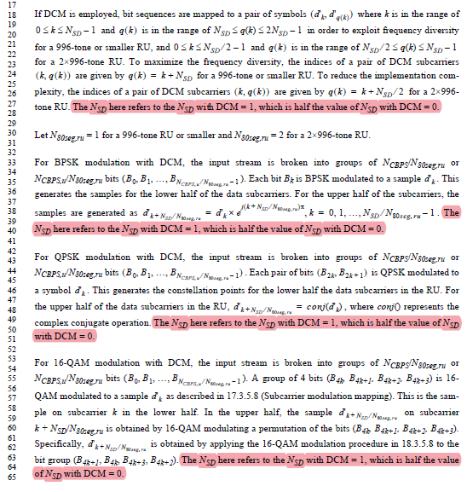

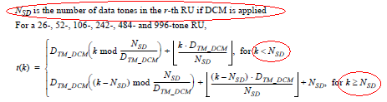
In summary, in the specification of 11ax D8.0, in the scenario that it is unnecessary to emphasize the effect of DCM, $N_{SD}$ indicates the number of the data subcarriers (the number of the subcarriers that are not pilots in an RU/MRU). In the scenario that DCM affects the operation or the input/output parameters of the module and there exists special instructions about $N_{SD}$, the value of $N_{SD}$ with DCM is reduced to a half.
Following the spirit of 11ax, we believe that for the module of segment deparser, it is unnecessary to emphasize the effect of DCM and $N_{SD}/N_{SD_l}$ indicates the number of the data subcarriers, i.e, the number of the subcarriers that are not pilots in an RU/MRU.
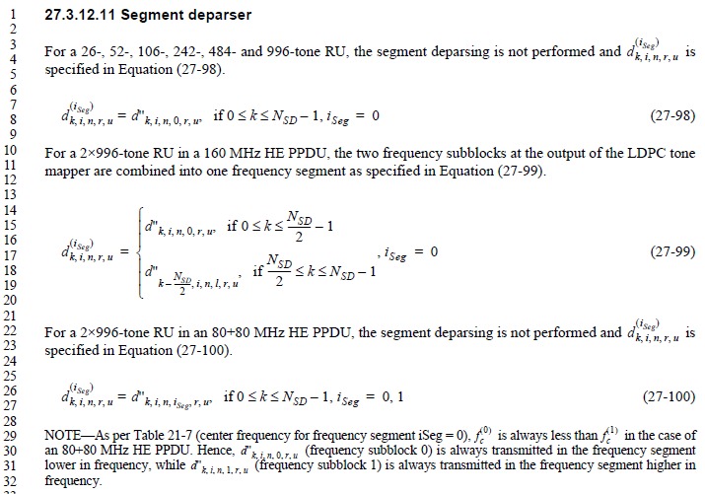
Instructions to the editor:
Please insert the subsection 36.3.13.9 Segment deparser in Line 24 Page 407 in Draft P802.11be D0.4, and insert the subsection 36.3.13.13 Dual carrier modulation in Line 46 Page 414 in Draft P802.11be D0.4.
36.3.13.9 Segment deparser
For a 26-, 52-, 52+26-, 106-, 106+26-, 242-, 484-, 484+242-,and 996-tone RU or MRU, the segment deparsing is not performed and is specified in Equation (xx-xx1),
$d_{k,i,n,r,u}=d_{k,i,n,0,r,u}^{''}$, if $0≤k≤N_{SD}-1$. (xx-xx1)
For a 996+484-, 996+484+242-, 2×996-, 2×996+484-, 3×996-, 3×996+484-, and 4×996-tone RU or MRU in EHT PPDU, the frequency subblocks at the output of the LDPC tone mapper are combined into one frequency segment as specified in Equation (xx-xx2),
$d_{k,i,n,r,u}=d_{k-\sum_{i=0}^{l-1}{N_{SD_i}},i,n,l,r,u}^{''}$, if $\sum_{i=0}^{l-1}{N_{SD_i}}≤k≤\sum_{i=0}^{l}{N_{SD_i}-1}$, (xx-xx2)
where$l ∈ \left[1,L-1\right]$, and $\sum_{i=0}^{l-1}{N_{SD_i}}=0$ for frequency subblock $l=0$.
36.3.13.13 Dual carrier modulation
DCM modulates the same information on a pair of subcarriers. DCM is a modulation scheme for EHT-SIG and Data fields, which is applied for EHT-MCSs 14 and 15 and EHT-SIG MCS 3. DCM is only applicable to BPSK, rate-1/2 coding and the single spatial stream.
The constellation mapper for DCM is defined in 36.3.13.7 (Constellation mapping). The LDPC tone mapper for DCM is defined in 36.3.13.8 (LDPC tone mapper). The BCC interleaver for DCM is defined in 36.3.13.6 (BCC interleavers). The segment parser for DCM is defined in 36.3.13.5 (Segment parser).

