IEEE P802.11
Wireless LANs
Comment resolution for ML Reconfiguration
Date: 2021-06-16
Author(s):
Name | Affiliation | Address | Phone | email
Payam Torab | Facebook | 1 Hacker Way  Menlo Park, CA 95034 |  | torab@ieee.org
Chunyu Hu |  |  |  | chunyuhu07@gmail.com
Morteza Mehrnoush |  |  |  | mmehrnoush@fb.com
Muhammad Kumail Haider |  |  |  | haiderkumail@fb.com
Chittabrata Ghosh |  |  |  | chittabrata@fb.com
Rojan Chitrakar | Panasonic |  |  | rojan.chitrakar@sg.panasonic.com
Yoshio Urabe |  |  |  | urabe.yoshio@jp.panasonic.com
Jarkko Kneckt | Apple |  |  | jkneckt@apple.com
Pooya Monajemi | Cisco |  |  | pmonajem@cisco.com
Brian Hart |  |  |  | brianh@cisco.com
Malcolm Smith |  |  |  | mmsmith@cisco.com
Gaurav Patwardhan | HPE |  |  | gaurav.patwardhan@hpe.com
Eldad Perahia |  |  |  | eldad.perahia@hpe.com
Insun Jang | LGE |  |  | insun.jang@lge.com
Namyeong Kim |  |  |  | namyeong.kim@lge.com
Zhiqiang Han | ZTE |  |  | han.zhiqiang1@zte.com.cn
Abhishek Patil | Qualcomm |  |  | appatil@qti.qualcomm.com
George Cherian |  |  |  | gcherian@qti.qualcomm.com
Duncan Ho |  |  |  | dho@qti.qualcomm.com
Ahmed ElArabawy | Google |  |  | arabawy@google.com
Srinivas Kandala | Samsung |  |  | srini.k1@samsung.com
Jonghun Han |  |  |  | jong_hun.han@samsung.com
Mark Rison |  |  |  | m.rison@samsung.com
Thomas Derham | Broadcom |  |  | thomas.derham@broadcom.com
Matthew Fischer |  |  |  | matthew.fischer@broadcom.com
Saju Palayur | MaxLinear |  |  | spalayur@maxlinear.com
Sigurd Schelstraete |  |  |  | sschelstraete@maxlinear.com
Xiaofei Wang | InterDigital |  |  | xiaofei.wang@interdigital.com
Stephane Baron | Canon |  |  | stephane.baron@crf.canon.fr
Mickael Lorgeoux |  |  |  | mickael.lorgeoux@crf.canon.fr
Julien Sevin |  |  |  | julien.sevin@crf.canon.fr
Arik Klein | Huawei |  |  | arik.klein@huawei.com
Xiandong Wang | Xiaomi |  |  | dongxiandong@xiaomi.com

Abstract
Proposed draft text for multi-link (ML) reconfiguration, broadly referring to a set of post-association procedures to make changes to links between APs and non-AP STAs affiliated with two MLDs, and without disassociation. The submission resolves 5 CIDs from Comment Collection (CC) 34: 1852, 1857, 2511, 2595 and 2513.

Revision History

Date | Revision | Changes
2021-04-16 | 0 | Initial draft
2021-04-30 | 1 | Note about co-hosted BSSs and non-transmitted BSSIDs when adding APs
2021-05-16 | 2 | Minor edits, terminology
2021-05-29 | 3 | ML Configuration Request/Response/Notify frames renamed to ML Reconfiguration
2021-06-16 | 4 | Trivial updates to Reconfiguration variant ML element to harmonize with Draft 1.0.  AP removal announcement through the Reconfiguration variant ML element

Comments

CID | Page | Clause | Comment | Proposed Change | Proposed Resolution
1857 | 125.59 | 35.3.1 | The AP MLD Multi Link Operation (MLO) should specify how AP MLD adds new affiliated AP(s) or removes affiliated AP(s). AP MLD may need to add or delete the affiliated AP in order to optimize network performance or to minimize its power consumption in order to be nature friendly. | Please describe how AP MLD may add new affiliated APs and/or remove affiliated APs. | Agree in principle with the comment.  Resolution: Revised, please implement the changes as shown in IEEE 802.11-21/0534r4 and identified with the CID 1857.
2513 | 132.23 | 35.3.5.3 | There are cases when an AP of an AP MLD will need to shutdown. In such scenarios other links affiliated with the MLDs should not be affected. | Add a single link tear down procedure. | Agree in principle with the comment.  Resolution, Revised, please implement the changes as shown in IEEE 802.11-21/0534r4 and identified with the CID 2513.

Discussion on CIDs 1857 and 2513:
The comments ask to clarify how AP MLD may add a new affiliated AP or delete an affiliated AP. Currently, 802.11be does not specify this operation, which may lead to interoperability issues in the 802.11be deployments.
An AP MLD may need to adjust the number of available affiliated APs based on traffic load, interference, and the number of associated STAs. All devices should be environmentally friendly, so it is important to minimize and optimize AP MLD power consumption. Detailed description of the AP MLD configuration use cases is described in the submission 20/810r1.
802.11be should specify how an AP MLD adds a new affiliated AP. Similarly, 802.11be should specify how an associated non-AP MLDs sets up a link with a new affiliated AP in order to exchange data with the new affiliated AP.
The baseline 802.11 allows an AP to signal that it will terminate/stop operating by sending a BSS Transition Management Request frame with BSS Termination Included field set to 1 to all associated STAs. The current 802.11 description forces the AP to disassociate all STAs before the BSS is terminated.
The disassociation of the non-AP MLD terminates data transmission in all links of the non-AP MLD. This is not desired in ML setup, because non-AP MLD may have links with other affiliated APs and data transmission with these APs may continue without interrupts. 802.11be should clarify when the disassociation of the non-AP MLD is needed and how non-AP MLD operates if one of the APs to which it has a link is deleted.
CID 2513 requests to clarify signaling to delete a single link. It is better to define both Add Link and Delete Link operations to enable flexible link handling. The Add and Delete link signaling are discussed with the CIDs 1852 and 2511.

CID | Page | Clause | Comment | Proposed Change | Proposed Resolution
1852 | 100.01 | 11.3.5.3 | The non-AP MLD reassociation to the same AP MLD causes hard reset of all parameters that prevents data transmission for some time, i.e., all links need to reset block acks, SNs, PNs, etc., as listed in p.100. The hard reset is especially bad for low delay applications, because it forces all links to stop using the existing parameter values. The add link should be robust in order to protect the privacy of the non-AP MLD.  To avoid data transmissions interrupts in all links, the non-AP MLD should have robust Add Link signaling to add a link or modify parameters of a STA affiliated with non-AP MLD. | Please include robust Add Link signaling to 802.11be. Add Link allows non-AP MLD to modify the number of links it operates and parameters in uses in the links. Please make sure that Add Link does not cause interrupts to the data transmissions on other links. | Agree in principle with the comment, and there are good use cases for link addition (e.g., client getting rejected for one or more of the links it asked for during association (but still successful association), justifying client trying to add those requested links again from time to time, all without reassociating (which would mean potentially losing existing links, or resources on those links)).  Resolution: Please implement the changes as shown in IEEE 802.11-21/0534r4 and identified with the CID 1852.
2511 | 100.12 | 11.3.5.4 | All agreements and allocations listed on this page are reset or deleted once a reassociation occurs. This is completely unnecessary and disruptive in a scenario in which a device needs to add a link to an existing setup. There are many use cases for link addition, including a case where an AP is added to an existing AP MLD. | Add a mechanism for link addition such that existing agreements on other links are not affected. | Agree in principle with the comment, which is similar to 1852.  Resolution: Please implement the changes as shown in IEEE 802.11-21/0534r4 and identified with the CID 2511.
2595 |  | 35.3.5.3 | There could be instances where either a non-AP MLD or an AP MLD may need to remove (unassociate) one or more setup links without having to perform a multi-link tear down. 11be should allow such link removals. | Provide means for a non-AP MLD or an AP MLD to remove (unassociate) one or more setup links without having to perform a multi-link tear down. | Agree in principle with the comment, and there are good reasons for non-AP to remove a link (e.g., deploy one of its basebands to an altogether new application (ranging, shared frontend, a different secure L2 connection in a different band…)), and good reasons for an AP to remove a link to a client (traffic engineering, optimization...).  Resolution: Please implement the changes as shown in IEEE 802.11-21/0534r4 and identified with the CID 2595.
Discussion on CIDs 1852, 2511 and 2595:
The comments say that there should be a way to configure the ML setup i.e., add a new link, delete a link or modify STA parameters in a link, without long interrupts and hard reset of security keys, Sequence numbers, and Packet numbers. The long interrupt is caused by the need to redo the 4-way handshake before any link may send any data. Efficient data transmission also requires setting up block ack agreements, TWTs, traffic streams, etc.
In general, the proposed comment resolution agrees with the comments. The discussion first introduces reasons why reassociation introduces long delays to link add/delete operations. Then resolution for the comments is explained.

Challenges of using re-association signaling in ML configuration
As explained in clause 11.3.5.4 the non-AP MLD deletes its keys before it transmits reassociation request frame.
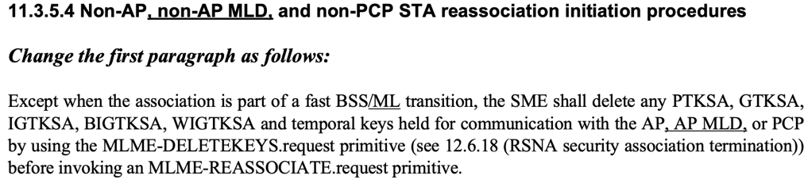
Figure 1 – IEEE802.11be D0.3 rules for Reassociation Request transmission to the associated AP.
The transmission of a Re-association Request frame causes the ML setup to transition from State 4 to State 2. When STA operates in State 2, the transmission of class 3 Frames is not allowed. For instance, data frames transmission between AP affiliated with AP MLD and STA affiliated with non-AP MLD is not allowed.
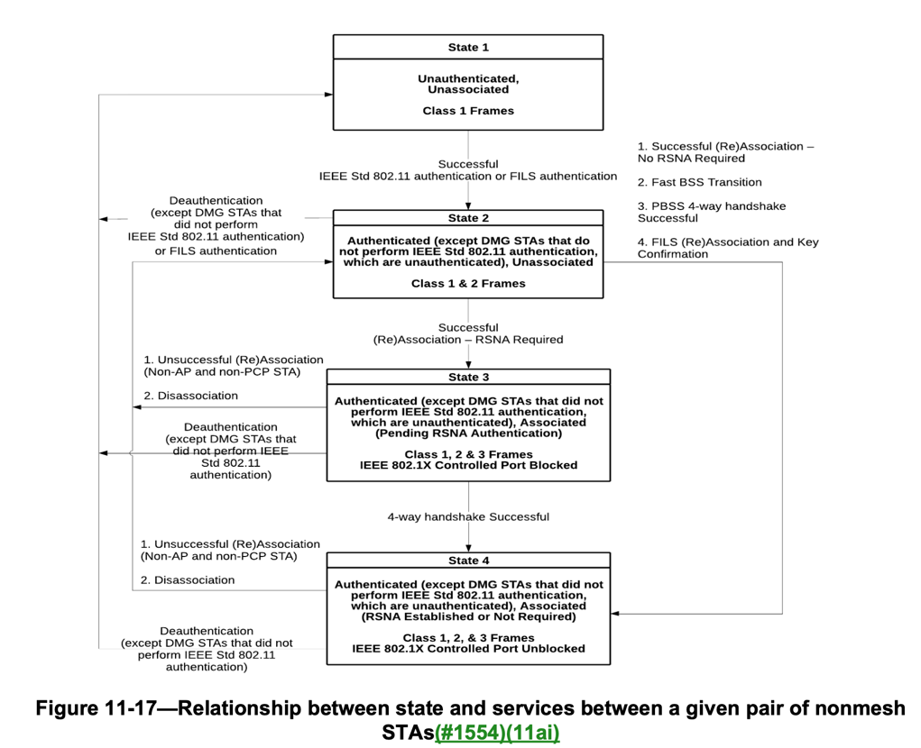
Figure 2 – IEEE802.11md D5.0 State transition diagram and allowed services.
To enable again the data transmissions in the ML setup, the AP MLD needs to accept the Reassociation Request frame by sending Reassociation Response. The AP MLD may also reject the Reassociation Request, in which case the ML setup remains in state 2. For instance, AP MLD may not desire to setup the same number of links as were setup before the reassociation and create fewer links, or reject the whole association. If AP allows smaller number of links creation, the non-AP MLD may try its luck again in another re-association signaling.
A successful Reassociation changes the ML setup to state 3. In this state, the ML does not have PTK, GTK, IGTK and BIGTKS keys that were deleted before the Reassociation Request transmission. The AP MLD and non-AP MLD need to exchange 4-Way handshake to re-establish the keys. After successful key exchange, the MLDs may transmit data.
Efficient data transmission requires still at least block acknowledgements setup, MSCS and/or SCS configurations for QoS and TWT Setup for power save. These setups require transmission of multiple frames. The Figure 3 summarizes the signaling, but due to lack of space the setup signaling for block acks, etc. are not shown in full details.
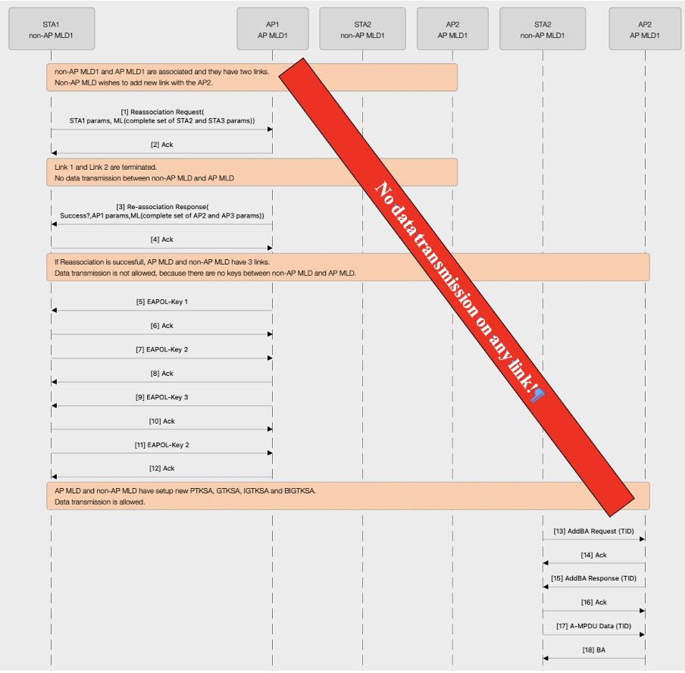
Figure 3– example of adding a link with re-association signaling.

Proposed resolution for ML reconfiguration signaling
The non-AP MLD should be able to change its ML configuration (i.e., to reconfigure) by using protected management frames, so it is secure operation and does not leak information of the MLDs. As discussed in the 802.11bi and 802.11bh, user privacy is very important and over the air transmitted information allows attackers to trace the non-AP MLD.
The ML reconfiguration should be done in state 4, same as all multi-link management operations. With ML reconfiguration there is no need to reset PTKSA, GTKSA, IGTKSA and BIGTKSA keys, block acks, MSCS, SCS, TWT, or other parameters. The MLDs continue to use them and may transmit data during ML reconfiguration.
The ML reconfiguration should not cause any changes to the links that are not modified. The simplest solution is to include only the parameters related to the added, deleted and modified links into ML Reconfiguration Request and ML Reconfiguration Response frames.
One ML reconfiguration signaling should be able to add one or more links, so that single signaling can carry all required modifications. When the reconfiguration request contains multiple changes (e.g., multiple link additions and/or link deletions), the AP MLD should be only allowed to accept or reject the requested changes as a whole. This avoids situations where a link is deleted, but no new link is created. Reconfiguration requests that include only link deletions should be always accepted by the AP MLD.
The basics of ML reconfiguration as defined in this contribution are as follows:
- The reconfiguration request is always initiated by non-AP MLD.
- The AP MLD can send a notification to suggest adding a link, but choice is left to non-AP MLD.
- The AP MLD adds and removes APs – after adding an AP, non-AP MLDs can request to add links to the new APs.
- Deleting AP, which removes links from one or more non-AP MLDs, is through an indication – no need any further approval from the non-AP MLD.
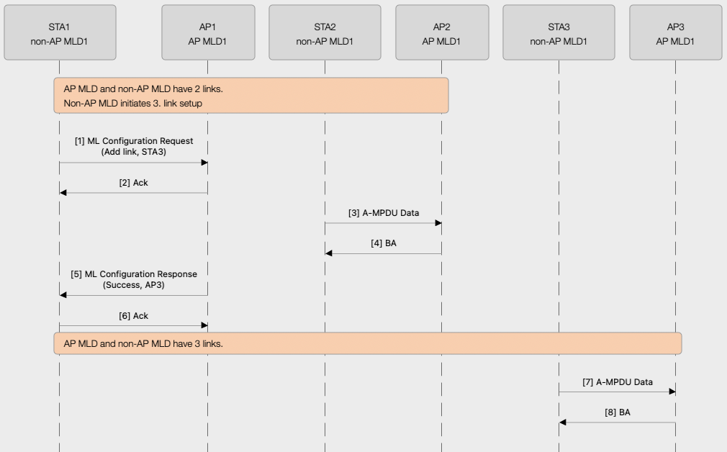
Figure 5 – Example of ML reconfiguration signaling to add a link. Data can be transmitted in other links while the new link is being added and no need to redo block ack setups after the new link addition.

TGbe Editor: Editing instructions preceded by “TGbe Editor” are instructions to the TGbe editor to modify existing material in the TGbe draft. As a result of adopting the changes, the TGbe editor will execute the instructions rather than copy them to the TGbe Draft.

9.4.1.9 Status Code field [#1852], [#2511], [#2595]
TGbe editor: Add a new row to Table 9-50 (Status codes) in numerical order, and update the Reserved row:
Table 9-50—Status codes
Status code | Name | Meaning
<ANA> | REJECTED_WITH_SUGGESTED_LINKS | Requested reconfiguration is rejected and alternative links are suggested.

9.4.2.295b Multi-Link element [#1852], [#2511], [#2595]

9.4.2.295b.1 General
TGbe editor: Add a new row to Table 9-322am (Type subfield encoding) in numerical order, and update the Reserved row:
Table 9-322am—Type subfield encoding
Type subfield value | Multi-Link element variant name
0 | Basic
1 | Probe Request
2 | Reconfiguration
3-7 | Reserved

TGbe editor: Modify the paragraph at P128L19 as follows:
The Presence Bitmap subfield is used to indicate the presence of various subfields in the Common Info field as described in 9.4.2.295b.2 (Basic variant Multi-Link element), 9.4.2.295b.3 (Probe Request variant Multi-Link element), and 9.4.2.295b.4 (Reconfiguration variant Multi-Link element)).

TGbe editor: Modify the paragraph at P128L24 as follows:
The Common Info field carries information that are common to all the links except for Link ID Info subfield and BSS Parameters Change Count subfield that are for the link on which Multi-Link element is sent and is optionally present based on the value of the Type subfield (see 9.4.2.295b.2 (Basic variant Multi-Link element), 9.4.2.295b.3 (Probe Request variant Multi-Link element), and 9.4.2.295b.4 (Reconfiguration variant Multi-Link element)).

TGbe editor: Modify the paragraph at P128L35 as follows:
The Link Info field carries information specific to the links and is optionally present based on the value of the Type subfield (see 9.4.2.295b.2 (Basic variant Multi-Link element), 9.4.2.295b.3 (Probe Request variant Multi-Link element) and 9.4.2.295b.4 (Reconfiguration variant Multi-Link element)).

TGbe editor: Add the following new sub-clause:

9.4.2.295b.4 Reconfiguration variant Multi-Link element
The Reconfiguration variant Multi-Link element is used to announce, recommend or request an ML reconfiguration operation (see 35.3.6 (Multi-link reconfiguration)).
The format of the Presence Bitmap subfield of the Reconfiguration variant Multi-Link element is defined in Figure 9-322n0 (Presence Bitmap subfield of the Reconfiguration variant Multi-Link element format).

 | EML  Capabilities  Present | MLD  Capabilities  Present | Reserved
Bits: | 1 | 1 | 14
Figure 9-322n0—Presence Bitmap subfield of the Reconfiguration variant Multi-Link element format
The EML Capabilities Present subfield is set to 1 if the EML Capabilities field is present in the Common Info field. Otherwise, the EML Capabilities Present subfield is set to 0.
The MLD Capabilities Present subfield is set to 1 if the MLD Capabilities subfield is present in the Common Info field. Otherwise, the MLD Capabilities Present subfield is set to 0.
The format of the Common Info subfield of the Reconfiguration variant Multi-Link element is defined in Figure 9-322n1 (Common Info field of the Reconfiguration variant Multi-Link element format).

 | EML  Capabilities | MLD  Capabilities
Octets: | 0 or 2 | 0 or 2
Figure 9-322n1—Common Info field of the Reconfiguration variant Multi-Link element format
The EML Capabilities subfield has the same definition as the EML Capabilities subfield of the Common Info field of the Basic variant Multi-Link element (see 9.4.2.295b.2 and Figure 9-788el—EML Capabilities subfield format).
The MLD Capabilities subfield has the same definition as the MLD Capabilities subfield of the Common Info field of the Basic variant Multi-Link element (see 9.4.2.295b.2 and Figure 9-788em—MLD Capabilities subfield format).
The Link Info field contains one or more subelements. The subelement format and ordering of subelements are defined in 9.4.3 (Subelements).
The Subelement ID field values for the defined subelements are shown in Table 9-322an1 (Optional subelement IDs for the Reconfiguration variant Multi-Link element).
Table 9-322an1—Optional subelement IDs for the Reconfiguration variant Multi-Link element
Subelement ID | Name | Extensible
0 | Per-STA Profile | Yes
1-220 | Reserved
221 | Vendor Specific | Vendor defined
222-255 | Reserved
Zero or more Per-STA Profile subelements are included in the list of subelements.
Each Per-STA Profile subelement starts with a STA Control field, followed by a variable number of fields and elements, as defined in 35.3.6 (Multi-link reconfiguration).
The format of a Per-STA Profile subelement is defined in Figure 9-788ez2 (Per-STA Profile subelement format for the Reconfiguration variant Multi-Link element).
 | Subelement  ID | Length | STA Control | STA Info | STA Profile
Octets: | 1 | 1 | 2 | variable | variable
Figure 9-788ez2—Per-STA Profile subelement format for the Reconfiguration variant Multi-Link element
The format of the STA Control field is defined in Figure 9-788ek2 (STA Control field format for the Reconfiguration variant Multi-Link element).
 | B0 B3 | B4 | B5 | B6 | B7 | B8 B11 | B12 | B13 B15
 | Link ID | Complete Profile | MAC Address Present | NSTR Link Pair Present | NSTR Bitmap Size | New Link ID | Delete  Request | Reserved
Bits: | 4 | 1 | 1 | 1 | 1 | 4 | 1 | 3
STA Control field format when transmitted by a non-AP STA
 | B0 B3 | B4 | B5 | B6 | B7 | B8 B11 | B12 | B13 B15
 | Link ID | Complete Profile | MAC  Address  Present | NSTR Link Pair Present | NSTR Bitmap Size | New Link ID | Delete  Imminent | Reserved | Delete Timer
Bits: | 4 | 1 | 1 | 1 | 1 | 4 | 1 | 3 | 0 or 16
STA Control field format when transmitted by an AP
Figure 9-788ek2—STA Control field format for the Reconfiguration variant Multi-Link element
The Link ID subfield specifies a value that uniquely identifies the link that the reported STA is operating on.
The Complete Profile subfield is set to 1 when the Per-STA Profile subelement of the Multi-Link element is complete as defined in 35.3.2.2 (Advertisement of complete or partial per-link information). Otherwise, the subfield is set to 0.
The MAC Address Present subfield indicates the presence of the STA MAC Address subfield in the STA Info field and is set to 1 if the STA MAC Address subfield is present in the STA Info field; otherwise set to 0. An STA sets this subfield to 1 when the element carries complete profile.
In the remainder of this subclause, the non-AP STA related to each Per-STA Profile subelement included in the Reconfiguration variant Multi-Link element is referred to as the subject non-AP STA.
NOTE—The subject non-AP STA is the non-AP STA that is either directly represented by the Per-STA Profile subelement (when transmitted by a non-AP MLD), or associated with the AP that is represented by the Per-STA Profile subelement (when transmitted by an AP MLD).
When transmitted by a non-AP MLD,
- The New Link ID subfield identifies the new AP that the non-AP MLD is requesting to associate the subject non-AP STA with. The subfield is reserved when the Delete Request subfield is nonzero.
- The Delete Request subfield is set to 1 to request to delete the link to the subject non-AP STA, and set to 0 otherwise.
When transmitted by an AP MLD,
- The New Link ID subfield identifies the AP that the AP MLD is recommending the subject non-AP STA associate with, or to 15 if the AP MLD is not making any recommendation.
- The Delete Imminent subfield is set to 1 to indicate that the link to the subject non-AP STA will be deleted at the time indicated by the Delete Timer subfield, and set to 0 otherwise.
- The Delete Timer subfield is present when the Delete Imminent subfield is nonzero, and indicates the number of target beacon transmission times (TBTTs) of the AP the subject non-AP STA is associated with until the link is deleted; it is not present when the Delete Imminent subfield is zero.
The NSTR Link Pair Present and NSTR Bitmap Size subfields have the same definition as similarly named subfields in the STA Control field of the Per-STA Profile subelement for the Basic Variant Multi-Link element.
9.6.35 Protected EHT Action frame details
9.6.35.1 Protected EHT Action field [#1852], [#2511], [#2595]
TGbe editor: Add the following rows to the end of Table 9-526p and change the reserved range:
Table 9-526p—Protected EHT Action field values
Value | Meaning
6 | ML Reconfiguration Notify
7 | ML Reconfiguration Request
8 | ML Reconfiguration Response
9–255 | Reserved

TGbe editor: Add the following new subclause:
9.6.35.8 ML Reconfiguration Notify frame format [#1852], [#2511], [#2595]
The ML Reconfiguration Notify frame is an Action frame of category Protected EHT. The Action field of an ML Reconfiguration Notify frame contains the information shown in Table 9-xxx2 (ML Reconfiguration Notify frame Action field format).
Table 9-xxx2—ML Reconfiguration Notify frame Action field format
Order | Information
1 | Category
2 | Protected EHT Action
3 | Dialog Token
4 | Multi-Link
The Category field is defined in Table 9-51 (Category values).
The Protected EHT Action field is defined in 9.6.36.1 (General).
The Dialog Token field is a nonzero value chosen by the transmitting AP MLD to identify a notify/request/response sequence.
The Multi-Link element is defined in 9.4.2.295b (Multi-Link element); the variant of the Multi-Link element used in the frame is the Reconfiguration variant (9.4.2.295b.4 (Reconfiguration variant Multi-Link element)).

TGbe editor: Add the following new subclause:
9.6.35.9 ML Reconfiguration Request frame format [#1852], [#2511], [#2595]
The ML Reconfiguration Request frame is an Action frame of category Protected EHT. The Action field of an ML Reconfiguration Request frame contains the information shown in Table 9-xxx3 (ML Reconfiguration Request frame Action field format).
Table 9-xxx3—ML Reconfiguration Request frame Action field format
Order | Information
1 | Category
2 | Protected EHT Action
3 | Dialog Token
4 | Multi-Link
The Category field is defined in Table 9-51 (Category values).
The Protected EHT Action field is defined in 9.6.36.1 (General).
The Dialog Token field is set to the value of the Dialog Token field in the corresponding ML Reconfiguration Notify frame to identify the notify/request/response sequence, or set to a nonzero value chosen by the transmitting non-AP MLD to identify the request/response sequence.
The Multi-Link element is defined in 9.4.2.295b (Multi-Link element); the variant of the Multi-Link element used in the frame is the Reconfiguration variant (9.4.2.295b.4 (Reconfiguration variant Multi-Link element)).

TGbe editor: Add the following new subclause:
9.6.35.10 ML Reconfiguration Response frame format [#1852], [#2511], [#2595]
The ML Reconfiguration Response frame is an Action frame of category Protected EHT. The Action field of an ML Reconfiguration Response frame contains the information shown in Table 9-xxx4 (ML Reconfiguration Response frame Action field format).
Table 9-xxx4—ML Reconfiguration Response frame Action field format
Order | Information
1 | Category
2 | Protected EHT Action
3 | Dialog Token
4 | Status Code
5 | Multi-Link (optional)
The Category field is defined in Table 9-51 (Category values).
The Protected EHT Action field is defined in 9.6.36.1 (General).
The Dialog Token field is set to the value of the Dialog Token field in the corresponding ML Reconfiguration Request frame.
The Status Code field is defined in 9.4.1.9 (Status Code field).
The Multi-Link element is defined in 9.4.2.295b (Multi-Link element); the variant of the Multi-Link element used in the frame is either the Basic variant (9.4.2.295b.2 (Basic variant Multi-Link element)) or the Reconfiguration variant (9.4.2.295b.4 (Reconfiguration variant Multi-Link element)).

TGbe editor: Add the following new clause and renumber other sections under 35.3 accordingly; the requested section number is the section immediately after Multi-link (re)setup (35.3.5 in 11be Draft 1.0), to maintain a logical flow.
35.3.6 Multi-link reconfiguration
35.3.6.1 General [#1857], [#2513], [#1852], [#2511], [#2595]
Multi-link reconfiguration (ML reconfiguration, or reconfiguration for short) refers to a set of procedures through which an AP MLD and an associated non-AP MLDs can make changes to their multi-link (ML) configuration, or the set of links between their affiliated STAs, while the non-AP MLD stays in the associated state throughout the procedure. The term reconfiguration is also used for procedures for an AP MLD to add APs to or remove APs from its multi-link operation.
Through reconfiguration,
- A non-AP MLD can request to add and/or delete multiple links to the AP MLD it is associated with.
- An AP MLD can add multiple APs to or remove multiple APs from its multi-link operation.
- An AP MLD can indicate deletion of one or more links to an associated non-AP MLD.
- An AP MLD can prompt an associated non-AP MLD to request to add and/or delete multiple links, and provide a recommended configuration.
Reconfiguration procedures can use any link that has already been set up between the associated MLDs (i.e., through any non-AP STA that is associated with an AP affiliated with the AP MLD), as long as the link is enabled, while staying in the associated state.
Figure 35-xyz1 illustrates two example reconfiguration scenarios. In Figure 35-xyz1(a), an AP MLD makes a new AP available to its multi-link operation. An associated non-AP MLD, having discovered the new AP (through a recent beacon for example, or through a targeted notify message as described later in this subclause), requests a new link to the new AP, while staying in the associated state. In Figure 35-xyz1(b), a non-AP MLD adds a new non-AP STA to its multi-link operation and requests a new link to an AP affiliated with that AP MLD, again while staying in the associated state.
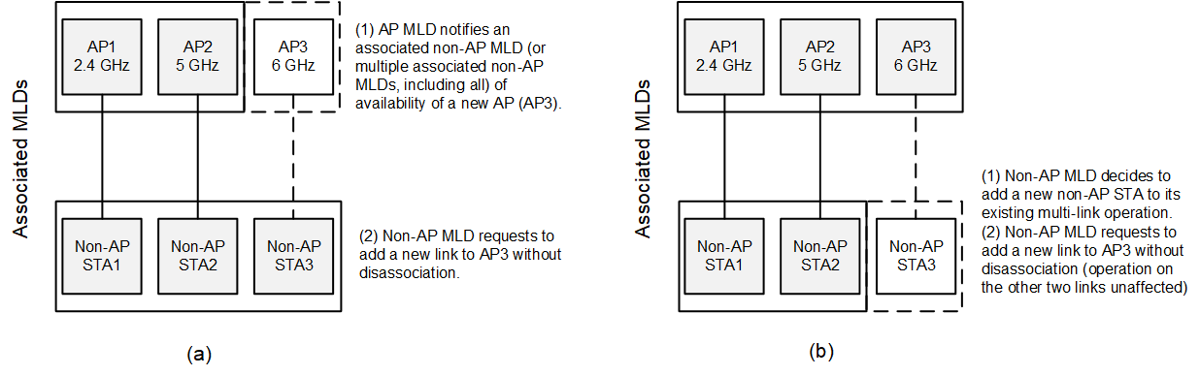
Figure 35-xyz1 – Examples of multi-link reconfiguration
This subclause also defines procedures for an AP MLD to announce adding and/or removing one or more affiliated APs.
Reconfiguration signaling is in the form of a request/response exchange initiated by a non-AP MLD; however, an AP MLD may recommend that a non-AP MLD initiates a reconfiguration request. Procedures to add or remove affiliated APs are defined in 35.3.6.2. The basic reconfiguration procedure is defined in 35.3.6.3 (Basic reconfiguration procedure). AP MLD recommended reconfiguration is defined in 35.3.6.4 (AP MLD recommended reconfiguration). Changes to multi-link operation caused by reconfiguration are defined in 35.3.6.5 (Changes to multi-link operation after reconfiguration).

35.3.6.2 Adding or removing affiliated APs [#1857], [#2513]

35.3.6.2.1 Adding new affiliated APs
An AP MLD may add new affiliated APs anytime during its multi-link operation. New affiliated APs may be announced through Basic variant Multi-Link and Reduced Neighbor Report elements in Beacon and Probe Response frames.
NOTE—The MAC address of any new co-hosted AP is assumed to be within the address space defined by the value of the Max Co-Hosted BSSID Indicator field (see 9.4.2.249 (HE Operation element) and 26.17.7 (Co-hosted BSSID set)). Similarly, the MAC address of any new nontransmitted BSSID is assumed to be within the address space defined by the value of the MaxBSSID Indicator (see 9.4.2.45 (Multiple BSSID element) and 11.1.3.8 (Multiple BSSID procedure)).

35.3.6.2.2 Removing affiliated APs
An AP MLD may remove one or more of its affiliated APs anytime during its multi-link operation. Removal of APs shall be announced through an ML Reconfiguration element (see 9.4.2.295b.4 (Reconfiguration variant Multi-Link element)) in a Beacon frame or an ML Notify frame (notify frame for short) with the RA field set to the broadcast address. The notify frame may be transmitted over any enabled link that has been set up between the AP MLD and the non-AP MLD, and shall contain a Reconfiguration variant Multi-Link element.
For each affiliated AP that is about to be removed, the AP MLD shall include a Per-STA Profile subelement with the subfields of the Per-STA Control field set as following: The Link ID subfield shall identify the AP, the Delete Imminent subfield shall be set to 1, and the Delete Timer subfield shall be set to the number of target beacon transmission times (TBTTs) of that AP before it is removed. The initial value of the Delete Timer subfield shall be longer than the MLD max idle period.
If the link corresponding to the removed AP has an NSTR relationship with one or more AP links that are not going to be removed, the AP MLD shall also include Per-STA Profile subelements for those APs to indicate an updated NSTR Bitmap (including possibly no NSTR Bitmap).
If an AP removal needs to be announced while other AP removals are in progress, the notify frame shall include updated values of the Delete Timer subfield for all APs that are about to be removed, and all Per-STA Profile subelements shall contain fields and elements that assume all APs in the notify frame have been removed.
When removing an affiliated AP, the AP MLD shall follow the procedure in 11.21.7 (BSS transition management for network load balancing) to notify STAs that are not affiliated with any MLD associated with that AP MLD of the corresponding BSS termination.
Once an affiliated AP to which a non-AP MLD has a link is removed, from the non-AP MLD perspective the link to the removed AP has been deleted and the non-AP MLD shall not transmit any frames to that AP. The non-AP MLD will operate on the remaining links as specified in 36.3.6.5 (Changes to multi-link operation after reconfiguration).
35.3.6.3 Basic reconfiguration procedure [#1852], [#2511],[#2595]
A non-AP MLD in the associated state may request modification of an ML configuration by sending, from an affiliated STA, an ML Reconfiguration Request frame to the corresponding AP affiliated with the AP MLD that it is associated with. The ML Reconfiguration Request frame shall contain a Reconfiguration variant Multi-Link element that includes per-STA profile of each STA that the non-AP MLD is requesting to add, delete, or to associate with a different AP, as well as the per-STA profile of each STA that would see a change to its EML Capabilities or MLD Capabilities as a result of the requested reconfiguration. The Reconfiguration variant Multi-Link element shall not include any other Per-STA Profile subelements.
The following rules apply for each Per-STA Profile subelement that corresponds to a non-AP STA whose corresponding AP will change as a result of the requested reconfiguration:
- If the non-AP MLD is requesting to add a link connecting the non-AP STA to an affiliated AP, it shall set the Link ID subfield to 15, the New Link ID subfield to the value that identifies the AP, and the Delete Request subfield to 0. In addition, it shall set the Complete Profile subfield to 1, and the per-STA profile of the non-AP STA shall be complete as defined in 35.3.2.2 (Advertisement of complete or partial per-link information).
- If the non-AP MLD is deleting the link connecting the non-AP STA to an affiliated AP, it shall set the Link ID subfield to the value that identifies the AP, and the Delete Request subfield to 1.
- If the non-AP MLD is requesting to associate the non-AP STA with a different affiliated AP (assuming no other non-AP STA affiliated with the non-AP MLD is associated with that AP), it shall set the Link ID subfield to the value that identifies the AP that the non-AP STA is associated with, and the New Link ID subfield to a value that identifies the requested new AP. In addition, it shall set the Complete Profile subfield to 1, and the per-STA profile of the non-AP STA shall be complete as defined in 35.3.2.2 (Advertisement of complete or partial per-link information).
For all per-STA profiles included in the request frame, the EML and MLD Capabilities subfield shall be set as if the request has been accepted.
NOTE—For example, a non-AP MLD operating in EMLSR mode with two links (Link 0 and Link 1) that requests to add a new link (Link 2) using a new radio can indicate EMLMR operation with NSTR relationship between Links 0 and Link 1.
If the AP MLD accepts the request, it shall set the Status Code field in the ML Reconfiguration Response frame to SUCCESS, and shall include in the response frame a Basic variant Multi-Link element that includes one or more Per-STA Profile subelements for each AP that has formed a new link with a non-AP STA affiliated with the non-AP MLD as a result of the reconfiguration. The Basic variant Multi-Link element shall not include any other Per-STA Profile subelements. For each Per-STA Profile subelement included in the Multi-Link element, the Complete Profile subfield in the Per-STA Control field shall be set to 1, and the per-STA profile of the AP shall be complete as defined in 35.3.2.2 (Advertisement of complete or partial per-link information)).
If the AP MLD does not accept the request, it may suggest an alternative ML configuration by setting the Status Code field in the ML Reconfiguration Response frame to REFUSED_WITH_SUGGESTED_LINKS, and including in the response frame a Reconfiguration variant Multi-Link element that includes a recommended AP for each non-AP STA connection request present in the ML Reconfiguration Request frame. For each non-AP STA in the recommended ML configuration, the Reconfiguration variant Multi-Link element shall include a Per-STA Profile subelement constructed as follows:
- The Link ID subfield in the Per-STA Control field shall identify the AP that the STA is associated with at the time of sending the response frame, or (for new links) the AP that the non-AP MLD had requested to associate the STA with.
- If the AP MLD is recommending deletion of the link to the non-AP STA, it shall set the Complete Profile subfield to 0, and the New Link ID subfield to 15. The Per-STA Profile subelement shall not include any other fields or elements.
- Otherwise, the AP MLD shall set the Complete Profile subfield to 1, and the New Link ID subfield to a value that identifies the recommended affiliated AP for the non-AP STA. The Per-STA Profile subelement shall include the per-STA profile of the recommended AP, and shall be complete as defined in 35.3.2.2 (Complete or partial per-STA profile).
If the AP MLD has not accepted the request, and is not suggesting an alternative ML configuration, it shall set the Status Code field in the ML Reconfiguration Response frame to one of REFUSED_REASON_UNSPECIFIED, REFUSED_CAPABILITIES_MISMATCH, REFUSED_EXTERNAL_REASON, REFUSED_AP_OUT_ OF_MEMORY, REFUSED_BASIC_RATES_MISMATCH, and REFUSED_TEMPORARILY. The ML Reconfiguration Response frame shall not include a Multi-Link element in this case.
A non-AP MLD shall not request a reconfiguration that would result in no links remaining between the MLDs.
An AP MLD shall accept reconfiguration requests that only delete links.
36.3.6.4 AP MLD recommended reconfiguration [#1852], [#2511], [#2595]
An AP MLD may recommend multi-link reconfiguration by sending an ML Reconfiguration Notify frame (notify frame for short) to an associated non-AP MLD. The notify frame may be transmitted over any link that has been set up between the AP MLD and the non-AP MLD, and shall contain a Reconfiguration variant Multi-Link element that follows the same rules as the Reconfiguration variant Multi-Link element included in an ML Reconfiguration Response frame when the Status Code field is set to REFUSED_WITH_SUGGESTED_LINKS, as defined in 36.3.6.2 (Basic reconfiguration procedure).
In addition, if the AP MLD is recommending deletion of a link or recommending that the associated non-AP STA on a link associate with a different affiliated AP, and the AP MLD intends to delete that link at a future time, it shall set to 1 the Delete Imminent subfield in the Per-STA Control field of the per-STA profile of the AP whose link will be deleted, and the Delete Timer subfield to the number of target beacon transmission times (TBTTs) of that AP before the link is deleted, if it has not been deleted by the non-AP STA by then. The value indicated by the Delete Timer subfield shall be longer than the MLD max idle period parameter of the target non-AP MLD.
In response to an ML Reconfiguration Notify frame, a non-AP MLD may initiate reconfiguration following the procedure defined in 35.3.6.3 (Basic reconfiguration procedure). The ML configuration requested in the ML Reconfiguration Request frame should not conflict with the configuration suggested in the notify frame; specifically, the requested configuration should not include a link to an affiliated AP from an affiliated non-AP STA that is different from the affiliated non-AP STA that the AP MLD has suggested for that AP.
Figure 35-xyz2 illustrates two examples of reconfiguration recommended by an AP MLD. In both examples, at the time of association, the AP and non-AP MLDs have two affiliated STAs each (operating on 2.4 and 5 GHz channels in this example), and sometime after association, AP MLD notifies the associated non-AP MLD, through an ML Reconfiguration Notify frame, of availability of a third AP (AP3, operating in 6 GHz in this example), and recommends that the non-AP STA2 associate with AP3. In the scenario shown in Figure 35-xyz2(b), the AP MLD also indicates (in the same ML Reconfiguration Notify frame) imminent deletion of the 5 GHz link by setting the Delete Imminent subfield in the Per-STA Profile subelement corresponding to AP2 to 1. The non-AP MLD requests a new configuration with non-AP STA2 associated with AP3 instead of AP2, which is accepted by the AP MLD. In the scenario shown in Figure 35-xyz2(c), the AP MLD does not indicate deletion of the 5 GHz link. The non-AP MLD, having learned about AP3, requests to add a new link to AP3 using a new non-AP STA (STA3), keeping its existing two links, which is accepted by the AP MLD. Reconfiguration frames can be transmitted on either of the 2.4 GHz or 5 GHz channels (the figure shows transmission on the 2.4 GHz channel), and the non-AP MLD stays in the associated state throughout reconfiguration.
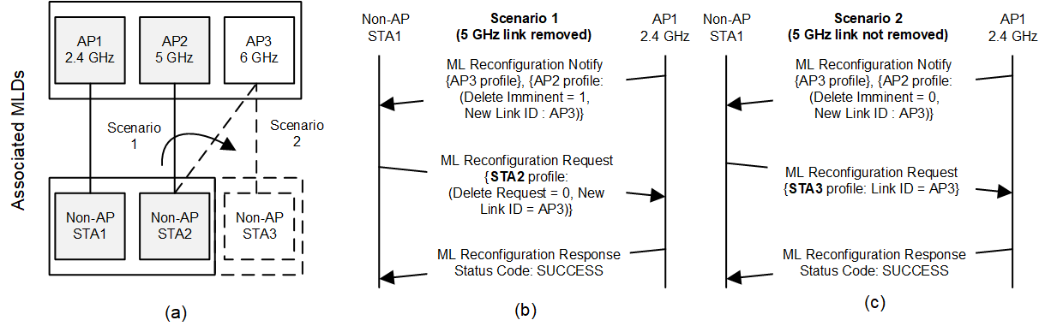
Figure 35-xyz2 – Examples of AP-recommended reconfiguration
35.3.6.5 Changes to multi-link operation after reconfiguration [#1857], [#2513], [#1852], [#2511], [#2595]
There shall be no changes to the operation of links that are not added or deleted by reconfiguration, e.g., no changes to security keys, power management mode, power state, established TWTs, and the list of TIDs mapped to the link.
Once a link is deleted, the AP and non-AP STA terminating the link at the time of deletion shall no longer transmit frames to and receive frames from each other on that link, and all operation aspects such as power management mode and established TWTs shall no longer be valid.
A new link added through reconfiguration shall:
- Use the same PMK, PTK, and PN space as the existing links.
- Use a different GTK/IGTK/BIGTK and PN space. The GTK/IGTK/BIGTK of the new link is delivered to the non-AP MLD using the group key handshake defined in 12.7.7 (Group key handshake).
A TID with default mapping (i.e., not mapped to specific link(s)) can be transmitted over any new link that has been successfully added through reconfiguration. To maintain TID operation continuity under reconfiguration, the MLDs should steer TIDs away from affected links before they are deleted, using the TID-to-link mapping procedure defined in 35.3.6.1(TID-to-link mapping).

