IEEE P802.11
Wireless LANs
Specification Framework for TGbf
Date: 2022-03-14
Author(s):
Name | Affiliation | Address | Phone | email
Claudio da Silva | Meta Platforms, Inc. |  |  | claudiodasilva@fb.com
Abstract
This document provides the framework from which the draft TGbf amendment will be developed. The document provides an outline of each the functional blocks that will be a part of the final amendment. The document is intended to reflect the working consensus of the group on the broad outline for the draft specification. As such it is expected to begin with minimal detail reflecting agreement on specific techniques and highlighting areas on which agreement is still required. It may also begin with an incomplete feature list with additional features added as they are justified. The document will evolve over time until it includes sufficient detail on all the functional blocks and their inter-dependencies so that work can begin on the draft amendment itself.

Revision history

Revision | Date | Changes
0 | March 19, 2021 | Initial draft version. Includes motions up to and including the 802.11 March 2021 plenary meeting.
1 | April 28, 2021 | Includes feedback received on r0 of the document, as well as motions accepted after the March 2021 plenary meeting and before the May 2021 interim meeting.
2 | July 20, 2021 | Includes motions accepted during and after the May 2021 interim up to and including the July 2021 plenary.
3 | September 24, 2021 | Includes motions accepted after the July 2021 plenary up to and including the September 2021 interim.
4 | November 30, 2021 | Includes motions accepted after the September 2021 interim up to and including the November 2021 plenary.
5 | December 21, 2021 | Includes motions approved in the December 21, 2021 conference call.
6 | January 12, 2022 | Includes motions approved in the January 11, 2022 conference call.
7 | January 23, 2022 | Includes motions approved during the 2022 January 802 Wireless Interim.
8 | February 22, 2022 | Includes motions approved in the February 22, 2022 conference call. Also includes editorial modifications.
9 | March 14, 2022 | Motion 67 added.

Definitions, acronyms, and abbreviations (Clause 3, [1])

Definitions

Abbreviations and acronyms

SENS | WLAN Sensing

General description (Clause 4, [1])
[Editor’s note: 4.3 Components of the IEEE 802.11 architecture, 4.3.19 Wireless network management]

Layer management (Clause 6, [1])
[Editor’s note: 6.3 MLME SAP interface]

The 11bf amendment shall define a new subclause under 6.3 (MLME SAP interface) that specifies request, confirm, indication, and response primitives for WLAN sensing (Motion 50, 21/1949r0).

PHY service specification (Clause 8, [1])

Frame formats (Clause 9, [1])
[Editor’s note: 9.3 Format of individual frame types]
[Editor’s note: 9.4 Management and extension frame body components]
[Editor’s note: 9.6 Action frame format details]

Note: General motions on frame format
(Motion 61, 21/1828r4) The 11bf amendment shall define both public and protected action frames, which include Sensing Measurement Setup Request/Response, Sensing Measurement Report, Sensing Measurement Setup Termination, and SBP Request/Response/Termination frames.
- Other public and protected action frames for sensing are TBD.

(Motion 63, 22/0286r1) A new action category of robust “Protected Sensing Frame” is defined to separate PN segment.

Note: Topic – Sensing NDPA frame
(Motion 25c, 21/0990r2; Motion 26c, 21/1015r2; Motion 39, 21/1433r2) A Sensing NDP Announcement (NDPA) frame is defined that allows a STA to indicate the transmission of NDP frame(s) used to obtain sensing measurements.
- Details of the format of the Sensing NDPA frame are TBD.

Note: Topic – Trigger frame
(Motion 25c, 21/0990r2; Motion 27, 21/1015r2) A Trigger frame variant is defined that allows an AP STA to solicit NDP transmission(s) from STA(s) to obtain sensing measurements.
- Details of the format of the Trigger frame variant are TBD.

Note: Topic – Sensing Measurement Report frame
(Motion 21, 21/0908r2) A Sensing Measurement Report frame, which allows a sensing receiver to report sensing measurements, is defined. This frame contains at least the following two fields:
- Measurement report control field: Contains information necessary to interpret the measurement report field.
- Measurement report field: Carries CSI measurements obtained by a sensing receiver.

Note: Topic – SBP frames
(Motion 38, 21/1692r4) A Sensing by Proxy Request frame, which allows a non-AP STA to invoke a sensing by proxy procedure, is defined.
- The format and contents of the Sensing by Proxy Request frame are TBD.

(Motion 38, 21/1692r4) A Sensing by Proxy Response frame, which allows an AP STA to accept or reject a request for a sensing by proxy procedure, is defined.
- The format and contents of the Sensing by Proxy Response frame are TBD.

Note: Topic – Sensing Measurement Setup frames
(Motion 41, 21/1735r3) Sensing Measurement Setup Request and Response frames, which allow to perform a sensing measurement setup, are defined.
- The subtype of Sensing Measurement Setup Request and Response frames are Action and those are individually addressed.
- Formats of the Sensing Measurement Setup Request and Response frames are TBD.

Note: Topic – BRP frames
EDMG/DMG sensing receiver initiator bistatic sensing is based on a BRP Request frame (Motion 46, 21/1735r3).

Feedback for DMG sensing measurement is carried in the BRP Response frame (Motion 45, 21/1735r3).

Note: Topic – DMG sensing capability
(Motion 47, 21/1865r1) EDMG/DMG bistatic and multistatic sensing capability set may include (at least):
- TRN field Golay sequence lengths supported
- Maximum number of directions in Tx and Rx (Number of Tx/RX AWV sets used for sensing)
- Beam sets in which every beam has direction, gain, and beam width.

Note: Topic – DMG Sensing Measurement Setup frames
(Motion 48, 21/1865r1) In an DMG/EDMG bistatic and multistatic measurement setup exchange (at least) the following parameters may be exchanged:
- set of beam directions in TX (sets of TX AWV settings to be used in the measurements)
- set of beam directions in RX (sets of RX AWV settings to be used in the measurements)
- beamforming TRN field information such as TRN-P, TRN-M, TRN-N
- location and orientation of each of the STAs
- coordinates can be local or earth coordinates
- relative locations orientation may be estimated using TGaz based exchanges or available from management layer
- Scheduling

Note: Topic – DMG sensing measurement information element
(Motion 42, 21/1801r2) The 11bf amendment shall define at least one measurement report type for 2D, 3D and 4D filtered maps.
- This measurement report type is an optional feature.
- Supporting 2D, 3D and 4D are each optional feature
- The details of the measurement report format is TBD
- 2D is a two-dimensional map, where the two dimensions are any from: Range, Azimuth, Elevation & Doppler.
- 3D is a three-dimensional map, where the three dimensions are any from: Range, Azimuth, Elevation & Doppler.
- 4D is a four-dimensional map, where the four dimensions are: Range, Azimuth, Elevation & Doppler.

(Motion 43, 21/1801r2) The 11bf amendment shall define at least one measurement report type for targets.
- “Target” is a detected object
- This measurement report type is an optional feature.
- The details of the measurement report format is TBD.

Note: Topic – DMG passive sensing frames
(Motion 57, 22/0002r0) To support DMG passive sensing, DMG Sensing Information Request and DMG Sensing Information Response frames are defined that provide information about the DMG Beacon frame. Sensing information may include:
- Azimuth and elevation for each Sector ID (of beacons)
- Location information of the PCP/AP

MAC sublayer functional description (Clause 10, [1])

MLME (Clause 11, [1])
[Editor’s note: 11.21 Wireless network management procedures]

7.1 WLAN sensing (SENS) procedure

7.1.1 Overview
A WLAN sensing procedure allows a STA to perform WLAN sensing and obtain measurement results (Motion 8, 20/1849r4).

A sensing initiator is a STA that initiates a WLAN sensing procedure. A sensing responder is a STA that participates in a WLAN sensing procedure initiated by a sensing initiator. A sensing transmitter is a STA that transmits PPDUs used for sensing measurements in a WLAN sensing procedure. A sensing receiver is a STA that receives PPDUs sent by a sensing transmitter and performs sensing measurements in a WLAN sensing procedure (Motion 9, 20/1849r4; Motion 29, 21/1543r1).

A STA can assume multiple roles in a WLAN sensing procedure (Motion 9, 20/1849r4; Motion 29, 21/1543r1). In a WLAN sensing procedure, a sensing initiator might be a sensing transmitter, a sensing receiver, both or neither (Motion 10c, 21/0147r3; Motion 29, 21/1543r1). In a WLAN sensing procedure, a sensing responder might be a sensing transmitter, a sensing receiver, or both (Motion 29, 21/1543r1).

A WLAN sensing procedure is composed of one or more of the following: sensing session setup, sensing measurement setup, sensing measurement instance, sensing measurement setup termination, and sensing session termination (Motion 15, 20/1851r4; Motion 29, 21/1543r1).

A WLAN sensing procedure may be comprised of multiple sensing measurement instances (Motion 14, 21/0145r4; Motion 29, 21/1543r1).

Examples of WLAN sensing procedures are shown in Figure 1 and Figure 2 (Motion 29, 21/1543r1; Motion 35, 21/1701r1).

More than one type of sensing measurement results may be defined (Motion 12, 21/0147r3).

PASN for unassociated STA is used in WLAN sensing (Motion 62, 22/0286r1).

Enhance the sensing procedure initiated by an AP to optionally allow sensing responder to sensing responder NDP measurement (Motion 67, 22/0312r2).

Figure 1: WLAN sensing procedure (example). (Motion 29, 21/1543r1)
Figure 2: WLAN sensing procedure (example). (21/1701r1)

7.1.2 Sensing session setup
A sensing session is an agreement between a sensing initiator and a sensing responder to participate in a WLAN sensing procedure (Motion 8, 20/1849r4; Motion 29, 21/1543r1).

In the sensing session setup of a WLAN sensing procedure, a sensing session is established, and operational parameters associated with the sensing session are determined and may be exchanged between STAs (Motion 15, 20/1851r4; Motion 29, 21/1543r1).

A sensing session is pairwise and is identified by MAC addresses and/or associated AID/UID (Motion 23, 21/0644r4).

A sensing initiator may maintain multiple sensing sessions (Motion 23, 21/0644r4).

7.1.3 Sensing measurement setup

7.1.3.1 General
An optional negotiation process in the sensing measurement setup is defined that allows for a sensing initiator and a sensing responder to exchange and agree on operational attributes associated with a sensing measurement instance (Motion 17, 21/0370r1; Motion 23, 21/0644r4; Motion 29, 21/1543r1). The operational attributes may include sensing initiator’s and sensing responder’s roles, measurement report types, and other operational parameters (Motion 29, 21/1543r1).

The type of measurement result reported in a WLAN sensing procedure shall be decided by its initiator (Motion 13, 21/0147r3; Motion 29, 21/1543r1).

(Motion 36, 21/1736r2) During a sensing measurement setup, the role(s) of a sensing responder shall be determined as one of following:
- Sensing receiver
- Sensing transmitter
- Sensing transmitter and sensing receiver

The Measurement Setup ID may be used to identify attributes of the sensing measurement instances (Motion 24, 21/0644r4).

Measurement Setup ID is set by sensing initiator, the tuple <Sensing Initiator’s MAC address, Measurement Setup ID> is used to identify a specific Measurement Setup. (Motion 54, 21/ 1941r1).

The sensing transmitter and sensing receiver role(s) of a STA corresponding to a Measurement Setup ID until the sensing measurement setup is terminated shall be fixed as determined during the sensing measurement setup (Motion 37, 21/1736r2).

(Motion 41, 21/1735r3; Motion 51, 21/1828r4) The sensing measurement setup procedure consists of:
- The transmission of a sensing measurement setup request frame by the sensing initiator to a sensing responder with which it intends to perform a sensing measurement setup, followed by the transmission of an Ack frame by the intended sensing responder; and
- The transmission of a sensing measurement setup response frame by the intended sensing responder to the sensing initiator which transmitted the sensing measurement setup request frame to accept or reject the sensing measurement setup, followed by the transmission of an Ack frame by the sensing initiator.

(Motion 52, 21/1828r4) In a sensing measurement setup procedure, if the sensing responder intends to reject the assigned operational parameters included in the sensing measurement setup request frame, it may provide its preferred operational parameters in the sensing measurement setup response frame. For the accept case, whether the sensing responder may provide its preferred operational parameters or not is TBD.

7.1.3.2 Trigger-based (TB) sensing measurement setup

7.1.3.3 Non-Trigger based (non-TB) sensing measurement setup

7.1.4 Sensing measurement instance

7.1.4.1 General
In a sensing measurement instance of a WLAN sensing procedure, sensing measurements are performed (Motion 15, 20/1851r4; Motion 29, 21/1543r1).

The Measurement Instance ID may be used to identify the sensing measurement instance that utilizes attributes of the same Measurement Setup ID (Motion 24, 21/0644r4).

The Dialog Token field may be a possibility to contain both the Measurement Setup ID and the Measurement Instance ID (Motion 24, 21/0644r4).

More than one sensing responder may participate in a sensing measurement instance (Motion 16, 21/0145r5; Motion 29, 21/1543r1).

7.1.4.2 TB sensing measurement instance
(Motion 25c, 21/0990r2) A TB sensing measurement instance includes a polling phase, an NDPA sounding phase, and a TF sounding phase. The order of the NDPA sounding phase and of the TF sounding phase is TBD.
- Note: This is for HE and/or EHT STAs. Methods to support other STAs are TBD.

(Motion 29, 21/1543r1) Examples of possible TB sensing measurement instances are shown in Figure 3. In this figure,
- How to define the sounding order, as in example 3 or as in example 4, is TBD.
- The reporting phase in example 5 may be separated from the sounding phases (TBD).
- The polling in the reporting phase in example 5 could be addressed to sensing responders other than those involved in the sounding (TBD).
- LTF security update is TBD.
Figure 3: TB sensing measurement instance (examples). (Motion 29, 21/1543r1)

7.1.4.2.1 Polling phase
In the polling phase, an AP sends a Trigger frame to check the availability of STAs. If a STA is available, it responds with a CTS-to-self (Motion 25c, 21/0990r2).

7.1.4.2.2 NDPA sounding phase
The NDPA sounding phase shall be present in a TB sensing measurement instance if at least one STA that is a sensing receiver responds in the polling phase (Motion 25c, 21/0990r2).

(Motion 25c, 21/0990r2; Motion 26c, 21/1015r2) The NDPA sounding phase consists of
- The transmission of a Sensing NDP Announcement (NDPA) frame by an AP; and
- The transmission of an NDP by an AP SIFS after the transmission of the Sensing NDPA frame.
- Note: NDPA sounding may be used by pre-HE STAs (i.e., its use is not limited to HE and/or EHT STAs).

NDP can be used for the channel measurement (e.g. CSI) between sensing transmitter and sensing receiver(s) in sub-7 GHz bands. NDP format for sensing is TBD (Motion 22, 21/1015r1; Motion 29, 21/1543r1).

7.1.4.2.3 Trigger frame (TF) sounding phase
The TF sounding phase shall be present in a TB sensing measurement instance if at least one STA that is a sensing transmitter responds in the polling phase (Motion 25c, 21/0990r2).

(Motion 25c, 21/0990r2; Motion 27, 21/1015r2) The TF sounding phase consists of
- The transmission of a Trigger frame by an AP to solicit NDP transmission(s) from STA(s); and
- The transmission of an NDP by STA(s) SIFS after receiving the Trigger frame.
- Note: TF sounding is defined for HE and/or EHT STAs. Supporting other STAs is TBD.

NDP can be used for the channel measurement (e.g. CSI) between sensing transmitter(s) and sensing receiver in sub-7 GHz bands. NDP format for sensing is TBD (Motion 22, 21/1015r1; Motion 29, 21/1543r1).

7.1.4.2.4 Reporting phase
In the reporting phase of a sensing measurement instance, sensing measurement results are reported (Motion 15, 20/1851r4; Motion 29, 21/1543r1).

Results of measurements performed in a WLAN sensing procedure should be obtained by or reported to its initiator (Motion 11, 21/0147r3; Motion 29, 21/1543r1). For the case when the sensing initiator is the sensing transmitter, the sensing initiator may optionally request the sensing responder to report sensing measurement results (Motion 60, 22/0038r2).

Transmission of the Sensing Measurement Report frame is initiated by an MLME primitive. Both immediate and delayed reporting are acceptable (Motion 21, 21/0908r2).

(Motion 34, 21/1438r1) In the reporting phase, sensing measurement results of multiple sensing measurement setups of a sensing responder may be included in a single Sensing Measurement Report frame for delayed reporting.
- Support for obtaining more than one sensing measurement result in a single Sensing Measurement Report frame sent by the sensing responder is optional for the sensing initiator.
- Support for buffering more than one sensing measurement result and sending it in a single Sensing Measurement Report frame to the sensing initiator is optional for the sensing responder.

7.1.4.3 Non-TB sensing measurement instance
(Motion 39, 21/1433r2) A non-TB sensing measurement instance is defined as follows:
- One non-AP STA is the sensing initiator and one AP is the sensing responder.
- Once the non-AP STA obtains a TXOP, it initiates a non-TB sensing measurement instance by transmitting an NDPA frame to the AP followed by an Initiator-to-Responder (I2R) NDP after SIFS. SIFS after the I2R NDP, the AP shall transmit a Responder-to-Initiator (R2I) NDP to the non-AP STA.
- If the non-AP STA is only the sensing transmitter, then the NDPA frame should configure the R2I NDP to be transmitted with minimum possible length with one LTF symbol.
- If the non-AP STA is only the sensing receiver, then the NDPA frame should configure the I2R NDP to be transmitted with minimum possible length with one LTF symbol.
- The details of the NDPA frame are TBD.
- I2R/R2I NDP formats are TBD.

7.1.5 Sensing measurement setup termination
(Motion 35, 21/1701r1) The following holds for sensing measurement setup termination:
- The device keeps active the established sensing measurement setup identified with the Measurement Setup ID until it is terminated.
- Termination of the sensing measurement setup identified with the Measurement Setup ID by one device does not impact the activity of this sensing measurement setup of another device(s)/session(s).
- Termination of the sensing measurement setup identified with one Measurement Setup ID does not impact the device/session activity of another sensing measurement setup with a different Measurement Setup ID.
- The sensing initiator and/or the sensing responder may initiate termination of the sensing measurement setup.
- A handshake between the sensing initiator and the sensing responder and/or expiration of the predefined inactivity time may terminate the sensing measurement setup. (Detailed protocol is TBD.)
- The sensing initiator and the sensing responder may release the resources they allocated to store the setup after the termination of the sensing measurement setup.
- The sensing initiator shall not indicate the Measurement Setup ID of the terminated sensing measurement setup in the sensing measurement instances it initiates.
- The sensing initiator may ignore the pending report(s) indicated to belong to the terminated sensing measurement setup.
- The sensing responder should not respond to request/poll/trigger that all sensing measurement setups it indicates are terminated.
- The sensing responder should not transmit the report that indicates the terminated sensing measurement setup.

7.1.6 Sensing session termination
In the sensing session termination, STAs stop performing measurements and terminate the sensing session (Motion 15, 20/1851r4; Motion 29, 21/1543r1).

7.1.7 Threshold-based measurement and reporting
(Motion 18, 21/0351r5; Motion 33; 21/1364r3) An optional threshold-based measurement and reporting procedure is defined in which
- The difference between the current measured CSI and the previous measured CSI is quantified. The difference is referred to as CSI variation.
- A threshold value to be used by the sensing receiver in the threshold-based procedure is defined.
- The threshold value for each sensing responder is determined by the sensing initiator.
- By comparing the CSI variation with the threshold, the sensing receiver can send a feedback resulting from the large CSI variation to the sensing transmitter.
- Whether the threshold is predefined, or defined by the sensing receiver, sensing transmitter, sensing initiator or sensing responder is TBD.
- The threshold-based procedure is not always required (Procedure A in 21/0351r5 is not always required).

7.2 Sensing by proxy (SBP) procedure
(Motion 38, 21/1692r4) An optional sensing by proxy (SBP) procedure is defined in which:
- An “SBP request” consists of a non-AP STA sending an SBP Request frame to an SBP-capable AP STA.
  - A STA that sends an SBP Request frame to invoke SBP (and, as a result, WLAN sensing) is denoted by “SBP requesting STA”.
- An AP STA that receives an SBP request shall send to the SBP requesting STA an SBP Response frame to accept or reject the request.
- An AP STA that accepts an SBP request shall initiate a WLAN sensing procedure with one or more non-AP STAs using operational parameters derived from those indicated within the SBP Request frame.
  - Whether the SBP requesting STA participates or not in the WLAN sensing procedure as a sensing responder is TBD.
- Measurement results obtained in a WLAN sensing procedure resultant from an SBP request shall be reported to the SBP requesting STA.

How the SBP Requesting STA identifies the Measurement Setup ID is TBD (Motion 54, 21/1941r1). The method of assigning Measurement Setup ID for the SBP Requesting STA in Sensing by proxy (SBP) procedure is that AP assigns the Measurement Setup ID in its SBP Response frame (Motion 64, 22/0125r3).

7.3 DMG sensing (SENS) procedure

7.3.1 Overview (Motion 55, 21/2015r4)
DMG sensing types include monostatic, bistatic, multistatic, monostatic sensing with coordination, and bistatic sensing with coordination. Monostatic sensing with coordination is an extension of monostatic to coordinate monostatic devices. Bistatic sensing with coordination is an extension of bistatic type to coordinate multiple sensing responders by one sensing initiator.

In the monostatic sensing with coordination sensing type, the transmissions of one or more devices that perform monostatic sensing are coordinated by a PCP/AP (Motion 40, 21/1914r0).

The DMG sensing procedure defines all DMG sensing types.

The behavior of each type of DMG sensing type is defined separately (Motion 56, 22/0031r0).

A DMG sensing procedure is a subset of the WLAN sensing procedure. Unless otherwise noted, the rules for WLAN SENS apply to DMG SENS.

DMG sensing procedure defines the behavior of a single sensing initiator with one or more sensing responders (Motion 56, 22/0031r0).

A DMG sensing procedure is composed of one or more of the following: DMG sensing session setup, DMG measurement setup, DMG sensing burst, DMG sensing instance, DMG measurement setup termination, and DMG sensing session termination.

A DMG sensing procedure may be comprised of multiple DMG sensing bursts. A DMG sensing burst may be comprised of multiple DMG sensing instances.

NOTE – Measurements over a certain time period are needed to compute the Doppler frequency shift. The occupancy time per link access cannot exceed the TXOP limit. If a longer measurement time is needed, then the approach of the DMG sensing burst allows scheduling of the multiple link accesses to collect measurements for the Doppler frequency shift computation.

One sensing responder may participate in multiple DMG sensing bursts and DMG sensing instances associated with different DMG measurement setups.

A sensing initiator may maintain multiple sensing responders in multiple DMG sensing bursts and DMG sensing instances associated with different DMG measurement setups.

A sensing initiator may instruct the sensing responder in the sensing receiver role or in the sensing receiver and sensing transmitter role to report at the DMG sensing instance, and/or it may instruct the sensing responder to accumulate the results and report once per DMG sensing burst.

Examples of DMG SENS are shown in Figures 4-10.

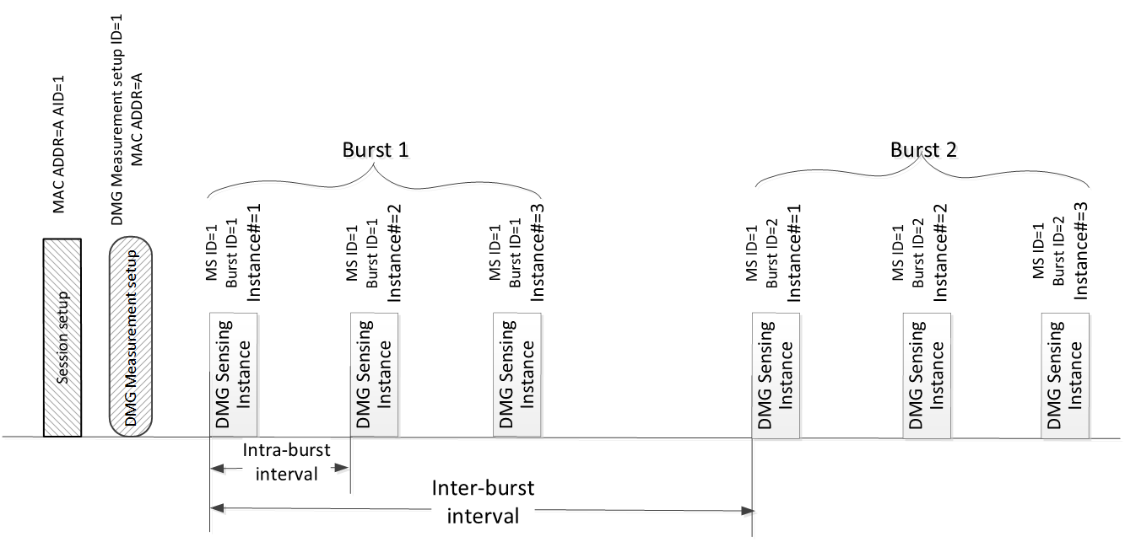
Figure 4: DMG sensing procedure with one sensing responder.

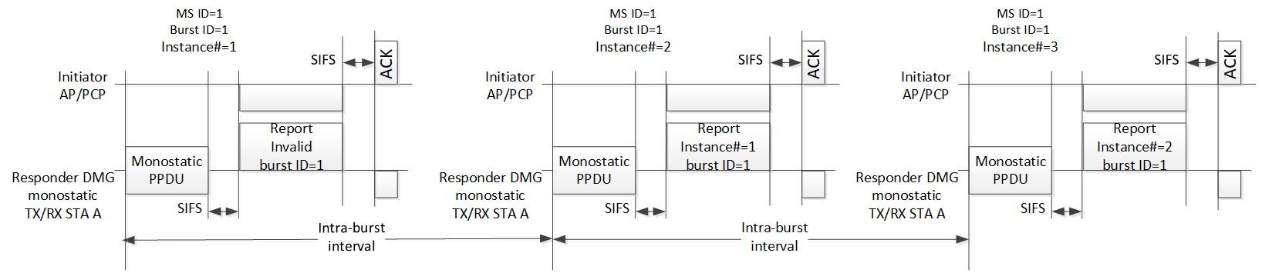
Figure 5: DMG sensing instances of one DMG sensing burst with PCP/AP as sensing initiator and a single monostatic sensing device as sensing responder. Per DMG sensing instance delayed reporting.

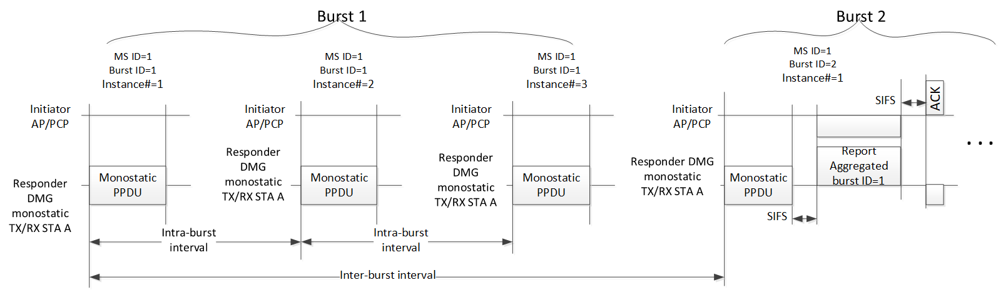
Figure 6: DMG sensing instances with PCP/AP as sensing initiator and single monostatic sensing device as sensing responder. Per DMG sensing burst delayed delivery of the aggregated report.

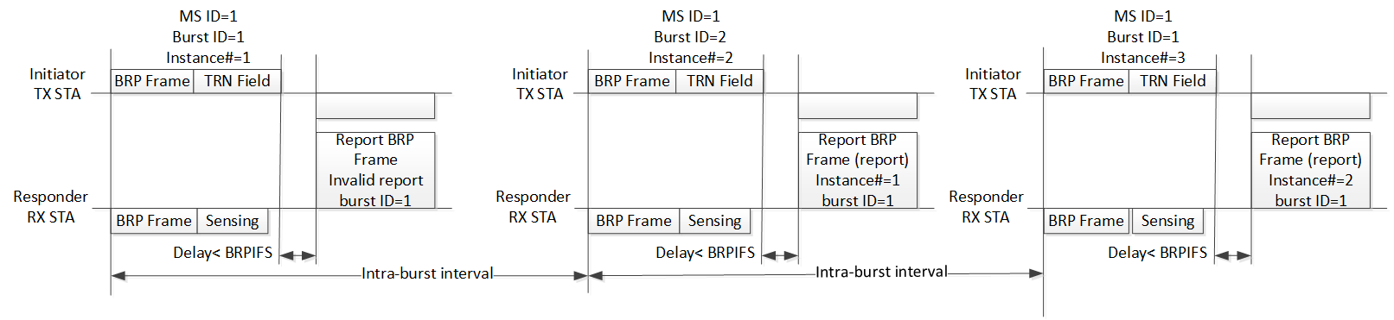
Figure 7: DMG sensing instances of one DMG sensing burst of bistatic DMG sensing with the sensing initiator in the sensing transmitter role. Per DMG sensing instance delayed delivery of the report. NOTE: The BRP frame is an Action No Ack frame.
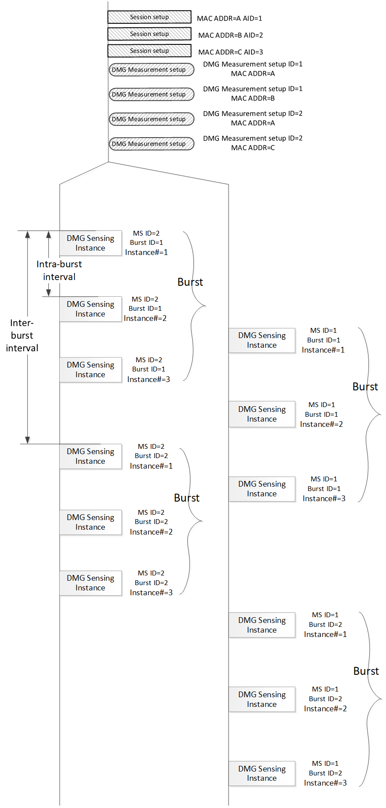
Figure 8: DMG sensing procedure with three sensing responders.

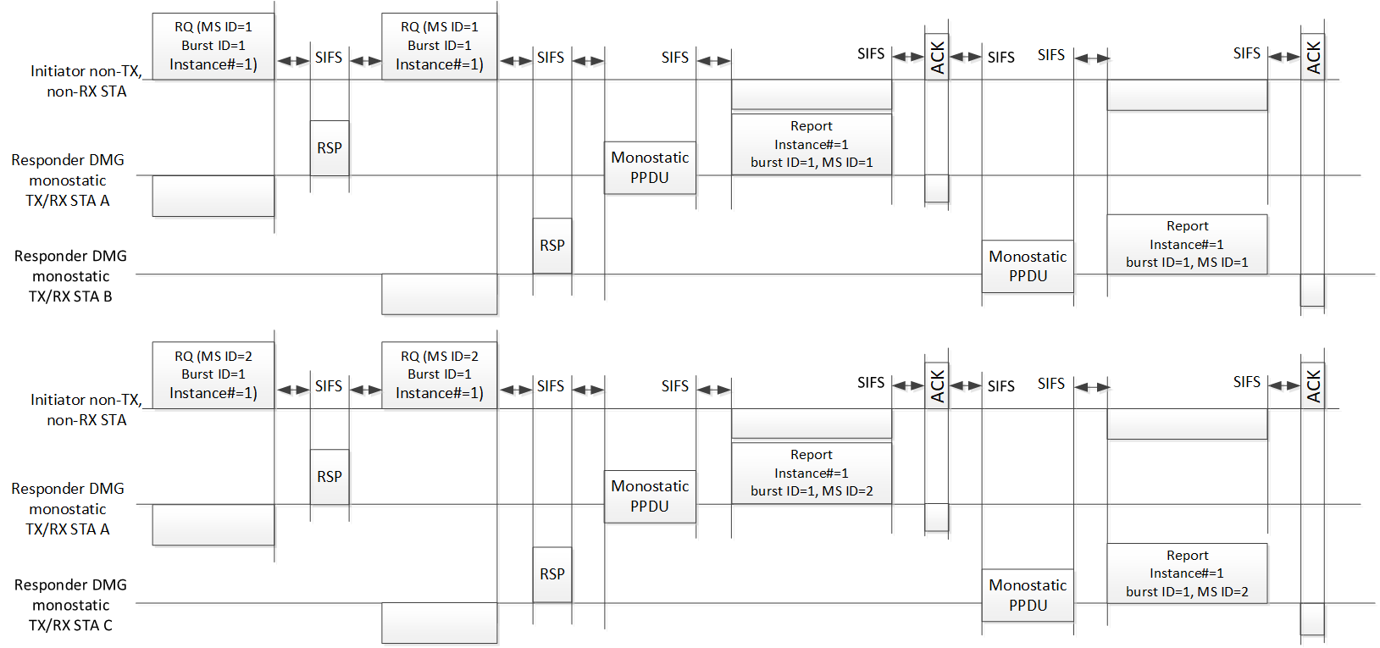
Figure 9: DMG sensing instances with PCP/AP as sensing initiator and two monostatic sensing devices as sensing responders. The sounding phase of both monostatic devices in the instance may happen in parallel. Two illustrated instances belong to two different DMG measurement setups.

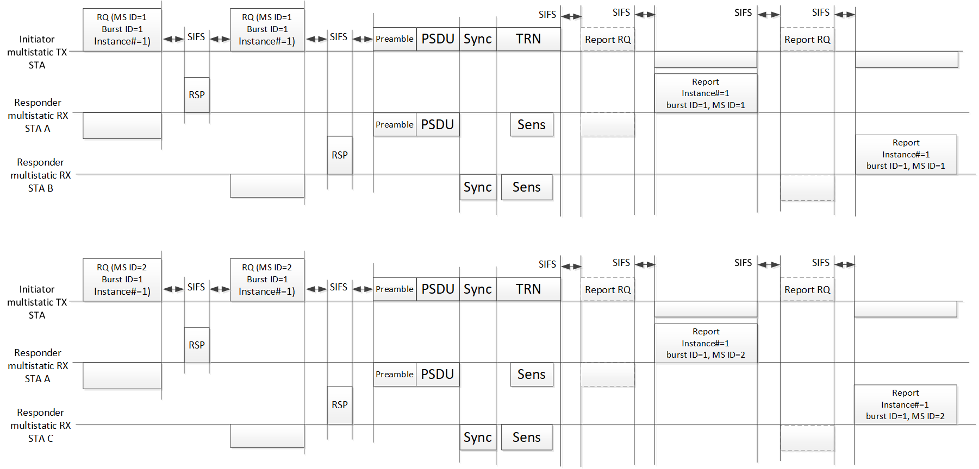
Figure 10: DMG sensing instances of multistatic sensing. The PCP/AP is the sensing initiator in the role of sensing transmitter and two sensing responders are in the role of sensing receivers. Two illustrated instances belong to two different DMG measurement setups.

7.3.2 DMG sensing session setup (Motion 56, 22/0031r0)
In a DMG sensing session setup of a DMG sensing procedure, the sensing initiator and the sensing responder exchange DMG sensing capabilities. The capabilities may include the types of DMG sensing and the roles the STA may assume for each of the supported DMG sensing types.

To coordinate more than one sensing responder, the sensing initiator of DMG sensing shall be an PCP/AP STA.

The sensing initiator may be capable of the roles of sensing transmitter, sensing receiver, both sensing transmitter and sensing receiver, or none of them.

A sensing responder may be capable of one or more of the following roles: Sensing receiver, sensing transmitter, and both sensing transmitter and sensing receiver.

A sensing initiator of the DMG sensing types monostatic and coordinated monostatic shall be capable of the roles of both sensing transmitter and sensing receiver, or neither of them.

A sensing responder of the DMG sensing types monostatic and coordinated monostatic shall be capable of the roles of both sensing transmitter and sensing receiver.

A sensing initiator of the DMG sensing types bistatic and coordinated bistatic shall be capable of the sensing transmitter and/or the sensing receiver role.

A sensing responder of the DMG sensing types bistatic and coordinated bistatic shall be capable of the sensing transmitter and/or the sensing receiver role.

The sensing initiator of the DMG sensing type multistatic shall be capable of the sensing transmitter and/or the sensing receiver role.

The sensing responder of the DMG sensing type multistatic shall be capable of the sensing transmitter and/or the sensing receiver role.

7.3.3 DMG measurement setup (Motion 56, 22/0031r0)

7.3.3.1 General
DMG measurement setup may require an accomplishment of beamforming training between the sensing initiator and the sensing responder(s) in advance.

An optional negotiation process in the DMG measurement setup is defined that allows for a sensing initiator and a sensing responder to exchange and agree on operational attributes associated with DMG sensing bursts and DMG sensing instances. The operational attributes may include intra-burst and inter-burst schedule, number of instances per burst, sensing initiator’s and sensing responder’s roles, DMG sensing type, DMG measurement report types, and other parameters.

More than one type of DMG sensing measurement result may be defined. The type of measurement result reported in a DMG sensing procedure shall be decided by its sensing initiator per sensing responder capabilities per DMG sensing types.

The sensing initiator requests DMG measurement setup separately with each sensing responder. The set of the operational attributes and parameters established upon the negotiation is identified by the DMG Measurement Setup ID. The same DMG Measurement Setup ID may be asserted to the agreement with different sensing responders typically if the sensing initiator schedules to address the sensing responders in the same DMG measurement instance.

During a DMG measurement setup, the role(s) of the sensing initiator and sensing responder shall be determined as defined per DMG sensing types.

The sensing initiator and the sensing responder may proceed with the DMG positioning during a DMG measurement setup. They may exchange DMG positioning results such as ranging, AOA, and AOD. They may also exchange LCI and civic location.

7.3.3.2 Setup for monostatic and coordinated monostatic DMG sensing type
The sensing initiator of a coordinated monostatic DMG sensing measurement may be a STA not capable of monostatic DMG sensing.

7.3.3.3 Setup for bistatic and coordinated bistatic DMG sensing type
The sensing initiator of a bistatic DMG sensing measurement shall be capable of bistatic DMG sensing.

In DMG measurement instances of a DMG sensing procedure of sensing type bistatic, the sensing initiator shall interact with one sensing responder, and no more.

In DMG measurement instances belonging to the same DMG Measurement Setup ID, the sensing responder shall be in the sensing receiver role if the sensing initiator is in the sensing transmitter role, and vice versa.

7.3.3.4 Setup for multistatic measurement DMG sensing type
The sensing initiator of a multistatic DMG sensing measurement shall be capable of multistatic DMG sensing.

In DMG measurement instances of a DMG sensing procedure of sensing type multistatic, the sensing initiator may interact with one or more sensing responders.

In DMG measurement instances belonging to the same DMG Measurement Setup ID, all sensing responder(s) shall be in the sensing receiver role if the sensing initiator is in the sensing transmitter role. In DMG measurement instances belonging to the same DMG Measurement Setup ID, all sensing responder(s) shall be in the sensing transmitter role if the sensing initiator is in the sensing receiver role.

7.3.4 DMG sensing burst (Motion 56, 22/0031r0)
A DMG burst may be defined to include more than one sensing measurement instance. Each instance is limited by the TXOP limit.

A DMG burst is identified with the DMG Burst ID.

The DMG burst parameters defined at the measurement setup shall be identified by the DMG Measurement Setup ID.

A specific DMG burst may belong to not more than one DMG Measurement Setup ID.

All DMG sensing instances in the DMG burst shall belong to the same DMG Measurement Setup ID.

The sensing responder may aggregate the reports and report once per DMG burst if aggregated reporting is set in the DMG measurement setup.

7.3.5 DMG sensing instance (Motion 56, 22/0031r0)

7.3.5.1 General
A DMG sensing instance is limited to one TXOP.

A DMG sensing instance belongs to one DMG Measurement Setup ID.

A DMG sensing instance includes the following phases: initiation phase, sounding phase, and reporting phase. The sounding phase is mandatory, and the initiation and reporting phases are optional.
DMG measurement instances of the DMG sensing types monostatic and the bistatic may not contain the initiation phase.

DMG measurement instances of the DNG sensing types coordinated monostatic, coordinated bistatic, and multistatic shall contain the initiation phase.

The reporting phase is mandatory if the sensing responder is in the sensing receiver role and in the sensing transmitter and sensing receiver role.

A DMG sensing instance is identified with the DMG sensing instance number. The DMG sensing instance number shall be sequential in increasing order.

The DMG sensing instance number shall be unique in range (e.g. 0-31, the number is TBD).

The DMG sensing instance may belong to the DMG burst. The DMG sensing instance number shall be unique per the DMG Burst ID.

7.3.5.2 Coordinated monostatic instance

7.3.5.2.1 Initiation
In a coordinated monostatic instance of one or more sensing responders the following rules shall apply:
- The number of sensing responders in each instance of the same DMG Measurement Setup ID may be different
- The sensing initiator shall send a Coordinated Monostatic Instance Request frame to each sensing responder it requests to participate in the instance
- The sensing responder shall not respond with the Coordinated Monostatic Instance Response frame to the sensing initiator later than SIFS time after the request
- The sensing responder that responded to the sensing initiator shall proceed with monostatic sensing
- The order of sounding is indicated in the Coordinated Monostatic Instance Request frame
- The format of the Coordinated Monostatic Instance Request frame and the Coordinated Monostatic Instance Response frame is TBD

7.3.5.2.2 Sounding
The RA shall be set equal to the TA in the PSDU contained in the monostatic PPDU (name of this PPDU is TBD).

7.3.5.2.3 Reporting
- If the responses are configured to happen during the DMG measurement instance, each sensing responder shall respond in no longer than SIFS time after the monostatic PPDU, and
- If the polled responses are configured, each sensing responder shall respond in no longer than SIFS time after the polling by the sensing initiator.

7.3.5.3 Bistatic and coordinated bistatic instance

7.3.5.2.1 Initiation
In the coordinated bistatic instance of one or more sensing responders the following rules shall apply:
- Number of the sensing responders in each instance of the same DMG Measurement Setup ID may be different
- The sensing initiator shall send the Bistatic Instance Request frame to each sensing responder it invites to participate in the sensing instance
- The sensing responder shall not respond with the Bistatic Instance Response frame to the sensing initiator later than in SIFS time
- The sensing responder that responded to the sensing initiator shall remain active to receive the BRP PPDU
- The order of sounding is indicated in the Bistatic Instance Request Frame
- The format of the Bistatic Instance Request frame and of the Bistatic Instance Response frame is TBD

7.3.5.2.2 Sounding
(Motion 45, 21/1865r1) EDMG transmitter initiator bistatic sensing is based on a BRP Request frame in a BRP-RX/TX, BRP-TX, BRP-RX PPDU (as defined in Clause 28 of 802.11) and a BRP Response frame. Feedback for DMG sensing measurement is carried in the BRP Response frame:
- Feedback may be delayed
- Feedback may be aggregated (single feedback for some measurements, to facilitate Doppler measurement)

(Motion 46, 21/1865r1) EDMG/DMG sensing receiver initiator bistatic sensing is based on a BRP Request frame that includes a request for the sensing responder to transmit a BRP-RX/TX, BRP-TX, BRP-RX PPDU (as defined in Clause 28 of 802.11).

7.3.5.2.3 Reporting
In a measurement instance, the responses of the sensing responder in the DMG sensing receiver role to the sensing initiator in the sensing transmitter role may contain no more than one measurement report

7.3.5.3 Mulstistatic instance

7.3.5.2.1 Initiation
In a multistatic instance of one or more sensing responders the following rules shall apply:
- Number of sensing responders in each instance of the same DMG Measurement Setup ID may be different
- The sensing initiator shall send the Multistatic Instance Request frame to each sensing responder it invites to participate in the sensing instance
- The sensing responder shall not respond with the Multistatic Instance Response frame to the sensing initiator later than in SIFS time
- The sensing responder that responded to the sensing initiator shall remain active to receive the Multistatic PPDU (name of this PPDU is TBD)
- The format of the Multistatic Instance Request frame and the Multistatic Instance Response frame is TBD

7.3.5.2.2 Sounding
(Motion 58, 21/2023r0) A multi-static EDMG sensing measurement instance has the following parts:
- An Instance Request frame (frame type TBD) sent to each STA sequentially, and each STA responds to it.
- A multi-static EDMG sensing PPDU. The format of the EDMG sensing PPDU is TBD.
- A feedback part in which the sensing initiator polls each sensing responder for a report, and the sensing responders respond with a report.

7.3.5.2.3 Reporting
If the responses are configured to happen during the DMG measurement instance, each sensing responder shall respond in no longer than SIFS time after polling by the sensing initiator.

7.3.6 Passive DMG sensing (Motion 56, 22/0002r0)
DMG passive sensing is enabled by
- A capability bit in the beacon
- Sensing information request and response frames that provide information about the beacon

7.3.7 DMG sensing by proxy (DMG SBP) procedure (Motion 56, 22/0031r0)
DMG sensing by proxy (DMG SBP) is the DMG variant of the SBP procedure. The DMG SBP allows a non-AP and AP STA that is not the sensing initiator to request the sensing initiator to perform the measurement and report the results. The sensing initiator shall provide the DMG SBP service.

PHY (sub-7 GHz)
CSI (that is, the channel measured during the training symbols of a received PPDU) is a type of sensing measurement result for sub-7 GHz WLAN sensing (Motion 20, 21/0908r2).

To enable sub-7 GHz WLAN sensing, an RXVECTOR parameter CSI_ESTIMATE is defined that contains the channel measured during the training symbols of the received PPDU. The format of CSI_ESTIMATE is the same one used in the measurement report field within the Sensing Measurement Report frame. The format of CSI_ESTIMATE is TBD (Motion 21, 21/0908r2).

PHY (60 GHz)
A multi-static EDMG sensing PPDU is an EDMG BRP-RX, BRP-TX, BRP-RX/TX PPDU with an addition of sync fields between the data and the TRN field (Motion 59, 21/1865r1).

References
[1] Draft IEEE P802.11-REVme/D0.4
[2] IEEE Std 802.11ax-2021
[3] Draft IEEE P802.11be/D1.3
[4] IEEE Std 802.11ay-2021

