IEEE P802.11  
Wireless LANs

|  |  |  |  |  |
| --- | --- | --- | --- | --- |
| Specification Framework for TGbf | | | | |
| Date: 2021-07-20 | | | | |
| Author(s): | | | | |
| Name | Affiliation | Address | Phone | email |
| Claudio da Silva | Facebook |  |  | claudiodasilva@fb.com |
|  |  |  |  |  |

Abstract

This document provides the framework from which the draft TGbf amendment will be developed. The document provides an outline of each the functional blocks that will be a part of the final amendment. The document is intended to reflect the working consensus of the group on the broad outline for the draft specification. As such it is expected to begin with minimal detail reflecting agreement on specific techniques and highlighting areas on which agreement is still required. It may also begin with an incomplete feature list with additional features added as they are justified. The document will evolve over time until it includes sufficient detail on all the functional blocks and their inter-dependencies so that work can begin on the draft amendment itself.

# Revision history

|  |  |  |
| --- | --- | --- |
| **Revision** | **Date** | **Changes** |
| 0 | March 19, 2021 | Initial draft version. Includes motions up to and including the 802.11 March 2021 plenary meeting. |
| 1 | April 28, 2021 | Includes feedback received on r0 of the document, as well as motions accepted after the March 2021 plenary meeting and before the May 2021 interim meeting. |
| 2 | July 20, 2021 | Includes motions accepted during and after the May 2021 interim up to and including the July 2021 plenary. |
| 3 | September 24, 2021 | Includes motions accepted after the July 2021 plenary up to and including the September 2021 interim. |

# Definitions, acronyms, and abbreviations (Clause 3, [1])

## Definitions

## Abbreviations and acronyms

|  |  |
| --- | --- |
| SENS | WLAN Sensing |
|  |  |

# General description (Clause 4, [1])

[Editor’s note: 4.3 Components of the IEEE 802.11 architecture, 4.3.19 Wireless network management]

# Layer management (Clause 6, [1])

[Editor’s note: 6.3 MLME SAP interface]

# PHY service specification (Clause 8, [1])

# Frame formats (Clause 9, [1])

[Editor’s note: 9.3 Format of individual frame types]

[Editor’s note: 9.4 Management and extension frame body components]

[Editor’s note: 9.6 Action frame format details]

(Motion 21, 21/0908r2) A Sensing Measurement Report frame, which allows a sensing receiver to report sensing measurements, is defined. This frame contains at least the following two fields:

* Measurement report control field: Contains information necessary to interpret the measurement report field.
* Measurement report field: Carries CSI measurements obtained by a sensing receiver.

# MAC sublayer functional description (Clause 10, [1])

# MLME (Clause 11, [1])

[Editor’s note: 11.21 Wireless network management procedures]

## 7.1 WLAN sensing (SENS) procedure

### 7.1.1 Overview

A WLAN sensing procedure allows a STA to perform WLAN sensing and obtain measurement results (Motion 8, 20/1849r4).

A sensing initiator is a STA that initiates a WLAN sensing procedure. A sensing responder is a STA that participates in a WLAN sensing procedure initiated by a sensing initiator. A sensing transmitter is a STA that transmits PPDUs used for sensing measurements in a WLAN sensing procedure. A sensing receiver is a STA that receives PPDUs sent by a sensing transmitter and performs sensing measurements in a WLAN sensing procedure (Motion 9, 20/1849r4; Motion 29, 21/1543r1).

A STA can assume multiple roles in a WLAN sensing procedure (Motion 9, 20/1849r4; Motion 29, 21/1543r1). In a WLAN sensing procedure, a sensing initiator might be a sensing transmitter, a sensing receiver, both or neither (Motion 10c, 21/0147r3; Motion 29, 21/1543r1). In a WLAN sensing procedure, a sensing responder might be a sensing transmitter, a sensing receiver, or both (Motion 29, 21/1543r1).

A WLAN sensing procedure is composed of one or more of the following: sensing session setup, sensing measurement setup, sensing measurement instance, sensing measurement setup termination, and sensing session termination (Motion 15, 20/1851r4; Motion 29, 21/1543r1).

A sensing session is an agreement between a sensing initiator and a sensing responder to participate in a WLAN sensing procedure (Motion 8, 20/1849r4; Motion 29, 21/1543r1).

A WLAN sensing procedure may be comprised of multiple sensing measurement instances (Motion 14, 21/0145r4; Motion 29, 21/1543r1).

An example of a WLAN sensing procedure is shown in Figure 1 (Motion 29, 21/1543r1).

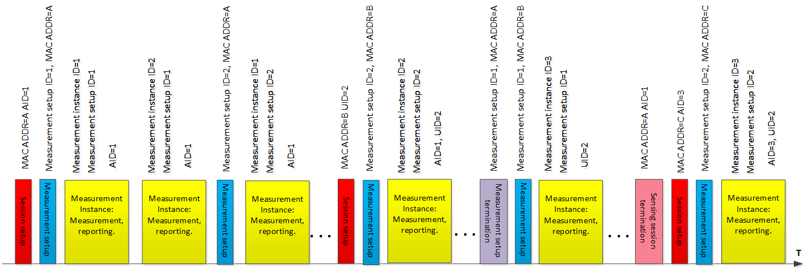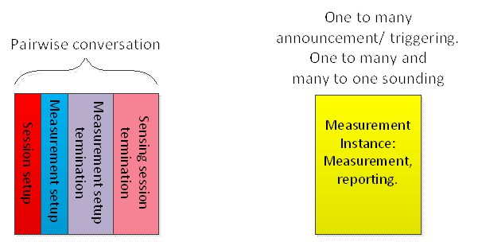

**Figure 1: WLAN sensing procedure (example). (Motion 29, 21/1543r1)**

The Measurement Setup ID may be used to identify attributes of the sensing measurement instances (Motion 24, 21/0644r4).

The Measurement Instance ID may be used to identify the sensing measurement instance that utilizes attributes of the same Measurement Setup ID (Motion 24, 21/0644r4).

The Dialog Token field may be a possibility to contain both the Measurement Setup ID and the Measurement Instance ID (Motion 24, 21/0644r4).

More than one type of sensing measurement results may be defined (Motion 12, 21/0147r3).

### 7.1.2 Sensing session setup

In the sensing session setup of a WLAN sensing procedure, a sensing session is established, and operational parameters associated with the sensing session are determined and may be exchanged between STAs (Motion 15, 20/1851r4; Motion 29, 21/1543r1).

A sensing session is pairwise and is identified by MAC addresses and/or associated AID/UID (Motion 23, 21/0644r4).

A sensing initiator may maintain multiple sensing sessions (Motion 23, 21/0644r4).

### 7.1.3 Sensing measurement setup

**7.1.3.1 General**

An optional negotiation process in the sensing measurement setup is defined that allows for a sensing initiator and a sensing responder to exchange and agree on operational attributes associated with a sensing measurement instance (Motion 17, 20/0370r1; Motion 23, 21/0644r4; Motion 29, 21/1543r1). The operational attributes may include initiator’s and responder’s roles, measurement report types, and other operational parameters (Motion 29, 21/1543r1).

The type of measurement result reported in a WLAN sensing procedure shall be decided by its initiator (Motion 13, 21/0147r3; Motion 29, 21/1543r1).

**7.1.3.2 Trigger-based (TB) sensing measurement setup**

**7.1.3.3 Non-TB sensing measurement setup**

### 7.1.4 Sensing measurement instance

**7.1.4.1 General**

In a sensing measurement instance of a WLAN sensing procedure, sensing measurements are performed (Motion 15, 20/1851r4; Motion 29, 21/1543r1).

More than one sensing responder may participate in a sensing measurement instance (Motion 16, 20/0145r5; Motion 29, 21/1543r1).

**7.1.4.2 TB sensing measurement instance**

(Motion 25c, 21/0990r2) A TB sensing measurement instance includes a polling phase, an NDPA sounding phase, and a TF sounding phase. The order of the NDPA sounding phase and of the TF sounding phase is TBD.

* Note: This is for HE and/or EHT STAs. Methods to support other STAs are TBD.

(Motion 29, 21/1543r1) Examples of possible TB sensing measurement instances are shown in Figure 3. In this figure,

* How to define the sounding order, as in example 3 or as in example 4, is TBD.
* The reporting phase in example 5 may be separated from the sounding phases (TBD).
* The polling in the reporting phase in example 5 could be addressed to responders other than those involved in the sounding (TBD).
* LTF security update is TBD.

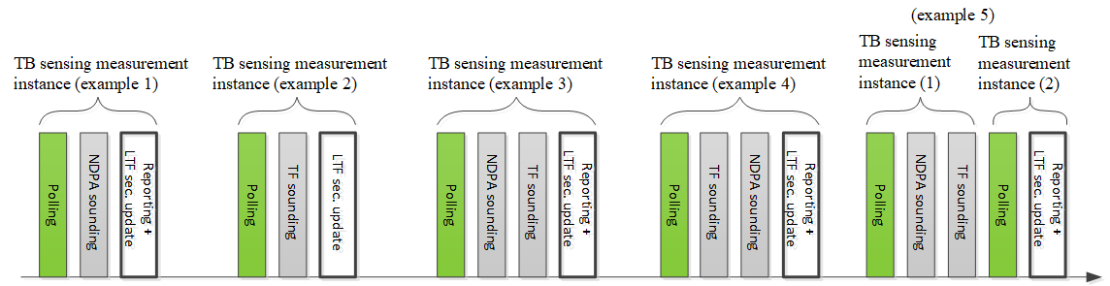

**Figure 3: TB sensing measurement instance (examples). (Motion 29, 21/1543r1)**

*7.1.4.2.1 Polling phase*

In the polling phase, an AP sends a trigger frame to check the availability of STAs. If a STA is available, it responds with a CTS-to-self (Motion 25c, 21/0990r2).

*7.1.4.2.2 NDPA sounding phase*

The NDPA sounding phase shall be present in a TB sensing measurement instance if at least one STA that is a sensing receiver responds in the polling phase (Motion 25c, 21/0990r2).

(Motion 25c, 21/0990r2; Motion 26c, 21/1015r2) The NDPA sounding phase consists of

* The transmission of an NDP Announcement (NDPA) frame by an AP; and
* The transmission of an NDP by an AP SIFS after the transmission of the NDPA frame.
* Note: NDPA sounding may be used by pre-HE STAs (i.e., its use is not limited to HE and/or EHT STAs).

Details of the format of the NDPA frame are TBD (Motion 25c, 21/0990r2; Motion 26c, 21/1015r2).

NDP can be used for the channel measurement (e.g. CSI) between sensing transmitter and sensing receiver(s) in sub-7 GHz bands. NDP format for sensing is TBD (Motion 22, 21/1015r1; Motion 29, 21/1543r1).

*7.1.4.2.3 Trigger frame (TF) sounding phase*

The TF sounding phase shall be present in a TB sensing measurement instance if at least one STA that is a sensing transmitter responds in the polling phase (Motion 25c, 21/0990r2).

(Motion 25c, 21/0990r2; Motion 27, 21/1015r2) The TF sounding phase consists of

* The transmission of a trigger frame by an AP to solicit NDP transmission(s) from STA(s); and
* The transmission of an NDP by STA(s) SIFS after receiving the trigger frame.
* Note: TF sounding is defined for HE and/or EHT STAs. Supporting other STAs is TBD.

Details of the format of the trigger frame are TBD (Motion 25c, 21/0990r2; Motion 27, 21/1015r2).

NDP can be used for the channel measurement (e.g. CSI) between sensing transmitter and sensing receiver(s) in sub-7 GHz bands. NDP format for sensing is TBD (Motion 22, 21/1015r1; Motion 29, 21/1543r1).

*7.1.4.2.4 Reporting phase*

In the reporting phase of a sensing measurement instance, sensing measurement results are reported (Motion 15, 20/1851r4; Motion 29, 21/1543r1).

Results of measurements performed in a WLAN sensing procedure should be obtained by or reported to its initiator (Motion 11, 21/0147r3; Motion 29, 21/1543r1).

Transmission of the Sensing Measurement Report frame is initiated by an MLME primitive. Both immediate and delayed reporting are acceptable (Motion 21, 21/0908r2).

**7.1.4.3 Non-TB sensing measurement instance**

### 7.1.5 Sensing measurement setup termination

### 7.1.6 Sensing session termination

In the sensing session termination, STAs stop performing measurements and terminate the sensing session (Motion 15, 20/1851r4; Motion 29, 21/1543r1).

### 7.1.7 Threshold-based measurement and reporting

(Motion 18, 21/0351r5) An optional threshold-based measurement and reporting procedure is defined in which

* The difference between the current measured CSI and the previous measured CSI is quantified. The difference is referred to as CSI variation.
* A threshold value to be used by the sensing receiver in the threshold-based procedure is defined.
* By comparing the CSI variation with the threshold, the sensing receiver can send a feedback resulting from the large CSI variation to the sensing transmitter.
* Whether the threshold is predefined, or defined by the sensing receiver, transmitter, initiator or responder is TBD.
* The threshold-based procedure is not always required (Procedure A in 21/0351r5 is not always required).

# PHY (sub-7 GHz)

CSI (that is, the channel measured during the training symbols of a received PPDU) is a type of sensing measurement result for sub-7 GHz WLAN sensing (Motion 20, 21/0908r2).

To enable sub-7 GHz WLAN sensing, an RXVECTOR parameter CSI_ESTIMATE is defined that contains the channel measured during the training symbols of the received PPDU. The format of CSI_ESTIMATE is the same one used in the measurement report field within the Sensing Measurement Report frame. The format of CSI_ESTIMATE is TBD (Motion 21, 21/0908r2).

## 8.1 HT PHY specification (Clause 19, [1])

### 8.1.1 HT PHY service interface

## 8.2 VHT PHY specification (Clause 21, [1])

### 8.2.1 VHT PHY service interface

## 8.3 HE PHY specification (Clause 27, [2])

### 8.3.1 HE PHY service interface

## 8.4 EHT PHY specification (Clause 36, [3])

### 8.4.1 EHT PHY service interface

# PHY (60 GHz)

## 9.1 DMG PHY specification (Clause 20, [1])

## 9.2 EDMG PHY specification (Clause 28, [4])

# References

[1] Draft IEEE P802.11-REVme/D0.0

[2] Draft IEEE P802.11ax/D8.0

[3] Draft IEEE P802.11be/D0.4

[4] Draft IEEE P802.11ay/D7.0