IEEE P802.11
Wireless LANs
Resolution for CID related to 35.3.2.3 inheritance rule in a per-STA profile
Date: 2021-04-08
Author(s):
Name | Affiliation | Address | Phone | email
Namyeong Kim | LG Electronics | 19, Yangjae-daero 11gil, Seocho-gu, Seoul 137-130, Korea |  | namyeong.kim@lge.com
Insun Jang | LG Electronics |  |  | insun.jang@lge.com
Sunhee Baek | LG Electronics |  |  | sunhee.baek@lge.com
Jinsoo Choi | LG Electronics |  |  | js.choi@lge.com
Gaurang Naik | Qualcomm |  |  | gnaik@qti.qualcomm.com
Abhishek Patil | Qualcomm |  |  | appatil@qti.qualcomm.com
Rojan Chitrakar | Panasonic |  |  | rojan.chitrakar@sg.panasonic.com
Young Hoon Kwon | NXP |  |  | younghoon.kwon@nxp.com
Jason Yuchen Guo | Huawei |  |  | guoyuchen@huawei.com
Laurent Cariou | Intel |  |  | laurent.cariou@intel.com

Abstract
This document proposes resoulution for CID 2416 related 35.3.2.3 inheritance rule in a per-STA profile.

Revisions:
- Rev 0: initial version of the document
- Rev 1: revised some text and figure to clarify (referred to 21/301 doc)
- Rev 2: changed the subfield name to “Complete Profile Requested” from “Complete Profile”
- Rev 3: referred to the 11be D1.0 spec.
- Rev 4: added text for signaling of same partial info request and simplified some text.
- Rev 5: modified text for clarification
TGbe editor: Please note that baseline is 11be D1.0

Interpretation of a Motion to Adopt

A motion to approve this submission means that the editing instructions and any changed or added material are actioned in the TGbe Draft. This introduction is not part of the adopted material.

Editing instructions formatted like this are intended to be copied into the TGbe Draft (i.e. they are instructions to the 802.11 editor on how to merge the text with the baseline documents).

TGbe Editor: Editing instructions preceded by “TGbe Editor” are instructions to the TGbe editor to modify existing material in the TGbe draft. As a result of adopting the changes, the TGbe editor will execute the instructions rather than copy them to the TGbe Draft.

CID | Pg/Ln | Section | Comment | Proposed Change | Resolution
2416 | 128/44 | 35.3.2.3 | We need to consider the use of inheritance rule for Probe Request variant Multi-Link element in a MLD probe request. For request of partial information of other APs, (Extended) Request element can be included in MLD probe request frame body and it can be applied to all APs by the inheritance rule when a STA requests part of same informaition for all APs. This can reduce overhead of MLD probe request. | Please add text to allow the inheritance rule on Probe Request variant Multi-Link element.  (Note: In current, we only allow the inheritance rule on Basic variant Multi-Link element) | Revised  The new clause 35.3.2.3.2 Inheritacnce rule for Probe Request variant Multi-Link element is added in section 35.3.2.3 Inhertiance in a per-STA profile.  This clause describes the inheritance rule for Probe Request variant Multi-Link element by partial information request of non-AP STA in more detail.  TGbe editor please implement changes as shown in doc 11-21/0500 tagged as 2416.

- Proposed spec text
TGbe editor: Please modify the clause 35.3.4.2 as shown below (Track Changes ON):
35.3.4.2 Use of ML probe request and response
An ML probe request is a Probe Request frame that is sent outside the context of active scanning that is used to discover an AP:
- with the Address 1 field set to the broadcast address and the Address 3 field set to the BSSID of an AP, or with the Address 1 field set to the BSSID of an AP’s BSS.
- and that includes a Probe Request variant Multi-Link element defined in 9.4.2.295b.3 (Probe Request variant Multi-Link element).
An ML probe request allows a non-AP STA to request an AP to include the complete or partial set of capabilities, parameters and operation elements of other APs affiliated to the same AP MLD as the AP. An AP affiliated to the same AP MLD as the AP identified in the Address 1 or Address 3 field of the Probe Request frame is a requested AP if one of the following conditions is met:
- the Multi-Link element in the Probe Request frame does not include any per-STA profile.
- the link ID of the AP is equal to the value in the Link ID field in a Per-STA Profile subelement in the Multi-Link element in the Probe Request frame.
The complete information of a requested AP is defined in 35.3.2.2 (Advertisement of complete or partial per-link information).
The partial information of a requested AP sent by a reporting AP consists of one or more elements that are requested in the (Extended) Request element carried in the ML probe request.
If a STA affiliated with a non-AP MLD sends an ML probe request to an AP to retrieve partial information for AP(s) affiliated with the same AP MLD as the AP, the STA shall include the (Extended) Request element in the Probe Request frame body and/or a Per-STA Profile subelement in a Probe Request variant Multi-Link element carried in the Probe Request frame. In this case, the Complete Profile subfield of the STA Control field in the Per-STA Profile subelement shall be set to 0. The (Extended) Request element carried in the per-STA profile corresponding to the requested AP that requests same partial information as the AP can be inherited from the (Extended) Request element in the frame body, subject to the rules defined in 35.3.2.3.2 (The inheritance in the per-STA profile of Probe Request variant Multi-Link element).
An ML probe request allows a non-AP STA to request an AP to include the complete information of all APs affiliated with the same AP MLD as the AP if the Probe Request frame does not include the (Extended) Request element in the frame body and the Probe Request variant Multi-Link element in the Probe Request frame does not include any per-STA profile.
An ML probe request allows a non-AP STA to request an AP to include the same requested partial information for all APs affiliated with the same AP MLD as the AP if the Probe Request frame includes the (Extended) Request element in frame body and the Probe Request variant Multi-Link element in the Probe Request frame does not include any per-STA profile.
An ML probe response is a Probe Response frame:
- that is transmitted in response to receiving an ML probe request
- and that includes Basic variant Multi-Link element which can carry complete or partial per-STA profile(s), based on the soliciting request, for each of the requested AP(s) of the AP MLD.

If an AP that is affiliated with an AP MLD receives an ML probe request from a non-AP STA requesting complete information, it shall respond with an ML probe response, which is a Probe Response frame that includes a Basic variant Multi-Link element with a per-STA profile with complete information for each of the APs that are affiliated to the same AP MLD as the AP and that are requested by the ML probe request, subject to the rules defined in 11.1.4.3.4 (Criteria for sending a response). If it receives an ML probe request from a non-AP STA requesting partial information, it shall respond with an ML probe response that includes a Basic variant Multi-Link element with a per-STA profile with at least the elements requested from the (Extended) Request element for each of the APs that are affiliated to the same AP MLD as the AP and that are requested by the ML probe request, unless the elements requested are not part of the complete information for each of the APs and subject to the rules defined in 11.1.4.3.4 (Criteria for sending a response).
If an AP that is operating in the 2.4 GHz band or the 5 GHz band that is part of an AP MLD receives an ML probe request requesting complete information and responds with an ML probe response (per 11.1.4.3.4 (Criteria for sending a response)), the Address 1 field of the Probe Response frame may be set to the broadcast address unless the AP is not including its actual SSID in the SSID element of its Beacon frames.
NOTE—An AP operating in 6 GHz sets the Address 1 field of the Probe Response frame to broadcast address as defined in 26.17.2.3.2 (AP behavior for fast passive scanning).
None of the non-AP STAs of a non-AP MLD shall send an ML probe request to an AP of the AP MLD in the corresponding link if any non-AP STA of the same non-AP MLD has already received a ML probe response including complete information from any of the AP of the AP MLD in any link, since the MLME-SCAN.request primitive with ScanType parameter indicating an active scan was issued.
TGbe editor: Please modify the clause 35.3.2.3 as shown below:
35.3.2.3 Inheritance in a per-STA profile
TGbe editor: Please add the new sub-clause 35.3.2.3.1 and move the all paragraphs and figures in 35.3.2.3 to the new sub-clause 35.3.2.3.1
35.3.2.3.1 Inheritance in the per-STA profile of Basic variant Multi-Link element
TGbe editor: Please add the new sub-clause 35.3.2.3.2 and paragraphs
35.3.2.3.2 Inheritance in the per-STA profile of Probe Request variant Multi-Link element (#2416)
If a non-AP STA affiliated with a non-AP MLD requests the same partial information for an AP to which it sends an ML probe request and for another AP affiliated with the same AP MLD as the AP and that is requested in the ML probe request (see 35.3.4.2 (Use of ML probe request and response)), the non-AP STA may include the (Extended) Request element only in the Probe Request frame body, and this element will be inherited for the other requested AP even if it is not carried in the Per-STA Profile subelement corresponding to the other requested AP, following the rules defined in 35.3.4.2 (Use of ML probe request and response).
Figure 35-xx (Example of inheritance in a Request element for ML probe request) illustrates a ML probe request transmitted by a non-AP STA that is affiliated with a non-AP MLD. The non-AP STA requests partial information for three APs and complete information for one AP, where all APs are affiliated with the same AP MLD. The non-AP STA includes a Request element in the Probe Request frame body requesting the element with element ID “a” for the AP to which the Probe Request frame is sent. The frame carries a Probe Request variant Multi-Link element that includes three Per-STA Profile subelements requesting information for AP x, AP y, AP z.
For AP x, the non-AP STA requests the element with element ID “a”, which is the same as the element requested for the AP. Hence, the Complete Profile subfield for the per-STA Profile x is set to 0 and the per-STA profile does not include the Request element in the STA Profile field by inheritance rule. For AP y, the non-AP STA requests the element with element ID “b”, which is not requested for the AP. Hence, the Complete Profile subfield for the per-STA profile y is set to 0 and the per-STA profile includes the Request element in the STA Profile field. The non-AP STA requests the complete information for AP z. The Complete Profile subfield for the per-STA profile z is set to 1 and the per-STA profile does not include any elements in the STA Profile field.
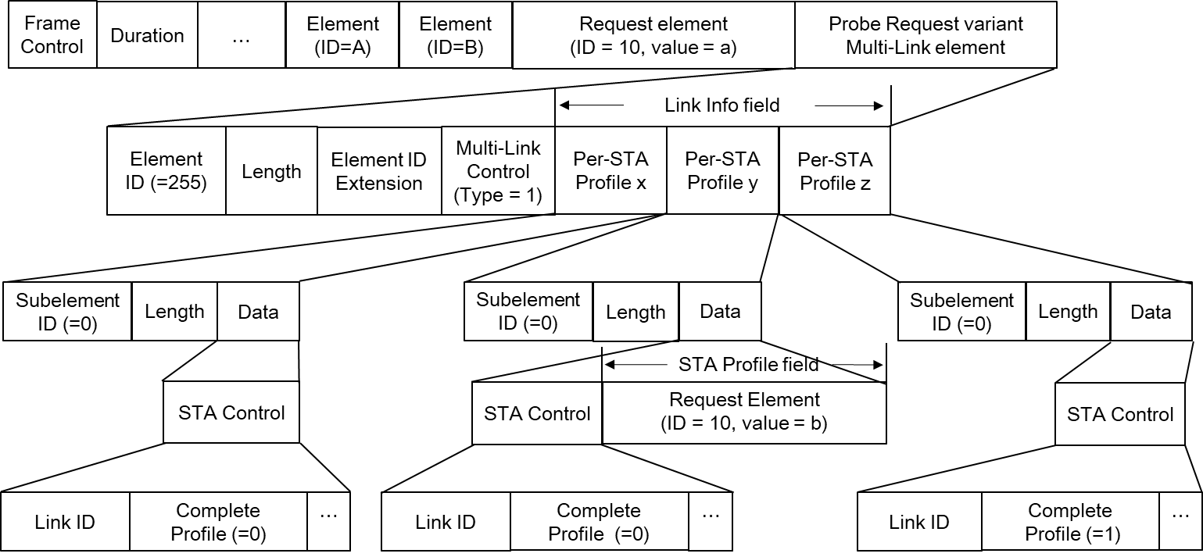
Figure 35-xx. Example of inheritance in a Request element for ML probe request

End of changes

