IEEE P802.11
Wireless LANs
Resolution for CID related to 35.3.2.3 inheritance rule in a per-STA profile
Date: 2021-04-08
Author(s):
Name | Affiliation | Address | Phone | email
Namyeong Kim | LG Electronics | 19, Yangjae-daero 11gil, Seocho-gu, Seoul 137-130, Korea |  | namyeong.kim@lge.com
Insun Jang | LG Electronics |  |  | insun.jang@lge.com
Sunhee Baek | LG Electronics |  |  | sunhee.baek@lge.com
Jinsoo Choi | LG Electronics |  |  | js.choi@lge.com
Gaurang Naik | Qualcomm |  |  | gnaik@qti.qualcomm.com
Abhishek Patil | Qualcomm |  |  | appatil@qti.qualcomm.com
Rojan Chitrakar | Panasonic |  |  | rojan.chitrakar@sg.panasonic.com
Young Hoon Kwon | NXP |  |  | younghoon.kwon@NXP.COM

Abstract
This document proposes resoulution for CID 2416 related 35.3.2.3 inheritance rule in a per-STA profile.

Revisions:
- Rev 0: Initial version of the document.
TGbe editor: Please note that baseline is 11be D0.4

Interpretation of a Motion to Adopt

A motion to approve this submission means that the editing instructions and any changed or added material are actioned in the TGbe Draft. This introduction is not part of the adopted material.

Editing instructions formatted like this are intended to be copied into the TGbe Draft (i.e. they are instructions to the 802.11 editor on how to merge the text with the baseline documents).

TGbe Editor: Editing instructions preceded by “TGbe Editor” are instructions to the TGbe editor to modify existing material in the TGbe draft. As a result of adopting the changes, the TGbe editor will execute the instructions rather than copy them to the TGbe Draft.

CID | Pg/Ln | Section | Comment | Proposed Change | Resolution
2416 | 128/44 | 35.3.2.3 | We need to consider the use of inheritance rule for Probe Request variant Multi-Link element in a MLD probe request. For request of partial information of other APs, (Extended) Request element can be included in MLD probe request frame body and it can be applied to all APs by the inheritance rule when a STA requests part of same informaition for all APs. This can reduce overhead of MLD probe request. | Please add text to allow the inheritance rule on Probe Request variant Multi-Link element.  (Note: In current, we only allow the inheritance rule on Basic variant Multi-Link element) | Revised  The new clause 35.3.2.3.2 Inheritacnce rule for Probe Request variant Multi-Link element is added in section 35.3.2.3 Inhertiance in a per-STA profile.  This clause describes the inheritance rule for Probe Request variant Multi-Link element by partial information request of non-AP STA in more detail.  TGbe editor please implement changes as shown in doc 11-21/0500 tagged as 2416.

- Proposed spec text
TGbe editor: Please modify the clause 35.3.2.3 as shown below:
35.3.2.3 Inheritance in a per-STA profile
TGbe editor: Please add the new sub-clause 35.3.2.3.1 and move the all paragraphs and figures in 35.3.2.3 to the new sub-clause 35.3.2.3.1
35.3.2.3.1 Inheritance rule for Basic variant Multi-Link element (#2416)
TGbe editor: Please add the new sub-clause 35.3.2.3.2 and paragraphs
35.3.2.3.2 Inheritance rule for Probe Request variant Multi-Link element (#2416)
A STA affiliated with a non-AP MLD may request partial information for other AP(s) affiliated with the same AP MLD as the AP receiving the ML probe request as defined in 35.3.4.2 (Use of ML probe request and response). The STA includes a (Extended) Request element in a Per-STA Profile subelement of Probe Request variant Multi-Link element to indicate the requested element IDs for the AP corresponding to the per-STA profile.
NOTE – In this sub-clause, when a STA affiliated with a non-AP MLD sends a Probe Request frame carrying the Probe Request variant Multi-Link element to an AP affiliated with an AP MLD, the AP to which the Probe Request frame is sent, and will respond with a Probe Response frame, is referred to as the reporting AP. All other AP(s) affiliated with the AP MLD whose information is carried in the Probe Response frame by the reporting AP are referred to as reported AP(s).
A STA of a non-AP MLD may request the same partial information on different links and it is expected that the (Extended) Request element that is carried in a Per-STA Profile subelement for a reported AP has the same value as the reporting AP. When a STA affiliated with a non-AP MLD sends an ML probe request to retrieve partial information for AP(s) affiliated with an AP MLD, the (Extended) Request element may be included in the body of the Probe Request frame for the reporting AP and/or within a Per-STA Profile subelement corresponding to a reported AP in a Probe Request variant Multi-Link element of the Probe Request frame. If the (Extended) Request element is present in the Probe Request frame body, the Per-STA Profile subelement that corresponds to a reported AP for which the requested partial information is the same as the reporting AP, does not include the (Extended) Request element and the Complete Profile subfield of the Per-STA Control field in that Per-STA Profile subelement shall be set to 0. In this case, the requested element IDs for the reported AP are inherited from the (Extended) Request element present in the Probe Request frame body. If the (Extended) Request element is present in the Probe Request frame body but the requested partial information is different from the reporting AP or the (Extended) Request element is not present in the Probe Request frame body, the Per-STA Profile subelement corresponding to the reported AP includes the (Extended) Request element and the Complete Profile subfield of the Per-STA Control field of the Per-STA Profile subelement shall be set to 0. If a non-AP STA affiliated with a non-AP MLD requests complete information for a reported AP, the Complete Profile subfield in the Per-STA Profile subelement corresponding to that AP shall be set to 1 regardless of the presence of the (Extended) Request element in the Probe Request frame body and the Per-STA Profile subelement shall not include the (Extended) Request element.
Figure 35-xx (Example of inheritance in a (Extended) Request element per-STA profile) illustrates inheritance when a STA affiliated with a non-AP MLD requests partial information.
The example shows a Probe Request frame transmitted by a requesting non-AP STA that is affiliated with a non-AP MLD. The Probe Request frame carries a (Extended) Request element in the Probe Request frame body when the non-AP STA requests partial information for the reporting AP. The frame also carries Probe Request variant Multi-Link element including a (Extended) Request element for a reported AP y and not including for a reported AP x based on the inheritance rule defined in 35.3.2.3.2 (Inheritance rule for Probe Request variant Multi-Link element).
The Complete Profile subfield for the per-STA profile x is set to 0 and the per-STA profile does not include the (Extended) Request element since the (Extended) Request element has same value with the corresponding (Extended) Request element carried in the Probe Request frame body. The (Extended) Request element for the reporting AP is inherited and shall not be carried in the profile for the reported AP x.

The Complete Profile subfield for the per-STA profile y is set to 0 and the per-STA profile includes the (Extended) Request element since the (Extended) Request element has differenct value with the corresponding (Extended) Request element carried in the Probe Request frame body. The (Extended) Request element for the reporing AP is not inherited and shall be carried in the profile for the reported AP y.
The Complete Profile subfield for the per-STA profile z is set to 1 if the STA requests complete information for the reported AP z and the per-STA profile shall not include any elements in the STA info field.

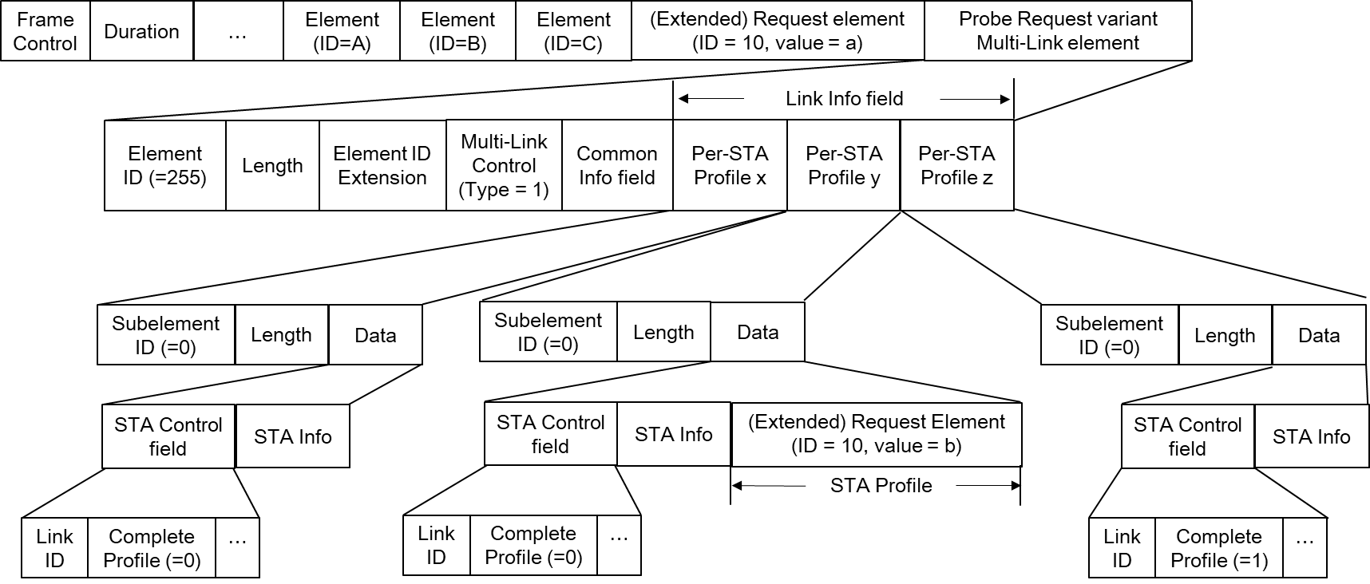
Figure 35-x. Example of inheritance in a (Extended) Request element for ML probe request

TGbe editor: Please modify the clause 9.4.2.295b.3 as shown below:
9.4.2.295b.3 Probe Request variant Multi-Link element
TGbe editor: Please insert the following paragraphs after the 5th paragraph of section 9.4.2.295b.3:
The Link ID subfield specifies a value that uniquely identifies the AP from which information is requested.
The Complete Profile subfield is set to 1 when complete information is requested from the AP as defined in 35.3.4.2 (Use of ML probe request and response). Otherwise the subfield is set to 0.
A Per-STA Profile subelement includes only a (Extended) Request element if a non-AP STA requests partial information from the AP corresponding to the per-STA profile, and does not include any elements if the non-AP STA requests complete information from the AP.

