IEEE P802.11
Wireless LANs
TGbe D0.3 Comment Resolution for CID 1599
Date: 2021-03-18
Author(s):
Name | Affiliation | Address | Phone | Email
Eunsung Park | LG Electronics | 19, Yangjae-daero 11gil, Seocho-gu, Seoul 137-130, Korea |  | esung.park@lge.com
Dongguk Lim |  |  |  | dongguk.lim@lge.com
Jinyoung Chun |  |  |  | jiny.chun@lge.com
Jinsoo Choi |  |  |  | js.choi@lge.com

Abstract
This submission proposes a resolution for CID 1599.

Revisions:
- Rev 0: Initial version of the document.

Interpretation of a Motion to Adopt

A motion to approve this submission means that the editing instructions and any changed or added material are actioned in the TGbe D0.3 Draft. This introduction is not part of the adopted material.

Editing instructions formatted like this are intended to be copied into the TGbe D0.3 Draft (i.e. they are instructions to the 802.11 editor on how to merge the text with the baseline documents).

TGbe Editor: Editing instructions preceded by “TGbe Editor” are instructions to the TGbe editor to modify existing material in the TGbe draft. As a result of adopting the changes, the TGbe editor will execute the instructions rather than copy them to the TGbe Draft.

CID 1599
CID | Clause | PP.LL | Comment | Proposed Change | Resolution
1599 | 9.3.1.22.1 | 57.20 | Trigger frame has the UL Spatial Reuse subfield in the Common Info field and when Trigger frame solicits HE TB PPDU this subfield is copied and pasted into the Spatial Reuse field in HE-SIG-A of HE TB PPDU. Even if Trigger frame solicits EHT TB PPDU, Trigger frame still has the UL Spatial Reuse subfield in the Common Info field and in this case spec needs to define how to set this subfield. | Describe how to set the UL Spatial Reuse subfield in Common Info field when EHT TB PPDU is triggered. | Revised  In 11-21/152r1, several options were discussed and most of the members agreed on Option 2.  TGbe editor to make the changes shown in 11-21/0491r0.

Discussion
This document proposes the resolution based on the following SP.
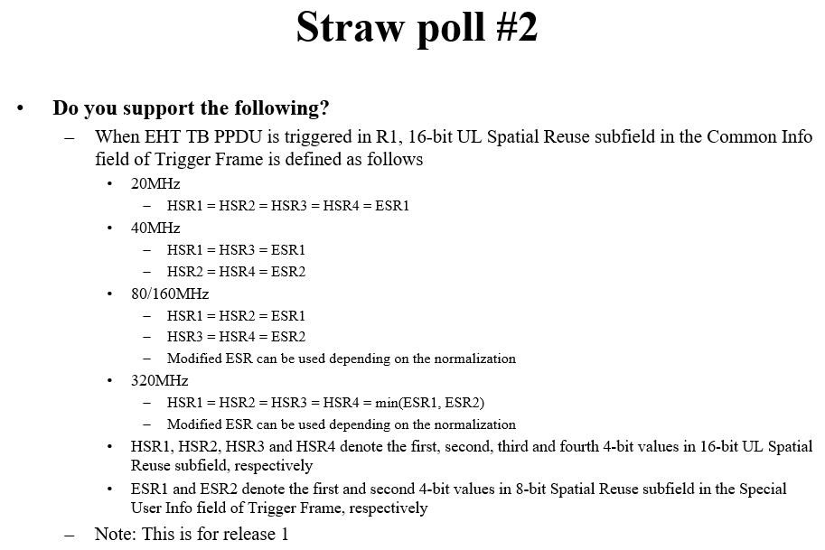

TGbe Editor: Please make the following changes to the paragraph right before Figure 9-64c (UL Spatial Reuse subfield format) in 9.3.1.22.1.1 Common Info field:
When the Trigger frame solicits an HE TB PPDU, the UL Spatial Reuse subfield of the Common Info field carries the values to be included in the Spatial Reuse fields in the HE-SIG-A field of the solicited HE TB PPDUs. The format of the UL Spatial Reuse subfield is shown in Figure 9-64c (UL Spatial Reuse subfield format), where each Spatial Reuse n subfield, 1 ≤ n ≤ 4, is set to the same value as its corresponding subfield in the HE-SIG-A field of the HE TB PPDU, which are defined in Table 27-21 (HE-SIG-A field of an HE TB PPDU).
When the Trigger frame solicits an EHT TB PPDU, each Spatial Reuse n subfield, 1 ≤ n ≤ 4, of the Common Info field is determined based on either the Spatial Reuse 1 subfield or the Spatial Reuse 2 subfield of the Special User Info field that is described in 9.3.1.22.1.3 (Special User Info field).
When the Trigger frame solicits a 20 MHz EHT TB PPDU, each Spatial Reuse n subfield, 1 ≤ n ≤ 4, of the Common Info field is set to the value of the Spatial Reuse 1 subfield of the Special User Info field.
When the Trigger frame solicits a 40 MHz EHT TB PPDU, the Spatial Reuse 1 subfield and the Spatial Reuse 3 subfield of the Common Info field are set to the value of the Spatial Reuse 1 subfield of the Special User Info field and the Spatial Reuse 2 subfield and the Spatial Reuse 4 subfield of the Common Info field are set to the value of the Spatial Reuse 2 subfield of the Special User Info field.
When the Trigger frame solicits an 80 MHz EHT TB PPDU or a 160 MHz EHT TB PPDU, the Spatial Reuse 1 subfield and the Spatial Reuse 2 subfield of the Common Info field are set to the value of the Spatial Reuse 1 subfield of the Special User Info field and the Spatial Reuse 3 subfied and the Spatial Reuse 4 subfield of the Common Info field are set to the value of the Spatial Reuse 2 subfield of the Special User Info field.
When the Trigger frame solicits a 320 MHz EHT TB PPDU, each Spatial Reuse n subfield, 1 ≤ n ≤ 4, of the Common Info field is set to the minimum between the values of the Spatial Reuse 1 subfield and the Spatial Reuse 2 subfield of the Special User Info field.
