IEEE P802.11  
Wireless LANs

|  |  |  |  |  |
| --- | --- | --- | --- | --- |
| CR on CID 1279 | | | | |
| Date: 2021-03-17 | | | | |
| Author: | | | | |
| Name | Affiliation | Address | Phone | Email |
| Yan Xin | Huawei Technologies |  |  | yan.xin@huawei.com |
| Ross Jian Yu | Huawei Technologies |  |  | ross.yujian@huawei.com |

This submission includes the resolution for CID 1279 on the terminology of 80 MHz segment in P802.11be D0.3.

##### Revision history:

##### R0 – initial version. To get the group’s view on the alternative options.

|  |  |  |  |  |  |
| --- | --- | --- | --- | --- | --- |
| CID | Clause | Page | Line | Comment | Proposed Change |
| **1279** | 36.3.2.1 | 175 | 45 | "composed of multiple 80 MHz segments." but "segments" is the wrong term - should be "frequency subblocks". E.g. look at Table 36-10 where all bandwidths only have 1 frequency segment | In clause 36, change "80MHz segment" and "80MHz frequency segment" to "80MHz frequency subblock". Delete "and frequency segment" and "per frequency segment" (or change to "and/per 80MHz frequency subblock". Keep "into one frequency segment". Delete Nseg row in Table 36-10. figure out a new term for "20 MHz segment" at P241L33.5 (perhaps "20 MHz" or "20 MHz frequency portion"). Change "on frequency segment i80FS" to "on frequency subblock i80Fs" . Change i080FS to i80FSB |

***Discussion***

- The term “80 MHz segment / frequency segment” is extensively used through Clause 36 in D0.3, for

example, in

36.3.2.1 Subcarriers and resource allocation for wideband;

36.3.2.3 Subcarriers and resource allocation for multiple RUs;

36.3.11.7 U-SIG

36.3.11.7.4 Encoding and modulation

36.3.11.8 EHT-SIG

36.3.11.11 Preamble punctured EHT PPDU

36.3.12.3 Coding

36.3.12.5 Segment parser

* + - 1. Constellation mapping
* The term “80 MHz subblock / frequency subblock” is also widely used through Clause 36 in D0.3, for example, in

36.3.6.10 Construction of Data field in an EHT PPDU

36.3.11.8 EHT-SIG

36.3.12.5 Segment parser

36.3.12.8 LDPC tone mapper

* In the most of cases, “frequency segment / frequency subblock” represents an 80 MHz spectrum range, with exception such as:

36.3.6.10 Construction of Data field in an EHT PPDU

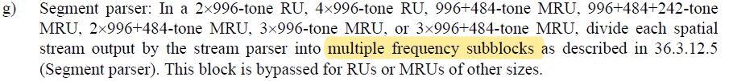

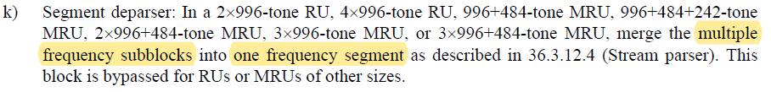

and

36.3.9 Time-related parameters



**Option 1:**

Use “frequency subblock” for 80 MHz and use “frequency segement” for a contigous spectrum.

Potential Action for Option 1:

1. Serach 80 MHz segment and frequency segment which are used to represent 80 MHz in P802.11be draft, and replace all of them with 80 MHz frequency subblock.
2. Change segment parser to frequency subblock parser in Revme.

**Option 2:**

Use “frequency segment” for 80 MHz and use another term (e.g., “frequency block”) for a contigous spectrum.

Potential Action for Option 2:

1. Search 80MHz subblock and frequency subblock which are used to represent 80 MHz in P802.11be draft, and replace all of them with 80 MHz frequency segment.
2. Change segment to frequency block in Revme.

**End of discussion**

**SP:**

**Which option do you prefer?**

* **Opt1**
* **Opt2**
* **Neitehr**
* **Abs**

Proposed resolution: TBD (to be provided later based on the SP result)