IEEE P802.11
Wireless LANs
CR on Overview of the PPDU Encoding Process
Date: 2021-03-03
Author(s):
Name | Affiliation | Address | Phone | email
Youhan Kim | Qualcomm |  |  | youhank@qti.qualcomm.com

Abstract
This submission proposes resolutions for the following comments on subclause 36.3.6 (excluding 36.3.6.10) in P802.11be D0.3:

1556, 3280, 2763, 3281, 3282, 3283

NOTE – Set the Track Changes Viewing Option in the MS Word to “All Markup” to clearly see the proposed text edits.

Revision History:

R0: Initial version.
R1: Updated during conference call on 3/17/2021. Note that CID 2763 was not strawpolled, pending more discussion on frequency segment vs. frequency subblock which will be dealt in a CID being lead by Yan Xin.

CID 1556

CID | Clause | Page.Line | Comment | Proposed Change
1556 | 36.3.6.6 | 207.30 | we defined the ER-preamble in 11be. And the U-SIG symbols are composed differently compared with described in 36.3.6.6. add the description for construction of U-SIG when ER preamble is assumed. | as in comment.

Proposed Resolution: CID 1556
Rejected
An EHT STA is required to detect and defer to PPDUs whose preamble has the characteristics of the ER preamble described in 36.3.11.7. However, there are no EHT PPDUs defined using the ER preamble – i.e., an EHT STA does not transmit PPDUs using the ER preamble. A future generation STA may transmit a PPDU which ‘spoofs’ an EHT STA to recognize the properties of the ER preamble. But the exact PPDU encoding process of that future generation PPDU is unknown at this point. Hence, it is neither necessary nor appropriate to describe the PPDU encoding process of a hypothetical PPDU where only a portion of it has known characteristics at this point.

CID 3280

CID | Clause | Page.Line | Comment | Proposed Change
3280 | 36.3.6.6 | 207.32 | disregard and validate bits should be Disregard and Validate bits to be consistent throught the spec | as in comment

Background

D0.3 P207
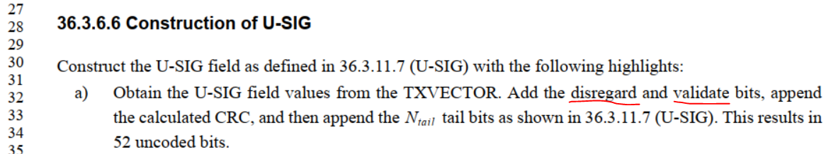

Proposed Resolution: CIDs 3280
Revised
Note to commenter:
Commenter is correct. The instruction to editor below simply makes commenter’s proposal actionable.

Instruction to Editor:
At D0.3 P207L32, change “disregard bits” to “Disregard fields”, and “validate” to “Validate fields”.
NOTE – CIDs 1353 and 1355 have already made these changes.

CID 2763

CID | Clause | Page.Line | Comment | Proposed Change
2763 | 36.3.6.6 | 207.46 | The U-SIG field, in particular for an MU PPDU, may be different within each 80 MHz segment, so it is not always duplicated over every 20 MHz channel within the entire bandwidth | Clarify in subclause 36.3.6.6. that duplication may be performed within each 80 MHz segment (can refer to Section 36.3.11.7 which describes U-SIG encoding and modulation)

Background

D0.3 P207
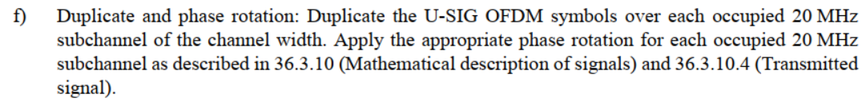

Proposed Resolution: CID 2763
Revised.
Note to Commenter:
Instruction to Editor updates the text to clarify that the U-SIG content may be different per 80 MHz.

Instruction to Editor:
Implement the proposed text updates for CID 2763 in https://mentor.ieee.org/802.11/dcn/20/11-21-0371-01-00be-cr-on-ppdu-encoding.docx

Proposed Text Updates: CID 2763

Instruction to Editor: Update D0.3 P207L31 as shown below.

36.3.6.6 Construction of U-SIG

Construct the U-SIG field as defined in 36.3.11.7 (U-SIG) with the following highlights:
Steps a)~f) apply for each frequency subblock:
- Obtain the U-SIG field values from the TXVECTOR. Add the Disregard and Validate bits, append the calculated CRC, and then append the tail bits as shown in 36.3.11.7 (U-SIG). This results in 52 uncoded bits.
- BCC encoder: Encode the data by a convolutional encoder at the rate of as described in 17.3.5.6 (Convolutional encoder).
- BCC interleaver: Interleave as described in 27.3.12.8 (BCC interleavers) for HE-SIG-A/HE-SIG-B.
- Constellation mapper: BPSK modulate the first 52 interleaved bits as described in 17.3.5.8 (Subcarrier modulation mapping) to form the first OFDM symbol of U-SIG. BPSK modulate the second 52 interleaved bits to form the second OFDM symbol of U-SIG.
- Pilot insertion: Insert pilots as described in 17.3.5.9 (Pilot subcarriers).
- Duplicate: Duplicate the U-SIG OFDM symbols over each occupied 20 MHz subchannel of the frequency subblock.

NOTE 1 – 20, 40 and 80 MHz EHT PPDUs have one 20, 40 and 80 MHz frequency subblock, respectively. 160 and 320 MHz EHT PPDUs have two and four 80 MHz frequency subblocks, respectively.

NOTE 2 – U-SIG content may vary between frequency subblocks in a 160 or 320 MHz EHT MU PPDU with the PPDU Type And Compression Mode field in the U-SIG equal to 0 (DL OFDMA). For all other cases, U-SIG content is the same for all frequency subblocks. See 36.3.11.7.

- Phase rotation: Apply the appropriate phase rotation for each occupied 20 MHz subchannel as described in 36.3.10 (Mathematical description of signals) and 36.3.10.4 (Transmitted signal).
- IDFT: Compute the inverse discrete Fourier transform.

CID 3281

CID | Clause | Page.Line | Comment | Proposed Change
3281 | 36.3.6.7 | 208.06 | the reserved bits should be Disregard and Validate bits | as in comment

Background

D0.3 P208
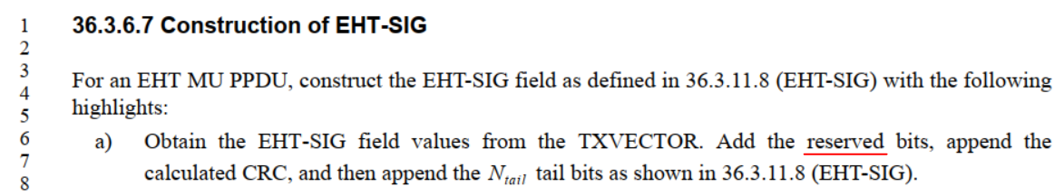

Proposed Resolution: CID 3281
Revised.
Note to Commenter:
Commenter is correct that EHT-SIG does not have “reserved” bits. Note that while EHT-SIG has validate “states” (e.g., the value 31 in the RU Allocation subfield is ‘validate’), there are no Validate “bits” in EHT-SIG. EHT-SIG has Disregards bits.

Instruction to Editor:
At D0.3 P208L6, change “reserved bits” to “Disregard fields”.

CID 3282

CID | Clause | Page.Line | Comment | Proposed Change
3282 | 36.3.6.7 | 208.12 | delete HE-SIG-A/HE-SIG-B. It should be EHT-SIG | as in comment

Background

D0.3 P208
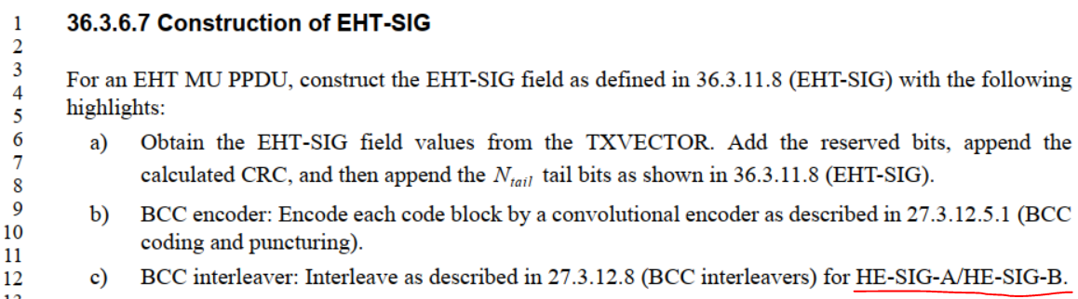

11ax D8.0 P644-645
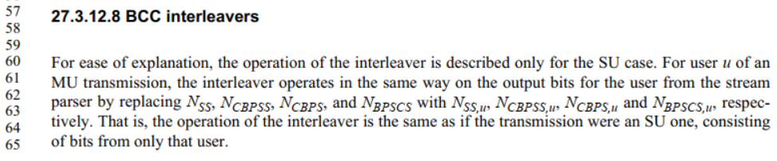
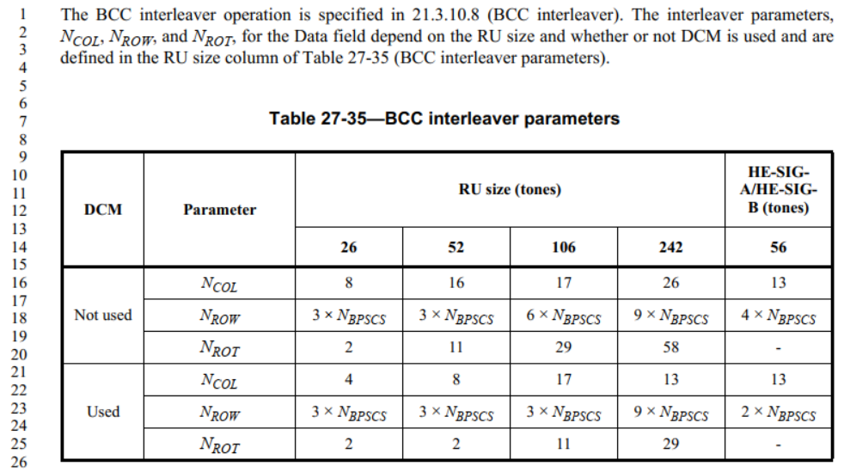

Proposed Resolution: CID 3282
Rejected.
27.3.12.8 describes the BCC interleaver for 26-tones RU, 52-tones RU, 106-tones RU, 242-tones RU and HE-SIG-A/HE-SIG-B. Hence, we need to specify that the interleavers defined for HE-SIG-A/HE-SIG-B are used for EHT-SIG.

CID 3283

CID | Clause | Page.Line | Comment | Proposed Change
3283 | 36.3.6.9 | 208.65 | only single stream pilot is supported in UL MU-MIMO in 11be | delete "except the UL MU-MIMO transmission not"

Background

D0.3 P208-209
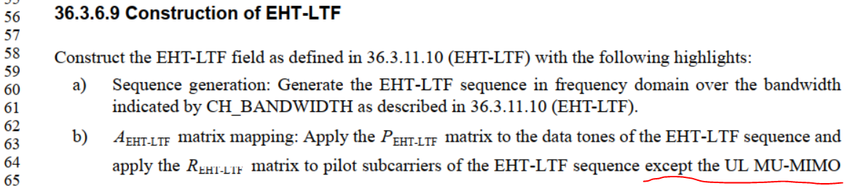

https://mentor.ieee.org/802.11/dcn/21/11-21-0114-04-00be-pdt-updates-on-ltf.docx
Single stream pilots shall be used for all spatial multiplexing modes (both UL and DL) defined in EHT except when 1x EHT-LTF is used.

…

(36-46)

Proposed Resolution: CID 3283
Rejected.
On Feb. 24, 2021, Motion 152 (see https://mentor.ieee.org/802.11/dcn/20/11-20-1982-06-00be-tgbe-motions-list-for-teleconferences-part-2.pptx) adopted the text updates in https://mentor.ieee.org/802.11/dcn/21/11-21-0114-04-00be-pdt-updates-on-ltf.docx, according to which single stream pilot EHT-LTF mode is not used in 1x EHT-LTF.

[End of File]

