IEEE P802.11  
Wireless LANs

|  |  |  |  |  |
| --- | --- | --- | --- | --- |
| Resolutions to 32.3.13 NGV receive procedure | | | | |
| Date: 2021-03-01 | | | | |
| Author(s): | | | | |
| Name | Affiliation | Address | Phone | email |
| Yujin Noh | Newracom |  |  | yujin.noh at newracom.com |
|  |  |  |  |  |

Abstract

This submission shows

* Resolutions for comments from TGbd draft 1.0
* 2 CIDs: 1000 and 1171

Revisions:

* Rev 0: Initial version of the document.
* Rev 1: editorial modification.

|  |  |  |  |  |
| --- | --- | --- | --- | --- |
| **CID** | **P.L** | **Comment** | **Proposed Change** | **Resolution** |
| 1000 | 86.40 | TBDs in Figure 32-15 PHY receive procedure for NGV transmission. RX state and padding bits TBDs need to be defined in the figure and text. | Define TBDs for padding and Rx State in Figure 32-15. Change Rx state "TBD" to "A-MPDU" and reference in draft text. | Revised.  The similar comments have been resolved in DCN 11-20-1950-00-00bd Resolutions to 32.3.13 NGV receive procedure.  Same resolution applied for CIDs 1096, 1118, 1238, 1239, 1293, 1475, 1500, 1506, 1513, 1549, 1688 and 1730.  TGbd Editor: Incorporate the changes according to https://mentor.ieee.org/802.11/dcn/20/11-20-1950-00-00bd-resolutions-to-32-3-13-ngv-receive-procedure.docx |
| 1171 | 86.36 | Inclusion of TBD | Two TBDs - total length of the PSD needs to be either specified or some other term besides TBD should be used | Revised.  The similar comments have been resolved in DCN 11-20-1950-00-00bd Resolutions to 32.3.13 NGV receive procedure.  Same resolution applied for CIDs 1096, 1118, 1238, 1239, 1293, 1475, 1500, 1506, 1513, 1549, 1688 and 1730.  TGbd Editor: Incorporate the changes according to https://mentor.ieee.org/802.11/dcn/20/11-20-1950-00-00bd-resolutions-to-32-3-13-ngv-receive-procedure.docx |

***To TGbd Editor:*** ***P62L51*** *update the description as below.*

***Discussion***

* Since BCC is not supported for data portion, the part corresponding to tail bits is removed.
* Given in subclause 9.7.1 (A-MPDU format) as below, 11bd has decided to support A-MPDU format not including EOF padding. TBD in MAC layer in the figure is updated to A-MPDU.

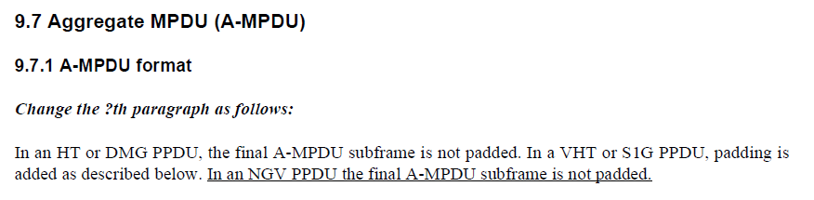

***To TGbd Editor:*** ***P86L52*** *delete the original Figure 32-15 (PHY receive procedure for NGV transmission) and add the new one as below. Please find visio file in DCN724 (draft visio for NGV transmit procedure)*

***------------- Begin Text Changes ---------------***

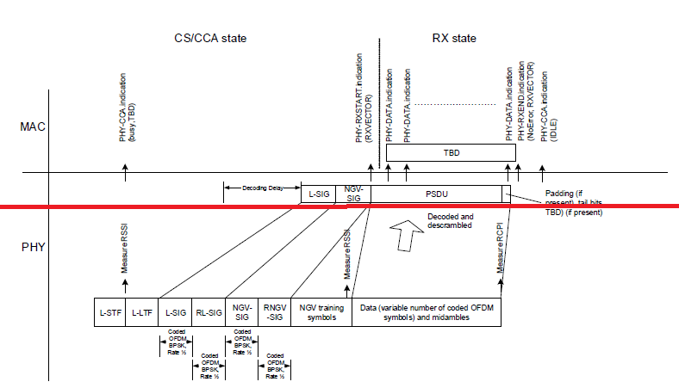



**Figure 32-15—PHY receive procedure for NGV transmission**

***------------- End Text Changes ------------------***