IEEE P802.11  
Wireless LANs

|  |  |  |  |  |
| --- | --- | --- | --- | --- |
| Editorial fixes to subclause 35.3.4.3 | | | | |
| Date: 2021-02-21 | | | | |
| Author: | | | | |
| Name | Affiliation | Address | Phone | Email |
| Edward Au | Huawei Technologies | 303 Terry Fox Drive, Suite 400, Ottawa, Ontario K2K 3J1 |  | edward.ks.au@gmail.com |

##### This submission clarifies the contents of subclause 35.3.4.3 (Multi-link element usage rules in the content of discovery). The proposed changes are based on P802.11be D0.3.

##### Revision history:

##### R0 – initial version

***Discussion:***

The following three paragraphs originating from [20/1333r2](https://mentor.ieee.org/802.11/dcn/20/11-20-1333-02-00be-pdt-mac-mlo-discovery-ml-ie-usage-rules-in-the-context-of-discovery.docx) appeared in P802.11be D0.1:



When Editor rolled-in [20/1651r6](https://mentor.ieee.org/802.11/dcn/20/11-20-1651-06-00be-pdt-tbds-mac-mlo-discovery-discovery-procedures-including-probing-and-rnr.docx), these three paragraphs were removed as shown in the redline verison of P802.11be D0.2:



The main reason that these 3 paragraphs were removed is because of the confusion on the Editor’s instruction in [20/1651r6](https://mentor.ieee.org/802.11/dcn/20/11-20-1651-06-00be-pdt-tbds-mac-mlo-discovery-discovery-procedures-including-probing-and-rnr.docx):

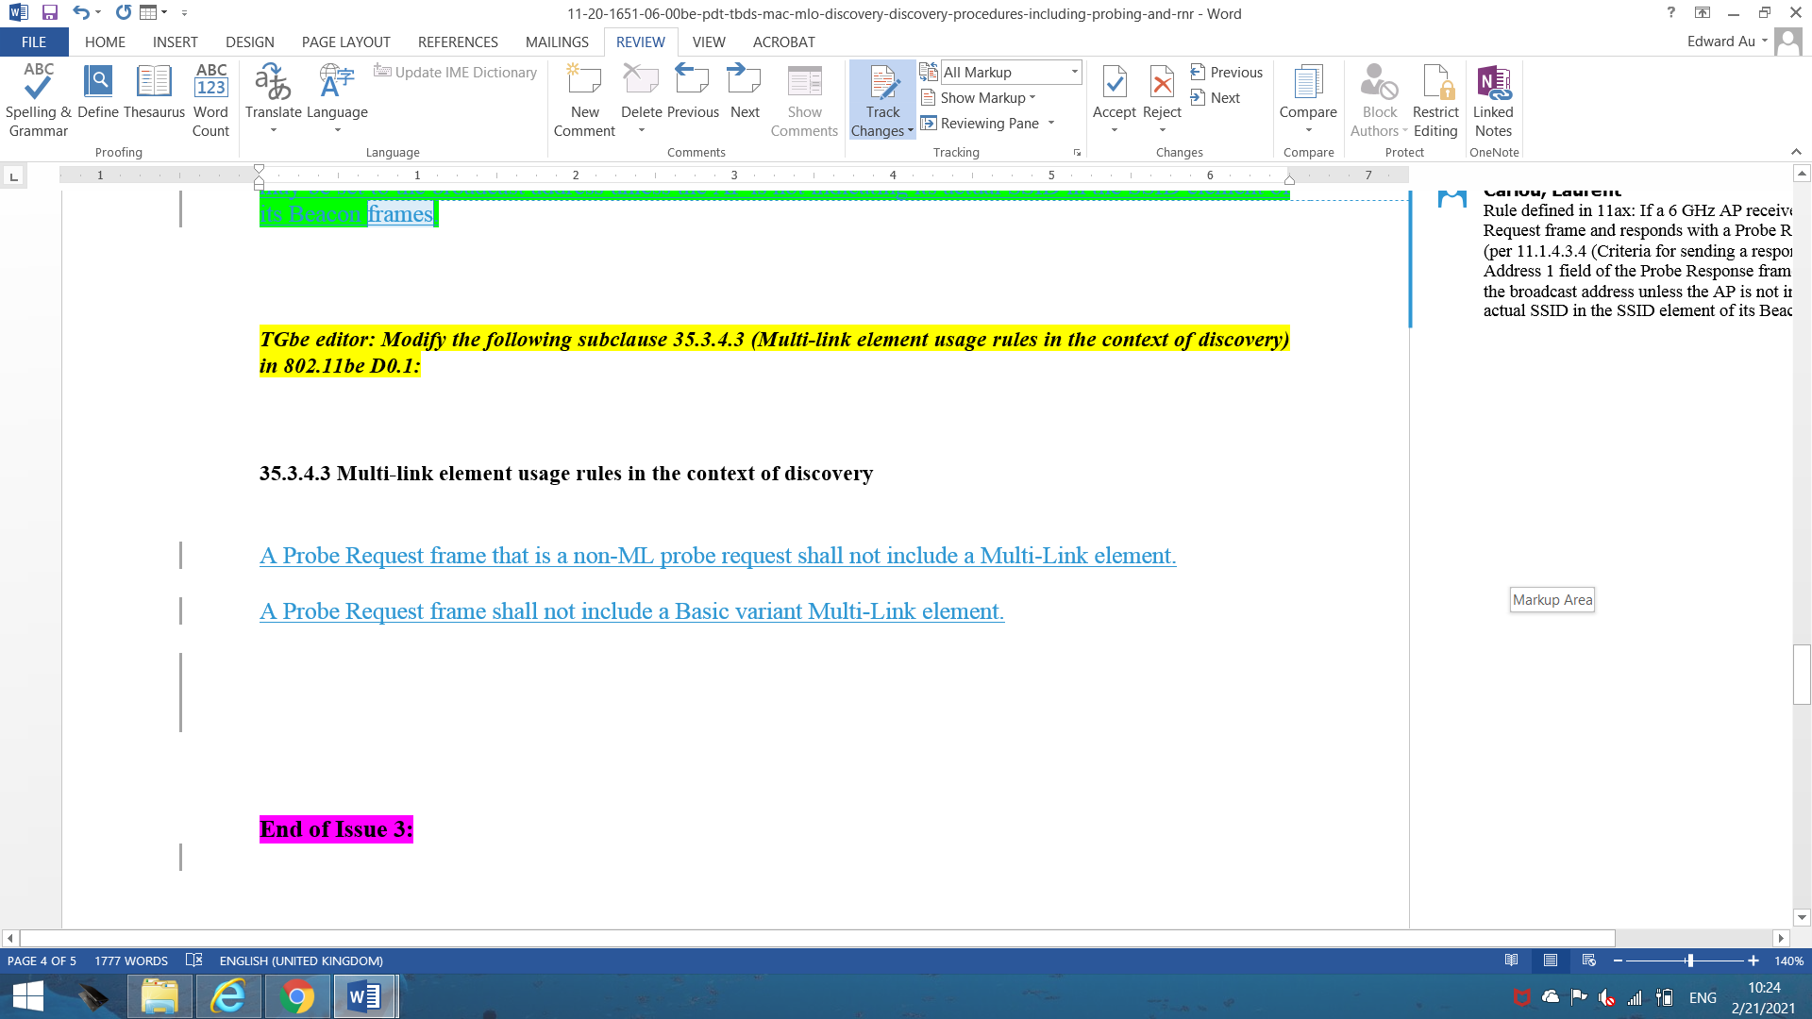

Editor has clarified with the author of [20/1651r6](https://mentor.ieee.org/802.11/dcn/20/11-20-1651-06-00be-pdt-tbds-mac-mlo-discovery-discovery-procedures-including-probing-and-rnr.docx) that the intention was not to remove these three paragraphs but to add the sentences from the submission to the subclause.

***Proposed Editor’s action item:***

To recover the above-mentioned three paragraphs from D0.1 so that the contents of subclause 35.3.4.3 in D0.4 will be updated as follows.

**35.3.4.3 Multi-link element usage rules in the context of discovery**

An AP within an AP MLD should include in the Beacon and non-ML Probe Response frames only the MLD level/common information carried in the field(s) of the Multi-Link element as defined in 9.4.2.247b (Multi-Link element) that is common to all APs affiliated with the AP MLD. The MLD Level/Common Information field shall include the MLD MAC address of the AP MLD with which the AP is affiliated and other information (TBD).

NOTE—Whether the Multi-Link element is always present in the Beacon and non-ML Probe Response frames or is optionally present is TBD.

An AP that is part of an AP MLD that supports SAE authentication shall include the MLD MAC address of the AP MLD with which the AP is affiliated in the Beacon and Probe Response frames it transmits. The container of the MLD MAC address is TBD.

A Probe Request frame that is a non-ML probe request shall not include a Multi-Link element.

A Probe Request frame shall not include a Basic variant Multi-Link element.

[End of the submission]