IEEE P802.11
Wireless LANs

CC36 Comment Resolution for EMLSR – Part 2
Date: 2021-8-31
Author(s):
Name | Affiliation | Address | Phone | email
Minyoung Park | Intel Corporation |  |  | Minyoung.park@intel.com

Abstract
This submission proposes comment resolutions for the following CIDs received in CC36 related to EMLSR mode duration:

- 4758, 6351, 6343, 6344, , 7466, 5222, 8355, 6068, 6346

Revisions:
- Rev 0: Initial version of the document.
- Rev 1: Updated the procedure returning to the listening operation and included unresolved CC34 comments received again in CC36
- Rev 2: Minor update for clarification.
- Rev 3: Updated based on comments received during the presentation on August 9 from Chunyu Hu, Liwen Chu, Yongho Seok, and Yuxin Lu to simplify the rules to determine the end of frame exchanges between AP and STA by removing the rules that cover Case 4 (EMLSR timer expires in the middle of packet reception) and the EMLSR timer based rules.
- Rev 4: Further updates based on comments from Yuxin Lu, Arik Klein, Chunyu Hu, and Shawn Kim (colored in dark gray).
- Rev 5: Removed BAR/BA from the list of frames (comments from George, Gaurang, Liwen). The CF-End condition removed since it is covered by the second condition (comment from Liwen, checked with Shawn).
- Rev 6: Updated based on comments from Ming (delete “The STA affiliated with the non-AP MLD that received the initial Control frame does not respond to the most recently received frame from the AP affiliated with the AP MLD that requires immediate response after a SIFS.”) and Yongho (delete “An AP affiliated with the AP MLD may initiate frame exchanges on one of the EMLSR links after the time duration indicated in the EMLSR Transition Delay subfield after the end of the TXOP.”) during the call on Nov. 8th.
- Rev 7: Adding back the removed sentence (“The STA affiliated with the non-AP MLD that received the initial Control frame does not respond to the most recently received frame from the AP affiliated with the AP MLD that requires immediate response after a SIFS.”) from Rev 6 based on the comment from Evgeny on the call on Nov. 11th. Updated based on the most recent draft 11be D1.3.

CID | Commenter | Clause Number | Page.  Line | Comment | Proposed Change | Resolution
4758 | Chunyu Hu | 35.3.15 | 281.53 | About "until the end of the frame exchange sequence": since the txop has been obtained over the the link where the initial Control frame was transmitted, AP shall not stay on the same link to resume rest frame sequences in the same txop if there is enough time. It's not efficient for each DATA/ACK frame sequences within the same txop, a control frame exchange (MU-RTS/CTS) is conducted. | Change to "until the end of TXOP." | Revised.  Agree in principle. The ‘frame exchange’ sequence has been replaced with ‘frame exchanges’ to indicate that there could be multiple frame exchanges during the TXOP. Also defined a procedure to determine when a non-AP MLD should return to the listening mode.  TGbe editor to make the changes with the CID tag (#4758) in doc.: IEEE 802.11-21/287r7  [https://mentor.ieee.org/802.11/dcn/21/11-21-0287  -07-00be-cc34-cr-emlsr-part2.docx]
6351 | Minyoung Park | 35.3.15 | 281.17 | The description in this subclause only applies for downlink traffic. Add the operation of uplink procedure or reference to other subclause. | As in the comment. | Revised.  The current 11be draft doesn’t prevent a non-AP MLD operating in the EMLSR mode from initiating a transmission to an AP MLD. However, the spec also is lacking a procedure how to determine when to return to the listening mode after initiating an UL transmission. A procedure is added to the subclause.  TGbe editor to make the changes with the CID tag (#6351) in doc.: IEEE 802.11-21/287r7  [https://mentor.ieee.org/802.11/dcn/21/11-21-0287  -07-00be-cc34-cr-emlsr-part2.docx]
6343 | Minyoung Park | 35.3.15 | 281.34 | When an AP MLD transmits MU-RTS or BSRP as an initial control frame, multiple frame exchanges could follow the initial control frame (e.g. MU-RTS/CTS/Data/BA/Data/BA). However, in 35.3.14, the phase 'a frame exchange sequence' is used, which could be interpreted as a single frame exchange sequence, e.g. BSRP follwed by BSR or Data followed by BA. This needs to be rephrased to represent multiple frame exchanges. | Replace 'a frame exchange sequence' with 'frame exchanges'. Also apply the change in the subclause where appropriate. | Revised.  Agree in principle. The proposed changes are made in subclause 35.3.16.  TGbe editor to make the changes with the CID tag (#6343) in doc.: IEEE 802.11-21/287r7  [https://mentor.ieee.org/802.11/dcn/21/11-21-0287  -07-00be-cc34-cr-emlsr-part2.docx]
6344 | Minyoung Park | 35.3.15 | 281.61 | It is unclear when the non-AP MLD switches back to the listening operation on the enabled/EMLSR links. The end of frame exchange seqeuence is not defined clearly. The spec should define a deterministic way of knowing when the non-AP MLD switches back to the listening operation. | Define a procedure that clearly indicates when the STA can switch back to the listening operation. | Revised.  Agree in principle. A procedure to determine when to return to the listening operation is added to the subclause.  TGbe editor to make the changes with the CID tag (#6344) in doc.: IEEE 802.11-21/287r7  [https://mentor.ieee.org/802.11/dcn/21/11-21-0287  -07-00be-cc34-cr-emlsr-part2.docx]
7466 | Thomas Handte | 35.3.15 | 281.60 | "The non-AP MLD switches back to the listening operation on the enabled links immediately after the end of the frame exchange sequence." Immediately contradicts with p.281 l.55, where it is stated that a link switch delay may be present. | Consider to revise to "The non-AP MLD *initiates* switching back to the listening operation on the enabled links immediately after the end of the frame exchange sequence" | Revised.  Agree in principle. A procedure to determine when to return to the listening operation is added to the subclause.  TGbe editor to make the changes with the CID tag (#7466) in doc.: IEEE 802.11-21/287r7  [https://mentor.ieee.org/802.11/dcn/21/11-21-0287  -07-00be-cc34-cr-emlsr-part2.docx]
5222 | Huizhao Wang | 35.3.15 | 281.59 | If the TXOP is established by the initial Control frame sent by the AP MLD, and the subsequent frame exchanges are using more than 1 spatial stream, then the non-AP MLD shall stay on the link for further frame exchanges expected by the AP MLD until the TXOP has expired or terminated then to go back to listen mode on the enabled links. | TXOP multiple frame exchanges should be honored for EMLSR operation | Revised.  Agree in principle. A procedure to determine when to return to the listening operation is added to the subclause.  TGbe editor to make the changes with the CID tag (#5222) in doc.: IEEE 802.11-21/287r7  [https://mentor.ieee.org/802.11/dcn/21/11-21-0287  -07-00be-cc34-cr-emlsr-part2.docx]
8355 | Zhiqiang Han | 35.3.15 | 281.54 | How long does the frame exchange sequence last? How to know which frame exchange is the end of the frame exchange sequence | Please clarify it | Revised.  Agree in principle. A procedure to determine when to return to the listening operation is added to the subclause.  TGbe editor to make the changes with the CID tag (#8355) in doc.: IEEE 802.11-21/287r7  [https://mentor.ieee.org/802.11/dcn/21/11-21-0287  -07-00be-cc34-cr-emlsr-part2.docx]
6068 | Liwen Chu | 35.3.15 | 281.17 | The ending of eMLSR frame exchange sequence should be defined. The possible method could be similar to dynamic SM power operation. | Change the text according to the comment. | Revised.  Agree in principle. A procedure to determine when to return to the listening operation is added to the subclause.  TGbe editor to make the changes with the CID tag (#6068) in doc.: IEEE 802.11-21/287r7  [https://mentor.ieee.org/802.11/dcn/21/11-21-0287  -07-00be-cc34-cr-emlsr-part2.docx]
6346 | Minyoung Park | 35.3.15 | 281.60 | The STA that was exchanging frames with the AP in the EMLSR mode may need a transition time going back to the listening operation and this time could be shorter or longer than the EMLSR Delay time that is defined for the MAC padding duration in the initial control frame. A separate field that defines the EMLSR transition time to the listening operation needs to be defined in the spec. | As in the comment. | Revised.  Agree in principle. Defined EMLSR Transition Delay subfield in the EML Capabilities subfield and the corresponding procedure to the subclause. Also renamed the EMLSR Delay subfield to the EMLSR Padding Delay subfield.  TGbe editor to make the changes with the CID tag (#6346) in doc.: IEEE 802.11-21/287r7  [https://mentor.ieee.org/802.11/dcn/21/11-21-0287  -07-00be-cc34-cr-emlsr-part2.docx]

TGbe Editor to make the following changes in Subclause 35.3.16 :

35.3.16 Enhanced multi-link single radio operation
…
When a non-AP MLD is operating in the EMLSR mode with an AP MLD supporting the EMLSR mode the following applies:

— The non-AP MLD shall be able to listen on the EMLSR links, by having its affiliated STA(s) corresponding to those links in the awake state. The listening operation includes CCA and receiving the initial Control frame of frame exchanges that is initiated by the AP MLD. (#4758, 6343)
— The initial Control frame of frame exchanges shall be sent in the OFDM PPDU or non-HT duplicate PPDU format using a rate of 6 Mbps, 12 Mbps, or 24 Mbps. (#4758, 6343)
— The initial Control frame shall be an MU-RTS Trigger frame or a BSRP Trigger frame. (#1582)Reception of MU-RTS and BSRP Trigger frames is mandatory for a non-AP MLD that is in the EMLSR mode. The number of spatial streams for the response to the BSRP Trigger frame shall be limited to one.
— (#2916)(#1773)(#3206)The non-AP MLD shall indicate the delay time duration in the EMLSR Padding Delay subfield of the EML Capabilities subfield in the Common Info field of the Basic variant MultiLink element. (#6346)

…
— (#4758, 6343)After receiving the initial Control frame of frame exchanges, a STA affiliated with the non-AP MLD that was listening on the corresponding link shall be able to transmit or receive frames on the link in which the initial Control frame was received and shall not transmit or receive on the other EMLSR link(s) until the end of the frame exchanges, and subject to its spatial stream capabilities, operation mode, and link switch delay, the STA affiliated with the non-AP MLD shall be capable of receiving a PPDU that is sent using more than one spatial stream a SIFS after the end of its response frame transmission solicited by the initial Control frame. (#4758, 6343)During the frame exchanges, the other AP(s) affiliated with the AP MLD shall not transmit frames to the other STA(s) affiliated with the non-AP MLD on the other EMLSR link(s). (#5222, 6068, 6344, 7466)

— (#5222, 6068, 6344, 7466) The non-AP MLD shall be switched back to the listening operation on the EMLSR links after the time indicated in the EMLSR Transition Delay subfield of the EML Capabilities subfield in the Common Info field of the Basic variant Multi-Link element if any of the following conditions is met and this is defined as the end of the frame exchanges:
- The MAC of the STA affiliated with the non-AP MLD that received the initial Control frame does not receive a PHY-RXSTART.indication primitive during a timeout interval of aSIFSTime + aSlotTime + aRxPHYStartDelay starting at the end of the PPDU transmitted by the STA of the non-AP MLD as a response to the most recently received frame from the AP affiliated with the AP MLD or starting at the end of the reception of the PPDU containing a frame for the STA from the AP affiliated with the AP MLD that does not require immediate acknowledgement.
- The MAC of the STA affiliated with the non-AP MLD that received the initial Control frame receives a PHY-RXSTART.indication primitive during a timeout interval of aSIFSTime + aSlotTime + aRxPHYStartDelay starting at the end of the PPDU transmitted by the STA of the non-AP MLD as a response to the most recently received frame from the AP affiliated with the AP MLD or starting at the end of the reception of the PPDU containing a frame for the STA from the AP affiliated with the AP MLD that does not require immediate acknowledgement and the STA affiliated with the non-AP MLD does not detect, within the PPDU corresponding to the PHY-RXSTART.indication any of the following frames:
  - an individually addressed frame with the RA equal to the MAC address of the STA affiliated with the non-AP MLD
  - a Trigger frame that has one of the User Info fields addressed to the STA affiliated with the non-AP MLD
  - a CTS-to-self frame with the RA equal to the MAC address of the AP affiliated with the AP MLD
  - a Multi-STA BlockAck frame that has one of the Per AID TID Info fields addressed to the STA affiliated with the non-AP MLD
  - a VHT/HE/EHT NDP Announcement frame that has one of STA Info fields addressed to the STA affiliated with the non-AP MLD
- The STA affiliated with the non-AP MLD that received the initial Control frame does not respond to the most recently received frame from the AP affiliated with the AP MLD that requires immediate response after a SIFS.

— When a STA of the non-AP MLD initiates a TXOP the following applies: (#6351)
- The non-AP MLD shall switch back to the listening operation on the EMLSR links after the time duration indicated in the EMLSR Transition Delay subfield after the end of the TXOP.

[Example time diagram Case1-Case2 (this is not a part of the proposed spec text)]
Case1: SU case
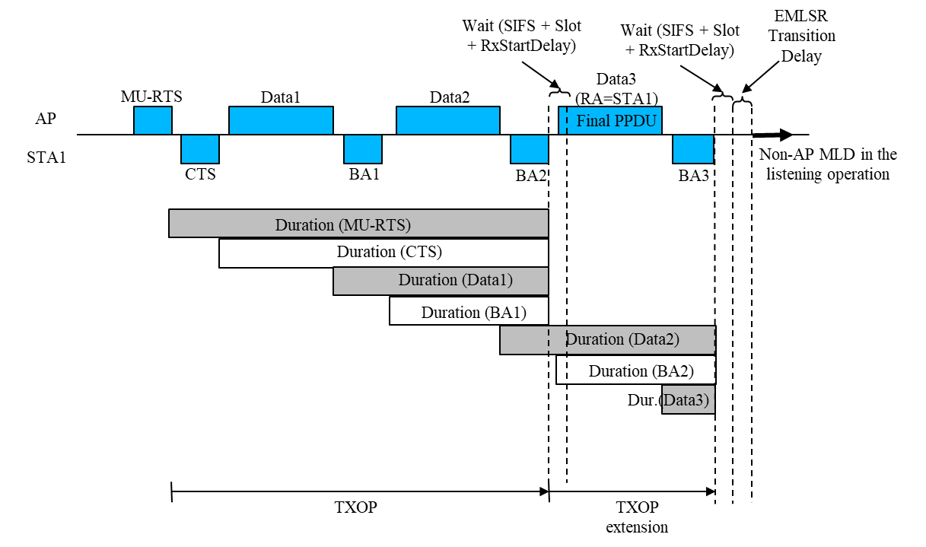

Case 2: MU-case
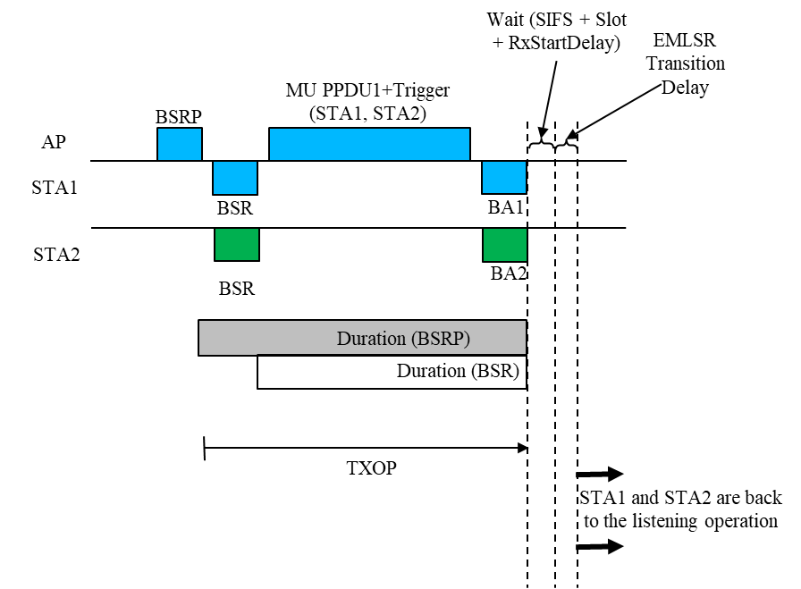

9.4.2.312.2 Basic Multi-Link element

…

 | B0 | B1 B3 | B4 B6 | B7 | B8 B10 | B11 B14 | B15 | B16 B19 | B20 B23
 | EMLSR Support | EMLSR Padding Delay | EMLSR Transition Delay | EMLMR Support | EMLMR Delay | Transition Timeout | Reserved | EMLMR Rx NSS | EMLMR Tx NSS
Bits: | 1 | 3 | 3 | 1 | 3 | 4 | 1 | 4 | 4

Figure 9-1002h—EML Capabilities subfield format (#1773, 2603, 6346)

(#1773)(#2603)(#3206)(#2745)(#2917)(#7335)The EMLSR Padding Delay subfield indicates the minimum MAC padding duration of the Padding field of the initial Control frame requested by the non-AP MLD as defined in 35.3.16 (Enhanced multi-link single radio operation). (#8168)When the EMLSR Padding Delay subfield is included in a frame sent by an AP affiliated with an AP MLD, the EMLSR Padding Delay subfield is set to 0. (#5829)The EMLSR Padding Delay subfield includes 3 bits and is set as defined in Table 9-401e (Encoding of the EMLSR Padding Delay subfield(#7335)(#5829)).

(#6346)The EMLSR Transition Delay subfield indicates the transition delay time needed by a non-AP MLD to switch from exchanging frames on one of the enabled links to the listening operation on the enabled links (see 35.3.16 (Enhanced multi-link single radio operation)). The EMLSR Transition Delay subfield is 3 bits and set to 0 for 0 µs, set to 1 for 16 µs, 2 for 32 µs, set to 3 for 64 µs, set to 4 for 128 µs, set to 5 for 256 µs, and the values 6 to 7 are reserved.

