IEEE P802.11
Wireless LANs

CC34/CC36 Comment Resolution for EMLSR – Part 2
Date: 2021-7-19
Author(s):
Name | Affiliation | Address | Phone | email
Minyoung Park | Intel Corporation |  |  | Minyoung.park@intel.com

Abstract
This submission proposes comment resolutions for the following CIDs received in CC34 related to EMLSR mode duration:
- 1459, 1758, 2337, 2338, 2550, 2551, 2936
And comment resolutons for the following CIDs received in CC36:
- 4758, 6351, 6343, 6344, 6350, 5222, 6068, 6346

Revisions:
- Rev 0: Initial version of the document.
- Rev 1: Updated the procedure returning to the listening operation and included unresolved CC34 comments received again in CC36
- Rev 2: Minor update for clarification.

CID | Commenter | Clause Number | Page.  Line | Comment | Proposed Change | Resolution
1459 | Chunyu Hu | 35.3.14 | 145.34 | Since the txop holder is specific to a link, it makes more sense that the non-AP MLD stays on the same link till end of the TXOP. It's also more efficient by reducing some overhead. | "immediately after the end of the frame exchange sequence" ==> "immediately after the end of theTXOP" | Revised.  Agree in principle. The ‘frame exchange’ sequence has been replaced with ‘frame exchanges’ to indicate that there could be multiple frame exchanges during the TXOP. Also defined a procedure to determine when a non-AP MLD should return to the listening mode.  TGbe editor to make the changes with the CID tag (#1459) in doc.: IEEE 802.11-20/287r2  [https://mentor.ieee.org/802.11/dcn/21/11-21-0287  -02-00be-cc34-cr-emlsr-part2.docx]
4758 | Chunyu Hu | 35.3.15 | 281.53 | About "until the end of the frame exchange sequence": since the txop has been obtained over the the link where the initial Control frame was transmitted, AP shall not stay on the same link to resume rest frame sequences in the same txop if there is enough time. It's not efficient for each DATA/ACK frame sequences within the same txop, a control frame exchange (MU-RTS/CTS) is conducted. | Change to "until the end of TXOP." | Revised.  Agree in principle. The ‘frame exchange’ sequence has been replaced with ‘frame exchanges’ to indicate that there could be multiple frame exchanges during the TXOP. Also defined a procedure to determine when a non-AP MLD should return to the listening mode.  TGbe editor to make the changes with the CID tag (#4758) in doc.: IEEE 802.11-20/287r2  [https://mentor.ieee.org/802.11/dcn/21/11-21-0287  -02-00be-cc34-cr-emlsr-part2.docx]
1758 | Hanseul Hong | 35.3.14 | 145.36 | The description in this subclause only applies for downlink traffic. Add the operaiton of uplink procedure or reference to other subclause. | As in the comment | Revised.  The current 11be draft doesn’t prevent a non-AP MLD operating in the EMLSR mode from initiating a transmission to an AP MLD. However, the spec also is lacking a procedure how to determine when to return to the listening mode after initiating an UL transmission. A procedure is added to the subclause.  TGbe editor to make the changes with the CID tag (#1758) in doc.: IEEE 802.11-20/287r2  [https://mentor.ieee.org/802.11/dcn/21/11-21-0287  -02-00be-cc34-cr-emlsr-part2.docx]
6351 | Minyoung Park | 35.3.15 | 281.17 | The description in this subclause only applies for downlink traffic. Add the operation of uplink procedure or reference to other subclause. | As in the comment. | Revised.  The current 11be draft doesn’t prevent a non-AP MLD operating in the EMLSR mode from initiating a transmission to an AP MLD. However, the spec also is lacking a procedure how to determine when to return to the listening mode after initiating an UL transmission. A procedure is added to the subclause.  TGbe editor to make the changes with the CID tag (#6351) in doc.: IEEE 802.11-20/287r2  [https://mentor.ieee.org/802.11/dcn/21/11-21-0287  -02-00be-cc34-cr-emlsr-part2.docx]
2337 | Minyoung Park | 35.3.14 | 145.04 | When an AP MLD transmits MU-RTS or BSRP as an initial control frame, multiple frame exchanges could follow the initial control frame (e.g. MU-RTS/CTS/Data/BA/Data/BA). However, in 35.3.14, the phase 'a frame exchange sequence' is used, which could be interpreted as a single frame exchange sequence, e.g. BSRP follwed by BSR or Data followed by BA. This needs to be rephrased to represent multiple frame exchanges. | Replace 'a frame exchange sequence' with 'frame exchanges'. Also make the same changes in L5, L21, L25, L27, L31, L35. | Revised.  Agree in principle. The proposed changes are made in subclause 35.3.14.  TGbe editor to make the changes with the CID tag (#2337) in doc.: IEEE 802.11-20/287r2  [https://mentor.ieee.org/802.11/dcn/21/11-21-0287  -02-00be-cc34-cr-emlsr-part2.docx]
6343 | Minyoung Park | 35.3.15 | 281.34 | When an AP MLD transmits MU-RTS or BSRP as an initial control frame, multiple frame exchanges could follow the initial control frame (e.g. MU-RTS/CTS/Data/BA/Data/BA). However, in 35.3.14, the phase 'a frame exchange sequence' is used, which could be interpreted as a single frame exchange sequence, e.g. BSRP follwed by BSR or Data followed by BA. This needs to be rephrased to represent multiple frame exchanges. | Replace 'a frame exchange sequence' with 'frame exchanges'. Also apply the change in the subclause where appropriate. | Revised.  Agree in principle. The proposed changes are made in subclause 35.3.14.  TGbe editor to make the changes with the CID tag (#6343) in doc.: IEEE 802.11-20/287r2  [https://mentor.ieee.org/802.11/dcn/21/11-21-0287  -02-00be-cc34-cr-emlsr-part2.docx]
2338 | Minyoung Park | 35.3.14 | 145.34 | It is unclear when the non-AP MLD switches back to the listening operation on the enabled links. The end of frame exchange seqeuence is not defined clearly. The spec should define a deterministic way of knowing when the non-AP MLD switches back to the listening operation. | Define a timer at the non-AP MLD that initializes based on a received frame's Duration field so that the non-AP MLD knows when the frame exchanges with the AP MLD end and can safely go back to the listening operation. Also define a timeout interval so that the non-AP MLD can go back to the listening operation when the medium is idle for the timeout interval knowing that there is no more frame exchange between the AP MLD and the non-AP MLD. The details will be provided by the commenter. | Revised.  Agree in principle. A procedure to determine when to return to the listening operation is added to the subclause.  TGbe editor to make the changes with the CID tag (#2338) in doc.: IEEE 802.11-20/287r2  [https://mentor.ieee.org/802.11/dcn/21/11-21-0287  -02-00be-cc34-cr-emlsr-part2.docx]
6344 | Minyoung Park | 35.3.15 | 281.61 | It is unclear when the non-AP MLD switches back to the listening operation on the enabled/EMLSR links. The end of frame exchange seqeuence is not defined clearly. The spec should define a deterministic way of knowing when the non-AP MLD switches back to the listening operation. | Define a procedure that clearly indicates when the STA can switch back to the listening operation. | Agree in principle. A procedure to determine when to return to the listening operation is added to the subclause.  TGbe editor to make the changes with the CID tag (#6344) in doc.: IEEE 802.11-20/287r2  [https://mentor.ieee.org/802.11/dcn/21/11-21-0287  -02-00be-cc34-cr-emlsr-part2.docx]
2550 | Robert Stacey | 35.3.14 | 145.21 | Inappropriate shall: the requirement is not to initiate a frame exchange sequence, the requirement is that a frame exchange sequence begin with an initial Control frame. | Change to "An AP MLD that initiates a frame exchange sequence with an EMLSR non-AP STA, shall begin the frame exhange with an initial Control frame." | Revised.  Agree in principle.  TGbe editor to make the changes with the CID tag (#2550) in doc.: IEEE 802.11-20/287r2  [https://mentor.ieee.org/802.11/dcn/21/11-21-0287  -02-00be-cc34-cr-emlsr-part2.docx]
6350 | Minyoung Park | 35.3.15 | 281.47 | Inappropriate shall: the requirement is not to initiate a frame exchange sequence, the requirement is that a frame exchange sequence begin with an initial Control frame. | Change to "An AP MLD that initiates a frame exchange sequence with an EMLSR non-AP STA, shall begin the frame exhange with an initial Control frame." | Revised.  Agree in principle.  TGbe editor to make the changes with the CID tag (#6350) in doc.: IEEE 802.11-20/287r2  [https://mentor.ieee.org/802.11/dcn/21/11-21-0287  -02-00be-cc34-cr-emlsr-part2.docx]
2551 | Robert Stacey | 35.3.14 | 145.25 | An initial Control frame is not something that you identify just by its content. It is identified by (and behavior is dependent on) both context and content. | I would suggest we create two modes for this EMLSR non-AP STA; a listen state and full-on active channel state. This statement then becomes something like: "An EMLSR non-AP STA that is in _listen_ state and that receives a MU-RTS Trigger or BSRP Trigger frame with a STA Info field addressed to it shall enter the _full on active channel_ state." Add additional statements for transitioning between these two states so that both sides know which state the EMLSR non-AP ST is in at all times. | Revised.  To clarify that the non-AP MLD is listening on the enabled links before receiving an initial Control frame from the AP MLD, the paragraph is modified as follows: “After receiving the initial Control frame of frame exchanges, the non-AP MLD that was listening on the EMLSR links shall be able to transmit or receive frames on the link in which the initial Control frame was received …”  A method to determined when the non-AP MLD returns to listen on the enabled links is added.  TGbe editor to make the changes with the CID tag (#2551) in doc.: IEEE 802.11-20/287r2  [https://mentor.ieee.org/802.11/dcn/21/11-21-0287  -02-00be-cc34-cr-emlsr-part2.docx]
2936 | Thomas Handte | 35.3.14 | 145.33 | "The non-AP MLD switches back to the listening operation on the enabled links immediately after the end of the frame exchange sequence." The immediately contradicts with p.146 l.10-12, where it is stated that a link switch delay may be present. | Consider to revise to "The non-AP MLD *initiates* switching back to the listening operation on the enabled links immediately after the end of the frame exchange sequence" | Revised.  Agree in principle. Deleted the sentence and added a procedure to determine when to return to the listening operation.  TGbe editor to make the changes with the CID tag (#2936) in doc.: IEEE 802.11-20/287r2  [https://mentor.ieee.org/802.11/dcn/21/11-21-0287  -02-00be-cc34-cr-emlsr-part2.docx]
5222 | Huizhao Wang | 35.3.15 | 281.59 | If the TXOP is established by the initial Control frame sent by the AP MLD, and the subsequent frame exchanges are using more than 1 spatial stream, then the non-AP MLD shall stay on the link for further frame exchanges expected by the AP MLD until the TXOP has expired or terminated then to go back to listen mode on the enabled links. | TXOP multiple frame exchanges should be honored for EMLSR operation | Revised.  Agree in principle. A procedure to determine when to return to the listening operation is added to the subclause.  TGbe editor to make the changes with the CID tag (#5222) in doc.: IEEE 802.11-20/287r2  [https://mentor.ieee.org/802.11/dcn/21/11-21-0287  -02-00be-cc34-cr-emlsr-part2.docx]
6068 | Liwen Chu | 35.3.15 | 281.17 | The ending of eMLSR frame exchange sequence should be defined. The possible method could be similar to dynamic SM power operation. | Change the text according to the comment. | Revised.  Agree in principle. A procedure to determine when to return to the listening operation is added to the subclause.  TGbe editor to make the changes with the CID tag (#6068) in doc.: IEEE 802.11-20/287r2  [https://mentor.ieee.org/802.11/dcn/21/11-21-0287  -02-00be-cc34-cr-emlsr-part2.docx]
6346 | Minyoung Park | 35.3.15 | 281.60 | The STA that was exchanging frames with the AP in the EMLSR mode may need a transition time going back to the listening operation and this time could be shorter or longer than the EMLSR Delay time that is defined for the MAC padding duration in the initial control frame. A separate field that defines the EMLSR transition time to the listening operation needs to be defined in the spec. | As in the comment. | Revised.  Agree in principle. Defined EMLSR Transition Delay subfield in the EML Capabilities subfield and the corresponding procedure to the subclause. Also renamed the EMLSR Delay subfield to the EMLSR Padding Delay subfield.  TGbe editor to make the changes with the CID tag (#6346) in doc.: IEEE 802.11-20/287r2  [https://mentor.ieee.org/802.11/dcn/21/11-21-0287  -02-00be-cc34-cr-emlsr-part2.docx]

TGbe Editor to make the following changes in Subclause 35.3.15 :

35.3.15 Enhanced multi-link single radio operation
…
When a non-AP MLD is operating in the EMLSR mode with an AP MLD supporting the EMLSR mode the following applies:

— The non-AP MLD shall be able to listen on the EMLSR links, by having its affiliated STA(s) corresponding to those links in the awake state. The listening operation includes CCA and receiving the initial Control frame of frame exchanges that is initiated by the AP MLD. (#2337, 6343)
— The initial Control frame of frame exchanges shall be sent in the OFDM PPDU or non-HT duplicate PPDU format using a rate of 6 Mbps, 12 Mbps, or 24 Mbps. (#2337, 6343)
— The initial Control frame shall be an MU-RTS Trigger frame or a BSRP Trigger frame. (#1582)Reception of MU-RTS and BSRP Trigger frames is mandatory for a non-AP MLD that is in the EMLSR mode. The number of spatial streams for the response to the BSRP Trigger frame shall be limited to one.
— (#2916)(#1773)(#3206)The non-AP MLD shall indicate the delay time duration in the EMLSR Padding Delay subfield of the EML Capabilities subfield in the Common Info field of the Basic variant MultiLink element.
— An AP of the AP MLD that initiates frame exchanges with the non-AP MLD on one of the EMLSR links shall begin the frame exchanges by transmitting the initial Control frame to the non-AP MLD with the limitations specified above. (#2337, 2550, 6343, 6350)
— After receiving the initial Control frame of frame exchanges, a STA affiliated with the non-AP MLD that was listening on the corresponding link (#2551) shall be able to transmit or receive frames on the link in which the initial Control frame was received and shall not transmit or receive on the other link(s) until the end of the frame exchanges, and subject to its spatial stream capabilities, operation mode, and link switch delay, the STA affiliated with the non-AP MLD shall be capable of receiving a PPDU that is sent using more than one spatial stream a SIFS after the end of its response frame transmission solicited by the initial Control frame.(#2337, 6343) During the frame exchanges, the other AP(s) affiliated with the AP MLD shall not transmit frames to the other STA(s) affiliated with the non-AP MLD on the other link(s). . (#1459, 2338, 2936, 2551, 5222, 6068, 6344)

— The EMLSR timer in a STA affiliated with the non-AP MLD shall be initialized with the duration value in the Duration/ID field of the initial Control frame if the initial Control frame is successfully transmitted by an AP affiliated with the AP MLD that initiated the frame exchanges. The EMLSR timer begins counting down from the end of the reception of the PPDU that contains the initial Control frame. The EMLSR timer in the STA affiliated with the non-AP MLD shall be updated with the duration value in the Duration/ID field of a received frame that requires immediate response from the STA if the frame is successfully transmitted by the AP affiliated with the AP MLD and the MAC of the STA affiliated with the non-AP MLD receives PHY-RXSTART.indication primitive during a timeout interval of aSIFSTime + aSlotTime + aRXPHYStartDelay starting at the end of the PPDU transmitted by the STA affiliated with the non-AP MLD as a response to the frame received from the AP affiliated with the AP MLD. (#1459, 2338, 2936, 2551, 5222, 6068, 6344)

— When the EMLSR timer in a STA affiliated with the non-AP MLD expires
- in the middle of the reception of a PPDU containing a frame destined for the STA affiliated with the non-AP MLD, the STA affiliated with the non-AP MLD shall continue to operate on the link it received the frame until the STA affiliated with the non-AP MLD responds with an acknowledgement or until a timeout interval of the duration value of the Duration/ID field of the received frame contained in the PPDU starting at the end of the PPDU expires.
- Otherwise, PPDUs exchanged between the AP affiliated with the AP MLD and the STA affiliated with the non-AP MLD shall be separated by SIFS. (#1459, 2338, 2936, 2551, 5222, 6068, 6344)

— The non-AP MLD shall switch back to the listening operation on the EMLSR links after the time indicated in the EMLSR Transition Delay subfield of the EML Capabilities subfield in the Common Info field of the Basic variant Multi-Link element if any of the following conditions is met and this is defined as the end of the frame exchanges: (#1459, 2338, 2936, 2551, 5222, 6068, 6344, 6346)
- The EMLSR timer in the STA affiliated with the non-AP MLD has expired and the MAC does not receive a PHY-RXSTART.indication primitive during a timeout interval of aSIFSTime + aSlotTime + aRxPHYStartDelay starting at the end of the PPDU transmitted by the STA of the non-AP MLD as a response to the most recently received frame from the AP affiliated with the AP MLD or starting at the end of the reception of the PPDU containing a frame from the AP affiliated with the AP MLD that does not require immediate acknowledgement.
- The EMLSR timer in the STA affiliated with the non-AP MLD has expired and the STA affiliated with the non-AP MLD has received an individually addressed frame with the RA not equal to the MAC address of the STA affiliated with the non-AP MLD or has received a Trigger frame that does not have one of the User Info fields addressed to the STA affiliated with the non-AP MLD, except when a CTS-to-self frame with the RA equal to the MAC address of the AP affiliated with the AP MLD has received.
- The STA affiliated with the non-AP MLD has received a CF-End frame from the AP affiliated with the AP MLD that initiated the frame exchanges.

— When a STA of the non-AP MLD initiates a TXOP the following applies: (#1758, 2338, 2936, 2551, 5222, 6068, 6344, 6346, 6351)
- The non-AP MLD shall switch back to the listening operation on the EMLSR links after the time duration indicated in the EMLSR Transition Delay subfield after the end of the TXOP.
- An AP affiliated with the AP MLD may initiate frame exchanges on one of the EMLSR links after the time duration indicated in the EMLSR Transition Delay subfield after the end of the TXOP.

[Example time diagram: Case1-Case4 (this is not a part of the proposed spec text)]
Case1: SU case
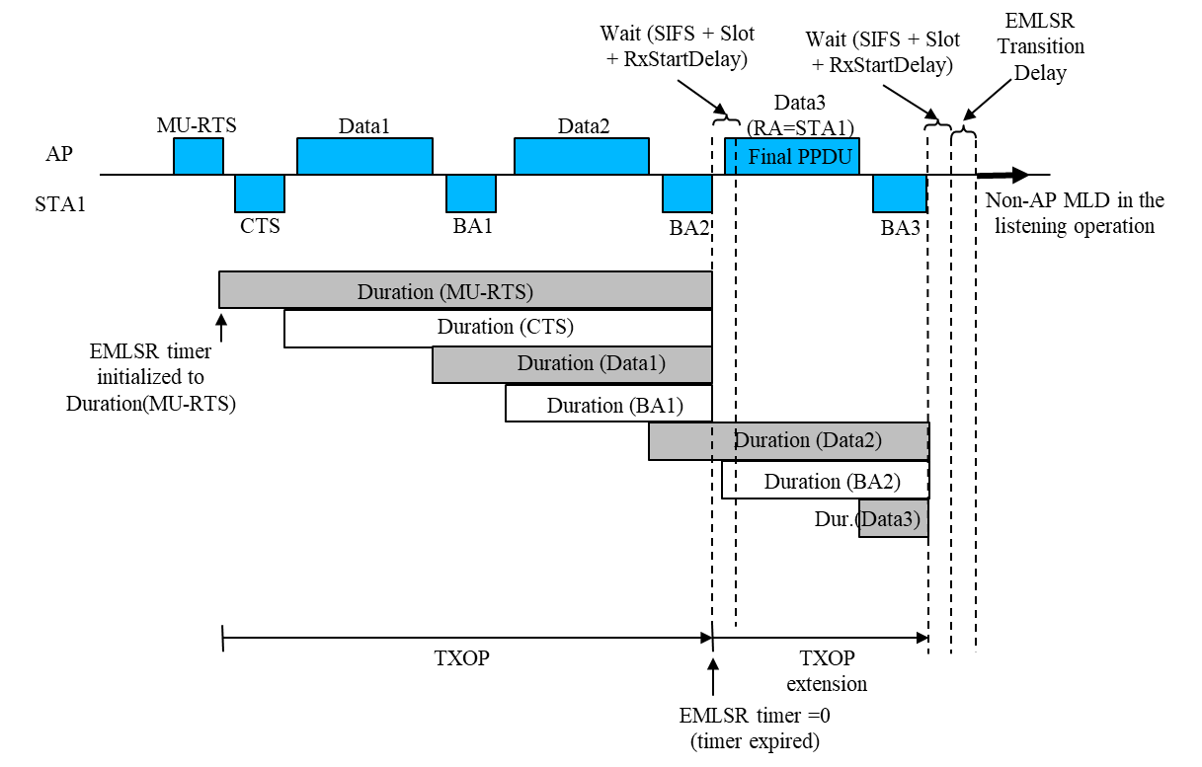
Case 2: MU-case - MU sequence is scheduled in the initial TXOP duration; no TXOP extension
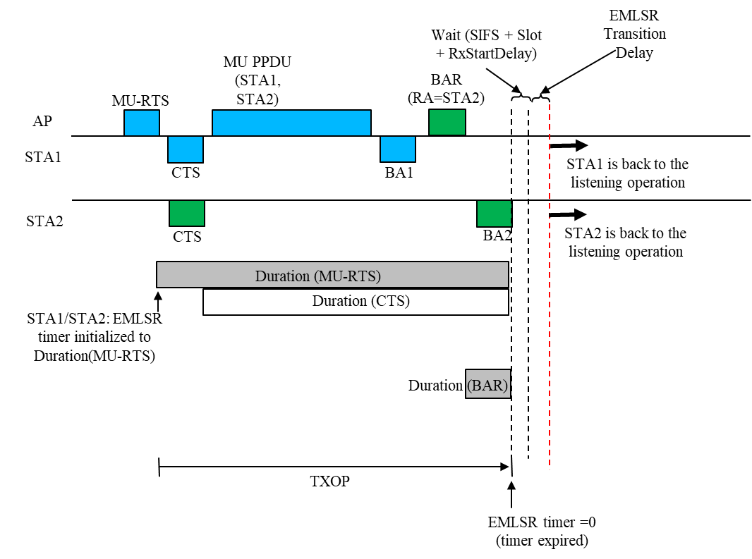
Case3: MU case with TXOP extension – BAR/BA scheduled in the initial TXOP duration, frame exchange between AP and STA2 after the EMLSR timer expires is separated by SIFS; STA1 switches back to the listening after detecting Data2 (RA) doesn’t match.
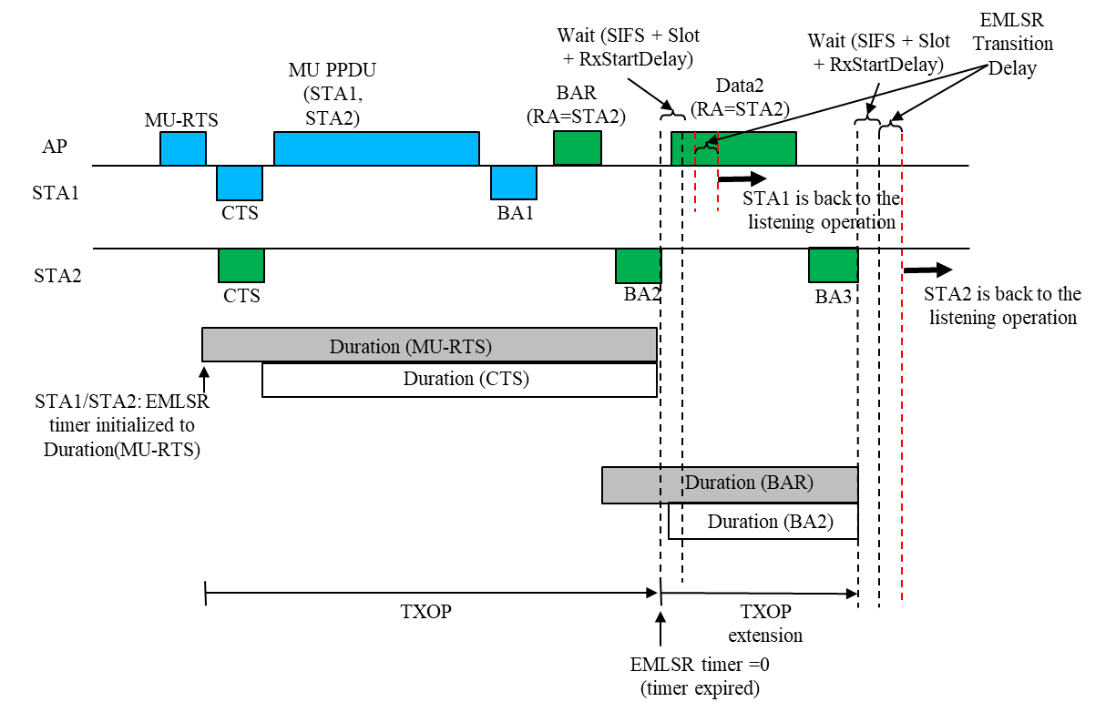

Case4: MU case with the EMLSR Timer expires in the middle of the second MU PPDU reception. STA1/STA2 stays on the link until they respond with acknowledgement or the duration of the frame in the MU PPDU expires.

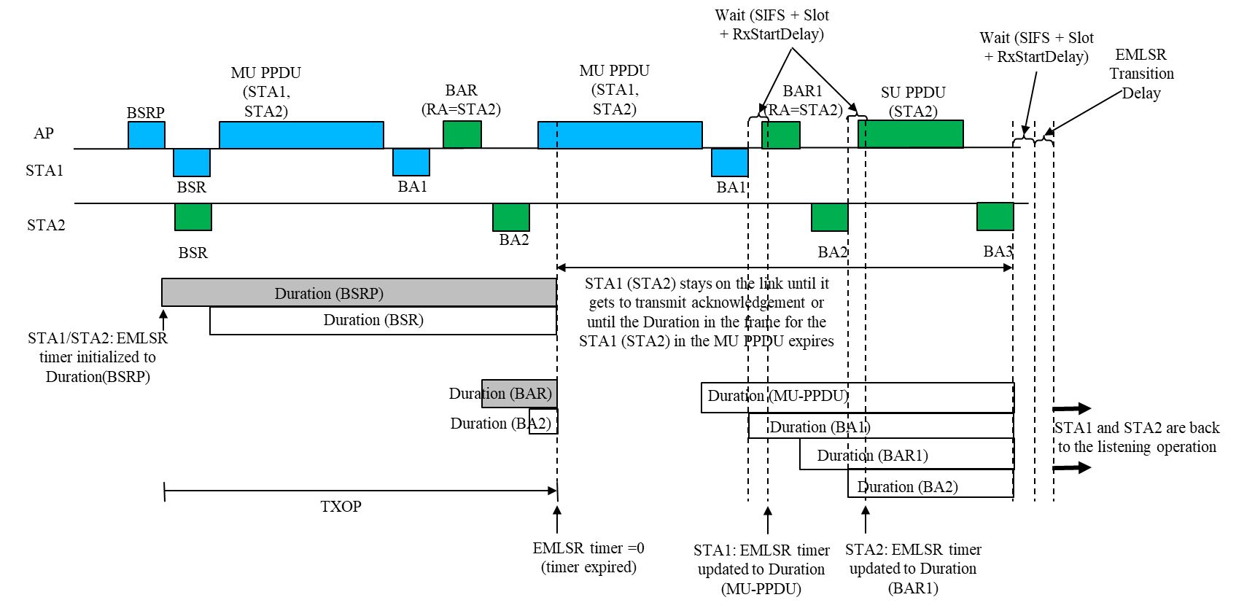

9.4.2.295b.2 Basic variant Multi-Link element

…

 | B0 | B1 B3 | B4 B6 | B7 | B8 B10 | B11 B14 | B15 | B16 B19 | B20 B23
 | EMLSR Support | EMLSR Padding Delay | EMLSR Transition Delay | EMLMR Support | EMLMR Delay | Transition Timeout | Reserved | EMLMR Rx NSS | EMLMR Tx NSS
Bits: | 1 | 3 | 3 | 1 | 3 | 4 | 1 | 4 | 4

Figure 9-788eh1—EML Capabilities subfield format (#1773, 2603, 6346)

(#1773)(#2603)(#3206)(#2745)(#2917)The EMLSR Padding Delay subfield indicates the MAC padding duration of
the Padding field of the initial Control frame defined in 35.3.15 (Enhanced multi-link single radio operation). The EMLSR Padding Delay subfield is 3 bits and set to 0 for 0 µs, set to 1 for 32 µs, set to 2 for 64 µs, set to 3
for 128 µs, set to 4 for 256 µs, and the values 5 to 7 are reserved (#6346)

The EMLSR Transition Delay subfield indicates the transition delay time needed by a non-AP MLD to switch from exchanging frames on one of the enabled links to the listening operation on the enabled links (see 35.3.15 (Enhanced multi-link single radio operation)). The EMLSR Transition Delay subfield is 3 bits and set to 0 for 0 µs, set to 1 for 16 µs, 2 for 32 µs, set to 3 for 64 µs, set to 4 for 128 µs, set to 5 for 256 µs, and the values 6 to 7 are reserved. (#6346)

