IEEE P802.11
Wireless LANs
Resolution for CIDs related to TDLS (CC34)
Date: Feb 11, 2021
Author(s):
Name | Affiliation | Address | Phone | email
Abhishek Patil | Qualcomm Inc. |  |  | appatil@qti.qualcomm.com
George Cherian
Duncan Ho
Alfred Asterjadhi
Yanjun Sun
Gaurang Naik
Menzo Wentink
Jouni Malinen
Michael Montemurro | Huawei
Stephen McCann
Po-Kai | Intel
Liwen | NXP
Srinivas Kandala | Samsung
Mark Rison
Tomo Adachi | Toshiba
Ryuichi Hirata | Sony
Jarkko Kneckt | Apple
Morteza | Facebook
Kumail
Insun | LGE
Rojan | Panasonic
Matthew Fischer | Broadcom
Yongho Seok | Mediatek

Abstract
This submission proposes resolutions for following CIDs received for TGbe (CC34): 1032
Revisions:
- Rev 0: Initial version of the document.
- Rev 1: contribution was revised based on feedback received from several members (added as co-authors)
  - Special thanks to Mike M. & Jouni for their inputs on the TDLS discovery and security aspects
- Rev 2: Updated based on feedback from Stephen McCan and Guogang
- Rev 3: updates based on feedback from Stephen and Rojan
- Rev 4: updated based on additional feedback from Rojan and Menzo
  - Includes TDLS variant ML IE in the computation of MIC
  - Deleted text on setting of Responder STA MAC address since the rules are covered in baseline
  - Since all TDLS frame carry Link Identifier element, the text for setting the fields of the element is generalized
- Rev 5: Fixed the names of the To DS and From DS subfields (the space between To/From and DS was missing)
- Rev 6: Deferred CID 1029 [to be resolved in a separate contribution]
  - removed changes related to TDLS security and signaling of AP MLD MAC address
  - Minor updates based on feedback from Matt (35.3.xx.2) and Yongho (Table 11-11a)
- Rev 7: Updates based on suggestions from Rojan and Mike
- Rev 8: Minor clarification on TA setting based on additional suggestions from Rojan

Interpretation of a Motion to Adopt

A motion to approve this submission means that the editing instructions and any changed or added material are actioned in the TGbe Draft. This introduction is not part of the adopted material.

Editing instructions formatted like this are intended to be copied into the TGbe Draft (i.e. they are instructions to the 802.11 editor on how to merge the text with the baseline documents).

TGbe Editor: Editing instructions preceded by “TGbe Editor” are instructions to the TGbe editor to modify existing material in the TGbe draft. As a result of adopting the changes, the TGbe editor will execute the instructions rather than copy them to the TGbe Draft.

CID | Commenter | Pg/Ln | Section | Comment | Proposed Change | Resolution
1032 | Abhishek Patil | 125.51 | 35.3 | TDLS operation between a STA of a non-AP MLD and a (legacy) non-AP STA is broken. Furthermore, there are other issues that need to be addressed - for example: issue1: when the intermediate AP is an AP MLD, the frame can cross over and be received on the wrong link. issue 2: TDLS operation on an nSTR link.  These topics are discussed in doc 11-20/1692. | The commenter will provide a contribution | Revised  Agree in principle with the comment. Without any rules in 11be spec, legacy TDLS operation is broken – i.e., a STA affiliated with a non-AP MLD cannot form a TDLS link with a legacy STA. In addition, during TDLS discovery, a non-AP MLD cannot differentiate if the peer device on the other side is a legacy STA or a non-AP MLD. Furthermore, a non-AP MLD can’t determine which link a legacy STA is operating on. Therefore, additional considerations need to be applied during TDLS discovery such what values to set for the fields carried in the Link Identifier element. Several examples with figures are provided to draw attention to the various problems that are possible when establishing TDLS that involves non-AP MLD on at least one end. A separate contribution addressing CID 1490 will address NSTR handling.  TGbe editor, please make changes as shown in doc 11-21/0240r8 tagged 1032

TGbe Editor: Please note, the baselines for this document are REVmd D5.0 and 11be D1.0

TGbe editor: Please insert the following (new) subclause as follows:
35.3.xx TDLS procedure in multi-link operation[1032]
35.3.xx.1 General
When the frames exchanged during TDLS discovery or setup does not include multi-link information, the TDLS direct link discovery or setup respectively, is for a single link. When the frames exchanged during TDLS discovery or setup includes multi-link information, the operation is for TDLS direct link over more than one link.
A non-AP MLD that intends to establish a single link TDLS direct link with a peer STA on one of its links follows the procedures defined in 11.20 (Tunneled direct-link setup), with additional rules as defined in 35.3.xxx.2 (TDLS direct link over a single link).
35.3.xx.2 TDLS direct link over a single link
When a non-AP MLD that has performed multi-link setup with an AP MLD establishes a single link TDLS direct link on one of its links, it shall set the context (i.e., security, SN/PN, BA) for the TDLS direct link with respect to the MLD MAC address of the non-AP MLD. For ease of description in the rest of this subclause, the single link TDLS context is described with respect to a TDLS STA affiliated with the non-AP MLD. The TDLS STA affiliated with the non-AP MLD shall be able to receive frames sent over the direct link with RA field set to the MLD MAC address of the non-AP MLD. When a TDLS STA affiliated with the non-AP MLD initiates TDLS discovery or TDLS setup, it shall set the TA field of frames sent over the TDLS direct link to the MLD MAC address of the non-AP MLD.
TDLS discovery and setup between a non-AP MLD and a peer STA involves frames that are sent and received via an intermediate AP (MLD) or sent and received through direct communication (see Table 11-11a (Frame type and their pathway in a TDLS setup)). Frames that traverse the intermediate AP (MLD) are sent or received by a STA affiliated with a non-AP MLD. Frames sent over the direct link are sent or received by a TDLS STA affiliated with the non-AP MLD. The TDLS direct link, when successfully established, is between the TDLS STA affiliated with the non-AP MLD and a TDLS peer STA at the other end of the direct link.
If the TDLS initiator is a non-AP MLD, then the TDLS initiator STA Address field contained in the Link Identifier element of the TDLS frames shall be set to the MLD MAC address of the non-AP MLD.
When a non-AP MLD initiates a TDLS discovery operation, it may need to transmit more than one TDLS Discovery Request frame with the BSSID field of the Link Identifier element set to a different BSSID in each attempt. In each instance, the attempted BSSID corresponds to a different AP affiliated with the AP MLD. Since the TDLS Discovery Response frame is received over the direct link, the initiating non-AP MLD shall be able to determine the link(s) on which the peer STA or non-AP MLD is operating on.
NOTE - Due to the nature of multi-link operation, when a Data frame traverses an AP MLD, it can be relayed on any available link. Furthermore, when a frame that was transmitted by a STA of a non-AP MLD traverses an AP MLD, the AP MLD sets the SA field to the transmitting STA’s non-AP MLD MAC address. Therefore, when an affiliated STA of a non-AP MLD receives a frame from its corresponding associated AP that is affiliated with an AP MLD, it cannot determine the link where the frame originated from and it cannot determine if the initiating STA is affiliated with a non-AP MLD or not. Consequently, the non-AP MLD initiating a TDLS discovery doesn’t know the BSSID of the link where the intended peer STA is operating on.
After TDLS peer is successfully discovered, the non-AP MLD shall set the BSSID field contained in the Link Identifier element of the subsequent TDLS frames to the BSSID of the corresponding AP affiliated with the AP MLD that is operating on the link on which the TDLS direct link is established or being established.
After a TDLS direct link is successfully established between the TDLS STA affiliated with a non-AP MLD and a TDLS peer STA at the other end of the TDLS direct link, STAs affiliated with the non-AP MLD shall cease transmitting MSDUs to the TDLS peer, at the other end, through their associated AP that is affiliated with the AP MLD to which the non-AP MLD has performed multi-link setup.
NOTE – The STAs affiliated with the non-AP MLD can transmit/receive frames to/from other STAs or the DS via the AP MLD.

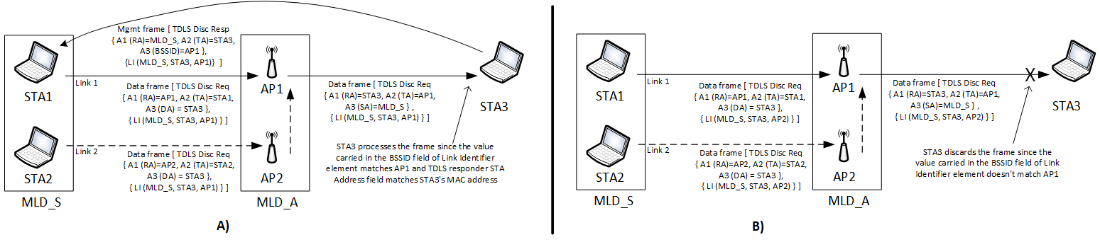
Figure 35-xx1 – Example of TDLS discovery initiated by a non-AP MLD
Figure 35-xx1 (Example of TDLS discovery initiated by a non-AP MLD) illustrates the scenario where the TDLS discovery is initiated by a non-AP MLD (MLD_S). MLD_S has performed multi-link setup with an AP MLD (MLD_A). MLD_S has two affiliated STAs, STA1 and STA2. STA3 is not capable of performing multi-link operation and is not affiliated with a non-AP MLD. MLD_A has two affiliated APs, AP1 and AP2, where AP1 operates on link 1 and AP2 operates on link 2. STA1 and STA3 operate on link 1 and are associated with AP1. STA2 operates on link 2 and is associated with AP2. In the example, MLD_S initiates TDLS discovery by transmitting two TDLS Discovery Request frames (which are Data frames) as it does not know which link STA3 is operating on and whether STA3 is an MLD or a STA not affiliated with an MLD. The first TDLS Discovery Request frame (shown on the left side A) has the BSSID field in the Link Identifier element set to the BSSID of AP1 and the second TDLS Discovery Request frame has this field set to the BSSID of AP2 (shown on the right side B). Both the frames have their A3 (DA) set to the STA3 MAC address and the To DS subfield of the Frame Control field set to 1. The TDLS Discovery Request frame can be transmitted over either link 1 (through STA1 as represented by solid line) or link 2 (through STA2 as represented by dotted line). When the TDLS Discovery Request frame is received at the AP MLD (i.e., through AP1 or AP2), it routes the frame to STA3, through AP1 by setting the From DS subfield of the Frame Control field to 1 and A3 (SA) to the non-AP MLD Address (i.e., MLD_S). STA3 discards the TDLS Discovery Request frame that had the BSSID field of Link Identifier element set to BSSID of AP2 as it does not recognize the BSSID. STA3 recognizes the BSSID set to AP1 and responds with a TDLS Discovery Response frame, which is a Management frame, with the RA set to the MLD_S and both To DS and From DS subfields set to 0. The TDLS STA affiliated with MLD_S receives the TDLS Discovery Response frame, which is sent on the TDLS direct link (see Table 11-11a (Frame type and their pathway in a TDLS setup)). The TDLS initiator STA Address field and the TDLS responder STA Address field contained in the Link Identifier element (denoted as LI in the figure) are carried in the TDLS Discovery Request frame and in the TDLS Discovery Response frame and are set to MLD_S and STA3, respectively.
The same considerations apply for setting the fields in the Link Identifier element when the TDLS discovery is initiated by STA3 to establish a single link TDLS direct link with the non-AP MLD. In this scenario, since STA3 is not affiliated with a non-AP MLD and is not aware of MLD, the BSSID field of the Link Identifier element is set to the BSSID of AP1.
Due to the nature of multi-link operation, it is possible that a Data frame sent by a STA is relayed on a different link when it traverses the AP MLD. As a result, it is possible that the TDLS Discovery Request frame (which is a Data frame) sent by STA3 is received on link 2. Figure 35-xx2 (Example of TDLS discovery initiated by a STA to a non-AP MLD) illustrates this case. The capabilities of each device are the same as described in Figure 35-xx1 (Example of TDLS discovery initiated by a non-AP MLD).

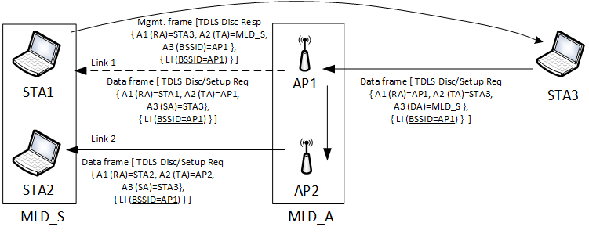
Figure 35-xx2 – Example of TDLS discovery initiated by a STA to a non-AP MLD
In Figure 35-xx2 (Example of TDLS discovery initiated by a STA to a non-AP MLD), the TDLS Discovery Request frame transmitted by STA3 has the To DS subfield of the Frame Control field set to 1 and A3 (DA) set to non-AP MLD address (MLD_S) since STA3 is only aware of MLD_S and not the link addresses of STA1 or STA2 as the AP MLD sets the SA to non-AP MLD’s MAC address. In this example, when the TDLS Discovery Request frame (which is a Data frame) is received by AP1 and routed to the non-AP MLD, the AP MLD sets the From DS subfield of the Frame Control field to 1 and the A3 (SA) to STA3 and transmits the frame either on link 2 (solid line) or link 1 (dotted line). The non-AP MLD receives the TDLS Request Discovery frame and identifies the intended TDLS direct link using the BSSID field of the Link Identifier element. In this case, the BSSID is set to AP1 (i.e., link 1), so the non-AP MLD enables the TDLS STA affiliated with the non-AP MLD on link 1. The TDLS STA affiliated with the non-AP MLD responds by transmitting a TDLS Discovery Response frame on the direct link to STA3 with the To DS and From DS subfields of the Frame Control field set to 0, and A1 set to STA3 (i.e. RA=STA3, TA=MLD_S, A3=AP1). In both the TDLS Discovery Request and TDLS Discovery Response frames, the BSSID, the TDLS initiator STA Address and the TDLS responder STA Address fields in the Link Identifier element (represented as LI in the figure) are set to AP1, STA3 and MLD_S, respectively
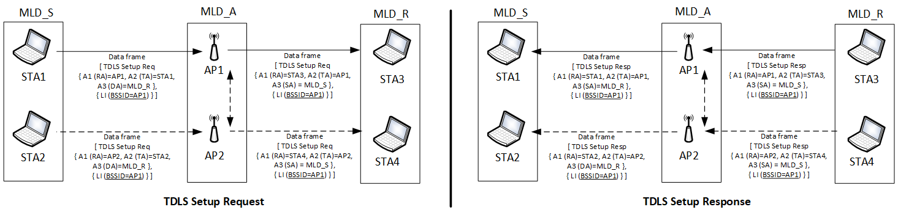
Figure 35-xx3 – TDLS Setup exchange between two STAs each affiliated with a different non-AP MLD
Figure 35-xx3 (TDLS Setup exchange between two STAs each affiliated with a different non-AP MLD) illustrates the case where a single link TDLS direct link is set up between two non-AP MLDs that have performed multi-link setup with the same AP MLD. The example assumes that the two non-AP MLDs have performed TDLS discovery and that the initiating non-AP MLD (in this example, MLD_S) has decided to perform single link TDLS setup for link 1. As shown in the figure, the TDLS Setup Request frame is transmitted by the non-AP MLD, MLD_S, through affiliated STA1 to MLD_R through affiliated STA3. The BSSID field in the Link Identifier element identifies the intended link for establishing the TDLS direct link.

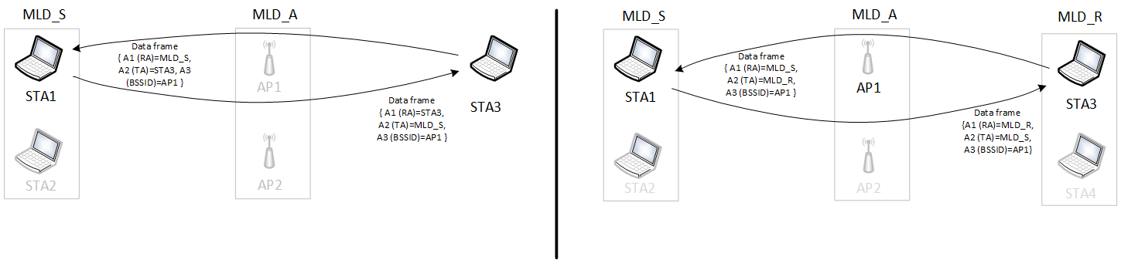
Figure 35-xx4 – Example of TDLS direct link involving a non-AP MLD
Figure 35-xx4 (Example of TDLS direct link involving a non-AP MLD) provides examples of a single link TDLS direct link where at least one of the peer STAs is a TDLS STA affiliated with a non-AP MLD. The TA field of Data frames transmitted by the TDLS STA that is affiliated with an MLD over the direct link is set to its non-AP MLD’s MAC address. The To DS and From DS subfields of the Frame Control field of the Data frame are set to 0.

Editor's Note: In the case for the TPK derivation between two non-AP MLDs, the TPK handshake needs to be updated to include the address of the AP MLD.

- Multi-link device addressing
TGbe editor: Please add the following NOTE at the end of the clause:
NOTE – For frames sent over a direct path in a single link TDLS direct link, by a STA affiliated with a non-AP MLD, the value of the Address 2 (TA) field and Address 1 (RA) field is set to the MLD MAC address of the non-AP MLD as described in 35.3.xx.2 (TDLS direct link over a single link).

- Tunneled direct-link setup
- General[1032]
TGbe editor: Please update the 14th paragraph (including adding the table) as shown below:
TDLS frames shall use the formatting specified in 11.20.2 (TDLS payload) when they are transmitted through the AP and when they are transmitted over the TDLS direct link. A STA shall not transmit a TDLS Action field in a frame with the Type field of the frame set to Management. A received TDLS Action field in a frame with the Type field equal to Management shall be discarded. Note that the TDLS Discovery Response frame is not a TDLS frame but a Public Action frame. Table 11-11a (Frame type and their pathway in a TDLS setup) shows the frames that can be exchanged between the TDLS peer STAs and the path taken by each of them.
Table 11-11a – Frame type and their pathway in a TDLS setup
Frame | Pathway (link) | Frame type | Description
TDLS Discovery Request frame | Via AP | Data frame | See 11.20.3 (TDLS Discovery)
TDLS Discovery Response frame | Direct | Public Action (Management frame) | Can be sent unsolicited (i.e., without receiving a TDLS Discovery Request frame). See 11.20.3 (TDLS Discovery)
TDLS Setup Request frame  TDLS Setup Response frame  TDLS Setup Confirm frame | Via AP | Data frame | See 11.20.4 (TDLS direct-link establishment)
TDLS Teardown frame | Direct or via AP | Data frame | The frame is sent via the AP if the TDLS peer is not reachable. See 11.20.5 (TDLS direct-link teardown)
TDLS Channel Switch Request frame  TDLS Channel Switch Response frame | Direct | Data frame | See 11.20.6 (TDLS channel switching)
TDLS Peer PSM Request frame | Direct or via AP | Data frame | See 11.2.3.12 (TDLS peer power-save mode)
TDLS Peer PSM Response frame | Direct
TDLS Peer Traffic Indication frame | Via AP | Data frame | See 11.2.3.13 (TDLS peer U-APSD (TPU))
TDLS Peer Traffic Response frame | Direct
Data frame or Control frame | Direct |  | Data and Control frames exchange after TDLS session is successfully established
GAS frame carrying TDLS Capability ANQP-element | Direct | Public Action (Management frame) | Discovery of TDLS peer STAs. See 11.22.3.3.10 (TDLS Capability procedure)

- TDLS Capability procedure[1032]
TGbe editor: Please add the following NOTE after the last paragraph in this subclause:

The mechanism shall work as follows:
…
TGbe editor: The contents of the last paragraph remain unchanged
…
NOTE – The TA field of the frame carrying a TDLS Capability ANQP-element is the non-AP MLD’s MAC address (see 35.3.xx.2 (TDLS over a single link)) when the STA transmitting the frame is affiliated with a non-AP MLD.

- Link Identifier element[1032]
TGbe editor: Please modify the 3rdand 4th paragraphs in this subclause as follows:
The BSSID field is set to the BSSID of the BSS of which the TDLS initiator STA is a member when the frame carrying the element is transmitted by a STA that is not affiliated with a non-AP MLD. Otherwise the BSSID field is set to the BSSID of the AP that is operating on the link where the non-AP MLD intends to establish a single link TDLS direct link.
The TDLS initiator STA Address field is set to the TDLS initiator STA’s MAC address if the STA is not affiliated with a non-AP MLD. Otherwise, the TDLS initiator STA Address field is set to the MAC address of the initiating non-AP MLD.

Strawpoll:
Do you support incorporating the changes proposed in doc 11-21/0240r8 into the next TGbe draft?

