IEEE P802.11
Wireless LANs
Resolution for CIDs related to TDLS (CC34)
Date: Feb 11, 2021
Author(s):
Name | Affiliation | Address | Phone | email
Abhishek Patil | Qualcomm Inc. |  |  | appatil@qti.qualcomm.com
George Cherian
Duncan Ho
Alfred Asterjadhi
Yanjun Sun
Gaurang Naik

Abstract
This submission proposes resolutions for following CIDs received for TGbe (CC34): 1032, 1029

Revisions:
- Rev 0: Initial version of the document.

TGbe Editor: Please note, the baseline for this document is REVmd D5.0

Interpretation of a Motion to Adopt

A motion to approve this submission means that the editing instructions and any changed or added material are actioned in the TGbe Draft. This introduction is not part of the adopted material.

Editing instructions formatted like this are intended to be copied into the TGbe Draft (i.e. they are instructions to the 802.11 editor on how to merge the text with the baseline documents).

TGbe Editor: Editing instructions preceded by “TGbe Editor” are instructions to the TGaxbe editor to modify existing material in the TGbe draft. As a result of adopting the changes, the TGbe editor will execute the instructions rather than copy them to the TGbe Draft.

CID | Commenter | Pg/Ln | Section | Comment | Proposed Change | Resolution
1032 | Abhishek Patil | 125.51 | 35.3 | TDLS operation between a STA of a non-AP MLD and a (legacy) non-AP STA is broken. Furthermore, there are other issues that need to be addressed - for example: issue1: when the intermediate AP is an AP MLD, the frame can cross over and be received on the wrong link. issue 2: TDLS operation on an nSTR link.  These topics are discussed in doc 11-20/1692. | The commenter will provide a contribution | Revised
1029 | Abhishek Patil | 118.34 | 12.7.8 | Update 12.7.8 to cover PTK establishment for a TDLS link involving a STA of a non-AP MLD | Commenter will provide a contribution (also see details in 11-20/1692) | Revised

TGbe editor: Please add the following (new) subclause after 35.3.17:
35.3.xx TDLS handling with multi-link operation
35.3.xxx.1 General
When the TDLS discovery frame or setup frame or confirm frame does not include Multi-Link element, the direct link discovery or setup or confirmation, respectively, is for a single link. Otherwise, the operation is for direct link over more than one link.
A non-AP MLD may establish a single link TDLS session with a peer STA on one of its links by following the procedures defined in clause 11.20 (Tunneled direct-link setup) with the exceptions as defined in this clause 35.3.xxx.2 (TDLS over a single link).
35.3.xxx.2 TDLS over a single link
For a single link TDLS session, a non-AP MLD has an affiliated STA with a MAC address same as the MLD address. This STA of the non-AP MLD communicates with the TDLS peer STA over the direct link during TDLS Discovery phase and after TDLS setup (see Table 11-11a (TDLS frame types and their pathway) for frames that are sent over the direct link). As a result, the TA field of the TDLS Discovery Response frame or ANQP request/response frames or TDLS Teardown frame or a Data frames sent over the direct link by a STA affiliated with a non-AP MLD is the MLD MAC address.
If the initiator STA is affiliated with a non-AP MLD, then the TDLS initiator STA Address field contained in the Link Identifier element of the TDLS Discovery Request frame or TDLS Setup Request frame or TDLS Teardown frame shall be set to the MLD MAC address.
If the initiator STA is affiliated with a non-AP MLD, then the BSSID field contained in the Link Identifier element of the TDLS Discover Request frame or TDLS Setup Request or TLDS Setup Response frame or TDLS Setup Confirm frame shall be set to the BSSID of the link where it intends to establish the direct link.
If the TDLS peer STA is affiliated with a non-AP MLD, then the BSSID field contained in the Link Identifier element of the TDLS Teardown frame that it transmits shall be set to the BSSID of the link that it intends to teardown.
If the responding STA is affiliated with a non-AP MLD, then the TDLS responder STA Address field contained in the Link Identifier element of the TDLS Discovery Response frame or TDLS Setup Response frame shall be set to the MLD MAC address.
When a TDLS peer STA is affiliated with a non-AP MLD, the corresponding TDLS initiator STA Address field or the TDLS responder STA Address field contained in the Link Identifier element is set to the non-AP MLD’s MAC address and as a result, the non-AP MLD MAC address is used during TPK generation between the two TDLS peer STAs.
After a TDLS link is successfully established between a STA affiliated with a non-AP MLD and a TDLS peer STA, other STA(s) affiliated with the non-AP MLD shall cease transmitting MSDUs to the TDLS peer through their associated AP affiliated to the AP MLD to which the non-AP MLD is associated with.

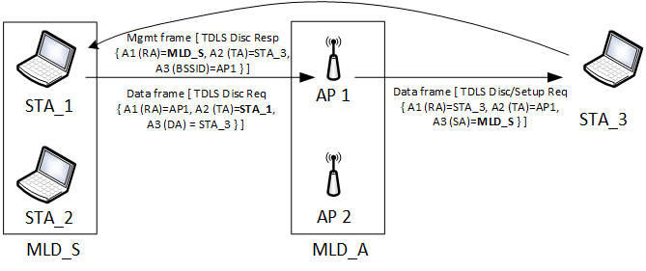
Figure 35-xx1 – Example of a TDLS discovery between a STA affiliated with an MLD and a non-MLO STA
Figure 35-xx1 illustrates the scenario where TDLS discovery frames are exchanges between a STA (STA_1) which is affiliated with a non-AP MLD (MLD_S) and a peer STA (STA_3) that is not affiliated with an MLD. The MLD_S has performed multi-link association with an AP MLD (MLD_A). MLD_A consists of AP1 and AP2 where AP1 is operating on the same link as STA_1 and STA_3. STA_1 and STA_2 of MLD_S are in associated state with AP1 and AP2 respectively. STA_3 is in associated state with AP1. In the example, STA_1 initiates a TDLS discovery by transmitting a TDLS Discovery Request frame, a Data frame, having A3 (DA) field set to the STA_3. When the frame traverses the AP MLD (i.e., AP1), the A3 (SA) field set to the MLD MAC address of the transmitting STA (i.e., MLD_S). STA_3 responds with Discovery Response frame, a Management frame, with RA set to the MLD_S. The BSSID field, the TDLS initiator STA Address field and the TDLS responder STA Address field contained in Link Identifier element carried in TDLS Discovery Request frame and TDLS Discovery Response frame is set to AP1, MLD_S and STA_3 respectively.
Due to the nature of multi-link operation, a Data frame can be transmitted on any available link between the two MLDs. Therefore, it is possible that a TDLS Discovery Request frame, which is a Data frame, meant to discovery a peer STA on a certain is received on a different link when it traverses an AP MLD.

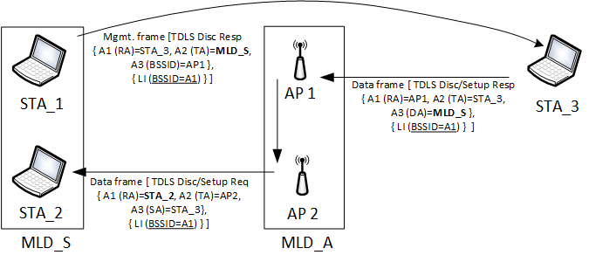
Figure 35-xx2 – Example of cross-over of a TDLS Discovery Request frame
Figure 35-xx2 illustrates this case. The Discovery Request frame transmitted by STA_3 has the A3 (DA) field set to MLD_S (since STA_3 is only aware of MLD_S not the link addresses STA_1 or STA_2). When the Discovery Request frame traverses the AP MLD, it happens to be sent on the link between AP2 and STA_2. In this situation, the BSSID field contained in the Link Identifier element of the Discovery Request frame identifies the intended link. STA_1 responds with a Discovery Response frame on the direct link to STA_3 (RA=STA_3, TA=MLD_S, A3=AP1). The cross-over effect can occur for other TDLS Action frames (such as TDLS Setup Request/Response or Setup Confirm or Teardown) that traverses an AP MLD (see Table 11-11a (TDLS frame types and their pathway)) and is intended for a non-AP MLD. In such situations the BSSID field in the Link Identifier element identifies the intended link.

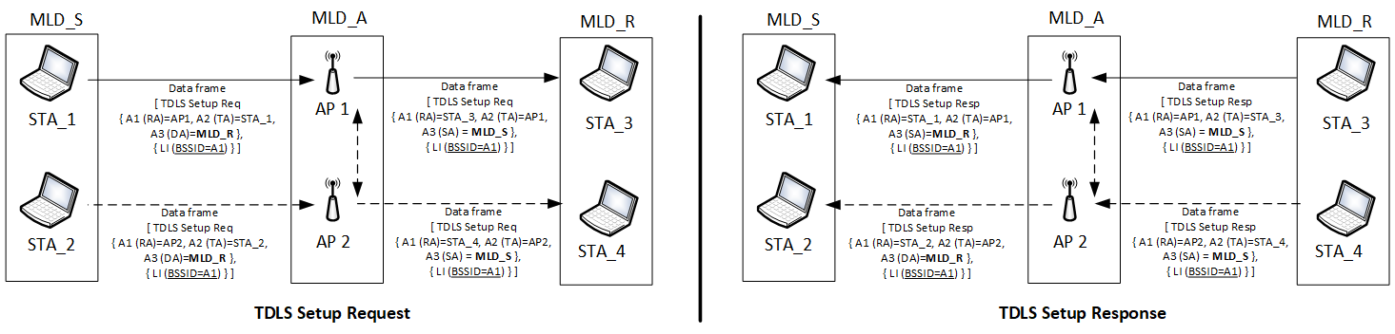
Figure 35-xx3 – TDLS Setup exchange between two STAs each affiliated with a different non-AP MLD
Figure 35-xx3 illustrates the case where a single link TDLS is being setup between STAs that are affiliated with their respective non-AP MLDs. In such situations, the cross-over of the frames can occur in both directions and the BSSID field in the Link Identifier element identifies the intended link for establishing the TDLS direct link.

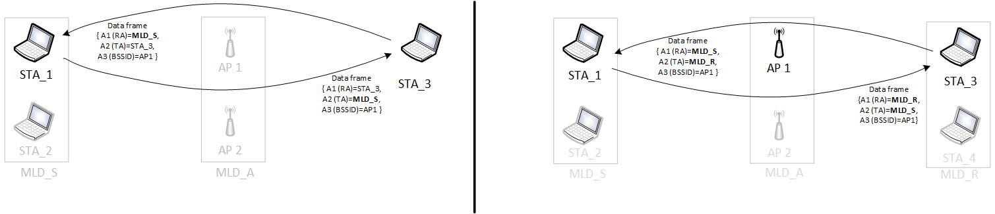
Figure 35-xx4 – Example of TDLS link between a STA affiliated with an MLD and another STA
Figure 35-xx4 provides an examples of a single link TDLS between TDLS peer STAs in which at least one of the peer STA is affiliated with a non-AP MLD. The TA field of a Data frame, sent over the direct link, transmitted by the TDLS peer STA that is affiliated with an MLD is set to the corresponding MLD MAC address.
- Tunneled direct-link setup
- General[1032]
TGbe editor: Please add the following table after the 14th paragraph in this subclause as shown below:
TDLS frames shall use the formatting as specified in 11.20.2 (TDLS payload) when they are transmitted through the AP and when they are transmitted over the TDLS direct link. A STA shall not transmit a TDLS Action field in a frame with the Type field of the frame set to Management. A received TDLS Action field in a frame with the Type field equal to Management shall be discarded. Note that the TDLS Discovery Response frame is not a TDLS frame but a Public Action frame. Table 11-11a shows the types of frames that can be exchanged between the TDLS peer STAs during discovery, setup and after setup and whether or not they traverse the associated AP.
Table 11-11a – TDLS frame types and their pathway
Frame | Pathway (link) | Frame type | Notes
TDLS Discovery Request | Via AP | Data frame
TDLS Discovery Response | Direct | Public Action (Management frame) | Unsolicited allowed
TDLS Setup Request  TDLS Setup Response frames  TDLS Setup Confirm frames | Via AP | Data frame
TDLS Teardown frame | Both allowed | Data frame | via AP if the peer is not in reachable
TDLS Channel Switch Request frame  TDLS Channel Switch Response frame | Direct | Data frame
TDLS Peer PSM Request frame  TDLS Peer PSM Response frame | Direct | Data frame
TDLS Peer Traffic Indication frame | Direct | Data frame
TDLS Data frame | Direct |  | Data frame exchange after TDLS session is successfully established

- TDLS Capability procedure[1032]
TGbe editor: Please add the following NOTE after the last paragraph in this subclause:

The mechanism shall work as follows:
…
TGbe editor: The contents of the last paragraph remain unchanged
…
NOTE – In case of a single link TDLS, when a TDLS peer STA is affiliated with a non-AP MLD, the TA field of the ANQP request/response frames is the non-AP MLD’s MAC address (see 35.3.xx.2 (TDLS over a single link)).

- Link Identifier element[1032]
TGbe editor: Please modify the 3rd, 4th and 5th paragraph in this subclause as follows:
The BSSID field is set to the BSSID of the BSS of which the TDLS initiator STA is a member.
The TDLS initiator STA Address field is set to the TDLS initiator STA’s MAC address if the STA is not affiliated with a non-AP MLD. Otherwise, the TDLS initiator STA Address field is set to the MAC address of the MLD to which the initiating STA is affiliated with.
The TDLS responder STA Address field is set to the TDLS responder STA’s MAC address if the STA is not affiliated with a non-AP MLD; Otherwise, the TDLS responder STA Address field is set to the MAC address of the MLD to which the responding STA is affiliated with.

- TPK handshake
TGbe editor: Please add NOTE after the 4th paragraph in this subclause:
The TDLS initiator STA and the TDLS responder STA perform the following exchange to set up a TPK:
…
TGbe editor: The contents of the 4th paragraph remain unchanged
…
The MIC field of the FTE is 0 for message 1 and computed as described in 12.7.8.4.3 (TPK handshake message 2) and 12.7.8.4.4 (TPK handshake message 3) for messages 2 and 3 respectively
[1029]NOTE – In case of a single link TDLS, when a TDLS peer STA is affiliated with a non-AP MLD, the corresponding TDLS initiator STA Address field or the TDLS responder STA Address field contained in the Link Identifier element is set to the non-AP MLD’s MAC address (see 35.3.xx.2 (TDLS over a single link)). As a result, the corresponding non-AP MLD MAC address is used during TPK generation.

