IEEE P802.11
Wireless LANs
Resolutions for Clause 11.100.2
Date: 2021-09-15
Author(s):
Name | Affiliation | Address | Phone | email
Hitoshi Morioka | SRC Software | Fukuoka, JAPAN |  | hmorioka@src-soft.com
Abstract
This document describes the resolutions for LB252.

The baseline is D1.04.

Suggested resolution

TGbc editor: please add the following definitions:

3.2 Definitions specific to IEEE 802.11

enhanced broadcast services (EBCS) Data frame: A Data frame used to carry data for an EBCS downlink traffic stream. [1149, 1415, 1420, 1274, 1005]
enhanced broadcast service (EBCS) downlink (DL) content server: An entity reachable via the DS that is a source of an EBCS DL traffic stream. [1005]

TGbc editor: please add the following subclauses at the end of clause 5.1.5:

5.1.5 MAC data service architecture

5.1.5.1 General

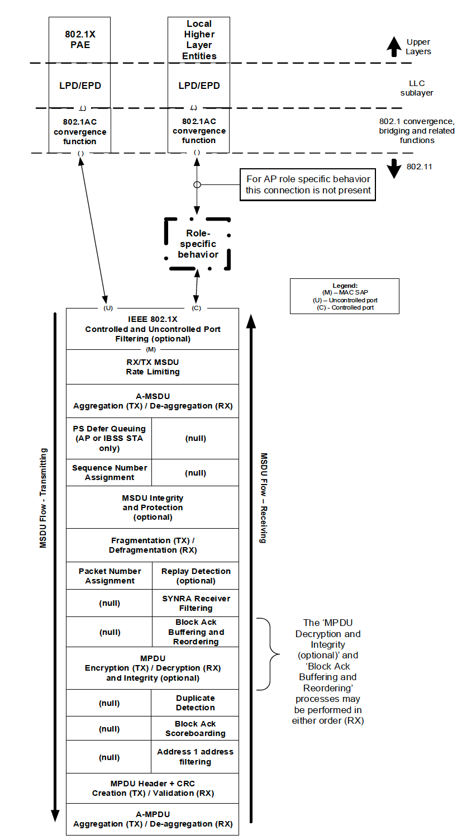
(M)
EBCS Filtering (optional) [1409]
IEEE 802.1X Controlled and Uncontrolled Port Filtering (optional)

Figure 5-1---MAC data plane architecture
NOTE---EBCS UL is a Management frame and this figure does not apply. [1409]

5.1.5.2 Non-GLK non-AP role

The MAC data plane architecture of a non-GLK non-AP STA is completed by replacing the role-specific behavior block with that shown in Figure 5-3 (Role-specific behavior block for a non-GLK non-AP STA).
The function of this block in a non-AP STA is to perform destination address filtering as described in 10.2.8
(MAC data service).

In the context of EBCS, the EBCS filter strips the EBCS content ID. [1409]

NOTE—In implementations, the DA address filtering function may be done “lower in the stack.” It is shown in the rolespecific behavior block location for simplicity, and any implementation choice needs to provide equivalent behavior.

NOTE—An EBCS traffic stream passes through the IEEE 802.1X Controlled Port even if this is blocked (e.g. because the STA is not associated) (see 11.55.2.3 (EBCS DL operation at an EBCS receiver)). [1409]

5.1.5.3 Non-GLK AP role

In a non-GLK AP, the MAC data plane architecture includes distribution system access in its role-specific behavior block, as shown in Figure 5-4 (Role-specific behavior block for a non-GLK AP). This block provides access to the DS for associated non-AP STAs as described in 4.5.2.1 (Distribution).

In the context of EBCS, an EBCS traffic stream mapper, located at the entry of the DS, assigns the EBCS content ID for frames of EBCS traffic stream according to the configuration. [1409]

NOTE—This behavior block indicates that there is no access through the controlled port to or from the local upperlayers (the LLC sublayer) at an AP. Any such access is logically achieved in the architecture via transition of the DS and Portal to an integrated LAN. In actual implementations, this is likely to be optimized, and Data frames appear to be delivered directly to one or more local LLC sublayer entities on the same physical device as the AP. Such optimization is effectively distributing the functions of the DS and Portal, and it is the responsibility of the implementation to ensure the logical behavior of these entities is maintained.

NOTE—The EBCS traffic might originate from another STA in the ESS, or from a device outside the ESS, through a portal. [1409]

5.2.3 MA-UNITDATA.request [1409]

5.2.3.2 Semantics of the service primitive

TGbc editor: please modify the parameter of MA-UNITDATA.request as follows:

The parameters of the primitive are as follows:
MA-UNITDATA.request(
source address,
destination address,
routing information,
data,
priority,
drop eligible,
service class,
station vector,
MSDU format,
EBCS content ID
)

TGbc editor: please insert the following paragraph at the end of clause 5.2.3.2:

The EBCS content ID parameter allows different EBCS traffic streams with the same destination address parameter to be distinguished. If the MSDU does not carry part of an EBCS traffic stream, the EBCS content ID parameter is null.

9.2.4 Frame fields

9.2.4.1 Frame Control field

9.2.4.1.3 Type and Subtype subfields

TGbc editor: please add the following line to Table 9-1:

Table 9-1--- Valid type and subtype combinations [1409, 1149, 1415, 1420]

Type value  B3 B2 | Type  description | Subtype value  B7 B6 B5 B4 | Subtype description
10 | Data | [ANA] | EBCS Data

9.3.2 Data frames

9.3.2.1 Format of Data frames

9.3.2.1.4 The frame body

TGbc editor: please add the following sentence to the third paragraph:

For Data frames of subtype Null, QoS Null, QoS CF-Ack, QoS CF-Poll, and QoS CF-Ack +CF-Poll, the Frame Body field is null (i.e., has a length of 0 octets); these subtypes are used for MAC control purposes. For Data frames of subtype Data, the Frame Body field contains all of, or a fragment of, an MSDU after any encapsulation for security. For Data frames of subtypes QoS Data, QoS Data +CF-Ack, QoS Data +CF-Poll, and QoS Data +CF-Ack +CF-Poll, the Frame Body field contains an MSDU (or fragment thereof) or A-MSDU after any encapsulation for security. For Data frames of subtype QoS Data that are transmitted by a mesh STA, the Frame Body field also contains a Mesh Control field, as described in 9.2.4.8.3 (Mesh Control field). For Data frames of subtype EBCS Data, the Frame Body field contains an MSDU and overhead for authentication in case of PKFA or HCFA, as described in 12.13.2.3 (PKFA MPDU generation) or 12.13.3.3 (HCFA MPDU generation) respectively, in case of HLSA the Frame Body field contains an MSDU and EBCS overhead as described in 12.13.4.2 (HLSA MPDU generation). [1409, 1149, 1415, 1036]

9.3.3 Management frames

9.3.3.2 Beacon frame format [1005]

TGbc editor: please insert the following line before “Vendor Specific” in Table 9-32 and align Order:

Table 9-32---Beacon frame body

Order | Information | Notes
93 | EBCS Parameters element | This element is optionally present if dot11EBCSSupportActivated is true.
[ANA] | EBCS TIM | The EBCS TIM is present if the length of dot11EBCSContentList is larger than 0; otherwise not present.

9.4.2 Elements

9.4.2.1 General [1005]

TGbc editor: please insert the following line in Table 9-92 and align Element ID Extension:

Table 9-92---Element IDs

Element | Element ID | Element ID Extension | Extensible | Fragmentable
… | … | … | … | …
EBCS TIM (see 9.4.2.x (EBCS TIM element)) | 255 | [ANA] | Yes | No
Reserved | 255 | ([ANA]+1)-255

TGbc editor: please insert the following subclause at the end of clause 9.4.2:

9.4.2.297 EBCS TIM element [1005]

The EBCS TIM element is used to signal the availability of EBCS traffic stream frames. The format of this element is shown in Figure 9-xx (EBCS TIM element format).

 | Element ID | Length | Element ID Extension | EBCS DTIM Count | EBCS DTIM Period | Content ID Bitmap Control | Content ID Bitmap
Octets: | 1 | 1 | 1 | 1 | 1 | 1 | 0-32

Figure 9-xx---EBCS TIM element format

The Element ID, Length and Element ID Extension fields are defined in 9.4.2.1 (General).
The format of the Content ID Bitmap Control field is shown in Figure 9-yy (Bitmap Control field format).

 | B0 | B1 | B3 | B4 | B7
 | Bitmap Mode | Bitmap Offset |  | Reserved
Bits: | 1 | 3 |  | 4

Figure 9-yy---Content ID Bitmap Control field format

The EBCS traffic indication virtual bitmap, maintained by the AP or the mesh STA that generates an EBCS TIM, consists of 256 bits, and it is organized into 8 octets such that bit number $N (0≤N ≤255)$ in the bitmap corresponds to bit number $(N \text{mod} 8)$ in octet number $\left\lfloor N/8\right\rfloor$ where the low order bit of each octet is bit number 0, and the high order bit is bit number 7. A bit value 1 means the corresponding EBCS traffic stream is buffered at the AP.

The EBCS DTIM Count field indicates how many Beacon frames (including the current frame) appear before the next EBCS DTIM. An EBCS DTIM count of 0 indicates that the current EBCS TIM is an EBCS DTIM.

The EBCS DTIM Period field indicates the number of beacon intervals or short beacon intervals between successive EBCS DTIMs. If all EBCS TIMs are EBCS DTIMs, the EBCS DTIM Period field has the value 1. The EBCS DTIM Period value 0 is reserved. The EBCS DTIM Period field is set to dot11EBCSDTIMPeriod.

If the Bitmap Mode subfield value is 0, the Bitmap Offset subfield is set to 0 and the Content ID Bitmap field contains the Content ID (see 11.100.2.x (Content stream configuration)) of the EBCS traffic stream that is buffered at the AP in each octet.

If the Bitmap Mode subfield value is 1, the Bitmap Offset subfield is set to the starting octet number of the Content ID Bitmap field. If a bit is not included in the Content ID Bitmap field, the corresponding EBCS traffic stream is not buffered at the AP.

If no EBCS traffic stream are buffered at the AP, the Bitmap Mode field is set to 1 and the length of the Content ID Bitmap field is 0.

When dot11MultiBSSIDImplemented is true and the Nontransmitted BSSID provides EBCS DL, this element is included in the Nontransmitted BSSID Profile subelement.

9.4.5 Access network query protocol (ANQP) elements

9.4.5.30 Enhanced Broadcast Services ANQP-element

TGbc editor: please modify the Figure 9-839b as follows:

 | Control | Content ID | Negotiation Method | Next Tx Schedule (Optional) | Time To Termination (Optional)
Octets: | 1 | 1 | 1 | 0 or 8 | 0 or 2

 | Content Authentication Algorithm | Content Address Type (Optional) | Content Address (Optional) | Title Length (Optional) | Title (Optional) | PHY Type | TX Rate
Octets: | 1 | 0 or 1 | variable | 0 or 1 | variable | 1 | variable

 | Next Tx Schedule (Optional) | Time To Termination (Optional)
Octets: | 0 or 8 | 0 or 2

Figure 9-839b---Enhanced Broadcast Service Tuple field format

TGbc editor: please modify the Figure 9-839c as follows:

 | B1 | B2 | B3 | B4 | B53 | B64 | B7
 | Next Tx Schedule Present | Time To Termination Present | Content Address Present | Title Present | Association Required | Reserved
Bits: | 1 | 1 | 1 | 1 | 1 | 24

Figure 9-839c---Control field format

TGbc editor: please remove the following paragraphs at P32L7-12:

The Content Address Present subfield is set to 1 by a STA to indicate that the Enhanced Broadcast Services Tuple field contains Content Address Type and Content Address fields. This subfield is set to 0 to indicate that there are no Content Address Type and Content Address fields.

The Title Present subfield is set to 1 by a STA to indicate that the Enhanced Broadcast Services Tuple field contains a Title Length field and a Title field. This subfield is set to 0 to indicate that there are no Title Length and Title fields.

TGbc editor: please insert the following paragraphs after P34L28:

The PHY Type subfield indicates the PHY type of the EBCS Data frames of the content stream. The PHY type is encoded as shown in Table 9-340d (PHY Type subfield).

Table 9-840d---PHY Type subfield
Value | PHY Type
0 | DSSS / HR/DSSS / OFDM / ERP
1 | HT
2 | DMG
3 | VHT
4 | TVHT
5 | S1G
6 | CDMG
7 | CMMG
8 | HE
9 | EDMG
10-255 | Reserved

The TX Rate subfield indicates the transmission rate of the EBCS Data frames of the content stream.

The format of the TX Rate subfield for DSSS, HR/DSSS, OFDM or ERP is shown in Figure 9-839d (DSSS / HR/DSSS / OFDM / ERP TX Rate subfield format).

 | Data Rate
Octets: | 1

Figure 9-839d--- DSSS / HR/DSSS / OFDM / ERP TX Rate subfield format

The Data Rate subfield indicates the transmission rate multiplied by 2 in unit of Mbps.

The format of the TX Rate subfield for HT is shown in Figure 9-839e (HT TX Rate subfield format).

 | HT MCS | Flags
Octets: | 1 | 1

Figure 9-839e--- HT TX Rate subfield format

The MCS subfield indicates the HT MCS Index.
The format of the Flags subfield is shown in Figure 9-839f (Flags subfield format).

 | B0 | B1 | B2 | B7
 | 40MHz | Short GI | Reserved
Bits: | 1 | 1 | 6

Figure 9-839f--- Flags subfield format

The 40MHz subfield is set to 1 when the channel bandwidth is 40MHz. Otherwise, the subfield is set to 0.
The Short GI subfield is set to 1 when short GI is used. Otherwise, the subfield is set to 0.

The format of the TX Rate subfield for DMG is shown in Figure 9-839g (HT TX Rate subfield format).

 | DMG MCS
Octets: | 1

Figure 9-839g--- DMG TX Rate subfield format

The format of the DMG MCS subfield is shown in Figure 9-839h (DMG MCS subfield format).

 | B0 | B5 | B6 | B7
 | MCS Index |  | PSK Applied | Reserved
Bits: | 6 |  | 1 | 1

Figure 9-839h--- DMG MCS subfield format

The MCS Index subfield indicates the DMG MCS index. The DMG MCS index 9.1, 12.1, 12.2, 12.3, 12.4, 12.5 and 12.6 are mapped to 32, 33, 34, 35, 36, 37 and 38 respectively.
The PSK Applied subfield is set to 1 when π/2-8-PSK is applied. Otherwise, the subfield is set to 0.

The format of the TX Rate subfield for VHT is shown in Figure 9-839i (VHT TX Rate subfield format).

 | VHT MCS
Octets: | 2

Figure 9-839i--- VHT TX Rate subfield format

The format of the VHT MCS subfield is shown in Figure 9-839j (VHT MCS subfield format).

 | B0 | B3 | B4 | B6 | B7 | B9 | B10 | B11 | B12 | B15
 | MCS Index |  | Channel Bandwidth |  | Nss |  | STBC | Short GI | Reserved
Bits: | 4 |  | 3 |  | 3 |  | 1 | 1 | 4

Figure 9-839j--- VHT MCS subfield format

The MCS Index subfield indicates the VHT MCS index.
The Channel Bandwidth subfield value is encoded as shown in Table 9-840e (Channel Bandwidth subfield).

Table 9-840e---Channel Bandwidth subfield
Value | Channel Bandwidth
0 | 20MHz
1 | 40MHz
2 | 80MHz
3 | 160MHz
4 | 80+80MHz
5-7 | Reserved

The Nss subfield value indicates the N_{SS}-1.
The STBC subfield is set to 1 when the STBC is used. Otherwise, the subfield is set to 0.
The Short GI subfield is set to 1 when short GI is used. Otherwise, the subfield is set to 0.

The format of the TX Rate subfield for TVHT is shown in Figure 9-839k (TVHT TX Rate subfield format).

 | TVHT MCS
Octets: | 2

Figure 9-839k--- TVHT TX Rate subfield format

The format of the TVHT MCS subfield is shown in Figure 9-839l (TVHT MCS subfield format).

 | B0 | B3 | B4 | B6 | B7 | B8 | B9 | B10 | B11 | B15
 | MCS Index |  | Mode |  | Nss |  | STBC | Short GI | Reserved
Bits: | 4 |  | 3 |  | 2 |  | 1 | 1 | 5

Figure 9-839l--- TVHT MCS subfield format

The MCS Index subfield indicates the TVHT MCS index.
The Mode subfield value is encoded as shown in Table 9-840f (Mode subfield).

Table 9-840f---Mode subfield
Value | Mode
0 | TVHT_MODE_1
1 | TVHT_MODE_2C
2 | TVHT_MODE_2N
3 | TVHT_MODE_4C
4 | TVHT_MODE_4N
5-7 | Reserved

The Nss subfield value indicates the N_{SS}-1.
The STBC subfield is set to 1 when the STBC is enabled. Otherwise, the subfield is set to 0.
The Short GI subfield is set to 1 when short GI is used. Otherwise, the subfield is set to 0.

The format of the TX Rate subfield for S1G is shown in Figure 9-839m (S1G TX Rate subfield format).

 | S1G MCS
Octets: | 2

Figure 9-839m--- S1G TX Rate subfield format

The format of the S1G MCS subfield is shown in Figure 9-839n (S1G MCS subfield format).

 | B0 | B3 | B4 | B6 | B7 | B8 | B9 | B10 | B11 | B15
 | MCS Index |  | Channel Bandwidth |  | Nss |  | STBC | Short GI | Reserved
Bits: | 4 |  | 3 |  | 2 |  | 1 | 1 | 5

Figure 9-839n--- S1G MCS subfield format

The MCS Index subfield indicates the S1G MCS index.
The Channel Bandwidth subfield value is encoded as shown in Table 9-840g (Channel Bandwidth subfield).

Table 9-840g---Channel Bandwidth subfield
Value | Channel Bandwidth
0 | 1MHz
1 | 2MHz
2 | 4MHz
3 | 8MHz
4 | 16MHz
5-7 | Reserved

The Nss subfield value indicates the N_{SS}-1.
The STBC subfield is set to 1 when the STBC is enabled. Otherwise, the subfield is set to 0.
The Short GI subfield is set to 1 when short GI is used. Otherwise, the subfield is set to 0.

The format of the TX Rate subfield for CDMG is shown in Figure 9-839o (CDMG TX Rate subfield format).

 | CDMG MCS
Octets: | 1

Figure 9-839o--- CDMG TX Rate subfield format

The CDMG MCS subfield indicates the CDMG MCS index.

The format of the TX Rate subfield for CMMG is shown in Figure 9-839p (CMMG TX Rate subfield format).

 | CMMG MCS
Octets: | 1

Figure 9-839p--- CMMG TX Rate subfield format

The format of the CMMG MCS subfield is shown in Figure 9-839q (CMMG MCS subfield format).

 | B0 | B4 | B5 | B6 | B7
 | MCS Index |  | 1080MHz | STBC | Reserved
Bits: | 5 |  | 1 | 1 | 1

Figure 9-839q--- CMMG MCS subfield format

The MCS Index subfield indicates the CMMG MCS index.
The 1080MHz subfield is set to 1 when the channel bandwidth is 1080MHz. Otherwise, the subfield is set to 0.
The STBC subfield is set to 1 when the STBC is enabled. Otherwise, the subfield is set to 0.

The format of the TX Rate subfield for HE is shown in Figure 9-839r (HE TX Rate subfield format).

 | HE MCS
Octets: | 2

Figure 9-839r--- HE TX Rate subfield format

The format of the HE MCS subfield is shown in Figure 9-839s (HE MCS subfield format).

 | B0 | B3 | B4 | B6 | B7 | B9 | B10 | B11 | B12 | B13 | B15
 | MCS Index |  | Channel Bandwidth |  | Nss |  | STBC | GI |  | Reserved
Bits: | 4 |  | 3 |  | 3 |  | 1 | 2 |  | 3

Figure 9-839s--- HE MCS subfield format

The MCS Index subfield indicates the HE MCS index.
The Channel Bandwidth subfield value is encoded as shown in Table 9-840e (Channel Bandwidth subfield).
The Nss subfield value indicates the N_{SS}-1.
The STBC subfield is set to 1 when the STBC is used. Otherwise, the subfield is set to 0.
The GI subfield value is encoded as shown in Table 9-840h (GI subfield).

Table 9-840h---GI subfield
Value | Guard Interval
0 | 0.8μs
1 | 1.6μs
2 | 3.2μs
3 | Reserved

The format of the TX Rate subfield for EDMG is shown in Figure 9-839t (EDMG TX Rate subfield format).

 | EDMG MCS | Channel Configuration
Octets: | 2 | 1

Figure 9-839t--- EDMG TX Rate subfield format

The format of the EDMG MCS subfield is shown in Figure 9-839u (EDMG MCS subfield format).

 | B0 | B4 | B5 | B7 | B8 | B9 | B10 | B11 | B12 | B13 | B14 | B15
 | MCS Index |  | Nss |  | Modulation | DCM BPSK | Phase Hopping | Open Loop PC | GI |  | Reserved
Bits: | 5 |  | 3 |  | 1 | 1 | 1 | 1 | 2 |  | 2

Figure 9-839u--- EDMG MCS subfield format

The MCS Index subfield indicates the EDMG MCS index.
The Nss subfield value indicates the N_{SS}-1.
The Modulation subfield is set to 1 when EDMG OFDM mode is used. Otherwise, the subfield is set to 0.
The DCM BPSK subfield is set to 1 when DCM π/2-BPSK is applied. Otherwise, the subfield is set to 0.
The Phase Hopping subfield is set to 1 when phase hopping modulation is applied. Otherwise, the subfield is set to 0.
The Open Loop PC subfield is set to 1 when open loop precoding is applied. Otherwise, the subfield is set to 0.
The GI subfield value is encoded as shown in Table 9-840i (GI subfield).

Table 9-840i---GI subfield
Value | Guard Interval
0 | Short GI
1 | Normal GI
2 | Long GI
3 | Reserved

The Channel Configuration subfield indicates the channel configuration number.

TGbc editor: please move the description about the TimeTo Termination subfield and the Next Tx Schedule subfield at P32L24-P33L5 to the end of this subclause (after the TX Rate subfield).

TGbc editor: please insert the following paragraph at the end of clause 10.2.7:

10.2.7 MAC data service [1409]

In an AP, if the EBCS content ID parameter of the MA-UNITDATA.request primitive is not null, the MSDU shall be encoded according to the EBCS content ID as described in 11.55.2.2 (EBCS DL operation at an EBCS AP).

TGbc editor: please modify the following clause:

10.6.5.3 Rate selection for EBCS frames [1409, 1027, 1615, 1277]

The transmission rate for EBCS Info frames, and EBCS UL frames, and EBCS Data frames is determined from dot11EBCSInfoTxRate and dot11EBCSDataTxRate respectively, if FMS or GCR is not used,. The transmission rate for EBCS Data frames is determined from dot11EBCSContentList. otherwise follow clause 10.6.5.4 (Rate selection for other group addressed Data and Management frames) and 10.6.5.6 (Rate selection for Data frames sent within an FMS stream).

TGbc editor: please change clause 11.3.3 as follows:

11.3.3 Frame filtering based on STA state

The frame classes are defined as follows:
- Class 1 frames
3) Data frames
i) Data frames between IBSS STAs
ii) Data frames within PBSS
iii) EBCS Data frames [1409, 1149, 1415, 1420]

TGbc editor: please change clause 11.55.2 as follows:

11.55.2 EBCS DL procedures

11.55.2.1 General

The EBCS DL uses three types of frame authentication mechanisms as follows:
• PKFA (12.13.2 Public Key Frame Authentication)
• HCFA (12.13.3 Hash Chain Frame Authentication)
• HLSA (12.13.4 No frame authentication with mandatory higher layer source authentication)

EBCS DL uses both EBCS Info frames and EBCS Data frames.

In addition to these frames, Management frames are optionally used.

The frame sequence for a non-AP STA without association is shown in Figure 11-61f (EBCS DL frame sequence for a non-AP STA without association). The frame sequence for a non-AP STA with association is shown in Figure 11-61g (EBCS DL frame sequence for a non-AP STA with association).

The EBCS DL allows an EBCS AP to distribute multicast contents to both associated and unassociated EBCS receivers with data origin authenticity. [1001 1413 1530 1629 1578 1618]

11.55.2.2 EBCS DL capability indications [1001 1413 1530 1629 1578 1618]

The EBCS AP shall include the EBCS Capability element (9.4.2.300 EBCS Parameters element) in Beacon and Probe Response frames. The EBCS Capability element indicates the next EBCS Info transmission time in units of Beacon Interval. The EBCS Info frame is transmitted immediately after the indicated beacon.

11.55.2.3 Content stream configuration [1001 1413 1530 1629 1578 1618]

The EBCS traffic streams are specified in dot11EBCSContentList. The content ID shall be unique within the BSS and shall not be changed in the lifetime of the content stream.

11.55.2.2 EBCS DL operation at an EBCS AP [1001 1413 1530 1629 1578 1618]

EBCS DL is enabled in an EBCS AP with the length of the dot11EBCSContentList greater than 0. The EBCS traffic streams to be transmitted are specified in dot11EBCSContentList. The EBCS traffic streams are handled completely different from other traffic. The EBCS content ID shall be assigned by the EBCS traffic stream mapper that locates at the portal to be able to identify the content. The EBCS traffic stream mapper shall be configured according to the EBCS content list. The content ID shall be unique to the AP certificate. [1409]

An EBCS AP shall advertise the capabilities of the EBCS in the EBCS Support field in the Extended Capabilities element in Beacon frames and Probe Response frames. An EBCS AP that is enabled EBCS DL shall transmit EBCS Info frames periodically in the interval that is specified by the dot11EBCSInfoInterval, at the transmission rate that is specified by the dot11EBCSInfoTxRate. An EBCS AP shall advertise the next EBCS Info frame transmission timing in the EBCS Info Frame TX Countdown field in the EBCS Parameters element (9.6.2.296 EBCS Parameters element) [1029] and shall not signal the EBCS Info frame in the TIM element in Beacon frames and Probe Response frames. [1030, 1290, 1293, 1031, 1005] The EBCS Info frame shall be transmitted among the set of group addressed frames transmitted immediately after the Beacon frame identified by the EBCS Parameters element. [1291, 1292, 1031, 1029] Details of the EBCS Info frame generation is described in 11.55.2.4 (EBCS Info frame generation and usage).

In the MAC, MSDUs with non-null EBCS content ID in the MA-UNITDATA.request shall bypass IEEE 802.1X filtering. The EBCS filter affiliated with the AP (see Figure 5-1 (MAC data plane architecture)) that shall be configured according to the dot11EBCSContentList shall filter the MSDU by the destination address and the EBCS content ID in the MA-UNITDATA.request. If the EBCS content ID is not null, and the destination address and the EBCS content ID are specified in the dot11EBCSContentList, the EBCS filter shall pass the MSDU. If the EBCS content ID is not null, and the destination address or the EBCS content ID is not specified in the dot11EBCSContentList, the EBCS filter shall discard the MSDU. If the EBCS content ID is null, the EBCS filter shall pass the MSDU as non-EBCS traffic. The MSDU with non-null EBCS content ID shall use one of the following three frame authentication mechanisms. [1409]

The EBCS DL uses three types of frame authentication mechanism as follows: [1409]

- PKFA (12.13.2 Public Key Frame Authentication)
- HCFA (12.13.3 Hash Chain Frame Authentication)
- HLSA (12.13.4 No frame authentication with mandatory higher layer source authentication)

EBCS DL uses both EBCS Info frames and EBCS Data frames.
In addition to these frames, Management frames are optionally used.
The frame sequence for a non-AP STA without association is shown in Figure 11-bc1 (EBCS DL frame sequence for a non-AP STA without association). The frame sequence for a non-AP STA with association is shown in Figure 11-bc2 (EBCS DL frame sequence for a non-AP STA with association). [1287 1128 1579 1619 1286 1150 1580 1289 1288]

The EBCS traffic streams are carried by EBCS Data frames. The Type and Subtype subfield in the Frame Control field of the EBCS Data frames shall be set to EBCS Data. [1409, 1274]

NOTE—The DA that is a group address is assigned by the EBCS DL content server according to the HLP destination address, and the AP uses it as the RA. [1416, 1005]

The EBCS AP generates PHY-TXSTART.request with the transmission rate information that is specified by the dot11EBCSContentList for each MPDU according to the EBCS content ID. [1409]

An EBCS AP shall signal buffered EBCS Data frames via the EBCS TIM element (see 9.4.2.x (EBCS TIM element)) instead of the TIM element. [1005]
NOTE—The TIM element has only 1 bit for signaling buffered group addressed frames and so cannot differentiate between different streams of traffic. If an EBCS AP were to use the TIM element, an associated non-AP STA that does not subscribe to any EBCS traffic stream would stay awake for the EBCS traffic streams. This would cause unnecessary power consumption at the STA. Similarly, using a TIM element would cause an unassociated non-AP STA that subscribes to an EBCS traffic stream to stay awake for any non-EBCS group addressed traffic. [1005]

The frame sequence of the EBCS DL is shown in Figure 11-bc1 (EBCS DL frame sequence). [1287 1128 1579 1619 1286 1150 1580 1289 1288]

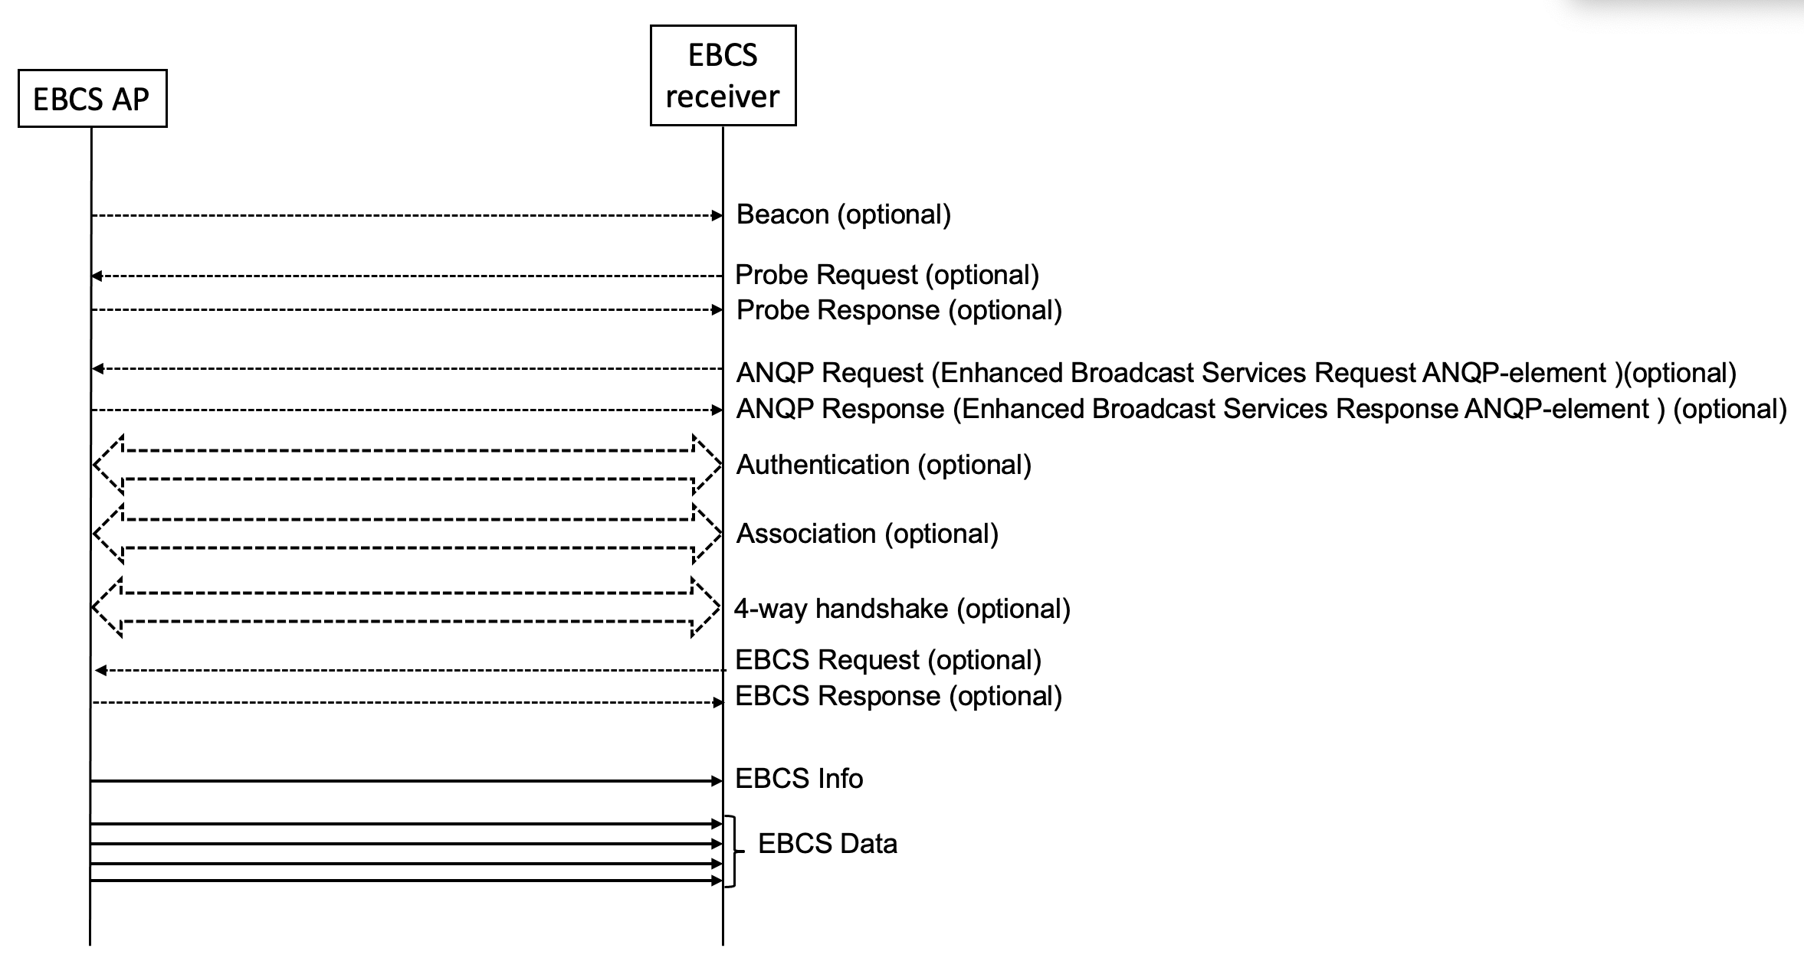
(TGbc Editor: please replace Figure 11-bc1 as shown above.) [1287 1128 1579 1619 1286 1150 1580 1289 1288]

Figure 11-bc1 EBCS DL frame sequence for a non-AP STA without association [1287 1128 1579 1619 1286 1150 1580 1289 1288]

(TGbc editor: please remove Figure 11-bc2) [1287 1128 1579 1619 1286 1150 1580 1289 1288]

Figure 11-bc2 EBCS DL frame sequence for a non-AP STA with association [1287 1128 1579 1619 1286 1150 1580 1289 1288]

11.55.2.3 EBCS DL operation at an EBCS receiver [1001 1413 1530 1629 1578 1618]

An EBCS receiver finds an EBCS capable AP by receiving Beacon, Probe Response, EBCS Info frame or by Enhanced Broadcast Services ANQP-element. To validate the source of an EBCS traffic stream, an EBCS receiver shall use the content of received EBCS Info frames. An EBCS receiver is able to know when the next EBCS Info frame is transmitted by the EBCS Parameters element in Beacon frames and Probe Response frames. [1029] An EBCS receiver may select the EBCS traffic streams to receive and consume. Details of the usage of the EBCS Info frame is described in 11.55.2.4 (EBCS Info frame generation and usage).

The SME of an EBCS receiver obtains EBCS content list from the EBCS Info frame or Enhanced Broadcast Services ANQP-element. The SME selects one or more EBCS contents to receive and set dot11GroupAddressesTable. If the HLP destination address is IPv4 address or IPv6 address, the DA is assumed to be mapped according to IETF RFC 1112 and IETF RFC 2464 respectively. [1409]

An EBCS receiver shall authenticate all EBCS Info frames and EBCS Data frames by the authentication mechanism specified in the EBCS Info Authentication Algorithm subfield in the EBCS Info Control field for the EBCS Info frame and the Content Authentication Algorithm subfield in the Content Information field for the EBCS Data frames, in the EBCS Info frame. Details of the frame authentication are described in 12.13 (Frame authentication for EBCS).

Authenticated MSDUs shall be forwarded to the higher layer via the EBCS filter. The EBCS filter shall be configured by the SME to filter out the undesired MSDUs if they have the corresponding source address and the corresponding EBCS content ID. An EBCS traffic stream shall pass through the IEEE 802.1X Controlled Port even if the IEEE 802.1X Controlled Port is blocked (e.g. because the STA is not associated). [1409]

If an EBCS receiver receives an EBCS traffic stream that is transmitted from multiple APs with the same AP certificate and the same content ID, the EBCS may forward the EBCS traffic stream received from multiple APs to the higher layer. [1002, 1003, 1004]

11.55.2.4 EBCS Info frame generation and usage

The EBCS Info frame is transmitted periodically every dot11EBCSInfoInterval beacon periods. An EBCS AP that is not in a multiple BSSID set shall transmit an EBCS Info frame every dot11EBCSInfoInterval beacon periods. [1294] (For the APs iIn a multiple BSSID set, only the AP corresponding to the transmitted BSSID may have EBCS DL enabled BSSID and may, if enabled, shall transmit (i.e., TA field and BSSID field set to the transmitted BSSID) an EBCS Info frame every dot11EBCSInfoInterval beacon periods; the other APs corresponding to EBCS DL disabled BSSIDs in the multiple BSSID set shall not transmit an EBCS Info frame. [1032, 1294, 1416] In a co-hosted BSSID set, at most one AP may have EBCS DL enabled and, if enabled, shall transmit an eBCS Info frame every dot11EBCSInfoInterval beacon periods.; the other APs in the co-hosted BSSID set shall not have eBCS DL enabled and shall not transmit an eBCS Info frame. [1033] The RA of the EBCS Info frame shall be the broadcast address. [1416]

The EBCS Info Sequence Number subfield in the first EBCS Info frame is initialized shall be set to a random number at the time of starting an EBCS and shall be incremented by 1 for every new subsequent EBCS Info frame transmission. If the Sequence Number field value overflows, it is shall be set to 0. [1295]

If all content EBCS traffic streams uses HLSA, the EBCS Info aAuthentication aAlgorithm of subfield in the EBCS Info frame may be indicate nNone, otherwise the EBCS Info frame shall use RSASSA-PSS, ECDSA or Ed25519 it shall not indicate None. [1298]

On reception of an EBCS Info frame, an EBCS non-AP STA receiver [1000] shall check the integrity of the EBCS Info frame as described in 12.10013.2.2 (Frame authentication for EBCSAuthentication of EBCS Info frame) [1151] if the Certificate of the AP is included EBCS Info Authentication Algorithm subfield in the EBCS Info frame does not indicate None. [1299]
If the integrity of the EBCS Info frame is verified, the EBCS non-AP STA receiver [1000] shall processes each Content Information field according to the value of the Content Authentication Algorithm subfield: [1300]

- The following processes are Ccommon in all authentication algorithms, [1184]
  - The non-AP STA EBCS receiver [1000, 1300] shall cache the title, the negotiation method, the higher layer destination address, the time to termination and the next schedule values of the Content Information List field. [1153]
  - The non-AP STA EBCS receiver [1000, 1300] shall notify the cached information to the SME through the SME-MLME SAP as described in (see 6.3.200126.3 (EBCS procedures MLME-EBCSINFO.indication)). [1301, 1152]
- In case of PKFA,
  - If data the Vendor Specific subfield [w/o CID] is present in the Content Information field, the non-AP STA EBCS receiver [1000, 1300] shall forward the MSDU in the data the Vendor Specific subfield [w/o CID] to a higher layer and shall cache the certificate in the EBCS Info frame to authenticate PFKA MSPDUs. [1154]
- In case of HCFA,
  - The HCFA base key in the Content Information field shall be cached. The EBCS receiver shall cache the HCFA base key in the Content Information field. [1302]
  - If instant authenticators are present in the content information, the instant authenticators shall be cached the EBCS receiver shall cache them. [1302]
  - If HCFA base keys from a previous period are present in the Content Informatio Information field, the non-AP STA shall authenticate the EBCS data frames of the previous HCFA period.

11.55.2.5 EBCS Info frame fragmentation

An EBCS Info frame may be fragmented into multiple MMPDUs. [1417] The length of each fragment shall be an even number of octets, except for the last fragment, which may have an odd length. The length of a fragment shall not be larger than dot11FragmentationThreshold.

The fragmentation procedure is following.
An EBCS Info frame is fragmented as follows: [1582, 1303]

1. Construct an unfragmented EBCS Info frame which is not yet fragmented and determine the length of fragments. [1303]
2. Select a fragment length such that the Fragment Hash Values field, the Certificate field and the Signature field will fit in the first fragment. [1303]
23. When the EBCS Info frame is fragmented to N MPDUs, the Number of Fragments subfield in the EBCS Info Control field is set to N-1. Determine the number of fragments n and set the Number Of Fragments subfield to n-1. [1303]
34. Insert a space for Nn-1 Fragment Hash Values fields into the EBCS Info frame. [1303, 1620]
45. Divide the EBCS Info frame after the Fragment Hash Values field into fragments. The Fragment Hash Values field, the Certificate and the Signature shall be contained in the first fragment. [1303]
56. The Fragment Index subfield in the EBCS Info Control field is set to 0 (the first) to N-1 (the last) respectively. Set the Fragment Index subfield from 0 to n-1 for successive fragments. [1303]
67. Calculate the hash value of each fragment (see 12.13.2.1 (Signature of an EBCS Info frame)) except the first one and put set into the corresponding Fragment Hash Values field. [1303]
78. Calculate (see 12.13.2.1 (Signature of an EBCS Info frame)) and fill set into the sSignature field of in the first fragment. [1303]
89. Transmit the fragments consecutively in order of the Fragment Index field. Data frames for EBCS Data frames shall not be transmitted before all of the fragments are transmitted. [1303]

The EBCS Info frame fragmentation is shown in Figure 11-bc3 (EBCS Info frame fragmentation).

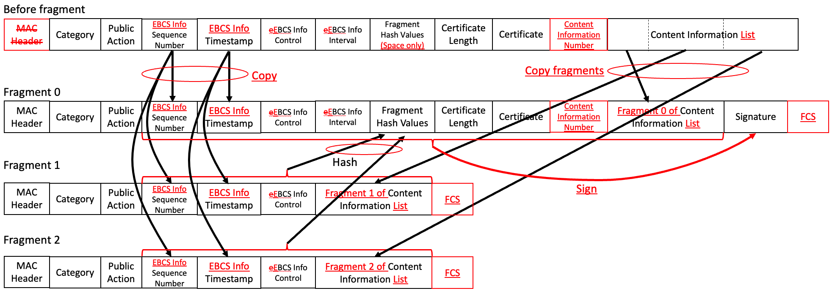

Figure 11-bc3 EBCS Info frame fragmentation [1305, 1309, 1308, 1307, 1306, 1186]

11.55.2.6 EBCS Info frame defragmentation

The EBCS Info fame defragmentation procedure is described in 12.13.2.2 (Authentication of an EBCS Info frame). [1315, 1316, 1118, 1621]

C.3 MIB Detail

TGbc editor: please delete dot11EBCSDataTxRate (P75L16, P77L11-36 and P78L56). [1409]

TGbc editor: please insert dot11EBCSDTIMPeriod as follows: [1005]

At P75L16:

dot11EBCSDTIMPeriod Unsigned32,

At P77L11:

dot11EBCSDTIMPeriod OBJECT-TYPE
SYNTAX Unsigned32 (1..255)
MAX-ACCESS read-write
STATUS current
DESCRIPTION
"This is a control variable.
It is written by an external management entity.
Changes take effect for the next MLME-START.request primitive.
This attribute specifies the number of beacon intervals that elapsebetween transmission of Beacon frames containing a EBCS TIM element whose DTIM Count field is 0. This value is transmitted in the DTIM Period field of Beacon frames."
::= { dot11StationConfigEntry <ANA> }

At P78L56:

dot11EBCSDTIMPeriod,

TGbc editor: please change dot11EBCSInfoTxRate at P76L41 as follows: [1232, 1279, 1280, 1238]

dot11EBCSInfoTxRate OBJECT-TYPE
SYNTAX OCTET STRING (SIZE(2..4))
MAX-ACCESS read-write
STATUS current
DESCRIPTION
"This is a control variable.
It is written by an external management entity or the SME. Changes take effect as soon as practical in the implementation.
This attribute indicates the transmission rate of EBCS Info frame. The first octet represents the PHY type. A value 0 indicates OFDM. A value 1 indicates HT. A value 2 indicates VHT. A value 3 indicates HE.
The second octets represents transmission rate in unit of Mbps in case of OFDM or MCS index in case of other PHY type.
The third octet represents bandwidth in unit of MHz in case of VHT or RU tones in case of HE. For RU tones, a value 0 indicates 20-tone RU, a value 1 indicates 52-tone RU, a value 2 indicates 106-tone RU, a value 3 indicates 242-tone RU, a value 4 indicates 484-tone RU, a value 5 indicates 996-tone RU and a value 6 indicates 2x996-tone RU. For MHz, a value 0 represents 20 MHz, a value 1 represents 40 MHz, a value 2 represents 80 MHz, a value 3 represents 80+80 MHz or 160 MHz.
The fourth octet represents NSS in case of VHT or HE.
This variable encoded as a PHY Type subfield and a TX Rate subfield in the Enhanced Broadcast Tuple as described in 9.4.5.30 (Enhanced BroadcastServices ANQP-element)."
DEFVAL {’00060000000C’H}
::= { dot11StationConfigEntry <ANA+5> }

