IEEE P802.11
Wireless LANs
Resolutions for Clause 11.100.2
Date: 2021-05-26
Author(s):
Name | Affiliation | Address | Phone | email
Hitoshi Morioka | Koden-TI | Fukuoka, JAPAN |  | hmorioka@src-soft.com
Abstract
This document describes the resolutions for clause 11.100.2 on LB252.

The baseline is D1.02.

Suggested resolution

TGbc editor: please add the following definitions:

3.2 Definitions specific to IEEE 802.11

enhanced broadcast services (EBCS) Data frame: a Data frame used to carry an EBCS traffic stream. [1149]

TGbc editor: please modify the figures, Figure 5-1, 5-2 and 5-7, as shown below:

5.1.5 MAC data service architecture

5.1.5.1 General

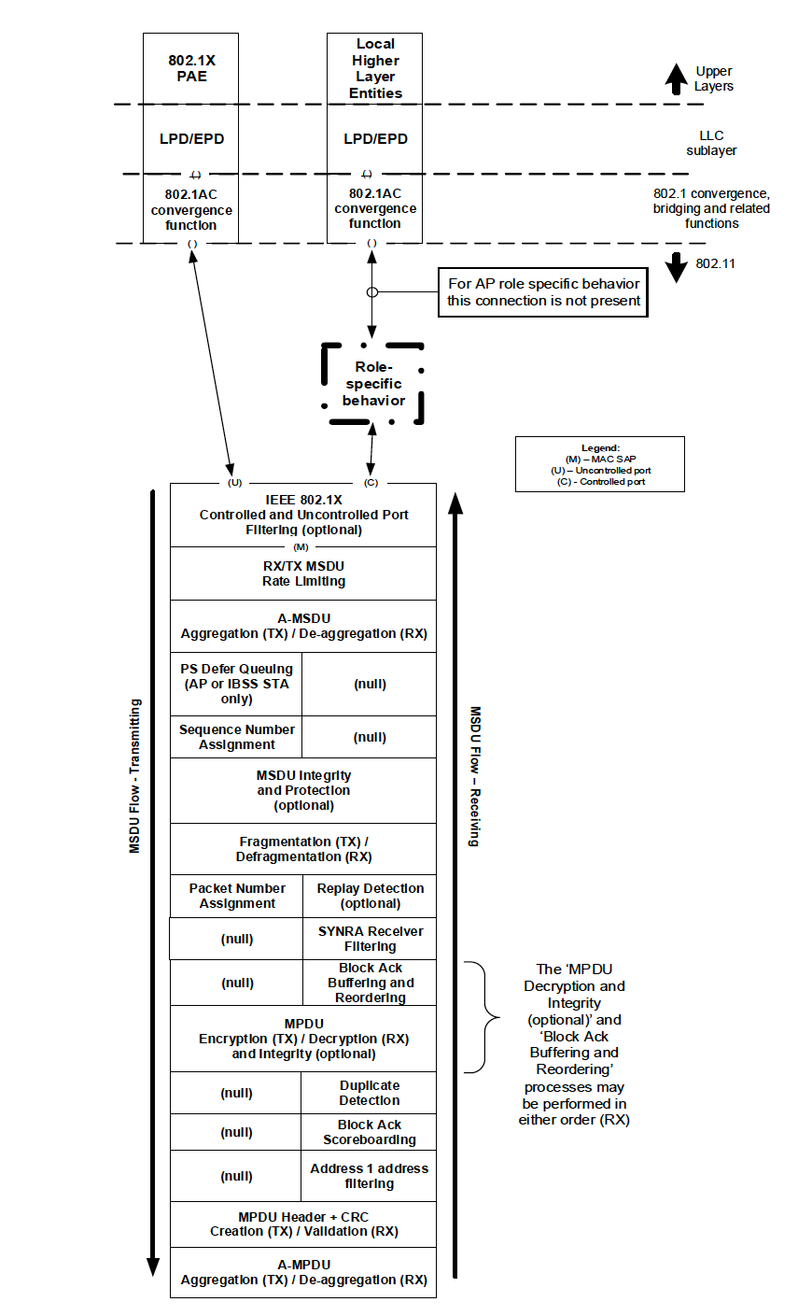
EBCS proxy
Bypass for EBCS
(optional)
LPD/EPD
802.1AC convergence function

Figure 5-1 ---MAC data plane architecture [1409]
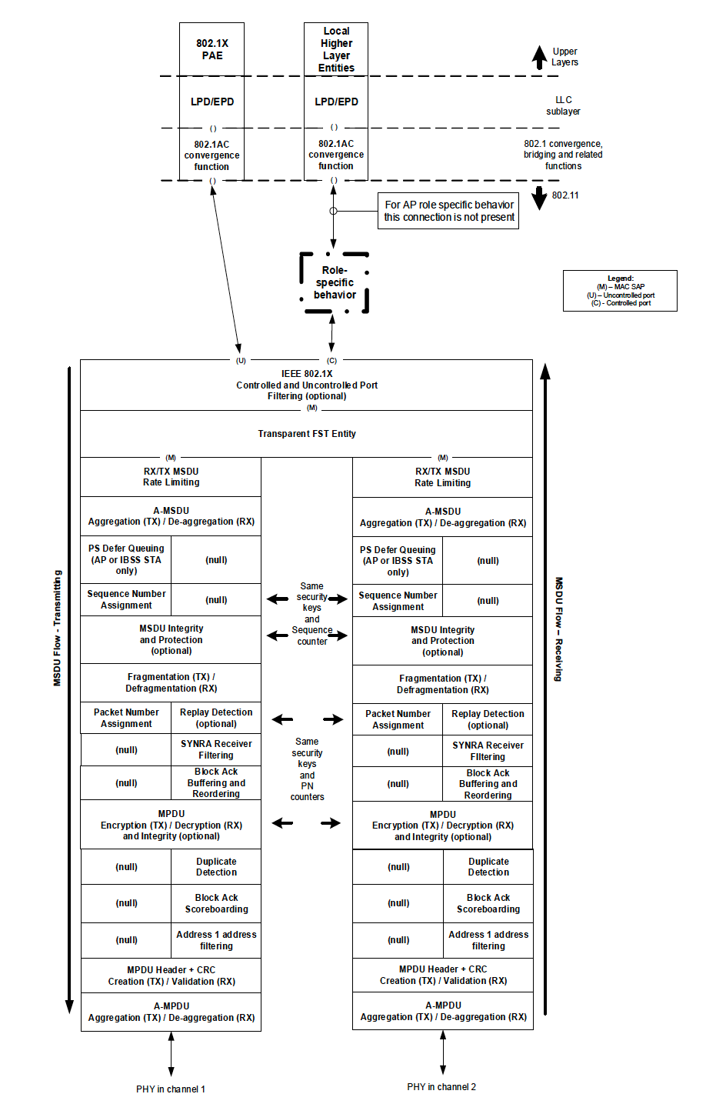
Bypass for EBCS
802.1AC convergence function
LPD/EPD
EBCS proxy

Figure 5-2 ---MAC data plane architecture (transparent FST) [1409]

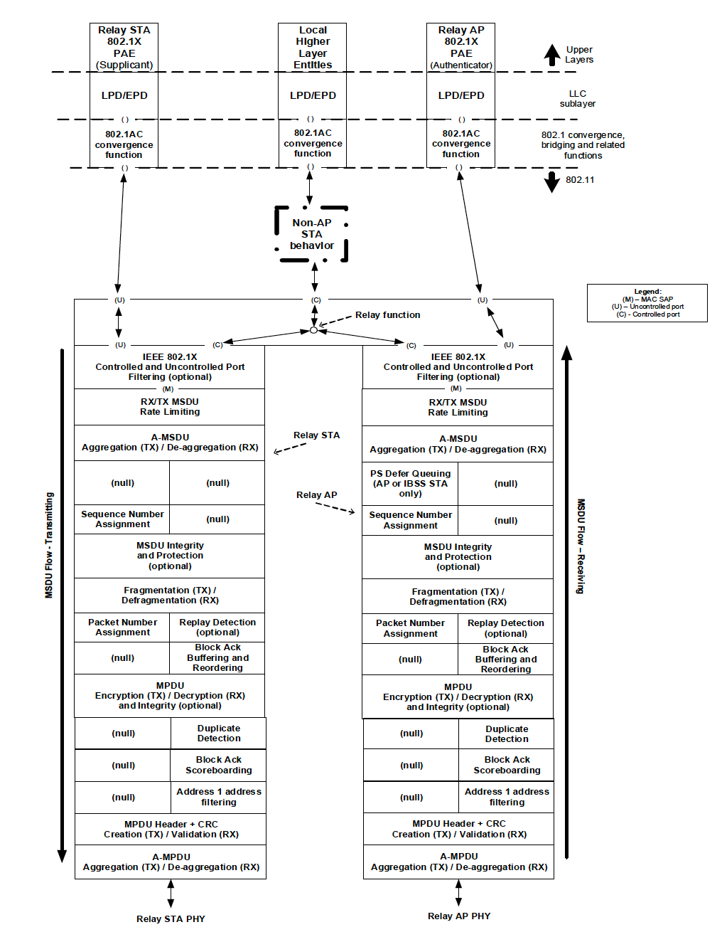
Bypass for EBCS
EBCS proxy
LPD/EPD
802.1AC convergence function

Figure 5-7 ---S1G relay data plane architecture [1409]

5.2.3 MA-UNITDATA.request [1409]

5.2.3.2 Semantics of the service primitive

TGbc editor: please modify the parameter of MA-UNITDATA.request as follows:

The parameters of the primitive are as follows:
MA-UNITDATA.request(
source address,
destination address,
routing information,
data,
priority,
drop eligible,
service class,
station vector,
MSDU format,
EBCS traffic
)

TGbc editor: please insert the following paragraph at the end of clause 5.2.3.2:

The EBCS traffic parameter is a Boolean that indicates whether this MSDU is an EBCS traffic or not. If EBCS traffic is true, the MSDU is encapsulated in an EBCS Data frame.

5.2.4 MA-UNITDATA.indication

5.2.4.2 Semantics of the service primitive

TGbc editor: please modify the parameter of MA-UNITDATA.indication as follows:

The parameters of the primitive are as follows:
MA-UNITDATA.indication(
source address,
destination address,
routing information,
data,
priority,
drop eligible,
service class,
station vector,
MSDU format,
EBCS traffic
)

TGbc editor: please insert the following paragraph at the end of clause 5.2.3.2:

The EBCS traffic parameter is a Boolean that indicates whether this MSDU is an EBCS traffic or not.

NOTE-If EBCS traffic is true, the MSDU is forwarded to the EBCS proxy.

9.3.3 Management frames

9.3.3.2 Beacon frame format

TGbc editor: please insert the following line before “Vendor Specific” in Table 9-32 and align Order:

Table 9-32---Beacon frame body

Order | Information | Notes
[ANA] | EBCS TIM | The EBCS TIM is present if the length of dot11EBCSContentList is larger than 0.

9.4.2 Elements

9.4.2.1 General

TGbc editor: please insert the following line in Table 9-92 and align Element ID Extension:

Table 9-92---Element IDs

Element | Element ID | Element ID Extension | Extensible | Fragmentable
… | … | … | … | …
EBCS TIM (see 9.4.2.x (EBCS TIM element)) | 255 | [ANA] | No | No
Reserved | 255 | ([ANA]+1)-255

TGbc editor: please insert the following subclause at the end of clause 9.4.2:

9.4.2.x EBCS TIM element

The EBCS TIM element is used to signal the availability of EBCS traffic stream frames. The format of this element is shown in Figure 9-xx (EBCS TIM element format).

 | Element ID | Length | Element ID Extension | Bitmap Control | Partial Virtual Bitmap
Octets: | 1 | 1 | 1 | 1 | 0-32

Figure 9-xx---EBCS TIM element format

The Element ID, Length and Element ID Extension fields are defined in 9.4.2.1 (General).
The format of the Bitmap Control field is shown in Figure 9-yy (Bitmap Control field format).

 | B0 | B1 | B3 | B4 | B7
 | Bitmap Mode | Bitmap Offset |  | Reserved
Bits: | 1 | 3 |  | 4

Figure 9-yy---Bitmap Control field format

The EBCS traffic indication virtual bitmap, maintained by the AP or the mesh STA that generates an EBCS TIM, consists of 256 bits, and it is organized into 8 octets such that bit number $N (0≤N ≤255)$ in the bitmap corresponds to bit number $(N \text{mod} 8)$ in octet number $\left\lfloor N/8\right\rfloor$ where the low order bit of each octet is bit number 0, and the high order bit is bit number 7. A bit value 1 means the corresponding EBCS traffic stream is buffered at the AP.

If the Bitmap Mode subfield value is 0, the Bitmap Offset subfield is set to 0 and the Partial Virtual Bitmap field contains the Content ID (see 11.100.2.x (Content stream configuration)) of the EBCS traffic stream that is buffered at the AP in each octet.

If the Bitmap Mode subfield value is 1, the Bitmap Offset subfield is set to the starting octet number of the Partial Virtual Bitmap field. If a bit is not included in the Partial Virtual Bitmap field, the corresponding EBCS traffic stream is not buffered at the AP.

If no EBCS traffic stream are buffered at the AP, the Bitmap Control field is set to 1 and the length of the Partial Virtual Bitmap field is 0.

When dot11MultiBSSIDImplemented is true, this element is included in the Nontransmitted BSSID Profile subelement.

The EBCS TIM element is included in Beacon frame only when the DTIM count in the TIM element is equal to 0.

TGbc editor: please change clause 11.100.2 as follows:

11.100.2 EBCS DL procedures

11.100.2.1 General

The EBCS DL allows an EBCS AP to distribute multicast contents to both associated and unassociated EBCS receivers with origin authenticity. [1001 1413 1530 1629 1578 1618]

11.100.2.2 EBCS DL operation at an EBCS AP [1001 1413 1530 1629 1578 1618]

An EBCS AP shall advertise the capabilities of the EBCS in the EBCS Support field in the Extended Capabilities element in Beacon frames and Probe Response frames. An EBCS AP that is enabled EBCS DL shall transmit EBCS Info frames periodically in the interval that is specified by the dot11EBCSInfoInterval, at the transmission rate that is specified by the dot11EBCSInfoTxRate. An EBCS AP shall advertise the next EBCS Info frame transmission timing in the EBCS Info Frame TX Countdown field in the EBCS Parameters element (9.6.2.296 EBCS Parameters element) and shall not signal the EBCS Info frame in the TIM element in Beacon frames and Probe Response frames. The EBCS Info frame shall be transmitted immediately after the indicated Beacon frame. Details of the EBCS Info frame generation is described in 11.100.2.x (EBCS Info frame generation and usage). [1005]

An EBCS proxy affiliated with the AP (see Figure 5-1 (MAC data plane architecture)) shall compare each packet of the multicast traffic and the dot11EBCSContentList. If the packet matches one of the dot11EBCSContentList, the EBCS proxy forwards it to MAC. Otherwise, the packest shall follow non-EBCS AP rules. [1409]

In the MAC, the packet forwarded by the EBCS Proxy shall bypass IEEE 802.1X filtering as shown in Figure 5-1 (MAC data plane architecture) and use of the following three frame authentication mechanisms.

The EBCS DL uses three types of frame authentication mechanism as follows:

- PKFA (12.bc.2 Public Key Frame Authentication)
- HCFA (12.bc.3 Hash Chain Frame Authentication)
- HLSA (12.bc.4 No frame authentication with mandatory higher layer source authentication)

EBCS DL uses both EBCS Info frames and EBCS Data frames.
In addition to these frames, Management frames are optionally used.
The frame sequence for a non-AP STA without association is shown in Figure 11-bc1 (EBCS DL frame sequence for a non-AP STA without association). The frame sequence for a non-AP STA with association is shown in Figure 11-bc2 (EBCS DL frame sequence for a non-AP STA with association). [1287 1128 1579 1619 1286 1150 1580 1289 1288]

The EBCS traffic streams are carried by EBCS Data frames. The EBCS Data frames shall be signaled in the EBCS TIM element (see 9.4.2.x (EBCS TIM element)) instead of the TIM element in Beacon frames. [1005] (Is RA description required? The RA (Dst MAC address) is set by the content server and the AP uses it. It is general behavior of the AP.)

The frame sequence of the EBCS DL is shown in Figure 11-bc1 (EBCS DL frame sequence). [1287 1128 1579 1619 1286 1150 1580 1289 1288]

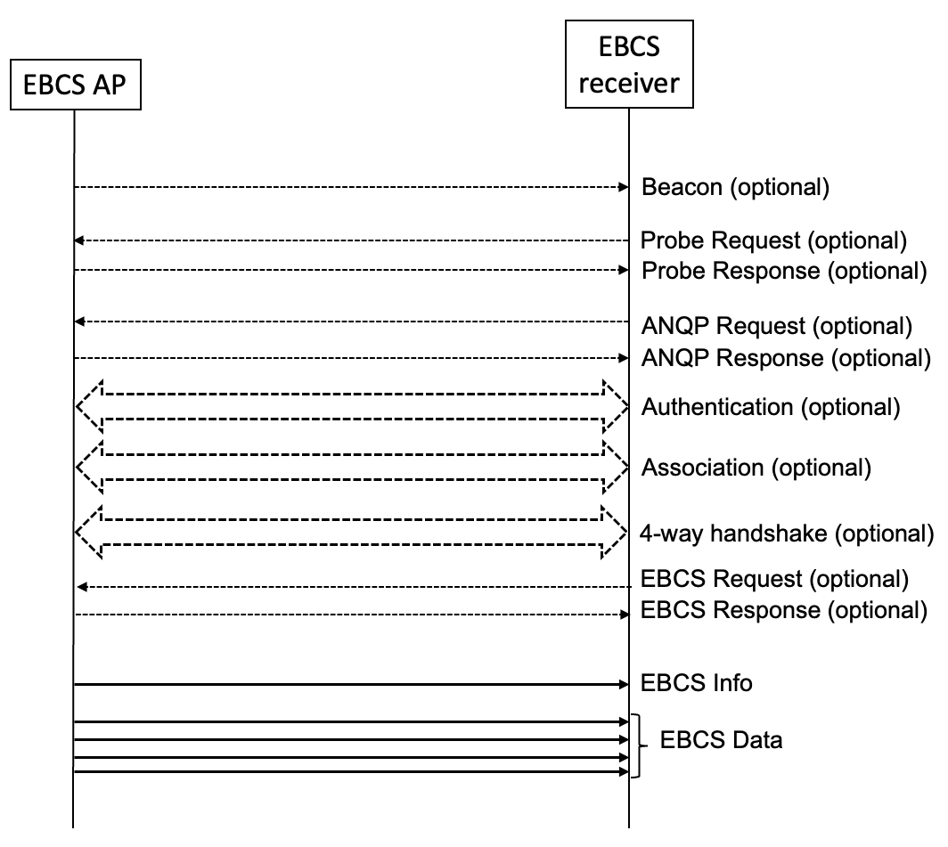
(TGbc Editor: please replace Figure 11-bc1 as shown above.) [1287 1128 1579 1619 1286 1150 1580 1289 1288]

Figure 11-bc1 EBCS DL frame sequence for a non-AP STA without association [1287 1128 1579 1619 1286 1150 1580 1289 1288]

(TGbc editor: please remove Figure 11-bc2) [1287 1128 1579 1619 1286 1150 1580 1289 1288]

Figure 11-bc2 EBCS DL frame sequence for a non-AP STA with association [1287 1128 1579 1619 1286 1150 1580 1289 1288]

11.100.2.2 EBCS DL capability indications

The EBCS AP shall include the EBCS Capability element (9.4.2.300 EBCS Parameters element) in Beacon and Probe Response frames. The EBCS Capability element indicates the next EBCS Info transmission time in units of Beacon Interval. The EBCS Info frame is transmitted immediately after the indicated beacon.

11.100.2.3 EBCS DL operation at an EBCS receiver [1001 1413 1530 1629 1578 1618]

An EBCS receiver finds an EBCS capable AP by receiving Beacon, Probe Response or EBCS Info frame. An EBCS receiver shall wait for receiving the EBCS Info frame to receive EBCS traffic streams. An EBCS receiver is able to know when the next EBCS Info frame is transmitted by the EBCS Parameters element in Beacon frames and Probe Response frames. An EBCS receiver may select the EBCS traffic streams to receive and consume. Details of the usage of the EBCS Info frame is described in 11.100.2.x (EBCS Info frame generation and usage).

An EBCS receiver shall authenticate all EBCS Info frames and EBCS Data frames by the authentication mechanism specified in the EBCS Info Authentication Algorithm subfield in the EBCS Info Controlfield for the EBCS Info frame and the Content Authenticatino Algorithm subfield in the Content Information field for the EBCS Data frames, in the EBCS Info frame. Details of the frame authentication is described in 12.100 (Frame authentication for EBCS).

If the frame authentication succeeds, the EBCS traffic stream shall be forwarded to the higher layer via EBCS proxy.

If an EBCS receiver receives an EBCS traffic stream that is transmitted from multiple APs with the same AP certificate and the same content ID, the EBCS may forward the EBCS traffic stream received from multiple APs to the higher layer via the EBCS proxy.

NOTE – The higher layer protocol of the EBCS traffic stream shall provide duplicate detection.

11.100.2.3 EBCS Info frame generation and usage

The EBCS Info frame is transmitted periodically every dot11EBCSInfoInterval beacon periods. ([w/o CID] For the APs in a multiple BSSID set, only the AP corresponding to the EBCS DL enabled BSSID may transmit an EBCS Info frame; other APs corresponding to EBCS DL disabled BSSIDs shall not transmit an EBCS Info frame. The RA of the EBCS Info frame shall be the broadcast address. [1416]

The EBCS Info [w/o CID] Sequence Number subfield is initialized to a random number at the time of starting an EBCS and incremented by 1 for every new EBCS Info frame transmission. If the EBCS Info [w/o CID] Sequence Number overflows, it is set to 0.

If all content uses HLSA, the authentication algorithm of the EBCS Info frame may be none, otherwise the EBCS Info frame shall use RSASSA-PSS, ECDSA or Ed25519.

On reception of an EBCS Info frame, an EBCS non-AP STA shall check the integrity of the EBCS Info frame as described in 12.100 (Frame authentication for EBCS) if the Certificate of the AP is included in the EBCS Info frame.
If the integrity of the EBCS Info frame is verified, the EBCS non-AP STA processes each Content Information according to the Authentication Algorithm.

- Common in all authentication algorithms,
  - The non-AP STA shall cache the title, the negotiation method, the higher layer destination address, the time to termination and the next schedule.
  - The non-AP STA shall notify the cached information to the SME through the SME-MLME SAP as described in 6.3.200 (EBCS procedures).
- In case of PKFA,
  - If data is present in the Content Information field, the non-AP STA shall forward the MSDU in the data to a higher layer and shall cache the certificate in the EBCS Info frame to authenticate PFKA MSDUs.
- In case of HCFA,
  - The HCFA base key in the Content Information field shall be cached.
  - If instant authenticators are present in the content information, the instant authenticators shall be cached.
  - If HCFA base keys from a previous period are present in the Content Informatio Information field, the non-AP STA shall authenticate the EBCS data frames of the previous HCFA period.

11.100.2.4 EBCS Info frame fragmentation

An EBCS Info frame may be fragmented into multiple MPDUs. The length of each fragment shall be an even number of octets, except for the last fragment, which may have an odd length. The length of a fragment shall not be larger than dot11FragmentationThreshold.

The fragmentation procedure is following.

- Construct an EBCS Info frame which is not yet fragmented and determine the length of fragments.
- When the EBCS Info frame is fragmented to Nn [w/o CID] MPDUs, the Number of Fragments subfield in the EBCS Info Control field is set to Nn-1 [w/o CID]
- Insert a space for Nn-1 [w/o CID] Fragment Hash Values fields to the EBCS Info frame.
- Divide the EBCS Info frame after the Fragment Hash Values field into fragments. The Fragment Hash Values field, the Certificate field [w/o CID] and the Signature field [w/o CID] shall be contained in the first fragment.
- The Fragment Index subfield in the EBCS Info Control field is set to 0 (the first) to Nn-1 [w/o CID] (the last) respectively.
- Calculate the hash value of each fragment except the first one and put into the Fragment Hash Values field.
- Calculate and fill the signature of the first fragment.
- Transmit the fragments consecutively in order of the Fragment Index. Data frames for EBCS shall not be transmitted before all of the fragments are transmitted.

The EBCS Info frame fragmentation is shown in Figure 11-bc3 (EBCS Info frame fragmentation).

Figure 11-bc3 EBCS Info frame fragmentation

11.100.2.5 EBCS Info frame defragmentation

When an EBCS non-AP STA receives an EBCS Info frame with the Number Of Fragments subfield in the EBCS Info Control field not equal to 0 and the Fragment Index subfield equal to 0, the EBCS non-AP STA shall verify the signature. If the verification succeeds, the EBCS non-AP STA shall cache the EBCS Info frame Sequence Number, Timestamp, EBCS Info Control and Fragment Hash Values field values.
When the EBCS non-AP STA receives the subsequent fragments of the EBCS Info frame, the EBCS non-AP STA shall check the integrity of the fragments by the following procedure.

- Verify that the EBCS Info frame Sequence Number field, Timestamp field and Number Of Fragments subfield in the EBCS Info Control field in the received fragment are equal to those (sub)fields in the first fragment. If the values are different, the received fragment shall be discarded.
- Calculate the hash value of the received fragment and compare it with the corresponding hash value in the Fragment Hash Values field in the first fragment. If the hash values are different, the received fragment shall be discarded.
- Cache the content information of the received fragment.

After all fragments are received, the EBCS non-AP STA concatenates the fragments and processes the EBCS Info frame as described in 11.100.2.3 (EBCS Info frame generation and usage).

From this line, just reminder, please ignore

Modify EBCS proxy operation (4.5.xx)

EBCS TIM should be optional ->
Multiple BSSID -> single content ID pool

EBCS Data frame -> class 1

Name of EBCS proxy

