IEEE P802.11  
Wireless LANs

|  |  |  |  |  |
| --- | --- | --- | --- | --- |
| PDT-EHT-preamble-EHT-SIG for D0.4 – part 2 | | | | |
| Date: 2021-02-04 | | | | |
| Author(s): | | | | |
| Name | Company | Address | Phone | email |
| Ross Jian Yu | Huawei | Huawei Industrial Base, Shenzhen, Guangdong, China |  | ross.yujian@huawei.com |
| Mengshi Hu | Huawei |  |  |  |
| Ming Gan | Huawei |  |  |  |
|  |  |  |  |  |
|  |  |  |  |  |

Abstract

R0: initial version – further update based on P802.11ax D0.4 and 802.11-21/0140r2

**36.3.11.8 EHT-SIG**

36.3.11.8.3 Common field for OFDMA transmission

**Table 36-24—Common field for OFDMA transmission**

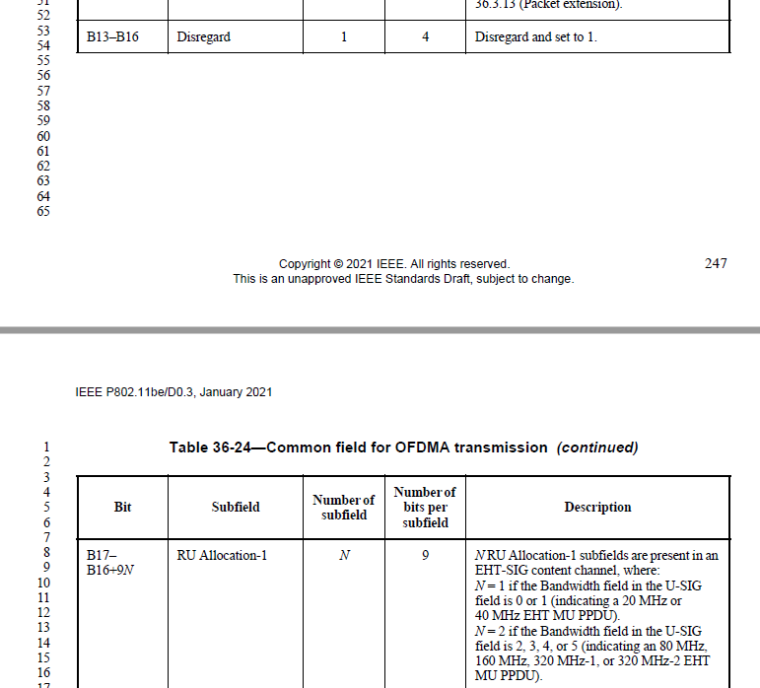

B0-B16 of Table 36-24 are U-SIG Overflow bits for OFDMA transmission and are duplicated in each content channels.

A 4x996-tone RU cannot be indicated by the RU Allocation subfield.

**Table 36-26—RU Allocation subfield *(continued)***

|  |  |  |
| --- | --- | --- |
| 296-303 (100101y2y1y0) | **MRU of 996-996-484-[]** | **8** |
| 304-511 (100110y2y1y0 -111111y2y1y0) | **Disregard** | **26****8** |
| If signaling RUs or MRUs of size greater than or equal to 242 subcarriers, y2y1y0 = 000–111 indicates the number of User fields in the EHT-SIG content channel that contains the corresponding 9-bit RU Allocation subfield. The binary vector y2y1y0 indicates *Nuser*(r, c) = 22 × y2 + 21 × y1 + y0 + 1 User fields in the EHT-SIG content channel that contains the corresponding 9-bit RU Allocation subfield. | | |

For an MU-MIMO allocation of RU/MRU size greater than 242 subcarriers in an OFDMA transmission, the dynamic split of User fields between EHT-SIG content channel 1 and EHT-SIG content channel 2 per 80 MHz is decided by the AP (on a per case basis) and signaled by the AP using the RU Allocation subfields in each EHT-SIG content channel.

36.3.11.8.4 Common field for non-OFDMA transmission

Table 36-27—Common field for non-OFDMA transmission to a single user and non-OFDMA transmission to multiple users

|  |  |  |  |
| --- | --- | --- | --- |
| B12 | PE Disambiguity | 1 | Indicates PE disambiguity as defined in 36.3.13 (Packet extension).  The values shall be the same in different 80MHz subblocks. |
| B13-B16 | Disregard | 4 | Disregard and set to 1 |
| B17-B19 | Number Of Non-OFDMA Users | 3 | Indicates the number of non-OFDMA users.  Set to n to indicate n+1 non-OFDMA users. |

B0-B16 of Table 36-27 are U-SIG Overflow bits for non-OFDMA transmission to a single user and non-OFDMA transmission to multiple users. Both the U-SIG Overflow bits and Number of Non-OFDMA Users subfields are duplicated in each content channels.

Table 36-28 Common field for EHT Sounding NDP

|  |  |  |  |
| --- | --- | --- | --- |
| Bit | Subfield | Number of bits per subfield | Description |
| B0-B3 | Spatial reuse | 4 | Indicates whether or not spatial reuse modes are allowed during the transmission of this PPDU.  Set to value 15 from Table 27-22 (Spatial Reuse field encoding for an HE SU PPDU, HE ER SU PPDU, and HE MU PPDU), see 26.11.6 (SPATIAL_REUSE) and 26.10 (Spatial reuse operation) |

B0-B15 of Table 36-28 are U-SIG Overflow bits for EHT Sounding NDP and are duplicated in each content channels.

Table 36-32—User field format for a MU-MIMO allocation

For non-OFDMA transmission to multiple users (in U-SIG, the UL/DL field is set to 0, and the PPDU Type And Compression Mode field is set to 2) when the Bandwidth of the PPDU is greater or equal to 40 MHz, equitable split is defined as the split of User fields across EHT-SIG content channels, i.e., User field k of a K user non-OFDMA MU-MIMO transmission is carried in EHT-SIG content channel c, where c is defind in equation (36-xx1).

 (36-xx1)