IEEE P802.11  
Wireless LANs

|  |  |  |  |  |
| --- | --- | --- | --- | --- |
| PDT-EHT-preamble-EHT-SIG for D0.4 – part 2 | | | | |
| Date: 2021-02-04 | | | | |
| Author(s): | | | | |
| Name | Company | Address | Phone | email |
| Ross Jian Yu | Huawei | Huawei Industrial Base, Shenzhen, Guangdong, China |  | ross.yujian@huawei.com |
| Mengshi Hu | Huawei |  |  |  |
| Ming Gan | Huawei |  |  |  |
|  |  |  |  |  |
|  |  |  |  |  |

Abstract

R0: initial version – further update based on P802.11ax D0.4 and 802.11-21/0140r2

**36.3.11.8 EHT-SIG**

36.3.11.8.3 Common field for OFDMA transmission

**Table 36-24—Common field for OFDMA transmission**

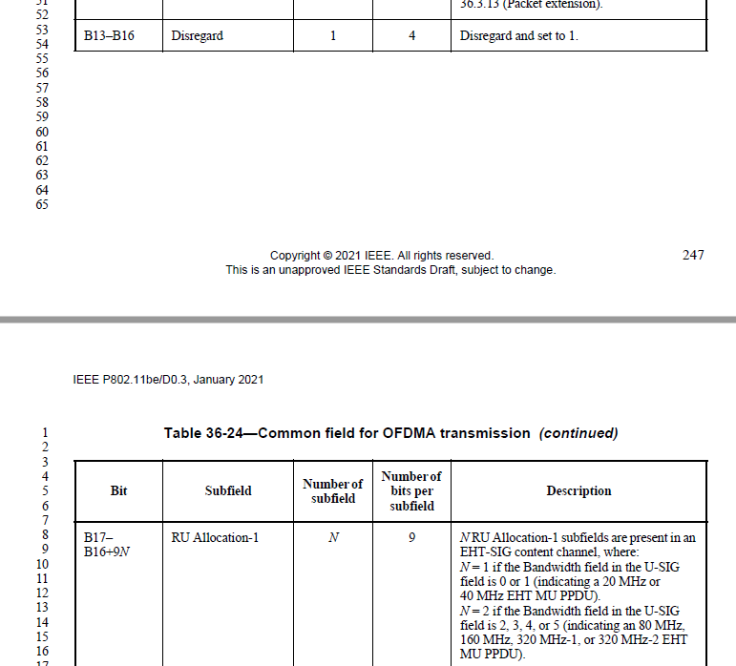

B0-B16 of Table 36-24 are U-SIG Overflow bits for OFDMA transmission and are duplicated in each content channels.

A 4x996-tone RU cannot be indicated by the RU Allocation subfield.

**Table 36-26—RU Allocation subfield *(continued)***

|  |  |  |
| --- | --- | --- |
| 296-303 (100101y2y1y0) | **MRU of 996-996-484-[]** | **8** |
| 304-511 (100110y2y1y0 -111111y2y1y0) | **Disregard** | **26****8** |
| If signaling RUs or MRUs of size greater than or equal to 242 subcarriers, y2y1y0 = 000–111 indicates the number of User fields in the EHT-SIG content channel that contains the corresponding 9-bit RU Allocation subfield. The binary vector y2y1y0 indicates *Nuser*(r, c) = 22 × y2 + 21 × y1 + y0 + 1 User fields in the EHT-SIG content channel that contains the corresponding 9-bit RU Allocation subfield. | | |

For an MU-MIMO allocation of RU/MRU size greater than 242 subcarriers in an OFDMA transmission, the dynamic split of User fields between EHT-SIG content channel 1 and EHT-SIG content channel 2 per 80 MHz is decided by the AP (on a per case basis) and signaled by the AP using the RU Allocation subfields in each EHT-SIG content channel.

36.3.11.8.4 Common field for non-OFDMA transmission

Table 36-27—Common field for non-OFDMA transmission to a single user and non-OFDMA transmission to multiple users

|  |  |  |  |
| --- | --- | --- | --- |
| B12 | PE Disambiguity | 1 | Indicates PE disambiguity as defined in 36.3.13 (Packet extension).  The values shall be the same in different 80MHz subblocks. |
| B13-B16 | Disregard | 4 | Disregard and set to 1 |
| B17-B19 | Number Of Non-OFDMA Users | 3 | Indicates the number of non-OFDMA users.  Set to n to indicate n+1 non-OFDMA users. |

B0-B16 of Table 36-27 are U-SIG Overflow bits for non-OFDMA transmission to a single user and non-OFDMA transmission to multiple users. Both the U-SIG Overflow bits and Number of Non-OFDMA Users subfields are duplicated in each content channels.

Table 36-28 Common field for EHT Sounding NDP

|  |  |  |  |
| --- | --- | --- | --- |
| Bit | Subfield | Number of bits per subfield | Description |
| B0-B3 | Spatial reuse | 4 | Indicates whether or not spatial reuse modes are allowed during the transmission of this PPDU.  Set to value 15 from Table 27-22 (Spatial Reuse field encoding for an HE SU PPDU, HE ER SU PPDU, and HE MU PPDU), see 26.11.6 (SPATIAL_REUSE) and 26.10 (Spatial reuse operation) |

B0-B15 of Table 36-28 are U-SIG Overflow bits for EHT Sounding NDP and are duplicated in each content channels.

Table 36-32—User field format for a MU-MIMO allocation

For non-OFDMA transmission to multiple users (in U-SIG, the UL/DL field is set to 0, and the PPDU Type And Compression Mode field is set to 2), equitable split is defined as the split of User fields across EHT-SIG content channels, i.e., User field k of a K user non-OFDMA MU-MIMO transmission is carried in EHT-SIG content channel c, where c is defind in equation (36-xx1).

 (36-xx1)