IEEE P802.11  
Wireless LANs

|  |  |  |  |  |
| --- | --- | --- | --- | --- |
| Comment resolution for Section 32.3.9.9 (Midambles) | | | | |
| Date: 2021-01-15 | | | | |
| Author(s): | | | | |
| Name | Affiliation | Address | Phone | email |
| Miguel Lopez | Ericsson | Torshamnsgatan 23, Stockholm, Sweden |  | Miguel.m.lopez@ericsson.com |
|  |  |  |  |  |

Abstract

This submission proposes resolutions to CIDs: 1504, 1505, and 1599

Revisions:

* Rev 0: Initial revision
* Rev 1: Updated Eq 32-31 and Eq 32-33 after comments

**CID 1504, 1505, 1599**

|  |  |  |  |  |  |
| --- | --- | --- | --- | --- | --- |
| **CID** | **Page** | **Clause** | **Comment** | **Proposed Change** | **Resolution** |
| 1504 | 76.3 | 32.3.9.9 | According to IEEE 802.11-20/0682r3 the midambles shall be randomized | Replace the text "The midamble in an NGV PPDU is shown in Figure 32-12" by "The midambles and data fields are randomized to remove spectral lines in the NGV PPDU spectrum.  Randomization is achieved by multiplying the midambles and data fields by the pseudo-random sequence p_n given in (17-25). The randomization shall by applied to the first midamble and to subsequent data symbols and midambles in the NGV PPDU.  The (n+1)-th midamble and the following M data field symbols in an NGV PPDU shall be multiplied by p_(n mod 127), n >= 0, where mod is the modulus operation. The midamble and the randomization in an NGV PPDU are shown in Figure 32-12. | Revised.  Agree to comment. Made some changes to the proposed text  TGbd Editor: Incorporate the changes in <https://mentor.ieee.org/802.11/dcn/21/11-21-0126-01-00bd-the-comment-resolution-for-32-3-9-9.docx> |
| 1505 | 76.10 | 32.3.9.9 | Update Figure 32-12 to reflect changes suggested in the previous comment | A proposed version of figure 32-12 is attached below | Revised.  Agree to comment. Made minor changes to proposed figure  TGbd Editor: Incorporate the changes in <https://mentor.ieee.org/802.11/dcn/21/11-21-0126-01-00bd-the-comment-resolution-for-32-3-9-9.docx> |
| 1599 | N/A | N/A | As a reminder, midamble randomization (802.11-20/0682) as passed in a motion on August 4, 2020 needs to be added. | As in the comment. | Revised.  Agree to comment. The resolution to CIDs 1504 and 1505, and the modification of Equation 32-31 resolves this comment  <https://mentor.ieee.org/802.11/dcn/21/11-21-0126-01-00bd-the-comment-resolution-for-32-3-9-9.docx> |

*TGbd editor: please modify the text Section 32.3.9.8.1 of Rev D1.1, P74L41 as follows*

* **Transmission in NGV format**

The time domain waveform of the Data field of an NGV PPDU from transmit chain shall be as defined in Equation (32-31).

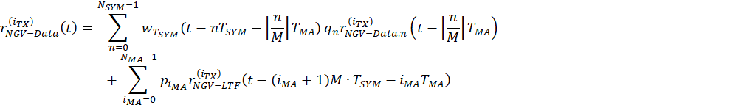

(32-31)

where

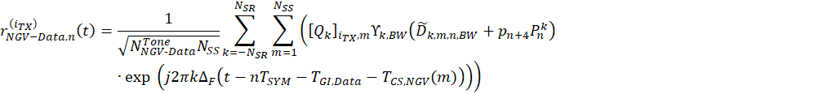

(32-32)

is the *nth* OFDM data symbol in the Data field,



is defined in Equation (32-27)



is the duration of one midamble



is defined in 17.3.5.10 (OFDM modulation)



(32-33)



is the index for the midambles, (#1599)



is defined in Clause 32.3.9.7 (Pilot subcarriers)



…

*TGbd editor: : please modify the text Section 32.3.9.9 of Rev D1.1 P75L58 as follows*

* Midambles

An NGV STA shall include midambles in an NGV PPDU transmission when *NMA* is set to a nonzero value. Midambles facilitate updating of the channel estimate during the NGV PPDU reception.

Midambles are present in the Data field of the NGV PPDU every *M* OFDM symbols, where *M* is either 4, 8, or 16 as indicated by the Midamble Periodicity field in NGV-SIG field (see Table 32-10 (Fields in the NGV-SIG field)).

The midamble field shall use the same format as the NGV-LTF field of the same PPDU, which format is signalled in NGV-SIG field. The generation of midamble is defined in Clause 32.3.8.3.6 (NGV-LTF definition).



If present…a single user.

The midambles and succeeding Data field OFDM symbols shall be randomized to prevent the generation of spectral lines in the NGV PPDU spectrum. The *nth* midamble and *M* Data field OFDM symbols following immediately after the *nth* midamble shall be multiplied by pn, *n*=0,…,*NMA*-1, where pn is defined in 17.3.5.10 (OFDM modulation). The midamble and the randomization procedure in an NGV PPDU are shown in Figure 32-12 (NGV PPDU with midamble and randomization procedure). (#1504,#1599)

|  |
| --- |
|  |
| * NGV PPDU with midamble and randomization procedure (#1505) |

As shown in Figure 32-12 (NGV PPDU with midamble and randomization procedure), the first midamble is inserted immediately after the *M*-th OFDM symbol in the Data field, and a midamble is not inserted after the last data OFDM symbol if .

