IEEE P802.11
Wireless LANs
Subcarriers and Resource Allocation for Multiple RUs Update
Date: 2021-01-11
Author(s):
Name | Affiliation | Address | Phone | Email
Jianhan Liu | Mediatek |  |  | jianhan.liu@mediatek.com
Srinath Puducheri Sundaravaradhan | Broadcom |  |  | srinath.puducheri@broadcom.com
Myeongjin KIM | Samsung |  |  | mj1108.kim@samsung.com
Oded Redlich | Huawei |  |  | oded.redlich@HUAWEI.COM

Abstract
The baseline for this text is 802.11be D0.3.
This document contains draft text of the following motion in [1]: Motion 144 (SP #312, SP #313, SP #314, SP #315, SP #316, and SP #333)

R0: Initial version (The baselin for this text was 802.11be D0.2.)
R1: Further reflect Ross, Edward, Jinyoung’s comments. The baseline for this text is 802.11be D0.3.
R2: Further reflect Dongguk’s comment and add the notes on the figures for small size MRUs

36.3.2.3 Subcarriers and resource allocation for multiple RUs

36.3.2.3.1 General

An EHT STA shall be allowed to be assigned with more than one Resource Unit (RU). RUs in this context are RUs of 26-tone RU, 52-tone RU, 106-tone RU, 242-tone RU, 484-tone RU, 996-tone RU, 2×996-tone RU, and 4×996-tone RU. The tones indices of the various RUs have been updated in relation to RUs defined for HE STAs (see Table 27-7 (Data and pilot subcarrier indices for RUs in a 20 MHz HE PPDU and in a non-OFDMA 20 MHz HE PPDU) and Table 27-8 (Data and pilot subcarrier indices for RUs in a 40 MHz HE PPDU and in a non-OFDMA 40 MHz HE PPDU)) and are defined in 36.3.2 (Subcarrier and resource allocation).

RUs with equal to or more than 242 tones are defined as large size RUs and RUs with less than 242 tones are defined as small size RUs.

Small size RUs can only be combined with small size RUs to form small size MRUs. The supported small size MRUs are defined in 36.3.2.3.2 (Small size multiple RUs).

Large size RUs can only be combined with large size RUs to form large size MRUs. The supported large size MRUs are defined in 36.3.2.3.3 (Large size multiple RUs).

36.3.2.3.2 Small size multiple RUs

The small size MRUs defined for DL and UL transmissions in OFDMA format are as follows: 26+52 tone MRU, and 26+106 tone MRU.

The 26+52 tone MRU is obtained by combining a certain 26-tone RU and a certain 52-tone RU that both fall within a 20 MHz channel boundary. The data subcarriers of a 26+52 tone MRU consist of the data subcarriers of the 26-tone and 52-tone RUs that make up the 26+52 tone MRU. The pilot subcarriers of a 26+52 tone MRU consist of the pilot subcarriers of the 26-tone and 52-tone RUs that make up the 26+52 tone MRU.

The 26+106 tone MRU is obtained by combining a certain 26-tone RU and a certain 106-tone RU that both fall within a 20 MHz channel boundary. The data subcarriers of a 26+106 tone MRU consist of the data subcarriers of the 26-tone and 106-tone RUs that make up the 26+106 tone MRU. The pilot subcarriers of a 26+106 tone MRU consist of the pilot subcarriers of the 26-tone and 106-tone RUs that make up the 26+106 tone MRU.

The allowed 26+52 tone MRUs in a 20 MHz EHT PPDU are indicated in Figure 36-5 (Allowed 26+52 tone MRUs in a 20 MHz EHT PPDU).

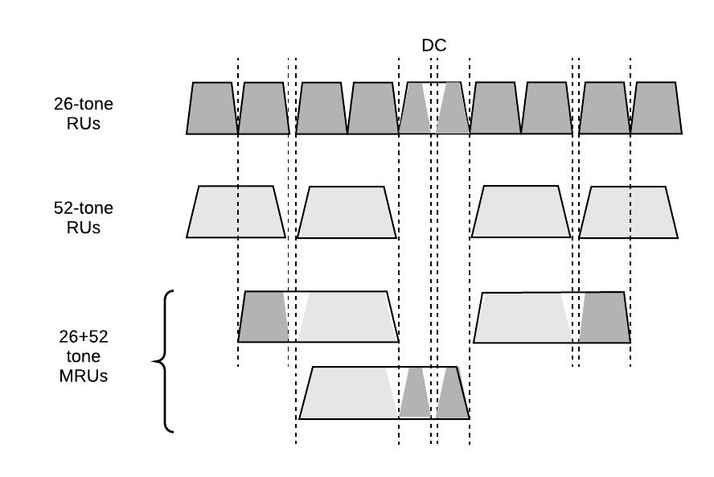

Figure 36-5 – Allowed 26+52 tone MRUs in a 20 MHz EHT PPDU

The allowed 26+52 tone MRUs in a 40 MHz EHT PPDU are indicated in Figure 36-6 (Allowed 26+52 tone MRUs in a 40 MHz EHT PPDU).

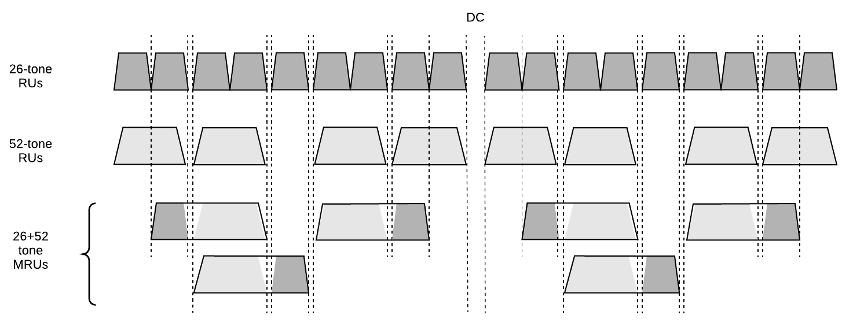

Figure 36-6 – Allowed 26+52 tone MRUs in a 40 MHz EHT PPDU

The allowed 26+52 tone MRUs in each 80 MHz segment of an 80 MHz, 160 MHz or 320 MHz EHT PPDU are indicated in Figure 36-7 (Allowed 26+52 tone MRUs in each 80 MHz segment of an 80 MHz, 160 MHz, or 320 MHz EHT PPDU).

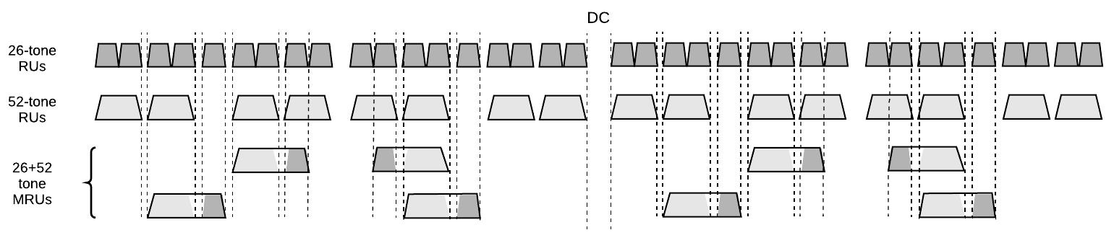

Figure 36-7 – Allowed 26+52 tone MRUs in each 80 MHz segment of an 80 MHz, 160 MHz, or 320 MHz EHT PPDU

The allowed 26+106 tone MRUs in a 20 MHz EHT PPDU are indicated in Figure 36-8 (Allowed 26+106 tone MRUs in a 20 MHz EHT PPDU).
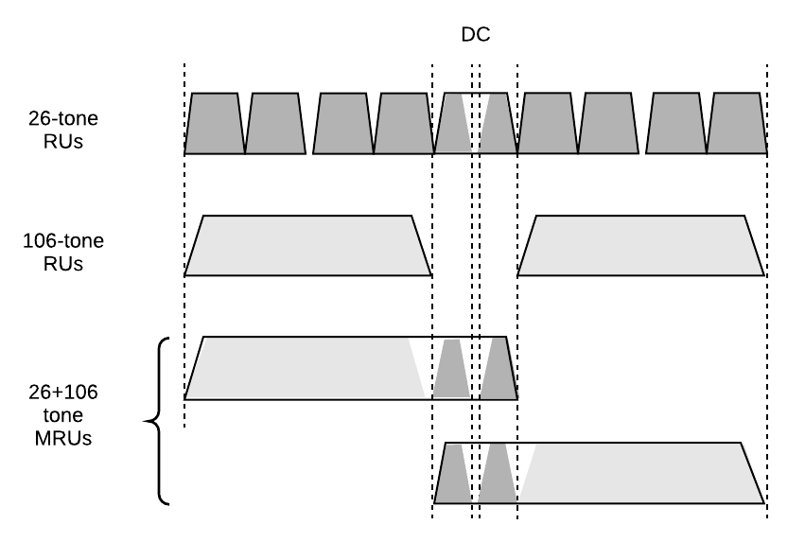
Figure 36-8 – Allowed 26+106 tone MRUs in a 20 MHz EHT PPDU

The allowed 26+106 tone MRUs in a 40 MHz EHT PPDU are indicated in Figure 36-9 (Allowed 26+106 tone MRUs in a 40 MHz EHT PPDU).

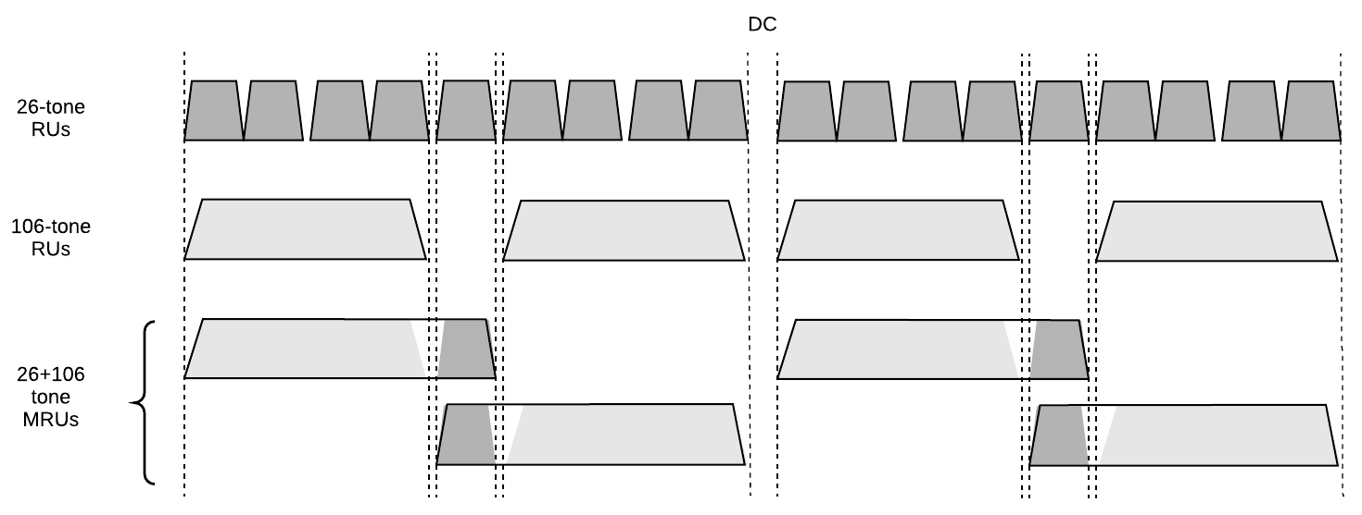

Figure 36-9 – Allowed 26+106 tone MRUs in a 40 MHz EHT PPDU

The allowed 26+106 tone MRUs in each 80 MHz segment of an 80 MHz, 160 MHz or 320 MHz EHT PPDU are indicated in Figure 36-10 (Allowed 26+106 tone MRUs in each 80 MHz segment of an 80 MHz, 160 MHz, or 320 MHz EHT PPDU).

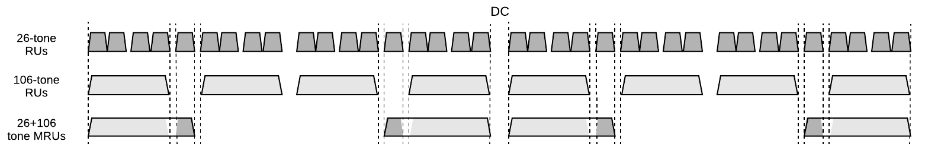

Figure 36-10 – Allowed 26+106 tone MRUs in each 80 MHz segment of an 80 MHz, 160 MHz, or 320 MHz EHT PPDU

The location of the small size MRUs are fixed as defined in Table 36-X1 (Indices for small size MRUs in an OFDMA 20 MHz EHT PPDU), Table 36-X2 (Indices for small-size MRUs in an OFDMA 40 MHz EHT PPDU), Table 36-X3 (Indices for small size MRUs in an OFDMA 80 MHz EHT PPDU), Table 36-X4 (Indices for small size MRUs in an OFDMA 160 MHz EHT PPDU), and Table 36-X5 (Indices for small size MRUs in an OFDMA 320 MHz EHT PPDU).

Table 36-X1 - Indices for small size MRUs in an OFDMA 20 MHz EHT PPDU
MRU type | MRU index | MRU combination
26+52 tone MRU | MRU 1 | 52-tone RU 2 + 26-tone RU 2
 | MRU 2 | 52-tone RU 2 + 26-tone RU 5
 | MRU 3 | 52-tone RU 3 + 26-tone RU 8
26+106 tone MRU | MRU 1 | 106-tone RU 1 + 26-tone RU 5
 | MRU 2 | 106-tone RU 2 + 26-tone RU 5

Table 36-X2 - Indices for small size MRUs in an OFDMA 40 MHz EHT PPDU
MRU type | MRU index | MRU combination
26+52 tone MRU | MRU 1 | 52-tone RU 2 + 26-tone RU 2
 | MRU 2 | 52-tone RU 2 + 26-tone RU 5
 | MRU 3 | 52-tone RU 3 + 26-tone RU 8
 | MRU 4 | 52-tone RU 6 + 26-tone RU 11
 | MRU 5 | 52-tone RU 6 + 26-tone RU 14
 | MRU 6 | 52-tone RU 7 + 26-tone RU 17
26+106 tone MRU | MRU 1 | 106-tone RU 1 + 26-tone RU 5
 | MRU 2 | 106-tone RU 2 + 26-tone RU 5
 | MRU 3 | 106-tone RU 3 + 26-tone RU 14
 | MRU 4 | 106-tone RU 4 + 26-tone RU 14

Table 36-X3 - Indices for small size MRUs in an OFDMA 80 MHz EHT PPDU
MRU type | MRU index | MRU combination | Note
26+52 tone MRU | MRU 1 | 52-tone RU 2 + 26-tone RU 2 | Not supported
 | MRU 2 | 52-tone RU 2 + 26-tone RU 5 | -
 | MRU 3 | 52-tone RU 3 + 26-tone RU 8 | -
 | MRU 4 | 52-tone RU 6 + 26-tone RU 11 | -
 | MRU 5 | 52-tone RU 6 + 26-tone RU 14 | -
 | MRU 6 | 52-tone RU 7 + 26-tone RU 17 | Not supported
 | MRU 7 | 52-tone RU 10 + 26-tone RU 21 | Not supported
 | MRU 8 | 52-tone RU 10 + 26-tone RU 24 | -
 | MRU 9 | 52-tone RU 11 + 26-tone RU 27 | -
 | MRU 10 | 52-tone RU 14 + 26-tone RU 30 | -
 | MRU 11 | 52-tone RU 14 + 26-tone RU 33 | -
 | MRU 12 | 52-tone RU 15 + 26-tone RU 36 | Not supported
26+106 tone MRU | MRU 1 | 106-tone RU 1 + 26-tone RU 5 | -
 | MRU 2 | 106-tone RU 2 + 26-tone RU 5 | Not supported
 | MRU 3 | 106-tone RU 3 + 26-tone RU 14 | Not supported
 | MRU 4 | 106-tone RU 4 + 26-tone RU 14 | -
 | MRU 5 | 106-tone RU 5 + 26-tone RU 24 | -
 | MRU 6 | 106-tone RU 6 + 26-tone RU 24 | Not supported
 | MRU 7 | 106-tone RU 7 + 26-tone RU 33 | Not supported
 | MRU 8 | 106-tone RU 8 + 26-tone RU 33 | -

Table 36-X4 - Indices for small size MRUs in an OFDMA 160 MHz EHT PPDU
MRU type | MRU index | MRU combination | Note
26+52 tone MRU | MRU 1 | 52-tone RU 2 + 26-tone RU 2 | Not supported
 | MRU 2 | 52-tone RU 2 + 26-tone RU 5 | -
 | MRU 3 | 52-tone RU 3 + 26-tone RU 8 | -
 | MRU 4 | 52-tone RU 6 + 26-tone RU 11 | -
 | MRU 5 | 52-tone RU 6 + 26-tone RU 14 | -
 | MRU 6 | 52-tone RU 7 + 26-tone RU 17 | Not supported
 | MRU 7 | 52-tone RU 10 + 26-tone RU 21 | Not supported
 | MRU 8 | 52-tone RU 10 + 26-tone RU 24 | -
 | MRU 9 | 52-tone RU 11 + 26-tone RU 27 | -
 | MRU 10 | 52-tone RU 14 + 26-tone RU 30 | -
 | MRU 11 | 52-tone RU 14 + 26-tone RU 33 | -
 | MRU 12 | 52-tone RU 15 + 26-tone RU 36 | Not supported
 | MRU 13 | 52-tone RU 18 + 26-tone RU 39 | Not supported
 | MRU 14 | 52-tone RU 18 + 26-tone RU 42 | -
 | MRU 15 | 52-tone RU 19 + 26-tone RU 45 | -
 | MRU 16 | 52-tone RU 22 + 26-tone RU 48 | -
 | MRU 17 | 52-tone RU 22 + 26-tone RU 51 | -
 | MRU 18 | 52-tone RU 23 + 26-tone RU 54 | Not supported
 | MRU 19 | 52-tone RU 26 + 26-tone RU 58 | Not supported
 | MRU 20 | 52-tone RU 26 + 26-tone RU 61 | -
 | MRU 21 | 52-tone RU 27 + 26-tone RU 64 | -
 | MRU 22 | 52-tone RU 30 + 26-tone RU 67 | -
 | MRU 23 | 52-tone RU 30 + 26-tone RU 70 | -
 | MRU 24 | 52-tone RU 31 + 26-tone RU 73 | Not supported
26+106 tone MRU | MRU 1 | 106-tone RU 1 + 26-tone RU 5 | -
 | MRU 2 | 106-tone RU 2 + 26-tone RU 5 | Not supported
 | MRU 3 | 106-tone RU 3 + 26-tone RU 14 | Not supported
 | MRU 4 | 106-tone RU 4 + 26-tone RU 14 | -
 | MRU 5 | 106-tone RU 5 + 26-tone RU 24 | -
 | MRU 6 | 106-tone RU 6 + 26-tone RU 24 | Not supported
 | MRU 7 | 106-tone RU 7 + 26-tone RU 33 | Not supported
 | MRU 8 | 106-tone RU 8 + 26-tone RU 33 | -
 | MRU 9 | 106-tone RU 9 + 26-tone RU 42 | -
 | MRU 10 | 106-tone RU 10 + 26-tone RU 42 | Not supported
 | MRU 11 | 106-tone RU 11 + 26-tone RU 51 | Not supported
 | MRU 12 | 106-tone RU 12 + 26-tone RU 51 | -
 | MRU 13 | 106-tone RU 13 + 26-tone RU 61 | -
 | MRU 14 | 106-tone RU 14 + 26-tone RU 61 | Not supported
 | MRU 15 | 106-tone RU 15 + 26-tone RU 70 | Not supported
 | MRU 16 | 106-tone RU 16 + 26-tone RU 70 | -

Table 36-X5 - Indices for small size MRUs in an OFDMA 320 MHz EHT PPDU
MRU type | MRU index | MRU combination | Note
26+52 tone MRU | MRU 1 | 52-tone RU 2 + 26-tone RU 2 | Not supported
 | MRU 2 | 52-tone RU 2 + 26-tone RU 5 | -
 | MRU 3 | 52-tone RU 3 + 26-tone RU 8 | -
 | MRU 4 | 52-tone RU 6 + 26-tone RU 11 | -
 | MRU 5 | 52-tone RU 6 + 26-tone RU 14 | -
 | MRU 6 | 52-tone RU 7 + 26-tone RU 17 | Not supported
 | MRU 7 | 52-tone RU 10 + 26-tone RU 21 | Not supported
 | MRU 8 | 52-tone RU 10 + 26-tone RU 24 | -
 | MRU 9 | 52-tone RU 11 + 26-tone RU 27 | -
 | MRU 10 | 52-tone RU 14 + 26-tone RU 30 | -
 | MRU 11 | 52-tone RU 14 + 26-tone RU 33 | -
 | MRU 12 | 52-tone RU 15 + 26-tone RU 36 | Not supported
 | MRU 13 | 52-tone RU 18 + 26-tone RU 39 | Not supported
 | MRU 14 | 52-tone RU 18 + 26-tone RU 42 | -
 | MRU 15 | 52-tone RU 19 + 26-tone RU 45 | -
 | MRU 16 | 52-tone RU 22 + 26-tone RU 48 | -
 | MRU 17 | 52-tone RU 22 + 26-tone RU 51 | -
 | MRU 18 | 52-tone RU 23 + 26-tone RU 54 | Not supported
 | MRU 19 | 52-tone RU 26 + 26-tone RU 58 | Not supported
 | MRU 20 | 52-tone RU 26 + 26-tone RU 61 | -
 | MRU 21 | 52-tone RU 27 + 26-tone RU 64 | -
 | MRU 22 | 52-tone RU 30 + 26-tone RU 67 | -
 | MRU 23 | 52-tone RU 30 + 26-tone RU 70 | -
 | MRU 24 | 52-tone RU 31 + 26-tone RU 73 | Not supported
 | MRU 25 | 52-tone RU 34 + 26-tone RU 76 | Not supported
 | MRU 26 | 52-tone RU 34 + 26-tone RU 79 | -
 | MRU 27 | 52-tone RU 37 + 26-tone RU 82 | -
 | MRU 28 | 52-tone RU 38 + 26-tone RU 85 | -
 | MRU 29 | 52-tone RU 38 + 26-tone RU 88 | -
 | MRU 30 | 52-tone RU 39 + 26-tone RU 91 | Not supported
 | MRU 31 | 52-tone RU 42 + 26-tone RU 95 | Not supported
 | MRU 32 | 52-tone RU 42 + 26-tone RU 98 | -
 | MRU 33 | 52-tone RU 43 + 26-tone RU 101 | -
 | MRU 34 | 52-tone RU 46 + 26-tone RU 104 | -
 | MRU 35 | 52-tone RU 46 + 26-tone RU 107 | -
 | MRU 36 | 52-tone RU 47 + 26-tone RU 110 | Not supported
 | MRU 37 | 52-tone RU 50 + 26-tone RU 113 | Not supported
 | MRU 38 | 52-tone RU 50 + 26-tone RU 116 | -
 | MRU 39 | 52-tone RU 51 + 26-tone RU 119 | -
 | MRU 40 | 52-tone RU 54 + 26-tone RU 122 | -
 | MRU 41 | 52-tone RU 54 + 26-tone RU 125 | -
 | MRU 42 | 52-tone RU 55 + 26-tone RU 128 | Not supported
 | MRU 43 | 52-tone RU 58 + 26-tone RU 132 | Not supported
 | MRU 44 | 52-tone RU 58 + 26-tone RU 135 | -
 | MRU 45 | 52-tone RU 59 + 26-tone RU 138 | -
 | MRU 46 | 52-tone RU 62 + 26-tone RU 141 | -
 | MRU 47 | 52-tone RU 62 + 26-tone RU 144 | -
 | MRU 48 | 52-tone RU 63 + 26-tone RU 147 | Not supported
26+106 tone MRU | MRU 1 | 106-tone RU 1 + 26-tone RU 5 | -
 | MRU 2 | 106-tone RU 2 + 26-tone RU 5 | Not supported
 | MRU 3 | 106-tone RU 3 + 26-tone RU 14 | Not supported
 | MRU 4 | 106-tone RU 4 + 26-tone RU 14 | -
 | MRU 5 | 106-tone RU 5 + 26-tone RU 24 | -
 | MRU 6 | 106-tone RU 6 + 26-tone RU 24 | Not supported
 | MRU 7 | 106-tone RU 7 + 26-tone RU 33 | Not supported
 | MRU 8 | 106-tone RU 8 + 26-tone RU 33 | -
 | MRU 9 | 106-tone RU 9 + 26-tone RU 42 | -
 | MRU 10 | 106-tone RU 10 + 26-tone RU 42 | Not supported
 | MRU 11 | 106-tone RU 11 + 26-tone RU 51 | Not supported
 | MRU 12 | 106-tone RU 12 + 26-tone RU 51 | -
 | MRU 13 | 106-tone RU 13 + 26-tone RU 61 | -
 | MRU 14 | 106-tone RU 14 + 26-tone RU 61 | Not supported
 | MRU 15 | 106-tone RU 15 + 26-tone RU 70 | Not supported
 | MRU 16 | 106-tone RU 16 + 26-tone RU 70 | -
 | MRU 17 | 106-tone RU 17 + 26-tone RU 79 | -
 | MRU 18 | 106-tone RU 18+ 26-tone RU 79 | Not supported
 | MRU 19 | 106-tone RU 19+ 26-tone RU 88 | Not supported
 | MRU 20 | 106-tone RU 20 + 26-tone RU 88 | -
 | MRU 21 | 106-tone RU 21 + 26-tone RU 98 | -
 | MRU 22 | 106-tone RU 22 + 26-tone RU 98 | Not supported
 | MRU 23 | 106-tone RU 23 + 26-tone RU 107 | Not supported
 | MRU 24 | 106-tone RU 24 + 26-tone RU 107 | -
 | MRU 25 | 106-tone RU 25 + 26-tone RU 116 | -
 | MRU 26 | 106-tone RU 26 + 26-tone RU 116 | Not supported
 | MRU 27 | 106-tone RU 27 + 26-tone RU 125 | Not supported
 | MRU 28 | 106-tone RU 28 + 26-tone RU 125 | -
 | MRU 29 | 106-tone RU 29 + 26-tone RU 135 | -
 | MRU 30 | 106-tone RU 30 + 26-tone RU 135 | Not supported
 | MRU 31 | 106-tone RU 31 + 26-tone RU 144 | Not supported
 | MRU 32 | 106-tone RU 32 + 26-tone RU 144 | -

For Table 36-X1 (Indices for small size MRUs in an OFDMA 20 MHz EHT PPDU), the indices for MRUs are defined based on the indices for RUs in Table 27-7 (Data and pilot subcarrier indices for RUs in a 20 MHz HE PPDU and in a non-OFDMA 20 MHz HE PPDU).

For Table 36-X2 (Indices for small size MRUs in an OFDMA 40 MHz EHT PPDU), the indices for MRUs are defined based on the indices for RUs in Table 27-8 (Data and pilot subcarrier indices for RUs in a 40 MHz HE PPDU and in a non-OFDMA 20 MHz HE PPDU).

For Table 36-X3 (Indices for small size MRUs in an OFDMA 80 MHz EHT PPDU), the indices for MRUs are defined based on the indices for RUs in Table 36-5 (Data and pilot subcarrier indices for RUs in an 80 MHz EHT PPDU).

For Table 36-X4 (Indices for small size MRUs in an OFDMA 160 MHz EHT PPDU), the indices for MRUs are defined based on the indices for RUs in Table 36-6 (Data and pilot subcarrier indices for RUs in a 160 MHz EHT PPDU).

For Table 36-X5 (Indices for small size MRUs in an OFDMA 320 MHz EHT PPDU), the indices for MRUs are defined based on the indices for RUs in Table 36-7 (Data and pilot subcarrier indices for RUs in a 320 MHz EHT PPDU).

It is mandatory for a non-AP STA to support the transmission and reception of 26+52 tone and 26+106 tone MRUs in OFDMA.

36.3.2.3 Large-Size Multiple RUs

The large size MRUs defined for DL and UL transmissions in non-OFDMA format are as follows: 484+242 tone MRU, 996+484 tone MRU, 996+484+242 tone MRU, 2×996+484 tone MRU, 3×996-tone MRU, and 3×996+484 tone MRU.

The 484+242 tone MRU is allowed in non-OFDMA 80 MHz EHT PPDU. The 484+242 tone MRU is obtained by puncturing any one of four 242-tone RUs in the 80 MHz EHT PPDU. The data subcarriers of a 484+242 tone MRU consist of the data subcarriers of the 484-tone and 242-tone RUs that make up the 484+242 tone MRU. The pilot subcarriers of a 484+242 tone MRU consist of the pilot subcarriers of the 484-tone and 242-tone RUs that make up the 484+242 tone MRU. The four allowed 484+242 tone MRUs in non-OFDMA 80 MHz EHT PPDU are shown in Figure 36-11 (Allowed 484+242 tone MRUs in non-OFDMA 80 MHz EHT PPDU).

Figure 36-11 – Allowed 484+242 tone MRUs in non-OFDMA 80 MHz EHT PPDU

The 996+484 tone MRU is allowed in non-OFDMA 160 MHz EHT PPDU. The 996+484 tone MRU is obtained by puncturing any one of four 484-tone RUs in the 160 MHz EHT PPDU. The data subcarriers of a 996+484 tone MRU consist of the data subcarriers of the 996-tone and 484-tone RUs that make up the 996+484 tone MRU. The pilot subcarriers of a 996+484 tone MRU consist of the pilot subcarriers of the 996-tone and 484-tone RUs that make up the 996+484 tone MRU. The four allowed 996+484 tone MRUs in non-OFDMA 160 MHz EHT PPDU are shown in Figure 36-12 (Allowed 996+484 tone MRUs in non-OFDMA 160 MHz EHT PPDU).

Figure 36-12 – Allowed 996+484 tone MRUs in non-OFDMA 160 MHz EHT PPDU

The 996+484+242 tone MRU is allowed in non-OFDMA 160 MHz EHT PPDU. The 996+484+242 tone MRU is obtained by puncturing any one of eight 242-tone RUs in the 160 MHz EHT PPDU. The data subcarriers of a 996+484+242 tone MRU consist of the data subcarriers of the 996-tone, 484-tone, and 242-tone RUs that make up the 996+484+242 tone MRU. The pilot subcarriers of a 996+484+242 tone MRU consist of the pilot subcarriers of the 996-tone, 484-tone, and 242-tone RUs that make up the 996+484+242 tone MRU. The eight allowed 996+484+242 tone MRUs in non-OFDMA 160 MHz EHT PPDU are shown in Figure 36-13 (Allowed 996+484+242 tone MRUs in non-OFDMA 160 MHz EHT PPDU).

Figure 36-13 – Allowed 996+484+242 tone MRUs in non-OFDMA 160 MHz EHT PPDU

The 2×996+484 tone MRU is allowed in non-OFDMA 320 MHz EHT PPDU. The 2×996+484 tone MRU is obtained by puncturing either the first or the fourth 996-tone RU in a 320 MHz EHT PPDU and puncturing any one of six 484-tone RUs in the remaining 240 MHz. The data subcarriers of a 2×996+484 tone MRU consist of the data subcarriers of the two 996-tone RUs and a 484-tone RU that make up the 2×996+484 tone MRU. The pilot subcarriers of a 2×996+484 tone MRU consist of the pilot subcarriers of the two 996-tone RUs and a 484-tone RU that make up the 2×996+484 tone MRU. The twelve allowed 2×996+484 tone MRUs in non-OFDMA 320 MHz EHT PPDU are shown in Figure 36-14 (Allowed 2×996+484 tone MRUs in non-OFDMA 320 MHz EHT PPDU).

Figure 36-14 – Allowed 2×996+484 tone MRUs in non-OFDMA 320 MHz EHT PPDU

The 3×996-tone MRU is allowed in non-OFDMA 320 MHz EHT PPDU. The 3×996-tone MRU is obtained by puncturing any one of four 996-tone RUs in the 320 MHz EHT PPDU. The data subcarriers of a 3996-tone MRU consist of the data subcarriers of the three 996-tone RUs that make up the 3×996-tone MRU. The pilot subcarriers of a 3×996-tone MRU consist of the pilot subcarriers of the three 996-tone RUs that make up the 3×996-tone MRU. The four allowed 3×996-tone MRUs in non-OFDMA 320 MHz EHT PPDU are shown in Figure 36-15 (Allowed 3×996 tone MRUs in non-OFDMA 320 MHz EHT PPDU).

Figure 36-15 – Allowed 3×996-tone MRUs in non-OFDMA 320 MHz EHT PPDU

The 3×996+484 tone MRU is allowed in non-OFDMA 320 MHz EHT PPDU. The 3×996+484 tone MRU is obtained by puncturing any one of eight 484-tone RUs in the 320 MHz EHT PPDU. The data subcarriers of a 3×996+484 tone MRU consist of the data subcarriers of the three 996-tone RUs and a 484-tone RU that make up the 3×996+484 tone MRU. The pilot subcarriers of a 3×996+484 tone MRU consist of the pilot subcarriers of the three 996-tone RUs and a 484-tone RU that make up the 3×996+484 tone MRU. The eight allowed 3×996+484 MRUs in non-OFDMA 320 MHz EHT PPDU are shown in Figure 36-16 (Allowed 3×996+484 tone MRUs in non-OFDMA 320 MHz EHT PPDU).

Figure 36-16 – Allowed 3×996+484 tone MRUs in non-OFDMA 320 MHz EHT PPDU

It is mandatory for AP and STA to support the transmission and reception of 484+242 tone MRU in 80 MHz PPDU, 996+484 tone MRU in 160 MHz PPDU, 996+484+242 tone MRU in 160 MHz PPDU, 2×996+484 tone MRU in 320 MHz PPDU, 3×996-tone MRU in 320 MHz PPDU, and 3×996+484 tone MRU in 320 MHz PPDU in non-OFDMA unless the MRU size is larger than its supported bandwidth.

The large size MRU defined for DL and UL in OFDMA format are as follows: 484+242 tone MRU, 996+484 tone MRU, 2×996+484 tone MRU, 3×996-tone MRU, and 3×996+484 tone MRU.

The 484+242 tone MRU is allowed in OFDMA 80 MHz, 160 MHz, and 320 MHz EHT PPDU. The 484+242 tone MRU is obtained by combining a 484-tone RU and a 242-tone RU. The data subcarriers of a 484+242 tone MRU consist of the data subcarriers of the 484-tone and 242-tone RUs that make up the 484+242 tone MRU. The pilot subcarriers of a 484+242 tone MRU consist of the pilot subcarriers of the 484-tone and 242-tone RUs that make up the 484+242 tone MRU. For OFDMA 80 MHz EHT PPDU, the four allowed 484+242 tone MRUs are shown in Figure 36-17 (Allowed 484+242 tone MRUs in OFDMA 80 MHz EHT PPDU).

Figure 36-17 – Allowed 484+242 tone MRUs in OFDMA 80 MHz EHT PPDU

For OFDMA transmission in 160 MHz and 320 MHz, the allowed combinations for a 484+242 tone MRU in OFDMA 80 MHz EHT PPDU are allowed in each 80 MHz segment of OFDMA 160 MHz and 320 MHz EHT PPDU.

The 996+484 tone MRU is allowed in OFDMA 160 MHz and 320 MHz EHT PPDU. The 996+484 tone MRU is obtained by combining a 996-tone RU and a 484-tone RU. The data subcarriers of a 996+484 tone MRU consist of the data subcarriers of the 996-tone and 484-tone RUs that make up the 996+484 tone MRU. The pilot subcarriers of a 996+484 tone MRU consist of the pilot subcarriers of the 996-tone and 484-tone RUs that make up the 996+484 tone MRU. For OFDMA 160 MHz EHT PPDU, the four allowed 996+484 tone MRUs are shown in Figure 36-18 (Allowed 996+484 tone MRUs in OFDMA 160 MHz EHT PPDU).

Figure 36-18 – Allowed 996+484 tone MRUs in OFDMA 160MHz EHT PPDU

For OFDMA transmission in 320 MHz, the allowed combinations for a 996+484 tone MRU in OFDMA 160 MHz EHT PPDU are allowed only within primary 160 MHz channel or secondary 160 MHz channel, respectively.

The 2×996+484 tone MRU is allowed in OFDMA 320 MHz EHT PPDU. The 2×996+484 tone MRU is obtained by combining two 996-tone RUs and a 484-tone RU. The data subcarriers of a 2×996+484 tone MRU consist of the data subcarriers of the two 996-tone RUs and a 484-tone RU that make up the 2×996+484 tone MRU. The pilot subcarriers of a 2×996+484 tone MRU consist of the pilot subcarriers of the two 996-tone RUs and a 484-tone RU that make up the 2×996+484 tone MRU. The twelve allowed 2×996+484 tone MRUs in OFDMA 320 MHz EHT PPDU are shown in Figure 36-19 (Allowed 2×996+484 tone MRUs in OFDMA 320 MHz EHT PPDU).

Figure 36-19 – Allowed 2×996+484 tone MRUs in OFDMA 320 MHz EHT PPDU

The 3×996-tone MRU is allowed in OFDMA 320 MHz EHT PPDU. The 3×996-tone MRU is obtained by combining three 996-tone RUs. The data subcarriers of a 3×996-tone MRU consist of the data subcarriers of the three 996-tone RUs that make up the 3×996-tone MRU. The pilot subcarriers of a 3×996-tone MRU consist of the pilot subcarriers of the three 996-tone RUs that make up the 3×996-tone MRU. The four allowed 3×996-tone MRUs in OFDMA 320 MHz EHT PPDU are shown in Figure 36-20 (Allowed 3×996 tone MRUs in OFDMA 320 MHz EHT PPDU).
Figure 36-20 – Allowed 3×996-tone MRUs in OFDMA 320 MHz EHT PPDU

The 3×996+484 tone MRU is allowed in OFDMA 320 MHz EHT PPDU. The 3×996-tone MRU is obtained by combining three 996-tone RUs and a 484-tone RU. The data subcarriers of a 3×996+484 tone MRU consist of the data subcarriers of the three 996-tone RUs and a 484-tone RU that make up the 3×996+484 tone MRU. The pilot subcarriers of a 3×996+484 tone MRU consist of the pilot subcarriers of the three 996-tone RUs and a 484-tone RU that make up the 3×996+484 tone MRU. The eight allowed 3×996+484 MRUs in OFDMA 320 MHz EHT PPDU are shown in Figure 36-21 (Allowed 3×996+484 tone MRUs in OFDMA 320 MHz EHT PPDU).

Figure 36-21 – Allowed 3×996+484 tone MRUs in OFDMA 320 MHz EHT PPDU

The location of the large size MRUs are fixed as defined in Table 36-X6 (Indices for large size MRUs in an 80 MHz EHT PPDU and in a non-OFDMA 80 MHz EHT PPDU), Table 36-X7 (Indices for large size MRUs in a 160 MHz EHT PPDU and in a non-OFDMA 160 MHz EHT PPDU), and Table 36-X8 (Indices for large size MRUs in a 320 MHz EHT PPDU and in a non-OFDMA 320 MHz EHT PPDU).

Table 36-X6 - Indices for large size MRUs in an 80 MHz EHT PPDU and in a non-OFDMA 80 MHz EHT PPDU
MRU type | MRU index | MRU combination
484+242 tone MRU | MRU 1 | 484+242 tone MRU; [empty-RU242 RU242 RU484]
 | MRU 2 | 484+242 tone MRU; [RU242 empty-RU242 RU484]
 | MRU 3 | 484+242 tone MRU; [RU484 empty-RU242 RU242]
 | MRU 4 | 484+242 tone MRU; [RU484 RU242 empty-RU242]

Table 36-X7 - Indices for large size MRUs in a 160 MHz EHT PPDU and in a non-OFDMA 160 MHz EHT PPDU
MRU type | MRU index | MRU combination
484+242 tone MRU | MRU 1 | 484+242 tone MRU; [empty-RU242 RU242 RU484] in lower 80 MHz channel
 | MRU 2 | 484+242 tone MRU; [RU242 empty-RU242 RU484] in lower 80 MHz channel
 | MRU 3 | 484+242 tone MRU; [RU484 empty-RU242 RU242] in lower 80 MHz channel
 | MRU 4 | 484+242 tone MRU; [RU484 RU242 empty-RU242] in lower 80 MHz channel
 | MRU 5 | 484+242 tone MRU; [empty-RU242 RU242 RU484] in upper 80 MHz channel
 | MRU 6 | 484+242 tone MRU; [RU242 empty-RU242 RU484] in upper 80 MHz channel
 | MRU 7 | 484+242 tone MRU; [RU484 empty-RU242 RU242] in upper 80 MHz channel
 | MRU 8 | 484+242 tone MRU; [RU484 RU242 empty-RU242] in upper 80 MHz channel
996+484 tone MRU | MRU 1 | 996+484 tone MRU; [empty-RU484 RU484 RU996]
 | MRU 2 | 996+484 tone MRU; [RU484 empty-RU484 RU996]
 | MRU 3 | 996+484 tone MRU; [RU996 empty-RU484 RU484]
 | MRU 4 | 996+484 tone MRU; [RU996 RU484 empty-RU484]
996+484+242 tone MRU (Only for non-OFDMA) | MRU 1 | 996+484+242 tone MRU; [empty-RU242 RU242 RU484 RU996]
 | MRU 2 | 996+484+242 tone MRU; [RU242 empty-RU242 RU484 RU996]
 | MRU 3 | 996+484+242 tone MRU; [RU484 empty-RU242 RU242 RU996]
 | MRU 4 | 996+484+242 tone MRU; [RU484 RU242 empty-RU242 RU996]
 | MRU 5 | 996+484+242 tone MRU; [RU996 empty-RU242 RU242 RU484]
 | MRU 6 | 996+484+242 tone MRU; [RU996 RU242 empty-RU242 RU484]
 | MRU 7 | 996+484+242 tone MRU; [RU996 RU484 empty-RU242 RU242]
 | MRU 8 | 996+484+242 tone MRU; [RU996 RU484 RU242 empty-RU242]

Table 36-X8 - Indices for large size MRUs in a 320 MHz EHT PPDU and in a non-OFDMA 320 MHz EHT PPDU
MRU type | MRU index | MRU combination
484+242 tone MRU | MRU 1 | 484+242 tone MRU; [empty-RU242 RU242 RU484] in lower 80 MHz channel in lower 160 MHz
 | MRU 2 | 484+242 tone MRU; [RU242 empty-RU242 RU484] in lower 80 MHz channel in lower 160 MHz
 | MRU 3 | 484+242 tone MRU; [RU484 empty-RU242 RU242] in lower 80 MHz channel in lower 160 MHz
 | MRU 4 | 484+242 tone MRU; [RU484 RU242 empty-RU242] in lower 80 MHz channel in lower 160 MHz
 | MRU 5 | 484+242 tone MRU; [empty-RU242 RU242 RU484] in upper 80 MHz channel in lower 160 MHz
 | MRU 6 | 484+242 tone MRU; [RU242 empty-RU242 RU484] in upper 80 MHz channel in lower 160 MHz
 | MRU 7 | 484+242 tone MRU; [RU484 empty-RU242 RU242] in upper 80 MHz channel in lower 160 MHz
 | MRU 8 | 484+242 tone MRU; [RU484 RU242 empty-RU242] in upper 80 MHz channel in lower 160 MHz
 | MRU 9 | 484+242 tone MRU; [empty-RU242 RU242 RU484] in lower 80 MHz channel in upper 160 MHz
 | MRU 10 | 484+242 tone MRU; [RU242 empty-RU242 RU484] in lower 80 MHz channel in upper 160 MHz
 | MRU 11 | 484+242 tone MRU; [RU484 empty-RU242 RU242] in lower 80 MHz channel in upper 160 MHz
 | MRU 12 | 484+242 tone MRU; [RU484 RU242 empty-RU242] in lower 80 MHz channel in upper 160 MHz
 | MRU 13 | 484+242 tone MRU; [empty-RU242 RU242 RU484] in upper 80 MHz channel in upper 160 MHz
 | MRU 14 | 484+242 tone MRU; [RU242 empty-RU242 RU484] in upper 80 MHz channel in upper 160 MHz
 | MRU 15 | 484+242 tone MRU; [RU484 empty-RU242 RU242] in upper 80 MHz channel in upper 160 MHz
 | MRU 16 | 484+242 tone MRU; [RU484 RU242 empty-RU242] in upper 80 MHz channel in upper 16 0MHz
996+484 tone MRU | MRU 1 | 996+484 tone MRU; [empty-RU484 RU484 RU996] in lower 160 MHz
 | MRU 2 | 996+484 tone MRU; [RU484 empty-RU484 RU996] in lower 160 MHz
 | MRU 3 | 996+484 tone MRU; [RU996 empty-RU484 RU484] in lower 160 MHz
 | MRU 4 | 996+484 tone MRU; [RU996 RU484 empty-RU484] in lower 160 MHz
 | MRU 5 | 996+484 tone MRU; [empty-RU484 RU484 RU996] in upper 160 MHz
 | MRU 6 | 996+484 tone MRU; [RU484 empty-RU484 RU996] in upper 160 MHz
 | MRU 7 | 996+484 tone MRU; [RU996 empty-RU484 RU484] in upper 160 MHz
 | MRU 8 | 996+484 tone MRU; [RU996 RU484 empty-RU484] in upper 160 MHz
996+484+242 tone MRU (Only for non-OFDMA) | MRU 1 | 996+484+242 tone MRU; [empty-RU242 RU242 RU484 RU996] in lower 160 MHz
 | MRU 2 | 996+484+242 tone MRU; [RU242 empty-RU242 RU484 RU996] in lower 160 MHz
 | MRU 3 | 996+484+242 tone MRU; [RU484 empty-RU242 RU242 RU996] in lower 160 MHz
 | MRU 4 | 996+484+242 tone MRU; [RU484 RU242 empty-RU242 RU996] in lower 160 MHz
 | MRU 5 | 996+484+242 tone MRU; [RU996 empty-RU242 RU242 RU484] in lower 160 MHz
 | MRU 6 | 996+484+242 tone MRU; [RU996 RU242 empty-RU242 RU484] in lower 160 MHz
 | MRU 7 | 996+484+242 tone MRU; [RU996 RU484 empty-RU242 RU242] in lower 160 MHz
 | MRU 8 | 996+484+242 tone MRU; [RU996 RU484 RU242 empty-RU242] in lower 160 MHz
 | MRU 9 | 996+484+242 tone MRU; [empty-RU242 RU242 RU484 RU996] in upper 160 MHz
 | MRU 10 | 996+484+242 tone MRU; [RU242 empty-RU242 RU484 RU996] in upper 160 MHz
 | MRU 11 | 996+484+242 tone MRU; [RU484 empty-RU242 RU242 RU996] in upper 160 MHz
 | MRU 12 | 996+484+242 tone MRU; [RU484 RU242 empty-RU242 RU996] in upper 160 MHz
 | MRU 13 | 996+484+242 tone MRU; [RU996 empty-RU242 RU242 RU484] in upper 160 MHz
 | MRU 14 | 996+484+242 tone MRU; [RU996 RU242 empty-RU242 RU484] in upper 160 MHz
 | MRU 15 | 996+484+242 tone MRU; [RU996 RU484 empty-RU242 RU242] in upper 160 MHz
 | MRU 16 | 996+484+242 tone MRU; [RU996 RU484 RU242 empty-RU242] in upper 160 MHz
2×996+484 tone MRU | MRU 1 | 2×996+484 tone MRU; [empty-RU484 RU484 RU996 RU996 empty-RU996]
 | MRU 2 | 2×996+484 tone MRU; [RU484 empty-RU484 RU996 RU996 empty-RU996]
 | MRU 3 | 2×996+484 tone MRU; [RU996 empty-RU484 RU484 RU996 empty-RU996]
 | MRU 4 | 2×996+484 tone MRU; [RU996 RU484 empty-RU484 RU996 empty-RU996]
 | MRU 5 | 2×996+484 tone MRU; [RU996 RU996 empty-RU484 RU484 empty-RU996]
 | MRU 6 | 2×996+484 tone MRU; [RU996 RU996 RU484 empty-RU484 empty-RU996]
 | MRU 7 | 2×996+484 tone MRU; [empty-RU996 empty-RU484 RU484 RU996 RU996]
 | MRU 8 | 2×996+484 tone MRU; [empty-RU996 RU484 empty-RU484 RU996 RU996]
 | MRU 9 | 2×996+484 tone MRU; [empty-RU996 RU996 empty-RU484 RU484 RU996]
 | MRU 10 | 2×996+484 tone MRU; [empty-RU996 RU996 RU484 empty-RU484 RU996]
 | MRU 11 | 2×996+484 tone MRU; [empty-RU996 RU996 RU996 empty-RU484 RU484]
 | MRU 12 | 2×996+484 tone MRU; [empty-RU996 RU996 RU996 RU484 empty-RU484]
3×996-tone MRU | MRU 1 | 3×996-tone MRU; [empty-RU996 RU996 RU996 RU996]
 | MRU 2 | 3×996-tone MRU; [RU996 empty-RU996 RU996 RU996]
 | MRU 3 | 3×996-tone MRU; [RU996 RU996 empty-RU996 RU996]
 | MRU 4 | 3×996-tone MRU; [RU996 RU996 RU996 empty-RU996]
3×996+484 tone MRU | MRU 1 | 3×996+484 tone MRU; [empty-RU484 RU484 RU996 RU996 RU996]
 | MRU 2 | 3×996+484 tone MRU; [RU484 empty-RU484 RU996 RU996 RU996]
 | MRU 3 | 3×996+484 tone MRU; [RU996 empty-RU484 RU484 RU996 RU996]
 | MRU 4 | 3×996+484 tone MRU; [RU996 RU484 empty-RU484 RU996 RU996]
 | MRU 5 | 3×996+484 tone MRU; [RU996 RU996 empty-RU484 RU484 RU996]
 | MRU 6 | 3×996+484 tone MRU; [RU996 RU996 RU484 empty-RU484 RU996]
 | MRU 7 | 3×996+484 tone MRU; [RU996 RU996 RU996 empty-RU484 RU484]
 | MRU 8 | 3×996+484 tone MRU; [RU996 RU996 RU996 RU484 empty-RU484]

For Table 36-X6 (Indices for large size MRUs in an 80 MHz EHT PPDU and in a non-OFDMA 80 MHz EHT PPDU), the indices for MRUs are defined based on the indices for RUs in Table 36-5 (Data and pilot subcarrier indices for RUs in an 80 MHz EHT PPDU).

For Table 36-X7 (Indices for large size MRUs in a 160 MHz EHT PPDU and in a non-OFDMA 160 MHz EHT PPDU), the indices for MRUs are defined based on the indices for RUs in Table 36-6 (Data and pilot subcarrier indices for RUs in a 160 MHz EHT PPDU).

For Table 36-X8 (Indices for large size MRUs in a 320 MHz EHT PPDU and in a non-OFDMA 320 MHz EHT PPDU), the indices for MRUs are defined based on the indices for RUs in Table 36-7 (Data and pilot subcarrier indices for RUs in a 320 MHz EHT PPDU).

It is mandatory for non-AP STA to support the transmission and reception of 484+242 tone MRU in each 80 MHz segment, 996+484 tone MRU in the primary 160 MHz channel and the secondary 160 MHz channel, 2×996+484 tone MRU, 3×996-tone MRU, and 3×996+484 tone MRU in 80/160/320 MHz PPDU in OFDMA unless the MRU size is larger than its supported bandwidth.

References:

[1]. 11-20-1945-07-00be-compendium-of-straw-polls-and-potential-changes-to-the-specification-framework-document, Edward Au.

